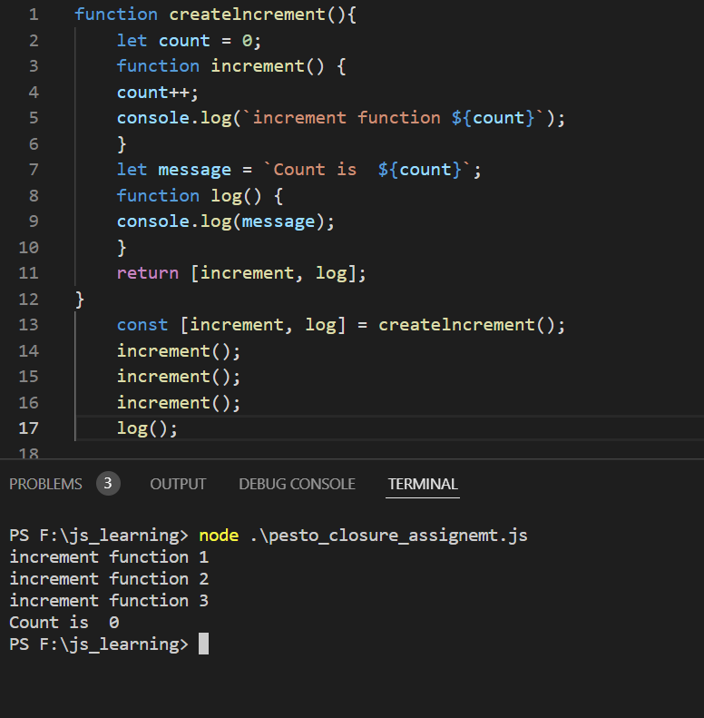

The output is 0.

\*Note the program is modified to explain clouser. Line no. 5 is added.

-when the function createIncrement is called; both nested function `increment` and `log` is returned(ACCORDING TO THE CODE).

-Now we notice that the variable `count` is local to both log and increment. So, both the function can access it.

-In increment function we are incrementing the value of count. But the value of count has limited scope to the function increment only.

-When the function log is executed. It will console out variable `message` which is in the scope of function createIncrement.

-We can observe that the variable will print the `count is` followed by the value of variable $count.

-The output is `count is 0` because the value of variable count = 0; although we are increment the value of count in increment function.

- The incremented count done by function increment and the same has scope of function increment only. It cannot be accessed by the other function log.

-This explains closure; which is a function that can access global scope from local scope. Closure prevents outer scope to access local scope.