What happens when your URL entered into the website?

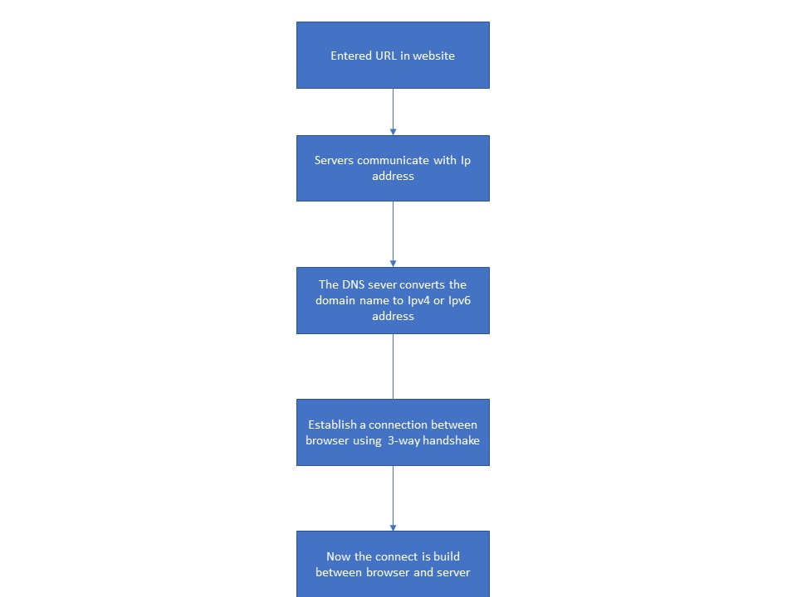

1. In the brower the URL should be translated to Ip address.

2. Servers communicate with Ip address not with domain name.So domain names need to be translated

3. The DNS sever converts the domain name to Ipv4 or Ipv6 address.The Browser searched for the IP address translation in DNS cache of browser if it not found there it looks up with the DNS operating system->check in ISP.

4. URl can be divided into 3 parts.

https:// ---> Protocol

google.com ----> Domain name

Home-page ----> path

5. In order to establish a connection between browser and server it need to establish three-way hand shake.

6.TCP is 3-ways handshaking techinic, Where we use two servers server-1 will sync with server-2 and Server-2 send sync-ack, then server-1 will send ack to server-2.Now the connect is build between browser and server.

7.What is the main functionality of the browser?

Browser main function is to fetch the web pages from the server along with the necessary files like, images, flashes, videos etc, interprets them and then displays it on the screen.

8. High Level Components of a browser?

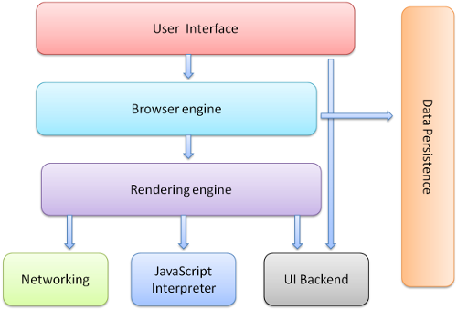

**The user interface**: Front end which user will use.

**The browser engine**: actions between the UI and the rendering engine.

**rendering engine:** responsible for displaying requested content.

**Networking**: Used for network calls such as HTTP requests.

**UI backend**: This backend exposes a generic interface.

**JavaScript interpreter:** Used to parse and execute JavaScript code.

**Data storage:** This is a persistence layer.

9. Rendering engines and uses?

It is a computer hardware that is used to optimize the performance of computations necessary for 3D computer graphic. It is used to interprets HTML and XML documents and also with images that are styled by using CSS, and a final layout is generated, which is displayed on the user interface.

10. Parser: It converts HTML and CSS to by analysing and converting a program into an internal format that runtime environment can actually run.

11.Script processing : Processing the events and object that are present in the script is called script processing.

12. Tree construction: The tree is constructed in tokenized stage and this tree construction is related to the DOM object which parser creates.

13.order of script processing

* Execution Stages.
* Activation.
* Generation.
* Processing.
* Completion.

14.Layout and painting:

Layout is adjusting the CSS on the screen making the screen visible and painting is adjusting the pixels on the screen.