1.When a user enters an URL in the browser, how does the browser fetch the desired result ? Explain this with the below in mind and Demonstrate this by drawing a diagram for the same.(2-3hours)

a.What is the main functionality of the browser?

b.High Level Components of a browser.

c.Rendering engine and its use.

d.Parsers (HTML, CSS, etc)

e.Script Processors

f.Tree construction

g.Order of script processing

h.Layout and Painting

Answers:

Functionality: To render web-pages and become an interface of communication

Components of a Web Browser

1. User Interface

It is an environment allowing users to use certain features like search bar, refresh button, menu, bookmarks, etc.

2. Browser Engine

The bridge connects the interface and the engine. It monitors the rendition engine while manipulating the inputs coming from multiple user interfaces.

3. Networking

The protocol provides an URL and manages all sorts of safety, privacy and communication.  
In addition, the store network traffic gets saved in retrieved documents.

4. Data Storage

The cookies store information as the data store is an uniform layer that the browsers use. Storage processes like IndexedDB, WebSQL, localStorage, etc works well on browsers.

5. JavaScript Interpreter

It allows conversion of JavaScript code in a document and the executes it. Then the engine shows the translation on the screen to the users.

These below are the inner functional components of the web-browser.

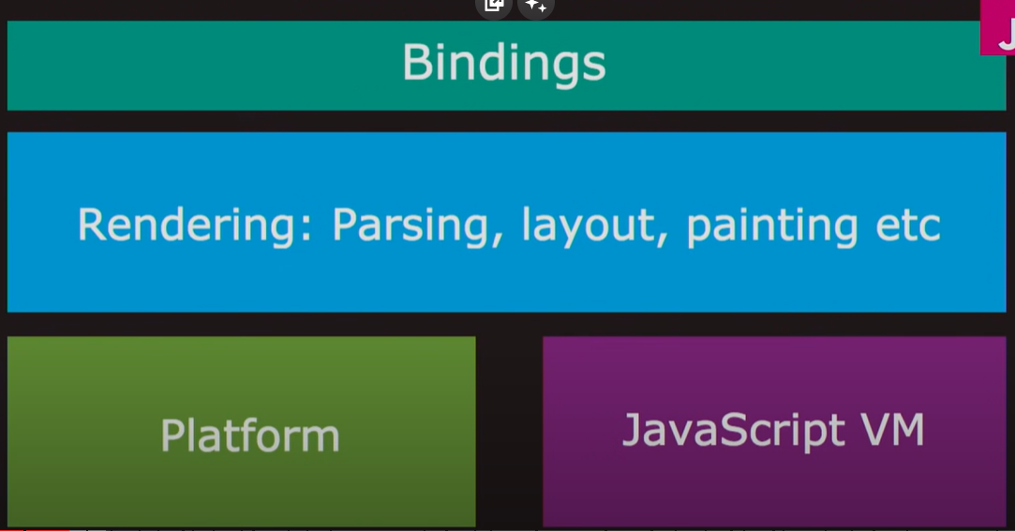

Parsing: the html tags are tokenised and then continues the below process.

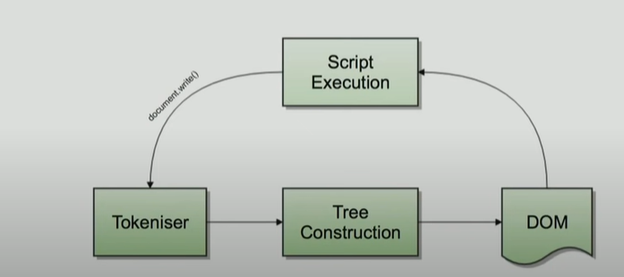

When an url is entered the browser uses its cache to look for the ip-address and if it is not present then its looksup in dns-server and gets the ip-address of the url and makes a connection (TCP) and gets the data from the server of that particular url.The data is most cases is combination of HTM+CSS+Javascript files.

Now the browser parses the html and css separately and then combines together to get the render tree which makes the layout of the viewport and then finally the paint gets applied.

