CricBuzz

High-Level Solution Design Document

Version: 1.00

Updated: 20/08/2000

Author: Aditya Chaudhari

# Introduction

**Cricbuzz** is a cricket news website which gives information about all the games, scores etc.

# Requirement Summary

# Design subscription-based sports website which can display scores, game status, and history for any games.

# User screen, live scores, live games, history

* + User should be able to search games

# Assumptions and Prerequisites

* Cricbuzz is more used for reading purpose only. It is more ready-heavy than write heavy. So let’s assume:
  + Reads per sec : 600000
* We will focus more on accessing database then to write in it.

# [High-Level Design](https://softwaredominos.com/home/software-design-development-articles/high-level-solution-design-documents-what-is-it-and-when-do-you-need-one/)

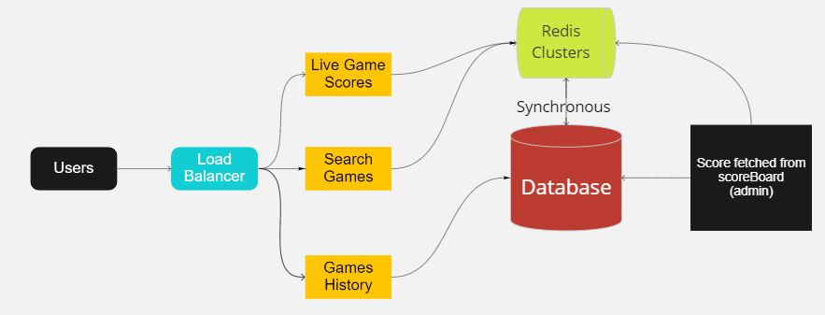

* The interaction happens between main user portal and database and admin who updates the scores ( from scoreboard directly ) (as shown in figure)

## Application Modules

Includes the following:

* User portal where default user can see ongoing live games
* User can see selected game live score
* User can search on the basis of games
* Server layer where all fetching and retrieving functions takes place

## Transactions and User Flows

* Live games: all the games is fetched when this page shown.
  + Get all the data from REDIS as it is in sync with main database
  + REDIS is fast so we will cached trending games score on it
  + And if required then we will fetch from main database.
* Old games history: all data till yesterday are fetched.
  + Get all the data from the main database.
  + As getting history should be that fast so we will save recent (especially ongoing) games on REDIS.
* Search : only data which are related with the entered game will be fetched
  + Get all data from the REDIS if required fetch from main database.
* Load balancers: To handle the request load in peek timings, load balancers will be used.
* REDIS clusters: used to cache some data so that it can easily be available.