**Queries:**

**Q1: Find the item that has minimum weight.**

SELECT DISTINCT ITEMNO,

DESCRIPTION FROM ITEMS

WHERE WEIGHT = (

SELECT MIN(WEIGHT)

FROM ITEMS);

**Q2: Find the different warehouses in “Pune”.**

select wname

from Warehouses

where lower(location)="pune";

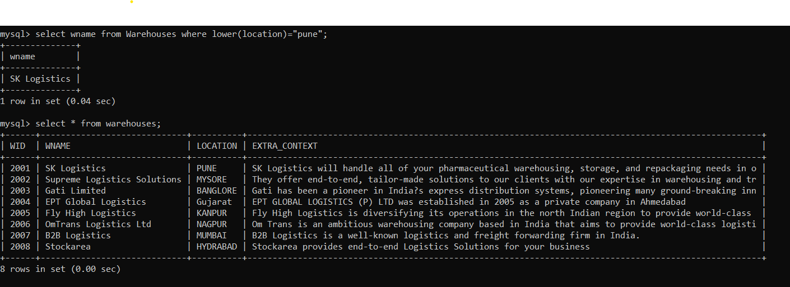

**Q3 Find the details of items ordered by a customer “Mr. Patil”.**

SELECT * FROM ITEMS WHERE ONO=( SELECT ONO FROM ORDERS WHERE CNO=(SELECT CNO FROM CUSTOMER WHERE CNAME="PATIL"));

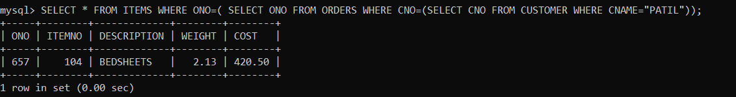

**Q4: Find a Warehouse which has maximum stores.**

select * from warehouses w

-> inner join

-> (select wid, count(wid)

-> from stores

-> group by wid limit 1)

-> stores

-> on w.wid=stores.wid;

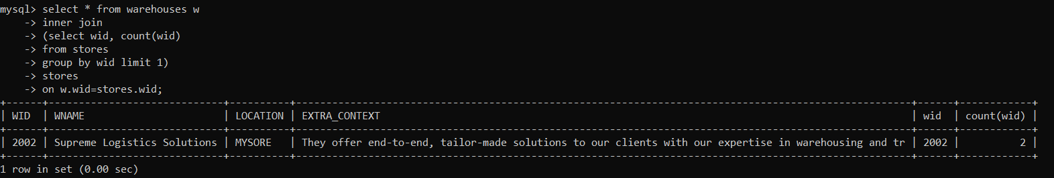

**Q5: Find an item which is ordered for a minimum number of times.**

select description,min(cnt) as count from

(select description, count(description) as cnt from items group by description)items;

**Q6: Find the detailed orders given by each customer.**

SELECT CNAME,O.*,I.* FROM CUSTOMER AS C INNER JOIN ORDERS AS O ON C.CNO=O.CNO INNER JOIN ITEMS AS I ON O.ONO=I.ONO;

