1.Home Page :

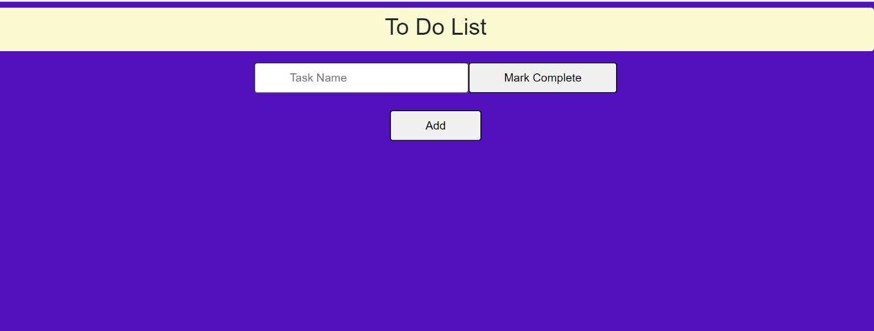

2.Insert task name and click on Add if you want to add further task. Mark task as completed

