WEEK1-HTML:

Exercise 1.1:1.
When a user enters an URL in the browser, how does the browser fetch the desired result ? Explain this with the below in mind and Demonstrate this by drawing a diagram for the same.(2-3hours)

- You type a URL in your browser and press Enter.
- Browser looks up IP address for the domain.
- Browser initiates TCP connection with the server.
- Browser sends the HTTP request to the server.
- Server processes request and sends back a response.
- Browser renders the content.
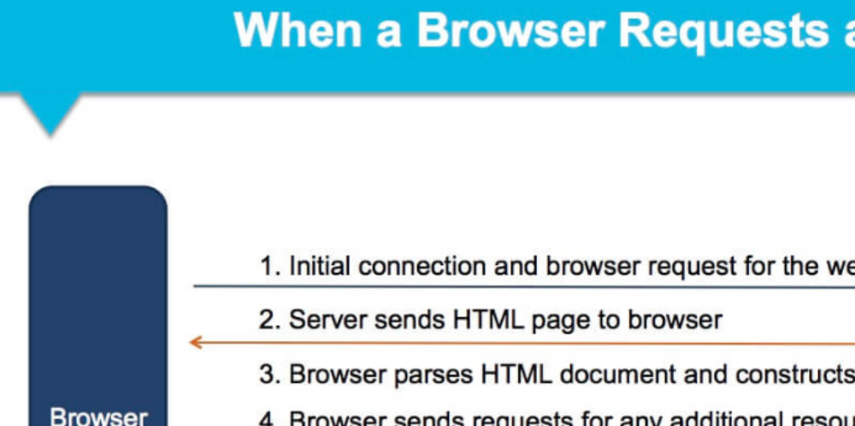

a.What is the main functionality of the browser?
--The main task is to collect information from the Internet and make it accessible to users.
- Or we can say functionality of web browser is to fetch or retrieve informative resources from World Wide Web to the client/ user on demand, translate those files received from web server and display those content to the user and allow the client /user to access all other relevant resources & information via hyperlinks.

b.High Level Components of a browser.

- 1. User Interface – It is the space where interaction between users and the browser occurs. Most of the browsers have common inputs for user interface. Some of them are - an address bar, next and back buttons, buttons for home, refresh and stop, options to bookmark web pages, etc.
- 2. Browser Engine – It is the piece of code that communicates the inputs of user interface with the rendering engine. It is responsible for querying and manipulating the rendering engine according to the inputs from various user interfaces.
- 3.Rendering Engine – It is the part thoroughly responsible for displaying the requested content on the screen. It first parses the html tags and then using the styles, it builds a render tree and finally a render layout, which displays the content on the screen.
- 4.Networking – The fraction of the code written in the browser, responsible to send various network calls. For example sending the http requests to the server.
- 5.Java Script Interpreter – It is the component of the browser written to interpret the java script code presented in a web page.
- 6.UI Backend – This draws basic widgets on the browser like combo boxes, windows, etc.
- 7.Data Storage – It is small database created on the local drive of the computer where the browser is installed. This database stores various files like cache, cookies, etc.

c.Rendering engine and its use.

As the name suggests, this component is responsible for rendering a specific web page requested by the user on their screen. It interprets HTML and XML documents along with images that are styled or formatted using CSS, and a final layout is generated, which is displayed on the user interface.

d.Parsers (HTML, CSS, etc)
Parsing means analyzing and converting a program into an internal format that a runtime environment can actually run, for example the JavaScript engine inside browsers.
The browser parses HTML into a DOM tree. HTML parsing involves tokenization and tree construction. HTML tokens include start and end tags, as well as attribute names and values. If the document is well-formed, parsing it is straightforward and faster. The parser parses tokenized input into the document, building up the document tree.

e.Script Processors

The aspects include browser systems and methods of loading/rendering a webpage by processing the web document (HTML page) in parallel. A scanner process scans the web document, identifies scripts, and initiates the downloading of the scripts. As the scripts are downloaded, an HTML parser generates an identifier for each script and the sends the scripts and associated identifiers to a script engine. The script engine parses, analyzes, compiles, and otherwise prepares the scripts for execution in an order that may be different than the execution order of the scripts.

The ScriptProcessorNode interface allows the generation, processing, or analyzing of audio using JavaScript.

f.Tree construction

The DOM and CSSOM trees are combined to form the render tree.
- Render tree contains only the nodes required to render the page.
First, the browser combines the DOM and CSSOM into a "render tree," which captures all the visible DOM content on the page and all the CSSOM style information for each node.
To construct the render tree, the browser roughly does the following:
- Starting at the root of the DOM tree, traverse each visible node.
- Some nodes are not visible (for example, script tags, meta tags, and so on), and
- are omitted since they are not reflected in the rendered output. Some nodes are hidden via CSS and are also omitted from the render tree; for example, the span node---in the example above---is missing from the render tree because we have an explicit rule that sets the "display: none" property on it.
- For each visible node, find the appropriate matching CSSOM rules and apply them.
- Emit visible nodes with content and their computed styles.
- The final output is a render tree that contains both the content and style information of all the visible content on the screen. With the render tree in place, we can proceed to the "layout" stage.

g.Order of script processing
Depending on the type of object, the task may have more than one Process page on which you can write scripts. The scripts in the Process pages are processed in the following order:
- Pre-Process page and Process page
- Child Post Process page
- Post Process page

h.Layout and Painting

The layout (also called reflow) peace will be in charge to calculate the positions and dimensions of each node on the screen. For instance, if you rotate your phone, or if you resize your browser, the layout peace will be executed.

Finally, now that we know which nodes are visible, and their computed styles and geometry, we can pass this information to the final stage, which converts each node in the render tree to actual pixels on the screen. This step is often referred to as “painting”, “rasterizing.” or “repainting”.

