## Basically whenever you type URL in browser and hit enter the operation is performed in below manner:

* This is how browser components look like: 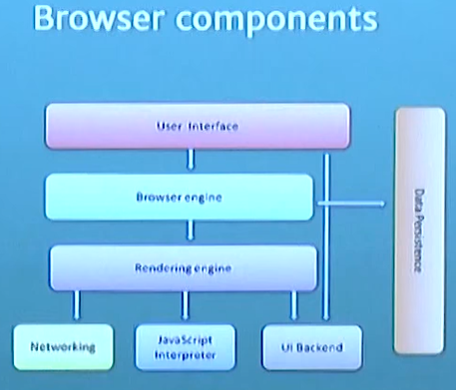
* UI where Address bar is present in which when you type URL and hit enter it first takes hostname and resolves it to its IP address. To resolve Hostname to its IP it uses DNS querying. To do DNS querying browser check four caches:
  + Browser cache: Browser maintains DNS records for a period of time
  + OS cache: Browser will make a system call to your underlying computer OS to fetch record since OS also maintains cache of DNS records.
  + Router cache: Router also maintains DNS records in its cache.
  + ISP cache: If all fails browser will move to the ISP. ISP maintains its own DNS server which includes a cache of DNS records.
* Once the browser receives correct IP address it will build a connection with the server, general it uses TCP protocol to establish connection with server. It uses TCP/IP 3 way handshake protocol.
* Once the connection is established it will start transferring data based on the protocol mentioned in IP ex: HTTP or HTTPS using secure TLS version.
* Based on the HTTP header whether it has GET method or POST method it interacts with server and gets response from server.
* Server sends out an appropriate HTTP response , browser will render the response using it’s rendering engine.

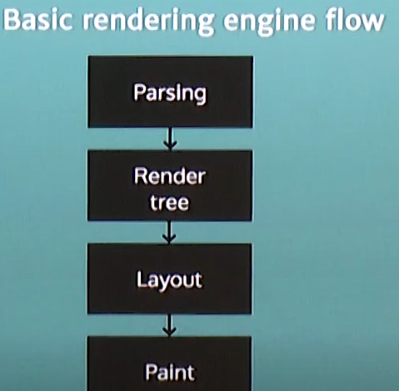

* Parsing:

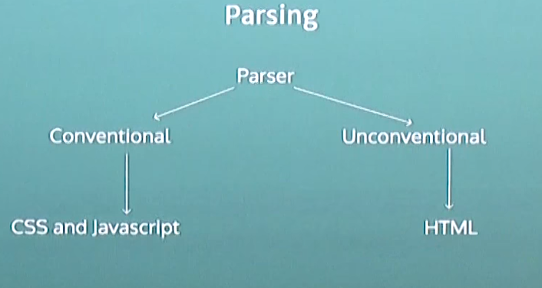There are two types of Parsers: Conventional and Unconventional HTML is parsed by unconventional parsers while CSS and JavaScript are parsed by conventional parsers.

* + HTML is parsed using unconventional parser because it is not context free grammar, it has document type definition (DTD) w3c.
  + Here is how HTML DOM Tree is parsed:

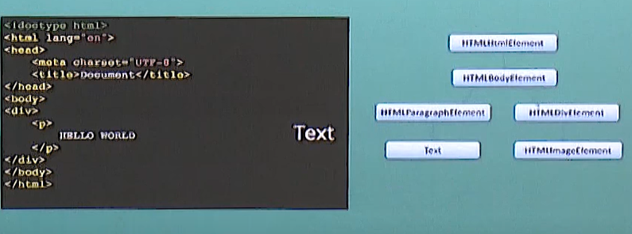

* Render Tree:
  + Render tree is generated while DOM tree is constructed.
  + Rendering determines the order in which visual elements are going to be displayed.
* Layout:
  + It calculates the manner in which DOM will be positioned and it’s size.
  + It calculates the geometry for adjusting document tree.
  + It’s recursive process begins at root object(html).
* Paint:
  + It basically paints the content with the CSS files which are linked to it.
  + Painting order:
    - Background color
    - Background image
    - Border
    - Children
    - Outline