Browser - We type a URL and press the enter and the server responds with index.html. However, an HTML content is not what we see when we visit a website... we see a web page with colors and backgrounds and animations and pictures. So there's a process that turns the HTML content to a pretty webpage, and that is parsing and rendering!
A web browser is a software application for retrieving, presenting and traversing information resources on the World Wide Web. An information resource is identified by a Uniform Resource Identifier (URI/URL) that may be a web page, image, video or other piece of content.

Functions -
- Provide a way for users to access and navigate any kind of web content that can be a part of web page/any information.

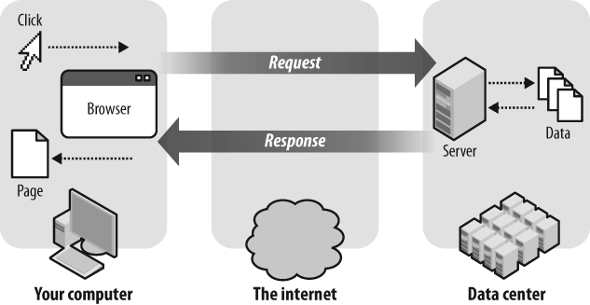

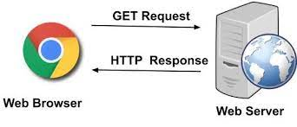
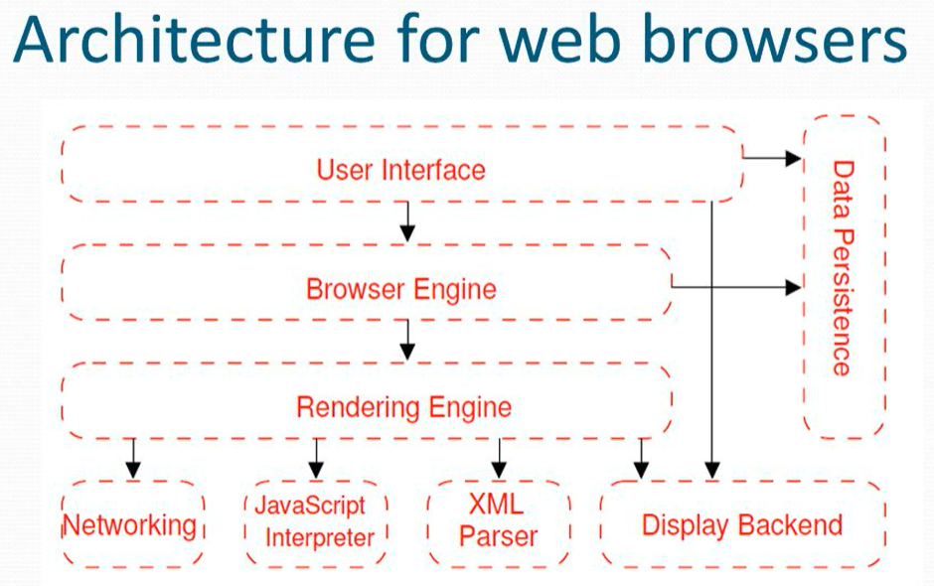

User Interface - This includes the design through which user intracts with a device, website/application. The UI subsystem is the layer between the user and the Browser Engine.
Browser Engine - Provides high level interface between the UI and the rendering engine.
Rendering Engine - Used to display requested content on the user interface. The engine or the software that draws structured text from a document (often HTML), and formats it properly based on the given style declarations as CSS.
Networking - It is a protocal such as HTTP request. It retrieves information from other parts of the web and displays it on your desktop or mobile device.
JavaScript Interpreter- Used to parse and execute JavaScript code.
XML Parser - Used to parse XML documents into a DOM tree.
Display Backend - used for drawing basic widgets like combo boxes and windows. This backend exposes a generic interface that is not platform specific. Underneath it uses operating system user interface methods.
Data Persistence - This is a persistence layer. The browser may need to save all sorts of data locally, such as cookies. Browsers also support storage mechanisms such as localStorage, IndexedDB, WebSQL and FileSystem.

Parsers(HTML & CSS) -
Critical Rendering path is the sequence of actions or steps performed by the browser in order to render a web page on the screen. These steps include fetching resources (HTML, CSS, JavaScript) from the server, parsing received HTML to create DOM, parsing CSS to create CSSOM, creating Render Tree which is the combination of DOM and CSSOM, calculating positioning and dimensions (Layout) of all elements, and finally Painting actual pixels on the screen.

