ASSIGNMENT-1 (SIDHANTH.K)

a.A browser is a software application used to locate, retrieve and display content on the World Wide Web, including Web pages, images, video and other files. As a client/server model, the browser is the client run on a computer that contacts the Web server and requests information. The Web server sends the information back to the Web browser which displays the results on the computer or other Internet-enabled device that supports a browser.

b.

1. **The User Interface**: The user interface is the space where User interacts with the browser. It includes the address bar, back and next buttons, home button, refresh and stop, bookmark option, etc. Every other part, except the window where requested web page is displayed, comes under it.
2. **The Rendering Engine**:It is responsible for rendering the requested web page on the browser screen. The rendering engine interprets the HTML, XML documents and images that are formatted using CSS and generates the layout that is displayed in the User Interface. However, using plugins or extensions, it can display other types data also. Different browsers user different rendering engines:  
   * Internet Explorer: Trident  
   * Firefox & other Mozilla browsers: Gecko  
   * Chrome & Opera 15+: Blink
3. **Networking**: Component of the browser which retrieves the URLs using the common internet protocols of HTTP or FTP. The networking component handles all aspects of Internet communication and security. The network component may implement a cache of retrieved documents in order to reduce network traffic.
4. **JavaScript Interpreter:** It is the component of the browser which interprets and executes the javascript code embedded in a website. The interpreted results are sent to the rendering engine for display. If the script is external then first the resource is fetched from the network. Parser keeps on hold until the script is executed.
5. **Data Persistence/Storage:** This is a persistence layer. Browsers support storage mechanisms such as localStorage, and FileSystem etc. It is a small database created on the local drive of the computer where the browser is installed. It manages user data such as cache, cookies, bookmarks and preferences.

c. The rendering engine parses the chunks of HTML document and convert the elements to DOM nodes in a tree called the c**ontent tree** or the **DOM tree**. It also parses both the external CSS files as well in style elements.

The browser constructs another tree, the **render tree**. This tree is of visual elements in the order in which they will be displayed. It is the visual representation of the document. The purpose of this tree is to enable painting the contents in their correct order. After the construction of the render tree, it goes through a **layout process** of the render tree. The next stage is **painting**. In the painting stage, the render tree is traversed and the renderer’s paint() method is called to display content on the screen. Painting uses the UI backend layer.

d. The browser can send a request to the server, receive its response, and parse the response. Now, HTML file is extracted. Next step, we need to **create a DOM Tree by parsing HTML**. The codes of HTML Parser will help you understand it. In general, the HTML Parser does following things in the order:

1.parse HTML character by character

2.tokenize HTML tag by tag

3.create the nodes of DOM Tree from the tokens, and mount the nodes on the tree

4.compute CSS rules and apply them on the nodes of the DOM Tree

e. The Script Processor Node interface allows the generation, processing, or analyzing of audio using JavaScript.

f. The CSSOM and DOM trees are combined into a render tree, which is then used to compute the layout of each visible element and serves as an input to the paint process that renders the pixels to screen. Optimizing each of these steps is critical to achieving optimal rendering performance.

* The DOM and CSSOM trees combine to form the render tree.
* Render tree contains only the nodes required to render the page.
* Layout computes the exact position and size of each object.
* The last step is paint, which takes in the final render tree and renders the pixels to the screen.

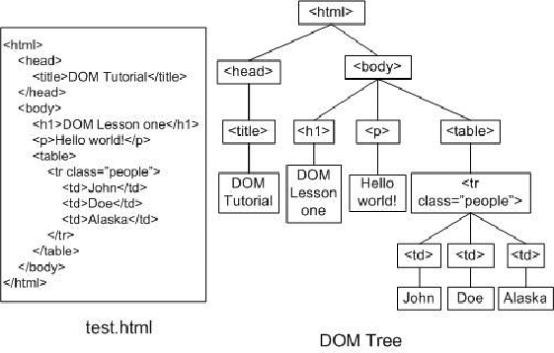

h.

1.Browser creates the DOM and CSSOM.

2.Browser creates the render tree, where the DOM and styles from the CSSOM are taken into account (display: none elements are avoided).

3.Browser computes the geometry of the layout and its elements based on the render tree.

4.Browser paints pixel by pixel to create the visual representation we see on the screen.

All of those steps combined is a lot of work for a browser to do on load… and actually, not just on load, but any time the DOM (or CSSOM) is changed. That’s why many web developers tend to partially solve this by using some sort of frontend framework, such as React which, apart from many other advantages, can help to highly optimize changes in the DOM to avoid unnecessary recalculating or rendering.