WEEK1-HTML:

Exercise1.1:

1.When a user enters an URL in the browser, how does the browser fetch the desired result? Explain this with the below in mind and demonstrate this by drawing a diagram for the same. (2-3hours)

a. What is the main functionality of the browser?

b. High Level Components of a browser.

c. Rendering engine and its use.

d. Parsers (HTML, CSS, etc)

e. Script Processors

f. Tree construction

g. Order of script processing

h. Layout and Painting

Ans:

**URL (Uniform Resource Locator)**-It is the address of the website which is a reference to any resource available on the internet like images, hypertext pages, audio/video files, etc.

**Functionality of the browser**

**Browser**- A Web Browser is an application software that can take you anywhere on the internet. It retrieves information from other parts of the web and displays it on your desktop or mobile device. The information is transferred using the Hypertext Transfer Protocol(HTML), which defines how text, images and video are transmitted on the web.

**High Level Components of a browser**

**1.** **User Interface** - The visible component of the browser to the user allowing them to use certain features like search bar, refresh button, menu, bookmarks, etc.

**2. Browser Engine**- The primary job of a browser engine is to transform HTML documents and other resources of a web page into an interactive visual representation on a user's device.

**3. Networking-**The protocol provides the URL and manages all sorts of safety, privacy and communication.

**4. Data Storage-**Store information in form of cookies, local storage, session storage, Indexed DB, Web SQL, cache storage to enhance user experience like personalising site preferences, storing login details, etc.

**5. JavaScript Interpreter-** It allows conversion of JavaScript code in a document and the executes it. Then the engine shows the translation on the screen to the users.

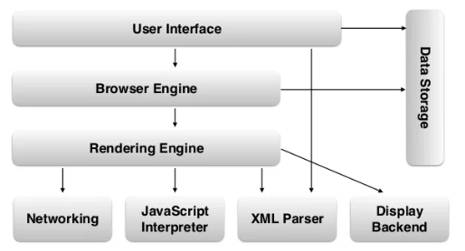

**Parsing and its importance-** Parsing is the step the browser takes to turn the data it receives over the network into the DOM and CSSOM, which is used by the renderer to paint a page to the screen.

In other words, parsing means taking the code we write as text (HTML, CSS) and transform it into something that the browser can work with. The parsing will be done by the browser engine.

**Order of Execution of Script-**

Order of execution in JavaScript is dependent on the following components working together to pass and order information.

* The Call stack
* The Event Loop
* The Task Queue
* Web APIs/External Resources

We can think through the order of execution using asynchronous fetch request.

Guidelines:

1.Submit this assignment on GIT - Answer should be in readme File (with images) on GIT.

2.Candidates should be able to explain how a browser works.

3.What are the high-level components of a browser?

4.How each component works with each other. (For example: Networking component is the one which makes HTTP calls, Data storage component is a browser’s persistence layer which saves data locally such as Cookies and Local Storage.

5.How Parsing works and its importance.

6.The order of execution of scripts.

Outcome:

1.Under the hood understanding of how a browser works.

2.What are the features a browser provides?

3.What a browser can do?

4.How a web page is translated from a string in a URL to a webpage.

Exercise1.2:(2-3hours)

Use "Lato" font for entire text in UI

- Use line awesome Icon library for all icons

- Cattyboard album image <URL:https://vif1g.csb.app/src/assets/cattyboard.jpg>

- Icons used in assignment:

la-bars

la-home

la-search

la-volume-up

la-user

la-cog

la-spotify

la-soundcloud

la-play

la-plus

la-ellipsis-h

la-step-backward

la-step-forward

la-undo-alt

la-random

- Note: Feel free to use any other font library if you wish

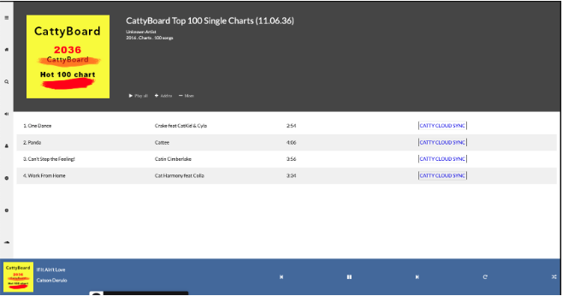

Guidelines:

1.There should be a separate branch created in GitHub for this exercise.

2.The UI should closely match with the screengrab given as sample. This includes the colours, fonts, icons, text etc.

3.Semantic tags should be used for laying out the UI.

4.There should be one or more Git commits with meaningful commit messages