非線性控制第一章作業

李佳玲 F44079029

1.

渾沌(chaos)的測試

(1) Consider a nonlinear equation:



(a) Time response figure for initial condition: 



(b) Time response figure for initial condition: 



Compare the two figures shown above, the result is nearly identical. Therefore, a figure is drawn to check the difference between two figures.



(2) If we change the nonlinear equation given to a linear equation instead:



The result is shown as follows.

(a) Time response figure for initial condition: 



(b) Time response figure for initial condition: 



Likewise, compare the two figures shown above, the result is nearly identical. Therefore, a figure is drawn to check the difference between two figures.



Now, if we compare the difference between (a) and (b) for the result of both nonlinear and linear equation, it’s clear that for the linear equation, the difference, which also represents the error, is convergent.

Thus, we can conclude that for both linear and nonlinear equation, a little change in initial condition doesn’t change the time response performance much. However, when looking closely between two figures with slightly different initial condition, we can observe that while the difference for nonlinear equation is quite unpredictable, the difference for linear equation will eventually converge.

2.

Lorentz奇異吸子的測試

Consider the nonlinear equations: 

(a) Phase space  with initial condition  , considering  from 0 to 100(s).

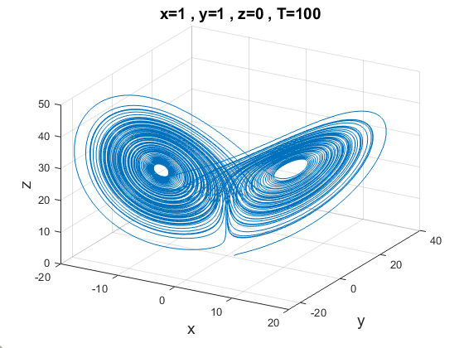

(b) Phase space  with initial condition  , considering  from 0 to 1000(s). 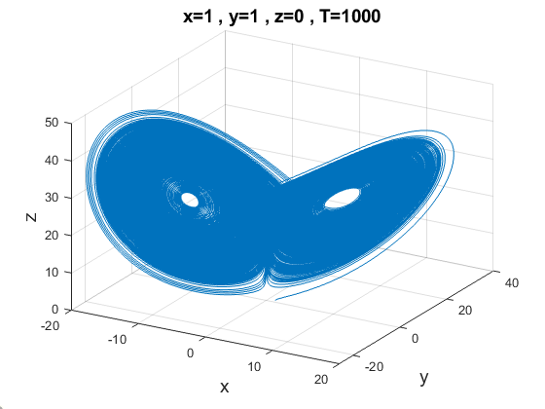

(c) Phase space  with initial condition  , considering  from 0 to 10000(s).

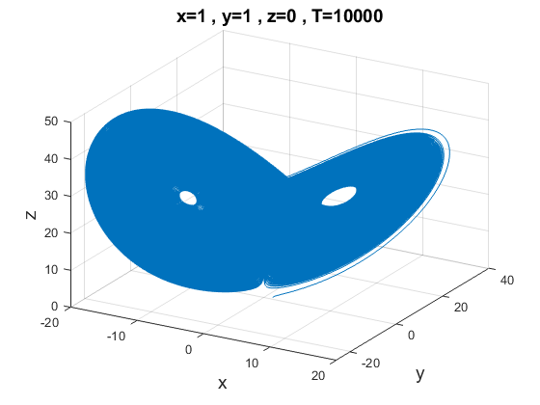

From figure (a-c) drawn above, we can conclude that as the final time becomes bigger (from 100 to 1000 to 10000), the shape also become more “complete”. That is, the longer we let the system run, it will go through more “paths” than it does with the shorter period of time. Also, each path will only be gone through once. Note that no matter for how long the system is running, it will always stay in the same region and will not diverge.

由圖(a-c)中可看出，當終端時間T增大時，相位圖的路徑會被越填越滿，每一條路徑都只會被經過一次，且均在同一個區域內移動，不會向外發散。

Now we try to put in different initial condition.

(d) Phase space  with initial condition  , considering  from 0 to 100(s).

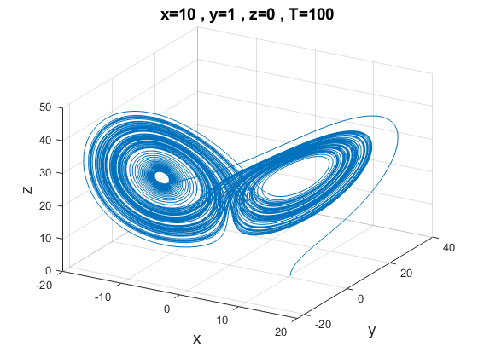

(e) Phase space  with initial condition  , considering  from 0 to 1000(s).

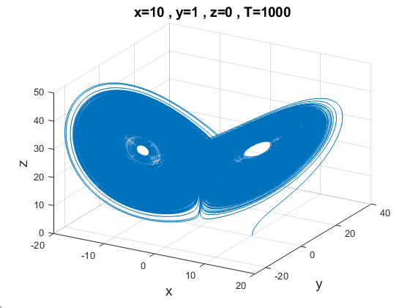

(f) Phase space  with initial condition  , considering  from 0 to 10000(s).

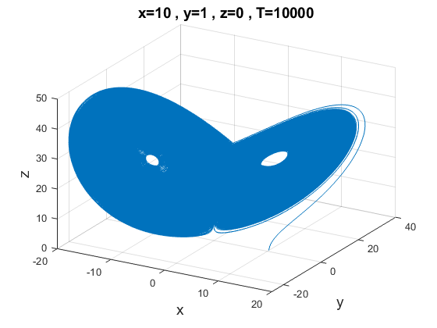

From figure (d-f) drawn above, we can see the same result as we did from figure (a-c) earlier. The only difference is that since they have different initial conditions, they start off from a different point at the very beginning. And then, as figure (d-f) shown, they eventually fall into the same “region” as figure (a-c) and stay in there no matter how long the time is.

由圖(d-f)中可看出與圖(a-c)中相同的結論，兩者相差之處僅為出發的起點，最後均會於同一區域中進行纏繞的動作，且每一路徑只會被經過一次。

3.

霍普夫分岔(Hopf bifurcation)的測試



(a)

Let 

Taking the derivative of  gives

Therefore, we obtain 

Let 

Taking the derivative of  gives



(b)

Case (i): 

Choosing  as an example which means  will make 



From the figure above, we can see that when  , three conditions will need to be discussed. The discussion is shown as follows.

(a)  : this condition will make  and therefore cause the system to diverge.

(b) : this condition will make  and therefore cause the system to fall into a limit cycle with the radius of which varies with the value of .

(c) : this condition will make and therefore cause the system to converge.

In this case, three different cases are shown in the figure above.

Case (ii): 



From the figure above, we can see that when  , the system will diverge for any . This is because any real number  will make .

Case(iii): 

Choosing  as an example.



From the figure above, we can see that when  , the system will diverge for any .

Likewise, this is because any real number  will make .

(c)

According to the figures from (b), we can observe that both Case(ii) and Case (iii) () will only make the system diverge; on the other hand, Case (i) () will cause the system to have three different phases which need to discuss with more details. Therefore, we conclude that  will bifurcate.

(d)

Knowing that , two cases can be discussed:

(1) When  (or ), the system will always satisfy the condition  which leads to the consequence of no in this case.

(2) When , the system will possibly cause the system to have the result of ,  and . Therefore, the number of equilibrium point will depend on whichever condition  provides and vary with the value of .