非線性控制第二章作業

李佳玲 F44079029

1.

Consider eq.(2.4.3) from the text book:  where 

Therefore, the characteristic equation can be written as 

Since different sets of  will lead to different characteristic values  which will then have different types of equilibrium point, 6 different sets of  are chosen and shown as follows from (a) to (f).

(a)

. Several initial conditions are selected and drawn in the figure.

|  |  |
| --- | --- |
|  |  |

When choosing , the characteristic values are shown in the figure above as **two conjugate complex numbers with real part being negative**. Consequently, causing the equilibrium point to be “**stable focus**” as type 1 in fig 2.4.1 in the text book.

(b)

. Several initial conditions are selected and drawn in the figure.

|  |  |
| --- | --- |
|  |  |

When choosing , the characteristic values are shown in the figure above as **two conjugate complex numbers with real part being positive**. Consequently, causing the equilibrium point to be “**unstable focus**” as type 2 in fig 2.4.1 in the text book.

(c)

. Several initial conditions are selected and drawn in the figure.

|  |  |
| --- | --- |
|  |  |

When choosing , the characteristic values are shown in the figure above as **two negative real numbers**. Consequently, causing the equilibrium point to be “**stable node**” as type 3 in fig 2.4.1 in the text book.

(d)

. Several initial conditions are selected and drawn in the figure.

|  |  |
| --- | --- |
|  |  |

When choosing , the characteristic values are shown in the figure above as **two positive real numbers**. Consequently, causing the equilibrium point to be “**unstable node**” as type 4 in fig 2.4.1 in the text book.

(e)

. Several initial conditions are selected and drawn in the figure.

|  |  |
| --- | --- |
|  |  |

When choosing , the characteristic values are shown in the figure above as **two conjugate complex numbers with real part being zero**. Consequently, causing the equilibrium point to be “**center**” as type 5 in fig 2.4.1 in the text book.

(f)

. Several initial conditions are selected and drawn in the figure.

|  |  |
| --- | --- |
|  |  |

When choosing , the characteristic values are shown in the figure above as **two real numbers, one being positive and the other one being negative**. Consequently, causing the equilibrium point to be “**saddle point**” as type 6 in fig 2.4.1 in the text book.

Compare the six phase-plane figures above to the figures in fig 2.4.1 in the text book, we can see the similarity between two figures in the same type. However, there are still some differences that can be observed in type 4 and 6 particularly. In type 4, the figure from text book diverges exactly from the equilibrium point; on the other hand, the figure from matlab simulation doesn’t really show that. When looking closer near the equilibrium point, we can see that there’s nothing around it. From my point of view, the reason is probably because that the figure from the text book is just showing what the simulation would look like in general, not the exact same. Hence, I tried putting more random initial conditions in just to see whether my understanding is correct.



From this figure, we can tell that even if we let the initial conditions have more variety, the general concept is pretty much the same. That is, the phase-plane will diverge from the equilibrium point which is (0,0) here and none of the lines will pass through (0,0).

In type 6, similar to type 4, the figure in (f) above from matlab shows that there’s not really anything near the equilibrium point. On the other hand, the figure from the text book clearly shows that even though it’s unstable, since there’s still one negative characteristic value, we can still see a little bit of convergent in the figure. More of a random initial conditions are put in here as well and shown as follows.



From this figure, since there’s more initial conditions, it’s more obvious than the one drawn in (f) that there contains both divergent and convergent situation. Overall, the phase-plane will still diverge but when it gets closer to the equilibrium point, it will converge first and then diverge.

2.

(a) 

Let 

Taking the derivative of  gives

Therefore, we obtain 

Let 

Taking the derivative of  gives



The analytical solution can be derived by forming  as a *Bernoulli differential equation:*  where .

Let , we can then rewrite  as 

, solving this equation we then have  where 

From , we know that the radius of limit cycle will be .

Hence, to test the stability, we can plug in different  to check whether  is bigger or smaller than 0 and consider their relationship with limit cycle .

(i) :

Consider , we can then derive . Since  and , when inside of limit cycle,  will continuously keep decreasing () which means  is getting further away from the limit cycle.

(ii)  :

Consider , we can then derive . Since  and , when outside of limit cycle,  will continuously keep increasing () which also means  is getting further away from the limit cycle.

(iii) :

Consider , we can then derive  which means that  will stay on the limit cycle at all time.

Conclude (i)~(iii), we can then predict that for this case, the limit cycle will be **unstable** because the path of  will keep getting further away from the limit cycle itself both inside and outside of the limit cycle.

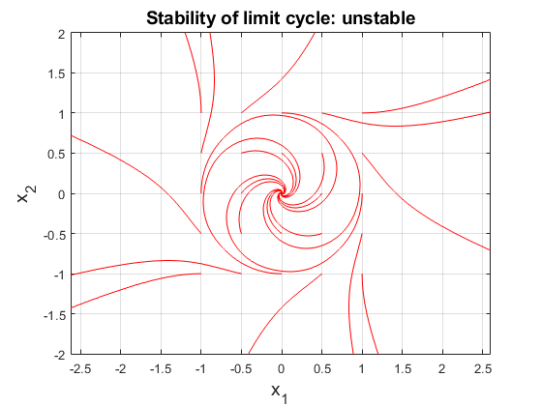

A Matlab simulation of the phase-plane is shown above where we can see that the result suits the prediction and therefore attests the stability of limit cycle is half stable in this case.

(b) 

Let 

Taking the derivative of  gives

Therefore, we obtain 

Let 

Taking the derivative of  gives



The analytical solution of  is more difficult to derived due to the higher order of , therefore, the assistance of Symbolab.com is being used and the solution is



From, we know that the radius of limit cycle will be .

Likewise, to test the stability, we can plug in different  to check whether  is bigger or smaller than 0 and consider their relationship with limit cycle .

(i) :

Consider , we can then derive . Since  and , when inside of limit cycle,  will continuously keep increasing () which means  is getting closer to the limit cycle.

(ii)  :

Consider , we can then derive . Since  and , when outside of limit cycle,  will also continuously keep increasing () which means  is getting further away from the limit cycle, unlike the situation in (i).

(iii) :

Consider , we can then derive  which means that  will stay on the limit cycle at all time.

Conclude (i)~(iii), we can then predict that for this case, the limit cycle will be **half stable and half unstable** because the path of  will keep getting further away from the limit cycle when outside of it but getting closer to the limit cycle when inside of it.

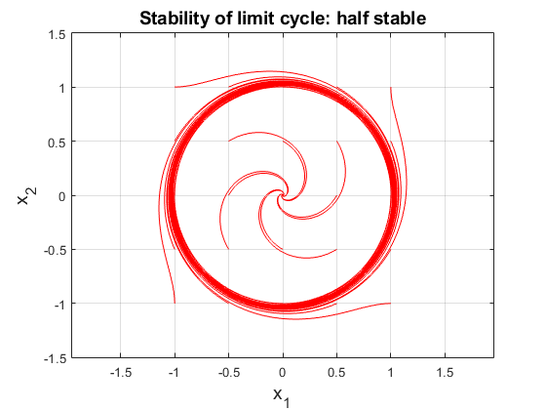

A Matlab simulation of the phase-plane is shown above where we can see that the result suits the prediction and therefore attests the stability of limit cycle is half stable in this case.

(c) 

Let 

Taking the derivative of  gives

Therefore, we obtain 

Let 

Taking the derivative of  gives



The analytical solution can be derived by forming  as a *Bernoulli differential equation* as well, similar to what was done in (a).

Let , we can then rewrite  as 

, solving this equation we then obtain  where 

From , we know that the radius of limit cycle will be .

Hence, to test the stability, we can plug in different  to check whether  is bigger or smaller than 0 and consider their relationship with limit cycle .

(i) :

Consider , we can then derive . Since  and , when inside of limit cycle,  will continuously keep increasing () which means  is getting closer to the limit cycle.

(ii)  :

Consider , we can then derive . Since  and , when outside of limit cycle,  will continuously keep increasing () which also means  is getting closer to the limit cycle as well.

(iii) :

Consider , we can then derive  which means that  will stay on the limit cycle at all time.

Conclude (i)~(iii), we can then predict that for this case, the limit cycle will be **stable** because the path of  will keep getting closer to the limit cycle itself both inside and outside of the limit cycle.



A Matlab simulation of the phase-plane is shown above where we can see that the result suits the prediction and therefore attests the stability of limit cycle is half stable in this case.

3.

A phase-plane of saturated system with the parameter: 

Due to the fact that  is set at 0.2, there are different cases that need to be considered when  which is linear region and  which is saturated region.

To see how the path actually changes in different region, three lines are drawn all together and  is added in the figure below.



From this figure, we can see clearly that three regions will have total different paths. In order to combine them in one, when the path is about to go into the linear region (), it will take the end point of the saturated region () it came from as the start point, and then start its path until it reaches the edge of linear region again where it will take that end point as another start point and starts its path in saturated region (). This will go on until the path doesn’t go through the edge of different regions and stay in it.

A Matlab simulation is drawn as follows.



When comparing this figure with the ones in the text book, it’s identical with fig. 2.7.9 which is also drawn by a computer. There exists a slight difference with fig. 2.7.8 which is drawn by hand. Since fig. 2.7.8 is drawn using the slope of lines to estimate the path, it will not be as precise as the one drawn by a computer even though it looks similar.

Therefore, we conclude that the figure drawn by using Matlab is more precise than the one drawn by hand.