非線性控制第三章作業

李佳玲 F44079029

(a)

Consider the input signal of the nonlinear saturated element  , the output signal of the nonlinear saturated element can be described as  where .

We can then express using Fourier Series:



Since the input and output signal is symmetric,  ;

Also,  is an odd function which means the  part can be ignored.

Therefore, we can derive that  where

and obtain the describing function:



The Nyquist plot of the plant  can be drawn as follows. Note that since we don’t know the value of  yet,  is considered here to find the frequency.

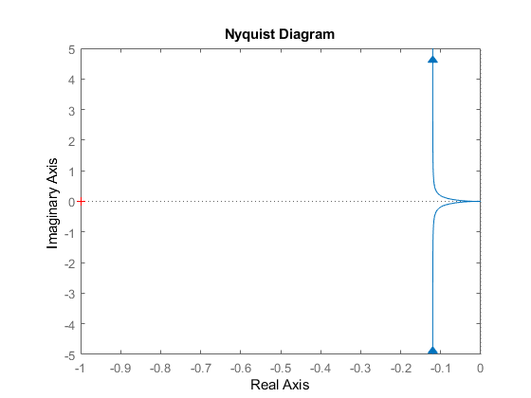

When looking more closely, there’s a little circle on the right side of the plot and then we can find the point when the path crosses the Real axis and obtain the frequency.

|  |  |
| --- | --- |
|  |  |

Referred to example 3.3.2 from the text book, the  from the text book is  in this problem, the critical point is then obtained: .

We then take the frequency  and obtain  which is:



To see whether this  is the one we’re looking for, Nyquist plot of the plant is drawn as follows where .

|  |  |
| --- | --- |
|  |  |

We can also then plot  with this Nyquist plot to make sure that this  can maintain the system as a stable system, since the condition to be stable is that the critical point of  can’t be encircled by the Nyquist plot.

|  |  |
| --- | --- |
|  |  |

From the figure we can see that the critical point -1 is fairly close to the intersection of the Nyquist plot and Real axis.

In all, based on the information we acquired from Nyquist plot, the largest tolerance of the gain  of the given plant which the system maintains stable is . In other words, to make the system stable,  needs to be satisfied.

Additionally, to check whether  makes sense, I also tried a different approach to get the value of .

From the characteristic equation , we can obtain the transfer function of the saturated element: 

Since there exists no imaginary part in , let . Then we will have .

Here we know that  is approximately 22.3607, which is pretty close to  from earlier.

Take the frequency  , plug it back in  to find the inequality: 

One can see that there’s a slight difference between  derived based on different approaches, the possible reasons will be discusses later in (d).

(b)

 is chosen here as  to satisfy the condition that .

Then, use the equation  to solve for  where:



 is then obtained as the amplitude while frequency .

Since choosing  will cause the system to be unstable, the input that will create the limit cycle (meaning the “junction” between stable and unstable) when having specific input which is  here when  is considered.

Additionally, I also derive a slightly different input by using :



is then obtained as the amplitude while frequency is.

By doing so, a different  is acquired when .

(c)

A simulation using Simulink in Matlab is performed. The block diagram is shown here.

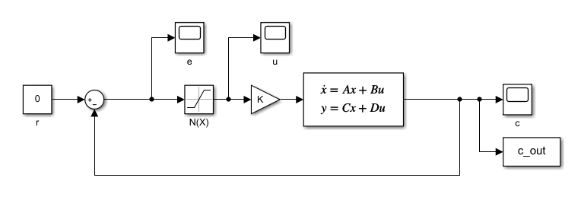

Due to the fact that Laplace transfer function can only have 0 as its initial condition, the plant  is converted to state-space model here to have initial condition .

Initial condition  is selected here to attest the stability of the system.

Now we try putting different value of  to find out the largest  which allows the system to be stable. A table of different value of  and its corresponding time response  is made as follows.

|  |  |
| --- | --- |
|  |  |
| 10 | The time response will converge to 0 pretty quickly (about 2 seconds). |
| 50 | With a bigger  (but not big enough), the time response will still converge to 0, just slower than when . |
| 59 | With an even bigger , the time response converges a lot slower but still to 0 at the end, which means the system is stable. |
| 60 | To check whether time response will converge or not, time span is extended from 10 to 50.    From this figure, we can observe that  will indeed make the time response have a sine wave and doesn’t converge to 0 no matter how long the system runs. Note that the amplitude of the “stable” sine wave is 20. |
| 61 | Now that  is bigger than 60, it appears that limit cylce exists. In order to ensure this fact, time span is extended from 20 to 100.    From this figure we can observe that the time response will converge first and then stay as a sine wave with certain amplitude and frequency. We then know that limit cycle exists when  and same should be applied for . |

From the table, when , the time response  will converge to 0. Thus, we can conclude that  is the largest tolerance of gain which the system maintains stable.

To double check the conclusion we have about stability previously, another initial condition is being considered to make sure that no matter how big or small the initial condition is,  will always be the largest tolerance of gain which the system maintains stable.

Another initial condition  is considered here and the corresponding time response based on different value of  is drawn and shown as follows.

|  |  |
| --- | --- |
|  |  |
| 10 | As before, the time response converges very quickly, the only difference is the initial condition. |
| 50 | Same as before, it will take a little longer with a bigger  (still less than 60) to converge to 0. |
| 59 | In a similar pattern, with an even bigger , it takes much longer time for time response to converge to 0. |
| 60 | Same as before, we extend time span to 100.    When comparing the time response here () with the previous one (), we can see that the pattern is very much alike: they both stay as a sine wave, however, with different amplitude. The reason behind this is that they don’t have the same input signal. When using , since it’s bigger than 20, the saturated element will “cut off” the signal. On the other hand, when using , since it’s smaller than 20, it won’t get “cut off” by the saturated element. |
| 61 | Same as before, we extend time span to 50.    From this figure, we can see that when we have an intial condition , the time response will diverge first before it reaches the limit cycle. When it reaches limit cycle, the amplitude of the sine wave is the same as  . The reason behind this is that when , we expect limit cycle to happen and have the same sine wave as well, however, when , same as we discussed previously, the signal won’t get “cut-off” by the saturated element. Therefore, the time response will look differently before it reaches limit cycle and stay in it. |

Compare the two tables we have for different initial condition, we can then state the conclusion with more confident which is the fact that based on the simulation done by Simulink in Matlab,  is the largest tolerance of gain which the system maintains stable (when reference input , whether the initial error  is bigger or smaller than 20, the output time response  can be guaranteed.).

(d)

In (a), we obtained two different , based on Nyquist plot and analytical solution, respectively. Since the  derived by analytical solution is the same as using Simulink in (c), the discussion will based on the difference between  gotten from Nyquist plot () and Simulink simulation ().

Due to the reason that Nyquist plot is used for linear system, when we try to obtain the gain  by applying Nyquist plot, the result we get is an approximation. The advantage of using Nyquist plot is that it can give you a general idea of where the frequency would be when the system is considered/assumed as a linear system. It’s simply faster and easier.

Additionally, the describing function is basically the “Laplace transfer function” for nonlinear systems. It’s not possible to derive the exact transfer function when the system is nonlinear, all we can do is try our best to get the closest thing which is describing function. When deriving describing function in (a), we ignored the higher order part in Fourier Transfer function for convenience and simplicity. That’s the main reason why the difference between two methods exists. And the result from doing so, as we saw, was actually pretty close to the more accurate ones when we used analytical solution/Simulink to simulate the system.

Also, that’s also why in (a), the gain  obtained from  is supposedly more accurate based on the analytical solution, comparing to  which was based on the data point from Nyquist plot.

(e)

 is chosen again here (the same  in (b)), a simulation can be done by Simulink in Matlab which contains the following block diagram.

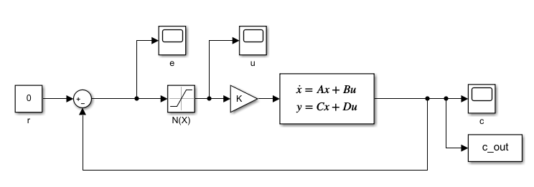

Both initial condition  and  are chosen here to prove that it doesn’t matter whether it’s larger or smaller than 20, the system should exist the same limit cycle solution .

The time response  is shown as follows.

|  |  |
| --- | --- |
|  |  |
|  |  |

The figures show that the amplitude and frequency of the sine wave will be identical once it reaches limit cycle, independent on the initial condition.

Two of the data points are pointed out in order to calculate the amplitude and frequency of the sine wave of the limit cycle.



We can first see that the amplitude is 26.75, and the frequency is obtained by calculation:

.

Consequently, we acquire  when the system goes into a limit cycle.

Recall the two slightly different sets of  we have from (b) which are  using Nyquist plot and  based on analytical solution.

When we compare all three of them, we see that there exists larger differences between  and  than that and . In fact, the difference between  and  is so small that we can almost ignore it. The reasons behind the differences based on Nyquist plot and Simulink simulation were stated in (d). The one based on Simulink simulation is more accurate than Nyquist plot because from the moment we “assume” the system as a linear system and use the same approach we would use for linear systems on this nonlinear system, everything we have is pretty much an approximation. However, it’s still a good way to obtain information which provides a general idea of the real one. What’s more, the result is actually not that far off from the more accurate one.