非線性控制第四章作業

李佳玲 F44079029

1.

Proof the stability at origin of the following nonlinear equation using Lyapunov direct method:



Consider the Lyapunov function .

From this function, we know that  and  will never be negative.  is then satisfied with any set of  except for  which will make .

We then derive  as follows.



To find the convergent range of , we have to ensure . Therefore, the condition  must be satisfied; In other words,  is the convergent range of .

(b)

To check the convergent range of  from (a), 3 sets of  which satisfy the condition  are chosen: 



From the phase plane figure, we can see that all three sets of  will converge to origin.

At the same time, we also choose another three sets of  which do not satisfy the condition : 



From the phase plane figure, we can see that all three of them will end up diverging.

The reason is because that they didn’t meet the condition , which means when plugging them into  ,  will happen which is against the Lyapunov direct method.

(c)

Since different Lyapunov function  will lead to different convergent range, we can apply  to convert the equation from  to .



Likewise, to find the convergent range of , we have to ensure . Therefore, the condition  must be satisfied.

However, according to polar coordinate,  is defined and stands for radius, which means the condition  needs to be ruled out; In other words,  simply doesn’t mean anything in the polar coordinate.

From the difference of convergent range between (a) and (c), we conclude that the most precise convergent range should be decided directly by the nonlinear equation itself. In (c), we defined  and obtain another convergent range based on  which leads to a different circumstance. This reminds us that when using any kind of coordinate transformation, we have to be very careful for the result we get from it, otherwise the result may be misleading and will lead to wrong conclusion.

2.

Consider the following nonlinear equation



Assume the gradient of the Lyapunov function  as



where different  will lead to different  and therefore obtain different convergent range of  to maintain the system’s stability.

Consider 

The gradient of the Lyapunov function  can be written as



We then derive  and  :





From the result of , we know that the condition  can be satisfied by all  except the origin ; In terms of , to ensure that , the condition  has to be satisfied.

To ensure the stability of the nonlinear system when choosing this particular , we have to find the convergent range where both  and  are met. Therefore, the convergent range  is acquired.

(b)

Consider 

The gradient of the Lyapunov function  can be written as



We then derive  and  :



Note that when deriving ,  is set to be zero; when deriving ,  is set as a constant.



From the result of , we know that the condition  has to be satisfied in order to ensure ; In other words, to make the system stable, the condition  needs to be met. In terms of , we can see that all  except  will ensure the condition .

Likewise, in order to ensure the stability of the nonlinear system when choosing this particular , we have to find the convergent range where both  and  are met. Therefore, the convergent range  is acquired.

A different approach for deriving  :



From this result, we obtain a different convergent range as we did before:  to ensure the condition . In my opinion, this is because Lyapunov stable is only sufficient condition when finding the stability range. That is, not only will we obtain different range based on different Lyapunov function, it’s also possible that we actually derive different range even using the same Lyapunov function. There’s another possible reason: we should be more careful when we cancelled out the  from denominator and numerator earlier. This won’t be acceptable if  which makes the denominator be zero. Nevertheless, in this case, I decided to use the range we obtained earlier and check whether it will case any trouble later.

(c)

When we’re looking for the convergent range of a system, we can try choosing different Lyapunov function  which leads us to different convergent range. After selecting a couple of them, we can obtain the convergent range that’s more accurate by taking the **union** of all the convergent range. The reason behind that is because when we’re checking the stability of certain point, it doesn’t have to lie within all the Lyapunov function’s convergent range. As long as you can find one Lyapunov function that will let that certain point satisfy the condition  and , we can state that this point is asymptotically stable and will converge to the equilibrium point. Note that just because it will converge to the equilibrium point, we can’t be sure that it will certainly converge to the origin. Further discussion will be made in problem 3.

With that being said, if we want to find the convergent range of this nonlinear system, the range we should consider would be the **union** of the range we obtained from (a) and (b) which are  and ; In conclusion, the convergent range is  for this nonlinear system.

To attest whether the convergent range  is right, the phase plane figure is drawn as follows.

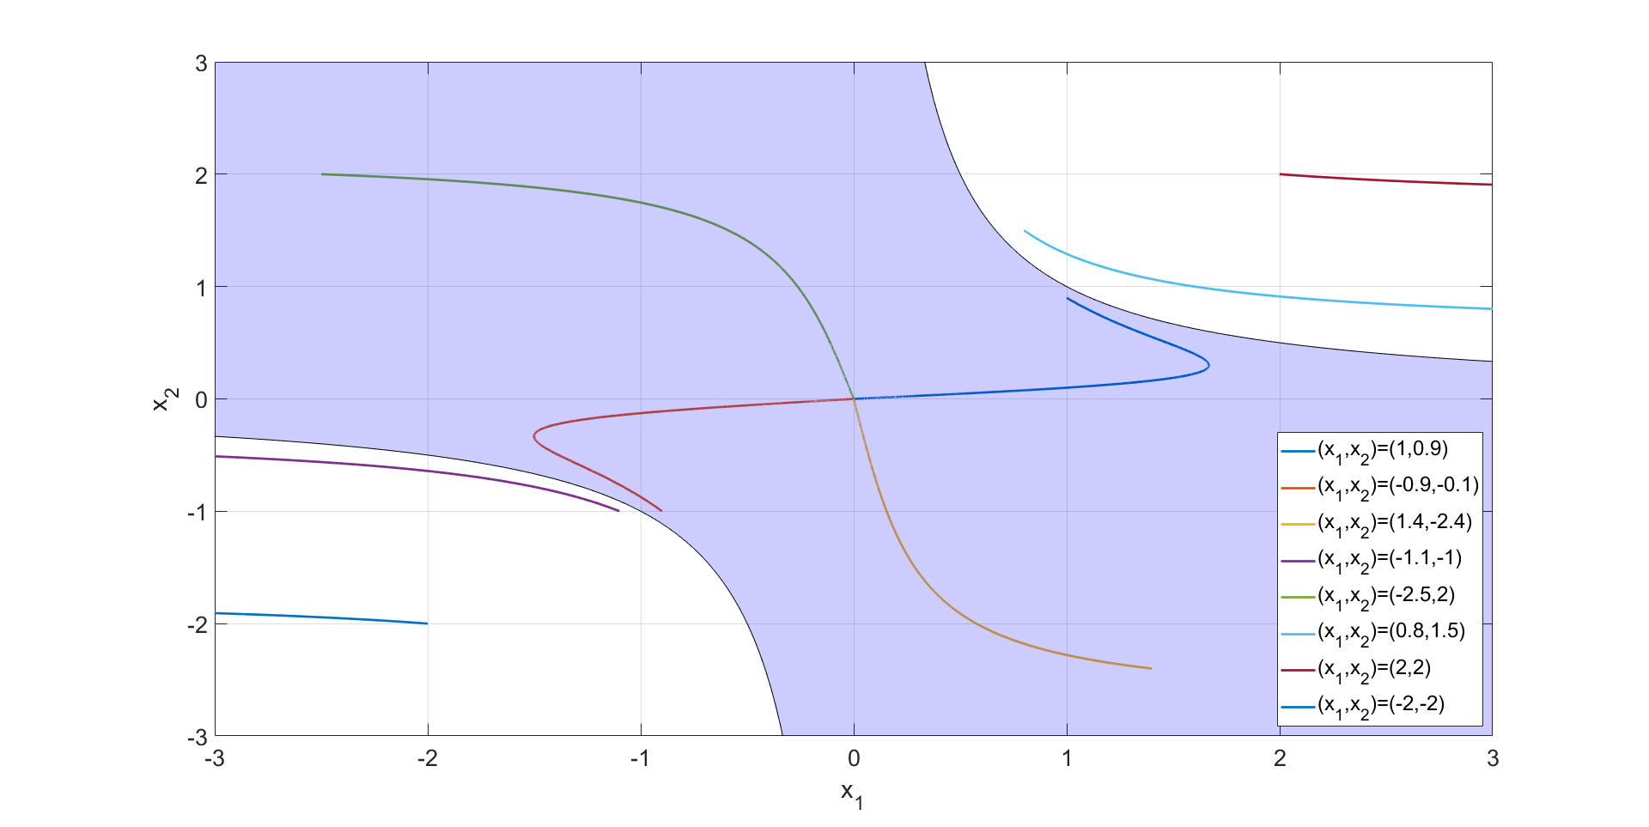

The filled region is . 8 different set of  are selected here and we can see clearly that if they lie within the filled area, they will converge to the origin; If not, they will end up diverging.

Hence, we know that what we concluded about the convergent range is correct.

However, it’s essential to note that this Lyapunov stability is sufficient condition, which means that there might exist some points outside of the converge region we obtained converging. In order to find the real stability region, we have to find as many Lyapunov function  as possible and then take the union of all the results. This can also mean that it’s almost impossible to find the “real” convergent range for nonlinear systems. Thus, what we can conclude is that the more suitable functions we find, the more “real” and “precise” the convergent range is.

3.

Consider the following nonlinear system



The purpose of this question is to check whether the system is globally stable at origin.

(a)

Take 



From  and , we know that for all  except , both  and  can be satisfied. Therefore, we conclude that the system is asymptotically stable to origin.

To check whether  is radially unbounded, we test whether the condition  is satisfied. This condition is also called “growth condition”. When the equilibrium point is Lyapunov stable and meets this condition, we can say that this equilibrium point is globally stable.

Let  , we then see that , which means the growth condition is not satisfied. Because when , we can’t promise that  as well; Instead,  will be dependent on the value of . Hence, for this system,  is not globally stable.

(c)

We can then use Matlab to draw the contour lines of  by setting it as different constant, and then add the phase plane figure onto it to see whether they will all converge to .

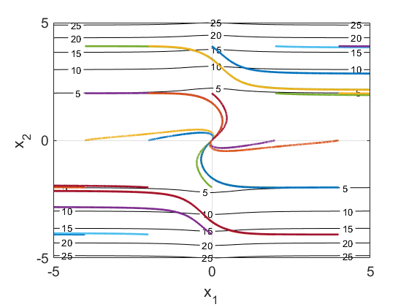

From the figure, we can see that clearly not all the points will converge to , which means there exist different equilibrium points since for all , both  and  can be satisfied.

To check approximately where did the points start to stop converging to , we have to use the technique of trial-and-error.

First, we try to convert  to  and then put in different value of :

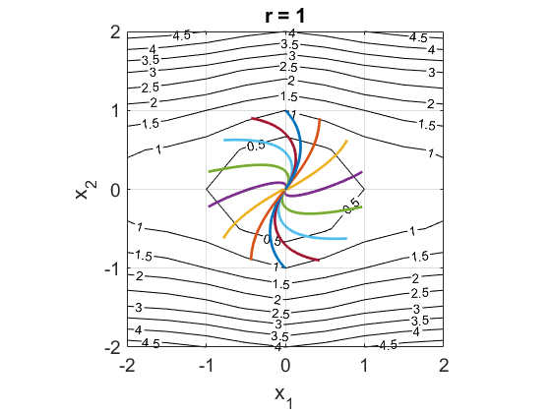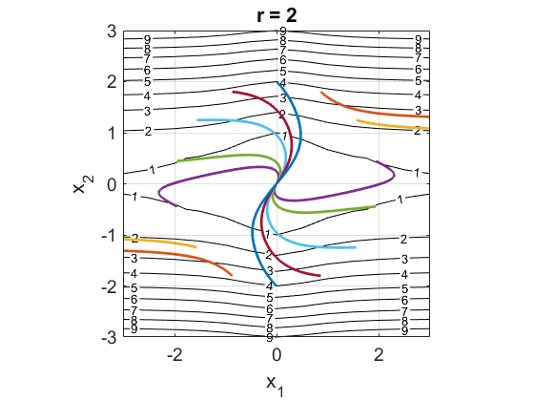

We can see here that when , some of the points will not converge to . Therefore, we know that the range which all points will converge to  lies within  and .

Using the technique of trial-and-error, we find out that around , there will be points not converging to the origin. Based on this observation, we conclude that the range that will ensure the system as an asymptotically stable system is .

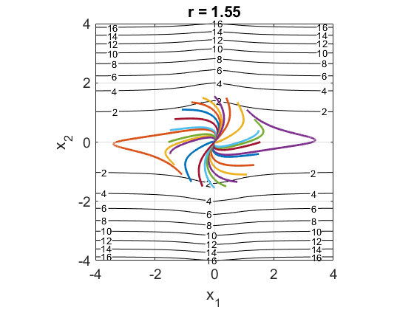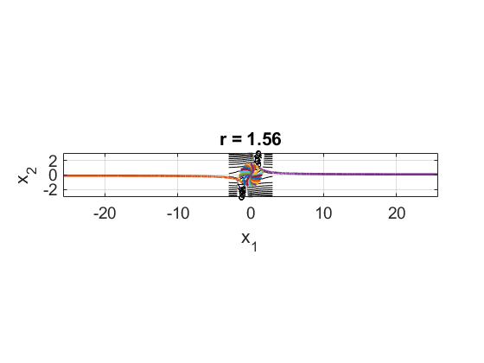

(d)

Due to what we derived from (b) and (c), we already know that the origin is not the only equilibrium point for this system. To ensure that  is another equilibrium point, we put it back into  and .



We can see that  is indeed another equilibrium point since it will make both  and  be  This is also why the origin  is not globally stable.

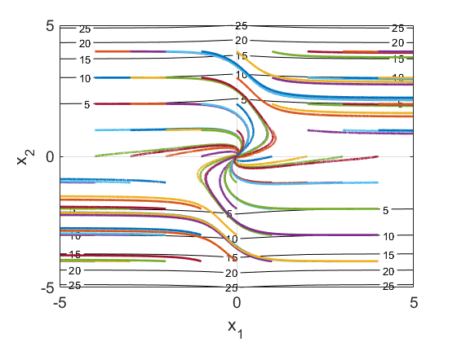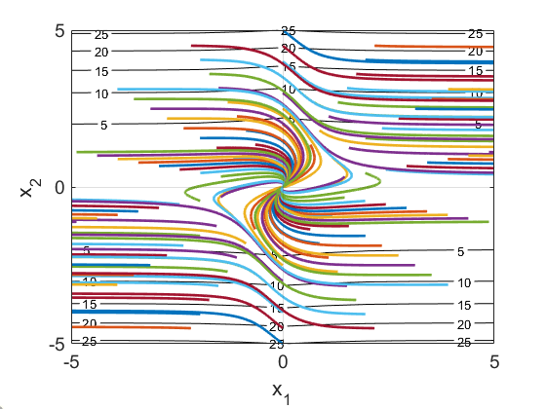

From these two figures, we can see clearly that some points will converge to the first equilibrium point  and some will converge to the second equilibrium point.