非線性控制第六章作業

李佳玲 F44079029

1. Consider the following nonlinear system



(1)

Express the system as , we can obtain that



Step1.

Check whether the controllability matrix satisfies







 (full rank)

Therefore, we know that this system is controllable, which means that  exists.

Step2.

Due to the fact that involutive condition will be automatically met as long as we successfully find  which satisfies , we’re going to go ahead and do so.

We can then derive  by applying Eq.(6.5.26) from the text book.

1. Condition 1: 



1. Condition 4: 



1. Condition 2: 



From (c), we know that  or 

Note that it’s possible that , which will fulfill condition (c) without having . However, this is proved not adoptable when designing control signal  and will be further discussed later.

Plugging  back into (a) gives 

Therefore, we know that both  and  have nothing to do with .

1. Condition 5: 



1. Condition 3: 



From (e), we obtain that 

Due to the fact that , we derive that .

We can then conclude that .

Therefore, we’re going to assume that  as this is very straightforward and it satisfies what we have derived so far, as well as the Condition 6 which is .

Step 3.

Set up the state coordinate transformation :



Also, set up the control signal transformation 



Step 4.

Design the new control law as 

First, we can obtain the linear equation:





where  is dependent on closed-loop eigenvalues 

In this case, 



Since we already know that , we can derive



Step 6.

Finally, we can derive the control law  by plugging 



where 

(2)

To see whether the origin is asymptotically stable, we put in 10 different initial  and draw the corresponding path in the phase plane:

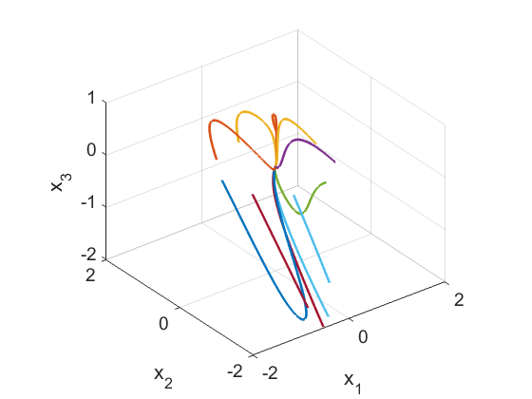

From the figure, we know that the origin is indeed asymptotically stable because there are several points ended up converging to the origin. This is because after we’ve done the transformation  in (1),  is still satisfied so that the equilibrium point remains . Since , we just have to ensure that  to check whether the origin is the equilibrium point after the transformation process.

After the transformation, the new state  will be exponentially stable as well as globally stable, since it became a linear system. During the transformation, each  will have a corresponding  and that’s how we transform the whole thing into a linear system. Therefore, the original state  will also be exponentially stable, but we can’t promise that it will be globally stable. This is because when we design the control law , it’s possible that there will be more constraints to avoid this control law being singular.

In the figure above, we notice that some of the points diverged. This is because during the transformation of control law, the denominator of  is , which means that whenever the path goes through the surface of , they will end up diverging. We then conclude that this surface is “singular”.

To see this clearer, I drew the surface of  with the phase plane.

|  |  |
| --- | --- |
|  |  |

In the figure above, I put all 10 initials on the right side of  and we can see as before that some points converged to the origin and some diverged.

I also tried putting some of the points on the left side of :

|  |  |
| --- | --- |
|  |  |

In the figure above, we can see that all the points started from the left side of  end up diverging and being on the right side of  doesn’t promise a convergent result either.

From my point of view, this kind of situation often happens when we transform the nonlinear system to linear system. This is the shortcoming of this type of method and we have to be conscious about it. To avoid this, we should carefully choose the initials and try our best to find the stable region.

(3)

The time response of  can be drawn as follows.



To check the speed of convergent when , we’re going to draw  where  stands for amplitude.

|  |  |
| --- | --- |
|  |  |
|  |  |

In the figure, we can see that at some point  actually intercepts with . This means  is convergent “faster” than .

To ensure that our inference is correct, I also tried putting bigger value of .

|  |  |
| --- | --- |
|  |  |
|  |  |

From the figures above, we can see that even though the time of interception happening is larger, the speed of convergent for  is still slower than . To say that this system is asymptotically stable in a specific speed, we have to find  of which its curve will “cover” the time response curve at all times and there exists no interception.

(4)

When we look back at (1), we know that the solution for  is certainly not unique. Because it’s dependent on  of which the value will change if we select a different . In other words, we will obtain different  when choosing a  different from what we had () but still satisfies our conditions.

To verify our derivation, we’re going to choose  here instead and repeat the same procedure starting from Step 3. in (1).

Let 

Step 3.

Set up the state coordinate transformation :



Also, set up the control signal transformation 



Step 4.

Design the new control law as 

In this case, 



Since we already know that , we can derive



Step 6.

Finally, we can derive the control law  by plugging 



where 

Now that we’ve gotten a different control law , we can do the same as we did in (2).

|  |  |
| --- | --- |
|  |  |

Again, we put in 10 different initials to see that what happened is pretty similar to what we had before in (2).

To draw the time response:



where the red dash line is the obtained based on the new  that we designed.

We can observe that the response curves are identical. However, this doesn’t represent that all different set of  will make the system have the same time response.

In my opinion, this is because when we decided to choose , the corresponding  will end up canceling out with one another and therefore cause the system to have the same time response.

To validate this saying, I’m going to try using another  here and repeat the process from Step 3. in (1) once again.

Let 

Step 3.

Set up the state coordinate transformation :



Also, set up the control signal transformation 



Step 4.

Design the new control law as 

In this case, 



Since we already know that , we can derive



Step 6.

Finally, we can derive the control law  by plugging 



where

Now that we’ve gotten a different control law , we can do the same as we did in (2).

Also, now that we know the denominator part of  : will cause issues when passing  , we’re going to try to avoid it first and draw the phase plane as follows.

|  |  |
| --- | --- |
|  |  |

From this figure, we can see that by having this different set of , as it is more complex and there are more “rules” we have to follow, it’s even harder for them to converge to the origin. As a matter of fact, it’s not even possible for them to converge to .

To draw the time response:



where the red line is the time response we obtained based on this new control law .

We can now see that clearly; the time response is not the same when using a different control law  even though they have the same . The new time response will “diverge” because at that point it probably hit the “singular” surface.

Moreover, we can conclude that this  is actually “worse” than what we have before because looking back at it, its equilibrium isn’t even on the origin due to the fact that the when being near , the system will diverge.

To sum it up, if we want to find the convergent range for the nonlinear system by using this particular method, we should try to look for control law  that doesn’t have the constraints that we had earlier. If we can design a control law of which the denominator part is a constant or always positive, it will give us a better picture of the whole system. Perhaps we can find a couple of them and then combine the convergent range together to determine the range for the nonlinear system. The more we have, the more accurate the range we obtained is.