非線性控制第七章作業

李佳玲 F44079029

Consider the following nonlinear system





Backstepping control: the idea behind backstepping control is to divide systems into layers of structure first, and then design control law starting from the inner layer toward the outer layer, finally we can obtain the nonlinear control law from the outer layer.

The procedure of backstepping control:

1. design the control law of inner layer structure
2. built dynamic equation for outer layer structure
3. define control signal for outer layer structure
4. decide the control law of outer layer structure

We can express the system as a two-layer structure with :



where



To transform this structure into the standard form, let



Therefore, we have



To follow the procedure of backstepping control, we first design the control law for inner layer system:

Choose Lyapunov function



We then have



To make sure  is asymptotically stable, choose a positive definite function :



We can derive the control law



Afterwards, we define the control signal for outer layer structure:





Therefore, we can translate the system as



Finally, we’re going to decide the control law of outer layer structure:

Choose Lyapunov function (for overall system)



Note that  is the Lyapunov function we chose before which is related to  and  is related to .

The further discussion of how to derive the control law which can make the overall system asymptotically stable will be done later in question 4.

For now, Eq. (7.2.13) from text book is applied here to design the control law:



We can obtain the control law



where it should be able to ensure that the nonlinear system is asymptotically stable.

2.

To see whether the equilibrium point is indeed the origin, the phase planes is drawn:

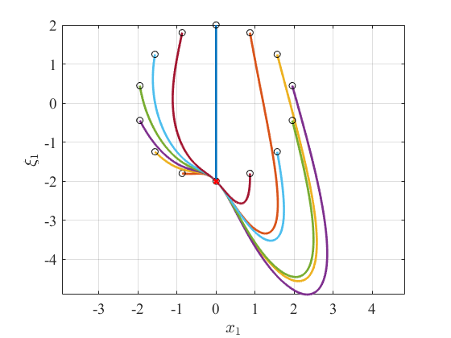

In the figure, we can see that the equilibrium point is clearly not  but .

Therefore, we’re going to go back and perform coordinate translation for the system to ensure that the origin being the equilibrium point.

1.1

Let



The nonlinear system becomes



Likewise, we’re going to repeat the same procedure again as before.

Express the system as a two-layer structure with :



where



Choose the same Lyapunov function



We then have



To make sure  is asymptotically stable, choose a positive definite function :



We can derive the control law



Next, we’re going to decide the control law for outer layer system:

To design the control law, Eq. (7.2.13) from text book is used here:



We can obtain the control law



where it should be able to ensure that the nonlinear system is asymptotically stable.

2.1

To see where the equilibrium point has been moved to, the phase planes is drawn:

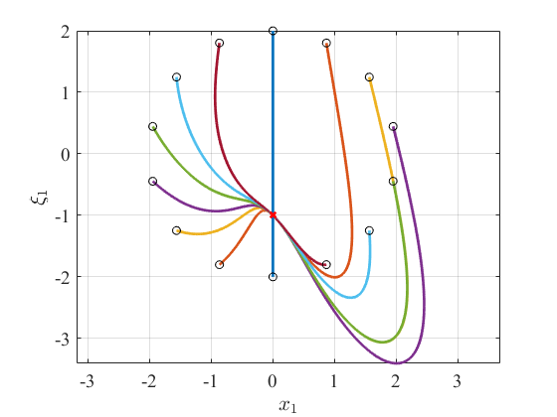

where we can see very clearly that the equilibrium point has been moved to . This is because when we did the translation earlier, we chose  where we can see that it matches the final equilibrium point we have. Therefore, we conclude that to successfully move the equilibrium point to the origin, we should use the translation  instead.

1.2

Let



The nonlinear system becomes



Likewise, we’re going to repeat the same procedure again as before.

Express the system as a two-layer structure with :



where



Choose the same Lyapunov function



We then have



To make sure  is asymptotically stable, choose a positive definite function :



We can derive the control law



Next, we’re going to decide the control law for outer layer system:

To design the control law, Eq. (7.2.13) from text book is used here:



We can obtain the control law



where it should be able to ensure that the nonlinear system is asymptotically stable.

2.2

To see whether the equilibrium point has been successfully translated to the origin, the phase planes is drawn:

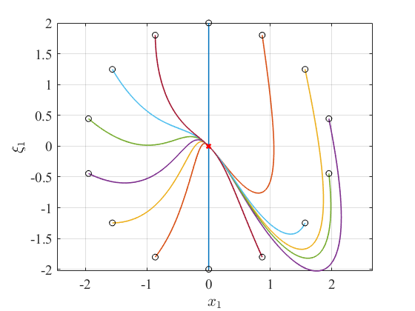

where we can see that the equilibrium is finally been moved to  and it’s asymptotically stable.

Remark: When we look at the original system, we can actually infer that the equilibrium point for this system might not be the origin. This is because in the system, we have “” where we can see that to make , we only have to satisfy  while  can be anything else. Thus, we can see that the original system has no control over  which might be one of the reasons that the equilibrium point ended up in a different place other than .

3.

Now, we’re going to expand the range of the initial points and see whether the closed-loop system is globally stable or locally stable.

Place the initial points as a circle with different radius:

|  |  |
| --- | --- |
|  |  |
|  |  |

where we can see that they all converge to the origin.

Hence, this system is proven to be globally stable since they all converge to only one equilibrium point, regardless of where we place the initial points.

4.

Recall the Lyapunov function



To ensure that this system is asymptotically stable,  has to satisfy both  and .

For , it’s automatically satisfied based on how we chose the function.

For , we have to choose the proper control law to do so.

First, we have



We then choose a proper control law :



Plugging this control law back gives



where we recall that  is a positive definite function.

We then obtain the control law :



which matches Eq.(7.2.13) from the text book and is what we applied in previous questions.

The definition of global stability is that no matter where we place , when ,  will always be true; in other words, the condition  is not limited by where the initial points are.

For the Lyapunov function we chose, both conditions including  and  are satisfied. This means that it doesn’t matter where we place the initial points, they will ultimately all converge to the equilibrium point which is the origin here after the coordinate translation.

Therefore, we conclude that it’s globally stable.

This conclusion also matches the figures we have from question 3: all initial points ended up converging to the origin regardless of where they started.

5.

When we look back at the design procedure in question 1, the control law we derived is not unique. As a matter of fact, it will vary with what the Lyapunov function , the positive definite function , as well as the value of  we decide to use.

Thus, we’re going to try out different control law and compare the results with what we had before.

Note that the system we’re going to use has been translated already.

Express the system as a two-layer structure with :



where



Choose the same Lyapunov function



We then have



To make sure  is asymptotically stable, choose a positive definite function :



where the additional  has been added which makes this different as before.

Derive the control law:



Next, we’re going to decide the control law for outer layer system:

To design the control law, Eq. (7.2.13) from text book is used here again:



We can finally obtain the control law



where we can see that it’s different than the  we derived in previous questions. However, it should still be able to ensure the nonlinear system as an asymptotically stable system.

The phase plane is once again drawn:

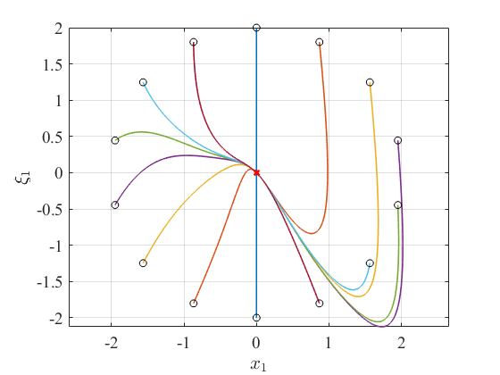

To compare it with what we had before, we put them in the same figure:

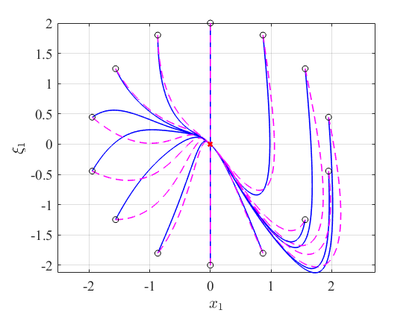

where the blue line is from the different set of control law and the magenta dash line is what we originally had.

In the figure, we can see clearly that they’re not the same but do have the same intention of converging to the origin ultimately. This is because when we designed the control law, we were following the procedure and they both satisfy the conditions we set for the system to asymptotically converge to its equilibrium point which is the origin.

Aside from choosing a different function , we can also try changing the value of  and see whether they’ll converge to the origin as well (under the condition ).

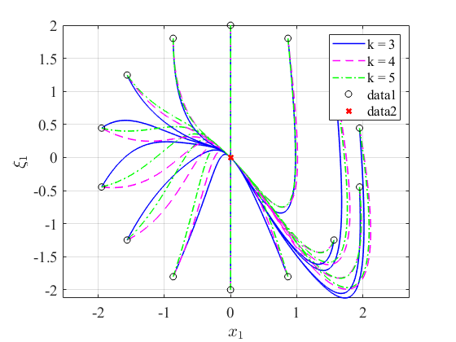

From the figure, three different  are performed and the result attests our conclusion.