[](https://admissionsportal.jooust.ac.ke/)

JARAMOGI OGINDA ODINGA

UNIVERSITY OF SCIENCE AND TECHNOLOGY

OASIS OF KNOWLEDGE

SCHOOL OF INFORMATICS AND INNOVATIVE SYSTEMS

**DEPARTMENT OF COMPUTER SECURITY AND FORENSICS**

***INDUSTRIAL ATTACHMENT: YEAR 3.3***

***ATTACHMENT PERIOD: 20TH MAY 2024 – 15TH AUGUST 2024***

**LOCATION OF ATTACHMENT:** MIGORI

**NAME OF ACADMIC SUPERVISOR:** ………………………………………….

**PHONE No:** …………………………………………..

**E-MAIL: …………………………………………**

**SIGNATURE: …………………….**

**NAME OF FIELD SUPERVISOR:** HILLARY OTIENO.O

**PHONE No:** +254 706935918

**E-MAIL:** [**otienohillary@migori.go.ke**](mailto:otienohillary@migori.go.ke)

**SIGNATURE: ………………………….**

**NAME OF ATTACHEE:** PETER CHACHA OMIA

**PHONE No:** +254 798890993

**E-MAIL:** [omia12887@gmail.com](mailto:omia12887@gmail.com)

**REGISTRATION NUMBER:** I132/G/1680/21

**SIGNATURE: …………………………..**

**ACKNOWLEDGEMENT**

I give thanks to God Almighty for his guidance, illumination, and ability to allow me to embark on this attachment from dawn till dusk. I am grateful to my relatives for their love and support. I am profoundly grateful to the esteemed Migori ICT and E-governance department, the entire county government of Migori for granting me the invaluable opportunity to undertake my field attachment within their organization. The experience gained throughout this industrial attachment period has been instrumental and transformative in shaping my understanding of the practical application of field of study.

I extend my heartfelt gratitude to the ICTO Mr. Hillary Otieno, my field supervisor, for his invaluable counsel and direction during my attachment period. I am immensely grateful for the mentorship of all the ICTO’s for their mentorship which has undoubtably shaped my professional growth. I want to express my gratitude to all the ICT employees and my fellow attachés for their collaboration, which was crucial to the success of my attachment training.

Thank you all.

**ABSTRACT**

This final report presents the discoveries and knowledge acquired during industrial attachment program at Migori county ICT and E-governance. The primary objective of the attachment was to attain hands on experience in ICT operations within the ICT department and actively contribute to improving overall efficiency and effectiveness in the department and all other departments. The report underscores the immense significance of fostering a spirit of collaboration and synergy between the ICT department and other key divisions within the county government. Recognizing that effective communication and seamless coordination between departments are pivotal to the organization's success, the document advocates for a cross-functional approach to problem-solving and decision making.

By promoting the culture of teamwork and shared goals, the ICT department can enhance its ability to optimize processes, streamline workflows, and reduce downtime. Moreover, through harmonized efforts, the department can deliver an unparalleled level of service excellence to its constituents, leading to enhanced public experiences and increased satisfactions.

Table of Contents

**1** **CHAPTER 1: INTRODUCTION** 8

**1.1** **Background of the Field Attachment** 8

**1.2** **Objectives of the Field Attachment** 8

**1.3** **Background of the Organization** 9

**1.3.1** **Geographical Background** 9

**1.3.2** **Historical Background** 10

**1.4** **Organizational structure of the organization** 11

**1.5** **Major activities and focus of the department** 11

**1.6** **Vision** 13

**1.7** **Mission** 13

**1.8** **Core values** 14

**2** **CHAPTER 2 ATTACHMENT EXPERIENCES** 15

**2.1** **General activities undertaken** 15

**2.2** **Specific activities undertaken** 19

**2.3** **Analysis of learnt knowledge and applied Skills** 21

**2.4** **A profile of skills and competencies gained/acquired** 24

**2.5** **Observations and Critique** 25

**2.5.1** **What learnt** 25

**2.5.2** **What not learnt** 27

**2.5.3** **Relevance of experience to the training** 28

**2.6** **Challenges encountered during the attachment period** 28

**2.7** **How I overcame the challenges** 29

**3** **CHAPTER 3 SUMMARY, CONCLUSION AND RECOMMENDATIONS** 30

**3.1** **Summary** 30

3.2 **Conclusion** 30

**3.3** **Recommendations** 31

**4** **CHAPTER 4** 31

**4.1** **REFERENCES** 31

**LIST OF FIGURES**

Fig 1. Map to the ICT Department offices

Fig 2. Department Organogram

Fig 3. Central processing unit

Fig 4. RJ5 connector

**LIST OF ACRONYMS/ABBREVIATIONS**

* ICT: Information and Communications Technology
* PC – personal computer
* LC – lucent current
* SC – subscriber current
* Fig - Figure
* OS: Operating System
* CPU: Central Processing Unit
* RAM: Random Access Memory
* LAN: Local Area Network
* IoT: Internet of Things
* PDF: Portable Document Format

# 

# **1 CHAPTER 1: INTRODUCTION**

## **Background of the Field Attachment**

The field attachment program is meant to provide the opportunity to gain real world experience in the IT field of study while applying the knowledge and skill acquired throughout my coursework. The purpose of the field attachment program is to bridge the gap between theoretical knowledge learned and their practical application.

By participating in this program in the Migori county department of ICT and E-governance I had the chance to observe and participate in the day-to-day activities of professionals working in IT. This hands-on experience helps develop a deeper understanding of the industry, learn about workplace dynamics, and enhance my problem-solving skills and critical thinking abilities. Apart from gaining practical skills and knowledge. I also have networked with professionals in the industry, which is instrumental in securing future job opportunities.

## **Objectives of the Field Attachment**

1. **Practical Experience:** Gain hands-on exposure to real-world IT tasks and projects, applying theoretical knowledge to practical scenarios.
2. **Skill Development:** Enhance technical abilities in various ICT areas, such as programming, database management, networking, and more.
3. **Industry Insights:** Understand how technology is utilized in a professional setting and learn about industry practices and trends.
4. **Teamwork and Communication**: Improve collaboration and interpersonal skills by working in teams with professionals from diverse backgrounds.
5. **Problem-Solving Abilities:** Develop critical thinking skills to tackle technical challenges and find innovative solutions.
6. **Professional Networking:** Build connections with industry professionals and potential mentors to expand career opportunities.
7. **Workplace Etiquette**: Learn about workplace norms, time management, and meeting deadlines in a professional environment.
8. **Career Exploration**: Explore various roles and career paths within the ICT industry to make informed career decisions.
9. **Resume Building:** Enhance the resume with practical experience, making participants more attractive to potential employers.
10. **Employment Opportunities:** Increase chances of securing job opportunities within the organization or the ICT industry based on exceptional performance and fitness.

## **Background of the Organization**

### **Geographical Background**

The County Government of Migori (044) is a devolved unit of the National Government of Kenya, located in Migori County. The Department of ICT and E-governance is situated next to the county headquarters in Migori town near Deputy Governor’s office. The office is easily accessible and plays a crucial role in the digital transformation and governance of the Migori county.

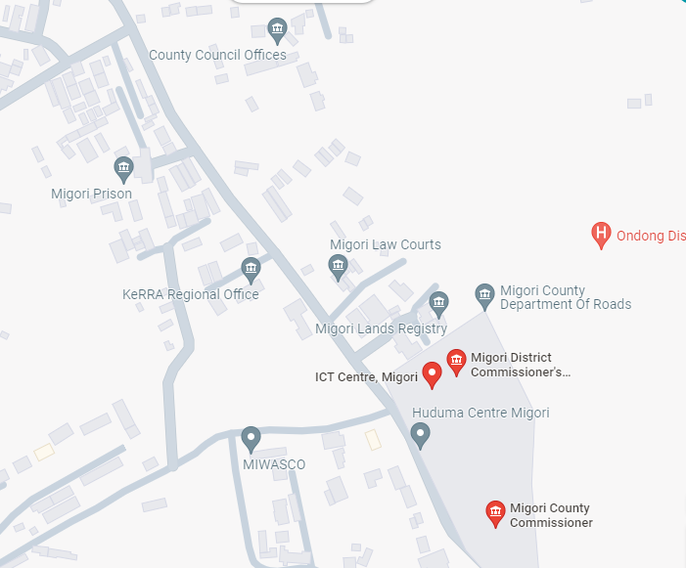

Fig 1. Map to the ICT Department offices

Here's the historical background tailored for the Migori County Government Department of ICT and E-governance:

### **Historical Background**

The County Government of Migori was established following the scheduled general elections in March 2013. In the 2013 general elections, 47 counties were established in Kenya, their size and boundaries based on the 47 legally recognized districts. Following the reorganization of Kenya’s national administration, counties were integrated into a new national framework, with the national government posting county commissioners to represent it in the counties. In March 2013, H.E. Hon. Okoth Obado was elected as the first Governor of Migori County, with H.E. Nelson Mahanga as his deputy. They served as the county heads from 27th March 2013 to 18th August 2017.

On 18th August 2017, H.E. Zachary Okoth Obado and Hon. Mwita Mahanga were re-elected as the Governor and Deputy Governor, respectively. They served the County Government of Migori from August 2017 and continued in office until 2022. The current governor of Migori County is Dr. Ochilo George Mbogo Ayacko. His deputy is Dr. Joseph Mahiri.

The county government is responsible for:

* County legislation
* Executive functions
* Functions outlined in the Fourth Schedule of the Constitution of Kenya
* Functions transferred from the national government
* Functions agreed upon with other counties
* Establishment and staffing of public service

## **Organizational structure of the organization**

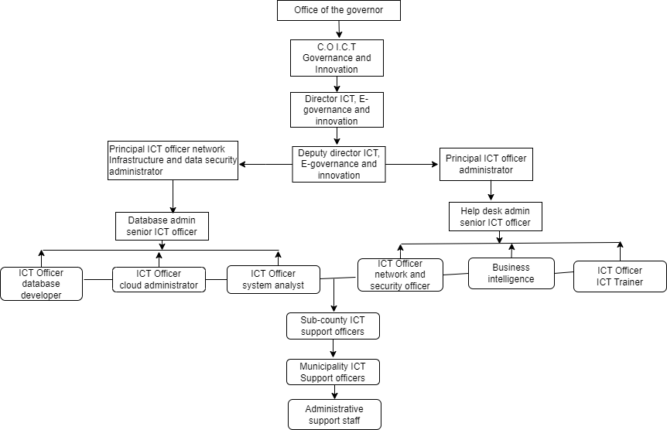

Fig 2. Department Organogram

## **Major activities and focus of the department**

The Migori County Government Department of ICT and E-governance is dedicated to enhancing the efficiency, transparency, and accessibility of county services through the implementation of modern information and communication technologies. A key focus of the department is the development and maintenance of robust ICT infrastructure across the county. This includes upgrading existing hardware and software systems to improve service delivery and ensuring reliable internet connectivity for government offices and public access points.

Another major activity of the department is the development and deployment of e-government services. By creating online platforms for various county services, such as revenue collection, licensing, and public information dissemination, the department aims to streamline administrative processes and reduce bureaucratic inefficiencies. Additionally, promoting digital literacy among county employees and residents is a priority to enhance the utilization of these e-government services.

Data management and security are critical areas of focus for the department. Implementing effective data management systems ensures accurate and timely data collection, storage, and retrieval. To protect sensitive information from unauthorized access and cyber threats, the department establishes stringent data security protocols and conducts regular audits and updates to maintain the integrity and security of the county’s data systems.

The department is also committed to capacity building and training. Organizing training programs for county staff enhances their ICT skills and knowledge, promoting continuous professional development to keep up with emerging technologies and best practices. Engaging with educational institutions and stakeholders’ fosters ICT education and innovation within the county, ensuring a skilled workforce capable of supporting the county's ICT initiatives. Public engagement and feedback are essential components of the department's strategy. Utilizing social media platforms and other digital tools to engage with the public allows the department to gather feedback on county services and improve responsiveness.

Implementing customer service solutions and hosting public forums and workshops educate residents about the benefits and usage of ICT in accessing government services, fostering a more informed and engaged community.

Project management and implementation are crucial for the success of ICT-related initiatives within the county. The department oversees the planning, execution, and monitoring of these projects, collaborating with other departments and external partners to ensure successful implementation. Regular evaluation of the impact of ICT projects on service delivery allows for necessary adjustments to achieve desired outcomes. Innovation and research are also key areas of focus. Encouraging the adoption of innovative technologies to address local challenges and improve public service delivery is a priority.

Conducting research to identify new opportunities for leveraging ICT in governance and development, and establishing partnerships with technology firms, research institutions, and other stakeholders, drives innovation in the county.

## **Vision**

To be a leading enabler of efficient, transparent, and innovative governance through the strategic use of information and communication technology, enhancing the quality of life for all residents of Migori County.

## **Mission**

To enhance the delivery of public services by leveraging advanced information and communication technologies, fostering digital literacy, and promoting innovative solutions that ensure efficiency, transparency, and inclusive access for all residents of Migori County.

## **Core values**

* **Integrity**: Upholding the highest standards of honesty, transparency, and accountability in all our operations and interactions.
* **Innovation**: Embracing and driving technological advancements to continuously improve service delivery and address emerging challenges.
* **Excellence**: Striving for superior performance and quality in every aspect of our work, ensuring that we meet and exceed the expectations of our stakeholders.
* **Inclusivity**: Promoting equal access to information and communication technologies, ensuring that all residents benefit from our services regardless of their background or circumstances.
* **Collaboration**: Fostering a culture of teamwork and partnership with other government departments, private sector, and the community to achieve our common goals.
* **Customer Focus**: Prioritizing the needs and feedback of the citizens we serve, ensuring that our services are user-friendly, responsive, and impactful.
* **Sustainability**: Committing to environmentally responsible practices and sustainable use of resources in the implementation of ICT initiatives.
* **Continuous Improvement**: Encouraging ongoing learning, development, and adaptation to new technologies and methodologies to enhance our effectiveness.

# **CHAPTER 2: EXPERIENCES**

## **Duties and responsibilities**

During my industrial attachment at the Migori County Government Department of ICT and E-governance, I was involved in various activities that allowed me to gain practical experience and apply my theoretical knowledge. The general activities undertaken included:

1. **ICT Infrastructure Maintenance and Support**:

* Assisting in the setup and configuration of computer hardware, software, and network systems.
* Providing technical support to county staff by troubleshooting and resolving ICT-related issues.
* Participating in regular maintenance of ICT equipment to ensure optimal performance and minimize downtime.

1. **E-Government Services Development**:

* Contributing to the development and enhancement of online platforms for various county services.
* Assisting in the implementation of e-governance projects aimed at streamlining administrative processes.

1. **Capacity Building and Training**:

* Attending training sessions and workshops to enhance my ICT skills and knowledge.
* Assisting in conducting training programs for county staff to improve their proficiency in using ICT tools and applications.
* Providing support during training sessions, including preparing training materials and assisting participants during presentation with projection.

1. **Public Engagement and Feedback**:

* Supporting the use of social media and other digital platforms to engage with the public and gather feedback on county services.
* Assisting in the development of customer service solutions to improve responsiveness to citizen concerns.

1. **Project Management and Implementation**:

* Collaborating with other departments and external partners to ensure successful project implementation.
* Contributing to the evaluation of the impact of ICT projects on service delivery and suggesting improvements.

1. **Innovation and Research**:

* Engaging in research activities to identify new opportunities for leveraging ICT in governance and development.
* Assisting in the adoption of innovative technologies to address local challenges and improve public service delivery.
* Participating in brainstorming sessions and discussions to generate ideas for ICT innovation within the county.

**7. Windows installation:**

* **Operating Systems/System Software**:

Installation and configuration of Windows operating systems such Windows 10 Professional 64-bit and Windows 11 Professional 64-bit. This involved setting up new installations, upgrading existing systems, and ensuring compatibility with county hardware standards.

* **Office installation and other software installation**:

Deployment of Microsoft Office suites including versions 2013,2016 and 2021, ensuring that all essential productivity tools were correctly installed and configured.

Installation of Adobe Reader XI and PDF Converter for document management and viewing.

* **Antivirus Software**:

Installation and configuration of antivirus solutions such as Kaspersky protect county systems from security threats and ensure data integrity.

* **Internet Browsers**:

Deployment of internet browsers including Google Chrome, and Brave, providing county staff with a choice of browsers suited to their preferences and operational needs.

* **Driver Pack 17**:

Installation of Driver Pack 17 to ensure that all hardware devices across the county's networked systems had the necessary drivers for optimal performance and compatibility.

8. **Clipping of ethernet cables**

To make a new connector or to get an Ethernet cable ready for termination into a network device or networking component, it is necessary to clip Ethernet cables. To create a wired network connection, Ethernet cables are frequently used to link devices like computers, routers, switches, and other network devices.

*Steps of clipping straight through Ethernet cables Gather the necessary tools:*

Ethernet cable (UTP), RJ-45 connectors (2 per cable), wire stripper or cutter, Ethernet cable crimping tool, optional cable tester for verification.

Prepare the cable: Measure and cut to the desired length, leaving some slack but avoiding excessive clutter.

Strip the outer insulation: Carefully remove 1-2 inches (2.5-5 cm) to expose the twisted wire pairs without damaging them.

Untwist the wire pairs: Keep the twists intact while separating the four pairs and ensure consistent color-coding on both ends.

Arrange the wires: Place them in this order from left to right: Orange-white, Orange, Green white, Blue, Blue-white, Green, Brown-white, Brown.

Trim the wires: Straighten and equalize their length, leaving around 0.5 inches (1.3 cm) extending from the outer insulation. Carefully place each wire into the RJ-45 connector in the correct order, ensuring they reach the end.

Crimp the connector: Position the connector with the wires in the crimping tool and firmly squeeze to secure the connector and trim excess wire. Follow the same steps to terminate the other end of the Ethernet cable with an RJ-45 connector in the same order.

**Internal part of the central processing unit I was dealing with.**

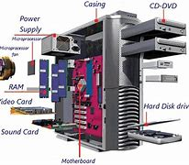

Fig 3. Central processing unit

9. **Cisco switch configurations**

Involved ensuring that the switch is secure such that it could only be accessed by verified users, accounts and password though the configurations on the RADIUS Server for the line and virtual terminals. Created and mapping of vlans to their correct networks and assigning them their proper Ip ranges, skills on port security, Interswitch communications using protocols such as RSTP, selecting and setting up root switch. This involved the analysis and implementation of the collapsed-core architecture to the KCA network scheme.

**STEPS**

**Step 1: Inspect your hardware**

Check the model number of your shiny new switch. Or, if you are using a spare, check the device hardware and its connected cables for any damages. If everything checks out, power on the switch and verify that all the indicator lights are in working order. Next, use a rollover cable to console into the switch from your computer. To do this, you will need to download and install Putty (or a similar, fun-named software tool). Run Putty and select the 9600 speed serial connection. You are now connected to the switch and ready to check the output of the following commands:

* show version
* show running-config
* show VLAN brief
* show VTP status
  + (config)# IP domain-name routerfreak.com
  + (config)# hostname Switch01
  + (config)# interface VLAN1
  + (config)# description Management VLAN
  + (config)# IP address 192.168.101.1 255.255.255.0
  + vtp [client | server | transparent]
  + vtp domain name
  + description *** DESCRIPTION ***
  + switchport access vlan ###
  + sswitchport mode access
  + power inline consumption ###
  + queue-set 2
  + mls qos trust dscp
  + storm-control multicast level 50.00
  + no cdp enable
  + spanning-tree portfast
  + spanning-tree bpduguard enable
  + Interface GigabitEthernet1/0/1
  + description *** UPLINK ***
  + switchport trunk encapsulation dot1q
  + switchport mode trunk
  + speed 1000
  + duplex full
  + Switch01(config)# crypto key generate rsa
  + The name for the keys will be:
  + Switch01.routerfreak.com
  + How many bits in the modulus [512]: 1024
  + % Generating 1024 bit RSA keys, keys will be non-exportable...[OK]
  + # line vty 0 4
  + (config-line)# transport input ssh
  + (config-line)# login local
  + (config-line)# password routerfreak
  + (config-line)# exit
  + # line console 0
  + (config-line)# logging synchronous
  + (config-line)# login local
  + Switch01# service password-encryption
  + remote-computer# ssh 192.168..101.1
  + Log in as: username
  + Password:
  + Switch01>en
  + Password:
  + Switch01#

For spare switches, make sure to delete the flash:vlan.dat file to erase the previous configuration.

**Step 2: Set up management IP**

Unlike with that punny name you gave your home Wi-Fi network, when setting up the hostname for your switch you should probably stick to a more professional and standard naming convention. Follow any preset naming assignment your company is using and then assign an IP address on the management VLAN. Next, make sure your switch has a set hostname and domain name:

**Step 3: Check VTP revision number**

Hit the show vtp status command to reveal your Virtual Trucking Protocol (VTP) revision numbers. The VTP revision numbers determine which updates are to be used in a VTP domain. When you set a VTP domain name, the revision number is set to zero—after which each change to the VLAN database increases the revision number by one. Your switch will only process data from a neighboring switch coming from the same domain and if the revision number of the neighboring switch is higher than its own. This means that the switches will update their VLAN configuration based on the VTP information being sent by the switch with the highest revision number.

So, before you add your switch to the network, you’re going to want to set its revision number to zero. To easily reset the domain back to zero, change the config mode to transparent:

**Step 4: Configure access ports**

You might already have a template ready for access port configuration, but in case you don’t, here are some commands you should use:

**Step 5: Configure trunk ports**

Enter the command sh int g0/1 capabilities and check the trucking protocol supported. If ISL is supported, you have to issue the switchport trunk encapsulation dot1q on the trunk port configuration. If not, simply type switchport mode trunk. It means there is no other encapsulation supported so there is no need for an encapsulation command. It only supports 802.1Q.

**Step 6: Configure access ports**

After already performing basic network switch configurations, it’s time to generate RSA keys to be used during the SSH process, using the crypto commands shown here:

Choose the size of the key modulus in the range of 360 to 2048 for your General-Purpose Keys. Choosing a key modulus greater than 512 may take a few minutes.

**Step 7: Set up VTY line config**

If you have not set the console line yet, you can easily input these values:

Set the enable password using the enable secret password command. Then, set the privilege exec password with username name privilege 15 secret password. Make sure that the password-encryption service is activated.

Verify SSH access by typing ‘sh ip ssh’ to confirm that the SSH is enabled. You can now try to log in from a remote machine to verify that you can ssh to your Cisco switch.

**RJ45 connector:**

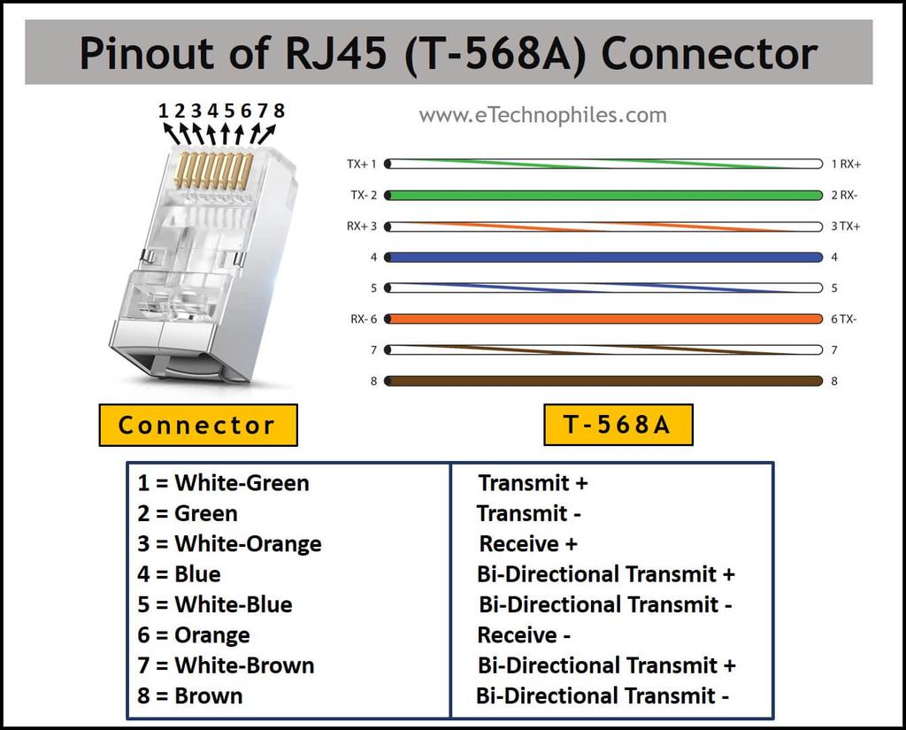

Fig 4. Sample connection of RJ45

## **Specific activities undertaken**

• **Networking Infrastructure Management**:

* Configuring and optimizing local area networks (LANs) across departmental offices to ensure seamless connectivity and efficient data transfer.
* Troubleshooting and resolving network connectivity issues, ensuring uninterrupted access to critical resources and services for county staff.

• **Server Management and Administration**:

* Assisting in the setup, maintenance, and administration of servers used for data storage and application hosting within the county government.
* Monitoring server performance and conducting routine maintenance tasks to ensure reliability and optimal functioning of critical systems.

• **Data Management and Backup Procedures**:

* Implementing data management protocols and procedures to ensure secure storage, retrieval, and backup of county data.
* Participating in data backup operations using reliable methodologies to mitigate data loss risks and ensure continuity of operations.

• **Advanced Troubleshooting and System Maintenance**:

* Booting computers in safe mode to diagnose and resolve complex issues such as black screen problems and system crashes, implementing effective solutions promptly.
* Enslaving hard drives using alternative CPU resources to create secure backups before formatting, ensuring data integrity and continuity in compliance with departmental protocols.

• **Software Deployment and Security**:

* Installing and configuring internet security solutions, including Kaspersky antivirus, on both existing and newly acquired computers across different departments.
* Activating operating systems and ensuring compliance across a diverse range of PC setups to optimize performance and uphold stringent security standards.

• **Hardware Upgrades and Maintenance**:

* Upgrading RAM modules and replacing hardware components as required to enhance system performance and meet operational demands efficiently.
* Partitioning hard drives and creating bootable flash drives tailored to specific departmental needs, facilitating streamlined data management and accessibility.

• **Optimization and Support Services**:

* Cleaning up temporary files on PCs and laptops to optimize operational speed and efficiency, enhancing productivity and user satisfaction within the county government.
* Establishing mobile hotspots and enabling internet sharing with external devices to expand connectivity options and accessibility for county staff members.

• **Peripheral Integration and User Support**:

* Connecting computers to online printers across various departments, facilitating seamless printing capabilities and efficient document management workflows.
* Conducting comprehensive worm and cold booting procedures on PCs and laptops as part of routine maintenance practices to ensure system reliability and performance.

• **User Account Management and Data Security**:

* Performing password recovery procedures for multiple user accounts across diverse computing platforms, ensuring uninterrupted access and operational continuity for county personnel.

## **Analysis of learnt knowledge and applied Skills**

During my industrial attachment at the Migori County Government Department of ICT and E-governance, I gained invaluable knowledge across various facets of ICT operations within a governmental setting. One of the key areas where I deepened my understanding was in network infrastructure management. I learned to configure and optimize local area networks (LANs), ensuring seamless connectivity and efficient data transfer between departmental offices. Troubleshooting network issues became a routine task, where I developed skills in diagnosing connectivity problems promptly to minimize downtime and maintain operational continuity.

Another significant area of knowledge acquisition was in server administration. I was actively involved in setting up and maintaining servers used for data storage and application hosting. This included monitoring server performance, conducting routine maintenance, and ensuring the reliability of critical systems essential for county-wide operations. Through these responsibilities, I learned the importance of robust server management in supporting effective ICT service delivery and enhancing organizational efficiency. Software installation and maintenance constituted another crucial aspect of my learning experience. I gained hands-on expertise in deploying and configuring various software applications, such as operating systems like Windows 10 and productivity suites like Microsoft Office. Additionally, I was involved in installing and managing antivirus solutions to safeguard county systems against security threats. This practical experience enhanced my proficiency in software deployment, troubleshooting, and ensuring compliance with departmental standards and security protocols.

Data management and security practices were also integral to my attachment experience. I participated in implementing data management protocols aimed at secure storage, efficient retrieval, and systematic backup of county data. This included performing regular data backups and enforcing stringent security measures to protect sensitive information from unauthorized access and potential risks. These activities underscored the critical importance of data security in maintaining public trust and operational integrity within governmental ICT environments. In terms of applied skills, my attachment provided ample opportunities to translate theoretical knowledge into practical competencies essential for effective ICT service delivery. Technical troubleshooting emerged as a core skill, as I adeptly resolved hardware and software issues, including booting computers in safe mode and performing advanced diagnostic procedures. Project management skills were honed through my involvement in ICT project planning, implementation, and documentation, where I gained insights into project lifecycle management and collaborative teamwork.

User support and training were also significant components of my role. I provided technical assistance to county staff, conducted user training sessions on software usage and best practices, and facilitated smooth transitions during software upgrades and implementations. Effective communication and collaboration skills were essential in fostering productive relationships with colleagues and stakeholders, ensuring alignment with departmental objectives and enhancing overall service delivery. Reflecting on my learning experience, my industrial attachment at the Migori County Government Department of ICT and E-governance was transformative in advancing my professional growth in ICT service management and administration. It equipped me with practical skills, enhanced my problem-solving abilities, and prepared me for future roles in managing ICT infrastructure and supporting organizational objectives through technology-driven solutions.

## **Skills gained**

1. **Network Infrastructure Management**: Proficient in configuring and optimizing LANs to ensure seamless connectivity across departmental offices. Skilled in troubleshooting network issues and implementing solutions to maintain uninterrupted access to critical resources. I have also worked with a variety of security tools and technologies such as firewalls, intrusion detection systems (IDS), vulnerability scanners, security information and event management (SIEM) systems, gaining hands-on experience with these tools enhancing my technical skills.
2. **Server Administration**: Hands-on experience in setting up, maintaining, and monitoring servers for data storage and application hosting. Competent in ensuring server reliability, performance optimization, and adherence to security protocols.
3. **Software Deployment and Maintenance**: Expertise in deploying and configuring operating systems (e.g., Windows 10) and application software (e.g., Microsoft Office suites). Proficient in installing and managing antivirus solutions to protect systems from security threats.
4. **Data Management and Security**: Knowledgeable in implementing data management protocols for secure storage, efficient retrieval, and systematic backup of county data. Skilled in enforcing data security measures to safeguard sensitive information from unauthorized access.
5. **Hardware Upgrades and Maintenance**: Capable of upgrading hardware components (e.g., RAM modules) and performing routine maintenance tasks to optimize system performance and extend equipment lifespan.
6. **Technical Troubleshooting**: Adept at diagnosing and resolving hardware and software issues, including booting computers in safe mode and conducting advanced troubleshooting procedures to restore functionality.
7. **Project Management**: Experienced in ICT project planning, implementation, and documentation. Familiar with project lifecycle management and collaborative teamwork to achieve project objectives effectively.
8. **User Support and Training**: Skilled in providing technical support to end-users, conducting user training sessions on software usage, and facilitating smooth transitions during software upgrades and implementations.
9. **Communication and Collaboration**: Effective communication skills demonstrated through interactions with colleagues and stakeholders. Proficient in fostering collaborative relationships to align ICT initiatives with departmental goals and enhance service delivery.
10. **Problem-Solving and Adaptability**: Strong problem-solving abilities honed through practical experience in addressing diverse ICT challenges. Flexible and adaptive in responding to new situations and implementing innovative solutions.
11. **Compliance and Quality Assurance**: Understanding of ICT compliance standards and quality assurance practices. Committed to maintaining high standards of service delivery and ensuring adherence to regulatory requirements.

## **Observations and Critique**

### **What learnt**

1. **Practical Application of Technical Skills**: I had the opportunity to apply theoretical knowledge gained from coursework in real-world scenarios. This hands-on experience was instrumental in reinforcing my understanding of network infrastructure management, server administration, and software deployment.
2. **Importance of Data Security and Management**: Witnessing firsthand the implementation of data security measures highlighted the critical importance of safeguarding sensitive information within governmental organizations. I learned protocols for data storage, backup, and security enforcement to mitigate risks effectively.
3. **Teamwork and Collaboration**: Collaborating with departmental colleagues on various projects underscored the significance of teamwork in achieving ICT objectives. Effective communication and coordination were essential in ensuring the smooth execution of tasks and project milestones.
4. **Adaptability and Problem-Solving**: The dynamic nature of ICT operations demanded adaptability and quick problem-solving skills. I encountered diverse challenges, from troubleshooting technical issues to managing user support requests, which enhanced my ability to think critically and find practical solutions.
5. **Professional Development and Networking**: Engaging with professionals within the department provided opportunities for mentorship and professional growth. Networking with experienced ICT practitioners broadened my perspective on career pathways and industry best practices.
6. **Compliance and Quality Assurance**: Understanding ICT compliance standards and quality assurance protocols was crucial in maintaining service excellence and meeting regulatory requirements. Compliance with government policies ensured adherence to ethical standards and operational integrity.

### **What not learnt**

* **Advanced Networking Protocols**: While I gained foundational skills in configuring and troubleshooting LANs, I did not have exposure to more advanced networking protocols such as in detailed VLANs, VPNs, or complex routing configurations.
* **Enterprise-level Server Management**: Although I assisted in server setup and maintenance, the scope was limited to basic administration tasks. I did not delve deeply into managing large-scale enterprise servers, virtualization technologies, or cloud computing platforms.
* **Cybersecurity Incident Response**: While I participated in implementing antivirus solutions and data security measures, I did not encounter significant exposure to cybersecurity incident response procedures, including handling and mitigating cybersecurity threats and breaches.
* **ICT Policy Development**: I did not participate directly in ICT policy formulation or governance frameworks within the county government. Understanding the strategic development and implementation of ICT policies would have provided insights into aligning technological initiatives with organizational objectives.
* **Emerging Technologies**: The attachment did not focus extensively on emerging technologies such as artificial intelligence (AI), blockchain, or Internet of Things (IoT). These technologies are increasingly relevant in modern ICT environments but were not part of my learning experience.
* **ICT Governance and Compliance**: Although I learned about ICT compliance standards, I did not engage deeply in governance frameworks or regulatory compliance audits specific to ICT operations within a governmental context.

### **Relevance of experience to the training**

My industrial attachment at the Migori County Government Department of ICT and E-governance provided a crucial bridge between theoretical learning from academic training and practical application in a real-world setting. Throughout the attachment, I was able to directly apply theoretical concepts learned in coursework, particularly in network infrastructure management, server administration, and software deployment. This hands-on experience not only solidified my understanding of these technical areas but also exposed me to industry-standard practices and operational challenges that are integral to effective ICT service delivery. Additionally, the attachment emphasized the development of soft skills such as communication, teamwork, and problem-solving, which are equally essential in professional environments. Engaging with stakeholders and navigating the dynamics of public sector ICT operations enhanced my awareness of organizational protocols, compliance requirements, and service delivery expectations within governmental settings. Overall, the attachment experience significantly complemented my academic training by providing practical insights and preparing me for future roles in ICT administration and governance.

### **COMMUNICATION AND RELATIONS WITH STAFF**

Professional Communication Skills: I have developed effective communication skills by interacting with staff members in a professional setting, learn to articulate my thoughts clearly, listen actively, ask relevant questions, and convey information effectively.

Teamwork and Collaboration: Working alongside staff members allowed me to understand the dynamics of teamwork and collaboration, contributing to team, navigate different perspectives, build relationships, and work towards common goals.

Adaptability and Flexibility: Field attachments provide opportunities to adapt to different working environments and organizational cultures. They learn to be flexible, open-minded, and adaptable to changes within the workplace.

Problem-solving and Conflict Resolution: By observing staff interactions and facing challenges themselves, students develop problem solving and conflict resolution skills. They learn to analyse situations, propose solutions, and resolve conflicts in a professional and constructive manner.

Professional Etiquette: I have learnt also about professional etiquette, including appropriate behaviour, dress code, punctuality, respect for hierarchies, and maintaining confidentiality. They understand the importance of professionalism in building positive relationships with staff members.

Networking: Engaging with staff members has provided me with networking opportunities. By establishing connections and building relationships, they learn how to network effectively, nurture professional contacts, and leverage these connections for future career prospects.

Feedback and Growth: Students can receive valuable feedback from staff members regarding their performance and areas for improvement. By being open to feedback and actively seeking growth, students can enhance their communication skills and develop professionally.

## **Challenges encountered during the attachment period**

* Adapting to a wide range of new office equipment, including printers and specialized scanning devices, required rapid familiarization to ensure smooth operational integration.
* Navigating the complexities of ICT infrastructure, including troubleshooting network connectivity issues and ensuring seamless performance across departmental offices.
* Balancing the management of user support requests with routine IT tasks, such as software installations and system upgrades.
* Access restrictions to certain systems and databases limited my hands-on practice and exploration of concepts covered during the attachment. This restricted access impacted my ability to fully engage with and apply theoretical knowledge in practical scenarios, particularly in areas requiring direct system interaction and configuration.

## **How I overcame the challenges**

* **Consulting My Supervisor**: I regularly consulted with my supervisor to understand the better and to seek alternative ways to gain the necessary practical experience. Their guidance helped me navigate the system limitations and provided insights into how to maximize my learning within the constraints.
* **Seeking Additional Learning Resources**: I supplemented my practical experience by seeking out additional learning resources outside of direct system access. This included watching YouTube tutorials, doing online research, and exploring related software tools to reinforce my understanding and skills.

## **BENEFITS DERIVED FROM FIELD ATTACHMENT PROGRAM**

1. ***Practical Experience:*** The field attachments provided me with hands-on practical experience in real-world IT environments. This enabled me to apply theoretical knowledge to solve actual IT problems, which enhances my understanding and skills.
2. ***Industry Exposure:*** Working as an IT officer exposed me to the dynamics of the IT industry. I got to interact with professionals, learn about current trends, technologies, and best practices. This exposure helped in aligning my skills with industry demands and build a network of valuable contacts.
3. ***Skill Development:*** The IT field attachment offered me opportunities to develop and enhance technical skills, such as network administration, cybersecurity, and hardware/software troubleshooting. I also have developed valuable non-technical skills like communication, problem-solving, time management, and teamwork.
4. ***Resume Building:*** The field attachment has also added value to my resume. It has demonstrated hands-on experience, which is highly valued by employers. It also showcases my ability to adapt to real-world challenges and work effectively in an IT environment.
5. ***Personal Growth:*** IT field attachments provide students with opportunities for personal growth and development. They learn to be self-reliant, take initiative, and work independently. They also gain confidence in their abilities, learn to think critically, and improve their decision-making skills
6. ***Potential Job Opportunities:*** A standout performance during an IT field attachment can lead to potential job offers or recommendations for future employment. Employers often prefer candidates with relevant work experience, and a successful attachment can give students a competitive edge in the job market.
7. ***Networking:*** During an IT field attachment, students have the chance to interact and build relationships with professionals in the industry. These connections can prove valuable in terms of mentorship, references, and potential job opportunities in the future.

# **CHAPTER 3: CONCLUSION AND RECOMMENDATIONS**

## **Conclusion**

In conclusion, the field attachment program has been beneficial to my career path as an IT expert and security guy by:

• improving my proficiency, hold workshops concentrating on the assembly's ICT requirements, such as network configuration and software creation.

• Encouraging my engagement in competitions and activities to promote innovation and encourage original thinking.

• Training in Soft Skills to improve leadership, teamwork, and communication skills—all crucial for professional integration.

• Maintaining Technology Updates and keeping the program current with the most recent ICT trends and resources used by the assembly.

• Creating a professional credential to increase my employability, offer possibilities for pertinent credentials.

• Job Guidance: Through counselling services, students help match my academic objectives with potential ICT job routes.

## **Recommendations**

**Full Exposure to Servers:** Provide trainees with comprehensive access to server systems to develop competence in managing and troubleshooting such critical infrastructure.

**Expansion of Practical Assignments:** Provide more opportunities for attachments to engage in practical assignments that simulate real-world ICT challenges, fostering hands-on learning and problem-solving skills.

**Involvement in Departmental Seminars:** Encourage active participation of attaches in departmental seminars, workshops, and knowledge-sharing sessions. This involvement will provide attaches with opportunities to learn from subject matter experts, stay updated on departmental initiatives, and contribute their perspectives. It can also foster networking with departmental staff and enhance their understanding of organizational goals and strategies.

# **CHAPTER 4**

## **REFERENCES**

1. My industrial attachment log book.
2. Chen, H.Y. and Shiu, S.W., 2008. Analysis of radiated fields for the design of a rj45 connector using fdtd method. *IEEE transactions on antennas and propagation*, *56*(4), pp.1041-1047.
3. Hucaby, D. and McQuerry, S., 2003. *Cisco field manual: catalyst switch configuration*. Cisco Press.
4. Putra, Fauzan Prasetyo Eka, Ubaidi Ubaidi, Alief Badrit Tamam, and Reynal Widya Efendi. "Implementation And Simulation Of Dynamic Arp Inspection In Cisco Packet Tracer For Network Security." *Brilliance: Research of Artificial Intelligence* 4, no. 1 (2024): 340-34
5. Choi, B., & Medina, E. (2023). Cisco Router and Switch Configuration with Ansible. In *Introduction to Ansible Network Automation: A Practical Primer* (pp. 595-660). Berkeley, CA: Apress.