SIMATS ENGINEERING
ASSESSMENT TOOL 3

COURSE CODE: ITA 0603 COURSE NAME: MACHINE LEARNING

COURSE OUTCOME COVERED

CO2: Neural Network Representation, Perceptron Model, Multilayer Perceptrons, Backpropagation Algorithm, Deep Neural Networks, Genetic Algorithms, Hypothesis Space Search, Genetic Programming, Models of Evaluation and Learning (BL1, BL2)

Assessment Tool Weightage: 10%

QUESTIONS: 15 Total Marks:25

Annexure A

DEBUGGING & OPTIMIZATION TASK QUESTIONS

Code of Conduct:

I Peta Harsha Vardhan (192311039) (Name / Reg No) certify that this submission is my original work and that I have adhered to the guidelines specified for this assessment.
I understand that any violation of academic integrity rules will result in disciplinary action.

Signature of the student:


Annexure A

Short Answer Test

1. A perceptron model is trained on a dataset that is known to be linearly separable, yet the algorithm fails to converge even after many iterations. Analyze the possible causes of this issue, including improper learning rate selection, incorrect weight initialization, bias handling errors, or flawed implementation of the update rule. Propose debugging strategies to identify the root cause and suggest optimization techniques to ensure faster and stable convergence. (5 Marks)
2. While training a multilayer perceptron using the backpropagation algorithm, the network exhibits slow convergence and gets stuck in local minima. Examine the potential reasons such as vanishing gradients, inappropriate activation functions, poor weight initialization, or suboptimal learning rates. Describe step-by-step debugging approaches to trace the issue and recommend optimization techniques like adaptive learning rates, normalization, or advanced optimizers to improve performance. (5 Marks)
3. A genetic algorithm designed for hypothesis space search is producing inconsistent and suboptimal solutions across multiple runs. Investigate possible issues such as improper encoding of chromosomes, incorrect fitness function design, premature convergence, or lack of diversity in the population. Explain how to debug these problems systematically and suggest optimization strategies like mutation tuning, selection pressure adjustment, and elitism to enhance solution quality and convergence speed. (5 Marks)
4. A deep neural network combined with genetic programming is used for solving a complex prediction problem, but it suffers from overfitting and high computational cost. Identify debugging steps to analyze issues related to model complexity, over-parameterization, and insufficient training data. Propose optimization techniques such as regularization, dropout, pruning, and efficient evaluation models to balance accuracy and computational efficiency while improving generalization capability. (5 Marks)
5. A decision tree model trained on a large dataset shows high accuracy on training data but poor performance on unseen data. Analyze possible causes such as overfitting, deep tree structure, or noisy data. Propose debugging steps and optimization methods like pruning, cross-validation, and feature selection to improve generalization. (5 Marks)

RUBRICS FOR CALCULATION
Criteria | Weightage | Level 4 – Exemplary (5 Marks) | Level 3 – Proficient (4 Marks) | Level 2 – Developing (2–3 Marks) | Level 1 – Beginning (0–1 Mark)
Conceptual Understanding | 30 | Demonstrates clear and complete understanding of the concept | Good understanding with minor gaps | Basic understanding with some misconceptions | Poor or incorrect understanding
Accuracy of Answer | 20 | Completely correct answer with no errors | Mostly correct with minor errors | Partially correct with noticeable errors | Incorrect or irrelevant answer
Application of Knowledge | 30 | Correctly applies concepts to solve the question/problem | Applies concepts with minor mistakes | Limited or partially correct application | No or incorrect application
Completeness of Response | 10 | Covers all required parts of the question | Covers most parts with minor omissions | Covers only some parts | Incomplete or missing response
Clarity & Presentation | 10 | Clear, concise, and well-organized answer | Understandable with minor issues | Somewhat unclear or poorly structured | Difficult to understand

Question 1
Concept Involved
Perceptron learning rule, convergence on linearly separable data, learning rate, weight initialisation, bias handling, debugging and optimisation of training.
Definition
The perceptron updates its weights only when it misclassifies an example: w ← w + η (t – y) x and b ← b + η (t – y). The Perceptron Convergence Theorem guarantees that if the data are linearly separable, this rule finds a separating line after a finite number of updates. Therefore, failure to converge on separable data is a symptom of a bug, a data problem or a wrong setting, and not a limitation of the model.
Problem Scenario / Given Data
Item | Observation
Dataset | Known to be linearly separable
Training | Many iterations (epochs) completed
Symptom | Number of misclassified samples per epoch never reaches 0
Expected | Zero errors after a finite number of updates
Answer (Step-by-Step Solution)
Step 1: Analyse the possible causes
Possible cause | What goes wrong | How to check
Bias handling error | Without a bias the decision line must pass through the origin, so many separable data sets cannot be separated; the bias may be missing or not updated | Check that b exists, is added to net, and is updated with the same error term
Flawed update rule | Wrong sign (y – t instead of t – y), missing the factor x, updating when the answer is correct, or never updating the bias | Hand-compute one update and compare with the code
Improper learning rate | For the pure perceptron with zero start, η only scales the weights; but η = 0 or negative gives no learning, and with a delta-rule / sigmoid unit a large η makes the weights oscillate | Try η = 0.01, 0.1, 1 and compare the error curve
Incorrect weight initialisation | Very large or NaN starting weights need many corrections or never recover | Print the initial weights; use zeros or small random values
Label / threshold mismatch | Labels coded –1/+1 while the output is 0/1, or step uses > instead of ≥ | Print labels and predictions side by side
Data problems | Unscaled features (one feature 1000 times larger), or label noise / duplicate points with different labels, so data are not truly separable | Standardise features; run a separability test
Step 2: Debugging strategy (step by step)
1. Confirm separability with a 2-D plot, a hard-margin linear SVM or a linear-programming check.
2. Test on a tiny problem with a known answer, for example the AND gate (below).
3. Log every epoch: number of errors, weights and bias; a flat error count means no learning.
4. Hand-check one update against the code, using the update rule above.
5. Plug in a known separating line. If the code still reports errors, the bug is in the prediction or evaluation step.
6. Check labels, threshold, array shapes and shuffling; fix the random seed so that the run can be repeated.
7. Change one setting at a time (η, initialisation, scaling) and observe the error curve.
Step 3: Worked test – AND gate (η = 1, zero start, y = 1 if net ≥ 0)
Epoch | Errors with bias | Weights w and bias b | Errors without bias | Weights w
1 | 2 | w = (1, 1), b = 0 | 4 | (0, 0)
2 | 3 | w = (2, 1), b = –1 | 4 | (0, 0)
3 | 3 | w = (2, 1), b = –2 | 4 | (0, 0)
4 | 2 | w = (2, 2), b = –2 | 4 | (0, 0)
5 | 1 | w = (2, 1), b = –3 | 4 | (0, 0)
6 | 0 | converged | 4 | (0, 0)
With a bias the perceptron converges in 6 epochs to w = (2, 1), b = –3 (net = 2x₁ + x₂ – 3, which is ≥ 0 only for (1, 1)). Without a bias, the input (0, 0) always gives net = 0, so it is always classified as 1 (wrong) and the weights just cycle back to (0, 0): 4 errors in every epoch, forever. Root cause found: missing bias.
Step 4: Corrected implementation
def train(X, t, eta=0.1, epochs=100):
X = np.c_[X, np.ones(len(X))] # bias trick: extra input 1
w = np.zeros(X.shape[1]) # zero initial weights
for ep in range(epochs):
errors = 0
for i in np.random.permutation(len(X)): # shuffle
y = 1 if X[i] @ w >= 0 else 0
if y != t[i]:
w += eta * (t[i] - y) * X[i] # correct sign
errors += 1
print(ep, errors)
if errors == 0: break # all correct: stop
return w
Step 5: Optimisation for faster and stable convergence
- Standardise features (z-score) so that no feature dominates and the updates are balanced.
- Use the bias trick and shuffle the data every epoch to avoid cycling.
- Choose a suitable η (0.01–1) or decay it slowly; start from zero or small random weights.
- Stop when errors = 0 and set a maximum number of epochs as a safeguard.
- Pocket or averaged perceptron keeps the best (or average) weights, which stays stable if a few labels are noisy.
- If the data are not truly separable, switch to a margin-based or smooth model (logistic regression, SVM, MLP).
Application
The same checks (tiny test case, per-epoch logging, bias and sign verification) are used when debugging any gradient-based learner, and the perceptron is the standard building block used to teach neural-network training.
Conclusion
A perceptron must converge on separable data, so non-convergence points to a bias error, a wrong update rule, a data or label problem, or bad settings. The AND-gate test exposed the missing bias (4 errors every epoch without it, 0 errors after 6 epochs with it). Adding the bias, using the correct update, scaling the inputs, shuffling and logging errors gives fast and stable convergence.
Question 2
Concept Involved
Backpropagation in a multilayer perceptron, vanishing gradients, activation functions, weight initialisation, learning rate, gradient checking, adaptive optimisers and normalisation.
Definition
Backpropagation computes the gradient of the loss with respect to every weight using the chain rule and updates w ← w – η ∂E/∂w. Training is slow when these gradients are tiny (vanishing), badly scaled or noisy, and it appears stuck when the weights reach a plateau, a saddle point or a poor minimum. In deep MLPs, truly bad local minima are rare; plateaus and saddle points caused by saturated units are the more common reason.
Problem Scenario / Given Data
Item | Observation
Model | Multilayer perceptron trained with backpropagation
Symptom 1 | Loss falls very slowly
Symptom 2 | Loss stops at a high value (appears stuck in a local minimum)
Answer (Step-by-Step Solution)
Step 1: Analyse the possible causes
Possible cause | What goes wrong | How to check
Vanishing gradients | The sigmoid slope is at most 0.25, so the error signal shrinks at every layer (see the figure); early layers hardly learn | Print the gradient norm of each layer; it falls by orders of magnitude towards the input
Inappropriate activation / loss | Sigmoid or tanh saturate; sigmoid with squared error gives a tiny gradient when the output is confidently wrong | Plot activation histograms; values piled near 0 or 1 mean saturation
Poor weight initialisation | All-zero weights make every neuron in a layer identical (symmetry); very large weights saturate units | Check that the weights differ and that activations have a sensible spread
Suboptimal learning rate | Too small: very slow; too large: the loss oscillates or diverges | Learning-rate range test; watch the loss curve
Unscaled inputs / data errors | Features with very different ranges make the loss surface narrow and elongated; wrong labels give no learnable signal | Check means and standard deviations of inputs; inspect labels
Gradient implementation bug | Wrong derivative or missing term in backpropagation | Gradient checking (below)
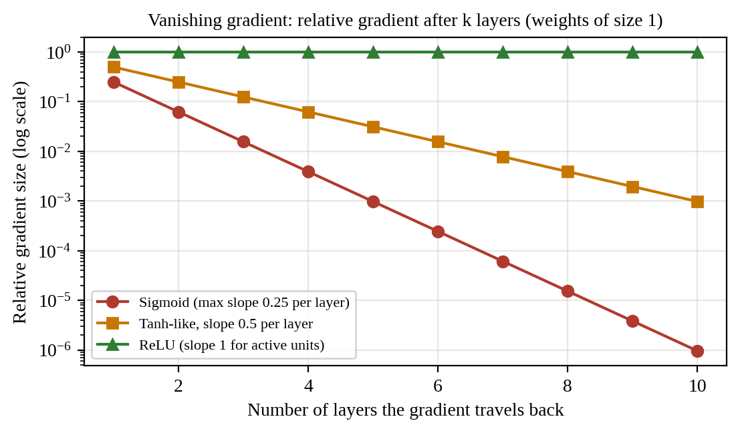
Fig. 1: Relative gradient size after k layers. Sigmoid: 0.25⁵ ≈ 0.001 after 5 layers and 0.25¹⁰ ≈ 10⁻⁶ after 10 layers
Step 2: Step-by-step debugging approach
1. Overfit a tiny batch (10 samples). A correct network must reach almost zero loss; if not, there is a bug.
2. Gradient checking: compare the backpropagation gradient with the numerical one, [J(θ + ε) – J(θ – ε)] / 2ε with ε = 10⁻⁴. A relative error below 10⁻⁷ is good; above 10⁻³ shows a bug.
3. Monitor per-layer gradient norms and activation histograms to detect vanishing gradients and saturation.
4. Learning-rate range test: raise η from 10⁻⁶ to 1 over a few hundred steps and pick the value just before the loss rises.
5. Check the data pipeline: standardise inputs, verify labels, and confirm that the loss matches the task (cross-entropy for classification).
6. Simplify: reduce depth and compare with a linear baseline; add one component at a time until the problem returns.
Step 3: Optimisation techniques
Technique | How it works | Benefit
ReLU / Leaky ReLU | f(z) = max(0, z); slope 1 for active units | Gradients do not vanish; faster training
He / Xavier initialisation | Var(w) = 2 / n_in (He, for ReLU); Var(w) = 2 / (n_in + n_out) (Xavier) | Keeps activation and gradient sizes stable across layers
Input standardisation and batch normalisation | Scale to zero mean, unit variance (inputs and layer outputs) | Rounder loss surface; allows a larger η
Momentum | v ← βv – η∇J, w ← w + v (β ≈ 0.9) | Rolls through plateaus and shallow minima, reduces oscillation
Adaptive optimisers (RMSprop, Adam) | Per-weight step size from running averages of gradient and squared gradient (Adam: β₁ = 0.9, β₂ = 0.999) | Fast, robust convergence with little tuning
Learning-rate schedule | Decay η (step or cosine) during training | Fast start, fine convergence
Mini-batch SGD, residual links, gradient clipping | Noisy gradients; skip connections; limit gradient norm | Escapes poor regions; helps very deep nets; prevents explosion
Application
These checks and fixes are routine when training deep networks for image, speech and tabular prediction; most modern deep-learning libraries use ReLU, He initialisation, batch normalisation and Adam as defaults for this reason.
Conclusion
Slow convergence and apparent local minima in an MLP usually come from vanishing gradients, saturating activations, poor initialisation, unscaled inputs or a badly chosen learning rate. They are traced by overfitting a tiny batch, gradient checking, and monitoring gradient norms and activations. Switching to ReLU with He/Xavier initialisation, normalising inputs and layers, and training with momentum or Adam and a learning-rate schedule restores fast and reliable convergence.
Question 3
Concept Involved
Genetic Algorithm for hypothesis space search, chromosome encoding, fitness function, premature convergence, population diversity, mutation, selection pressure and elitism.
Definition
A genetic algorithm (GA) searches a hypothesis space by evolving a population through selection, crossover and mutation. Its outcome depends on four design choices: how a hypothesis is encoded, how its fitness is measured, how strongly selection favours the best, and how much diversity the operators maintain. Premature convergence occurs when the population becomes almost identical before the global optimum is found.
Problem Scenario / Given Data
Item | Observation
Task | Hypothesis space search with a GA
Symptom | Different runs return different and suboptimal solutions
Possible issues | Encoding, fitness design, premature convergence, lack of diversity

Answer (Step-by-Step Solution)
Step 1: Analyse the possible causes
Possible cause | What goes wrong | How to check
Improper chromosome encoding | Plain binary coding has “Hamming cliffs”: 7 = 0111 and 8 = 1000 differ in 4 bits, so neighbouring values are far apart in gene space; also invalid or redundant chromosomes, or too few bits for the required precision | Decode random chromosomes and check validity; measure bit distance between neighbours
Incorrect fitness function | Does not reflect the real goal, wrong sign (minimising instead of maximising), negative values with roulette selection, flat regions, or noisy evaluation | Test on a function with a known optimum; plot fitness against the parameter
Premature convergence | A few super-fit individuals dominate selection and fill the population with copies | Average fitness approaches best fitness very early
Lack of diversity | Small population, very low mutation rate, strong crossover of similar parents | Count unique chromosomes; mean pairwise Hamming distance near 0
Randomness / operator bugs | Results vary because of different random seeds; wrong crossover point or mutation applied to a copy that is not stored | Fix the seed; unit-test each operator
Step 2: Systematic debugging
1. Benchmark first: run the GA on a function with a known answer, for example f(x) = x² on 0–31 (optimum x = 31). It should find it in nearly every run.
2. Log per generation: best, average and worst fitness, and a diversity measure (unique chromosomes, mean pairwise Hamming distance).
3. Read the curves: best fitness flat early with average catching up means premature convergence; average and best both low and noisy means a weak fitness function or too much mutation.
4. Unit-test each operator (selection frequencies, crossover keeps gene count, mutation flips about L × p_m bits).
5. Run 30 independent seeds and report the mean ± standard deviation of the best fitness, instead of judging from a single run.
6. Change one parameter at a time (population size, mutation rate, selection) and compare the statistics.
Step 3: Numerical illustrations
Selection pressure. Fitness values {1000, 10, 10, 10, 10}: roulette gives the best individual 1000 / 1040 = 96% of the selections, so the next generation is nearly all copies of it. Rank selection (ranks 5, 4, 3, 2, 1) gives 33.3%, 26.7%, 20%, 13.3% and 6.7%, which keeps weaker but possibly useful individuals alive.
Encoding. Gray code, g = n XOR (n >> 1): 7 → 0100 and 8 → 1100 differ in only 1 bit, so a one-bit mutation can move between neighbouring values.
Mutation rate. For L = 10 genes, p_m ≈ 1 / L = 0.1 per gene gives about one flipped gene per child; 0.001 would almost never change anything.
Step 4: Optimisation strategies
Strategy | Action | Effect
Better encoding / fitness | Use Gray or real-valued coding; scale fitness; add penalties for invalid hypotheses | Smoother search landscape; correct goal
Mutation tuning | p_m ≈ 1/L, or adaptive (higher when diversity is low, lower later) | Restores diversity and fine-tunes late in the run
Selection pressure | Tournament selection (k = 2–5), rank selection or fitness scaling | Controls how fast the population converges
Elitism | Copy the best 1–2 individuals unchanged into the next generation | Best solution is never lost; faster, steadier convergence
Population and crossover | Larger population (50–200); two-point or uniform crossover; crossover rate 0.6–0.9 | More exploration of the hypothesis space
Diversity maintenance | Fitness sharing / niching, random immigrants, restart on stagnation | Avoids local optima
gray = n ^ (n >> 1) # Gray encoding
def tournament(pop, fit, k=3):
idx = random.sample(range(len(pop)), k)
return pop[max(idx, key=lambda i: fit[i])]
elite = sorted(zip(fit, pop), reverse=True)[:2] # elitism
Application
A tuned GA is used for feature selection, hyper-parameter and architecture search, scheduling and design optimisation, where reliable and repeatable results across runs matter.
Conclusion
Inconsistent and poor GA results come from weak encoding, a badly designed fitness function, excessive selection pressure and loss of diversity. They are found systematically by benchmarking on a known function, logging best, average and diversity curves, testing the operators and repeating runs over many seeds. Gray or real coding, a correct scaled fitness, tuned mutation (about 1/L), tournament or rank selection and elitism give better, faster and more repeatable solutions.
Question 4
Concept Involved
Deep neural network combined with genetic programming, overfitting, over-parameterisation, regularisation, dropout, pruning, and computational efficiency of fitness evaluation.
Definition
Genetic programming (GP) evolves programs or tree-structured expressions (here, assumed to evolve features or the network structure for a deep neural network, DNN). Overfitting occurs when the model memorises the training data and fails on new data. In such hybrids it is made worse by over-parameterisation, small data and GP bloat (trees growing without improving accuracy), while cost is high because every GP candidate needs a full DNN training run to compute its fitness.
Problem Scenario / Given Data
Item | Observation
Model | DNN combined with genetic programming for a complex prediction task
Symptom 1 | Overfitting (training accuracy much higher than validation accuracy)
Symptom 2 | High computational cost
Answer (Step-by-Step Solution)
Step 1: Debugging steps
Issue | Debugging step | Finding that confirms it
Model complexity / over-parameterisation | Count the parameters and compare with the number of samples; plot training and validation curves | Parameters far exceed samples; training error keeps falling while validation error rises
Insufficient training data | Plot a learning curve (accuracy against training-set size) | Validation accuracy still rising as data increase, with a large gap
Fitness overfitting in GP | Check that GP fitness is computed on a separate validation set, not on the training data | Best GP individual scores very high on training but low on validation
GP bloat | Plot average tree size against generation | Size keeps growing while fitness is flat
High computational cost | Profile time per fitness evaluation, memory use and number of evaluations | Total cost = population × generations × training time
Step 2: Numerical illustration
Over-parameterisation. A DNN with layers 20-128-64-1 has (20 × 128 + 128) + (128 × 64 + 64) + (64 + 1) = 2,688 + 8,256 + 65 = 11,009 parameters. With only 500 training samples this is about 22 parameters per sample, so the network can easily memorise the data.
Cost. Population 50 × 30 generations = 1,500 fitness evaluations. At 100 s of training each, the cost is 1,500 × 100 s = 150,000 s ≈ 41.7 hours.
Step 3: Optimisation to improve generalisation
Technique | How it is applied | Effect
L2 regularisation (weight decay) | Loss = E + λ Σw² | Keeps weights small; smoother model
Dropout | Randomly switch off 20–50% of hidden neurons during training | Prevents co-adaptation; acts like an ensemble
Early stopping and data augmentation | Stop at the best validation loss; create extra samples | Less memorisation; more effective data
GP parsimony pressure | Fitness = accuracy – λ × tree size; limit the maximum depth | Controls bloat and prefers simple models
Pruning | Remove weights with the smallest magnitude (or entire neurons / sub-trees) and fine-tune | Smaller, faster model with almost the same accuracy
Efficient evaluation | Evaluate candidates on a data subset or for a few epochs, use a surrogate (predictive) fitness model, cache repeated individuals, evaluate in parallel | Large reduction in search time
Model compression and transfer learning | Quantisation, knowledge distillation, pre-trained layers | Lower cost and less data needed
Step 4: Effect of the optimisations (illustrative figures)
Parsimony: candidate A has accuracy 0.95 with 80 nodes, candidate B has 0.93 with 20 nodes; with λ = 0.001, fitness(A) = 0.95 – 0.08 = 0.87 and fitness(B) = 0.93 – 0.02 = 0.91, so the simpler B is selected and is likely to generalise better.
Pruning: removing 70% of the 11,009 weights leaves about 3,303 (11,009 × 0.3), which is roughly 6.6 parameters per sample instead of 22.
Cheaper evaluation: screening each candidate with a subset and few epochs (20 s instead of 100 s) reduces the search to 1,500 × 20 s = 30,000 s ≈ 8.3 hours, an 80% saving; only the finalists are fully trained.
Application
Evolutionary design combined with deep networks is used in neuroevolution, automated feature construction, and neural architecture search, where regularisation and cheap fitness evaluation make the approach practical.
Conclusion
Overfitting in the DNN–GP hybrid is caused by too many parameters for too little data, fitness measured on training data and GP bloat, and the high cost comes from repeated full training of every candidate. Learning curves, parameter counting and profiling reveal the causes. Regularisation, dropout, early stopping, parsimony pressure and pruning improve generalisation, while subset or surrogate evaluation, caching and parallelism cut the computational cost.
Question 5
Concept Involved
Decision tree learning, overfitting, tree depth, noisy data, pruning (pre- and post-), cross-validation and feature selection.
Definition
A decision tree splits the data on features (using entropy / information gain or Gini impurity) until the leaves are pure. If it is grown without limit, it can fit every training example, including noise, giving 100% training accuracy but poor results on unseen data, which is overfitting (high variance). Pruning removes branches that do not improve generalisation.
Problem Scenario / Given Data
Item | Observation
Model | Decision tree trained on a large dataset
Training accuracy | High
Accuracy on unseen data | Poor (large train–test gap)
Answer (Step-by-Step Solution)
Step 1: Analyse the possible causes
Possible cause | What goes wrong | How to check
Overfitting | The tree memorises training examples, including random variations | Large gap between training and validation accuracy
Deep tree structure | Very deep tree with many leaves, each covering only 1–2 samples | Check depth, number of leaves and samples per leaf
Noisy data / wrong labels | The tree creates special branches for mislabeled points | Inspect misclassified training points; look for conflicting duplicates
Irrelevant features / ID columns | Features such as an ID or timestamp split the data perfectly but mean nothing (data leakage) | Examine the feature-importance ranking
Unreliable evaluation | One lucky or unlucky split hides the real error | Compare scores over k-fold cross-validation
Step 2: Debugging steps
1. Compare training and validation accuracy. Illustration: unpruned tree 100% training, 72% test, a gap of 28 percentage points.
2. Inspect the tree: depth, number of leaves, samples per leaf and leaf purity.
3. Plot accuracy against tree depth (Fig. 2). Training accuracy keeps rising, while validation accuracy peaks and then falls.
4. Check the data: noisy or mislabeled records, duplicates, identifier columns and leakage.
5. Examine feature importance and remove features that look suspicious or irrelevant.
6. Use k-fold cross-validation to get a stable estimate and its variance.
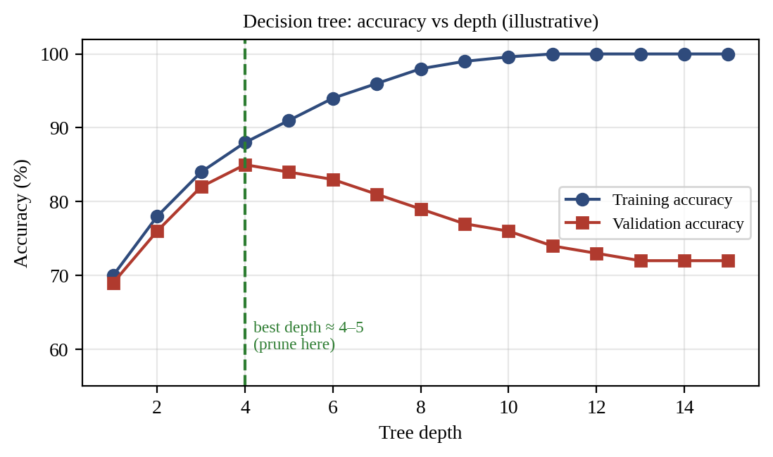
Fig. 2: Training and validation accuracy against tree depth (illustrative)
Step 3: Optimisation methods
Method | How it works | Effect
Pre-pruning | Limit max_depth, min_samples_split, min_samples_leaf or require a minimum information gain | Stops growth before noise is learned
Post-pruning | Grow the full tree, then remove branches by cost-complexity pruning, Rα(T) = R(T) + α × (number of leaves), or reduced-error pruning on validation data | Simpler tree with better generalisation
Cross-validation | Choose depth, leaf size and α by k-fold cross-validation (grid search) | Reliable hyper-parameters; avoids tuning to one split
Feature selection | Keep features with high information gain or importance; drop IDs and noisy features | Fewer misleading splits; faster model
Data cleaning / more data | Correct or remove noisy labels; collect more samples | Less noise to memorise
Ensembles | Random forest or gradient boosting (many trees, averaged) | Much lower variance
Step 4: Numerical illustration of cost-complexity pruning (α = 0.005)
Tree | Training error R(T) | Leaves | Rα(T) = R + α × leaves
Full tree | 0.05 | 40 | 0.05 + 0.005 × 40 = 0.25
Pruned tree | 0.12 | 8 | 0.12 + 0.005 × 8 = 0.16 (chosen)
The pruned tree has the smaller penalised cost, so it is preferred. After pruning to depth 5, the illustrative accuracy becomes 88% training and 84% test, so the gap falls from 28 to 4 points.
Step 5: Implementation with cross-validated pruning
params = {"max_depth": [3, 4, 5, 6, 8],
"min_samples_leaf": [5, 10, 20],
"ccp_alpha": [0.0, 0.001, 0.005, 0.01]}
tree = DecisionTreeClassifier(random_state=0)
grid = GridSearchCV(tree, params, cv=5)
grid.fit(X_train, y_train)
print(grid.best_params_, grid.best_score_) # best by 5-fold CV
print(grid.score(X_test, y_test)) # unseen data
Application
Pruned and cross-validated trees are used in credit scoring, medical diagnosis and customer analytics, where the rules must be understandable and the model must perform on future data.
Conclusion
High training accuracy with poor test accuracy shows that the tree is overfitting, usually because it is too deep or is learning noise or irrelevant features. The gap, the depth–accuracy curve, leaf sizes and feature importance reveal the problem. Pre- and post-pruning, cross-validated hyper-parameter selection, feature selection and data cleaning (or an ensemble such as a random forest) reduce the gap and improve generalisation.

