SIMATS ENGINEERING
ASSESSMENT TOOL 2

COURSE CODE: ITA 0603 COURSE NAME: MACHINE LEARNING

COURSE OUTCOME COVERED

CO3: Bayes Theorem – Concept Learning – Maximum Likelihood – Minimum Description Length Principle – Bayes Optimal Classifier – Gibbs Algorithm – Naïve Bayes Classifier – Bayesian Belief Network – EM Algorithm – Probability Learning – Sample Complexity – Finite and Infinite Hypothesis Spaces – Mistake Bound Model, (BL 6)

Assessment Tool Weightage: 20%

QUESTIONS: 15 Total Marks:25

Annexure A

CASE STUDY

Code of Conduct:
I Peta Harsha Vardhan (192311039) (Name / Reg No) certify that this submission is my original work and that I have adhered to the guidelines specified for this assessment.
I understand that any violation of academic integrity rules will result in disciplinary action.

Signature of the student:


Annexure A

Short Answer Test

1. A hospital aims to develop an intelligent system to diagnose diseases based on patient symptoms and medical history. Using concepts such as Bayes’ Theorem, Naïve Bayes classifiers, and Bayesian Belief Networks, design a probabilistic model for diagnosis. Analyze how uncertainty is handled and how conditional dependencies between symptoms influence predictions. Discuss the role of probability learning and evaluate the effectiveness of your approach with respect to real-world constraints.
2. An organization wants to build a spam detection system for emails using machine learning techniques. Using Naïve Bayes and Bayes Optimal Classifier concepts, design a classification system. Compare Maximum Likelihood estimation with Minimum Description Length (MDL) principle in feature selection. Analyze system performance, discuss trade-offs in model complexity, and evaluate how sample size and hypothesis space affect classification accuracy.
3. A retail company wants to segment its customers based on purchasing behavior, but the data contains hidden patterns and incomplete information. Apply the EM algorithm to identify clusters and estimate underlying distributions. Analyze convergence behavior, initialization challenges, and the role of probability learning. Discuss how the results can be used for targeted marketing and evaluate limitations of the approach.
4. A research team is developing a concept learning system to classify medical images into normal and abnormal categories. Using hypothesis space search and the Candidate Elimination approach, design a model that learns from labeled examples. Analyze the impact of finite vs infinite hypothesis spaces, sample complexity, and mistake bound model on learning performance. Evaluate how well the system generalizes to unseen data.
5. A financial institution needs to make investment decisions under uncertain market conditions. Using Bayesian inference, Gibbs algorithm, and probability learning, design a system to predict outcomes and update beliefs dynamically. Analyze how prior knowledge influences predictions, evaluate risk using posterior probabilities, and discuss how the model adapts as new data becomes available. Consider computational challenges and optimization strategies.

RUBRICS FOR CALCULATION
Criteria | Weightage | Level 4 – Exemplary (5 Marks) | Level 3 – Proficient (4 Marks) | Level 2 – Developing (2–3 Marks) | Level 1 – Beginning (0–1 Mark)
Conceptual Understanding | 30 | Demonstrates clear and complete understanding of the concept | Good understanding with minor gaps | Basic understanding with some misconceptions | Poor or incorrect understanding
Accuracy of Answer | 20 | Completely correct answer with no errors | Mostly correct with minor errors | Partially correct with noticeable errors | Incorrect or irrelevant answer
Application of Knowledge | 20 | Correctly applies concepts to solve the question/problem | Applies concepts with minor mistakes | Limited or partially correct application | No or incorrect application
Completeness of Response | 15 | Covers all required parts of the question | Covers most parts with minor omissions | Covers only some parts | Incomplete or missing response
Clarity & Presentation | 15 | Clear, concise, and well-organized answer | Understandable with minor issues | Somewhat unclear or poorly structured | Difficult to understand

Question 1
Question: A hospital aims to develop an intelligent system to diagnose diseases based on patient symptoms and medical history. Using concepts such as Bayes’ Theorem, Naïve Bayes classifiers, and Bayesian Belief Networks, design a probabilistic model for diagnosis. Analyze how uncertainty is handled and how conditional dependencies between symptoms influence predictions. Discuss the role of probability learning and evaluate the effectiveness of your approach with respect to real-world constraints.

Case Overview
A hospital wants a decision-support tool that reads a patient’s history and symptoms and returns the probability of a disease, so that a clinician can decide on further tests. The evidence is uncertain: symptoms occur in healthy people, some tests are not done, and symptoms such as fever and cough tend to occur together. This case study builds a probabilistic diagnosis model with Bayes’ theorem, a Naïve Bayes (NB) classifier and a Bayesian Belief Network (BBN), and tests them on synthetic patient data (no real patient records were used; the data were simulated from a known BBN so that the true answer is known).

Concepts Involved
- Bayes’ theorem: turns the test characteristics (sensitivity, specificity) and the prevalence into the probability of disease given a finding.
- Naïve Bayes: assumes the symptoms are conditionally independent given the disease.
- Bayesian Belief Network: a directed acyclic graph whose conditional probability tables (CPTs) encode dependencies between symptoms.
- Probability learning: CPT entries are learned from patient counts (maximum likelihood with Laplace smoothing).
- Uncertainty handling: posterior probabilities instead of hard labels, and marginalisation over unobserved variables.

Theory (Key Formulas)
P(D | E) = P(E | D) · P(D) / P(E), P(E) = P(E | D) P(D) + P(E | ¬D) P(¬D)
Naïve Bayes: P(D | x₁…xₙ) ∝ P(D) · Πᵢ P(xᵢ | D)
BBN: P(D, x₁…xₙ) = P(D) · Πᵢ P(xᵢ | D, Pa(xᵢ))
Laplace estimate: θ̂ = (nₖ + α) / (n + α·v), α = 1, v = number of values
Log-loss = −(1/N) Σ [ y log p + (1 − y) log(1 − p) ]
The NB model has 1 + 7×2 = 15 free probabilities for seven binary evidence variables. The BBN used here adds three symptom-to-symptom edges (Fever→Cough, Fever→Fatigue, Cough→Dyspnoea), which raises the count to 21 (each of those three children needs a separate row for each value of its extra parent).

Proposed System Design
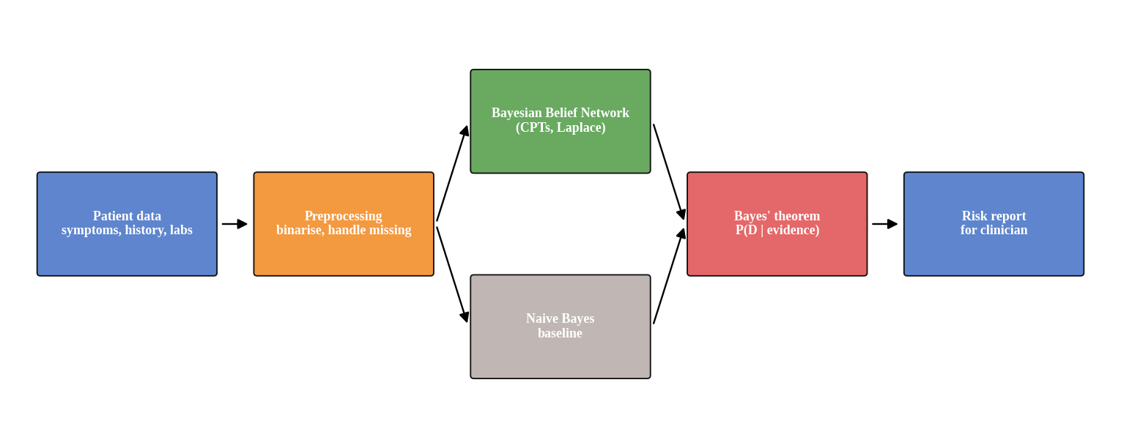
Figure 1: Architecture of the diagnosis system.
The system takes seven binary variables: two history factors (Smoker, Age ≥ 60) and five symptoms (Fever, Cough, Fatigue, Dyspnoea, Chest pain). The BBN structure is Disease → every variable, plus Fever → Cough, Fever → Fatigue and Cough → Dyspnoea. The NB baseline keeps only the Disease → variable edges. Posterior probabilities are computed by exact enumeration; an unobserved variable is summed out, so a missing test lowers confidence rather than breaking the model.

Experimental Evaluation
Data and Setup. Patients were simulated from a ground-truth BBN with 20% disease prevalence (NumPy, fixed seeds). A fixed test set of 5,000 patients (seed 999) was used: the first 2,000 for the learning curves, the first 1,000 for the missing-data test. Training sizes were 50, 100, 200, 500, 1,000 and 2,000 patients, repeated 20 times each with different seeds. All CPTs use Laplace smoothing (α = 1) unless stated. A separate 3%-prevalence population (2,000 training and 4,000 test patients) checks class imbalance.
Procedure. (1) Work through Bayes’ theorem for a screening test. (2) Measure how strongly fever and cough are correlated inside each disease group. (3) Train NB and BBN on increasing sample sizes and compare accuracy, log-loss and AUC. (4) Compare learning with and without Laplace smoothing. (5) Hide symptom values at random and recompute the posterior. (6) Test the imbalanced population.
Results.
Table 1: Bayes’ theorem worked example (prevalence 1%, sensitivity 90%, specificity 95%).
Quantity | Value
P(disease | positive test) | 15.4%
P(no disease | negative test) | 99.89%
P(disease | two independent positives) | 76.6%

Table 2: Correlation (φ) between symptoms within the same disease group (test set).
Pair | Disease absent | Disease present
Fever and Cough | 0.491 | 0.559
Cough and Dyspnoea | 0.352 | —

Table 3: Probability learning: NB vs BBN as the training size grows (mean of 20 runs).
Training n | Acc NB | Acc BBN | Log-loss NB | Log-loss BBN | AUC NB | AUC BBN
50 | 0.889 | 0.891 | 0.336 | 0.279 | 0.928 | 0.921
100 | 0.891 | 0.903 | 0.326 | 0.256 | 0.931 | 0.930
200 | 0.891 | 0.908 | 0.339 | 0.248 | 0.931 | 0.934
500 | 0.891 | 0.908 | 0.332 | 0.236 | 0.932 | 0.936
1000 | 0.892 | 0.909 | 0.336 | 0.232 | 0.932 | 0.938
2000 | 0.892 | 0.911 | 0.332 | 0.230 | 0.932 | 0.939

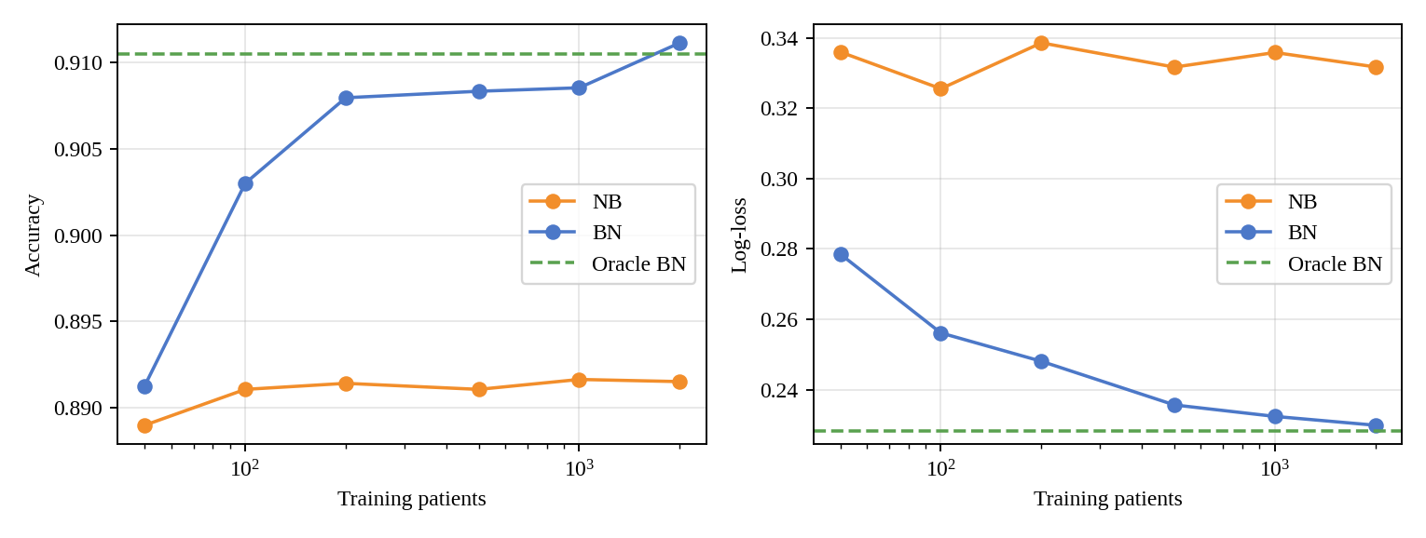
Figure 2: Accuracy and log-loss against training size (dashed: BBN with the true structure learned from 200,000 patients).
Table 4: Effect of Laplace smoothing with 50 training patients (BBN).
Setting | Accuracy | Log-loss | Predictions with p < 10⁻⁶ or > 1 − 10⁻⁶
No smoothing (α ≈ 0) | 0.875 | 1.046 | 63.3%
Laplace (α = 1) | 0.885 | 0.269 | —

Table 5: Robustness to missing symptom values (models trained on 2,000 patients).
Entries missing | Acc NB | Acc BBN | Log-loss NB | Log-loss BBN
0% | 0.889 | 0.907 | 0.322 | 0.229
20% | 0.887 | 0.895 | 0.300 | 0.248
40% | 0.879 | 0.882 | 0.302 | 0.271
60% | 0.848 | 0.851 | 0.338 | 0.326

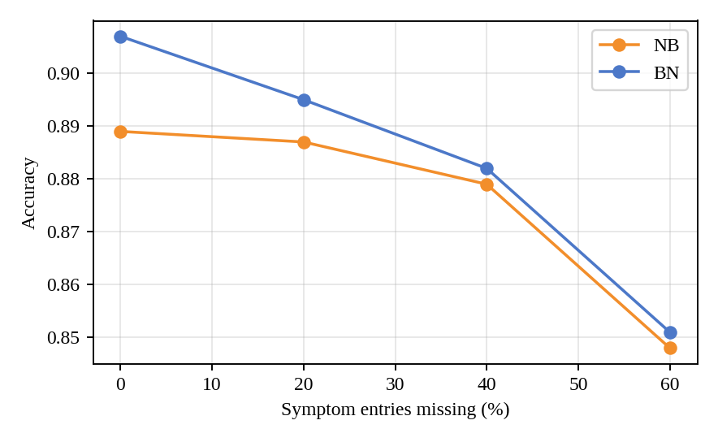
Figure 3: Accuracy as the share of missing symptom entries grows.
Table 6: Imbalanced population (3% prevalence, BBN trained on 2,000 patients with 71 diseased).
Decision threshold | Accuracy | Precision | Recall
0.50 | 0.976 | 0.732 | 0.403
0.15 | 0.952 | 0.383 | 0.791

Analysis and Discussion
- How uncertainty is handled. The output is a probability, not a label. Bayes’ theorem shows why: with 1% prevalence, a positive result from a 90%-sensitive, 95%-specific test gives only a 15.4% chance of disease; a second independent positive raises it to 76.6%. Beliefs are therefore updated as evidence arrives. Missing findings are summed out, and accuracy fell only from 0.907 to 0.882 when 40% of symptom entries were hidden.
- Conditional dependencies change the prediction. Fever and cough are correlated even within the same disease group (φ = 0.491 without disease, 0.559 with disease). NB ignores this and counts the two symptoms as independent evidence. For a patient with smoker, age ≥ 60, fever, cough and dyspnoea, NB reports a disease probability of 97.3% while the BBN reports 81.2%: NB is over-confident.
- BBN is better calibrated; accuracy gain is modest. With 2,000 training patients the BBN reached accuracy 0.911 and log-loss 0.230, against 0.892 and 0.332 for NB. This accuracy is close to the oracle BBN (0.910, AUC 0.940), which means the remaining errors come from overlap between sick and healthy patients, not from poor learning. NB gave higher recall (0.787 vs 0.730) but lower precision (0.709 vs 0.813), because it over-predicts disease.
- Role of probability learning. NB is flat as data grow (log-loss 0.336 at n = 50 and 0.332 at n = 2,000) because its error is a modelling bias, not a data shortage. The BBN improves from 0.279 to 0.230, and at n = 50 it already beats NB’s log-loss, although it has more parameters. Laplace smoothing is essential for small samples: without it, 63.3% of the predictions at n = 50 were essentially 0 or 1 and log-loss rose to 1.046 (against 0.269 with smoothing).
- Imbalance. At 3% prevalence the BBN’s accuracy of 0.976 looks excellent but recall is only 0.403. Lowering the threshold to 0.15 lifts recall to 0.791 at the cost of precision (0.383). The threshold is a clinical decision about the cost of a missed case against a false alarm.
- Missing data narrows the BBN advantage. The accuracy gap between BBN and NB shrinks from 0.018 with complete data to 0.003 when 60% of values are missing, since fewer correlated symptoms are observed to be double-counted.

Limitations and Real-world Constraints
- Synthetic data. The dependencies were designed by us, so the BBN’s advantage is partly built in; real hospital data may show weaker or different dependencies.
- Known structure. The BBN structure was assumed. In practice it must come from clinicians or structure learning, and a wrong edge can hurt.
- Privacy and ethics. Real records need consent, de-identification and compliance with data-protection rules.
- Missing not at random. Tests are ordered because the clinician already suspects disease; this violates the random-missingness assumption used here.
- Imbalance and calibration. Rare diseases need threshold selection, and probabilities must be re-checked when the patient population shifts.
- Interpretability. CPTs and graph edges can be read and audited by a clinician, which is an advantage over black-box models. The system should assist, not replace, the doctor.

Conclusion
Bayes’ theorem and probabilistic models give a principled way to turn uncertain symptoms into a disease probability. On simulated data, a BBN that models the fever–cough dependency was better calibrated than Naïve Bayes (log-loss 0.230 vs 0.332) and handled missing values gracefully; Laplace smoothing was necessary at small sample sizes. Real deployment would still require real data, validated structure, careful thresholds and clinician oversight.

Question 2
Question: An organization wants to build a spam detection system for emails using machine learning techniques. Using Naïve Bayes and Bayes Optimal Classifier concepts, design a classification system. Compare Maximum Likelihood estimation with Minimum Description Length (MDL) principle in feature selection. Analyze system performance, discuss trade-offs in model complexity, and evaluate how sample size and hypothesis space affect classification accuracy.

Case Overview
An organisation wants to filter spam from short text messages. This case study uses the real SMS Spam Collection (5,574 messages, 747 spam = 13.4%). Naïve Bayes is the main classifier. Maximum likelihood (ML) and the Minimum Description Length (MDL) principle are compared for choosing how many words to use, the Bayes Optimal Classifier is built as a posterior-weighted vote over models, and the effects of training-set size and vocabulary size are measured.

Concepts Involved
- Naïve Bayes with Laplace smoothing on word counts.
- Maximum likelihood vs MDL: ML chooses the model that fits the training data best; MDL adds the cost of describing the model.
- Bayes Optimal Classifier (BOC): combines all hypotheses weighted by their posterior probability.
- Hypothesis space: here, the family of NB models over the top-k words; sample size and k control the bias–variance trade-off.

Theory (Key Formulas)
P(spam | m) ∝ P(spam) · Π_w P(w | spam)^count(w, m)
P(w | c) = (count(w, c) + α) / (total words in c + α·|V|), α = 1
MDL(h) = −log P(D | ĥ) + (p / 2) · ln n (BIC-style penalty, p parameters, n messages)
BOC: P(spam | x) = Σₕ P(spam | x, h) · P(h | D), P(h | D) ∝ P(D | h) P(h)
For feature selection, words are ranked by mutual information with the label. A model with k selected words uses a class-dependent probability for those words and one shared probability for all other words, so models with different k describe the same data and their likelihoods are comparable. It has p = 1 + |V| + k parameters.

Proposed System Design
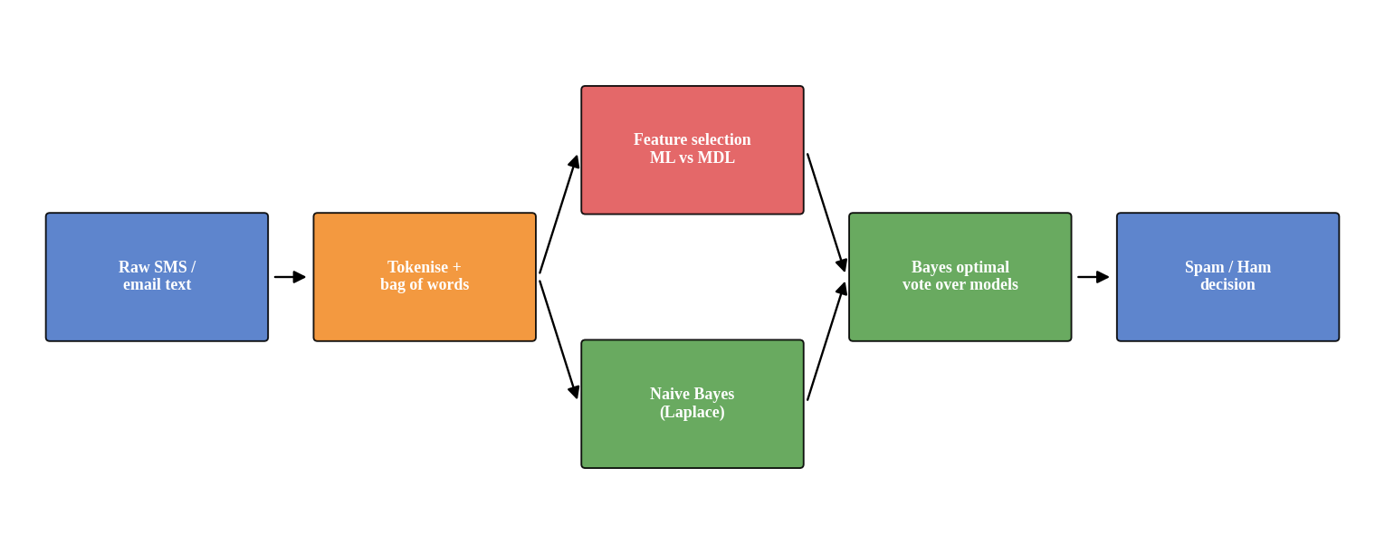
Figure 4: Architecture of the spam detection system.
Messages are tokenised into a bag of words. Features are ranked and the number of features is chosen by ML or MDL. A Naïve Bayes model is fitted for each candidate k, and the final decision is made either by the single best model or by the BOC vote.

Experimental Evaluation
Data and Setup. Real data from the SMS Spam Collection (downloaded from the URL in the assignment). A stratified 70/30 split with random_state = 42 gave 3,901 training and 1,673 test messages. The training vocabulary has 7,179 distinct words. A classifier that always says “ham” would score 86.6% accuracy, so precision, recall and F1 on the spam class are reported as well.
Procedure. (1) Train multinomial NB with and without Laplace smoothing. (2) Rank words by mutual information and fit a Bernoulli NB model for k = 10 … full vocabulary; compute training log-likelihood (ML) and MDL for each k. (3) Build the BOC as a vote over all these models with weights proportional to exp(−MDL). (4) Train on random subsets of 20 … 3,901 messages (10 repeats). (5) Record test accuracy, precision, recall and F1 for each setting.
Results.
Table 7: Naïve Bayes on the full vocabulary (test set).
Smoothing | Accuracy | Precision | Recall | F1
Laplace α = 1 | 0.984 | 0.967 | 0.911 | 0.938
None (α ≈ 0) | 0.983 | 0.962 | 0.906 | 0.933

Table 8: ML vs MDL for choosing the number of features k (Bernoulli NB; code length in nats).
k | Params p | −log L | MDL | Acc | Prec | Rec | F1
10 | 7,190 | 284,238 | 313,965 | 0.940 | 0.873 | 0.647 | 0.744
20 | 7,200 | 283,430 | 313,198 | 0.953 | 0.880 | 0.754 | 0.812
50 | 7,230 | 281,836 | 311,729 | 0.970 | 0.944 | 0.821 | 0.878
100 | 7,280 | 280,302 | 310,401 | 0.978 | 0.965 | 0.871 | 0.915
200 | 7,380 | 278,523 | 309,036 | 0.981 | 0.985 | 0.875 | 0.927
300 | 7,480 | 277,425 | 308,351 | 0.984 | 0.990 | 0.893 | 0.939
500 | 7,680 | 276,001 | 307,754 | 0.986 | 0.990 | 0.902 | 0.944
1000 | 8,180 | 273,950 | 307,770 | 0.987 | 0.995 | 0.906 | 0.949
2000 | 9,180 | 271,899 | 309,854 | 0.982 | 1.000 | 0.866 | 0.928
3000 | 10,180 | 270,880 | 312,969 | 0.981 | 1.000 | 0.862 | 0.926
7179 | 14,359 | 270,093 | 329,460 | 0.978 | 1.000 | 0.835 | 0.910

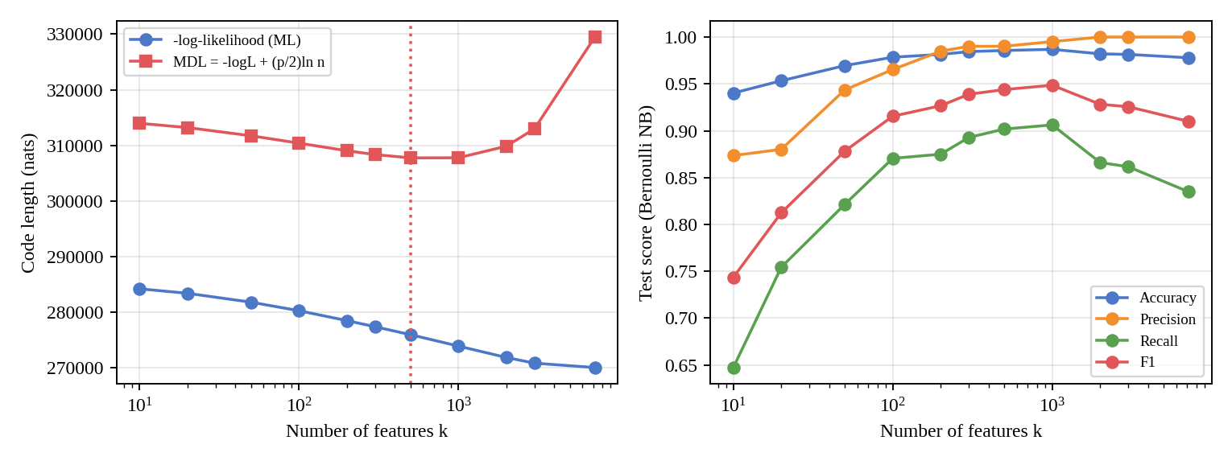
Figure 5: Left: −log-likelihood and MDL against k. Right: test scores against k.
Table 9: Maximum likelihood vs MDL selection (test set).
Criterion | Chosen k | Accuracy | Precision | Recall | F1
Maximum likelihood | 7179 | 0.978 | 1.000 | 0.835 | 0.910
MDL | 500 | 0.986 | 0.990 | 0.902 | 0.944
Bayes Optimal vote | all 11 models | 0.986 | 0.990 | 0.902 | 0.944

Table 10: Effect of training sample size (multinomial NB, full vocabulary of each subset; mean of 10 runs).
Training messages | Accuracy | Precision | Recall | F1
20 | 0.888 | 0.771 | 0.255 | 0.334
50 | 0.911 | 0.863 | 0.396 | 0.510
100 | 0.931 | 0.954 | 0.519 | 0.648
200 | 0.959 | 0.973 | 0.714 | 0.823
500 | 0.975 | 0.971 | 0.837 | 0.898
1000 | 0.979 | 0.982 | 0.858 | 0.915
2000 | 0.982 | 0.973 | 0.892 | 0.931
3901 | 0.984 | 0.967 | 0.911 | 0.938

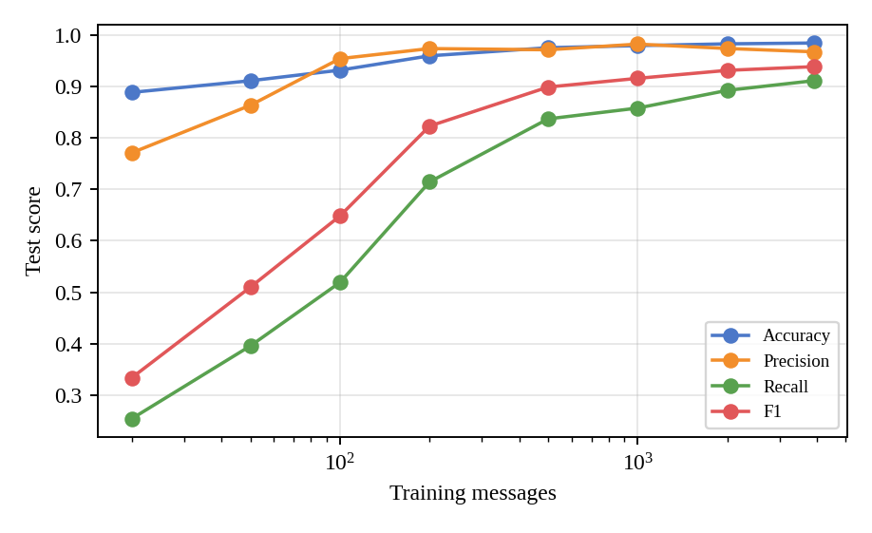
Figure 6: Test scores against training size.
Table 11: Effect of vocabulary size k = hypothesis-space size (multinomial NB, 3,901 training messages).
k | Accuracy | Precision | Recall | F1
10 | 0.938 | 0.992 | 0.540 | 0.699
20 | 0.946 | 0.986 | 0.607 | 0.751
50 | 0.961 | 0.954 | 0.741 | 0.834
100 | 0.969 | 0.934 | 0.826 | 0.877
200 | 0.968 | 0.894 | 0.866 | 0.880
300 | 0.975 | 0.914 | 0.897 | 0.905
500 | 0.978 | 0.923 | 0.915 | 0.919
1000 | 0.983 | 0.941 | 0.933 | 0.937
2000 | 0.986 | 0.967 | 0.924 | 0.945
3000 | 0.986 | 0.967 | 0.929 | 0.948
7179 | 0.984 | 0.967 | 0.911 | 0.938

Analysis and Discussion
- System performance. Naïve Bayes with Laplace smoothing reached accuracy 0.984, precision 0.967, recall 0.911 and F1 0.938, clearly above the 86.6% “always ham” baseline. The words with the highest mutual information include call, txt, free, claim, to, www, prize, mobile, which are typical spam cues. Smoothing helped slightly (F1 0.938 against 0.933 without it) because unseen words otherwise force a probability of zero.
- ML vs MDL. The training likelihood can only improve as features are added, so ML picks the largest model (k = 7,179). MDL balances fit against the cost of 6,679 extra parameters and picks k = 500. On the test set the MDL model is better: F1 0.944 against 0.910, and recall 0.902 against 0.835. ML’s larger model overfits rare words.
- Bayes Optimal Classifier. Weights proportional to exp(−MDL) are almost all on one model: k = 500 receives 0.9999999. The vote therefore behaves like that single model (F1 0.944, accuracy 0.986) and gives no gain here. With 3,901 training messages the data strongly prefer one hypothesis, so a vote only helps when several hypotheses have comparable posterior weights (small samples).
- Model-complexity trade-off. Test F1 for the Bernoulli model rises from 0.744 (k = 10) to a peak near k = 1,000 (0.949) and then falls to 0.910 with all words, while precision rises to 1.000 and recall falls. Too few words underfit (high bias); too many add noise (high variance). The multinomial model is more tolerant: its F1 stays between 0.919 and 0.948 for k ≥ 500.
- Effect of sample size. With 20 training messages, accuracy was 0.888 (almost the baseline) and recall only 0.255. Accuracy reached 0.959 at 200 messages and 0.984 with all data, while F1 rose from 0.334 to 0.938. Precision was high early (≥ 0.954 from 100 messages) but recall needed much more data, because spam vocabulary is varied. Gains were still positive between 2,000 and 3,901 messages (0.931 to 0.938), so more data would help.
- Effect of the hypothesis space. A larger space (more words) lowers bias but needs more data to estimate its parameters. This is why MDL selects 500 words with 3,901 messages. It is expected that a larger training set would move the MDL optimum to a larger k, because the penalty (p/2) ln n grows only logarithmically in n while the likelihood gain grows linearly.

Limitations and Real-world Constraints
- The dataset contains SMS messages, not e-mails; e-mail has headers, HTML and attachments.
- The independence assumption is wrong for phrases such as “call now”, so NB probabilities are over-confident even when accuracy is high.
- Spammers adapt, so the vocabulary drifts and the model must be retrained.
- Misclassifying a legitimate message (false positive) is usually costlier than letting spam through; the decision threshold should reflect this.
- The mutual-information ranking and the grid of k values were chosen on the training data only; results come from a single 70/30 split.

Conclusion
Naïve Bayes gives a fast and accurate spam filter (98.4% accuracy, F1 0.938). MDL selected a compact 500-word model that generalised better than the maximum-likelihood choice of the full vocabulary (F1 0.944 vs 0.910). The Bayes optimal vote collapsed onto the same model, and the learning curves show that the amount of data, more than the model, controls recall.

Question 3
Question: A retail company wants to segment its customers based on purchasing behavior, but the data contains hidden patterns and incomplete information. Apply the EM algorithm to identify clusters and estimate underlying distributions. Analyze convergence behavior, initialization challenges, and the role of probability learning. Discuss how the results can be used for targeted marketing and evaluate limitations of the approach.

Case Overview
A retailer wants to group customers by purchasing behaviour. The data hide the group labels and about 15% of the values are missing. Because no real retail data were provided, 2,000 customers were simulated from four hidden segments (synthetic data) with five features: annual spend, visits per month, basket value, recency and discount share. Values were removed completely at random: 14.9% of entries are missing, so 56.0% of customers have at least one missing value.

Concepts Involved
- Gaussian mixture model (GMM): each segment is a multivariate normal; the population is a weighted mixture.
- EM algorithm: the E-step computes the probability that each customer belongs to each segment; the M-step re-estimates weights, means and covariances. Missing values are treated as additional hidden variables.
- Probability learning: maximum-likelihood estimation of mixture parameters from incomplete data.
- Model selection: the Bayesian Information Criterion (BIC) chooses the number of clusters.

Theory (Key Formulas)
p(x) = Σₖ πₖ N(x | μₖ, Σₖ)
E-step: rᵢₖ = πₖ N(xᵢᵒ | μₖᵒ, Σₖᵒᵒ) / Σⱼ πⱼ N(xᵢᵒ | μⱼᵒ, Σⱼᵒᵒ) (only observed entries xᵒ)
Missing part: E[xᵐ | xᵒ, k] = μₖᵐ + Σₖᵐᵒ (Σₖᵒᵒ)⁻¹ (xᵒ − μₖᵒ)
M-step: μₖ = Σᵢ rᵢₖ x̂ᵢₖ / Σᵢ rᵢₖ, πₖ = Σᵢ rᵢₖ / N, Σₖ = Σᵢ rᵢₖ[(x̂ᵢₖ − μₖ)(x̂ᵢₖ − μₖ)ᵀ + Cᵢₖ] / Σᵢ rᵢₖ
BIC = −2 ln L + p ln N
Here Cᵢₖ is the conditional covariance of the missing entries. Each iteration cannot decrease the observed-data likelihood L, so EM converges, but only to a local maximum.

Proposed System Design
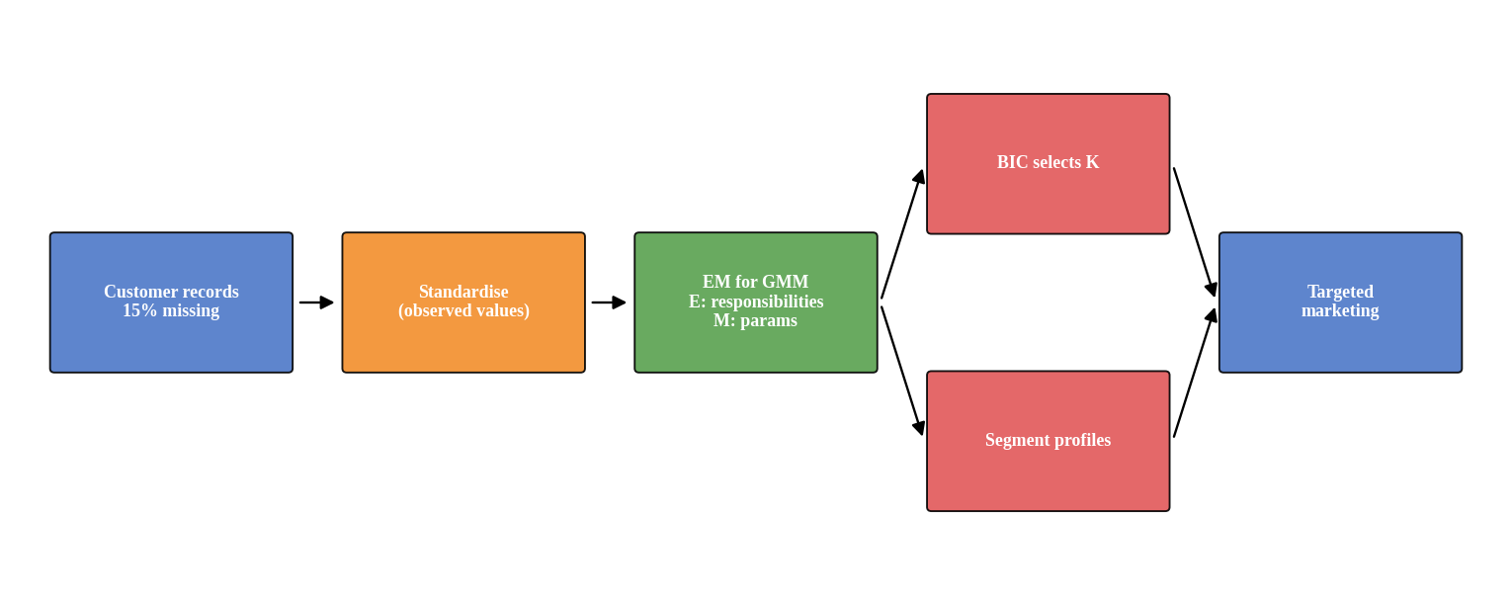
Figure 7: Architecture of the segmentation system.
Features are standardised using the observed values. A full-covariance GMM is fitted by EM written from scratch in NumPy; customers are grouped by missing-value pattern so that each pattern uses the correct marginal Gaussian. Initialisation is either random (K customers chosen as means) or k-means on mean-imputed data. The number of clusters is chosen by BIC, and the fitted means are converted back to original units to describe the segments.

Experimental Evaluation
Data and Setup. Four segments (true proportions 30%, 30%, 15%, 25%) with correlated Gaussian features (seed 42). Missing entries were generated at random with probability 0.15. EM stops when the relative change of log-likelihood is below 10⁻⁷ (maximum 300 iterations). One EM run takes about 0.42 s. Log-likelihoods are in standardised units. The true segment labels are used only for scoring with the Adjusted Rand Index (ARI; 1.0 = perfect).
Procedure. (1) 20 random and 20 k-means initialisations with K = 4. (2) Compare with mean-imputation followed by k-means, and with a GMM fitted on the complete data before values were removed. (3) BIC for K = 1 … 7. (4) Interpret the best solution.
Results.
Table 12: Initialisation study for EM (K = 4, 20 runs each).
Measure | Random init | k-means init
Final log-likelihood, best | -1249.7 | -1249.7
Final log-likelihood, worst | -2347.8 | -1249.7
Runs ending in a local optimum | 6 of 20 | 0 of 20
Mean iterations to converge | 74.0 | 19.0
Mean ARI | 0.905 | 0.987
Worst ARI | 0.585 | 0.987

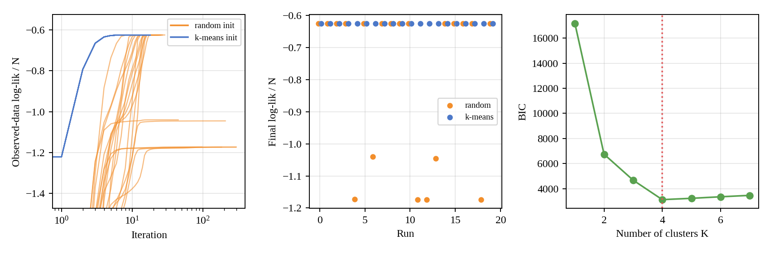
Figure 8: Left: log-likelihood per iteration. Middle: final log-likelihood of each run. Right: BIC against K.
Table 13: Clustering quality and parameter error.
Method | ARI | Mean error of segment means
EM with missing data (best run) | 0.987 | 1.6%
Mean imputation + k-means (mean of 20 runs) | 0.829 | 23.2% (best of 10 starts)
GMM on complete data (upper bound) | 0.997 | —

Table 14: BIC for the number of clusters (best of 5 runs per K).
K | 1 | 2 | 3 | 4 | 5 | 6 | 7
Log-likelihood | -8511 | -3219 | -2105 | -1250 | -1223 | -1204 | -1180
BIC | 17173 | 6750 | 4681 | 3130 | 3236 | 3358 | 3470

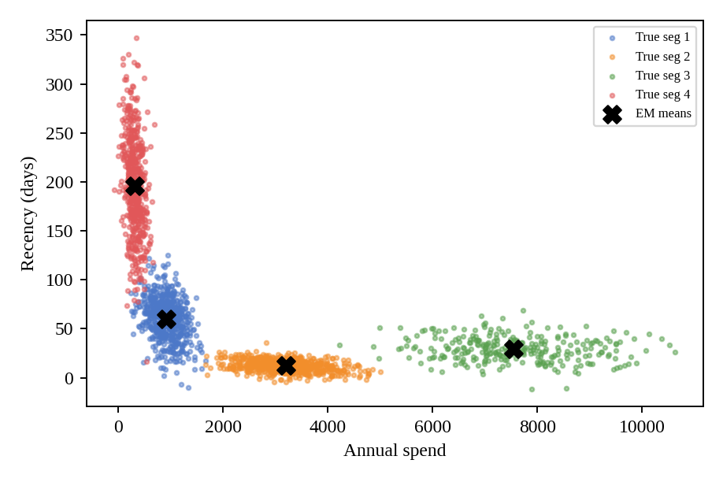
Figure 9: Simulated customers (coloured by true segment) and EM-estimated segment means (black crosses).
Table 15: Estimated segments (original units; names are our labels) and marketing action.
Segment | Size | Spend | Visits | Basket | Recency | Disc. | Action
Bargain hunters | 30.1% | 906 | 2.0 | 45 | 60 | 70% | Coupons, clearance alerts
Loyal regulars | 29.8% | 3,204 | 6.0 | 55 | 12 | 15% | Loyalty points, early access (no deep discounts)
Big spenders | 13.9% | 7,550 | 3.1 | 181 | 29 | 10% | Premium bundles, personal service
Dormant customers | 26.2% | 310 | 0.5 | 36 | 196 | 39% | Win-back offers, reactivation e-mail

Analysis and Discussion
- Convergence behaviour. Every run improved the observed-data likelihood and stopped. k-means starts converged in 19 iterations on average, all to the same value (-1249.7). Random starts needed 74 iterations on average.
- Initialisation and local optima. 6 of 20 random starts ended in a worse solution (log-likelihood as low as -2348 against -1250) and the worst ARI was 0.585. The k-means starts had no such failure. Remedies: k-means initialisation, several restarts keeping the best likelihood, and a small covariance regulariser. (All 20 k-means starts reaching the same optimum partly reflects that k-means itself is stable on this well-separated data.)
- Role of probability learning with missing data. EM uses the observed entries of all customers instead of discarding rows or guessing values. It recovered the segment means to within 1.6% on average and the segment sizes (30.1%, 29.8%, 13.9%, 26.2% against the true 30%, 30%, 15%, 25%), with ARI 0.987, close to the complete-data GMM (0.997).
- Comparison with mean-imputation + k-means. Imputing means pulls customers toward the global centre and assumes spherical clusters. ARI fell to 0.829 and the segment-mean error rose to 23.2%.
- Number of clusters. BIC is lowest at K = 4 (3130), and rises for K = 5 to 7 (3236, 3358, 3470) although the likelihood keeps improving slightly; the extra parameters are not justified.
- Use for targeted marketing. The segment profiles above translate directly into actions: discount-driven shoppers get coupons, frequent low-discount customers get loyalty rewards without margin loss, high-basket customers get premium offers, and customers with long recency get reactivation campaigns. Because EM gives each customer a membership probability, borderline customers can receive a blend of offers or be excluded from expensive campaigns.

Limitations and Real-world Constraints
- Synthetic and Gaussian. The data were generated from the model class being fitted, so recovery is optimistic. Real spend and recency are skewed and may need a log transform.
- Missing completely at random. Real missingness may depend on the value itself (for example customers who stop buying), which biases EM.
- Local optima and singular covariances remain a risk with more features or small segments; restarts and regularisation are needed.
- K must be chosen, and BIC assumes the Gaussian model is correct.
- Soft segments are not causal. A segment describes behaviour; whether an offer works must be tested with an experiment.
- Privacy. Purchase histories are personal data.

Conclusion
EM for a Gaussian mixture handled 15% missing data and recovered the four hidden segments (ARI 0.987), clearly better than mean-imputation with k-means (ARI 0.829). Initialisation matters: random starts sometimes reached poor local optima, while k-means starts did not. BIC selected four clusters, whose profiles give concrete marketing actions.

Question 4
Question: A research team is developing a concept learning system to classify medical images into normal and abnormal categories. Using hypothesis space search and the Candidate Elimination approach, design a model that learns from labeled examples. Analyze the impact of finite vs infinite hypothesis spaces, sample complexity, and mistake bound model on learning performance. Evaluate how well the system generalizes to unseen data.

Case Overview
A research team wants a system that labels biopsy images as normal or abnormal from labelled examples. The Breast Cancer Wisconsin (Diagnostic) dataset from scikit-learn is used: 569 cases described by 30 image-derived measurements (radius, texture, concavity, etc.); 212 are malignant (“abnormal”, the positive concept) and 357 benign. Raw images are not included, only the features computed from them.

Concepts Involved
- Concept learning and hypothesis-space search, with the Candidate Elimination algorithm (S and G boundaries).
- Finite and infinite hypothesis spaces: conjunctions of binary features versus threshold rules on continuous features.
- Sample complexity from |H| and from the VC dimension.
- Mistake bound model: Halving and Weighted Majority algorithms.

Theory (Key Formulas)
Conjunctive hypotheses on n Boolean features: |H| = 3ⁿ + 1 (each feature is 0, 1 or “?”, plus the empty hypothesis)
Consistent learner, finite H: m ≥ (1/ε) (ln|H| + ln(1/δ))
Agnostic (noisy) learner: m ≥ (1/(2ε²)) (ln|H| + ln(1/δ))
VC bound: m ≥ (1/ε) (4 log₂(2/δ) + 8·d·log₂(13/ε))
Halving mistake bound: ≤ log₂|H|; Weighted Majority (β = ½): ≤ 2.41 (k + log₂|H|)
The version space is the set of hypotheses consistent with all examples. Any consistent hypothesis must be at least as general as S (the most specific hypothesis covering the positives), so the version space becomes empty exactly when S covers a negative example. This is the test used on the 30-feature data.

Proposed System Design
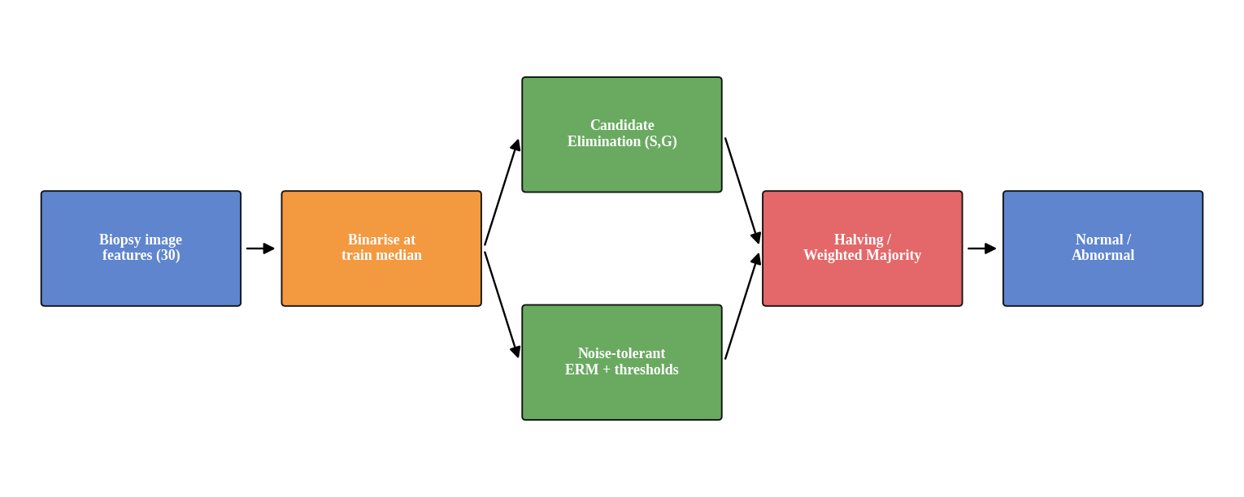
Figure 10: Architecture of the concept-learning system.
Each of the 30 features is turned into a Boolean (“above the training median”). Candidate Elimination searches the conjunctive space. Because real labels are noisy in this representation, a noise-tolerant learner chooses the conjunction with the fewest training errors (empirical risk minimisation, ERM) over 8 features selected by mutual information (6,562 hypotheses including the empty one). The infinite space is represented by threshold rules on the best single continuous feature (worst perimeter, VC dimension 1); logistic regression on all 30 features (VC dimension 31) is added for reference. Online learning is tested with Halving and Weighted Majority.

Experimental Evaluation
Data and Setup. Stratified 70/30 split (random_state = 42): 398 training and 171 test cases. Binarisation uses training medians. For the exact version-space count, the 6 most informative binary features were used (worst radius, worst area, worst perimeter, worst concave points, mean concave points, worst concavity), giving 730 hypotheses. For learning curves, 20 random subsets per training size were used.
Procedure. (1) Run Candidate Elimination on real labels (30 shuffles, all 30 features) and count the examples until the version space collapses. (2) Track the exact size of the version space for 6 features on real labels and on a noise-free synthetic concept (x₃ = 1 AND x₆ = 0 on the same features). (3) Compare learning curves of the three hypothesis spaces. (4) Compute sample-complexity bounds. (5) Run Halving and Weighted Majority online. (6) Re-split the data 20 times to measure generalisation reliably.
Results.
Table 16: Version-space size after t training examples (6 features, |H| = 730).
Examples t | 0 | 1 | 2 | 5 | 10 | 15 | 50 | 120
Real labels | 730 | 666 | 63 | 30 | 24 | 0 | 0 | 0
Noise-free concept | 730 | 666 | 603 | 30 | 30 | 7 | 6 | 3

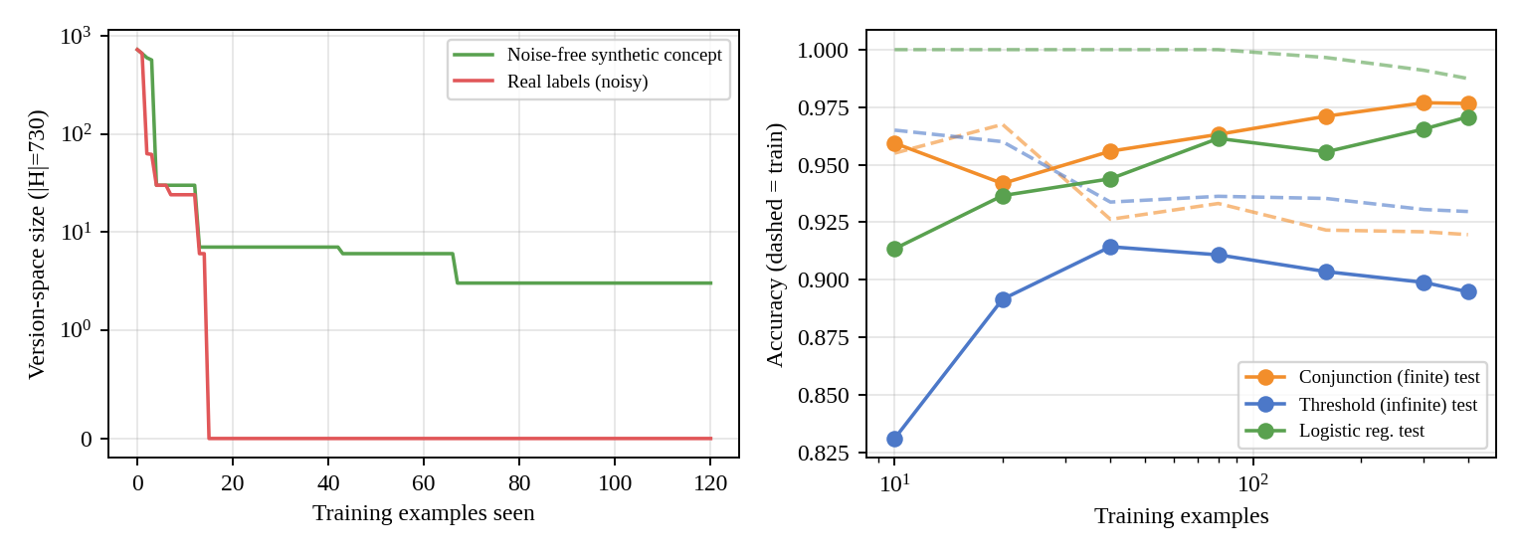
Figure 11: Left: version-space size (log scale). Right: test accuracy (solid) and training accuracy (dashed) against training size, seed-42 split.
Table 17: Test accuracy against training size (seed-42 split; mean of 20 subsets).
Training n | Conjunction (finite) | Threshold (infinite) | Logistic regression
10 | 0.959 | 0.831 | 0.913
20 | 0.942 | 0.892 | 0.937
40 | 0.956 | 0.914 | 0.944
80 | 0.963 | 0.911 | 0.961
160 | 0.971 | 0.904 | 0.956
300 | 0.977 | 0.899 | 0.965
398 | 0.977 | 0.895 | 0.971

Table 18: Sample-complexity bounds (δ = 0.05).
Bound | Required m
Consistent learner, |H| = 6,562, ε = 0.10 | 118
Agnostic learner, |H| = 6,562, ε = 0.05 | 2357
VC, d = 1 (threshold), ε = 0.10 | 775
VC, d = 31 (linear), ε = 0.10 | 17628

Table 19: Mistake-bound experiments over the 6,562 conjunctions (all 569 examples as an online stream).
Algorithm / data | Mistakes | Theoretical bound
Halving, noise-free concept (20 orders) | 4.55 mean, 6 max | 12.7
Halving, real labels | 2 then pool empty at example 8 | —
Weighted Majority, β = 0.5 (10 orders) | 44.0 | 115 (best hypothesis: 35 mistakes)
Weighted Majority, β = 0.9 (10 orders) | 70.3 | —

Table 20: Held-out generalisation: seed-42 test set (171 cases) and mean of 20 random re-splits.
Hypothesis space | Acc | Prec | Rec | F1 | Acc, 20 splits
Conjunction (finite) | 0.977 | 0.984 | 0.953 | 0.968 | 0.926 ± 0.016
Threshold (infinite, VC = 1) | 0.895 | 0.942 | 0.766 | 0.845 | 0.904 ± 0.014
Logistic regression (VC = 31) | 0.971 | 0.984 | 0.938 | 0.960 | 0.967 ± 0.011

Analysis and Discussion
- Noise collapses the version space. On the real labels the version space shrank from 730 to 63 hypotheses after two examples and was empty after 15 examples (6 features). With all 30 features, collapse occurred after 35.7 examples on average (range 14 to 95). Candidate Elimination assumes that a perfect conjunctive concept exists; borderline tumours violate this. On the noise-free concept the version space stayed non-empty and settled at 3 hypotheses (hypotheses that agree on all training data).
- Finite vs infinite hypothesis spaces. The finite space (6,562 conjunctions) makes ERM exhaustive and gives a clear bound: ln|H| = 8.79. The best conjunction was: worst radius high AND worst area high AND worst concave points high AND mean concave points high AND worst concavity high AND mean concavity high (training accuracy 92.0%). Its readable rule is an advantage. The infinite threshold space has VC dimension 1, so it generalises with few examples (accuracy 0.892 at n = 20) but cannot improve, since one feature is not enough: accuracy stayed near 0.895. Logistic regression has the highest capacity (VC = 31) and started lower (0.913 at n = 10) but kept improving to 0.971.
- Sample complexity. The finite-space bound for a consistent learner is 118 examples for ε = 0.1, but the agnostic (noisy) bound for ε = 0.05 is 2357, more than the 398 available. VC bounds are even larger (775 for d = 1 and 17628 for d = 31). These are worst-case guarantees; the observed learning curves are much better, so the bounds are loose but show the correct ordering (richer spaces need more data).
- Mistake bound model. On a noise-free concept Halving made 4.55 mistakes on average (6 at most), below its bound log₂|H| = 12.7. On real labels Halving fails: the pool of hypotheses was empty after 8 examples. Weighted Majority tolerates noise: it made 44.0 mistakes on 569 examples (online error 7.7%), which is within its bound of 115 given that the best single hypothesis makes 35 mistakes; the gentler β = 0.9 was worse (70.3) over this short stream.
- Generalisation to unseen data. On the seed-42 test set the conjunction scored 0.977, but over 20 random re-splits it averaged 0.926 ± 0.016 (training accuracy 0.943); the seed-42 split was favourable and should not be quoted alone. Logistic regression generalised best and most consistently (0.967 ± 0.011), then the conjunction, then the single threshold (0.904 ± 0.014). Recall for the abnormal class is the key clinical measure: 0.953 for the conjunction and 0.938 for logistic regression on the seed-42 split.

Limitations and Real-world Constraints
- Features are pre-computed measurements, not images; a real system would need image preprocessing or a convolutional network.
- Binarising at the median discards information, which is why the conjunction space cannot be consistent with the data.
- Test sets of 171 cases give wide confidence intervals; the 20 re-splits are not independent of each other.
- A missed abnormal case is far costlier than a false alarm, so recall must be prioritised and results validated clinically.
- Data come from a single source; scanners and hospitals will shift the feature distributions.

Conclusion
Candidate Elimination is exact and interpretable but fails on noisy medical labels (empty version space after about 36 examples). Noise-tolerant ERM over the finite space, Weighted Majority online, and logistic regression in a larger space all work; the latter generalised best (0.967 over 20 splits). The sample-complexity bounds are conservative but correctly show that richer hypothesis spaces need more labelled examples.

Question 5
Question: A financial institution needs to make investment decisions under uncertain market conditions. Using Bayesian inference, Gibbs algorithm, and probability learning, design a system to predict outcomes and update beliefs dynamically. Analyze how prior knowledge influences predictions, evaluate risk using posterior probabilities, and discuss how the model adapts as new data becomes available. Consider computational challenges and optimization strategies.

Case Overview
An investment institution must decide under uncertainty, and market behaviour can change. A simulated market of 1,000 trading days is used (synthetic data): for days 1–500 the daily mean return is +0.08% with 1.0% volatility (bull regime); from day 501 it is −0.10% with 1.5% volatility (bear regime). The system should predict outcomes, update beliefs as new data arrive, measure risk with posterior probabilities and adapt after the regime change.

Concepts Involved
- Bayesian inference with conjugate priors (Beta–Bernoulli for up/down days; Normal–Inverse-Gamma for returns).
- Prior knowledge: informative and flat priors.
- Gibbs algorithm (classification): sample one hypothesis from the posterior and use it to predict; its expected error is at most twice that of the Bayes optimal classifier.
- Gibbs sampler (MCMC): draw from the posterior by alternating conditional distributions.
- Probability learning with forgetting for non-stationary data.

Theory (Key Formulas)
Beta–Bernoulli: p ~ Beta(a, b); after u ups and d downs: Beta(a + u, b + d)
Normal–Inverse-Gamma update of (m, κ, α, β) for each return x: κ′ = κ + 1, m′ = (κm + x)/κ′, α′ = α + ½, β′ = β + κ(x − m)²/(2κ′)
Risk: P(μ < 0 | data) from the Student-t posterior; 5% Value-at-Risk = 5th percentile of the predictive distribution
Forgetting: before each update multiply the pseudo-counts by γ (γ = 0.98, effective window about 1/(1 − γ) = 50 days)
Gibbs algorithm: pick h ~ P(h | D); E[error(Gibbs)] ≤ 2 · E[error(Bayes optimal)]
Gibbs sampler: μ | σ², x ~ Normal; σ² | μ, x ~ Inverse-Gamma

Proposed System Design
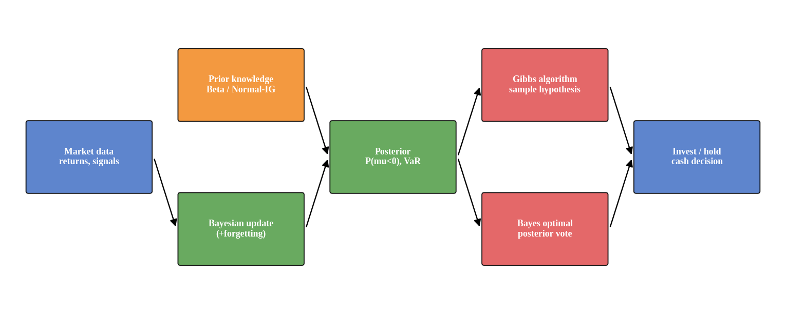
Figure 12: Architecture of the Bayesian investment system.
Prior knowledge enters as the prior of the update module. Each new day updates the posterior in constant time. Risk measures (probability of loss, VaR) are read from the posterior. For classification of the next-day direction from an observable signal, a finite grid of logistic hypotheses is used with either the Bayes optimal vote or the Gibbs algorithm. The decision rule holds the asset when P(mean return < 0) < 0.5, otherwise holds cash.

Experimental Evaluation
Data and Setup. Market seed 42 for the illustrations; 200 other seeds for the strategy comparison. Priors for the up-probability: flat Beta(1,1); informative and correct Beta(55,45) (built from the pre-change period); informative and wrong Beta(30,70). Return model prior: m₀ = 0, κ₀ = 1, α₀ = 2, β₀ = 2×10⁻⁴. The Gibbs-algorithm test uses 231 hypotheses P(up | s) = sigmoid(a·s + b) with a in [−3, 3] (21 values) and b in [−1, 1] (11 values); the true hypothesis is drawn from the prior (the condition of the 2× bound), and 1,000 trials were run.
Procedure. (1) Update beliefs day by day under each prior, with and without forgetting. (2) Track P(μ < 0), predictive probability of a loss and VaR. (3) Backtest the decision rule on 200 markets. (4) Compare Gibbs and Bayes optimal predictions for 10 to 300 training examples. (5) Run a Gibbs sampler on the first 500 returns and compare it with the exact posterior. (6) Time the updates.
Results.
Table 21: Posterior mean of P(up day) under different priors (true value: 0.526 before and 0.466 after the change).
Prior | Day 10 | Day 50 | Day 100 | Day 500 | Day 1000, no forgetting | Day 1000, γ = 0.98
Flat Beta(1,1) | 0.500 | 0.615 | 0.529 | 0.526 | 0.496 | 0.561
Informative correct Beta(55,45) | 0.545 | 0.573 | 0.540 | 0.530 | 0.501 | 0.561
Informative wrong Beta(30,70) | 0.318 | 0.407 | 0.415 | 0.488 | 0.478 | 0.561

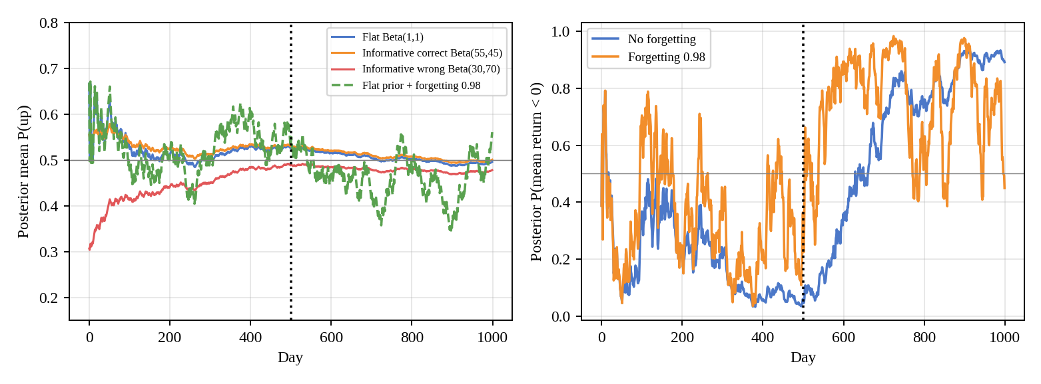
Figure 13: Left: posterior mean of P(up) for three priors and one forgetting model. Right: posterior P(mean return < 0). Dotted line: regime change.
Table 22: Risk measures from the Normal–Inverse-Gamma model.
Measure | No forgetting | Forgetting γ = 0.98
P(μ < 0) at day 500 | 0.060 | 0.363
P(μ < 0) at day 1000 | 0.892 | 0.449
Days after change until P(μ < 0) > 0.5 | 129 | 4
Days after change until P(μ < 0) > 0.9 | 389 | 83
5% VaR (daily return) at day 500 | -1.52% | -1.64%
5% VaR at day 1000 | -2.16% | -2.39%
VaR breach rate after change (ideal 5%) | 11.6% | 6.0%

Table 23: Backtest over 200 simulated markets (sum of daily log returns).
Strategy | Mean return | Std. dev. | Time in market
No forgetting | 0.013 | 0.244 | 78%
Forgetting gamma=0.98 | 0.197 | 0.268 | 53%
Buy and hold | -0.109 | 0.405 | 100%

Table 24: Gibbs algorithm vs Bayes optimal classifier (test error).
Training examples | Bayes optimal | Gibbs | Ratio
10 | 0.298 | 0.333 | 1.120
30 | 0.273 | 0.285 | 1.047
100 | 0.264 | 0.267 | 1.014
300 | 0.259 | 0.261 | 1.008
100 (1,000 trials) | 0.265 | 0.270 | 1.018

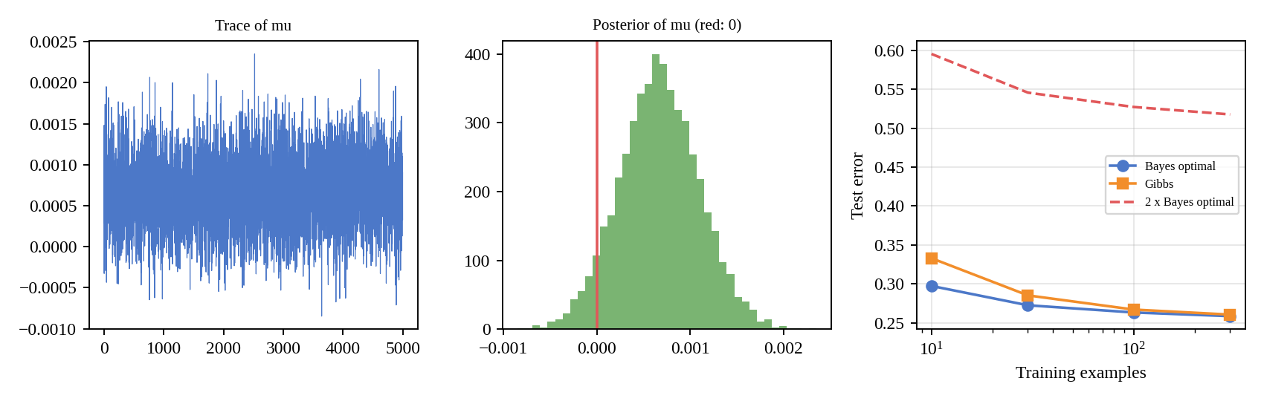
Figure 14: Gibbs sampler trace and posterior of μ (left, middle); Gibbs algorithm vs Bayes optimal error (right).
Table 25: Gibbs sampler (6,000 draws, 1,000 burn-in) vs exact conjugate posterior (first 500 days).
Quantity | Gibbs sampler | Exact / sample
Posterior mean of μ | 0.00067 | 0.00067
P(μ < 0) | 0.058 | 0.060
95% interval for μ | [-0.00018, 0.00152] | —
Effective sample size of μ | 5000 of 5,000 | —
Run time | 38 ms | —

Table 26: Cost per new observation.
Method | Time
Streaming conjugate update (constant time) | 0.53 µs
Recomputing statistics from the full history | 11.43 µs (averaged over history lengths up to 1,000)
Gibbs sampler, 6,000 draws on 500 days | 38 ms

Analysis and Discussion
- Influence of prior knowledge. With a flat prior the posterior mean of P(up) was 0.615 on day 50 (true 0.526), a noisy estimate. The correct informative prior gave 0.545 on day 10 against 0.500 (flat), i.e. a small gain in accuracy early on. The wrong informative prior started far off (0.318 on day 10) and still sat at 0.415 on day 100, but by day 500 all priors were within 0.042 of each other: data overwhelm the prior.
- Risk from posterior probabilities. Before the change, P(μ < 0) at day 500 was 0.060, supporting the long position. After 500 bear days it was 0.892 without forgetting. The 5% VaR widened from -1.52% to -2.16% as the volatility grew.
- Adaptation to the regime change. Without forgetting, the posterior stayed bullish for a long time: P(μ < 0) passed 0.5 only 129 days after the change and 0.9 after 389 days. With γ = 0.98 it passed 0.5 after 4 days, but this is partly noise: at day 1000 the forgetting model still gave P(μ < 0) = 0.449 and a posterior mean P(up) of 0.561, above 0.5 although the true post-change value is 0.466, because a 50-day window carries little information (it never reached 0.9). Forgetting trades speed for noise.
- Value of adapting. Over 200 markets the forgetting rule earned 0.197 mean log return, the non-forgetting rule 0.013, and buy-and-hold -0.109. Forgetting kept better VaR calibration after the change (breach rate 6.0% against 11.6%, ideal 5%). These results hold for this simulated market only.
- Gibbs algorithm. Averaged over 1,000 hypotheses drawn from the prior, the Gibbs error was 0.270 against 0.265 for the Bayes optimal vote, a ratio of 1.018, within the factor-2 guarantee. The gap is largest with little data (0.333 vs 0.298 at 10 examples) and closes as the posterior concentrates (0.261 vs 0.259 at 300). The large floor error (about 27%) reflects the noisy labels: markets are mostly unpredictable.
- Gibbs sampler and computational challenges. The sampler reproduced the exact posterior (mean 0.00067 vs 0.00067; P(μ < 0) 0.058 vs 0.060). Conjugacy makes the chain mix almost perfectly here (ESS 5000 of 5,000), but it takes 38 ms, versus 0.53 µs for a streaming conjugate update.
- Optimisation strategies. (1) Keep only sufficient statistics, so each update costs constant time and memory. (2) Use conjugate priors, and MCMC only for non-conjugate models. (3) Use discounting or a change-point detector for regime changes. (4) For many hypotheses, update the grid posterior in log space and prune hypotheses of negligible weight. (5) Vectorise the Gibbs algorithm by sampling one hypothesis instead of averaging over all.

Limitations and Real-world Constraints
- Simulated market. The Normal returns, the single abrupt regime change and the stationary signal model are simplifications; real returns are heavy-tailed and volatility clusters.
- No transaction costs, slippage or leverage were modelled in the backtest.
- Choice of γ (0.98) was fixed in advance and not tuned; a different value changes the speed–noise trade-off.
- Prior elicitation is subjective; a wrong confident prior costs many observations.
- Decision rule is simple; a real institution would use utility or risk limits, and regulatory model validation.
- Past results are not predictive. The strategy comparison is an illustration of the methods, not investment advice.

Conclusion
Sequential Bayesian updating gives a transparent way to turn uncertain market data into probabilities of gain or loss. Informative priors help early but are overruled by data; forgetting is needed when the regime changes, although it makes the estimate noisier. The Gibbs algorithm stayed within the 2× bound (ratio 1.018), and conjugate streaming updates are several orders of magnitude cheaper than MCMC.

