
Name: Peta Harsha Vardhan Register No: 192311039
Subject: Machine Learning – Unit 3 (SDG Project)
22. Bayesian Model for Predicting Crop Yield from Rainfall and Soil Quality
SDG: SDG 2 – Zero Hunger
22.1 Problem Statement
Smallholder farmers depend on seasonal rain and on the quality of their soil, yet they rarely know in advance whether the coming harvest will be good or poor. Agricultural officers face the same uncertainty when they plan seed, fertiliser, crop insurance and food stocks. A Bayesian model is well suited to this problem because it starts from what agronomists already know (a prior), updates that belief with every farm-season of data, and returns a full probability distribution for the yield rather than a single number. From that distribution the risk of a very poor harvest can be read off directly.
This assignment designs a Bayesian linear model that predicts crop yield (tonnes per hectare) from seasonal rainfall and a soil-quality index. One complete Bayesian update is worked out by hand with actual numbers for five farms, and the same procedure is then repeated in NumPy on a full dataset.
Objectives
- Predict crop yield (t/ha) from rainfall and soil quality, together with the uncertainty of every prediction.
- Specify a prior belief about the model weights and update it with data using Bayes’ theorem.
- Trace the posterior update by hand for five farms and compute the predictive distribution for a new farm.
- Convert the predictive distribution into the probability of a low-yield season (below 2 t/ha) to flag farms at risk.
- Show how the prior matters when data are scarce and stops mattering when data are plentiful.
- Support SDG 2 (Target 2.3: double the productivity of small-scale food producers) with better planning and early warning.
22.2 Dataset
Dataset used: A synthetic farm-season dataset (1,200 records, 3 columns) generated with NumPy for demonstration, because linked rainfall, soil and yield records at farm level are not openly available. The same pipeline applies to real data such as FAO crop statistics, ICRISAT village-level data, India’s district crop-production tables (data.gov.in) combined with IMD rainfall, and soil-health-card records.
Features
Feature | Description
x1 = rainfall_mm | Total rainfall during the growing season (mm); standardised to a z-score for modelling
x2 = soil_quality | Soil-quality index from 1 (poor) to 10 (excellent), based on organic carbon, nutrients and water-holding capacity; standardised
yield_t_ha (target y) | Crop yield in tonnes per hectare
low_yield (derived) | 1 if yield is below 2.0 t/ha, otherwise 0 (used for the risk alert)

Target: yield_t_ha (continuous) and the derived low_yield flag. Mean rainfall is 796 mm (SD 214), mean soil index 6.06 (SD 1.78), and mean yield 2.89 t/ha (SD 1.33).
Data Preparation
- Generated rainfall and soil values with NumPy (soil quality is mildly correlated with rainfall, r = 0.38) and created yield as 3.0 + 0.9·z(rain) + 0.7·z(soil) − 0.15·z(rain)² plus random noise with SD 0.45 t/ha, so that very heavy rain slightly reduces yield. Yields were floored at 0.2 t/ha (total crop failure); this affected 4.2% of farm-seasons.
- Standardised both inputs with the training mean and SD.
- Split into 80% training (960) and 20% testing (240) farm-seasons with a fixed random seed (42).
- Chose the prior from agronomic knowledge before looking at the data (Section 22.3) and fixed the noise level at σ = 0.5 t/ha, as if estimated from past seasons.
22.3 ML Approach
This is a regression problem solved with Bayesian linear regression using a conjugate Normal prior. The yield of a farm is modelled as y = w0 + w1·x1 + w2·x2 + ε, where ε ~ N(0, σ²). Instead of estimating one value for each weight, the model keeps a probability distribution over the weights. The prior is N(m0, S0) with m0 = (2.5, 0.5, 0.5) and S0 = 1.0² · I, meaning that the average yield is believed to be about 2.5 t/ha and that both rainfall and soil quality are expected to raise it. Because the prior is Normal and the likelihood is Normal, the posterior is also Normal and is obtained in closed form.
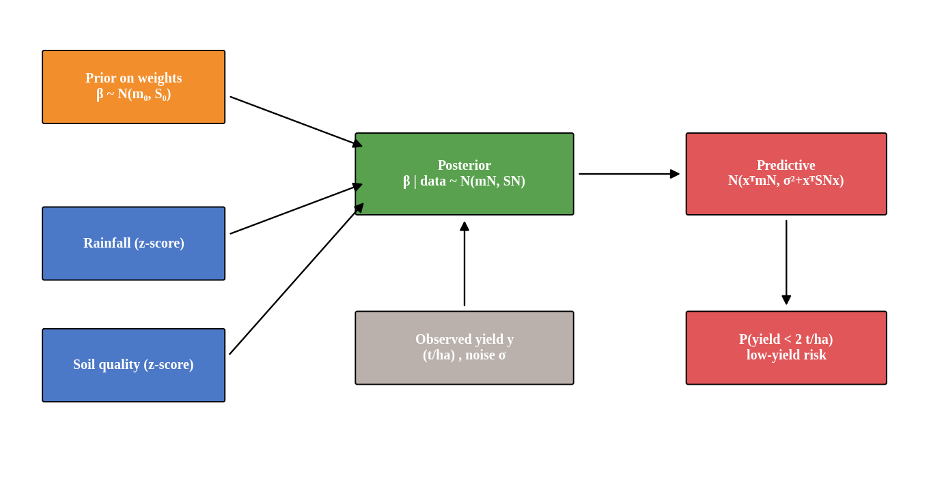
Figure 1: The Bayesian model: prior and data give the posterior over weights, which gives the predictive distribution and the low-yield risk.
Key formulas
Quantity | Formula
Bayes' theorem | P(w | data) = P(data | w) · P(w) / P(data)
Posterior precision | SN⁻¹ = S0⁻¹ + XᵀX / σ²
Posterior mean | mN = SN · ( S0⁻¹ m0 + Xᵀy / σ² )
Predictive distribution | y* ~ N( x*ᵀ mN , σ² + x*ᵀ SN x* )
Low-yield risk | P(y* < 2) = Φ( (2 − x*ᵀ mN) / sd )
MLE (for comparison) | ŵ = (XᵀX)⁻¹ Xᵀy (same as Bayes with a flat prior)

Notation
Symbol | Meaning
w = (w0, w1, w2) | Intercept, rainfall weight, soil-quality weight
m0, S0 | Prior mean and prior covariance of the weights
mN, SN | Posterior mean and covariance of the weights after N farms
σ | Noise standard deviation of yield (0.5 t/ha, assumed known)
x* = (1, z_rain, z_soil) | Standardised inputs of a new farm
Φ | Standard Normal cumulative distribution function

Workflow
Farm data (rainfall, soil quality, yield)
↓
Prior belief about the weights: N(m0, S0)
↓
Bayes update: posterior N(mN, SN)
↓
Predictive distribution for a new farm: mean and uncertainty
↓
Risk of low yield: P(yield < 2 t/ha)
↓
Decision: advise, insure or send inputs to farms with high risk

22.4 Bayesian Update Trace (worked example)
Worked example: the first five training farms are used, with prior N(m0, S0) and σ = 0.5. A small sample is chosen on purpose, so that the effect of the prior is easy to see.
Step 1: The data
Farm | Rainfall (mm) | Soil index | z_rain | z_soil | Yield (t/ha)
1 | 829 | 7.62 | 0.159 | 0.881 | 2.92
2 | 893 | 5.46 | 0.462 | -0.324 | 2.55
3 | 893 | 4.60 | 0.460 | -0.802 | 3.43
4 | 1198 | 9.25 | 1.899 | 1.795 | 5.42
5 | 1060 | 5.18 | 1.247 | -0.476 | 2.78

Step 2: Prior and likelihood information
Quantity | Calculation | Result
Prior mean m0 | Belief before data: average 2.5 t/ha, both inputs help | (2.500, 0.500, 0.500)
Prior precision S0⁻¹ | 1 / 1.0² on the diagonal | Identity matrix
XᵀX (5 farms) | Sum of x xᵀ over the five farms | [ 5.000, 4.228, 1.074 ]  [ 4.228, 5.613, 2.436 ]  [ 1.074, 2.436, 4.972 ]
Xᵀy | Sum of x · y | 17.093, 16.978, 7.402
Data precision | XᵀX / σ² = XᵀX / 0.25 | 4 × XᵀX

Step 3: Posterior
Quantity | Calculation | Result
SN⁻¹ | S0⁻¹ + XᵀX / σ² | [ 21.000, 16.910, 4.297 ]  [ 16.910, 23.451, 9.746 ]  [ 4.297, 9.746, 20.889 ]
SN | Inverse of SN⁻¹ | [ 0.120, -0.094, 0.019 ]  [ -0.094, 0.127, -0.040 ]  [ 0.019, -0.040, 0.063 ]
mN | SN ( S0⁻¹ m0 + Xᵀy / σ² ) | (2.608, 0.819, 0.523)
Posterior SD | √ diagonal of SN | (0.346, 0.357, 0.250)

The prior said the rainfall weight is 0.500 with SD 1.0. After only five farms it moves to 0.819 with SD 0.357, so the data have already pulled the belief a long way, but the SDs are still large because five farms carry little information.
Step 4: Prediction for a new farm
Quantity | Calculation | Result
New farm | Rainfall 700 mm, soil index 5.0 (z-scores) | x* = (1, -0.448, -0.579)
Predictive mean | x*ᵀ mN | 1.939 t/ha
Predictive SD | √( σ² + x*ᵀ SN x* ) | 0.676 t/ha
Low-yield risk | Φ( (2 − mean) / SD ) | P(yield < 2) = 0.536

With five farms the model is unsure: the farm is predicted at 1.94 ± 0.68 t/ha and has a 53.6% chance of a low yield.
Step 5: Check – the same update with all training farms
 | After 5 farms | After 960 farms
Rainfall weight (mean ± SD) | 0.819 ± 0.357 | 0.792 ± 0.017
Soil weight (mean ± SD) | 0.523 ± 0.250 | 0.698 ± 0.017
New farm: predicted yield | 1.94 ± 0.68 t/ha | 2.12 ± 0.50 t/ha
New farm: P(yield < 2 t/ha) | 0.536 | 0.409

The posterior SD of the rainfall weight falls from 0.357 to 0.017, about 20 times smaller. The predictive SD of the new farm falls from 0.68 to 0.50 t/ha and cannot go below the noise level σ = 0.5, which is the part of the uncertainty that more data cannot remove.
22.5 NumPy Implementation
The same update written in NumPy. The first block is the conjugate update; the second turns the posterior into a prediction and a low-yield risk.
import numpy as np
from scipy.stats import norm
# Xtr: [1, z_rain, z_soil] for training farms; ytr: yields (t/ha)
sigma = 0.5 # assumed noise SD (t/ha)
m0 = np.array([2.5, 0.5, 0.5]) # prior mean of weights
S0_inv = np.eye(3) / 1.0**2 # prior precision
# ---- Bayes update ----
SN_inv = S0_inv + Xtr.T @ Xtr / sigma**2
SN = np.linalg.inv(SN_inv)
mN = SN @ (S0_inv @ m0 + Xtr.T @ ytr / sigma**2)
# ---- prediction for new farms ----
mu = Xte @ mN
sd = np.sqrt(sigma**2 + np.einsum("ij,jk,ik->i", Xte, SN, Xte))
p_low = norm.cdf((2.0 - mu) / sd) # P(yield < 2 t/ha)

Key findings from the data
- Yield rises with both inputs: correlation with rainfall is 0.80 and with soil quality 0.75.
- 26.2% of farm-seasons yield less than 2 t/ha. This is the prior probability of a low yield.
- Bayes’ theorem in action: when rainfall is in the lowest third, the probability of a low yield rises from 26.2% to 66.3%; when it is in the highest third it falls to 1.5%.
- The same happens with soil: 57.3% low-yield rate on poor soil against 4.2% on good soil.
P(low yield) (n farms) | Poor soil | Medium soil | Good soil
Low rainfall | 95.6% (181) | 51.9% (129) | 21.1% (76)
Medium rainfall | 33.6% (143) | 2.9% (136) | 0.7% (136)
High rainfall | 8.3% (72) | 0.0% (132) | 0.0% (195)

The table shows the interaction: a farm with low rainfall and poor soil is almost certain to have a low yield, while a farm with high rainfall and good soil never did in this sample. The Bayesian regression summarises this pattern with three weights instead of nine cells.
22.6 Visualization
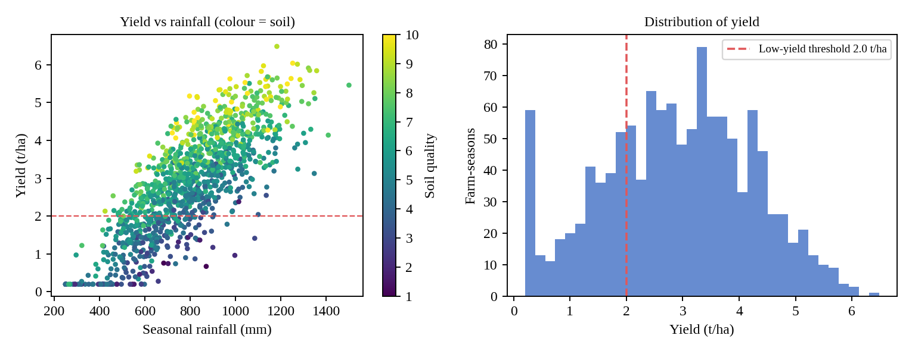
Figure 2: Yield rises with rainfall and with soil quality; 26% of farm-seasons fall below the 2 t/ha threshold.
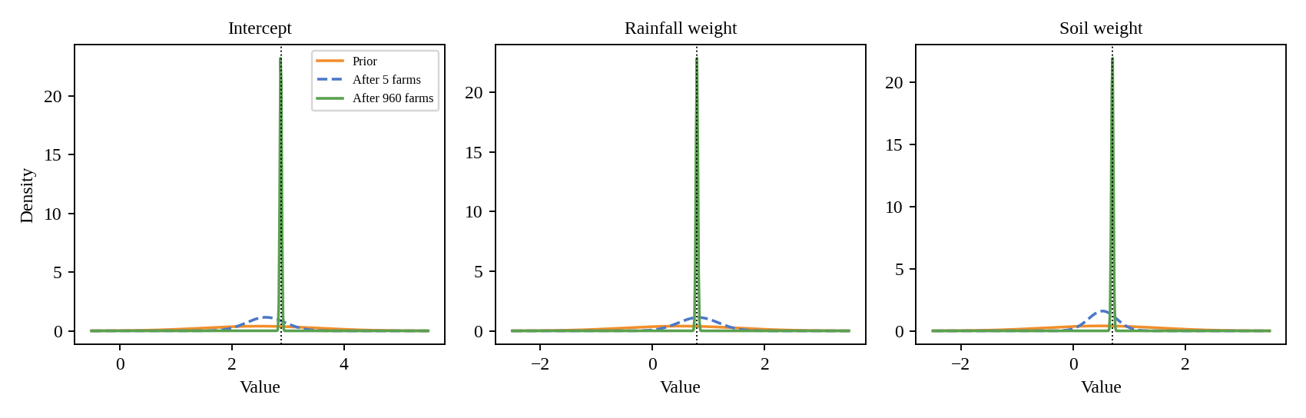
Figure 3: Prior (orange), posterior after 5 farms (blue, dashed) and after 960 farms (green) for each weight; dotted line = maximum-likelihood value.
Interpretation: The broad orange prior is quickly replaced by narrow posteriors. After 960 farms one standard deviation more rainfall (about 214 mm) adds 0.79 t/ha (95% credible interval 0.76 to 0.83), and one standard deviation more soil quality (about 1.8 index points) adds 0.70 t/ha (0.66 to 0.73). The two weights are negatively correlated in the posterior (-0.38) because rainy farms also tend to have better soil, so the model cannot separate their effects perfectly.
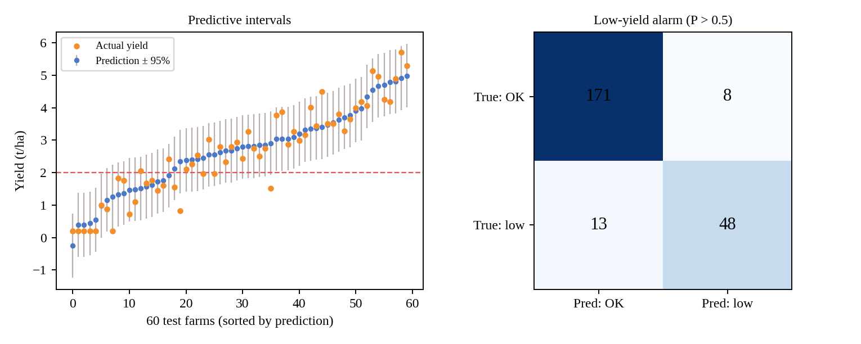
Figure 4: Left: predicted yield with 95% intervals and actual yield for 60 test farms. Right: confusion matrix of the low-yield alarm on the 240 test farms.
Interpretation: The actual yields (orange) lie inside the grey bands for almost all farms; the 95% interval covered 93.3% of the 240 test farms, close to the nominal 95%. The alarm correctly flagged 48 of the 61 low-yield farms and raised 8 false alarms.
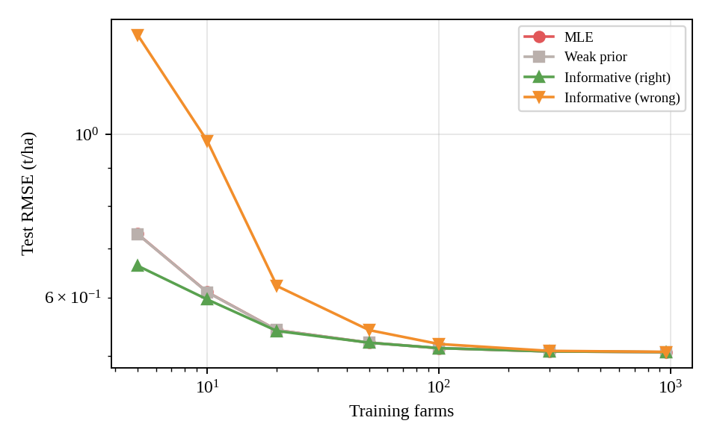
Figure 5: Test error against number of training farms for maximum likelihood and three priors.
Interpretation: With very few farms a sensible prior reduces the error, a badly wrong confident prior increases it, and with a few hundred farms all four curves coincide: the data overrule the prior.
22.7 Expected Outcome
The trained model predicts yield with an uncertainty band and flags farms at risk. Results on the 240-farm test set:
Model | RMSE (t/ha) | MAE (t/ha) | R²
Bayesian (informative prior) | 0.506 | 0.390 | 0.859
OLS / maximum likelihood | 0.506 | 0.390 | 0.859
Mean-yield baseline | 1.348 | 1.107 | -0.004
Bayesian + rainfall² term | 0.495 | 0.383 | 0.864

Low-yield alarm | Threshold | Accuracy | Precision | Recall | F1-score | TN / FP / FN / TP
P(low) above threshold | 0.5 | 0.912 | 0.857 | 0.787 | 0.821 | 171 / 8 / 13 / 48
P(low) above threshold | 0.3 | 0.912 | 0.786 | 0.902 | 0.840 | 164 / 15 / 6 / 55

The ROC-AUC of the low-yield probability is 0.969. Lowering the alarm threshold from 0.5 to 0.3 raises recall from 0.787 to 0.902 at the cost of precision (0.857 to 0.786); for food security a missed low-yield farm is usually worse than a false alarm, so the lower threshold is preferable.
Training farms | MLE | Weak prior | Informative (right) | Informative (wrong) | 95% interval coverage
5 | 0.732 | 0.732 | 0.663 | 1.365 | 96.2%
10 | 0.610 | 0.610 | 0.597 | 0.979 | 94.4%
20 | 0.542 | 0.542 | 0.541 | 0.622 | 94.1%
50 | 0.521 | 0.521 | 0.521 | 0.542 | 93.6%
100 | 0.512 | 0.512 | 0.512 | 0.519 | 93.5%
300 | 0.507 | 0.507 | 0.507 | 0.508 | 93.5%
960 | 0.506 | 0.506 | 0.506 | 0.506 | 93.3%

The table gives test RMSE (t/ha), averaged over 30 random training subsets of each size. With 5 farms the informative prior gave 0.663 against 0.732 for maximum likelihood, while the wrong prior gave 1.365. From 100 farms on, all methods agree to within 0.007 t/ha. The weak prior is indistinguishable from maximum likelihood.
Note: The data is synthetic, so the true relationships are known and the scores show how the method behaves, not how it would perform on real farms. Real yield data would need validation, and the model should be checked for each crop and region before any deployment.
22.8 Innovation and SDG
The work supports SDG 2 – Zero Hunger (Target 2.3: double the agricultural productivity and incomes of small-scale food producers; Target 2.4: sustainable and resilient food production) and also contributes to SDG 13 (Climate Action) and SDG 1 (No Poverty).
How a Bayesian model helps agriculture
- Early warning: the probability of a low-yield season is available as soon as rainfall is known, so seed, fertiliser, irrigation and food stocks can be planned earlier.
- Honest uncertainty: every forecast comes with an interval, so officers can see when the model is unsure.
- Prior knowledge: agronomists’ experience is used directly and is corrected by data, which helps in new districts with few records.
- Targeting: farms with a high probability of low yield can be prioritised for advice, insurance or input support.
- Continuous learning: each new season updates the posterior without retraining from scratch.
Advantages
- Closed-form update that is fast and easy to explain and verify
- Gives uncertainty and risk, not only a single prediction
- Works with very little data when a good prior is available
Limitations
The model is linear in its inputs and so misses the effect of excess rain; adding a rainfall² term reduced the test RMSE only from 0.506 to 0.495, which suggests other sources of error as well. The floor on crop failures (4.2% of farm-seasons) pulls the fitted weights below the generating values (rainfall weight 0.79 against 0.90 used to generate the data). Noise is assumed constant and known, whereas real variance changes with pests, temperature and management. The model ignores crop type, fertiliser, temperature, and the timing of rainfall within the season. A confident but wrong prior harms predictions for small samples, so priors should be chosen carefully and reviewed by experts. Predictions should support, not replace, extension officers’ judgement.
Conclusion
The worked update shows how Bayes’ theorem turns a prior belief and five farms into a posterior distribution, and how the predictive distribution gives both a yield estimate and the probability of a poor harvest. On the full dataset the Bayesian model reached R² = 0.859 (RMSE 0.506 t/ha), its 95% intervals covered 93.3% of test farms, and the low-yield alarm reached ROC-AUC 0.969. The experiments also show that the prior matters only when data are scarce. Used as a decision-support tool and checked against field data, such a model can help direct advice and resources to farmers facing poor harvests, supporting SDG 2 – Zero Hunger.

