# Read Me

This is a prototype of a mobile tool for searching against the NMSI API. It is written in HTML and JavaScript using jquery mobile. The main page for now is search.html which will do a search against the API and will return a list of results.

Things that will be added:

1. Additional Search parameters Score (e.g. Chemistry, EGEI) deviations
2. UI Graphics for Recyclable, Organic , Score Indicator (Substandard, Adequate, Good)
3. Compare Use case of two or more materials

To Try the screens out. Download from <https://github.com/petabyte/NMSI>

And click on the zip button then extract and save to a folder.

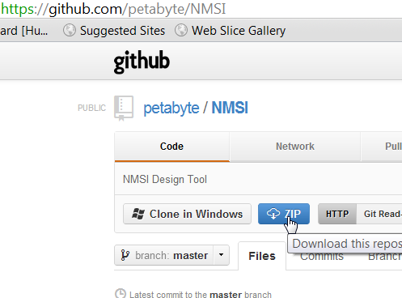

Open search.html

Tested on Safari and Chrome

To user Chrome:

chrome.exe --disable-web-security

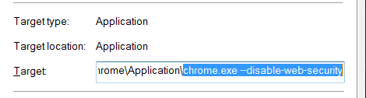

# Main Search screen

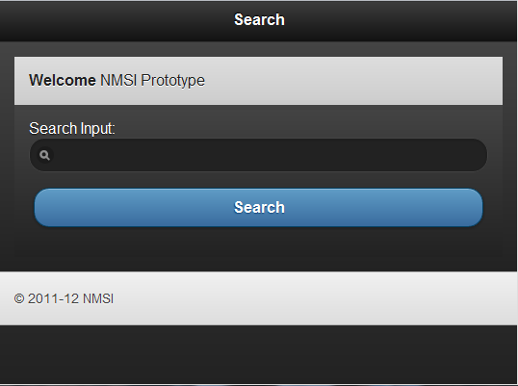

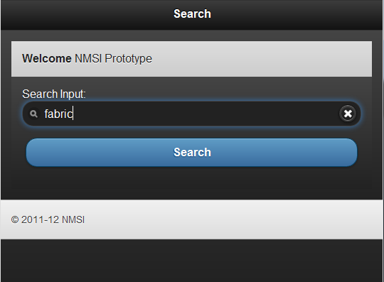

# Search Result Screen

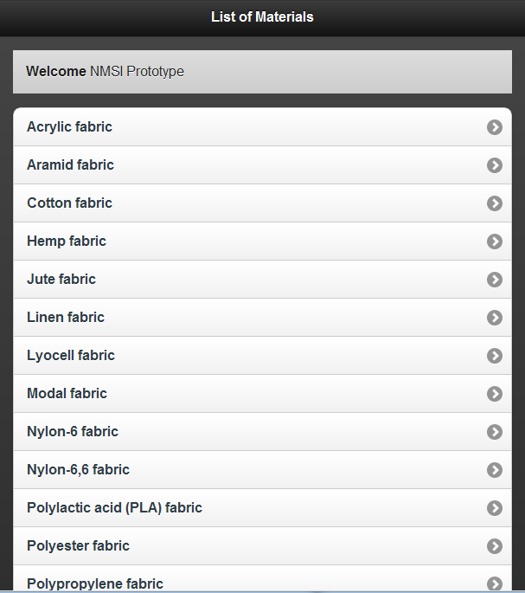

# Material Detail Screen

