RapidMiner
Linked Open Data Extension
Manual
Version 1.4, 08/11/14



Heiko Paulheim
Petar Ristoski
Evgeny Mitichkin
Christian Bizer
University of Mannheim
Data and Web Science Group

Contact: use the Google Group
https://groups.google.com/forum/#!forum/rmlod
rmlod@googlegroups.com

Table of Contents
1 Introduction 3
2 Use Cases 4
3 Enabling the RapidMiner LOD Extension 5
4 Configuring the Extension 7
4.1 Configuring SPARQL Endpoints 7
4.2 Caching Options 8
5 Using Linked Open Data as Input for Data Mining 10
6 Linking your Data to Existing Datasets 12
6.1 The Pattern-based Linker 13
6.2 The Label-based Linker 14
6.3 The DBpedia Lookup Linker 15
6.4 The DBpedia Spotlight Linker 17
6.5 The SameAs Linker 17
6.6 Combining Linkers 18
7 Using generators 19
7.1 Value Creation Strategies 19
7.2 Direct Types Generator 19
7.3 Data Properties Generator 20
7.4 Unqualified and Qualified Relation Generators 20
7.5 The Specific Relation Generator 21
7.6 The Custom SPARQL Generator 21
7.7 Combining Generators 22
8 Exploring the Linked Open Data Cloud 23
9 Accessing RDF Data Cubes 25
10 Filtering Attributes 29
11 Migration from Earlier Versions of the Extension 30
12 References 31
13 Release Notes 33

If you use the RapidMiner Linked Open Data Extension for scientific purposes, please kindly include a reference to the following paper:
H. Paulheim, P. Ristoski, E. Mitichkin, C. Bizer (2014): Data Mining with Background Knowledge from the Web. In: RapidMiner World, 2014.

Introduction
Linked Open Data is a collection of freely accessible, machine interpretable data on the web. It uses semantic web standards like RDF for data representation (Bizer et al., 2009). As of today, there are several hundred datasets from various domains, encompassing general knowledge as well as specific domains such as government, geographic, and life science data, scientific publications, and media (Schmachtenberg et al., 2014). A detailed list of datasets that are available as Linked Open Data can be obtained at http://lod-cloud.net/.
Essentially, Linked Open Data contains data as graphs with labeled edges, where each entity is represented by a dereferencable URI. Each statement can be understood as a triple with subject, predicate, and object, such as
<http://dbpedia.org/resource/Germany> <http://dbpedia.org/ontology/capital> <http://dbpedia.org/resource/Berlin> .
The RapidMiner Linked Open Data extension leverages those data sources both to create useful datasets for Data Mining, as well as for adding background knowledge to existing datasets. For example, on a dataset for countries, data like the population, area, and GDP can be added from DBpedia (Lehmann et al., 2013) in order to improve the results of the data mining process.
In particular, the extension works with datasets that provide a SPARQL endpoint, i.e., a web service which delivers data using the query language SPARQL. A list of such datasets is available at datahub.io. Furthermore, datasets not offering SPARQL endpoints may also be used via dereferencing URIs.
Furthermore, data from Linked Open Data sources can be used as input to the data mining process, e.g., reading data from the Eurostat Linked Open Data endpoint and running analysis on the data with RapidMiner.
Important notice: The RapidMiner LOD Extension usually accesses live data from the web. This requires a live internet connection and can result in longer operator runtimes, depending on the dataset and task at hand.
For larger datasets, the runtimes of can become rather long, depending on the dataset and specific operators used. Since in a typical setting, you will first generate data and then experiment with a larger number of subsequent operators (e.g., classification or regression algorithms), we suggest that you store the output dataset of the LOD operator chain in an intermediate file (e.g., CSV) or database, and perform all subsequent analysis on that stored dataset. That way, you will have to run the time consuming access to Linked Open Data only once.

Use Cases
The RapidMiner LOD extension, sometimes in conjunction with further RapidMiner extensions, can be used for various purposes. In the following, we give a list of use cases that the extension was already used for, each with a reference to a published paper in which further details can be found.
Using Linked Open Data in mining existing datasets:
- Generating explanations for statistics. We use a statistic as an input, e.g., unemployment figures from different regions, and add new attributes about the regions from dataset in LOD. Based on that enhanced dataset, possible explanations can be found, e.g., by correlation analysis (Paulheim, 2012; Ristoski and Paulheim, 2013)
- Classifying Tweets: We process twitter messages with DBpedia Spotlight and extract further categories for the entities found. Based on those categories, we can tell whether a twitter message reports about a certain type of event (e.g., a traffic accident) or not (Schulz et al., 2013b)
- Predicting the location of Twitter users: We process twitter user profiles and messages with DBpedia Spotlight to extract locations. Those are used as an indicator to predict a twitter user's location (Schulz et al., 2013a)
- Classifying event information extracted from Wikipedia: In a dataset of events extracted from Wikipedia, we predict the category of events (such as politics, sports, etc.) based on category information of entities involved in the event (Hienert et al., 2012)
Using Data Mining for Improving and/or Debugging Linked Open Data:
- Identifying wrong links in Linked Open Data. Given a set of links between two datasets, we extract features for both linked entities. Assuming that the majority of links are correct, wrong links can be identified using outlier detection methods (Paulheim, 2014).
- Schema Matching for Linked Open Data. We extract types from a set of interlinked instances in two datasets, and use association rule mining to find mappings between the schemas used by the datasets (Janssen et al., 2012)

Enabling the RapidMiner LOD Extension
- Searching for “Linked Open Data” in the RapidMiner Marketplace dialog will find the extension and allow you to install it:
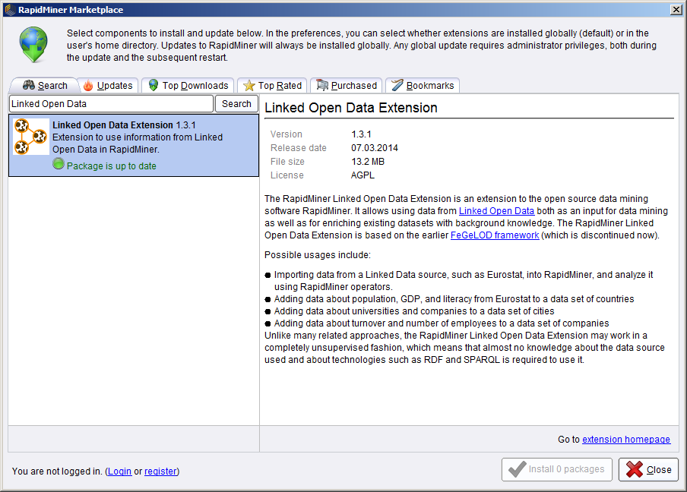
- Create a new process. You will see a new entry (Linked Open Data Extension) in the catalog available, showing the operators from the extension:
Note that most operators of the extension use an internet connection. In case you are behind a proxy, we use RapidMiner's proxy settings,

Configuring the Extension

Configuring SPARQL Endpoints
Most Linked Open Data sources provide a SPARQL endpoint. These endpoints allow for querying the underlying dataset using a standardized query language, i.e., SPARQL. Most of the operators use this query language internally. Although they are also capable of using the datasets in a different mode, i.e., dereferencing URIs (see below), it is advised to use SPARQL where available, as this will reduce the runtime of most operators.
To use SPARQL in the operators, you will first have to define SPARQL Endpoints for the datasets you are planning to use. To that end, go to the menu “Tools”->”Manage SPARQL Endpoint Connections...”. The SPARQL Endpoint Configuration Dialog Opens:
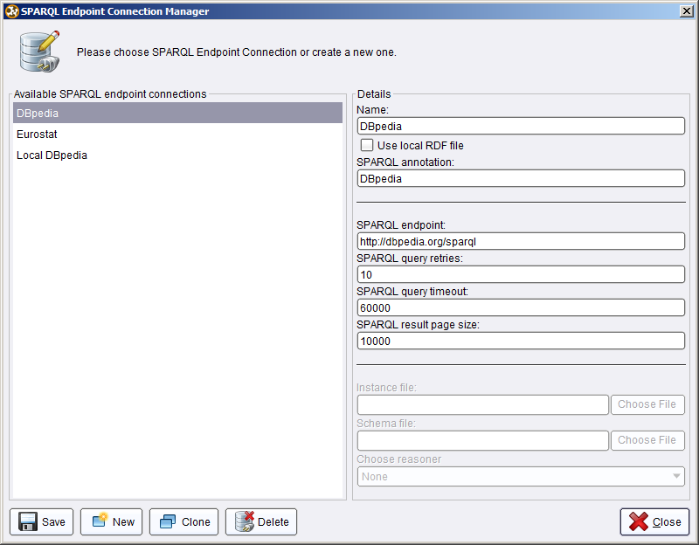

You can create new SPARQL Endpoints, as well as change the settings for existing ones.
The configuration parameters for SPARQL Endpoints are:
- Name: the SPARQL Endpoint will be selectable later by that name
- SPARQL Endpoint: the URL of the service
- SPARQL Annotation: a string that will be used for naming attributes generated from this SPARQL endpoint
Three more expert parameters are available (i.e., they appear only if RapidMiner is executed in expert mode):
- Paging Size: many SPARQL endpoints have limitations w.r.t. to the amount of data they deliver. Paging ensures that all data is retrieved. For example, with a paging size value of 1000, a SELECT query is broken down into several queries like
SELECT … LIMIT 1000 OFFSET 0
SELECT … LIMIT 1000 OFFSET 1000
SELECT … LIMIT 1000 OFFSET 2000
etc.
A Paging Size value of 0 disables paging.
- Query timeout defines the time which a SPARQL endpoint is given to respond (in milliseconds)
- Query retries defines the number of times a query is retried. If there are temporary errors, e.g., network problems, simply re-running the same query often resolves the issue.
Once the SPARQL Endpoint is defined, it may be used in subsequent operators. SPARQL Endpoint definitions for DBpedia and Eurostat are included as preconfigured endpoints.
The RapidMiner Linked Open Data extension also allows for local RDF files instead of remote SPARQL endpoints. To use a local RDF file, activate the corresponding checkbox. The options for local RDF files are:
- Specifying an instance and (optionally) a schema file
- Selecting a reasoner. The Jena built-in reasoners for RDFS as well as OWL Mini, OWL Micro and OWL Full are supported.

Caching Options
Since data from the web is used in the extension, some operators may run for a longer time. To mitigate that problem, the extension supports caching. Two different types of caches are used:
- models are cached when loading data from local files or from URLs
- SPARQL results are cached whenever loading data with a SPARQL query
For both caches, the size of the cache can be specified, as well as whether the cache should be emptied once a process has terminated, or persist as long as RapidMiner runs. The options are available in the
Tools->Preferences dialog under the “Lod” tab:
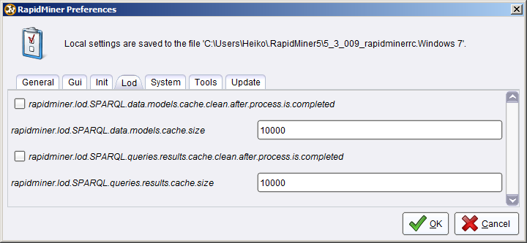
As a general recommendation, caches should be cleaned after the process finishes if subsequent processes use different datasets, since the memory consumption will drastically increase otherwise. However, if several processes are run on the same datasets, they will be significantly faster if keeping the caches over different processes.
In any case, caches will be cleared when RapidMiner is terminated.

Using Linked Open Data as Input for Data Mining
The RapidMiner Linked Open Data Extension provides an import operator to read data from a Linked Open Data source into a RapidMiner table. The SPARQL Data Importer uses a defined SPARQL Endpoint and a custom query to generate a RapidMiner table:

The SPARQL query is defined as follows:
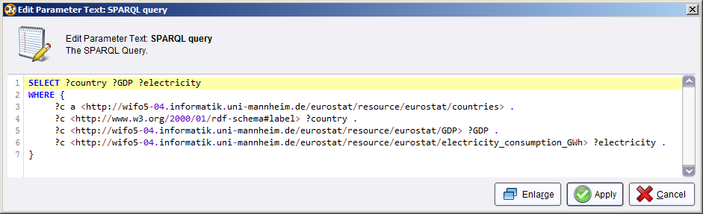
The table which is generated in the above example has three columns, named after the SPARQL query variables, i.e., country, GDP, and electricity. The output of the operator thus looks as follows:

In the meta data view, you will observe that the operator automatically assigns meaningful data types to the values read from the SPARQL Endpoint. In that case, the country name is a text attribute, while GDP and electricity are numeric:

When writing SPARQL statements, common prefixes are automatically resolved via a lookup in the prefix.cc catalogue. Thus, it is possible to use shorthand notations such as foaf:name or rdf:type without explicitly declaring a prefix.

Linking your Data to Existing Datasets
For using Linked Open Data as background knowledge for existing datasets, the first step is to link your data to a dataset from which you want to use additional data. For example, your dataset may contain a column “Country” with values “Germany”, “France”, etc. Linking your dataset to Linked Open Data means that an additional column is added, which contains URIs identifying those entities in Linked Open Data, such as http://dbpedia.org/resource/Germany, http://dbpedia.org/resource/France, etc.
The current version of the RapidMiner Linked Open Data extension comprises two linking methods:
- The Pattern-based Linker builds links using a defined URI pattern. For example, the contents of the column “Country” are appended to a fixed string, e.g., “http://dbpedia.org/resource/”.
- The Label-based linker searches for the contents of a column (and optionally word n-grams) in a data source, and finds the most suitable resource based on their labels. For example, for a string “United States of America”, the linker would search for word n-grams such as “United States” as well, and from all the results, use the best suited one.
Each linker has two output ports:
- App contains the data with the new column depicting the URI
- Att contains the attribute name which holds the URIs
The column is named ORIGINAL_COLUMN_link_to_SPARQL_ENDPOINT_ANNOTATION, where ORIGINAL_COLUMN is the name of the column where the values come from (e.g., City), and SPARQL_ENDPOINT_ANNOTATION is the value set when configuring the SPARQL endpoint. For example, linking a column City to DBpedia will result in a new column City_link_to_DBpedia.
The Att port has to be connected to subsequent steps, e.g., generators, to inform them on which attribute to perform data generation.
Since some naïve linkers (such as the Label-based Linker) may generate links that actually do not exist, the Web Validator checks the existence of each link and removes instances for which the link does not exist. Furthermore, it removes all instances for which no link could be found. The full pipeline of linking looks as follows:

The Web Validator has three outputs: App is the original data with an additional attribute boolean flag indicating whether the link is valid or not, Fil is the filtered data with instances removed for which no link is found, and Att bypasses the original Att input port.
Assume that the original set contains an entity which cannot be resolved in DBpedia, i.e., “MannheimX”. Linking that dataset to DBpedia with the simple linker results in the following table:
The output produced by the Web Validator operator then filters the table as follows:

Observation: the entity MannheimX, for which the DBpedia link is wrong, is removed from the dataset.

The Pattern-based Linker
The Pattern-based linker provides a simple method for creating links, which simply guesses links by forming simple URI patterns. The linker takes three arguments:
- The link pattern
- The name of the new attribute
Links are created by replacing attribute values in the pattern. In the example below, the values of the attribute name replace the string *AttributeName*. Multiple placeholders may be used in one pattern.
Further attributes that can be set are whether to perform URL Encoding (i.e., replacing special characters and creating proper UTF-8 links), and whether to use a specific link format for DBpedia (e.g., representing blanks as underscores).
In the example shown above, a column “City” containing values such as “Mannheim”, “Darmstadt” etc. would result in the corresponding links “http://dbpedia.org/resource/Mannheim”, “http://dbpedia.org/resource/Darmstadt”, etc.
If additional preprocessing is needed, it can be done with other RapidMiner operators. For example, the RDF book mashup dataset has links based on book ISBNs, such as
http://wifo5-03.informatik.uni-mannheim.de/bookmashup/books/006251587X
However, a dataset may contain ISBNs with dashes instead, such as 0-06-251587-X. The solution is to use RapidMiner's Generate Attribute operator first, creating a new attribute using the formula replace(isbn,"-",""), and then to use that new attribute in the linker:

The Label-based Linker
The Label-based Linker identifies entities by issuing SPARQL queries against an endpoint, trying to find entities whose labels contain a given string. It takes four parameters:
- A SPARQL endpoint
- The attribute to merge (see Pattern-based linker)
- A flag indicating whether the search should include n-grams (see below)

When including n-grams in the search, the linker will first try to identify entities whose labels contain the string in its entirety, e.g., “United States of America”. If this does not succeed, it will continue with sub tokens, eventually also finding entities whose label is only “United States”.
Note that the SPARQL Based linker, in particular when using the “Search by N-Grams” option, can take some time to link a dataset, since it performs full text search via SPARQL, which, depending on the endpoint used, may not be performed very fast.
In expert mode, you can also restrict the search to labels with a certain language tag, e.g., “en”. If the attribute is left empty (which is the default), labels in all languages, as well as without any language tag, are included in the search.

The DBpedia Lookup Linker
DBpedia Lookup is a web service which allows search over DBpedia. It can be used as an operator for linking and is more versatile the pattern-based and the label-based linker.
There are various parameters for the lookup linker:
- New Attribute is the name of the attribute containing the link
- Attribute is the name of the attribute that contains the text value
- QueryClass is an optional parameter which can be used to narrow the search results. It is a class name from the DBpedia ontology, e.g., “City”. If the attribute to link contains city names, and QueryClass is not set, the linker will link the cities, e.g., http://dbpedia.org/resource/Mannheim. If the QueryClass is set to “University” instead, the link will be http://dbpedia.org/resource/University_of_Mannheim. For convenience, the class can be selected from a visualized type hierarchy of the DBpedia ontology:
- DBpedia Lookup API defines the URL of the lookup service. There are two predefined endpoints (the keyword and prefix lookup, as well as the possibility to define a user-specified service URL)
- Connection timeout msec defines the timeout interval of the service.
- Additional string can be used to define any postfix that is respected when using the EDIT_DISTANCE selection method (see below). For example, if “university” is added, results containing “university” in their name are preferred.
- Max Hits defines the maximum number of results used from spotlight (per query).
- Selection Method defines how to disambiguate between multiple results. EDIT_DISTANCE, JARO_WINKLER and JACCARD select the result whose name is closest to the original attribute using the respective string similarity function. FIRST_RESULT uses the first result, which is usually the most prominent one.

The DBpedia Spotlight Linker
The DBpedia spotlight linker is a linker which can be used for linking text. It produces a set of attributes, each containing one concept identified. For example, for an attribute “text”, the attributes “text_Concept_1”, “text_Concept_2”, etc., are created.
In subsequent generators, the features generated for those attributes are automatically merged. For example, with a simple type feature generator, there would only be one feature called text_Concept_1_City, no matter if the city is identified as the first, second, third, etc. concept in the text.
The spotlight linker allows for configuring parameters of the service – confidence, support, and ccontextual score. Details can be found in the documentation of DBpedia Spotlight.
The Service URL parameter allows for selecting the URL of the service. Some public installed services for common languages are predefined, “Custom” allows for specifying another URL.
The Types parameter allows for finding only a list of types (e.g., Persons, Companies, etc.), as specified in the DBpedia ontology (see above) as a comma separated list.

The SameAs Linker
In Linked Open Data, a common way to establish links between datasets is the use of owl:sameAs links, indicating that a resource in dataset 1 is equal to a resource in dataset 2. The owl:sameAs linker follows such links in order to establish links to other data sources.
The typical use case for using the SameAs linker is to create links for a dataset that is difficult (or too slow) to link to with the other approaches, but which provides links to DBpedia, where links can be created,e.g., with the DBpedia Lookup Linker. Consider a setting where the Eurostat Linked Open Data endpoint contains triples such as
eurostat:France owl:sameAs dbpedia:France .
These links can be used using the following setup:

For configuring the linker, the user has to specify the field containing the original link, the name for the new link, the SPARQL endpoint used to search for owl:sameAs links, and optionally a string pattern for filtering the results:

With the pipeline and setting shown above, Eurostat URIs are found by first searching for DBpedia URIs, and then exploiting sameAs links in Eurostat.

Combining Linkers
In some cases, it might be useful to combine linkers – e.g., to add information from multiple sources, or to add information about different entities in a dataset, e.g., both the film as well as its director. In that case, the data can be multiplied with the Multiply operator (in “Process control”), and the output of both linkers is joined with the Join operator (in “Data Transformation”). Note that for the latter step, the original input data needs to define at least one ID column.

Using generators
The RapidMiner Linked Open Data extension supports different generators, which perform different knowledge extraction and aggregation steps. A general introduction to generation strategies can be found in (Paulheim and Fürnkranz, 2012).
A generator needs to know which attribute(s) contain the link(s). There are two ways of passing that information to the operator:
- by wiring the Att output of a linker to the corresponding input of the generator (this is the standard way when using generators).
- by entering the attribute name(s) in the Attribute to extend parameter (this is the way to go if the dataset at hand already contains links).
Apart from the attribute generation, most generators also generate a hierarchy of the attributes generated, which can be used for later filtering (see below). Furthermore, the output of the generator is made available in the form of RDF triples.
As a specific configuration option, most generators allow for specifying regular expressions for filtering
Each generator requires either the selection of a SPARQL endpoint or the selection of the “Use URI data model”, which generates attributes by URI derefencing.

Value Creation Strategies
Most generators support different value creation strategies:
- Binary creates a binary feature being true if a certain characteristic is fulfilled (e.g., a property exists), and false if not
- Count creates a numeric feature counting the occurences of a certain characteristc (e.g., the number of times a property occurs with an instance)
- Relative count creates a numeric feature, counting the occurences of a certain characteristics in relation to the total number of possible occurences (e.g., the percentage of properties of an instance being of a certain kind)
- TF-IDF creates a similar feature as relative count, but weighs the percentage with the overall occurrence of a characteristic in the dataset. Thereby, the influence of generic, most often useless characteristics (such as an instance being of type owl:Thing) can be reduced.
In general, it is hard to tell in advance which characteristic works best for a given use case. A detailed comparison of the strategies is given in (Paulheim and Ristoski, 2014a).

Direct Types Generator
The Direct Types Generator extracts all statements with predicate rdf:type and creates a boolean attribute for each type. For example, from a statement like
<http://dbpedia.org/resource/Mannheim> rdf:type <http://dbpedia.org/ontology/City> .
an attribute with name City_link_to_DBpedia would be created, and the value for the instance linked to <http://dbpedia.org/resource/Mannheim> would be set to true.
The process using the Simple Types Generator looks as follows:

Note that both outputs of the linker – App and Att – need to wired to the respective input ports of the generator. The output looks as follows:

Data Properties Generator
The Data Properties Generator creates an attribute for each literal value that the linked instances has. For example, from the property
<http://dbpedia.org/resource/Mannheim> <http://dbpedia.org/ontology/population> “123873”^^xsd:integer .
the generator would create an attribute City_link_to_DBpedia_data_http://dbpedia.org/ontology/population and set the value for the instance linked to Mannheim to 123873. Some basic guessing of data types is performed, e.g., numeric values are marked as such, and numeric literals without an explicit type are parsed into numbers, if possible.

Unqualified and Qualified Relation Generators
The RapidMiner Linked Open Data extension supports generators exploiting relations to other resources. The unqualified relations generators create attributes from the existence of relations, while the qualified relations generators also take the types of the related resources into account. Both generators exist in two variants, one generating boolean, one generating numeric features.
Consider the following triples:
<http://dbpedia.org/resource/Berlin> <http://dbpedia.org/ontology/capitalOf> <http://dbpedia.org/resource/Germany> .
<http://dbpedia.org/resource/Germany> rdf:type <http://dbpedia.org/ontology/Country> .
The Relation Boolean generator would create an attribute City_link_to_DBpedia_in_boolean_http://dbpedia.org/ontology/capitalOf and set its value to true for an instance linked to <http://dbpedia.org/resource/Berlin> . The Relation Numeric generator would create an attribute City_link_to_DBpedia_in_numeric_http://dbpedia.org/ontology/capitalOf and set its value to 1 for an instance linked to <http://dbpedia.org/resource/Berlin>.
The Qualified Relation Boolean generator would create an attribute City_link_to_DBpedia_in_boolean_http://dbpedia.org/ontology/capitalOf_type_http://dbpedia.org/ontology/Country and set its value to true for an instance linked to <http://dbpedia.org/resource/Berlin> . The Qualified Relation Numeric generator would create an attribute City_link_to_DBpedia_in_numeric_http://dbpedia.org/ontology/capitalOf_type_http://dbpedia.org/ontology/Country and set its value to 1 for an instance linked to <http://dbpedia.org/resource/Berlin>.
Note that in especially the qualified relation generators, while very powerful, may create a very large number of attributes, which can cause problems for subsequent processing steps.

The Specific Relation Generator
In order to pursue only a specific predicate, the specific relation linker can be used. Optionally, a predicate to use for generating the hierarchy can be specified.
For example, the configuration below extracts all categories from DBpedia, and uses the skos:broader predicate (which is used for category hierarchies in DBpedia) for generating the hierarchy:
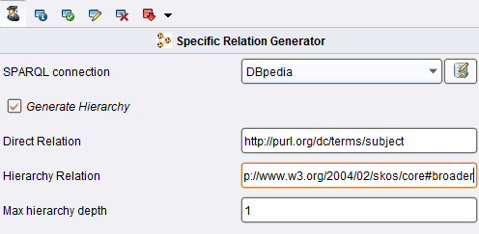

The Custom SPARQL Generator
In cases where you know the dataset you are using and want to add specific data not covered by any of the default generators, you can also define your own SPARQL statements. For example, for a dataset of cities, you might want to add the population of the state that the city is in. This can be done with the custom SPARQL generator, which allows to create a custom statement:
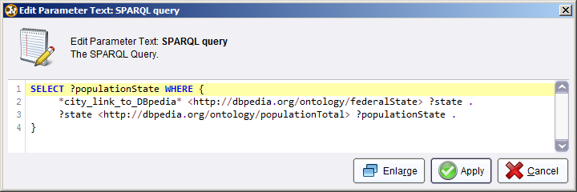
Within the statement, you can use links generated by linkers as placeholders, enclosed in asterisks. In the above example, a linker has generated the link attribute city_link_to_DBpedia, which is used in the query. The generator then generates a new attribute called “populationState” (using the variable name for naming the attribute) and adds it to the dataset.
The reserved term *ATT_INPUT_PORT* can be used in the query. It is filled with the attributes passed at the att input port.
As for the SPARQL data importer (see above), custom prefixes can be used, which are resolved using the prefix.cc service.

Combining Generators
For combining generators on the same link, e.g., extracting both data properties and types, the following process setup has to be used:

Two Multiply operators are used, one for multiplying the data, one for multiplying the attribute information. Like for combining linkers, the input data needs to define at least one ID attribute to allow the final Join. The Set Role operator can be used for defining IDs.
Note that you can also combine generators with data from different data sources. To that end, you have to run a linker and one or more generators for each data source.

Exploring the Linked Open Data Cloud
One key characteristic of Linked Open Data is that agents can navigate the cloud of interlinked datasets by following links, discovering new information on the fly. While in all example so far, we have looked at datasets that are known in advance, the LOD extension also supports an explorative way of dealing with data.
Starting from a link found by a linker (see above), the extension is capable of following certain links to a number of user specified hops, and collect all information found with one or more generators. An example process looks as follows:
The link explorer has two outputs: “lin” delivers all links discovered by the explorer, while “out” delivers the output collected from the generator(s) used by the explorer. That generator(s) is defined in a nested process inside the operator, e.g., collecting all data properties found at each discovered link:
Note that for the nested generator, “Use URI data model” has to be selected instead of a SPARQL endpoint, since the SPARQL endpoint for a discovered resource is usually not known (see Paulheim and Hertling, 2013, for a discussion of the problem).
The link explorer allows for different configuration options:
- SPARQL connection/Use URI data model are only relevant for the initial link to find the links from there. Once those are followed, only URI data models may be used (see above)
- List of links to follow: by default, the link explorer follows all owl:sameAs and rdfs:seeAlso links, but a custom list of links may also be used
- Number of hops: the depth of exploration of the LOD cloud
- Use LOD sources filter: a set of datasets may be defined here to restrict the exploration.

Accessing RDF Data Cubes
When publishing multi-dimensional datasets as Linked Open Data (e.g., statistical observations of different phenomena across several years), the RDF data cube vocabulary is often used. The LOD extension provides a data importer for such data cubes, which is based on the OLAP4LD library (Kämpgen and Harth, 2014).
For example, the dataset
http://olap4ld.googlecode.com/git/OLAP4LD-trunk/tests/estatwrap/tsdec420_ds.rdf#ds
contains unemployment rates for different states by age and sex. It can be accessed by using the “Data Cube Importer” and starting the corresponding wizard:
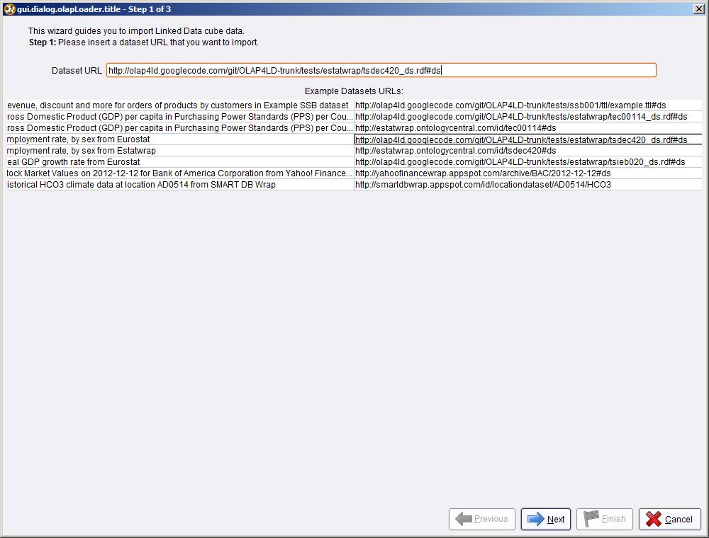
Upon clicking “Next”, the dataset found at the URI is analyzed, and the dimensions are extracted. In the next dialogue, the dimensions for the rows and columns, as well as the variable under inspection, are selected:
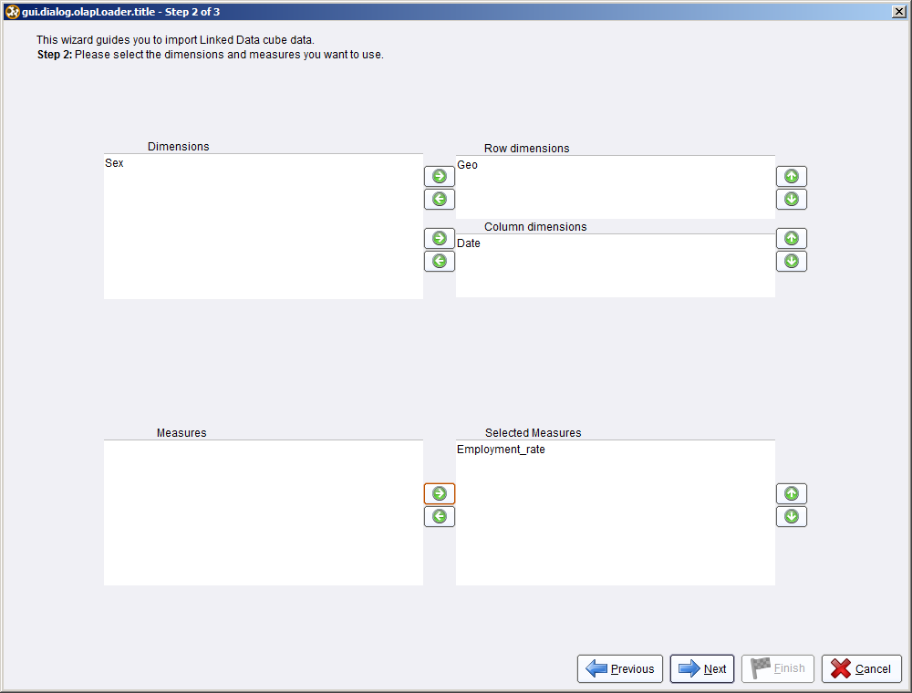
Finally, the instances of each dimension are selected:
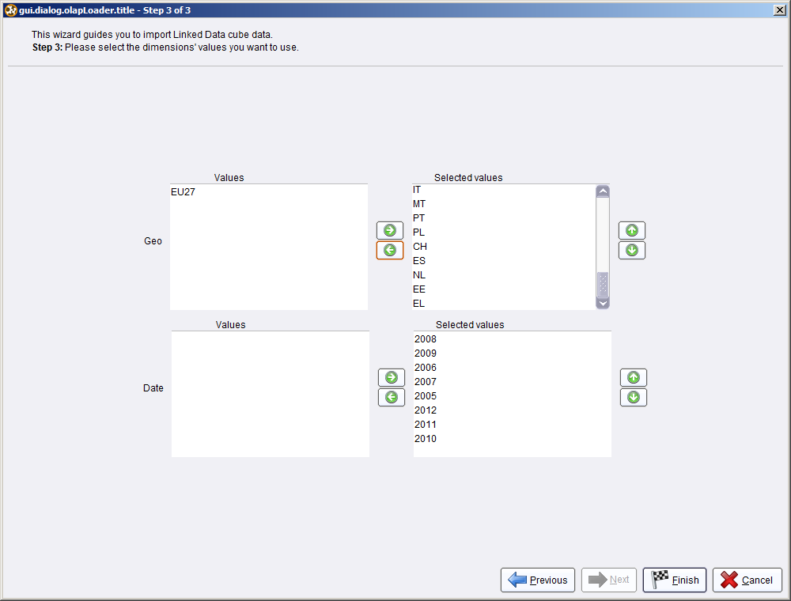
When running the process, a data table with the specified rows and columns is created, which can then be further analyzed:

Filtering Attributes
The RapidMiner LOD extension may create a lot of attributes. Thus, it is advisable to filter the attributes. Besides standard attribute selection operators that exist in RapidMiner (e.g. Remove Correlated Attributes) or the Feature Selection Extension, the extension provides means to exploit the semantics of Linked Open Data sources used to filter attributes.
Some generators, such as the direct types generator, also create a hierarchy of attributes. As for direct types, rdfs:subClassOf links are exploited to build the hierarchies of attributes generated.
The Simple Hierarchy Filter operator uses that hierarchy to filter attributes. Different algorithms are available:
- SHSEL eliminates redundant attributes along hierarchy paths, while pruneSHSEL further reduces the feature set by selecting only the most relevant attributes of the reduced hierarchy (Ristoski and Paulheim, 2014). For both algorithms, the underlying relevance measure can be correlation (C) or information gain (IC).
- TSEL (Jeong and Myaeng, 2013) selects the most valuable attributes from each branch in the hiearchy, based on information gain or lift.
- Hill Climbing is a bottom up approach which uses the purity of nearest neighbors of all instances in a dataset to assign scores to attributes (Wang et al., 2003).
- Greedy top down selects attributes that have a high information gain ratio, while pruning those attributes that are adjacent to the selected ones in the hierarchy (Lu et al., 2013)
All algorithms aim at removing redundant attributes, and avoiding to learn overfitting models. The usage is shown below.

A detailed comparison and evaluation on the filtering algorithms can be found in (Ristoski and Paulheim, 2014b).

Migration from Earlier Versions of the Extension
Migrating from earlier versions of the extension may cause problems in the SPARQL configurations dialog. If you experience such problems (which manifest themselves by repeated questions whether you want to store a connection), locate and delete the file configurable-sparqlconfig.xml on your harddisk, and restart RapidMiner.

References
- Christian Bizer, Tom Heath, and Tim Berners-Lee: Linked Data-the Story so Far. International Journal on Semantic Web and Information Systems 5(3), 1-22 (2009)
- Daniel Hienert, Dennis Wegener and Heiko Paulheim. Automatic Classification and Relationship Extraction for Multi-Lingual and Multi-Granular Events from Wikipedia. In: Proceedings of the Workhop on Detection, Representation, and Exploitation of Events in the Semantic Web (DeRiVE 2012); 1-10. RWTH, Aachen, 2012.
- Frederik Janssen, Faraz Fallahi, Jan Nößner and Heiko Paulheim. Towards Rule Learning Approaches to Instance-based Ontology Matching. In: Proceedings of the First International Workshop on Knowledge Discovery and Data Mining Meets Linked Open Data; 13-18. RWTH, Aachen, 2012.
- Yoonjae Jeong and Sung-Hyon Myaeng. Feature selection using a semantic hierarchy for event recognition and type classiffication. In: International Joint Conference on Natural Language Processing, 2013.
- Benedikt Kämpgen, Andreas Harth OLAP4LD - A Framework for Building Analysis Applications over Governmental Statistics. ESWC 2014 Posters & Demos.
- Jens Lehmann, Robert Isele, Max Jakob, Anja Jentzsch, Dimitris Kontokostas, Pablo N. Mendes, Sebastian Hellmann, Mohamed Morsey, Patrick van Kleef, Sören Auer, and Christian Bizer. DBpedia - A Large-scale, Multilingual Knowledge Base Extracted from Wikipedia. Semantic Web Journal, 2013.
- Sisi Lu, Ye Ye, Rich Tsui, Howard Su, Ruhsary Rexit, Sahawut Wesaratchakit, Xiaochu Liu, and Rebecca Hwa. Domain ontology-based feature reduction for high dimensional drug data and its application to 30-day heart failure readmission prediction. In International Conference Conference on Collaborative Computing (Collaboratecom), 2013.
- Heiko Paulheim. Generating Possible Interpretations for Statistics from Linked Open Data. In: 9th Extended Semantic Web Conference, ESWC 2012; 560-574. Springer, Berlin [u.a.], 2012.
- Heiko Paulheim. Identifying Wrong Links between Datasets by Multi-dimensional Outlier Detection. In: Third International Workshop on Debugging Ontologies and Ontology Mappings (WoDOOM 2014).
- Heiko Paulheim and Johannes Fürnkranz. Unsupervised Generation of Data Mining Features from Linked Open Data. In International Conference on Web Intelligence, Mining, and Semantics (WIMS'12), 2012.
- Heiko Paulheim and Sven Hertling. Discoverability of SPARQL Endpoints in Linked Open Data. In: ISWC 2013 Posters & Demonstrations Track, 2013.
- Heiko Paulheim, Petar Ristoski, Evgeny Mitichkin, Christian Bizer : Data Mining with Background Knowledge from the Web. In: RapidMiner World, 2014.
- Petar Ristoski and Heiko Paulheim. Analyzing Statistics with Background Knowledge from Linked Open Data. In: First International Workshop on Semantic Statistics (SemStats 2013).
- Petar Ristoski and Heiko Paulheim: A Comparison of Propositionalization Strategies for Creating Features from Linked Open Data. In: Workshop on Linked Data for Knowledge Discovery, 2014a
- Petar Ristoski and Heiko Paulheim: Feature selection in hierarchical feature spaces. In: Discovery Science, 2014b.
- Max Schmachtenberg, Christian Bizer, and Heiko Paulheim: Adoption of the Linked Data Best Practices in Different Topical Domains. In: International Semantic Web Conference, 2014
- Axel Schulz, Aristotelis Hadjakos, Heiko Paulheim, Johannes Nachtwey, Max Mühlhäuser. A Multi-Indicator Approach for Geolocalization of Tweets. In: International AAAI Conference on Weblogs and Social Media (ICWSM), 2013a.
- Axel Schulz, Petar Ristoski and Heiko Paulheim. I See a Car Crash: Real-time Detection of Small Scale Incidents in Microblogs. In: Workshop on Social Media and Linked Data for Emergency Response (SMILE), 2013b.
- Bill B. Wang, R. I. Bob Mckay, Hussein A. Abbass, and Michael Barlow. A comparative study for domain ontology guided feature extraction. In Australasian Computer Science Conference, 2003.

Release Notes
Version 1.4.0, released on August 11th, 2014
- Link Explorer
- Data Cube Importer
- RDF Output for generators
- Regex filters in generators
- Enhanced selection options for datatype property generator
- Easier handling of URI derefencing
- Web Validator also works with URI derefencing
- RapidMiner proxy settings are used
- Advanced caching mechanism
- Bug fixes
Version 1.3.3, released on May 15th, 2014
- Additional configuration options for DBpedia Lookup and DBpedia Spotlight
- Performance optimizations
- Bug fixes
Version 1.3.2, released on March 14th, 2014
- The SPARQL importer and generator now support common prefixes (e.g., rdf, owl, foaf, etc.) through prefix.cc
- Bugfix in SPARQL importer
Version 1.3.1, released on March 7th, 2014
- Support for feature extraction by resolving URIs
- Entity class detection during linking
- Visual selection of the query class for the DBpedia Lookup linker
- Performance improvements through multi threading
- Bugfixes

Version 1.2.116, released on November 29th, 2013
- Specific relation generator
- Sameas linker
- Simple hierarchy filter
- Support for pre-defined links
- Performance improvements
- Bugfixes
Version 1.1.024, released on October 15th, 2013
- Support for local RDF files, including reasoning
- DBpedia Lookup linker
- DBpedia Spotlight linker
- Support for binary features in Custom SPARQL generator
- Bugfixes
Version 1.0.071, released on September 13th, 2013.

http://lod-cloud.net/
http://dbpedia.org/
http://www.w3.org/TR/sparql11-overview/
http://www.w3.org/TR/sparql11-overview/
See http://jena.apache.org/documentation/inference/
http://prefix.cc/
http://lookup.dbpedia.org/
http://dbpedia.org/Ontology
See http://lookup.dbpedia.org/ for details.
See http://en.wikipedia.org/wiki/String_metric for details.
http://spotlight.dbpedia.org/
http://www.w3.org/TR/vocab-data-cube/
http://rm-featselext.sourceforge.net/

