Software Requirements Specification Document
<Project Name : webERP
Team Name: Team 18
Team Members: Yash Patel, Yash Khandelwal, Kartavya Gupta, Sachin Sharma>

Brief problem statement
webERP is a highly functional web based accounting and business management system. It is of vital utility. The application was not developed using a MVC based framework, which is a hindrance in further development of this application. Our task is to remake this web application using Laravel (a php based web framework) and to make a better and friendly User Interface.

System requirements
Web Framework : Laravel
Programming Language for Back-end : PHP
DBMS : MySQL
Tools for Front-end : JavaScript, Jquery, HTML, CSS, HTML5.
Server : Apache2
Operating System : Ubuntu
Additional tools : Text editors (eclipse PDT , VIM, nano, VI) , PHPmyadmin

Users profile

Company's Sales Department -
* Customers orders can be placed, maintained and referenced back to order number.
* The cumulative quantity on order for a stock item shows as a demand in stock status inquiries.
*The cumulative quantity on order for assembly items shows the demand against.its components in the stock status inquiries.
*Multiple dispatches are possible from a single order. Order retains references to each dispatch.
*Daily sales reports and ad-hoc sales graphs.
*Pricing is by currency.

Company's Account Department -
* Overdue inquiry.
*General ledger integration is optional.
*Unlimited accounts and unlimited number of branches.
*Flexible user definable sales analysis.
*Email of invoices and credit notes.

Company's Purchase Department -
*Purchase orders and suppliers can be in any currency.
*Purchase order approval levels and authorities can be defined.
*Purchase orders can be entered for nominal items.

Company's Tax Manager -
*Very flexible taxation options suitable for Canada, US, South Africa, UK, Australia, NZ and most other countries.
*Tax rates dependent on the type of product.
*Tax rates dependent on the location of the customer.
*Multiple taxes payable to different tax authorities.

Company's Manufacturing Section -
*Automatic cost rolls ups on change of BOM or component costs.
*Works orders can have multiple output items for handling by-products.

Back End Developer -
* The Project is developed using Laravel, PHP based MVC framework. Thus the Back End Developer have to deal with models, router and controller.

Front End Developer -
* The Project is developed using Laravel, PHP based MVC framework. Thus the Front End Developer have to deal with only views, without really worrying about models, router and controller.

DATES AND DEADLINES

Milestone | Due Date | Release |  | Deliverable?
Create draft requirements |  |  | Sep 5 2014 |  | R1 |  | A draft comprising of the requirements
Finalize requirements |  |  | Sep 12 2014 |  | R1 |  | Requirements signed off
Base infrastructure |  |  | Sep 12 2014 |  | R1 |  | Login system complete
Modules |  |  | Oct 12 2014 |  | R1 |  | all modules development complete
Testing |  |  | Oct 17 2014 |  | R1 |  | a report with all the bugs
Bugfixes |  |  | Oct 31 2014 |  | R1 |  | reported bugs fixed and verified
Documentation |  |  | Nov 5 2014 |  | R1 |  | Usage documentation complete

LIST OF PRIMARY ACTORS INVOLVED

1. | Company's Sales Department
2. | Company's Account Department
3. | Company's Purchase Department
4. | Company's Tax Manager
5. | Company's Manufacturing Section
6. | Back End Developer
7. | Front End Developer
8. | Company's Supervisor

USE CASES FOR BACK-END-DEVELOPER

1. | Modify Router : add new modules.
2. | Modify controller : add new functionality.
3. | Modify Models : to add/edit type of database system used.
4. | Add classes.

Note: Purpose behind converting webERP to webERP 2.0 type UI using Laravel Framework is to ease its further development. Therefore Back-end-Developer is one of our User of Project.

USE CASES FOR FRONT-END-DEVELOPER

1. | Change UI.
2. | Add new UI feature : drag/drop.
3. | Change theme : modify layouts.

Note: Purpose behind converting webERP to webERP 2.0 type UI using Laravel Framework is to ease its further development. Therefore Back-end-Developer is one of our User of Project.

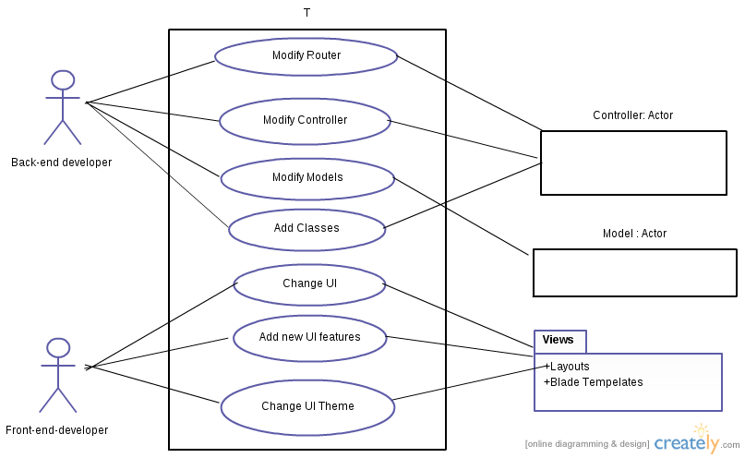

USECASES FOR LOGIN/SIGNUP SYSTEM
Purpose : This is basically used for authentication of user, who will be maintaining various company's parameters.
Users : Company's Sales Department, Company's Account Department, Company's Purchase Department, Company's Manufacturing Section, Company's Supervisor.
Use cases for user :
1. | Login for existing user
2. | Sign up for non-existing user
3. | Existing session for logged in user

Login for existing user
USE-CASE NUMBER | UC-001
OVERVIEW | User Logs into the application.
TYPE | Primary
ACTORS | USER  (Company's Sales Department, Company's Account Department, Company's Purchase Department, Company's Manufacturing Section, Company's Supervisor.)
PRE-CONDITION | User should enter correct UI, server should be running for localhost.
MAIN-FLOW | 1. System requests for user-id and password.  2. User enters user id and password.  3. If user Id and password are correct, redirect to dashboard.
ALTERNATE-FLOW | 2.1. User presses login without entering user id and password, refresh page with validations highlighted.  2.2 User don't enter a particular field, refreshes page with validation of particular field.  2.3 If email Id is not correct, then using AJAX highlight to enter a valid email-id.
POST-CONDITION | User is successful in logging in and getting redirected to dashboard.
CROSS-REFRENCE | Check database for existing email-id and corresponding password.

Sign up for non-existing user
USE-CASE NUMBER | UC-002
OVERVIEW | Sign up for non-existing user
TYPE | Primary
ACTORS | USER  (Company's Sales Department, Company's Account Department, Company's Purchase Department, Company's Manufacturing Section, Company's Supervisor.)
PRE-CONDITION | User should enter correct UI, server should be running for localhost.
MAIN-FLOW | 1. System requests for Email-id, password and confirm password.  2. User enters user id and password, and confirm password.  3. If password and confirm password fields matches, user's parameters are saved in database and user is redirected to login page.
ALTERNATE-FLOW | 2.1. User presses sign up without entering email-id, password and confirm password, refresh page with validations highlighted.  2.2 User don't enter a particular field, refreshes page with validation of particular field.  2.3 If email Id is not correct, then using AJAX highlight to enter a valid email-id.  2.4 If password and confirm password don't match then refresh page with validations.
POST-CONDITION | User is successful in sign up and gets redirected to log in page.
CROSS-REFRENCE | Check for corresponding models for user sign up and enter data in specified field.

Existing session for logged in user

USE-CASE NUMBER | UC-003
OVERVIEW | Existing session for logged in user
TYPE | Primary
ACTORS | USER  (Company's Sales Department, Company's Account Department, Company's Purchase Department, Company's Manufacturing Section, Company's Supervisor.)
PRE-CONDITION | User should already be logged in, and the browser should not be closed after logging in.
MAIN-FLOW | 1. System check for user session.  2. If user is already logged in then it will automatically redirect to dashboard.
ALTERNATE-FLOW | 1.1 User is not already logged in, then redirect to login page.
POST-CONDITION | User is redirected to dashboard.
CROSS-REFRENCE | Checking session parameters.

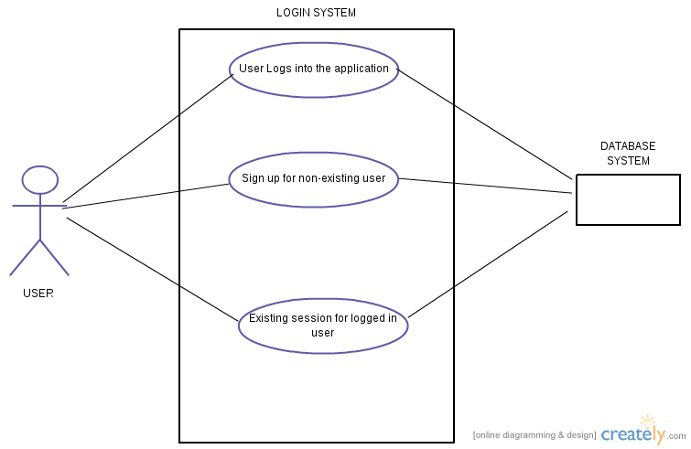

Use Cases: Maintenance , transactions, Inquiry and reports

Use Case no. | UC-004
Use Case name | Product Maintenance
Overview: | Adding new items, categories, update prices, Brands Maintenance etc.
Type: | Primary
Actors: | USER  (Company's Sales Department, Company's Account Department, Company's Purchase Department, Company's Manufacturing Section, Company's Supervisor.)
Pre-condition: | User should be logged in
Main Flow | 1. System requires login  2. If keys are valid the system acknowledges.  3. User can choose what he wants to do like Add item, add new category of item, Brands Maintenance, Update Prices, Reorder level by category/location without violating validations.
Alternate Flow | 2.1 If the user is invalid then system again asks for login.  2.2 If User logouts then system will redirect to login page.  2.3 If User adds an item which is already present  then he/she is acknowledged and redirected again on the same page.
Post condition | User is able to maintain stock

Use Case no. | UC-005
Use Case name | System Parameters
Overview: | General Settings of system
Type: | Primary
Actors: | USER  (Company's Sales Department, Company's Account Department, Company's Purchase Department, Company's Manufacturing Section, Company's Supervisor.)
Pre-condition: | User should be logged in
Main Flow | 1. System requires login  2. If keys are valid the system acknowledges.  3. User can set credit limit, overdue deadlines, invoice orientation, country of operations, default price list without violating validations.
Alternate Flow | 2.1 If the user is invalid then system again asks for login.  2.2 If User logouts then system will redirect to login page.  2.3 If any validations are violated then user is prompted.
Post condition | True

Use case table

Use Case Number: | UC-006
Use Case Name: | Purchase Orders
Overview: | Searches for items initiated by user
Actors: | USER  (Costumer)
Pre condition: | 1). System requires login.
Flow: | 1)User logs in  2)if the respective parameters are correct the system acknowledges.  3)user enters supplier, items (in multi select with quantity), locations, Initiator user and comments. Date of order is automatically taken.  4). Order is placed and saved into database.
Alternate flow: | 2.1)if the parameters are not correct system again asks for parameters  2.2)if the user logouts ,he/she will be redirected to login page.
Post Condition: | Data is saved into database, with unique purchase order ID and items following that purchase order.

Use case diagram

Use Case Number: | UC-007
Use Case Name: | Add locations.
Overview: | Add location of stocks with all details.
Actors: | USER  (Company's managing department.)
Pre condition: | 1)User must be logged in.  2)Add locations module should be choosen.
Main Flow: | 1). Enter inputs required.  2). Enter and select regions in google API field.  3). Enter add button.
Alternate Flow: | 1.1)if the parameters are not correct system again asks for parameters  1.2)if the user logouts ,he/she will be redirected to login page  3.1)if Unable to locate entered region by google API.
Post Condition: | New location of stocks is added and saved into database.

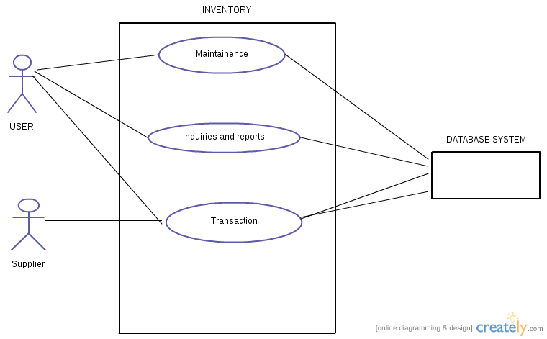

WITH RESPECT TO Company's Account Department -
* Overdue inquiry.
*General ledger integration is optional.
*Unlimited accounts and unlimited number of branches.
*Flexible user definable sales analysis.
*Email of invoices and credit notes.

USE-CASE NUMBER | UC-009
OVERVIEW | Display items.
TYPE | Primary
ACTORS | USER  (Company's Supervision department)
PRE-CONDITION | User should already be logged in, server should be running for localhost.
MAIN-FLOW | 1. after logging in User (Company's Account department ) should choose the module corresponding to show items added by company's maintenance department.  2. On successful choosing, list of all items of company is displayed in tabular form with details.
ALTERNATE-FLOW | 1.1 After logging in if user chooses any other module, he/she will be redirected to respective module.  2.1 refresh/ back button will give respective outputs.
POST-CONDITION | User is redirected to Information page containing List of all items of the company.
CROSS-REFRENCE | Refer to database and fetch information from items table.

USE-CASE NAME | Flexible user definable sales analysis.
USE-CASE NUMBER | UC-010
OVERVIEW
TYPE | Primary
ACTORS | USER  (Company's Account Department)
PRE-CONDITION | User should already be logged in, server should be running for localhost.
MAIN-FLOW | 1. after logging in User (Company's Account department ) should choose the module corresponding to Flexible user definable sales analysis.  2. Once the Flexible user definable sales analysis. page is opened, page should ask for secure code.  3. If the code matches to the logged in user, then user should be given options to define its sales analysis.  4. On success, the type of sales analysis should be stored in required table and corresponding changes should be made.
ALTERNATE-FLOW | 1.1 After logging in if user chooses any other module, he/she will be redirected to respective module.  2.1 refresh/ back button will give respective outputs.  3.1 If secure code is incorrect, then user should be logged out and asked to log in again in order to continue.  4.1 If demanded changes could not be made, then user will return to previous page of defining sales analysis.
POST-CONDITION | User is redirected to page highlighting success.
CROSS-REFRENCE | Checking that the demanded changes are feasible before applying them.

Company's Tax Manager -
*Very flexible taxation options suitable for Canada, US, South Africa, UK, Australia, NZ and most other countries.
*Tax rates dependent on the type of product.
*Tax rates dependent on the location of the customer.
*Multiple taxes payable to different tax authorities.

USE-CASE NAME | Flexible user definable sales analysis.
USE-CASE NUMBER | UC-010
OVERVIEW
TYPE | Primary
ACTORS | USER  (Company's Account Department)
PRE-CONDITION | User should already be logged in, server should be running for localhost.
MAIN-FLOW | 1. after logging in User (Company's Account department ) should choose the module corresponding to Flexible user definable sales analysis.  2. Once the Flexible user definable sales analysis. page is opened, page should ask for secure code.  3. If the code matches to the logged in user, then user should be given options to define its sales analysis.  4. On success, the type of sales analysis should be stored in required table and corresponding changes should be made.
ALTERNATE-FLOW | 1.1 After logging in if user chooses any other module, he/she will be redirected to respective module.  2.1 refresh/ back button will give respective outputs.  3.1 If secure code is incorrect, then user should be logged out and asked to log in again in order to continue.  4.1 If demanded changes could not be made, then user will return to previous page of defining sales analysis.
POST-CONDITION | User is redirected to page highlighting success.
CROSS-REFRENCE | Checking that the demanded changes are feasible before applying them.

