Product Design
Team 18 Project 23
Yash Patel, Yash Khandelwal, Kartavya Gupta, Sachin Sharma

Architectural Model

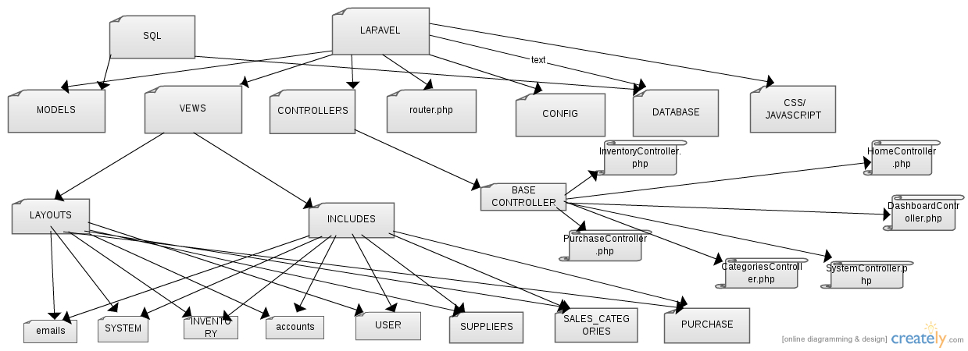

BaseController.php | Component state  - Holds basic information about the controller as provided by the framework.  Component behavior  - Responsible for giving basic functionalities to other user made controllers, as provided by the framework.
User  { UserController.php, models/User.php,signin.blade.php, signup.blade.php} | Component state  This component is responsible for Signin / Signup and manages the information entered by the user.  Component behaviour  - This component authenticates the user as an authorized user if the username and password filled in by the user is valid.  - It also maintains the profile information entered by a guest user while registering for the website.  - This Controller takes input from its corresponding view and passes all input parameters to the model User.php in case of signup , and in case of login it passes info to auth class so as to check if the user is authorized or not.
Dashboard  { DashboardController.php, dashboard.blade.php} | Component state  - Responsible for maintaining information about making dashboard i.e. displayed just after user login.
New Item  { InventoryController.php, add_item.blade.php, models/Inventory.php} | Component state  - Responsible for maintaining information about adding a new item.  Component behavior  - The Controller takes input from its corresponding view and passes all input parameters to the model Inventory.php, if validators aren't violated, and if violated then display corresponding errors.
Supplier  { SupplierController.php,models/Supplier.php,add_supplier.blade.php } | Component state  - Responsible for maintaining information about adding a new supplier.  Component behavior  - Controller takes input from its corresponding view and passes all input parameters to the model Supplier.php, if validators aren't violated.
Add Purchase Order  {PurchaseController.php, add_order.blade.php, models/Purchase.php} | Component state  - Responsible for maintaining information about adding a new purchase order, implementing ajax calls for auto complete feature for fields like from which Supplier user wants to buy items and which items to buy along with their quantities.  Component behavior  - Controller takes input from its corresponding view and passes all input parameters to the model Purchase.php so as to place a new order and save it to the databases.
System Parameters  {SystemController.php, parameters.blade.php, locations.blade.php, models/Parameters.php} | Component state  This controller is responsible for maintaining information about system parameters, and delivery locations.  Component behavior  This Controller takes input from its corresponding view and passes all input parameters to the corresponding model.
Database | Component State  - This component comprises of the database tables  - The User table assigns a user_id to each entry and stores all the user information.  - sales_category_maintenance tables stores information about  category of items.  - inventory_items tables stores information about items.  - Parameters table stores system parameters.  - Suppliers table stores info about every supplier.  Component behavior  - Database stores information that user enters or edits, in a particular table.  - Returns output if if query matches with tables in database.

Class Diagram(s)

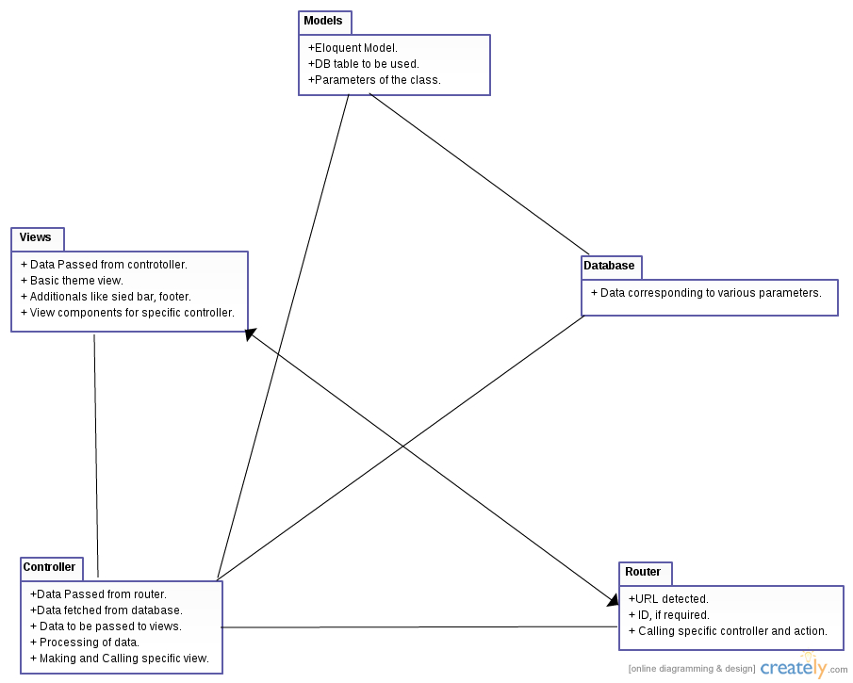

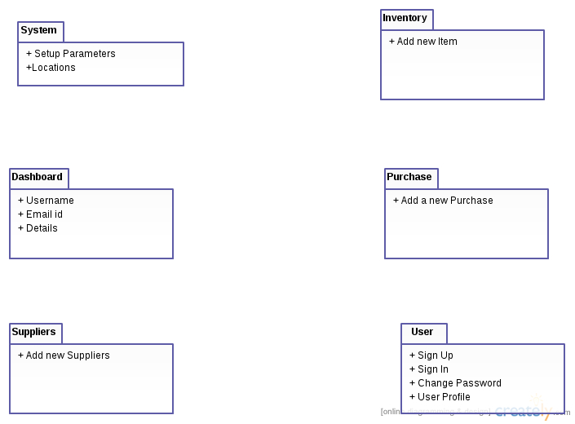

Sequence Diagram(s)

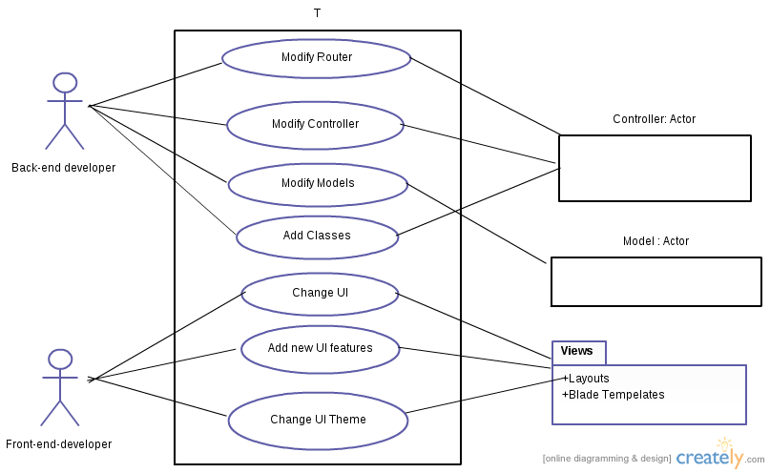

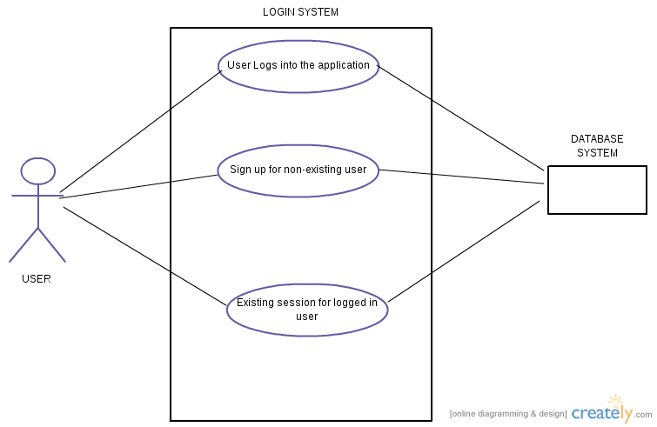

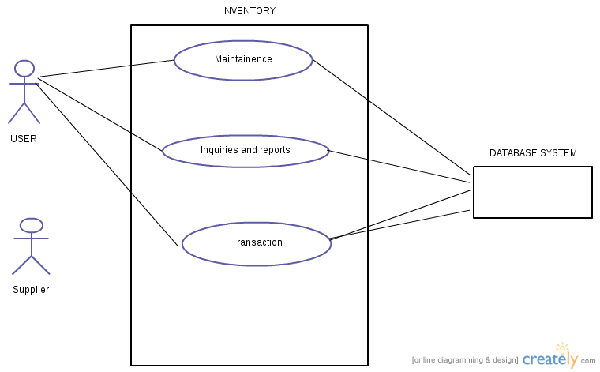

Design Rationale
The first thing in design is to enable a User to Signup / Signin. After that we thought of making modules which have least dependencies on others. Till now we completed System Parameters (doesn't have dependencies on any module, and is necessary for a company to have basic information i.e. system parameters to be stored priorly. After that we implemented add_item, add_categories, add_supplier, locations modules. Then, now we are implementing add_purchase_order which have dependencies with tables (inventory_items, sales_categories_ maintenance, locations).

