Lab: Arrays
Problems for exercises and homework for the "Technology Fundamentals" course @ SoftUni.
You can check your solutions in Judge.

Day of Week
Enter a day number [1…7] and print the day name (in English) or "Invalid day!". Use an array of strings.

Examples
Input | Output
1 | Monday
2 | Tuesday
7 | Sunday
0 | Invalid day!

Hints
- Use an array of strings holding the day names: {"Monday", "Tuesday", "Wednesday", "Thursday", "Friday", "Saturday", "Sunday"}.
- Print the element at index (day-1) when it is in the range [1…7] or "Invalid Day!" otherwise.

Print Numbers in Reverse Order
Read n numbers and print them in reverse order.

Examples
Input | Output
3  10  20  30 | 30  20  10
3  30  20  10 | 10  20  30
1  10 | 10

Solution
First, we need to read n from the console.
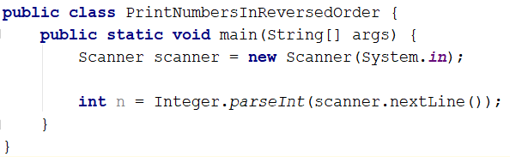
Create an array of integer with n size.
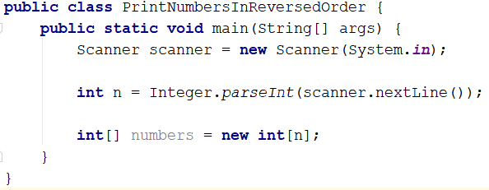
Read n numbers using for loop and fill the array.
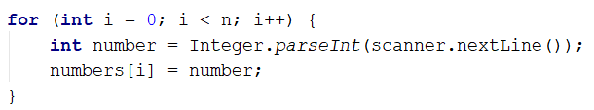
Print the array in reversed order.
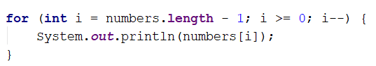

Sum Even Numbers
Read an array from the console and sum only the even numbers.

Examples
Input | Output
1 2 3 4 5 6 | 12
3 5 7 9 | 0
2 4 6 8 10 | 30

Solution
First, we need to read the array.
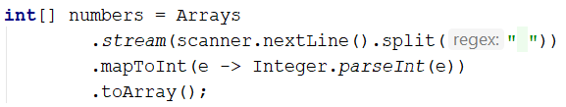
We will need a variable for the sum.
Iterate through all elements in the array with for loop. If the number is even add it to the sum.
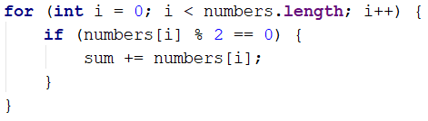
Print the total sum

Reverse an Array of Strings
Write a program to read an array of strings, reverse it and print its elements. The input consists of a sequence of space separated strings. Print the output on a single line (space separated).

Examples
Input | Output
a b c d e | e d c b a
-1 hi ho w | w ho hi -1

Hints
- Read the array of strings.
- Exchange the first element (at index 0) with the last element (at index n-1).
- Exchange the second element (at index 1) with the element before the last (at index n-2).
- Continue the same way until the middle of the array is reached.
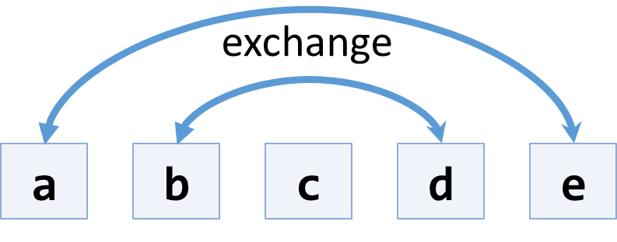

Even and Odd Subtraction
Write a program that calculates the difference between the sum of the even and the sum of the odd numbers in an array.

Examples
Input | Output | Comments
1 2 3 4 5 6 | 3 | 2 + 4 + 6 = 12  1 + 3 + 5 = 9  12 – 9 = 3
3 5 7 9 | -24
2 4 6 8 10 | 30

Solution
First, we need to read the array.
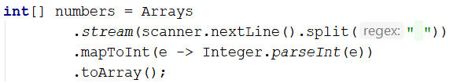
We will need two variables – even and odd sum.
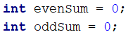
Iterate through all elements in the array. Check the current number – if it is even add it to the even sum, otherwise add it to the odd sum.
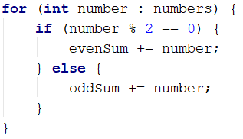
Print the difference.
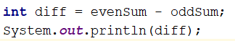

Equal Arrays
Read two arrays and print on the console whether they are identical or not. Arrays are identical if their elements are equal. If the arrays are identical find the sum of the first one and print on the console following message: "Arrays are identical. Sum: {sum}", otherwise find the first index where the arrays differ and print on the console following message: "Arrays are not identical. Found difference at {index} index."

Examples
Input | Output
10 20 30  10 20 30 | Arrays are identical. Sum: 60
1 2 3 4 5  1 2 4 3 5 | Arrays are not identical. Found difference at 2 index.
1  10 | Arrays are not identical. Found difference at 0 index.

Hints
First, we need to read two arrays.
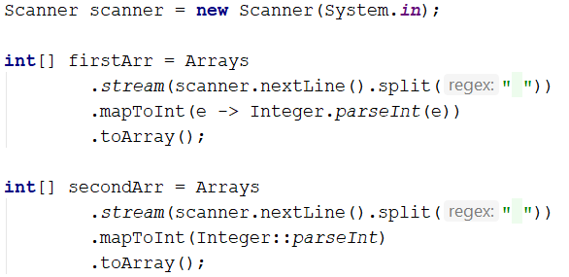
Iterate through arrays and compare element. If the elements are not equal print the required message and break the loop.
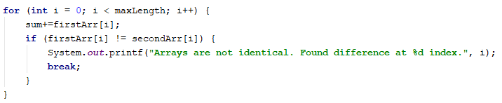
Think about how to solve the other part of the problem.

Condense Array to Number
Write a program to read an array of integers and condense them by summing adjacent couples of elements until a single integer is obtained. For example, if we have 3 elements {2, 10, 3}, we sum the first two and the second two elements and obtain {2+10, 10+3} = {12, 13}, then we sum again all adjacent elements and obtain {12+13} = {25}.

Examples
Input | Output | Comments
2 10 3 | 25 | 2 10 3 2+10 10+3 12 13 12 + 13 25
5 0 4 1 2 | 35 | 5 0 4 1 2 5+0 0+4 4+1 1+2 5 4 5 3 5+4 4+5 5+3 9 9 8 9+9 9+8 18 17 18+17 35
1 | 1 | 1 is already condensed to number

Hints
While we have more than one element in the array nums[], repeat the following:
- Allocate a new array condensed[] of size nums.Length-1.
- Sum the numbers from nums[] to condensed[]:
  - condensed[i] = nums[i] + nums[i+1]
- nums[] = condensed[]
The process is illustrated below:
