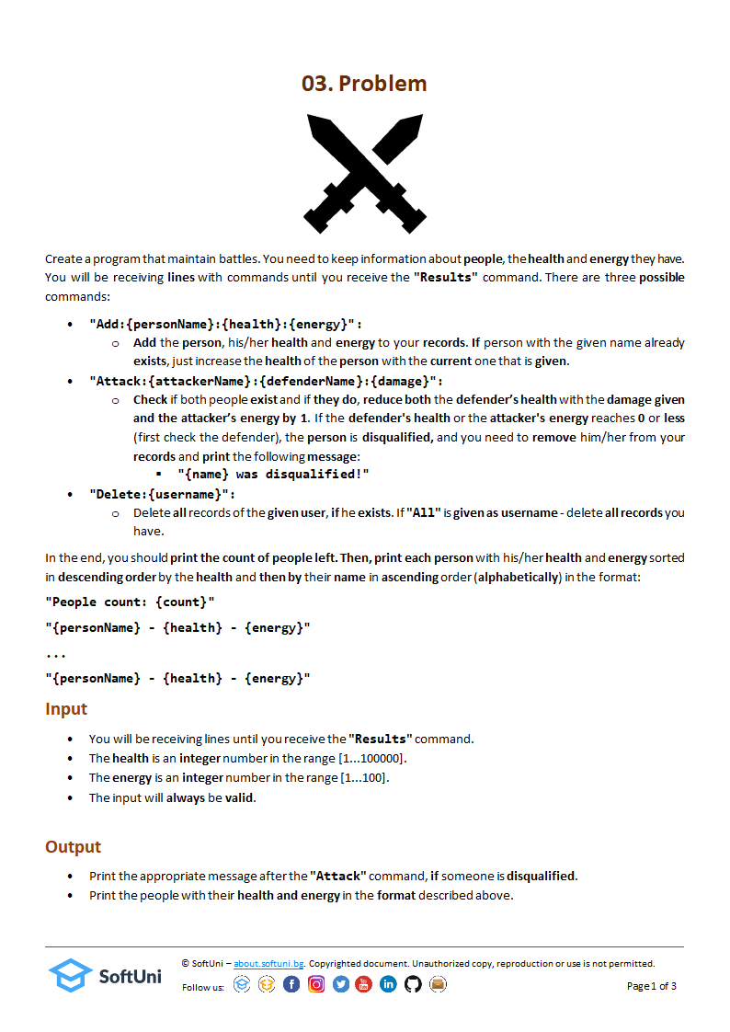

### Input

* The **possible** commands are:
  + **"****Results"**
  + **"Add:{personName}:{health}:{energy}"**
  + **"Attack:{attackerName}:{defenderName}:{damage}"**
  + **"Delete:{username}"**
  + **"All"**

### Output

* The **possible** outputs are:
* **"{name} was disqualified!"**
* **"People count: {count}"**

**"{personName} - {health} - {energy}"**

**...**

**"{personName} - {health} - {energy}"**

### Examples

|  |  |
| --- | --- |
| **Input** | **Output** |
| Add:Mark:1000:5  Add:Clark:1000:2  Attack:Clark:Mark:500  Attack:Clark:Mark:800  Add:Charlie:4000:10  Results | Mark was disqualified!  Clark was disqualified!  People count: 1  Charlie - 4000 - 10 |
|  | |
| Add:Bonnie:3000:5  Add:Kent:10000:10  Add:Johny:4000:10  Attack:Johny:Bonnie:400  Add:Johny:3000:5  Add:Peter:7000:1  Delete:Kent  Results | People count: 3  Johny - 7000 - 9  Peter - 7000 - 1  Bonnie - 2600 - 5 |
|  | |
| Add:Bonnie:3000:5  Add:Johny:4000:10  Delete:All  Add:Bonnie:3333:3  Add:Aleks:1000:70  Add:Tom:4000:1  Results | People count: 3  Tom - 4000 - 1  Bonnie - 3333 - 3  Aleks - 1000 - 70 |

### JS Input / Output

The input will be provided as an array of strings.

|  |  |
| --- | --- |
| **Input** | **Output** |
| (["Add:Mark:1000:5",  "Add:Clark:1000:2",  "Attack:Clark:Mark:500",  "Attack:Clark:Mark:800",  "Add:Charlie:4000:10",  "Results"]) | Mark was disqualified!  Clark was disqualified!  People count: 1  Charlie - 4000 - 10 |
|  | |
| (["Add:Bonnie:3000:5",  "Add:Kent:10000:10",  "Add:Johny:4000:10",  "Attack:Johny:Bonnie:400",  "Add:Johny:3000:5",  "Add:Peter:7000:1",  "Delete:Kent",  "Results"]) | People count: 3  Johny - 7000 - 9  Peter - 7000 - 1  Bonnie - 2600 - 5 |
|  | |
| (["Add:Bonnie:3000:5", "Add:Johny:4000:10", "Delete:All",  "Add:Bonnie:3333:3",  "Add:Aleks:1000:70",  "Add:Tom:4000:1", "Results"]) | People count: 3  Tom - 4000 - 1  Bonnie - 3333 - 3  Aleks - 1000 - 70 |