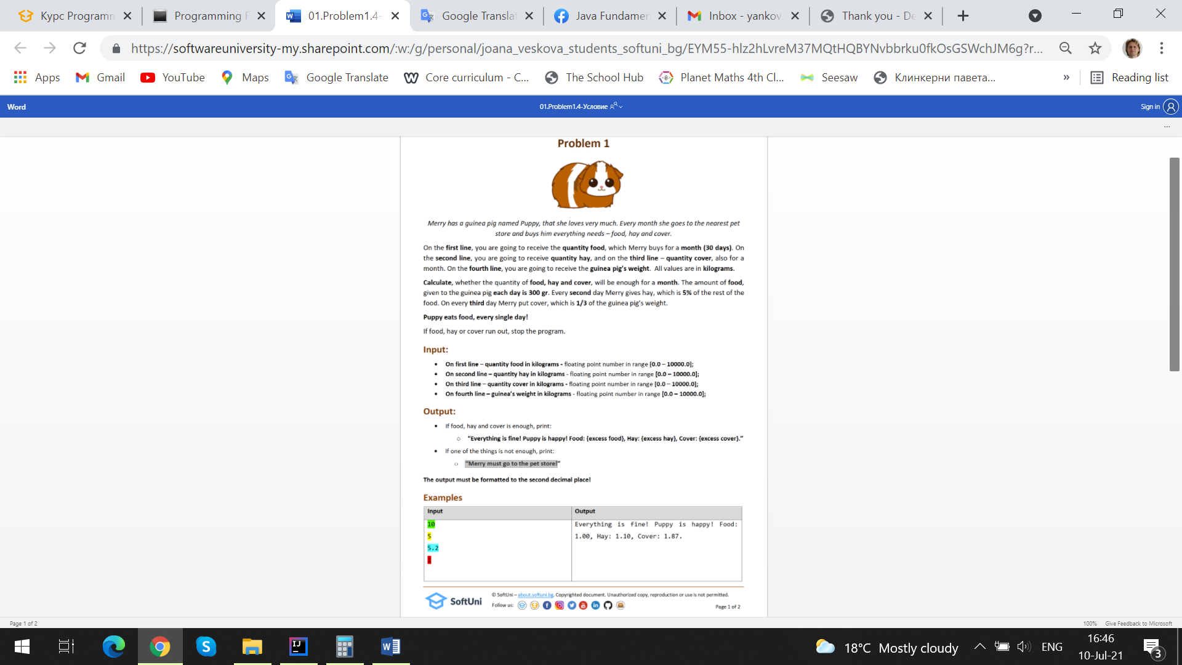

### Examples

|  |  |
| --- | --- |
| **Input** | **Output** |
| 10  5  5.2  1 | Everything is fine! Puppy is happy! Food: 1.00, Hay: 1.10, Cover: 1.87. |
| You receive food – **10000**, hay – **5000**, cover – **5200**, weight – **1000** (in grams). On first day Merry gives Puppy 300 gr food – 9700. On second day food – 9400 and need hay –  **9400 * 5% = 470,** remain hay – **5000 – 470 = 4530.** On third day cover – **5200 – (1000 / 3) = 4866.67** and food - 9100. On last day Merry has – food – 1.00, hay – 1.10, cover – 1.87. | |
| 1  1.5  3  1.5 | Merry must go to the pet store! |
| 9  5  5.2  1 | Merry must go to the pet store! |

**JS Input / Output**

|  |  |
| --- | --- |
| **Input** | **Output** |
| (["10",  "5",  "5.2",  "1"]) | Everything is fine! Puppy is happy! Food: 1.00, Hay: 1.10, Cover: 1.87 |
| (["1",  "1.5",  "3",  "1.5"  ]) | Merry must go to the pet store! |
| (["9",  "5",  "5.2",  "1"]) | Merry must go to the pet store! |