МИНИСТЕРСТВО ОБРАЗОВАНИЯ И НАУКИ РОССИЙСКОЙ ФЕДЕРАЦИИ ФЕДЕРАЛЬНОЕ ГОСУДАРСТВЕННОЕ АВТОНОМНОЕ ОБРАЗОВАТЕЛЬНОЕ УЧРЕЖДЕНИЕ ВЫСШЕГО ОБРАЗОВАНИЯ

«МОСКОВСКИЙ ПОЛИТЕХНИЧЕСКИЙ УНИВЕРСИТЕТ»



Кафедра СМАРТ технологий

Лабораторная работа №1

«Использование графических возможностей C# для визуализации данных стохастических процессов»

По дисциплине «Технологии визуализации данных систем управления»

Группа 201-325

Студент Холодилов И.В.

Дата 11.05.2023

Преподаватель Идиатулов Т.Т.

2023

# Цель работы

Разработать приложение по генерации стохастических данных с заданным профилем распределения и визуализации распределения случайных величин.

# Задачи

* Подготовить приложение на языке C# для статистической обработки и визуализации собранных наборов данных

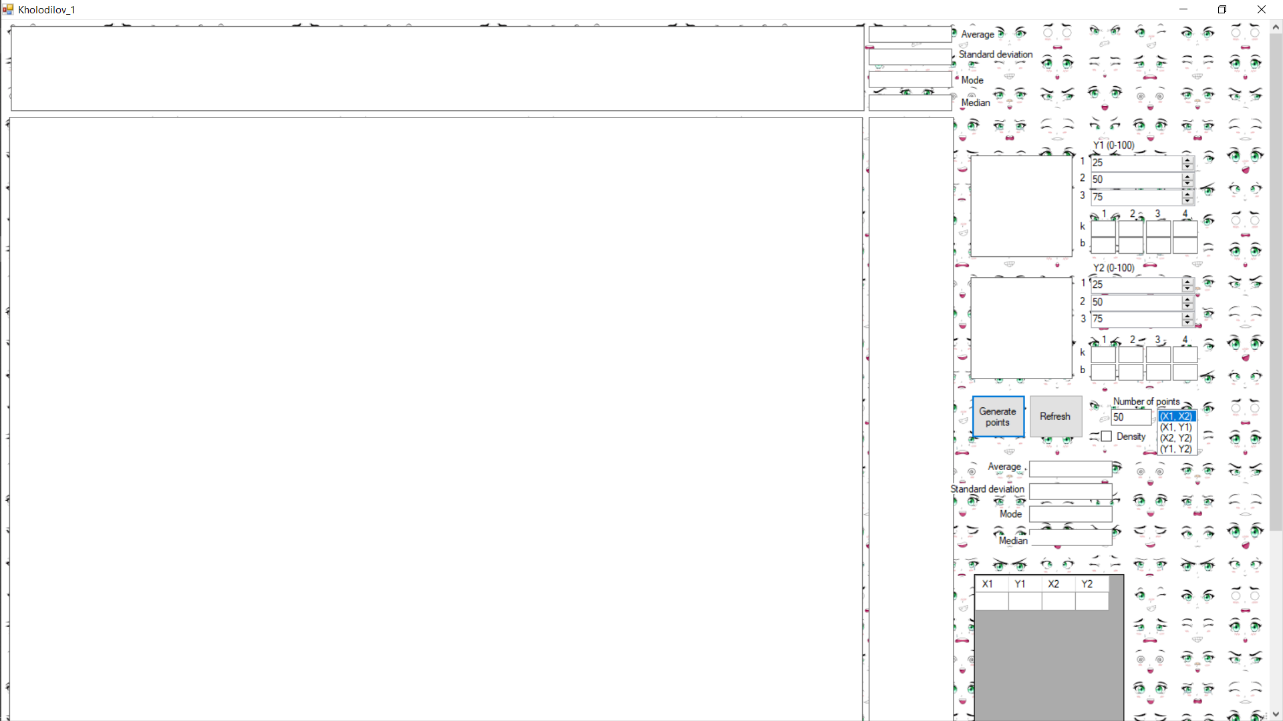

Рисунок 1 - Form

* Реализовать генерацию заданного (через текстовое поле) количества случайных точек (X1, X2), где X1 и X2 – равномерно распределенные случайные величины на диапазоне [0 ÷ 1]. Подготовить функционал для настройки профиля преобразования (пересчета) двух случайных величин (Y1, Y2) из равномерно распределенных случайных величин (X1, X2). Реализовать отрисовку наборов данных в виде облака точек, с возможностью выбора пар параметров, используемых как координаты точек.

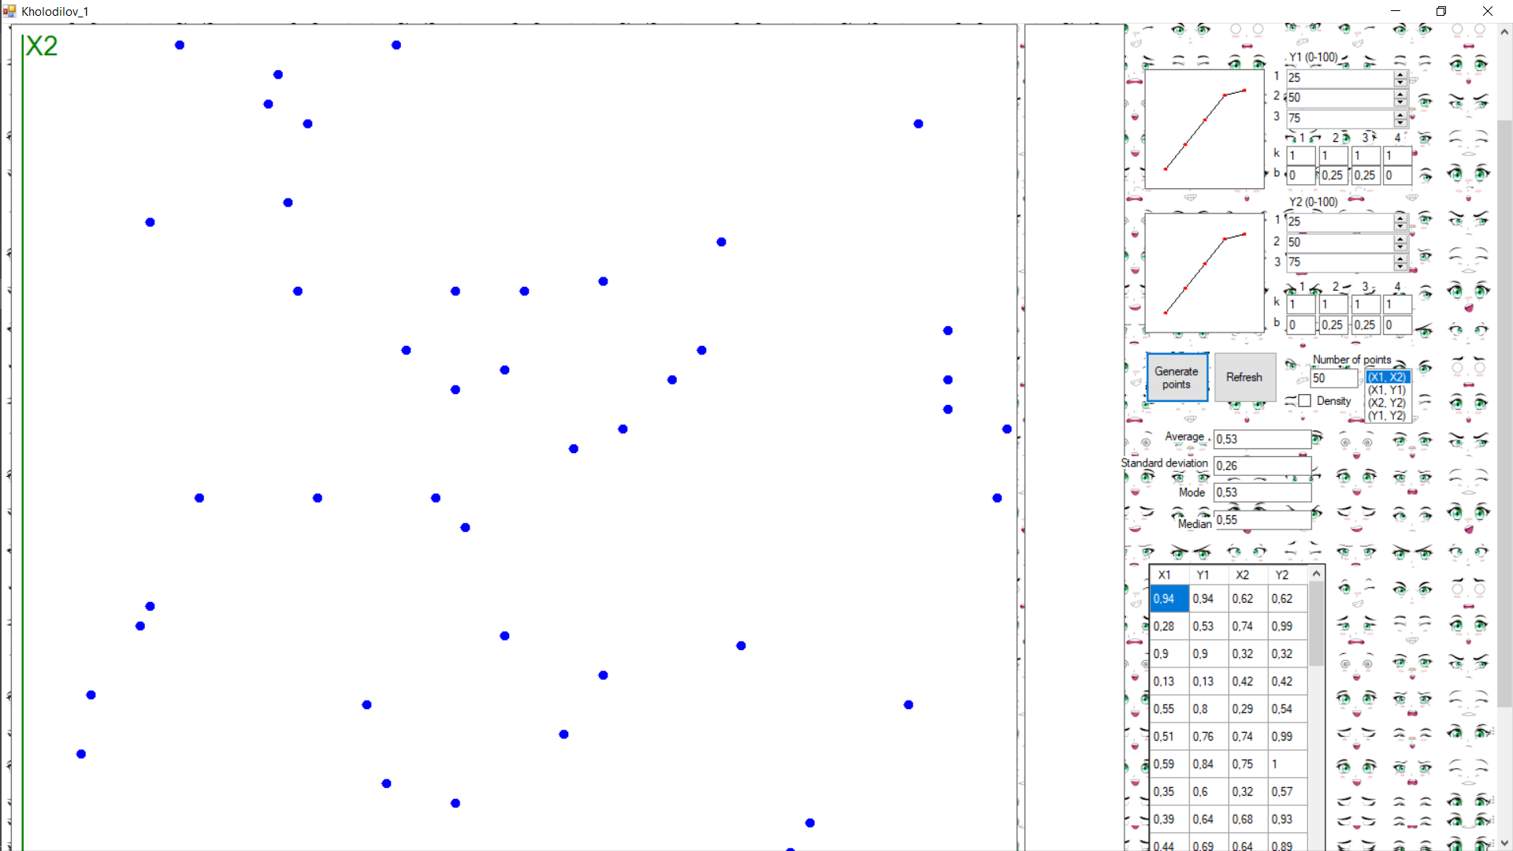

Рисунок 2 - Генерация и отображение данных в виде изображения с соответствующими осями

* Реализовать отображение профиля преобразования как кусочно-линейных функций (по пяти точкам – первая и последняя привязаны к границам диапазона генерации равномерно-распределенных случайных величин).

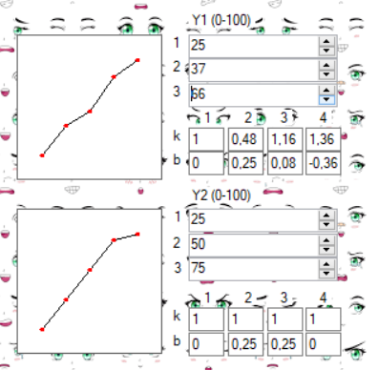

Рисунок 3 - Генерация вторых значений данных с помощию numericupdown

* Должна существовать возможность отобразить точки (X1, X2), (X1, Y1), (X2, Y2), (Y1, Y2).

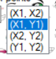

Рисунок 4 - Выбос зависимости осей

* Реализовать расчёт плотности распределения случайных точек и выполнить фоновую окраску области отрисовки случайных точек. При подсчете плотности разделить диапазон отображения по каждой оси на 10 интервалов.

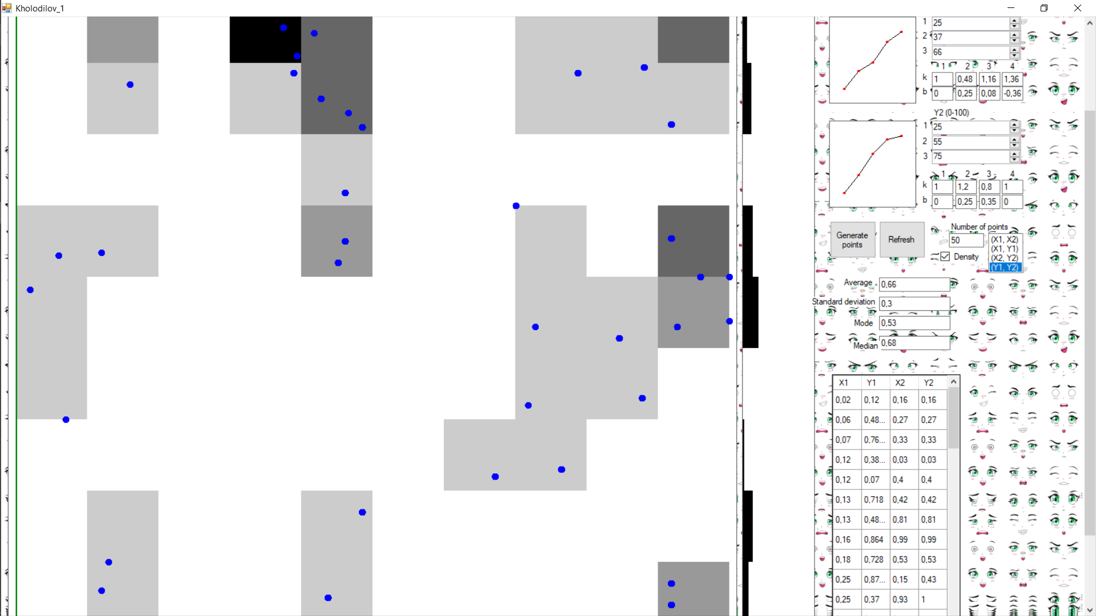

Рисунок 5 - Создание гистограммы по выбранным данным

* Добавлен в приложении расчёт статистических данных (описательной статистики) полученного распределения (среднее, средне-квадратическое отклонение, мода, медиана), а также отображения гистограммы распределения каждой из случайных величин. Расположить оси гистограмм вдоль соответствующих осей на диаграмме облака точек.

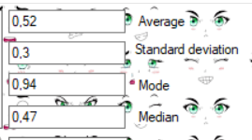

Рисунок 6 - Подсчет всех мат. функций

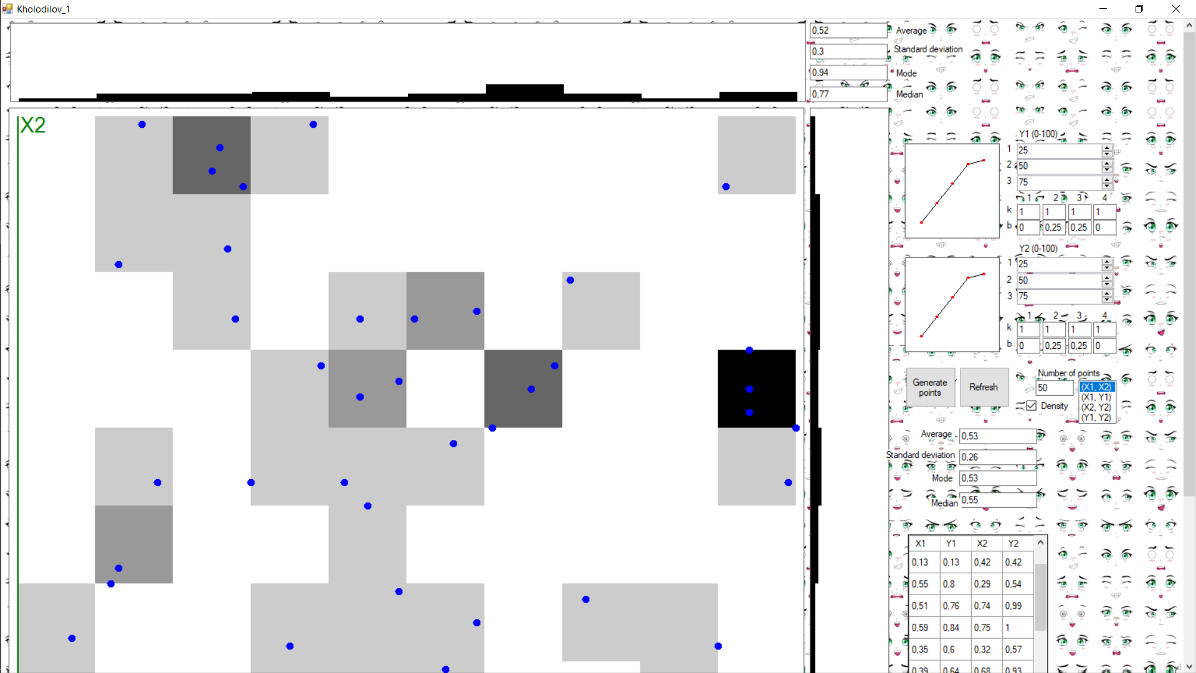

Рисунок 7 - Итоговый вид проекта

**Вывод**

В ходе создания программы было написанно ПО для визуализации собранных наборов пространственных данных методом проекции на плоскость.

# Приложение A

Листинг A-1 – программный код:

|  |
| --- |
| using System;  using System.Collections.Generic;  using System.Drawing;  using System.Windows.Forms;  //using System.Windows.Media;  namespace Lab_1  {  public partial class Kholodilov_1 : Form  {  Random random = new Random();  List<PointF> points_x = new List<PointF>();  List<PointF> points_y = new List<PointF>();  bool start_work = false;  bool is_y1_param_change = false;  bool is_y2_param_change = false;  bool is_axes_change = true;  bool is_density_change = false;  int[,] density = new int[10, 10];  int[] density_up = new int[10];  int[] density_right = new int[10];  float summ_up = 0;  float summ_right = 0;  public Kholodilov_1()  {  InitializeComponent();  timer1.Enabled = true;  dataGridView1.RowHeadersVisible = false;  dataGridView1.ColumnCount = 4;  int size_grid = 40;  dataGridView1.Columns[0].Width = size_grid;  dataGridView1.Columns[1].Width = size_grid;  dataGridView1.Columns[2].Width = size_grid;  dataGridView1.Columns[3].Width = size_grid;  dataGridView1.Width = size_grid * 4 + 20;  listBox1.SelectedIndex = 0;  X1Y1_box.Image = new Bitmap(120, 120);  X2Y2_box.Image = new Bitmap(120, 120);  Main_box.Image = new Bitmap(1020, 1020);  Up_box.Image = new Bitmap(1020, 100);  Right_box.Image = new Bitmap(100, 1020);  }  private void Form1_Load_1(object sender, EventArgs e)  {  }  public float check_max_min_point (float d)  {  if (d <= 0) return 0.0f;  else if (d >= 1) return 1.0f;  else return d;  }  private void Form1_FormClosed_1(object sender, FormClosedEventArgs e)  {  timer1.Stop();  }  public int check_id_density (int d)  {  if (d < 0) return 0;  else if (d > 9) return 9;  else return d;  }  public void draw_main_img ()  {  density = new int[10, 10] { { 0, 0, 0, 0, 0, 0, 0, 0, 0, 0 }, { 0, 0, 0, 0, 0, 0, 0, 0, 0, 0 }, { 0, 0, 0, 0, 0, 0, 0, 0, 0, 0 }, { 0, 0, 0, 0, 0, 0, 0, 0, 0, 0 }, { 0, 0, 0, 0, 0, 0, 0, 0, 0, 0 }, { 0, 0, 0, 0, 0, 0, 0, 0, 0, 0 }, { 0, 0, 0, 0, 0, 0, 0, 0, 0, 0 }, { 0, 0, 0, 0, 0, 0, 0, 0, 0, 0 }, { 0, 0, 0, 0, 0, 0, 0, 0, 0, 0 }, { 0, 0, 0, 0, 0, 0, 0, 0, 0, 0 } };  density_up = new int[10] { 0, 0, 0, 0, 0, 0, 0, 0, 0, 0 };  density_right = new int[10] { 0, 0, 0, 0, 0, 0, 0, 0, 0, 0 };  summ_right = 0;  summ_up = 0;  Graphics graphics = Graphics.FromImage(Main_box.Image);  Graphics graphics_up = Graphics.FromImage(Up_box.Image);  Graphics graphics_righ = Graphics.FromImage(Right_box.Image);  graphics.FillRectangle(Brushes.White, new Rectangle(0, 0, Main_box.Width, Main_box.Height));  graphics_up.FillRectangle(Brushes.White, new Rectangle(0, 0, Up_box.Width, Up_box.Height));  graphics_righ.FillRectangle(Brushes.White, new Rectangle(0, 0, Right_box.Width, Right_box.Height));  if (is_density.Checked)  {  int max = 0;  for (int i = 0; i < points_x.Count; i++)  {  switch (listBox1.SelectedIndex)  {  case 1:  density[check_id_density((int)Math.Ceiling(points_x[i].X * 10 - 1)), check_id_density((int)Math.Ceiling(points_y[i].X * 10 - 1))]++;  if (density[check_id_density((int)Math.Ceiling(points_x[i].X * 10 - 1)), check_id_density((int)Math.Ceiling(points_y[i].X * 10 - 1))] > max) max = density[check_id_density((int)Math.Ceiling(points_x[i].X * 10 - 1)), check_id_density((int)Math.Ceiling(points_y[i].X * 10 - 1))];  break;  case 2:  density[check_id_density((int)Math.Ceiling(points_x[i].Y * 10 - 1)), check_id_density((int)Math.Ceiling(points_y[i].Y * 10 - 1))]++;  if (density[check_id_density((int)Math.Ceiling(points_x[i].Y * 10 - 1)), check_id_density((int)Math.Ceiling(points_y[i].Y * 10 - 1))] > max) max = density[check_id_density((int)Math.Ceiling(points_x[i].Y * 10 - 1)), check_id_density((int)Math.Ceiling(points_y[i].Y * 10 - 1))];  break;  case 3:  density[check_id_density((int)Math.Ceiling(points_y[i].X * 10 - 1)), check_id_density((int)Math.Ceiling(points_y[i].Y * 10 - 1))]++;  if (density[check_id_density((int)Math.Ceiling(points_y[i].X * 10 - 1)), check_id_density((int)Math.Ceiling(points_y[i].Y * 10 - 1))] > max) max = density[check_id_density((int)Math.Ceiling(points_y[i].X * 10 - 1)), check_id_density((int)Math.Ceiling(points_y[i].Y * 10 - 1))];  break;  default:  density[check_id_density((int)Math.Ceiling(points_x[i].X * 10 - 1)), check_id_density((int)Math.Ceiling(points_x[i].Y * 10 - 1))]++;  if (density[check_id_density((int)Math.Ceiling(points_x[i].X * 10 - 1)), check_id_density((int)Math.Ceiling(points_x[i].Y * 10 - 1))] > max) max = density[check_id_density((int)Math.Ceiling(points_x[i].X * 10 - 1)), check_id_density((int)Math.Ceiling(points_x[i].Y * 10 - 1))];  break;  }  }  for (int i = 0; i < 10; i++)  {  for (int j = 0; j < 10; j++)  {  System.Drawing.Brush brush = new SolidBrush(System.Drawing.Color.FromArgb((int)(density[i,j]*255/max), 0, 0, 0));  graphics.FillRectangle(brush, 10 + 100 * i, 10 + 900 - (100 * j), 100, 100);  density_up[j] += density[i, j];  density_right[i] += density[i, j];  }  }  for (int i = 0; i < 10; i++)  {  graphics_up.FillRectangle(Brushes.Black, 10 + 100 * i, 100 - (int)((density_up[i] * 100) / Int32.Parse(num_point.Text)), 100, (int)((density_up[i] * 100) / Int32.Parse(num_point.Text)));  graphics_righ.FillRectangle(Brushes.Black, 0, 10 + 100 * i, (int)((density_right[i] * 100) / Int32.Parse(num_point.Text)), 100);  //graphics_up.FillRectangle(Brushes.Black, 10 + 100 * i, 100 - ((density_up[i] * 100) / Int32.Parse(num_point.Text)), 100, 10);  //MessageBox.Show((100 - (density_up[i] / Int32.Parse(num_point.Text) * 100)).ToString());  }  }  Font drawFont = new Font("Arial", 20);  StringFormat drawFormat = new StringFormat();  SolidBrush drawBrush = new SolidBrush(Color.Black);  graphics.DrawString(listBox1.Items[listBox1.SelectedIndex].ToString().Substring(5, 2), drawFont, Brushes.Green, 10, 5, drawFormat);  graphics.DrawString(listBox1.Items[listBox1.SelectedIndex].ToString().Substring(1, 2), drawFont, Brushes.Red, Main_box.Width - 47, Main_box.Height - 40, drawFormat);  graphics.FillRectangle(Brushes.Green, 10, 10, 2, Main_box.Height - 20);  graphics.FillRectangle(Brushes.Red, 10, Main_box.Height - 10, Main_box.Width - 20, 2);  for (int i = 0; i < points_x.Count; i++)  {  switch (listBox1.SelectedIndex)  {  case 1:  graphics.FillEllipse(Brushes.Blue, 10 + points_x[i].X * 1000 - 5, 10 + 1000 - points_y[i].X * 1000 - 5, 5 + 5, 5 + 5);  summ_right += points_y[i].X;  summ_up += points_x[i].X;  break;  case 2:  graphics.FillEllipse(Brushes.Blue, 10 + points_x[i].Y * 1000 - 5, 10 + 1000 - points_y[i].Y * 1000 - 5, 5 + 5, 5 + 5);  summ_right += points_y[i].Y;  summ_up += points_x[i].Y;  break;  case 3:  graphics.FillEllipse(Brushes.Blue, 10 + points_y[i].X * 1000 - 5, 10 + 1000 - points_y[i].Y * 1000 - 5, 5 + 5, 5 + 5);  summ_right += points_y[i].Y;  summ_up += points_y[i].X;  break;  default:  graphics.FillEllipse(Brushes.Blue, 10 + points_x[i].X * 1000 - 5, 10 + 1000 - points_x[i].Y * 1000 - 5, 5 + 5, 5 + 5);  summ_right += points_x[i].Y;  summ_up += points_x[i].X;  break;  }  }  if (is_y1_param_change || is_y2_param_change || is_axes_change)  {  float ave_right = ((float)(summ_right / points_x.Count));  float ave_up = ((float)(summ_up / points_x.Count));  double st_deviation_up = 0;  double st_deviation_right = 0;  for (int i = 0; i < points_x.Count; i++)  {  switch (listBox1.SelectedIndex)  {  case 1:  //summ_right += points_y[i].X;  //summ_up += points_x[i].X;  st_deviation_up += Math.Pow(points_x[i].X - ave_up, 2);  st_deviation_right += Math.Pow(points_y[i].X - ave_right, 2);  break;  case 2:  //summ_right += points_y[i].Y;  //summ_up += points_x[i].Y;  st_deviation_up += Math.Pow(points_x[i].Y - ave_up, 2);  st_deviation_right += Math.Pow(points_y[i].Y - ave_right, 2);  break;  case 3:  //summ_right += points_y[i].Y;  //summ_up += points_y[i].X;  st_deviation_up += Math.Pow(points_y[i].X - ave_up, 2);  st_deviation_right += Math.Pow(points_y[i].Y - ave_right, 2);  break;  default:  //summ_right += points_x[i].Y;  //summ_up += points_x[i].X;  st_deviation_up += Math.Pow(points_x[i].X - ave_up, 2);  st_deviation_right += Math.Pow(points_x[i].Y - ave_right, 2);  break;  }  }  average_right.Text = Math.Round(ave_right, 2).ToString();  average_up.Text = Math.Round(ave_up, 2).ToString();  standard_deviation_right.Text = Math.Round(Math.Sqrt((float)(st_deviation_right / points_x.Count)), 2).ToString();  standard_deviation_up.Text = Math.Round(Math.Sqrt((float)(st_deviation_up / points_x.Count)), 2).ToString();    // Mode  int m_right = 0;  int m_up = 0;  float m_data_right = -1;  float m_data_up = -1;  float m_last_right = -1;  float m_last_up = -1;  switch (listBox1.SelectedIndex)  {  case 1:  //summ_right += points_y[i].X;  //summ_up += points_x[i].X;  points_y = Sort_list(points_y, true);  points_x = Sort_list(points_x, true);  for (int i = 0; i < points_x.Count; i++)  {  if (points_y[i].X == m_last_right)  {  m_right++;  }  else  {  if (m_data_right < m_right)  {  mode_right.Text = m_last_right.ToString();  m_data_right = m_right;  }  m_right = 0;  }  m_last_right = points_y[i].X;  if (points_x[i].X == m_last_up)  {  m_up++;  }  else  {  if (m_data_up < m_up)  {  mode_up.Text = m_last_up.ToString();  m_data_up = m_up;  }  m_up = 0;  }  m_last_up = points_x[i].X;  }  break;  case 2:  //summ_right += points_y[i].Y;  //summ_up += points_x[i].Y;  points_y = Sort_list(points_y, false);  points_x = Sort_list(points_x, false);  for (int i = 0; i < points_x.Count; i++)  {  if (points_y[i].Y == m_last_right)  {  m_right++;  }  else  {  if (m_data_right < m_right)  {  mode_right.Text = m_last_right.ToString();  m_data_right = m_right;  }  m_right = 0;  }  m_last_right = points_y[i].Y;  if (points_x[i].Y == m_last_up)  {  m_up++;  }  else  {  if (m_data_up < m_up)  {  mode_up.Text = m_last_up.ToString();  m_data_up = m_up;  }  m_up = 0;  }  m_last_up = points_x[i].Y;  }  break;  case 3:  //summ_right += points_y[i].Y;  //summ_up += points_y[i].X;  points_y = Sort_list(points_y, false);  for (int i = 0; i < points_x.Count; i++)  {  if (points_y[i].Y == m_last_right)  {  m_right++;  }  else  {  if (m_data_right < m_right)  {  mode_right.Text = m_last_right.ToString();  m_data_right = m_right;  }  m_right = 0;  }  m_last_right = points_y[i].Y;  }  points_y = Sort_list(points_y, true);  for (int i = 0; i < points_x.Count; i++)  {  if (points_y[i].X == m_last_up)  {  m_up++;  }  else  {  if (m_data_up < m_up)  {  mode_up.Text = m_last_up.ToString();  m_data_up = m_up;  }  m_up = 0;  }  m_last_up = points_y[i].X;  }  break;  default:  //summ_right += points_x[i].Y;  //summ_up += points_x[i].X;  points_x = Sort_list(points_x, false);  for (int i = 0; i < points_x.Count; i++)  {  if (points_x[i].Y == m_last_right)  {  m_right++;  }  else  {  if (m_data_right < m_right)  {  mode_right.Text = m_last_right.ToString();  m_data_right = m_right;  }  m_right = 0;  }  m_last_right = points_x[i].Y;  }  points_x = Sort_list(points_x, true);  for (int i = 0; i < points_x.Count; i++)  {  if (points_x[i].X == m_last_up)  {  m_up++;  }  else  {  if (m_data_up < m_up)  {  mode_up.Text = m_last_up.ToString();  m_data_up = m_up;  }  m_up = 0;  }  m_last_up = points_x[i].X;  }  break;  }  }  // Median  switch (listBox1.SelectedIndex)  {  case 1:  //summ_right += points_y[i].X;  //summ_up += points_x[i].X;  if (points_x.Count % 2 == 0)  {  median_right.Text = ((points_y[(int)Math.Ceiling((double)points_x.Count / 2)].X + points_y[(int)Math.Ceiling((double)points_x.Count / 2) - 1].X) / 2).ToString();  median_up.Text = ((points_x[(int)Math.Ceiling((double)points_x.Count / 2)].X + points_x[(int)Math.Ceiling((double)points_x.Count / 2) - 1].X) / 2 ).ToString();  }  else  {  median_right.Text = points_y[ (int)Math.Ceiling((double)points_x.Count / 2) ].X.ToString();  median_up.Text = points_x[(int)Math.Ceiling((double)points_x.Count / 2)].X.ToString();  }  break;  case 2:  //summ_right += points_y[i].Y;  //summ_up += points_x[i].Y;  if (points_x.Count % 2 == 0)  {  median_right.Text = ((points_y[(int)Math.Ceiling((double)points_x.Count / 2)].Y + points_y[(int)Math.Ceiling((double)points_x.Count / 2) - 1].Y) / 2).ToString();  median_up.Text = ((points_x[(int)Math.Ceiling((double)points_x.Count / 2)].Y + points_x[(int)Math.Ceiling((double)points_x.Count / 2) - 1].Y) / 2).ToString();  }  else  {  median_right.Text = points_y[(int)Math.Ceiling((double)points_x.Count / 2)].Y.ToString();  median_up.Text = points_x[(int)Math.Ceiling((double)points_x.Count / 2)].Y.ToString();  }  break;  case 3:  //summ_right += points_y[i].Y;  //summ_up += points_y[i].X;  if (points_x.Count % 2 == 0)  {  median_up.Text = ((points_y[(int)Math.Ceiling((double)points_x.Count / 2)].X + points_y[(int)Math.Ceiling((double)points_x.Count / 2) - 1].X) / 2).ToString();  points_y = Sort_list(points_y, false);  median_right.Text = ((points_y[(int)Math.Ceiling((double)points_x.Count / 2)].Y + points_y[(int)Math.Ceiling((double)points_x.Count / 2) - 1].Y) / 2).ToString();  }  else  {  median_up.Text = points_y[(int)Math.Ceiling((double)points_x.Count / 2)].X.ToString();  points_y = Sort_list(points_y, false);  median_right.Text = points_y[(int)Math.Ceiling((double)points_x.Count / 2)].Y.ToString();  }  break;  default:  //summ_right += points_x[i].Y;  //summ_up += points_x[i].X;  if (points_x.Count % 2 == 0)  {  median_up.Text = ((points_x[(int)Math.Ceiling((double)points_x.Count / 2)].X + points_x[(int)Math.Ceiling((double)points_x.Count / 2) - 1].X) / 2).ToString();  points_x = Sort_list(points_x, false);  median_right.Text = ((points_x[(int)Math.Ceiling((double)points_x.Count / 2)].Y + points_x[(int)Math.Ceiling((double)points_x.Count / 2) - 1].Y) / 2).ToString();  }  else  {  median_up.Text = points_x[(int)Math.Ceiling((double)points_x.Count / 2)].X.ToString();  points_x = Sort_list(points_x, false);  median_right.Text = points_x[(int)Math.Ceiling((double)points_x.Count / 2)].Y.ToString();  }  break;  }  median_right.Text = Math.Round(float.Parse(median_right.Text), 2).ToString();  median_up.Text = Math.Round(float.Parse(median_up.Text), 2).ToString();  Main_box.Refresh();  Up_box.Refresh();  Right_box.Refresh();  }  private void timer1_Tick(object sender, EventArgs e)  {  if (start_work && (is_y1_param_change || is_y2_param_change))  {  if (is_y1_param_change) generate_y_points(2);  else generate_y_points(1);  view_datagreed();  draw_main_img();  is_y1_param_change = false;  is_y2_param_change = false;  }  else if (start_work && (is_axes_change || is_density_change))  {  draw_main_img();  is_axes_change = false;  is_density_change = false;  }  }  public List<PointF> Sort_list(List<PointF> list, bool is_fist = true)  {  float[,] massive_data = new float[2, list.Count];  for (int i = 0; i < list.Count; i++)  {  massive_data[0, i] = list[i].X;  massive_data[1, i] = list[i].Y;  }  int n = list.Count;  for (int i = 0; i < n - 1; i++)  for (int j = 0; j < n - i - 1; j++)  if (is_fist)  {  if (massive_data[0, j] > massive_data[0, j + 1])  {  var tempVar = massive_data[0, j];  massive_data[0, j] = massive_data[0, j + 1];  massive_data[0, j + 1] = tempVar;  tempVar = massive_data[1, j];  massive_data[1, j] = massive_data[1, j + 1];  massive_data[1, j + 1] = tempVar;  }  }  else  {  if (massive_data[1, j] > massive_data[1, j + 1])  {  var tempVar = massive_data[1, j];  massive_data[1, j] = massive_data[1, j + 1];  massive_data[1, j + 1] = tempVar;  tempVar = massive_data[0, j];  massive_data[0, j] = massive_data[0, j + 1];  massive_data[0, j + 1] = tempVar;  }  }  list.Clear();  for (int i = 0; i < Int32.Parse(num_point.Text); i++)  {  list.Add(new PointF(massive_data[0, i], massive_data[1, i]));  }  return list;  }  private void Start_but_Click(object sender, EventArgs e)  {  if (Int32.Parse(num_point.Text) > 0)  {  for (int i = 0; i < Int32.Parse(num_point.Text); i++)  {  PointF generate = new Point();  generate.X = (float)Math.Round(random.NextDouble(), 2);  generate.Y = (float)Math.Round(random.NextDouble(), 2);  points_x.Add(generate);  points_y.Add(generate);  }  start_work = true;  //Sort_x();  generate_y_points();  view_datagreed();  draw_main_img();  timer1.Start();  }  }  public void generate_y_points(int case_y = 0)  {  double k1_y1_p = 0.0f, k2_y1_p = 0.0f, k3_y1_p = 0.0f, k4_y1_p = 0.0f;  double b2_y1_p = 0.0f, b3_y1_p = 0.0f, b4_y1_p = 0.0f;  double k1_y2_p = 0.0f, k2_y2_p = 0.0f, k3_y2_p = 0.0f, k4_y2_p = 0.0f;  double b2_y2_p = 0.0f, b3_y2_p = 0.0f, b4_y2_p = 0.0f;  if (case_y == 2 || case_y == 0)  {  // For X1  // generate param k and b for x < 0.25  k1_y1_p = (((double)(y1_1_param.Value) / 100)) / (0.25 - 0);  k1_y1.Text = k1_y1_p.ToString();  b1_y1.Text = "0";  // generate param k and b for x >= 0.25 && x < 0.5  k2_y1_p = ((((double)(y1_2_param.Value) / 100) - ((double)(y1_1_param.Value)) / 100)) / (0.5 - 0.25);  b2_y1_p = ((double)(y1_2_param.Value) / 100) - k2_y1_p * 0.25;  k2_y1.Text = k2_y1_p.ToString();  b2_y1.Text = b2_y1_p.ToString();  // generate param k and b for x >= 0.5 && x < 0.75  k3_y1_p = ((((double)(y1_3_param.Value) / 100) - ((double)(y1_2_param.Value)) / 100)) / (0.75 - 0.5);  b3_y1_p = ((double)(y1_3_param.Value) / 100) - k3_y1_p * 0.5;  k3_y1.Text = k3_y1_p.ToString();  b3_y1.Text = b3_y1_p.ToString();  // generate param k and b for x >= 0.75  k4_y1_p = (1 - ((double)(y1_3_param.Value)) / 100) / (1 - 0.75);  b4_y1_p = ((double)(y1_3_param.Value) / 100) - k4_y1_p * 0.75;  k4_y1.Text = k4_y1_p.ToString();  b4_y1.Text = b4_y1_p.ToString();    Graphics graphics = Graphics.FromImage(X1Y1_box.Image);  Pen pen = new Pen(Color.Black);  graphics.FillRectangle(Brushes.White, new Rectangle(0, 0, X1Y1_box.Width, X1Y1_box.Height));  graphics.DrawLine(pen, 20, 100, 40, 100 - (int)y1_1_param.Value);  graphics.DrawLine(pen, 40, 100 - (int)y1_1_param.Value, 60, 100 - (int)y1_2_param.Value);  graphics.DrawLine(pen, 60, 100 - (int)y1_2_param.Value, 80, 100 - (int)y1_3_param.Value);  graphics.DrawLine(pen, 80, 100 - (int)y1_3_param.Value, 100, 20);  graphics.FillEllipse(Brushes.Red, 20 - 2, 100 - 2, 2 + 2, 2 + 2);  graphics.FillEllipse(Brushes.Red, 40 - 2, 100 - (int)y1_1_param.Value - 2, 2 + 2, 2 + 2);  graphics.FillEllipse(Brushes.Red, 60 - 2, 100 - (int)y1_2_param.Value - 2, 2 + 2, 2 + 2);  graphics.FillEllipse(Brushes.Red, 80 - 2, 100 - (int)y1_3_param.Value - 2, 2 + 2, 2 + 2);  graphics.FillEllipse(Brushes.Red, 100 - 2, 20 - 2, 2 + 2, 2 + 2);  X1Y1_box.Refresh();  }  if (case_y == 1 || case_y == 0)  {  // For X2 and Y2  // generate param k and b for x < 0.25  k1_y2_p = (((double)(y2_1_param.Value) / 100)) / (0.25 - 0);  k1_y2.Text = k1_y2_p.ToString();  b1_y2.Text = "0";  // generate param k and b for x >= 0.25 && x < 0.5  k2_y2_p = ((((double)(y2_2_param.Value) / 100) - ((double)(y2_1_param.Value)) / 100)) / (0.5 - 0.25);  b2_y2_p = ((double)(y2_2_param.Value) / 100) - k2_y2_p * 0.25;  k2_y2.Text = k2_y2_p.ToString();  b2_y2.Text = b2_y2_p.ToString();  // generate param k and b for x >= 0.5 && x < 0.75  k3_y2_p = ((((double)(y2_3_param.Value) / 100) - ((double)(y2_2_param.Value)) / 100)) / (0.75 - 0.5);  b3_y2_p = ((double)(y2_3_param.Value) / 100) - k3_y2_p * 0.5;  k3_y2.Text = k3_y2_p.ToString();  b3_y2.Text = b3_y2_p.ToString();  // generate param k and b for x >= 0.75  k4_y2_p = (1 - ((double)(y2_3_param.Value)) / 100) / (1 - 0.75);  b4_y2_p = ((double)(y2_3_param.Value) / 100) - k4_y2_p * 0.75;  k4_y2.Text = k4_y2_p.ToString();  b4_y2.Text = b4_y2_p.ToString();  Graphics graphics = Graphics.FromImage(X2Y2_box.Image);  Pen pen = new Pen(Color.Black);  graphics.FillRectangle(Brushes.White, new Rectangle(0, 0, X2Y2_box.Width, X2Y2_box.Height));  graphics.DrawLine(pen, 20, 100, 40, 100 - (int)y2_1_param.Value);  graphics.DrawLine(pen, 40, 100 - (int)y2_1_param.Value, 60, 100 - (int)y2_2_param.Value);  graphics.DrawLine(pen, 60, 100 - (int)y2_2_param.Value, 80, 100 - (int)y2_3_param.Value);  graphics.DrawLine(pen, 80, 100 - (int)y2_3_param.Value, 100, 20);  graphics.FillEllipse(Brushes.Red, 20 - 2, 100 - 2, 2 + 2, 2 + 2);  graphics.FillEllipse(Brushes.Red, 40 - 2, 100 - (int)y2_1_param.Value - 2, 2 + 2, 2 + 2);  graphics.FillEllipse(Brushes.Red, 60 - 2, 100 - (int)y2_2_param.Value - 2, 2 + 2, 2 + 2);  graphics.FillEllipse(Brushes.Red, 80 - 2, 100 - (int)y2_3_param.Value - 2, 2 + 2, 2 + 2);  graphics.FillEllipse(Brushes.Red, 100 - 2, 20 - 2, 2 + 2, 2 + 2);  X2Y2_box.Refresh();  }  for (int i = 0; i < Int32.Parse(num_point.Text); i++)  {  if (points_x[i].X < 0.25)  {  if (case_y == 1) points_y[i] = new PointF(points_y[i].X, check_max_min_point((float)(points_x[i].Y * k1_y2_p)));  else if (case_y == 2) points_y[i] = new PointF(check_max_min_point((float)(points_x[i].X * k1_y1_p)), points_y[i].Y);  else points_y[i] = new PointF(check_max_min_point((float)(points_x[i].X * k1_y1_p)), check_max_min_point((float)(points_x[i].Y * k1_y2_p)));  }  else if (points_x[i].X >= 0.25 && points_x[i].X < 0.5)  {  if (case_y == 1) points_y[i] = new PointF(points_y[i].X, check_max_min_point((float)(points_x[i].Y * k2_y2_p + b2_y2_p)));  else if (case_y == 2) points_y[i] = new PointF(check_max_min_point((float)(points_x[i].X * k2_y1_p + b2_y1_p)), points_y[i].Y);  else points_y[i] = new PointF(check_max_min_point((float)(points_x[i].X * k2_y1_p + b2_y1_p)), check_max_min_point((float)(points_x[i].Y * k2_y2_p + b2_y2_p)));  }  else if (points_x[i].X >= 0.5 && points_x[i].X < 0.75)  {  if (case_y == 1) points_y[i] = new PointF(points_y[i].X, check_max_min_point((float)(points_x[i].Y * k3_y2_p + b3_y2_p)));  else if (case_y == 2) points_y[i] = new PointF(check_max_min_point((float)(points_x[i].X * k3_y1_p + b3_y1_p)), points_y[i].Y);  else points_y[i] = new PointF(check_max_min_point((float)(points_x[i].X * k3_y1_p + b3_y1_p)), check_max_min_point((float)(points_x[i].Y * k3_y2_p + b3_y2_p)));  }  else  {  if (case_y == 1) points_y[i] = new PointF(points_y[i].X, check_max_min_point((float)(points_x[i].Y * k4_y2_p + b4_y2_p)));  else if (case_y == 2) points_y[i] = new PointF(check_max_min_point((float)(points_x[i].X * k4_y1_p + b4_y1_p)), points_y[i].Y);  else points_y[i] = new PointF(check_max_min_point((float)(points_x[i].X * k4_y1_p + b4_y1_p)), check_max_min_point((float)(points_x[i].Y * k4_y2_p + b4_y2_p)));  }  }  }  public void view_datagreed()  {  if (Int32.Parse(num_point.Text) > 0)  {  dataGridView1.RowCount = 1;  for (int i = 0; i < Int32.Parse(num_point.Text); i++)  {  dataGridView1.RowCount += 1;  dataGridView1.Rows[i].Cells[0].Value = points_x[i].X;  dataGridView1.Rows[i].Cells[1].Value = points_y[i].X;  dataGridView1.Rows[i].Cells[2].Value = points_x[i].Y;  dataGridView1.Rows[i].Cells[3].Value = points_y[i].Y;  }  }  }  private void Send_Click(object sender, EventArgs e)  {  points_x.Clear();  points_y.Clear();  dataGridView1.Rows.Clear();  dataGridView1.Refresh();  k4_y2.Clear(); k3_y2.Clear(); k2_y2.Clear(); k1_y2.Clear(); k4_y1.Clear(); k3_y1.Clear(); k2_y1.Clear(); k1_y1.Clear();  b4_y1.Clear(); b3_y1.Clear(); b2_y1.Clear(); b1_y1.Clear(); b4_y2.Clear(); b3_y2.Clear(); b2_y2.Clear(); b1_y2.Clear();  Graphics graphics = Graphics.FromImage(X1Y1_box.Image);  graphics.FillRectangle(Brushes.White, new Rectangle(0, 0, X1Y1_box.Width, X1Y1_box.Height));  X1Y1_box.Refresh();  graphics = Graphics.FromImage(X2Y2_box.Image);  graphics.FillRectangle(Brushes.White, new Rectangle(0, 0, X2Y2_box.Width, X2Y2_box.Height));  X2Y2_box.Refresh();  graphics = Graphics.FromImage(Main_box.Image);  graphics.FillRectangle(Brushes.White, new Rectangle(0, 0, Main_box.Width, Main_box.Height));  Main_box.Refresh();  graphics = Graphics.FromImage(Up_box.Image);  graphics.FillRectangle(Brushes.White, new Rectangle(0, 0, Up_box.Width, Up_box.Height));  Up_box.Refresh();  graphics = Graphics.FromImage(Right_box.Image);  graphics.FillRectangle(Brushes.White, new Rectangle(0, 0, Right_box.Width, Right_box.Height));  Right_box.Refresh();  }  private void y1_1_param_ValueChanged_1(object sender, EventArgs e)  {  is_y1_param_change = true;  }  private void y2_1_param_ValueChanged(object sender, EventArgs e)  {  is_y2_param_change = true;  }  private void listBox1_Click(object sender, EventArgs e)  {  is_axes_change = true;  }  private void is_density_CheckedChanged(object sender, EventArgs e)  {  is_density_change = true;  }  }  } |