D212 Data Mining II
Task 1: Clustering Techniques
Petra I Bier
Western Governors University
D212 Data Mining II
November 23, 2024
Dr. Kesselly Kamara PhD

D212 Data Mining II
Task 1: Predictive Analysis
Part I: Question
A :
A1: Question
Can patient age (Age), vitamin D levels (VitD_levels), and length of stay (Initial_days) be examined using K-Means clustering to determine similar groups within the patient population?
A2: Goal
As medical costs rise for patients and insurance companies, thorough data analysis to discover patterns and trends that can reduce costs and prevent readmissions would proactively benefit all parties. Based on the analysis's results, preventative interventions could be developed to reduce insurance company costs and improve patient outcomes. This K-Means clustering analysis aims to determine if the data can be segmented to determine related group characteristics.

Part II Technique
B :
B1: Clustering Technique
The method chosen for this analysis was the K-means algorithm. This unsupervised learning algorithm creates groups that can be “used directly, analyzed in more depth, or passed as a feature” (Bruce et al., 2020, p. 294). K-Means splits the data into a chosen number of groups, referred to as K groups, where K is a user-defined number of clusters. These clusters are created by minimizing within-cluster variance by using the sum of the squared distance of each observation to the cluster mean(Bruce et al., 2020, p. 295), called a centroid. This algorithm does not always create equal-sized clusters but instead aims to find the clusters with the most meaningful separation from one another.
This is done through an iterative process. First, the K number of clusters is chosen to group the data. The algorithm selects a center point, either at random or using k-means++ to select the starting centroid. When points are chosen using the random method in the algorithm, there is a possibility that the centroids may be initialized far away from data clusters or too close to each other. This can be overcome by using the k-means++ method, which strategically samples the data to pick starting centroids by maximizing the distance between them (Savyakhosla, 2024). The data is then assigned to the closest centroid.
In the next iteration, the algorithm recalculates the centroid of the cluster, and the points are again assigned based on how close they are to any given centroid. With each iteration, the centroid is recalculated to find tighter clusters. The calculation of the distance from a data point to a centroid is based on Euclidean distance, more simply understood as a straight-line distance between two points. This process is repeated until either the center points stop moving significantly or the maximum number of iterations set by the analyst is reached.
Since the analyst has to choose the number of K clusters to create, parameter tuning is often done, where multiple values of K are used, and the results can be evaluated using such tools as the Sum of Squared Error (SSE) or the Silhouette Score. The SSE measures variance within each cluster and is used in the “elbow method” (Bruce et al., 2020, p. 302). The Silhouette Score measures how similar points are to their cluster and how different they are from other clusters (Sacthesw, 2024), giving the analyst a means of interpreting the quality of the clusters.
The expected result of this k-means analysis is the separation of the data into groups with similar characteristics. This information can then be further analyzed to determine if possible interventions can be implemented to improve readmission rates.
B2: Method Assumption
The k-means model assumes that the data is spherical. When the data has more complex geometries, the model may return unintuitive clusters that do not capture the complex relationship of data points. When the data is non-spherical, other machine models may be preferred over k-means (Karani, 2024).
An example of data that is considered spherical is seen in Figure 1. The clustered data is seen in Figure 2.
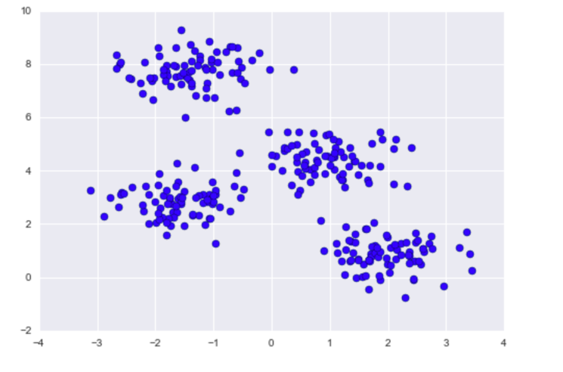
Figure 1: Spherical Data (VanderPlas, 2024)
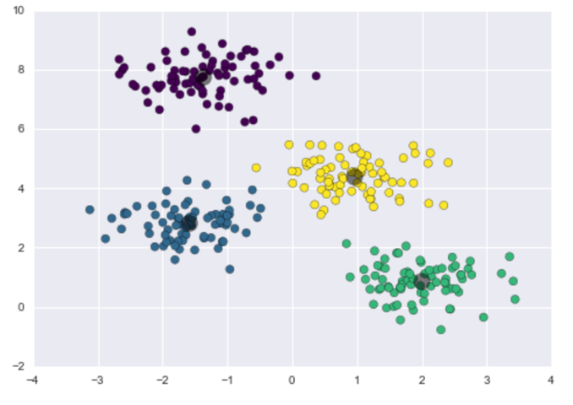
Figure 2: Clustered Spherical Data (VanderPlas, 2024)
The non-spherical data example in Figure 3 shows how some relationships between data points will be lost if k-means clustering is used to determine relationships in the data.
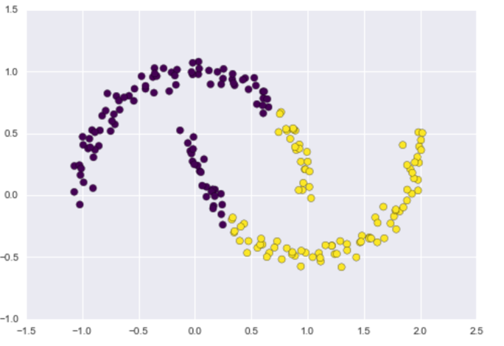
Figure 3: Non-spherical clustering (VanderPlas, 2024)

B3: Packages and Libraries
Packages and Libraries | Usage in analysis
pandas | Import data into DataFrame, One hot encoding
numpy | Objects are arrays for calculations
matplotlib.pyplot | Visualizations
seaborn | Visualizations
sklearn.cluster import KMeans | Run the K-means model for clustering data
sklearn.preprocessing import StandardScaler | Variable standardization
collections import Counter | Find the size of the clusters
sklearn.metrics import silhouette_score | Find the silhouette score

Part III Preparation
C :
C1: Preprocessing
When creating a K-means model for clustering, it is necessary to preprocess the data. Preprocessing tasks can include cleaning and ensuring no missing or null values. Data wrangling tasks can also be part of the preprocessing. These tasks ensure an accurate, well-fitted model. The most crucial preprocessing task performed on this data was scaling, which allowed for comparing the different measurement units in the patient variables.
When there are large distances between variables due to being on a larger scale, those measurements will dominate. Scaling of data allows variables on different measurement scales to be compared using the same comparison scale. The variable Age (Age) is in years, Vitamin D levels (VitD_levels) measured in nanograms per milliliter (ng/ml), and the length of stay (Initial_ days) measured in days, making comparing the two difficult. A k-means model would give unequal weight to these variables without scaling, as the variables with larger absolute values would dominate the algorithm's distance calculation. By standardizing the variables, each feature contributes equally to the distance calculations during the clustering process (Kumar, 2024).
The data was scaled using StandardScaler() from sklearn.preprocessing library.
scaled_df = StandardScaler().fit_transform(df_final)
scaled_df = pd.DataFrame(scaled_df, columns=df_final.columns)

The difference in the numerical values can be seen in a comparison before and after the scaling.
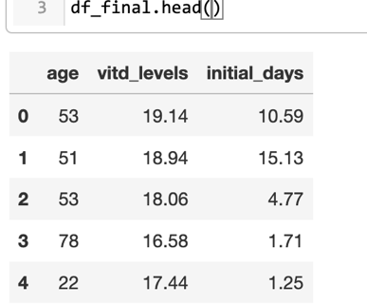
Figure 4: Before Scaling
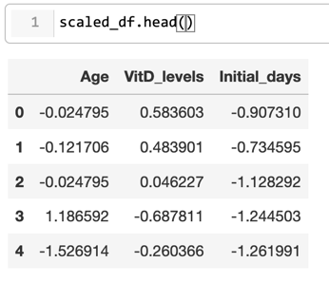
Figure 5: After StandardScaler()
C2: Variable Description
When creating k-means clusters, all the data should be continuous numeric. The data set was examined and passed down through several cleaning steps. The chart below shows each variable's data type (Soetewey, 2019) in the data to determine if it would be selected for the final model. The final variables chosen for the analysis are highlighted in blue.

Variable | Variable Type | Data Type | Selected final analysis
Population | Numeric | Discrete | No
Area | Categorical | Nominal | No
Timezone | Categorical | Nominal | No
Job | Categorical | Nominal | No
Children | Numeric | Discrete | No
Age | Numeric | Continuous | Yes
Education | Categorical | Nominal | No
Employment | Categorical | Nominal | No
Income | Numeric | Continuous | No, Considered
Marital | Categorical | Nominal | No
Gender | Categorical | Nominal | No
ReAdmis | Categorical | Nominal / Bivariate | No
VitD_levels | Numeric | Continuous | Yes
Doc_visits | Numeric | Discrete | No
Full_meals_eaten | Numeric | Discrete | No
VitD_supp | Numeric | Discrete | No
Soft_drink | Categorical | Nominal | No
Initial_admin | Categorical | Nominal | No
HighBlood | Categorical | Nominal / Bivariate | No
Stroke | Categorical | Nominal / Bivariate | No
Complication_risk | Categorical | Nominal | No
Overweight | Categorical | Nominal / Bivariate | No
Arthritis | Categorical | Nominal / Bivariate | No
Diabetes | Categorical | Nominal / Bivariate | No
Hyperlipidemia | Categorical | Nominal / Bivariate | No
Backpain | Categorical | Nominal / Bivariate | No
Anxiety | Categorical | Nominal / Bivariate | No
Allergic rhinitis | Categorical | Nominal / Bivariate | No
Reflux esophagitis | Categorical | Nominal / Bivariate | No
Asthma | Categorical | Nominal / Bivariate | No
Services | Categorical | Nominal | No
Initial_days | Numeric | Continuous | Yes
TotalCharge | Numeric | Continuous | No, considered
Additional_charges | Numeric | Continuous | No, considered

C3: Analysis Preparation Steps
Often, the data for an analysis needs to be prepared through cleaning, exploration, and wrangling. These preprocessing steps ensure clean data that will create an accurate model.
The steps for this analysis included:
  - Duplicate removal
  - Finding and treating missing values
  - Determining variables to be removed
  - Identify outliers
  - Scaling of numerical data

- Import and examine the data set
This step allows for familiarization with the data that will be worked with
med_df = pd.read_csv('medical_clean.csv')
med_df.info()
- Find and remove duplicates
This step removes data that could skew the results if left in and counted more than once.
print(med_df.duplicated().value_counts())
print(med_df.duplicated().sum())

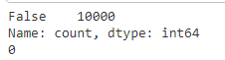
- Find Null values
This step finds values outside the data set. Many functions will not run if missing values are in the data set. Missing values are removed, but they are not the same as zero values, which should remain in the data.

med_df.isnull().sum()
#Visualization of missing values- Heatmap
plt.figure(figsize=(12, 8))
sns.heatmap(med_df.isnull(), cbar=False, cmap='viridis', yticklabels=False, xticklabels=med_df.columns)
plt.xticks(rotation=90)
plt.title('Missing Data Visualization')
plt.xlabel('Columns')
plt.ylabel('Rows')
plt.show()
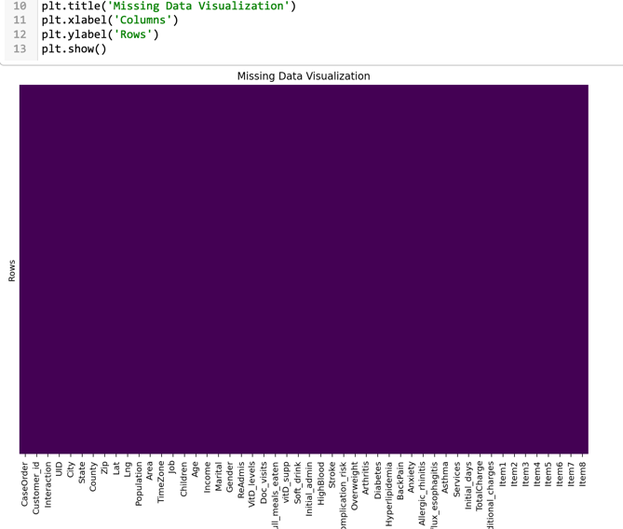

- Remove null values
Null values are removed in the cleaning process as many functions can not be correctly calculated without the information.
No null values were found. The data set was then renamed as a checkpoint in which duplicates and null values were addressed.
clean_df = med_df.copy()

- Remove columns that will not be used due to being an identifier or the volume of variables being unable to be used to build a desired prediction model.
clean_df.describe()
# Clean the data set columns using created function based on thresholds (Bold Analytics: Mark Keith, 2024)
#missing_threshold = 0.95, unique threshold = 0.95, only 1 value in a column --> removes
#Function
def clean_columns(df, columns =[], missing threshold = 0.95, unique threshold = 0.95, messages = True):

if len(columns) == 0:
columns = df.columns #this lets the columns be blank, and every column will be cleaned

for col in columns:
if col in df.columns:
missing = df[col].isna().sum()
unique = df[col].nunique()
rows = df.shape[0]

if missing / rows >= missing_threshold:
if messages: print(f"To many missing values with ({missing} out of {rows}, {round((missing / rows) * 100, 2)}%) for {col}, removed")
df.drop(columns =[col], inplace = True)
# For non-numeric columns, check if there are too many unique values
if not pd.api.types.is_numeric_dtype(df[col]) and (unique / rows >= unique threshold):
if messages:
print(f"Too many unique values with ({unique} out of {rows}, {round((unique / rows) * 100, 2)}%) for {col}, removed")
df.drop(columns=[col], inplace=True)
continue
elif unique == 1:
if messages: print(f"Only one value in ({df[col].unique()[0]} for {col}, removed")
df.drop(columns =[col], inplace = True)

else:
if messages: print(f"The column variable \"{col}\" doesnt exist as spelled in the DataFrame provided")
return df

clean_columns(clean_df)

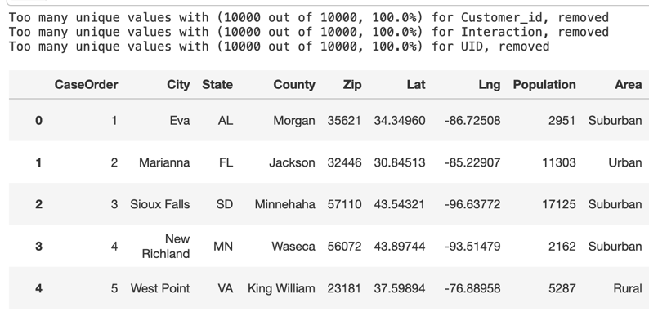
- Create a smaller data frame of continuous variables to consider for the k-means model.
df_cluster = clean_df[[
"Age", "Income", "VitD_levels", "Initial_days", "TotalCharge",
"Additional_charges"
]].copy()
df_cluster.info()
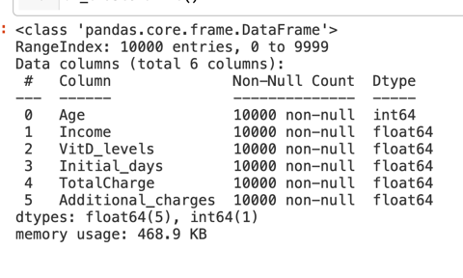

- Explore summary statistics and univariate visualizations
This step allows for familiarization with the data statistics to determine the distribution and the need to deal with outliers. Many models are sensitive to outliers and must be cleaned to help reduce errors within a model.

# Summary statistics
df_cluster.describe()

# Univariate visualizations
def plot_distributions(df, figsize=(10, 6), max_categories=30):
for col in df.columns:
col_data = df[col].dropna()

plt.figure(figsize=figsize)

if pd.api.types.is_numeric_dtype(col_data):
# Histogram with KDE for numeric data
sns.histplot(col_data, kde=True)
plt.title(f'Distribution of {col}')

else:
# Bar plot for categorical data
value_counts = col_data.value_counts()
if len(value_counts) > max_categories:
value_counts = value_counts.head(max_categories)
plt.title(f'Top {max_categories} Categories in {col}')
else:
plt.title(f'Category Distribution of {col}')

sns.barplot(x=value_counts.index, y=value_counts.values)
plt.xticks(rotation=45, ha='right')

plt.tight_layout()
plt.show()
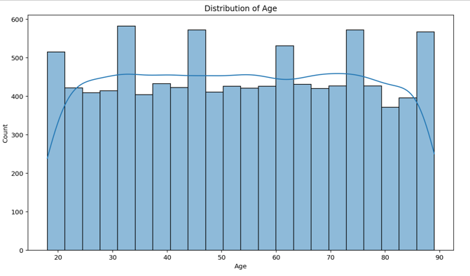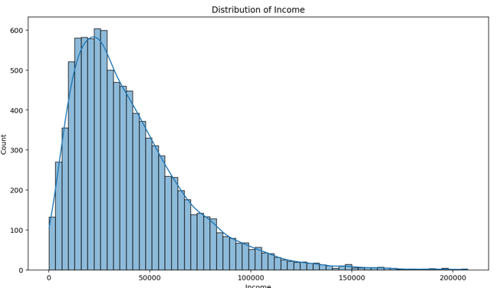
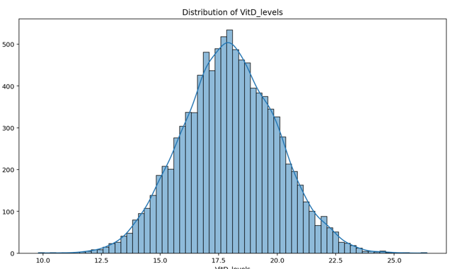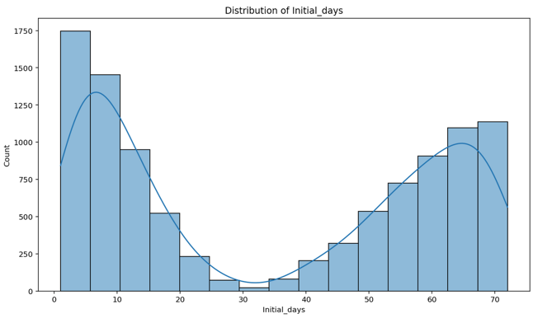
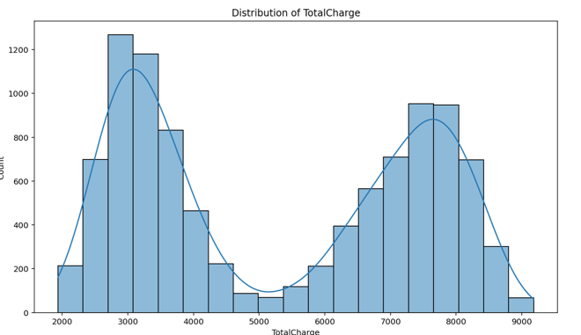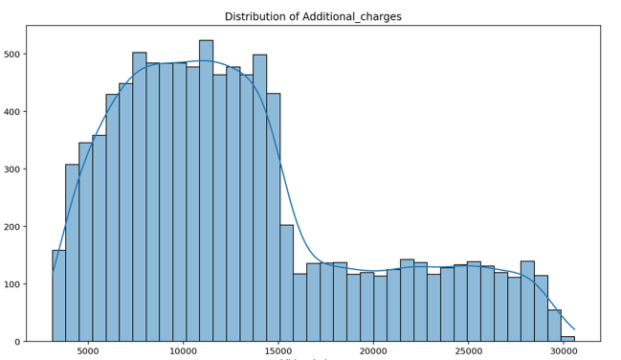

- Clean white spaces and round decimals
Cleaning data, such as white spaces and rounding decimals, helps with readability and prevents errors by creating uniformity within the data.

## Remove spaces in category names within columns
# To replace spaces with underscores in specific columns

for col in df_cluster.columns:
if not pd.api.types.is_numeric_dtype(df_cluster[col]):
df_cluster[col] = df_cluster[col].str.replace(" ", "_", regex = False)

##Clean White Space and make all lower case
df_cluster.columns = df_cluster.columns.str.lower().str.strip()

#round values to 2 decimal points
df_cluster = df_cluster.round(2).copy()

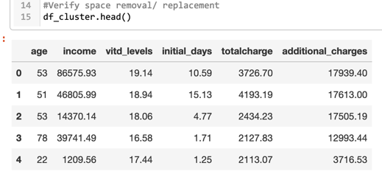

- Detect outliers
Outliers must be detected and evaluated to determine whether they are expected or erroneous data (Horsch, 2021). Additionally, it must be assessed whether the outliers can be tolerated or need to be treated. K-means models are sensitive to outliers and may create inappropriate clusters based on the strength of the outlier influence (Ankita, 2024).

#Function for Winsorization of outliers, using IQR
def winz_outliers(df):

print("Outlier Analysis Report")
print("=" * 50) # Print a separator line for visual clarity

for col in df:
if pd.api.types.is_numeric_dtype(df[col]):
Q1 = df[col].quantile(0.25)
Q3 = df[col].quantile(0.75)
IQR = Q3 - Q1
outliers = ((df[col] < (Q1 - 1.5 * IQR)) | (df[col] > (Q3 + 1.5 * IQR)))
outlier_count = outliers.sum()

if outlier_count > 0:
outer_fence = 3 * IQR
outer_fence_low = Q1 - outer_fence
outer_fence_up = Q3 + outer_fence

# Consolidating the print statements for each column
print(f"\nColumn: {col}")
print(f"Number of Outliers: {outlier_count}")
print(f"Lower Outer Fence: {round(outer_fence_low, 2)}")
print(f"Upper Outer Fence: {round(outer_fence_up, 2)}")

print("=" * 50)

winz_outliers(df_cluster)

# Create a boxplot for each column
for column in outlier_shape:
sns.boxenplot(x=df_cluster[column])
plt.title(f'Boxplot of {column}')
plt.show()

Several Outliers were expected and left unchanged since they were both reasonable and expected.
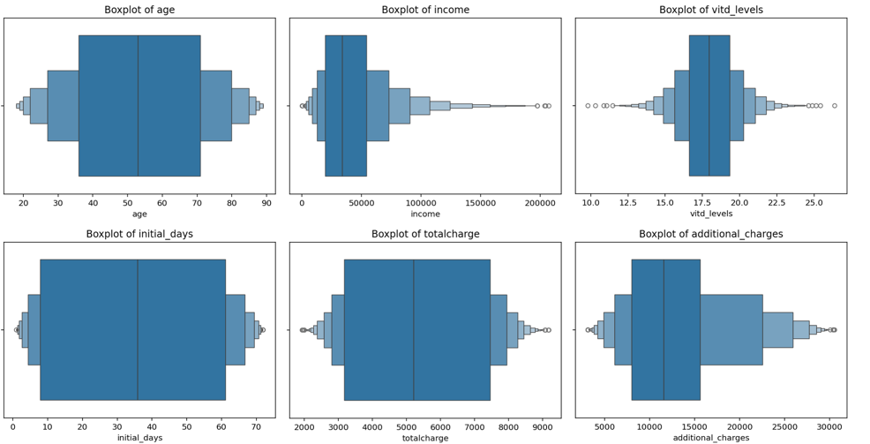

- Final variables were chosen, and a smaller data frame was created. The variables selected for the k-means model were Age (age), Vitamin D levels (vitd_levels), and length of stay (initial_days). These

# Will use 3 variables for clustering
df_final = df_cluster[["age", "vitd_levels", "initial_days"]].copy()
df_final.head()

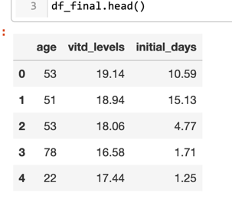
- Standardized the data using scikit-learn StandardScaler (Gramfort et al., 2022).

scaled_df = StandardScaler().fit_transform(df_final)
scaled_df = pd.DataFrame(scaled_df, columns=df_final.columns)

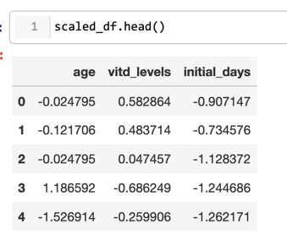

C4: Clean Data
A file of the cleaned data set is attached as a .csv file labeled KMeans_data.csv.

Part IV Analysis
D :
D1: Determine K Clusters
The number of k clusters must be determined ahead of time when using the k-means model because the algorithm itself does not determine the optimal number of clusters (VanderPlas, 2024). Organizational considerations or the subject matter may determine the optimal number of clusters. If there is no predetermined number of preferred clusters, several statistical methods may be used to evaluate the ideal number (Bruce et al., 2020, p. 302). For this analysis, three clusters were selected as a starting point, and then the elbow method was implemented to help determine the optimal number of clusters. Once the elbow method was analyzed, a new k cluster was chosen to re-run the k-means model.
The k-means model was instantiated with a k of 3, and the scaled data fit to the model.
kmeans_first = KMeans(init = "k-means++",
n_clusters = 3,
n_init = 50,
random_state = 42)
kmeans_first.fit(scaled_df)
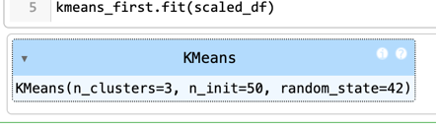

After the model was fit, several results were revised, including the cluster labels, the count of variables assigned to each label, and the cluster centers.
labels = kmeans_first.labels_
Counter(kmeans_first.labels_)
centers = pd.DataFrame(kmeans_first.cluster_centers_,
columns = ["age", "vitd_levels", "initial_days"])
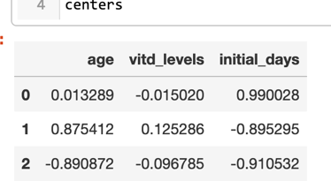
Figure 6: K-Means Centers
The cluster center results allow interpretation of how the variables associate or vary together in different groups within the data. The analysis can also be visualized to help with interpretation (Bruce et al., 2019).
f, axes = plt.subplots(3, 1, figsize=(5, 5), sharex=True)
for i, ax in enumerate(axes):
center = centers.loc[i, :]
maxPC = 1.01 * np.max(np.abs(center))
color = ["blue" if l > 0 else "red" for l in center]
ax.axhline(color="#888888")
center.plot.bar(ax=ax, color=color)
ax.set_ylabel(f"Cluster{i}")
ax.set_ylim(-maxPC, maxPC)

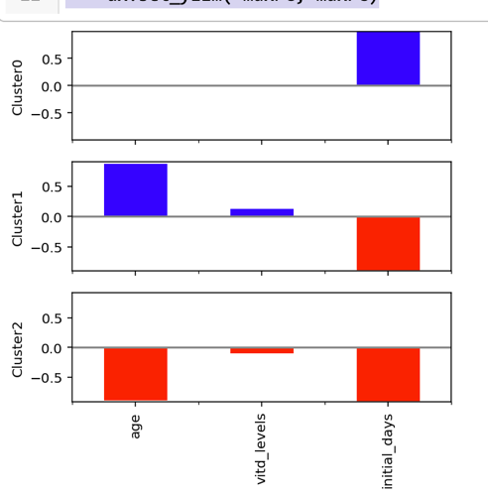

The clusters were plotted to visualize the size of each cluster.
# Create 3D plot
fig = plt.figure(figsize=(10, 8))
ax = fig.add_subplot(111, projection='3d')

scatter = ax.scatter(
scaled_df['age'],
scaled_df['vitd_levels'],
scaled_df['initial_days'],
c=labels,
cmap='viridis'
)

ax.scatter(
centers['age'],
centers['vitd_levels'],
centers['initial_days'],
marker='x',
color='red',
s=200,
linewidths=3,
label='Cluster Centers'
)

ax.set_title("K-means Clustering")
ax.set_xlabel("Age")
ax.set_ylabel("VitD_levels")
ax.set_zlabel("Initial_days")

ax.legend()

for pane in [ax.xaxis.pane, ax.yaxis.pane, ax.zaxis.pane]:
pane.fill = True
pane.set_color((0.8, 0.8, 1.0, 1.0))

plt.tight_layout()

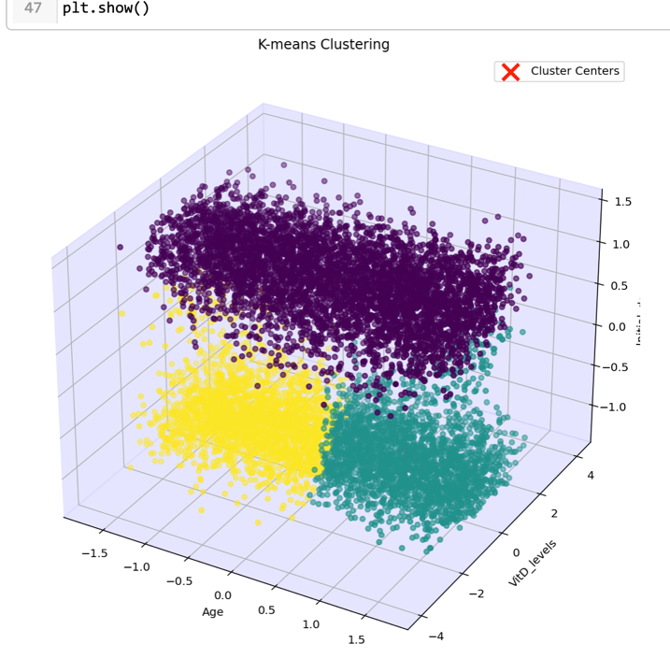
Since the k value for this initial model was chosen randomly, an analysis was performed to find the optimal number of clusters. The k-means model is run for a range of k-values, and the within-cluster SSE is plotted against each k. The visualization reveals a point on the graph where the slope decreases sharply, which is then used as the ideal k value. This is called the “elbow method” (Bruce et al., 2019, p. 302).
kmeans_kwargs = {"init": "k-means++",
"n_init": 50,
"random_state": 42}

# Find Sum of Squared errors (SSE)for each iteration of k.
sse =[]
for k in range(2,11):
kmeans = KMeans(n_clusters = k, **kmeans_kwargs)
kmeans.fit(scaled_df)
sse.append(kmeans.inertia_)
sse_s = pd.Series(sse, index = range(2, 11))

plt.figure(figsize = (10, 8))
ax = sns.lineplot(y =sse_s, x = sse_s.index)
ax = sns.scatterplot(y =sse_s, x = sse_s.index, s = 200)
plt.xlabel("Number of Clusters")
plt.ylabel("Sum of Squared Errors")

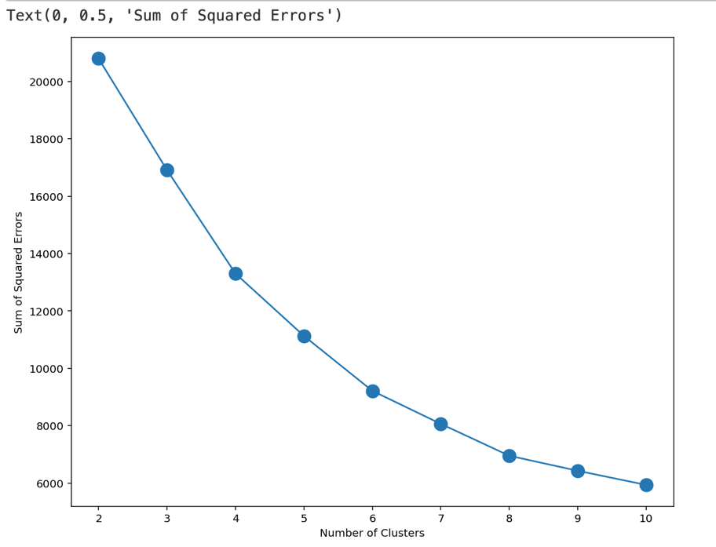

The point, or “elbow” in this plot, appears at six, so the model will be re-run with this value.
kmeans_model = KMeans(init="k-means++",
n_clusters=6,
n_init=50,
random_state=42)
kmeans_model.fit(scaled_df)
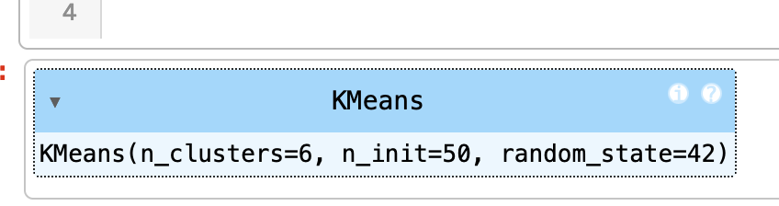

D2: Code
A Jupyter Notebook file of all the code used in the analysis is attached as PBier_212_pt1.ipynb.

E : Implications and Summary
E1: Cluster Quality
The quality of the clusters was evaluated using the Silhouette Score. This method evaluates how similar points are within each cluster while also measuring the separation between clusters. The score ranges from -1 to 1, with higher scores meaning the clusters are well-defined. It was found that the model with six clusters had a slight improvement over the model with only three.
The Silhouette Score was found for the first model as well as the final model.
silhouette_first = silhouette_score(scaled_df, kmeans_first.labels_).round(4)
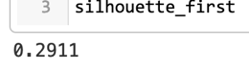
silhouette_value = silhouette_score(scaled_df, kmeans_model.labels_).round(2)
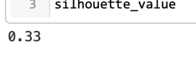
The initial model had a score of 0.29, and the final model had a score of 0.33. This improvement led to selecting six as the value of k for the final analysis. However, the final model's quality was still low, implying potential misclassification of data points or overlapping clusters since scores between 0.25 and 0.5 indicate overlapping clusters. A score above 0.5 is considered necessary for moderately well-classified clusters (Sacthesw, 2024).

E2: Results
The final model clusters were plotted and visualized.
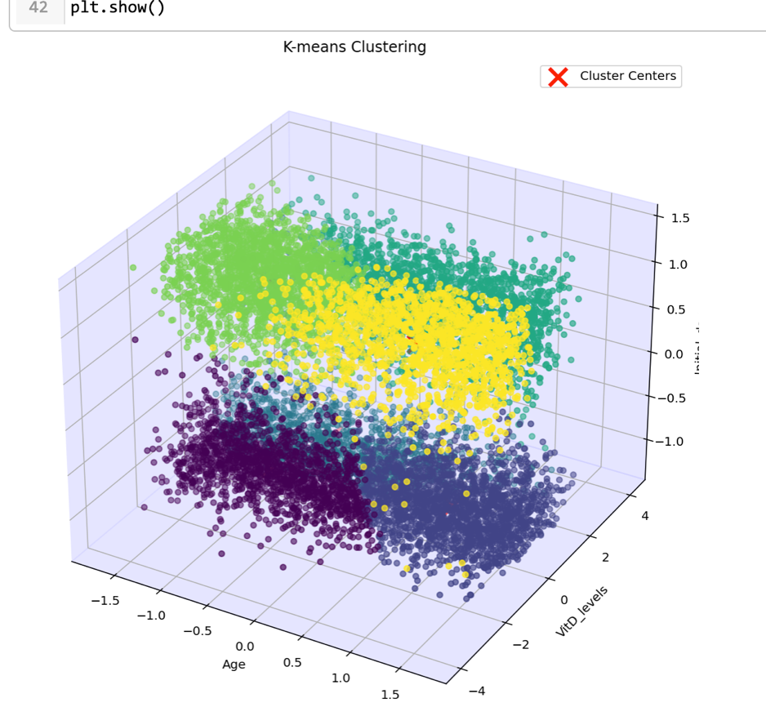
The cluster centers were analyzed and visualized to examine the relationships between the variables within each group.
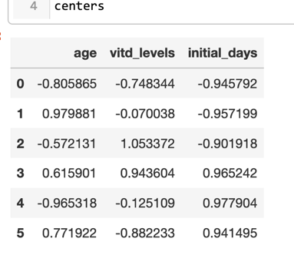
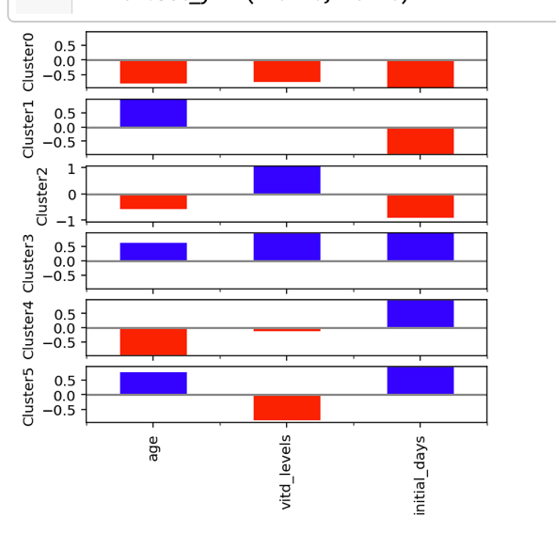
The cluster results can be interpreted as follows:
Cluster 0:
- Younger age group
- Very low vitamin D levels
- Very low length of stay
Cluster 1:
- Oldest age group
- Below-average vitamin D levels
- Very low length of stay
Cluster 2:
- Younger age group
- High vitamin D levels
- Low length of stay
Cluster 3:
- Medium aged group
- High vitamin D levels
- High length of stay
Cluster 4:
- Youngest age group
- Below-average vitamin D levels
- High length of stay
Cluster 5:
- Medium-high age group
- Very low vitamin D levels
- High length of stay
These results imply that there may be a relationship between vitamin D levels and length of stay that can change with age. These results should be interpreted with caution based on the final model's low Silhouette Score (0.33).

E3: Analysis limitation
This analysis ran the model with only a single random state, limiting the thoroughness of the cluster evaluation. The ideal number of clusters may not be found in this analysis, which is hinted at by the low Silhouette score.
When finding the optimal number of clusters, the k-means algorithm looks for the best k value based on the initial randomly assigned cluster centers. The algorithm may give different results each time it is run. To find the best number of clusters, it is recommended that the model be run multiple times with different random states (random_state) so that the results can then be compared to pick the optimum cluster number (James et al., 2023, p. 523). Assigning a new value to this factor means a new centroid starting point will be chosen, possibly returning different results. The random state parameter allows the analyst to reproduce the results once the optimal number of clusters has been found.

E4: Recommendations
Based on the results, this analysis recommends no immediate change in critical processes. With low confidence in the model outcome due to the poor Silhouette score, it could be a costly mistake if further exploration is not implemented. While hearing negative news after analysis can be frustrating, the result can prevent resource investment based on anecdotal evidence.
Some investigative projects to look further into patient groups:
  - Running the k-means model with an appropriate weighting of the variables, such as the importance of age over vitamin D levels.
  - Using an alternative model, such as hierarchical clustering, which does not require choosing a pre-defined number of clusters.

Part VI
F: Panopto
https://wgu.hosted.panopto.com/Panopto/Pages/Viewer.aspx?id=c8f99bf7-e514-4ed1-b8f5-b231015e0255

G: Web sources
Ankita (2024, October 17). K-Means: Getting the Optimal Number of Clusters. Analytics Vindhya. Retrieved November 15, 2024, from https://www.analyticsvidhya.com/blog/2021/05/k-mean-getting-the-optimal-number-of-clusters/

[Bold Analytics : Mark Keith]. (2024, February 5). Python Data Science: Automating Cleaning: Data Wrangling: Empty, Single Value, Primary Key Columns [Video]. YouTube. https://www.youtube.com/watch?v=8IsxTImOhF0&list=PLe9UEU4oeAuX3GZgRKzUlLcHd5SpYzZGW&index=8

Gramfort, A., Blondel, M., & Grisel, O. (2022, October 18). StandardScaler. Scikit Learn. Retrieved November 15, 2024, from https://scikit-learn.org/stable/modules/generated/sklearn.preprocessing.StandardScaler.html

Horsch, A. (2021, February 14). Detecting and Treating Outliers In Python — Part 3 Hands-On Tutorial On Treating Outliers — Winsorizing and Imputation. Towards Data Science. Retrieved April 15, 2024, from https://towardsdatascience.com/detecting-and-treating-outliers-in-python-part-3-dcb54abaf7b0

Karani, D. (2022, March 27). A Practical Guide on K-Means Clustering. Towards Data Science. Retrieved November 15, 2024, from https://towardsdatascience.com/a-practical-guide-on-k-means-clustering-ca3bef3c853d

Kumar, D. (2018, December 25). Introduction to Data Preprocessing in Machine Learning. Towards Data Science. Retrieved November 15, 2024, from https://futuremachinelearning.org/understanding-silhouette-score-a-key-metric-for-clustering/

Sacthesw, F. (2024). Understanding Silhouette Score: A Key Metric for Clustering. Future Machine Learning. Retrieved November 15, 2024, from https://futuremachinelearning.org/understanding-silhouette-score-a-key-metric-for-clustering/

Savyakhosla (2024, March 21). K-means++ Algorithm. Geeks for Geeks. Retrieved November 15, 2024, from https://www.geeksforgeeks.org/ml-k-means-algorithm/#

Soetewey, A. (2019, December 30). Variable types and examples. Stats and R. Retrieved August 26, 2023, from https://statsandr.com/blog/variable-types-and-examples/

I: Sources

Bruce, P., Bruce, A., & Gedeck, P. (2019). Practical Statistics for Data Scientists: 50+ Essential Concepts Using R and Python (2nd ed.). O'Reilly Media.

James, G., Witten, D., Hastie, T., Tibsharani, R., & Taylor, J. (2023). An Introduction to Statistical Learning with Applications in Python . Springer.

References
Ankita (2024, October 17). K-Means: Getting the Optimal Number of Clusters. Analytics Vindhya. Retrieved November 15, 2024, from https://www.analyticsvidhya.com/blog/2021/05/k-mean-getting-the-optimal-number-of-clusters/

[Bold Analytics : Mark Keith]. (2024, February 5). Python Data Science: Automating Cleaning: Data Wrangling: Empty, Single Value, Primary Key Columns [Video]. YouTube. https://www.youtube.com/watch?v=8IsxTImOhF0&list=PLe9UEU4oeAuX3GZgRKzUlLcHd5SpYzZGW&index=8

Bruce, P., Bruce, A., & Gedeck, P. (2019). Practical Statistics for Data Scientists: 50+ Essential Concepts Using R and Python (2nd ed.). O'Reilly Media.

Gramfort, A., Blondel, M., & Grisel, O. (2022, October 18). StandardScaler. Scikit Learn. Retrieved November 15, 2024, from https://scikit-learn.org/stable/modules/generated/sklearn.preprocessing.StandardScaler.html

Horsch, A. (2021, February 14). Detecting and Treating Outliers In Python — Part 3 Hands-On Tutorial On Treating Outliers — Winsorizing and Imputation. Towards Data Science. Retrieved April 15, 2024, from https://towardsdatascience.com/detecting-and-treating-outliers-in-python-part-3-dcb54abaf7b0

James, G., Witten, D., Hastie, T., Tibsharani, R., & Taylor, J. (2023). An Introduction to Statistical Learning with Applications in Python . Springer.

Karani, D. (2022, March 27). A Practical Guide on K-Means Clustering. Towards Data Science. Retrieved November 15, 2024, from https://towardsdatascience.com/a-practical-guide-on-k-means-clustering-ca3bef3c853d

Kumar, D. (2018, December 25). Introduction to Data Preprocessing in Machine Learning. Towards Data Science. Retrieved April 15, 2024, from https://towardsdatascience.com/introduction-to-data-preprocessing-in-machine-learning-a9fa83a5dc9d

Sacthesw, F. (2024). Understanding Silhouette Score: A Key Metric for Clustering. Future Machine Learning. Retrieved November 15, 2024, from https://futuremachinelearning.org/understanding-silhouette-score-a-key-metric-for-clustering/

Savyakhosla (2024, March 21). K-means++ Algorithm. Geeks for Geeks. Retrieved November 15, 2024, from https://www.geeksforgeeks.org/ml-k-means-algorithm/#

Soetewey, A. (2019, December 30). Variable types and examples. Stats and R. Retrieved August 26, 2023, from https://statsandr.com/blog/variable-types-and-examples/

