CPU4-103 Database Design and Implementation Report
https://github.com/petbul4epm/NHS_Assignment
Introduction
This project focuses on the design and implementation of a relational database for an NHS healthcare system using MySQL Workbench. The purpose of the database is to replace paper-based records and unstructured Microsoft Word and Excel files with a secure, efficient, and scalable relational database. The system stores and manages information about patients, doctors, clinics, appointments, and medications separately while maintaining data integrity through normalisation and relational constraints. This project demonstrates the application of database design principles, SQL programming, and database security within the NHS.
Entity Relationship Design
The Entity Relationship Diagram (ERD) provides the design of the database.
Six entities are identified and tables were created for them:
Clinic
Doctor
Patient
Medication
Appointment
Treatment
The relationships are:
Clinic (1) → (M) Doctor : One Clinic can employ many Doctors.
Doctor (1) → (M) Appointment: One Doctor can manage many Appointments
Patient (1) → (M) Appointment: One Patient can have many Appointments
Appointment (1) → (1) Treatment: Each Appointment is linked to one Treatment.
Patient (1) → (M) Medication: Each patient can have multiple medications.
Primary keys uniquely identify each record, while foreign keys establish relationships between the entities and maintain referential integrity.
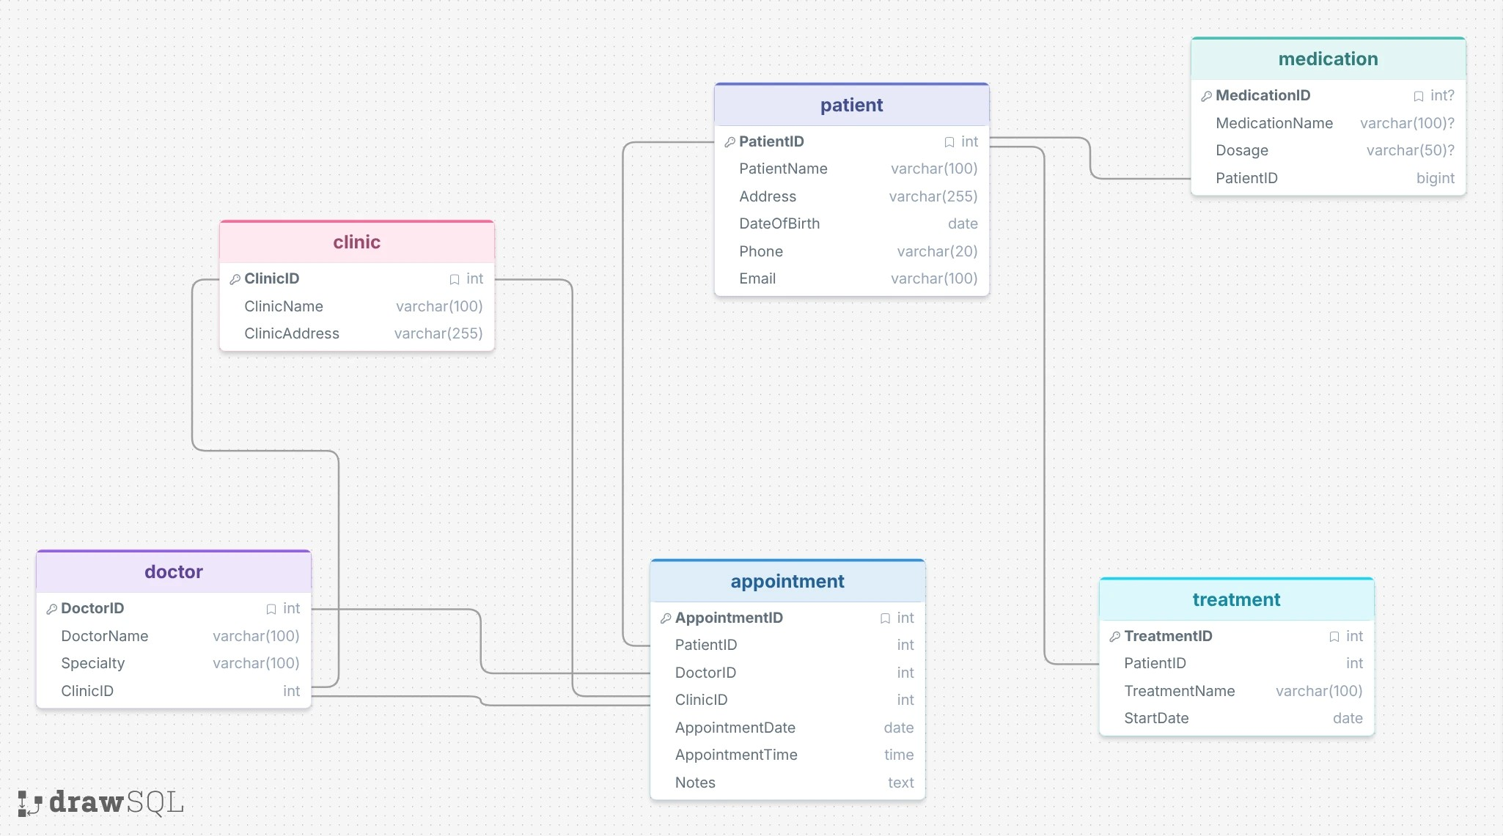

An Entity Relationship Diagram (ERD) is developed using Crow's Foot notation to identify the relationships between the main entities. The final database consists of six main tables: Patient, Doctor, Clinic, Appointment, Medication, and and Treatment. Each table contains a primary key to uniquely identify records, while foreign keys establish relationships between the tables and maintain referential integrity.

The database design begins with analysing the unnormalised NHS dataset( data file) provided in the assignment brief. The original dataset contains repeated patient information, doctor details, clinic addresses, medication lists, and appointment information stored within a single table. This structure creates redundancy and increases the risk of update, insertion, and deletion anomalies.
Normalisation organises data into logical tables to reduce redundancy and improve consistency.
The database is normalised to Third Normal Form (3NF). During First Normal Form (1NF), repeating groups such as multiple medications stored in a single field are removed so that each attribute contains only one value. In Second Normal Form (2NF), partial dependencies are eliminated by separating patient, doctor, and clinic information into individual tables. Finally, Third Normal Form (3NF) removes transitive dependencies by ensuring that all non-key attributes depend only on the primary key of their respective table. This process reduces data redundancy, improves consistency, and makes the database easier to maintain.
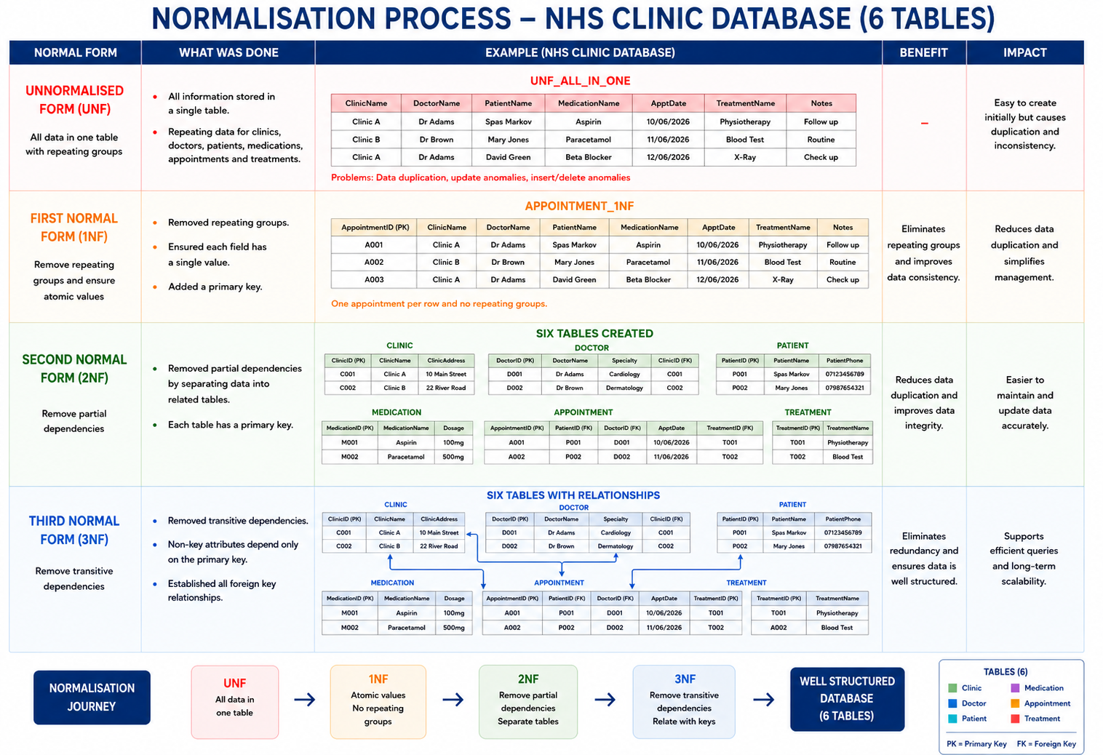

The physical database is implemented using MySQL Workbench. SQL Data Definition Language (DDL) statements create the database, tables, primary keys, foreign keys, and constraints.
SQL Data Manipulation Language (DML) statements populate each table with sample records to test the relationships and functionality of the system.
Relational Schema
The completed relational schema consists of five tables:
- Clinic
- Doctor
- Patient
- Appointment
- Medication
- Treatment
This structure ensures minimal redundancy while maintaining strong relationships between tables.
Each table includes:
- Primary Keys
- Foreign Keys
- NOT NULL constraints
- AUTO_INCREMENT identifiers
These constraints improve data validation and maintain referential integrity throughout the database.
Testing and Validation
Several SQL statements demonstrate the proper functioning of the database. Aggregate functions such as COUNT() calculate the total number of patients stored in the database. INNER JOIN and LEFT JOIN queries combine information from multiple tables to display patient appointments alongside doctor and clinic information. These queries show how a relational database retrieves related information efficiently without unnecessary duplication of data.
Inner JOIN queries retrieve appointment information alongside doctor and patient details.
GROUP BY clauses summarise appointment statistics.
Stored procedures automate frequently executed queries, while triggers validate information before records are inserted into the database.
These features improve efficiency and reduce repetitive coding.
Examples for queries are:
Query 1.
SELECT p.PatientName,
d.DoctorName,
a.AppointmentDate
FROM Appointment a
JOIN Patient p ON a.PatientID = p.PatientID
JOIN Doctor d ON a.DoctorID = d.DoctorID;
Query 2: Number of Patients per Doctor
SELECT DoctorID,
COUNT(*) AS TotalPatients
FROM Appointment
GROUP BY DoctorID;
Query 3: Show all appointments with patient, doctor, and clinic details
SELECT p.PatientName,
d.DoctorName,
c.ClinicName,
a.AppointmentDate
FROM Appointment a
JOIN Patient p
ON a.PatientID = p.PatientID
JOIN Doctor d
ON a.DoctorID = d.DoctorID
JOIN Clinic c
ON d.ClinicID = c.ClinicID
ORDER BY a.AppointmentDate;

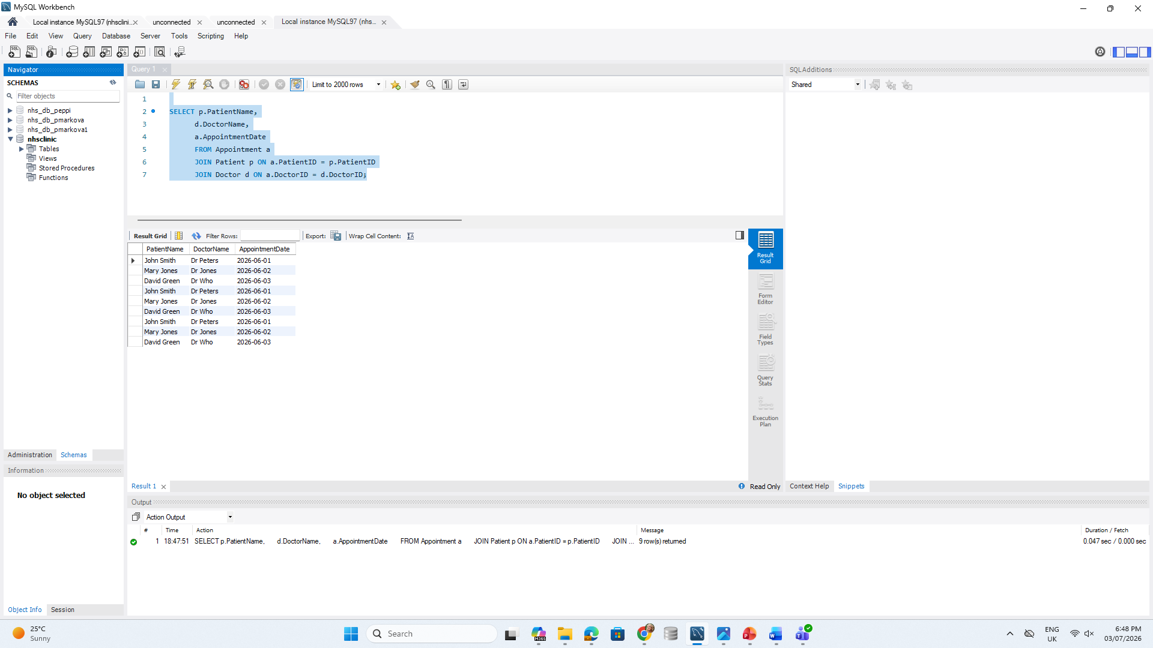

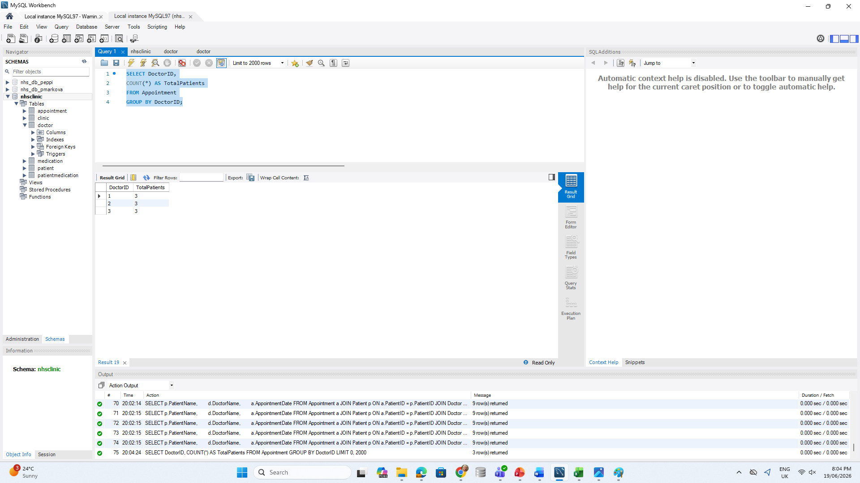
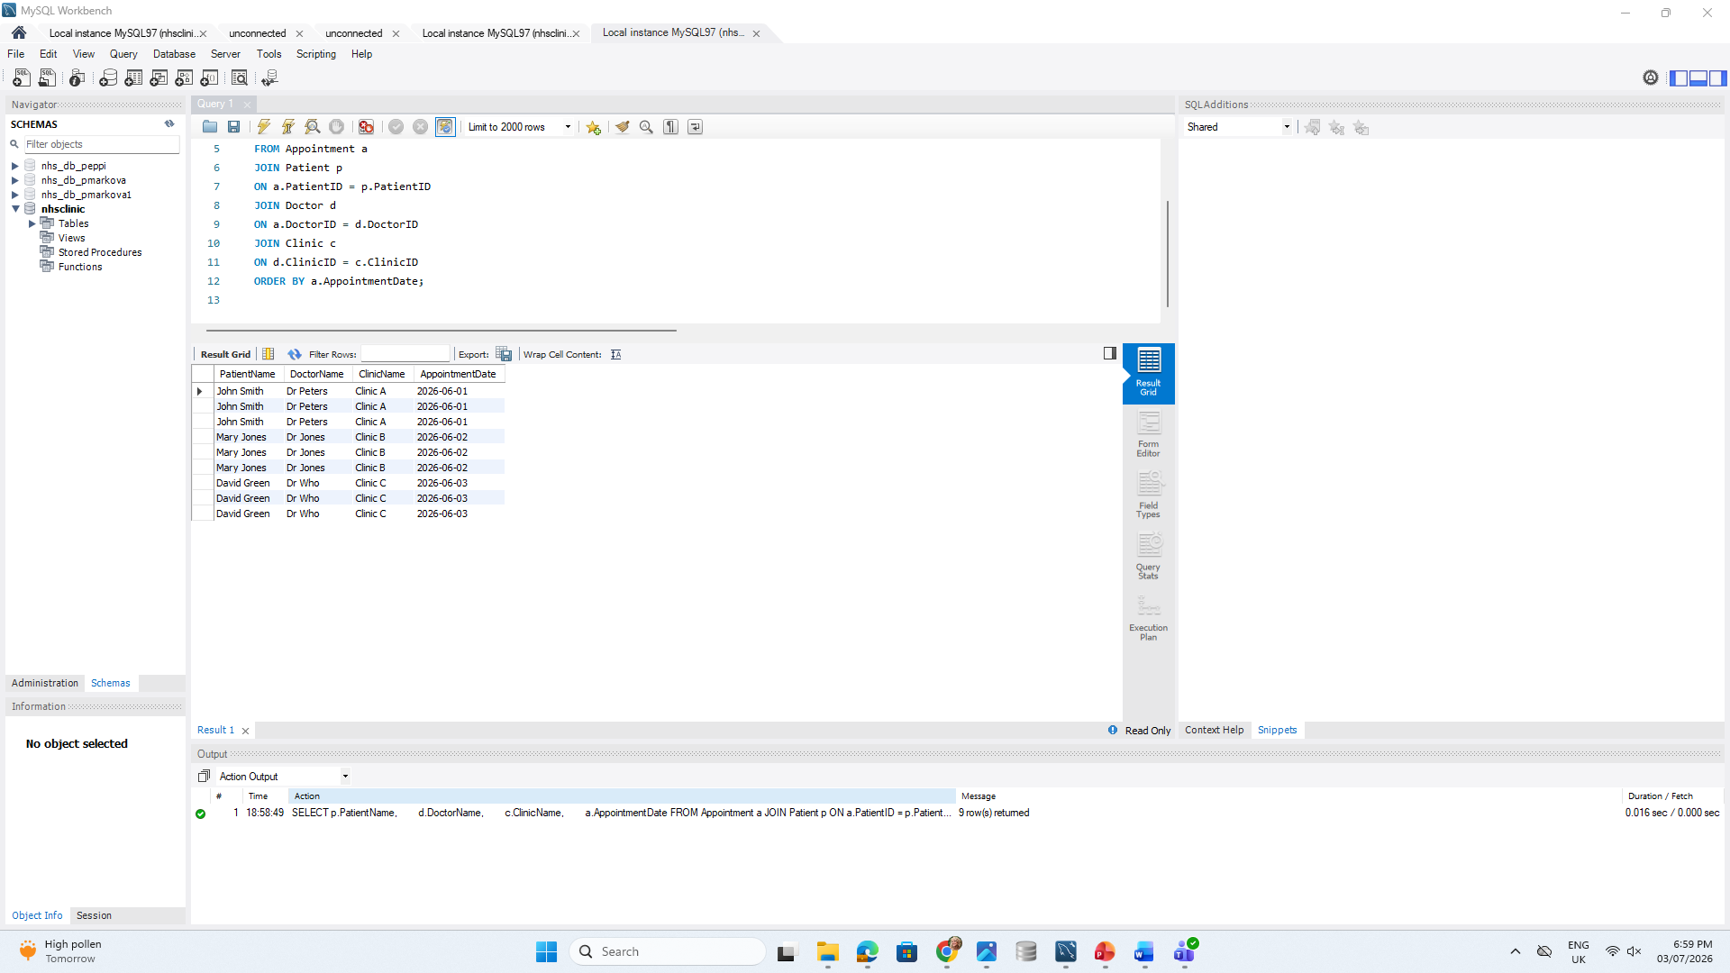

Database Security
Healthcare databases contain highly sensitive personal information. Appropriate security measures are therefore essential.
The database includes:
- User authentication
- Role-based permissions
- Input validation
- Referential integrity constraints
- Regular backups
The system follows the principles of the UK General Data Protection Regulation (UK GDPR), ensuring that patient information remains confidential, accurate, and secure.

Only authorised users should have access to patient records, and sensitive information should be protected against unauthorised disclosure.
Database security is implemented by creating four different user roles: Administrator, Doctor, Receptionist, and Patient. Each role receives permissions that match its responsibilities using SQL GRANT statements. Administrators have full access to the database, doctors can view and update patient information, receptionists manage appointments, and patients have limited read-only access to their own records.
Sensitive information, such as passwords, is protected using the SHA-256 hashing function. Although the database contains sample data, password hashing demonstrates how confidential information is securely stored within a healthcare system. These security measures help protect patient information while supporting the principles of confidentiality, integrity, and availability.
Reflection
This project improves my understanding of relational databases design and SQL programming. It allows me to apply database normalisation techniques, create relationships using primary and foreign keys, and write SQL statements to build and manage a relational database.
Creating stored procedures and triggers helps me understand how databases automate routine tasks, while implementing user roles and password hashing demonstrates the importance of protecting sensitive healthcare information. One of the main challenges is ensuring that tables are created in the correct order so that foreign key relationships work successfully. Testing each stage of the database within MySQL Workbench helps identify syntax errors and confirms that all relationships function correctly.
Overall, this project strengthens my knowledge of database administration and develops practical skills that are relevant to database administration and software development roles within the UK IT industry.
Conclusion
The completed NHS database provides a structured and efficient solution for managing healthcare information. Through database normalisation, appropriate table relationships, SQL implementation, and security controls, the system supports accurate data management, reduces redundancy, and improves data integrity. The project demonstrates how relational databases contribute to the effective management of healthcare information while ensuring that patient data remains secure and reliable.
Refereces
MySQL (2026) MySQL 8.0 Reference Manual. Available at: https://dev.mysql.com/doc/ (Accessed: 2 July 2026).
NHS England (2025) Data Security and Protection Toolkit. Available at: https://www.dsptoolkit.nhs.uk/ (Accessed: 2 July 2026).
Information Commissioner's Office (2025) Guide to UK GDPR. Available at: https://ico.org.uk/for-organisations/uk-gdpr-guidance-and-resources/ (Accessed: 2 July 2026).

