Capstone Project: M03L01 Process Model

Organization: HealthFirst Care

Created by: [Your Name]

Tool Used: Lucidchart

Date: October 2025

# Introduction

This report focuses on creating process models for HealthFirst Care to analyze and optimize operational workflows. The As-Is and To-Be process models have been designed using Lucidchart to enhance efficiency and patient satisfaction. The models target three primary workflows: Appointment Scheduling, Patient Check-In, and Interdepartmental Communication.

# Task 1: Analyze the Current Processes

The following analysis was derived from appointment, feedback, and resource datasets.

Key Findings:

|  |  |  |
| --- | --- | --- |
| Process | Key Challenges | Impact |
| Appointment Scheduling | Manual booking, no conflict detection, inconsistent data entry | Double-booking, delays, patient dissatisfaction |
| Patient Check-In | Paper-based forms, manual verification, poor queue management | Long waiting times, slow check-in |
| Interdepartmental Communication | Manual request handling, no tracking system | Slow issue resolution, poor coordination |

Summary: HealthFirst’s current workflows are manual, error-prone, and inefficient, causing delays and poor patient experience.

# Task 2: As-Is Process Models

The following flow summaries represent the current (As-Is) processes identified at HealthFirst Care.

## Appointment Scheduling (As-Is)

* → Patient requests appointment manually.
* → Admin checks doctor availability using spreadsheets.
* → Admin books appointment and sends confirmation manually.
* → Errors occur due to manual entry and no conflict detection.
* → Patient notified late or incorrectly.

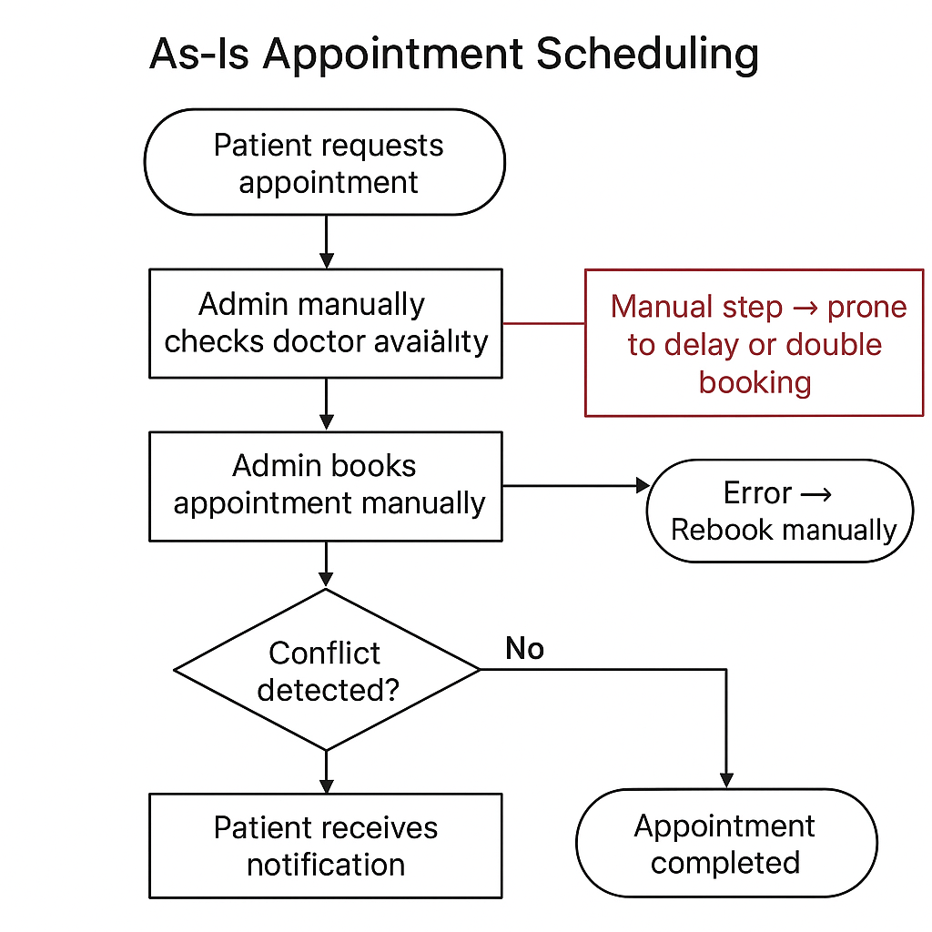

## Patient Check-In (As-Is)

* → Patient arrives at hospital.
* → Fills paper-based check-in form.
* → Admin verifies appointment manually.
* → Patient waits for verification and token assignment.
* → Check-in completed manually.

[Lucidchart Placeholder: As-Is Flow Diagram]

## Interdepartmental Communication (As-Is)

* → Admin identifies resource/IT issue.
* → Sends request manually via email or phone.
* → IT logs request and queues task manually.
* → Resolution delayed due to miscommunication.
* → Admin updates log once resolved.

[Lucidchart Placeholder: As-Is Flow Diagram]

# Task 3: To-Be Process Models

Optimized (To-Be) models focus on automation, digital integration, and improved communication to enhance efficiency and accuracy.

## Automated Appointment Scheduling (To-Be)

* → Patient requests appointment online or via mobile app.
* → System checks doctor availability automatically.
* → Conflict detection validates overlapping bookings.
* → Confirmation sent instantly via SMS/email.
* → Doctor and admin receive real-time updates.

[Lucidchart Placeholder: To-Be Flow Diagram]

## Streamlined Patient Check-In (To-Be)

* → Patient uses self-service kiosk or online check-in.
* → System verifies appointment ID automatically.
* → Digital form submission replaces paper forms.
* → Admin and doctor notified automatically.
* → Patient receives digital token and proceeds to waiting area.

[Lucidchart Placeholder: To-Be Flow Diagram]

## Improved Interdepartmental Communication (To-Be)

* → Admin logs request in central task system.
* → System auto-tags appropriate department.
* → Notifications sent instantly to concerned team.
* → Status updated in real time.
* → Automated alerts for delayed tasks.

[Lucidchart Placeholder: To-Be Flow Diagram]

# Task 4: Document Findings

A comparison between the As-Is and To-Be process models highlights the transformation from manual to automated operations.

|  |  |  |
| --- | --- | --- |
| Process | As-Is Challenges | To-Be Improvements |
| Appointment Scheduling | Manual entry, double-booking, late notifications | Automated scheduling with conflict detection and instant alerts |
| Patient Check-In | Manual paperwork and long waits | Self-service digital check-in reduces wait times |
| Interdepartmental Communication | Manual communication, slow updates | Centralized dashboard with real-time alerts and tracking |

The proposed workflows improve accuracy, speed, and patient satisfaction while reducing dependency on manual processes.

# Conclusion

The process models developed for HealthFirst Care illustrate the transformation from inefficient manual systems to streamlined, technology-driven workflows. By implementing these optimized processes, the organization can achieve greater operational efficiency, faster service delivery, and enhanced patient satisfaction.

