Exploring alternative bootstrap estimators for input-sample-size in a multi-level sampling design for age and length composition data

Benjamin C. Williams1, James T. Thorson2, Matthew R. Siskey3, and Peter-John F. Hulson1,*

1 Auke Bay Laboratories, Alaska Fisheries Science Center, National Marine Fisheries Service, National Oceanic and Atmospheric Administration, 17109 Point Lena Loop Rd., Juneau, AK 99801  
2 Resource Ecology and Fisheries Management Division, Alaska Fisheries Science Center, National Marine Fisheries Service, National Oceanic and Atmospheric Administration, 7600 Sand Point Way NE, Seattle, WA 98115  
3 Washington Department of Fish and Wildlife, 111 Washington St. SE, Olympia, WA, 98501

* Correspondence: [Peter-John F. Hulson <[pete.hulson@noaa.gov](mailto:pete.hulson@noaa.gov)>](mailto:pete.hulson@noaa.gov)

# Abstract

Integrated assessment models include multiple types of data, and their statistical leverage depends on sample sizes and variances that are assigned by the analyst. There is a long history of standardizing survey and fishery catch data to estimate abundance indices and associated variance, but surprisingly little research to standardize compositional data to estimate input-sample-sizes. Here we extend this research along three lines: (1) we expand an existing bootstrap estimator to compute an input-sample-size based on resampling individual lengths, age-length specimen samples, and survey hauls, and estimate the relative variance associated with each stage; (2) we compare these bootstrap types with a model-based estimate of input-sample-size; and (3) we compare assessment model outcomes using these alternative input-sample-size estimators. Results show that bootstrapping only hauls results in an average input-sample-size for ages of X1 and for lengths of Y1, while bootstrapping hauls, specimens, and length records substantially reduces this to X2 and Y2 [or some other sentence summarizing patterns across Bootstrap Types]. Also, [add sentence about patterns in input-sample-size by species type and/or life-history]. Similarly, existing model-based estimators for input-sample-size are typically higher than the full bootstrap estimator, perhaps because the model-based estimator does not propagate imprecision from age-length specimens used to create an age-length key. Finally, alternative input sample-size estimators have large/small impacts on a real-world assessment model for Gulf of Alaska Pacific cod. We conclude by suggesting avenues for future research to compare bootstrap and model-based estimators of input-sample-size, and also emphasize examples of how this information can be used to optimize survey operations for use in fisheries management.

# Introduction

# Methods

# Results

# Discussion

# Acknowledgments

# Citations

# Tables

Table 1: Species assessed at the Alaska Fisheries Science Center that were evaluated in the bootstrap analysis for bottom trawl survey length and age composition input sample size (AI - Aleutian Islands, EBS - Eastern Bering Sea, GOA - Gulf of Alaska)

| Stock | Scientific name | Survey evaluated |
| --- | --- | --- |
| Alaska plaice | Pleuronectes quadrituberculatus | EBS |
| arrowtooth flounder | Atheresthes stomias | AI, EBS, GOA |
| Atka mackerel | Pleurogrammus monopterygius | AI |
| Dover sole | Microstomus pacificus | GOA |
| flathead sole | Hippoglossoides elassodon | EBS, GOA |
| Greenland turbot | Reinhardtius hippoglossoides | EBS |
| Kamchatka flounder | Atheresthes evermanni | EBS |
| northern rock sole | Lepidopsetta polyxystra | EBS, GOA |
| northern rockfish | Sebastes polyspinis | AI, GOA |
| Pacific cod | Gadus macrocephalus | AI, EBS, GOA |
| Pacific ocean perch | Sebastes alutus | AI, GOA |
| rex sole | Glyptocephalus | GOA |
| southern rock sole | Lepidopsetta billineta | GOA |
| walleye pollock | Gadus chalcogrammus | AI, EBS, GOA |
| yellowfin sole | Limanda aspera | EBS |

Table 2: Bootstrap variability scenarios explored.

| Bootstrap type | Explanation | Low | Medium | Full |
| --- | --- | --- | --- | --- |
| NA | [ADD short description later] | NA | NA | NA |
| Length | NA | X | NA | NA |
| Haul | NA | X | X | NA |
| Specimen | NA | X | X | X |

# Figures

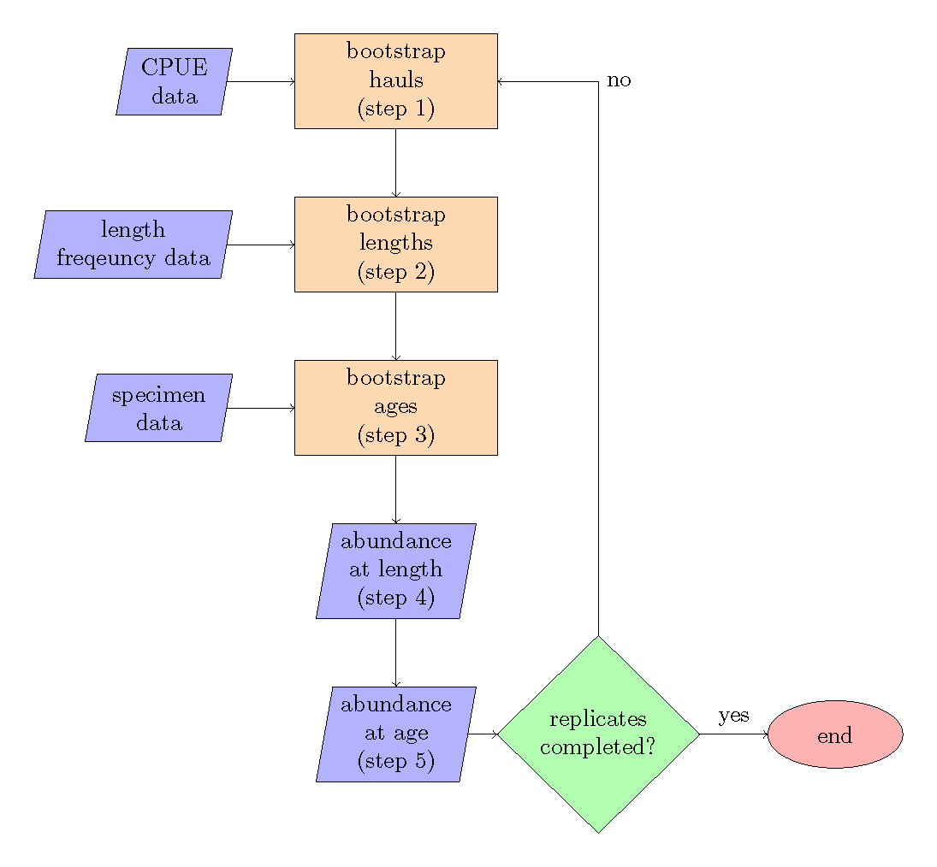

Figure 1: Bootstrap-simulation flow chart, with steps referring to the order of operations.

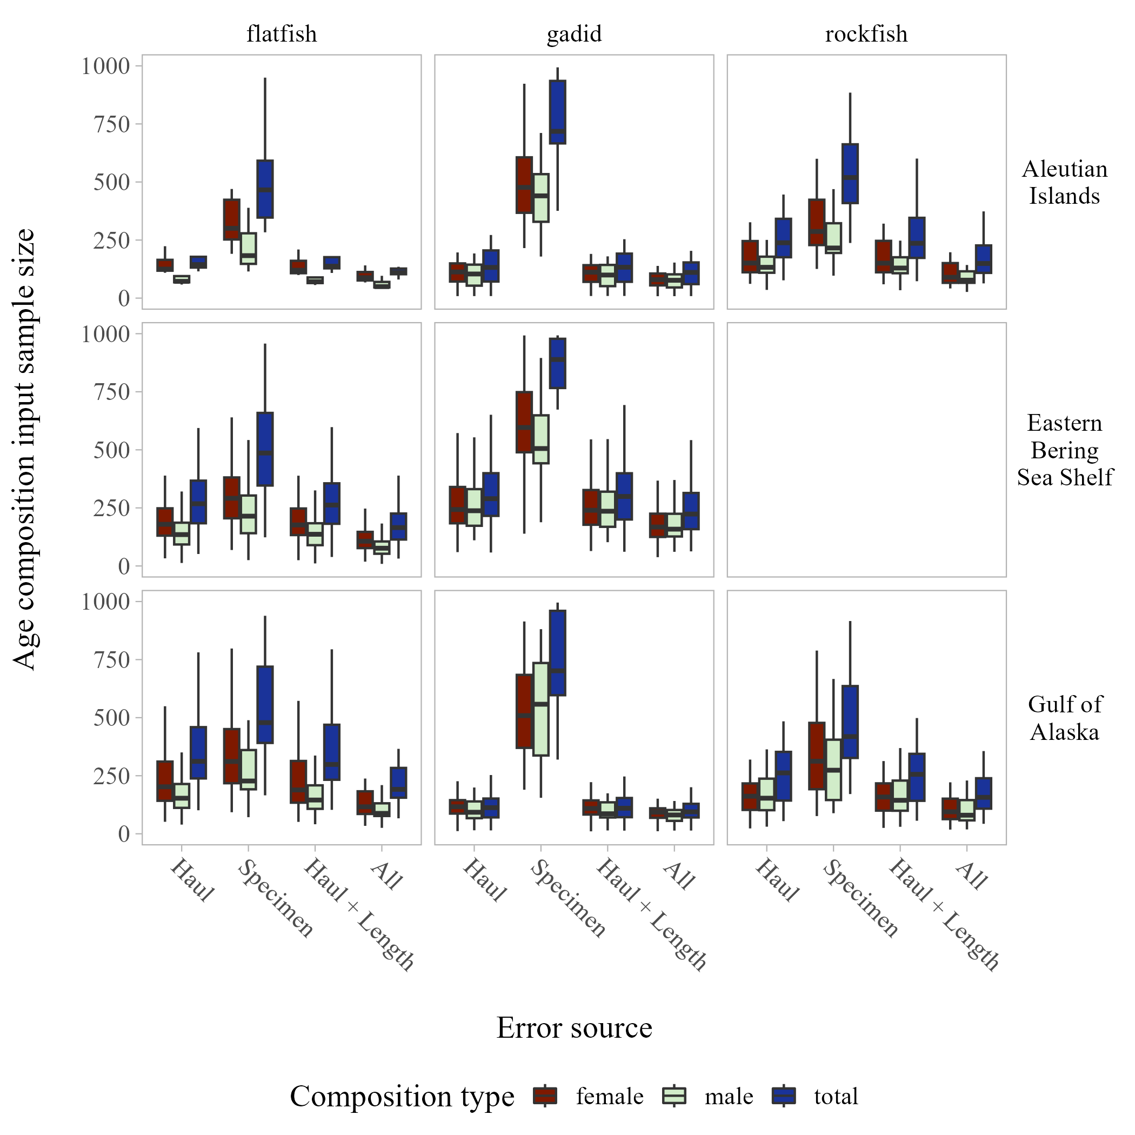

Figure 2: Example Figure 2 boxplot.