Summary of the 2023 Recommended Model Alternatives for Gulf of Alaska Pacific cod

Pete Hulson, Steve Barbeaux, and Ingrid Spies

# Executive Summary

In this summary of recommended model alternatives for the 2023 assessment of Gulf of Alaska (GOA) Pacific cod we explore and recommend two models to be considered in the 2023 assessment:

1. Correct the minimum sample size in the Stock Synthesis (SS) data file so that all the Conditional Age-at-Length (CAAL) data is included in model fitting, and,
2. Change the environmental index used for the link to the AFSC longline survey catchability.

Both of these model changes result in improvements to the model as compared to the accepted model in 2022 (model 2019.1a) and result in comparable estimates of model quantities, including spawning biomass.

# Data

The data used for these analyses were the final data used in the accepted 2022 assessment model. The following table summarizes the data fit by the GOA cod assessment for 2022:

|  |  |  |  |
| --- | --- | --- | --- |
| **Data** | **Source** | **Type** | **Years** |
| Federal and state fishery catch, by gear type | AKFIN | metric tons | 1977 – 2022 |
| Federal and state fishery catch-at-length, by gear type | AKFIN / FMA / ADF&G | number, by cm bin | 1977 – 2022 |
| GOA NMFS bottom trawl survey biomass | AFSC | metric tons | 1990 – 2021 |
| AFSC Sablefish Longline survey Pacific cod Relative Population Numbers | AFSC | RPN | 1990 – 2022 |
| GOA NMFS bottom trawl survey length composition | AFSC | number, by cm bin | 1990 – 2021 |
| GOA NMFS bottom trawl survey conditional age-at-length | AFSC | mean value and number | 1990 – 2021 |
| AFSC Sablefish Longline survey Pacific Cod length composition | AFSC | number, by cm bin | 1990 – 2022 |
| Federal fishery conditional age-at-length | AFSC | proportion age at length | 2007 – 2021 |

Additional analyses focused on evaluation of the environmental index used in the GOA cod assessment, which is described in more detail in the following section.

## Environmental indices

The Climate Forecast System Reanalysis (CFSR) is the latest version of the National Centers for Environmental Prediction (NCEP) climate reanalysis. The oceanic component of CFSR includes the Geophysical Fluid Dynamics Laboratory Modular Ocean Model version 4 (MOM4) with iterative sea-ice (Saha *et al.* 2010). It uses 40 levels in the vertical with a 10-meter resolution from surface down to about 262 meters. The zonal resolution is 0.5**°** and a meridional resolution of 0.25° between 10°S and 10°N, gradually increasing through the tropics until becoming fixed at 0.5° poleward of 30°S and 30°N.

To make the index, the CFSR reanalysis grid points were co-located with the AFSC bottom trawl survey stations. The co-located CFSR oceanic temperature profiles were then linearly interpolated to obtain the temperatures at the depths centers of gravity for various size ranges of Pacific cod as determined from the AFSC bottom trawl survey. All co-located grid points were then averaged to get the time series of CFSR temperatures over the period of 1979-2022. The CFSR data is available for size ranges of 0-20 cm, 20-40 cm, 40-60 cm, 60-80 cm and 80+ cm by month (from January to December).

# Analytic Approach

The base model used in this analysis is the accepted model from the 2022 assessment cycle (model 2019.1a). Model 19.1a is a single sex, age-based model with length-based selectivity and is optimized with the SS software (Methot and Wetzell 2013). An important aspect to consider in the presented analysis is that this model uses the CFSR index within an environmental link to the AFSC longline survey catchability parameter (first accepted in Barbeaux et al. 2017).

## Description of Alternative Models

Three model variants are presented in this analysis:

1. 2019.1b: same as 2019.1a but the minimum sample sizes for CAAL data in the SS data file are changed from 1 to 0.001.
2. 2019.1c: same as 2019.1b but the environmental link for the AFSC longline survey catchability parameter is removed
3. 2019.1d: same as 2019.1b but a new CFSR index is used in the environmental link for the AFSC longline survey catchability parameter

When CAAL data is employed within a stock assessment model optimized with SS an ‘input sample size’ is used to determine the weighing of each set of age-at-length proportions (i.e., proportion of ages for each length bin by fleet and year). Within SS a feature that is available is the ‘minimum sample size’, which can filter which age-at-length proportions are fit within the model based on the magnitude of the input sample size. For example, if the minimum sample size in the SS data file is set at 1, then all age-at-length proportions within the CAAL data that have input sample size’s less than 1 are removed from the model’s CAAL likelihood, where all age-at-length proportions within the CAAL data that have an input sample size greater than 1 are fit by the model. To include all the age-at-length proportions in the CAAL data fitting it is suggested in the SS manual to set the minimum sample size to 0.001. In the spring of 2023 it was discovered that the minimum sample size in the GOA cod assessment model had inadvertently been set at 1 in previous assessments (we are currently unable to determine when that occurred). This resulted in removing 1,812 of 2,825 age-at-length proportions within the CAAL data across the 3 fishery fleets and the bottom trawl survey, or, 64% of the data available for CAAL fitting was not included in the likelihood of the model. In this analysis, model 2019.1b sets the minimum sample size at 0.001 within the SS data file, thereby including all of the available CAAL data in the model fitting process.

At the November 2022 meeting of the GOA groundfish Plan Team a request was made to evaluate the assessment model without the environmental link to the AFSC longline survey catchability to determine whether this relationship was still appropriate. To address this request we include model 2019.1c, which is a model variant that removes the environmental link for the AFSC longline survey, to compare with the model that includes the environmental link.

In the process of developing model 2019.1c, the CFSR index was reevaluated to determine whether there was a more appropriate month and size range that explained the variability in the AFSC longline survey index for GOA cod. Model comparison with the Akaike Information Criterion (AIC, Burnham and Anderson 2002) was performed across the size ranges and months of the CFSR index, whereupon the index that resulted in the model with the smallest AIC was selected and presented as model variant 2019.1d.

# Results

## Model 2019.1b – correcting minimum sample size

As described above, in model 2019.1b the minimum sample size was changed from 1 to 0.001 in the SS data file so that all the CAAL data would be included in the model fitting process. Overall, with the addition of all the CAAL data the total likelihood in model 2019.1b decreased by over 1,000 compared to model 2019.1a. The primary driver of the decrease in total likelihood was in the age composition component, which represents the fit to the CAAL data. While the fit to the survey likelihood component (trawl and longline surveys) slightly increased, the difference in fit was not visually apparent, particularly in recent years (Figures 1 and 2). Overall, spawning biomass increased in model 2019.1b compared to 2019.1a across the time series (Figure 3), and increased by 6% in the final year of the model (2022). Due to this large decrease in the total likelihood, and that model 2019.1b represents a correction to a previous misspecification of the minimum sample size in the SS data file, we recommend 2019.1b be the base assessment model from this point forward, and use this model in subsequent analyses presented herein.

## Model 2019.1c – removing AFSC longline catchability environmental link

For comparison with the current model configuration in which the AFSC longline survey catchability is estimated with an environmental link to the CFSR index we constructed model variant 2019.1c, in which the environmental link was removed. To perform this comparison we did a retrospective analysis, in which the AIC value from model 2019.1b was compared to the AIC value from model 2019.1c for the last 10 years. For each of the last 10 years the AIC value from model 2019.1b was smaller than 2019.1c (Table 2), indicating that even with the addition of the environmental link parameter in model 2019.1b, model 2019.1b is continually preferred over 2019.1c based on AIC comparison. Further, Mohn’s ρ from each model was nearly the same, -0.0727 from model 2019.1b and -0.0722 from model 2019.1c. Due to the continued and sustained improvement resulting from the environmental link to the AFSC longline survey catchability in model 2019.1b, we recommend that the environmental link to AFSC longline survey catchability be continued in future assessments.

## Model 2019.1d – reevaluation of the AFSC longline catchability environmental link

To reevaluate the environmental link to the AFSC longline survey catchability parameter we performed an analysis in which each combination of month-size range in the CFSR data was sequentially used in model 2019.1b. Table 3 shows the difference in AIC value between the base model (2019.1b) and the model with each CFSR index by month and size range. While the current CFSR index used is still an improvement over a model with no environmental link (as discussed in the previous section), the CFSR index that resulted in the smallest AIC value was for the 40-60 cm size range with March temperatures (Table 3). Currently, the 0-20 cm size range for June temperatures is used (which is why the AIC difference in Table 3 is 0 in this case). We now denote model variant 2019.1d as the model that utilized the CFSR index that results in the smallest AIC value. Compared to model 2019.1b, model 2019.1d resulted in an overall decrease in the total likelihood, which is primarily driven by an improved fit to the AFSC longline survey index (Table 4 and Figure 4), particularly in recent years (e.g., 2019). For further comparison with the current base model configuration we performed a retrospective analysis in which models 2019.1b and 2019.1d are compared. Since 2019 the total likelihood for model 2019.1d has been smaller than 2019.1b, however, prior to 2018 the total likelihood from model 2019.1b was smaller. Mohn’s ρ from model 2019.1b was -0.0727 and from model 2019.1d was -0.0579, indicating that the new CFSR index improves retrospective performance. An increase in spawning biomass was estimated by model 2019.1d in comparison to model 2019.1b as well as 2019.1a (shown in Figure 5 for reference); in 2022 this resulted in an 11% increase in spawning biomass from model 2019.1d compared to model 2019.1a. Due to the improvement in model fit to the AFSC longline survey index, particularly for the recent surveys, we recommend that model 2019.1d be considered as an alternative model to be presented in the full assessment for 2023.

# Literature Cited

Barbeaux. S. J., K. Aydin, B. Fissel, K. Holsman, W. Palsson, K. Shotwell, Q. Yang, and S. Zador. 2017. Assessment of the Pacific cod stock in the Gulf of Alaska. *In* Stock assessment and fishery evaluation report for the groundfish resources of the Gulf of Alaska. North Pacific Fishery Management Council, 605 W. 4th Avenue Suite 306, Anchorage, AK 99501

Burnham, K.P. and Anderson, D.R. (2002) Model Selection and Inference: A Practical Information-Theoretic Approach. 2nd Edition, Springer-Verlag, New York.

Methot, R. D., and C. R. Wetzell. 2013. Stock synthesis: A biological and statistical framework for fish stock assessment and fishery management. Fish. Rsch. 142:86-99.

Saha, S., J. M. Solé, R. Arasa, M. Picanyol, [M. Á. González](https://www.scirp.org/(S(351jmbntvnsjt1aadkposzje))/journal/articles.aspx?searchCode=M%c2%aa+%c3%81ngeles+Gonz%c3%a1lez&searchField=authors&page=1), [A. Domingo-Dalmau](https://www.scirp.org/(S(351jmbntvnsjt1aadkposzje))/journal/articles.aspx?searchCode=Anna+Domingo-Dalmau&searchField=authors&page=1), [M. Masdeu](https://www.scirp.org/(S(351jmbntvnsjt1aadkposzje))/journal/articles.aspx?searchCode=Marta+Masdeu&searchField=authors&page=1), [I. Porras](https://www.scirp.org/(S(351jmbntvnsjt1aadkposzje))/journal/articles.aspx?searchCode=Ignasi+Porras&searchField=authors&page=1), and [B. Codina](https://www.scirp.org/(S(351jmbntvnsjt1aadkposzje))/journal/articles.aspx?searchCode=Bernat+Codina&searchField=authors&page=1). 2010. The NCEP Climate Forecast System Reanalysis. Bulletin of American Meteorological Society, 91, 1015-1057.

# Tables

Table 1. Likelihoods for model 2019.1a and 2019.1b, including the difference in likelihood for each data component. In the ‘Difference’ column green highlights components for which the likelihood for 2019.1b is less than 2019.1a, red highlights components for which the likelihood for 2019.1b is greater than 2019.1a.

|  |  |  |  |
| --- | --- | --- | --- |
| Likelihood | 2019.1a | 2019.1b | Difference |
| TOTAL | 3841.5 | 2780.1 | -1061.4 |
| Catch | 1.12E-12 | 6.65E-13 | 0.0 |
| Survey | -15.4 | -12.8 | 2.6 |
| Length_comp | 1715.6 | 1712.8 | -2.8 |
| Age_comp | 2124.9 | 1062.9 | -1062.0 |
| Recruitment | 3.9 | 4.4 | 0.5 |
| InitEQ_Regime | 2.4 | 2.5 | 0.1 |
| Forecast_Recruitment | 2.3 | 2.6 | 0.4 |
| Parm_priors | 1.3 | 1.1 | -0.2 |
| Parm_softbounds | 0.014 | 0.012 | 0.0 |
| Parm_devs | 6.5 | 6.5 | 0.0 |

Table 2. Total likelihood for models 2019.1b and 2019.1c and the difference in AIC (ΔAIC) between these two models (computed as AIC for model 2019.1c - AIC for model 2019.1b).

|  |  |  |  |
| --- | --- | --- | --- |
| Retro Year | 2019.1b | 2019.1c | ΔAIC |
| 2022 | 2780.1 | 2787.2 | 12.2 |
| 2021 | 2669.7 | 2677.9 | 14.4 |
| 2020 | 2503.0 | 2511.0 | 14.0 |
| 2019 | 2400.7 | 2408.0 | 12.6 |
| 2018 | 2251.6 | 2271.7 | 38.0 |
| 2017 | 2181.8 | 2204.3 | 43.0 |
| 2016 | 2046.8 | 2060.7 | 25.8 |
| 2015 | 1903.3 | 1919.4 | 30.1 |
| 2014 | 1769.5 | 1780.4 | 19.7 |
| 2013 | 1648.3 | 1661.3 | 23.9 |

Table 3. AIC value difference between model 2019.1b and the model with the CFSR index used for the environmental link with AFSC longline survey catchability as indicated by the month (rows) and size range (columns, in cm) of the CFSR index. A negative value indicates that the model with the specific CFSR index has a smaller AIC than model 2019.1b. Note that the size range 0-20 for June results in an AIC difference of 0, because this is the current index used in model 2019.1b (the base model). This model is highlighted with a border, as well as the model with the smallest AIC.

|  |  |  |  |  |  |
| --- | --- | --- | --- | --- | --- |
| **Month** | **0-20** | **20-40** | **40-60** | **60-80** | **80plus** |
| Jan | 0.2 | 6.66 | 8.46 | 7.94 | 8.82 |
| Feb | -9.82 | -7.7 | -1.86 | -6.62 | -0.9 |
| Mar | -12.84 | -10.4 | -16.28 | -12.22 | -15.74 |
| Apr | -0.02 | 9.32 | 0.56 | 7.82 | 0.4 |
| May | -4.72 | 8.26 | 5.8 | 7.88 | 5.44 |
| Jun | 0 | 7.8 | 6.7 | 7.56 | 7.14 |
| Jul | 0.08 | 8.12 | 9.26 | 8.38 | 9.86 |
| Aug | 6.58 | 6.72 | 9.82 | 7.56 | 10.5 |
| Sep | 5.24 | 7.34 | 10 | 8.04 | 10.5 |
| Oct | 13.52 | 6.64 | 8.56 | 6.96 | 9.24 |
| Nov | 3.52 | 6.06 | 7.16 | 6.08 | 8 |
| Dec | 14.16 | 10.18 | 4.42 | 9.46 | 3.52 |

Table 4. Likelihood components from model 2019.1b and 2019.1d. The ‘Difference’ column is highlighted in green when 2019.1d has a smaller likelihood value than 2019.1b, red when the likelihood value is greater.

|  |  |  |  |
| --- | --- | --- | --- |
| Likelihood | 2019.1b | 2019.1d | Difference |
| TOTAL | 2780.1 | 2772.0 | -8.1 |
| Catch | 6.65E-13 | 4.08E-13 | 0.0 |
| Survey | -12.8 | -19.2 | -6.4 |
| Srv | -9.6 | -9.1 | 0.6 |
| LLSrv | -3.1 | -10.2 | -7.0 |
| Length_comp | 1712.8 | 1711.9 | -0.9 |
| Age_comp | 1062.9 | 1062.8 | -0.2 |
| Recruitment | 4.4 | 4.1 | -0.3 |
| InitEQ_Regime | 2.5 | 2.2 | -0.3 |
| Forecast_Recruitment | 2.6 | 2.6 | -0.1 |
| Parm_priors | 1.1 | 1.1 | 0.0 |

Table 5. Retrospective total likelihood for model 2019.1b and 2019.1d. The ‘Difference’ column is highlighted in green when 2019.1d has a smaller likelihood value than 2019.1b, red when the likelihood value is greater.

|  |  |  |  |
| --- | --- | --- | --- |
| Retro Year | 2019.1b | 2019.1d | Difference |
| 2022 | 2780.1 | 2772.0 | -8.1 |
| 2021 | 2669.7 | 2662.6 | -7.1 |
| 2020 | 2503.0 | 2496.7 | -6.3 |
| 2019 | 2400.7 | 2394.1 | -6.7 |
| 2018 | 2251.6 | 2258.0 | 6.4 |
| 2017 | 2181.8 | 2189.0 | 7.2 |
| 2016 | 2046.8 | 2055.9 | 9.1 |
| 2015 | 1903.3 | 1912.8 | 9.5 |
| 2014 | 1769.5 | 1779.1 | 9.6 |
| 2013 | 1648.3 | 1658.0 | 9.6 |

# Figures

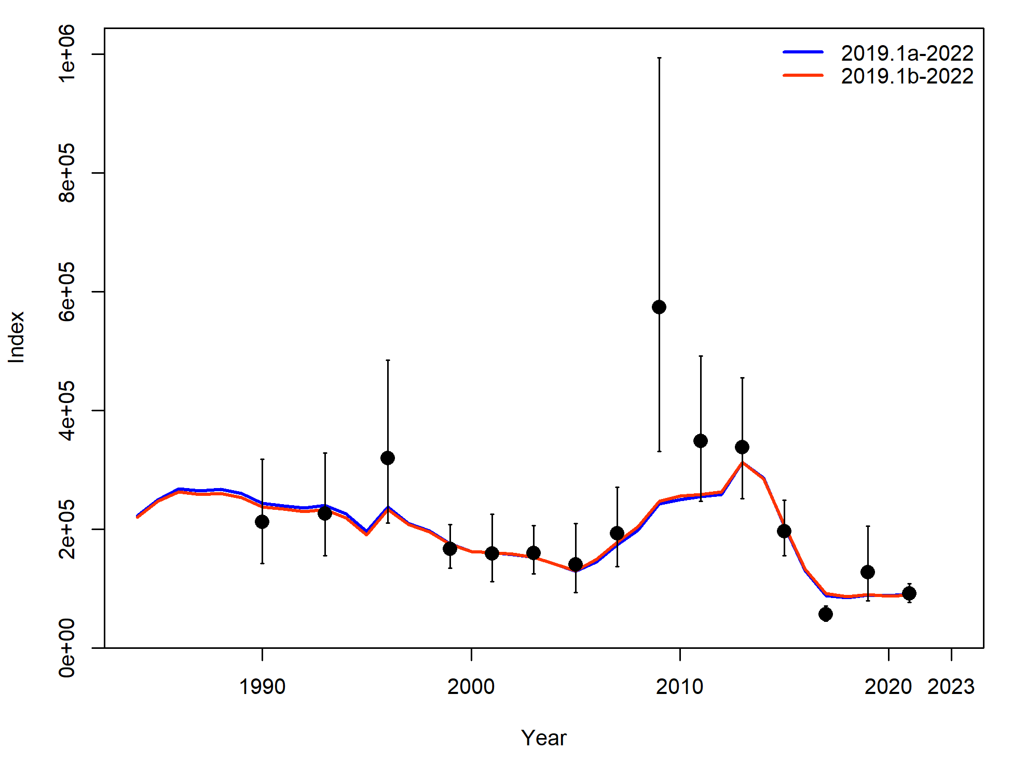

Figure 1. Model 2019.1a and 2019.1b fit to the AFSC bottom trawl survey.

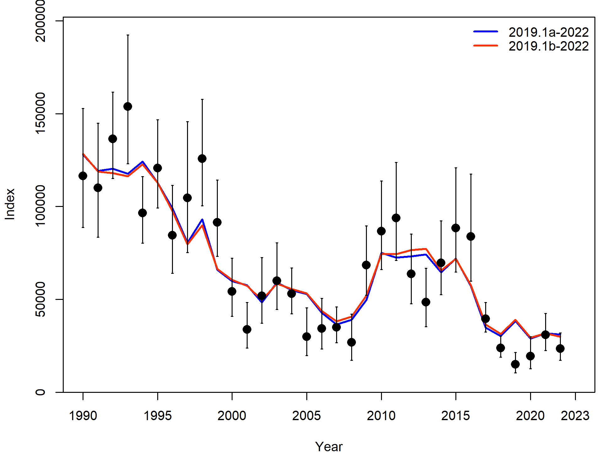

Figure 2. Model 2019.1a and 2019.1b fit to the AFSC longline survey.

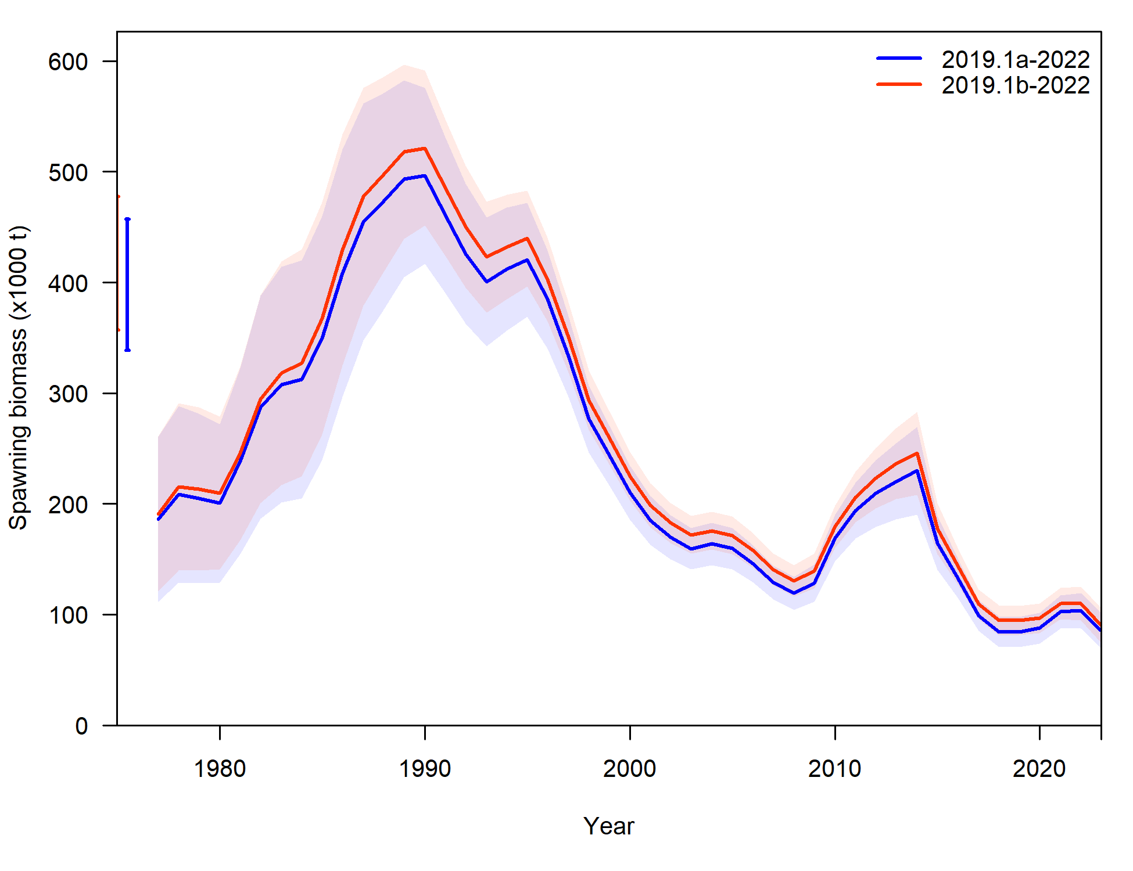

Figure 3. Estimated spawning biomass (with 95% confidence intervals) from models 2019.1a and 2019.1b.

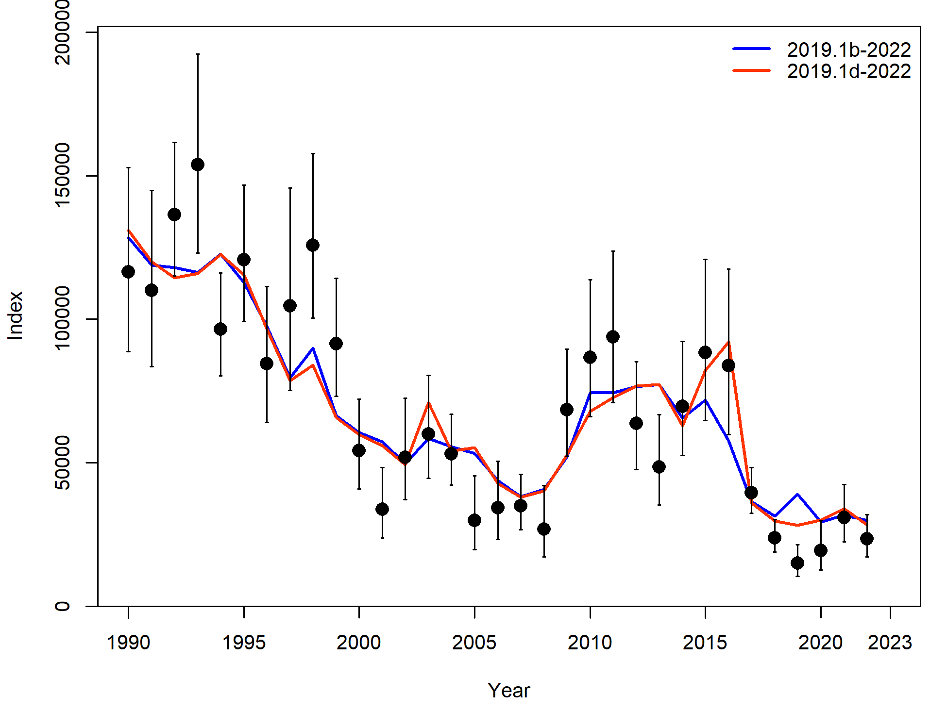

Figure 4. Fit to the AFSC longline survey from models 2019.1b and 2019.1d.

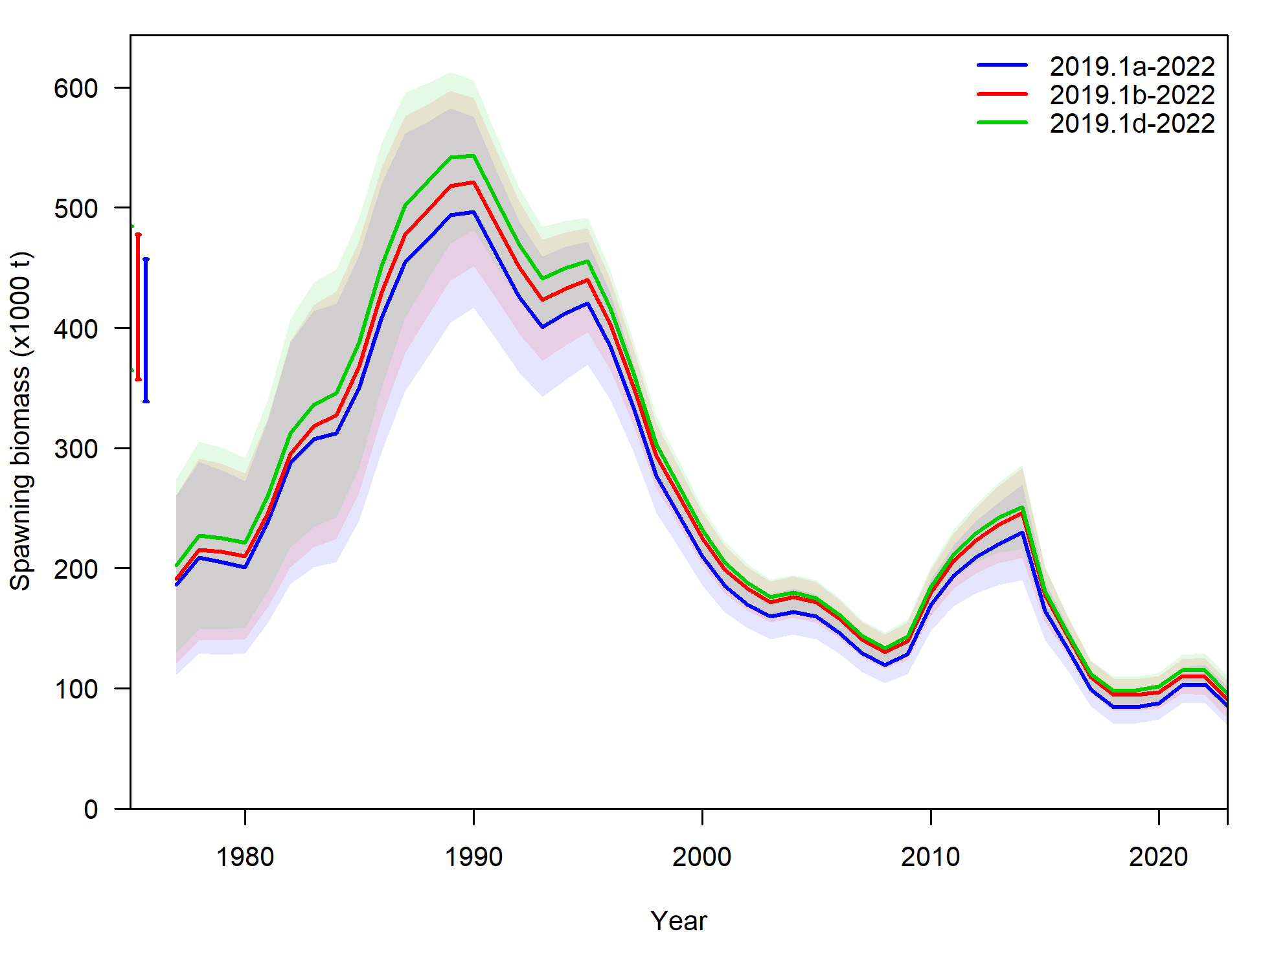

Figure 5. Estimated spawning biomass from models 2019.1a, 2019.1b, and 2019.1d.