**Introduction paragraph:** and between the eastern Bering Sea (EBS), Aleutian Islands (AI), and Gulf of Alaska (GOA) outside of their winter (January – April) spawning season. In 2021, a cooperative tagging study between the Alaska Fisheries Science Center (AFSC) and the Aleutian East Borough (AEB) was initiated to examine the seasonal movements of Pacific cod captured in the western GOA during the winter spawning season. Pop-up satellite tags will release and transmit data to satellites at predetermined lengths of time (e.g., 180 days), whereas conventional tags require a platform of recovery such as a fishery. Pathways between release and pop-up locations can be reconstructed from archival data provided by the satellite tags using a hidden Markov model. Satellite tags were deployed on Pacific cod in the western GOA in the vicinity of the Shumagin Islands and Sanak Island during March 2021 (n = 25, Fig. 2.2A) and April 2022 (n = 27, Fig. 2.2B). The goal of this study was to better understand the seasonal connectivity between winter spawning locations of Pacific cod in the western GOA and foraging locations in GOA and EBS during the summer months when both Alaska Fisheries Science Center's bottom-trawl surveys are conducted. In 2023, the study was expanded to the central GOA to understand seasonal migration patterns of both the western and central GOA populations. In March 2023, satellite tags were deployed on 54 Pacific cod at release locations ranging from Sanak Island to the entrance of Prince William Sound (Fig. 2.2C). Results to date indicate 1) substantial seasonal connectivity between the western GOA (Shumagin Islands and westward) and Bering Sea (including Russia and the Chukchi Sea), 2) limited seasonal connectivity between the GOA and AI management areas, 3) some tagged fish do not undertake large-scale migrations but instead remain in the release areas year-round, 4) the proportion of fish that undertake migrations and distance moved between winter spawning and summer foraging may vary by year (Fig. 2.2), and 5) preliminary results from 2023 indicate limited seasonal connectivity between western and central GOA. Additional satellite and conventional tag releases are planned for March 2024 in the GOA and summer 2024 in the Bering Sea.

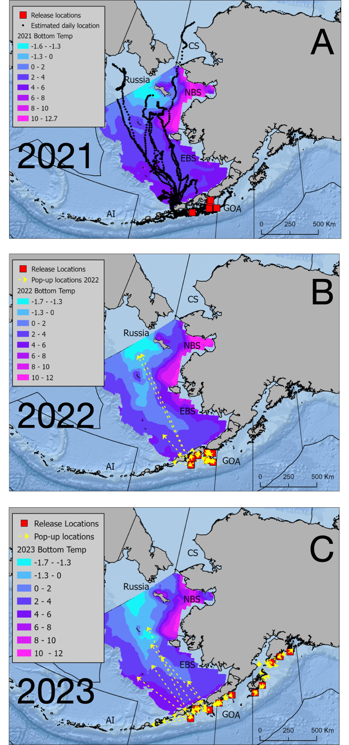

Figure 2.2. Movement of satellite-tagged Pacific cod from winter spawning areas in the Gulf of Alaska (GOA) to summer foraging locations. A) daily location estimates output by a geolocation model for cod tagged in 2021 in the western GOA, B) pop-up locations for cod tagged in 2022 in the western GOA, and C) pop-up locations for cod tagged in 2023 in western and central GOA. Bering Sea bottom temperatures for each year provided by Sean Rohan (RACE). Temperatures colder than -1.3 C (the minimum temperature observed for satellite-tagged fish) indicate potential physiological barriers to movement.