Gulf of Alaska Groundfish Condition

Contributed by Cecilia O’Leary1 and Sean Rohan1

1 Resource Assessment and Conservation Engineering Division, Groundfish Assessment Program, Alaska Fisheries Science Center, National Marine Fisheries Service, NOAA, Seattle, WA  
**Contact**: **Last updated**: September 2023

**Description of Indicator**: Length-weight residuals represent how heavy a fish is per unit body length and are an indicator of somatic growth variability (Brodeur et al., 2004). Therefore, length-weight residuals can be considered indicators of prey availability, growth, general health, and habitat condition (Blackwell et al., 2000; Froese, 2006). Positive length-weight residuals indicate better condition (i.e., heavier per unit length) and negative residuals indicate poorer condition (i.e., lighter per unit length) (Froese, 2006). Fish condition calculated in this way reflects realized outcomes of intrinsic and extrinsic processes that affect fish growth which can have implications for biological productivity through direct effects on growth and indirect effects on demographic processes such as, reproduction, and mortality (e.g., Rodgveller (2019); Barbeaux et al. (2020)).

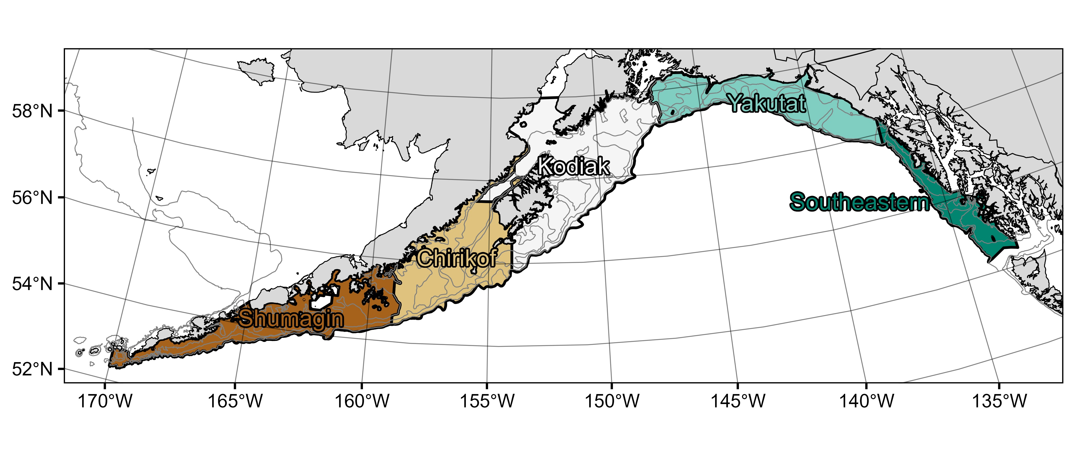

Figure 1. National Marine Fisheries Service (NMFS) Alaska Fisheries Science Center Resource Assessment and Conservation Engineering (AFSC/RACE) Groundfish Assessment Program (GAP) Gulf of Alaska summer bottom trawl survey area with International North Pacific Fisheries Commission (INPFC) statistical fishing strata delineated by the colors.

The groundfish morphometric condition indicator is calculated from paired fork lengths (mm) and weights (g) of individual fishes that were collected during the biennial summer bottom trawl survey of the Gulf of Alaska (GOA) conducted by the Alaska Fisheries Science Center Resource Assessment and Conservation Engineering (AFSC/RACE) - Groundfish Assessment Program (GAP). Fish condition analyses were applied to walleye pollock (*Gadus chalcogrammus*), Pacific cod (*Gadus macrocephalus*), Pacific ocean perch (*Sebastes alutus*), northern rockfish (*Sebastes polyspinis*), dusky rockfish (*Sebastes variabilis*), shortraker rockfish (*Sebastes borealis*), rougheye rockfish (*Sebastes aleutianus*), blackspotted rockfish (*Sebastes melanostictus*), sharpchin rockfish (*Sebastes zacentrus*), arrowtooth flounder (*Atheresthes stomias*), southern rock sole (*Lepidopsetta bilineata*), northern rock sole (*Lepidopsetta polyxystra*), flathead sole (*Hippoglossoides elassodon*), Dover sole (*Microstomus pacificus*), and rex sole(*Glyptocephalus zachirus*) collected in trawls with satisfactory performance at standard survey stations. Data were combined in the former International North Pacific Fisheries Commission (INPFC) strata: Shumagin, Chirikof, Kodiak, Yakutat, and Southeast (Figure 1).

To calculate indicators, length-weight relationships were estimated from linear regression models based on a log-transformation of the exponential growth relationship, *W = aLb*, where *W* is weight (g) and *L* is fork length (mm) for all areas for the period 1984 –2023. Unique intercepts (*a*) and slopes (*b*) were estimated for each survey stratum, sex, and stratum-sex interaction to account for sexual dimorphism and spatial-temporal variation in growth and bottom trawl survey sampling date. Length-weight relationships for 100–250 mm fork length walleye pollock (corresponding with ages 1–2 years) were calculated separately from adult walleye pollock (> 250 mm). Residuals for individual fish were obtained by subtracting observed weights from bias-corrected weights-at-length that were estimated from regression models. Individual length-weight residuals were aggregated and averaged for each stratum and weighted proportionally to total biomass in each stratum from area-swept expansion of mean bottom-trawl survey catch per unit effort (CPUE; i.e., design-based stratum biomass estimates). Variation in fish condition was evaluated by comparing average length-weight residuals among years. To minimize the influence of unrepresentative samples on indicator calculations, combinations of species, stratum, and year with a sample size < 10 were used to fit length-weight regressions but were excluded from calculating length-weight residuals. Morphometric condition indicator time series, code for calculating the indicators, and figures showing results for individual species are available through the *akfishcondition* R package and GitHub repository (<https://github.com/afsc-gap-products/akfishcondition>).

**Methodological changes**: In Groundfish Morphometric Condition Indicator contributions to the 2022 Bering Sea and Aleutian Islands Ecosystem Status Reports, historical stratum-biomass weighted residual condition indicators were presented alongside condition indicators that were calculated using the R package VAST following methods that were presented for select GOA species during the Spring Preview of Ecological and Economic Conditions (PEEC) in May 2020. The authors noted there were strong correlations between VAST and stratum-biomass weighted condition indicators for most species (r = 0.79–0.98). The authors received the following feedback about the change from the BSAI Groundfish Plan Team meeting during their November 2022 meeting:

“The Team discussed the revised condition indices that now use a different, VAST-based condition index, but felt additional methodology regarding this transition was needed. The Team recommended a short presentation next September to the Team to review the methods and tradeoffs in approaches. The Team encouraged collaboration with the NMFS longline survey team to develop analogous VAST indices.”

Based on feedback from the Plan Team, staff limitations, and the lack of a clear path to transition condition indicators for longline survey species to VAST, analyses supporting the transition to VAST were not conducted during 2023. Therefore, the 2023 condition indicator was calculated from stratum-biomass weighted residuals of length-weight regressions.

In 2023, we present condition indicator results for eight new species (shortraker rockfish, rougheye rockfish, sharpchin rockfish, Dover sole, northern rock sole, flathead sole, and rex sole).

**Status and Trends**: Residual body condition varied among survey years for all species considered (Figure 2). Fish condition indicators for fourteen of the fifteen species were below average in 2023. Many of these species condition in 2023 was the same or reduced relative to 2021. The exception to this was rougheye rockfish, which were in above average fish condition in 2023, representing an improvement from their below average condition in 2021. Residual body condition for walleye pollock, shortraker rockfish, arrowtooth flounder, flathead sole, Dover sole, and rex sole were below average and similar to condition in 2021. Residual body condition for Pacific cod, dusky rockfish, and sharpchin rockfish declined from 2021 to 2023. Southern rock sole morphometric condition has been below average since 2013, but had shown a positive trend over the previous four surveys (2017 to 2021) before declining slightly in 2023. Northern rock sole had the opposite trend, where body condition decreased from 2017 to 2021 before increasing slightly in 2023, though it remains below average. Residual body condition for northern rockfish, Pacific ocean perch, and blackspotted rockfish also improved, but are still below average. With respect to the 2014-2016 marine heatwave in this system, the following species have been in below average condition since 2015: walleye pollock, northern rockfish, dusky rockfish, flathead sole, northern rock sole, southern rock sole, and rex sole. Dover sole have been in below average condition since 2013. Pacific ocean perch reached average condition for the first time since the marine heatwave.

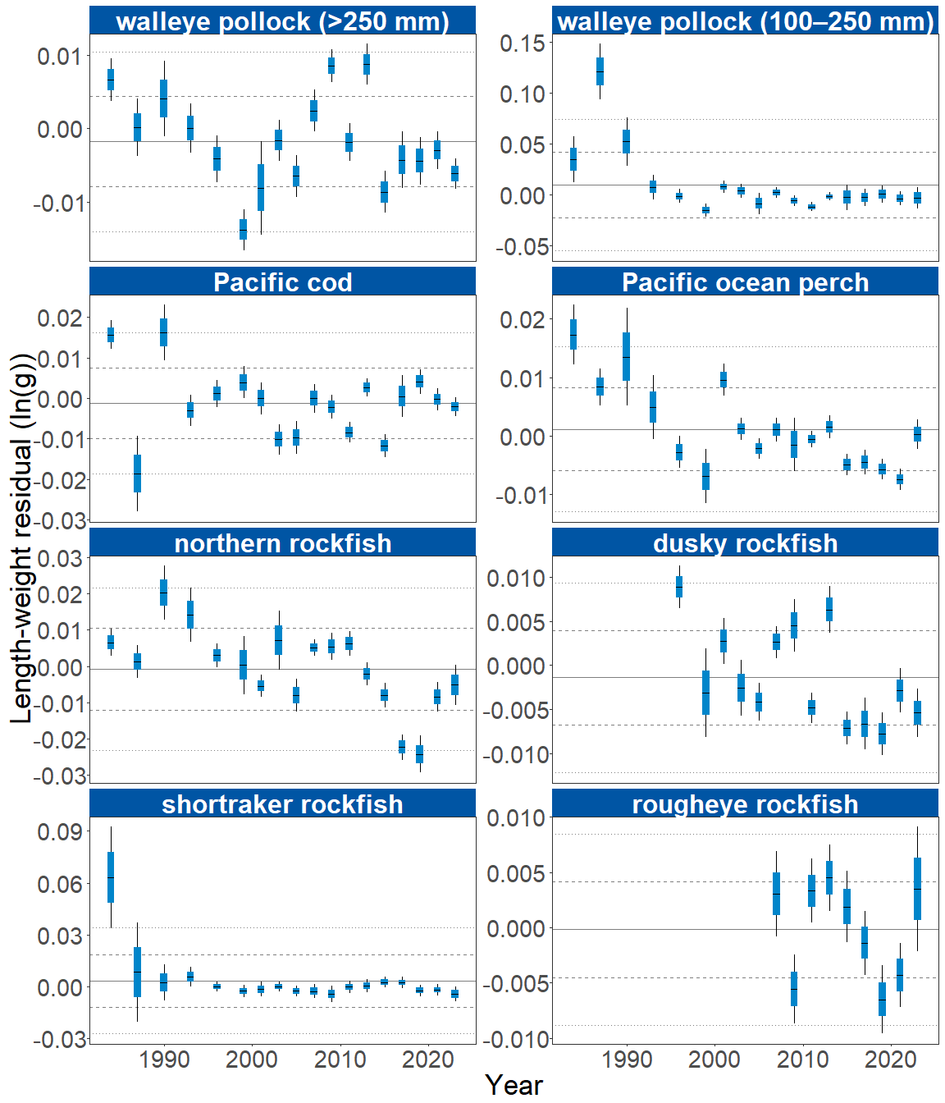

Figure 2A. Biomass-weighted residual body condition index across survey years (1984-2023) for fifteen Gulf of Alaska groundfish species collected on the National Marine Fisheries Service (NMFS) Alaska Fisheries Science Center Resource Assessment and Conservation Engineering (AFSC/RACE) Groundfish Assessment Program (GAP) standard summer bottom trawl survey. Filled bars denote weighted length-weight residuals, error bars denote two standard errors.

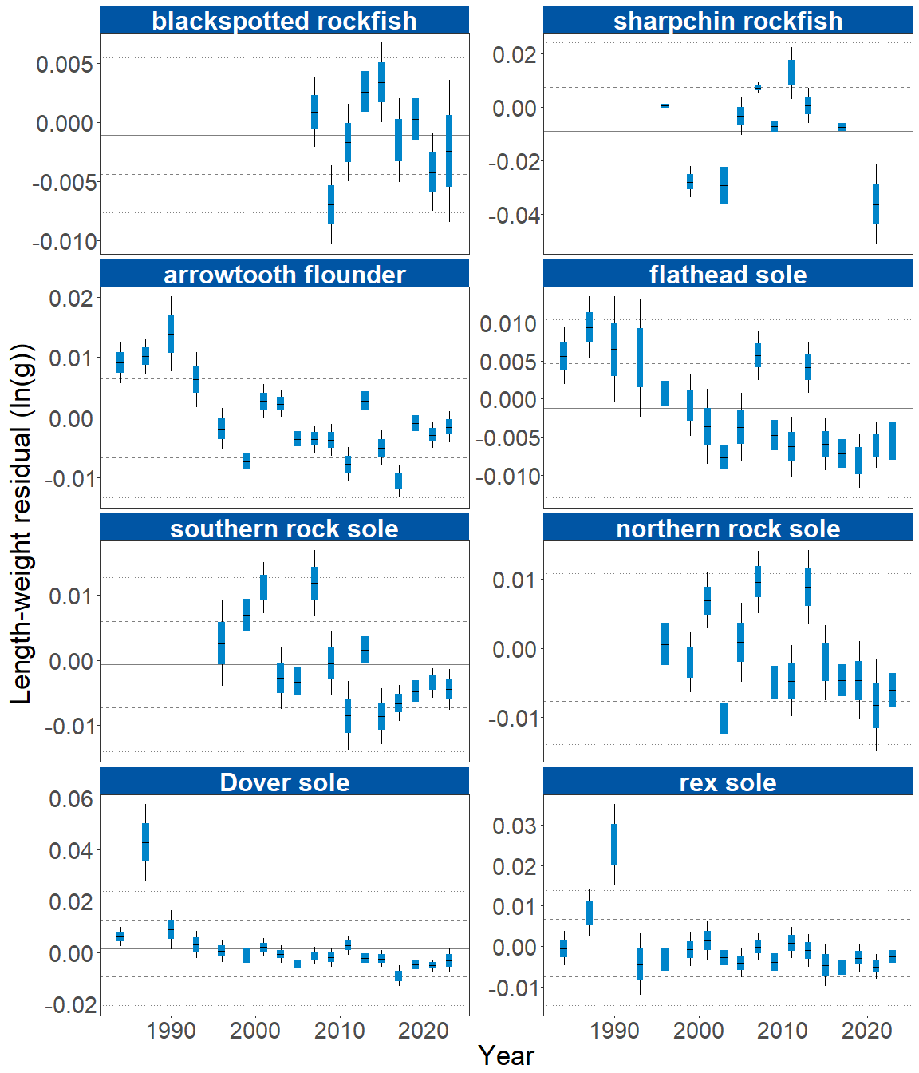

Figure 2B. Biomass-weighted residual body condition index across survey years (1984-2023) for fifteen Gulf of Alaska groundfish species collected on the National Marine Fisheries Service (NMFS) Alaska Fisheries Science Center Resource Assessment and Conservation Engineering (AFSC/RACE) Groundfish Assessment Program (GAP) standard summer bottom trawl survey. Filled bars denote weighted length-weight residuals, error bars denote two standard errors.

The general patterns of above and below average residual body condition index across recent survey years for the GOA as described above were also apparent in the spatial condition indicators across INPFC strata (Figure 3). The relative contribution of stratum-specific residual body condition to the overall trends (indicated by the height of each colored bar segment) does not demonstrate a clear pattern. Although, for many species, the direction of residual body condition (positive or negative) was synchronous among strata within years. For example, residual body condition for pollock, Pacific ocean perch, and dusky rockfish in Southeast was positive while the majority of other locations for other fish trended negative. Exceptions include rougheye rockfish in Chirikof and Kodiak and rex sole in Kodiak. While Pacific cod residuals trended negative again, residual body condition in the Kodiak stratum remained positive. Patterns of fish distribution were also apparent in the stratum condition indexes. For example, northern rockfish have primarily been collected from the Shumagin and Chirikof strata in recent surveys.

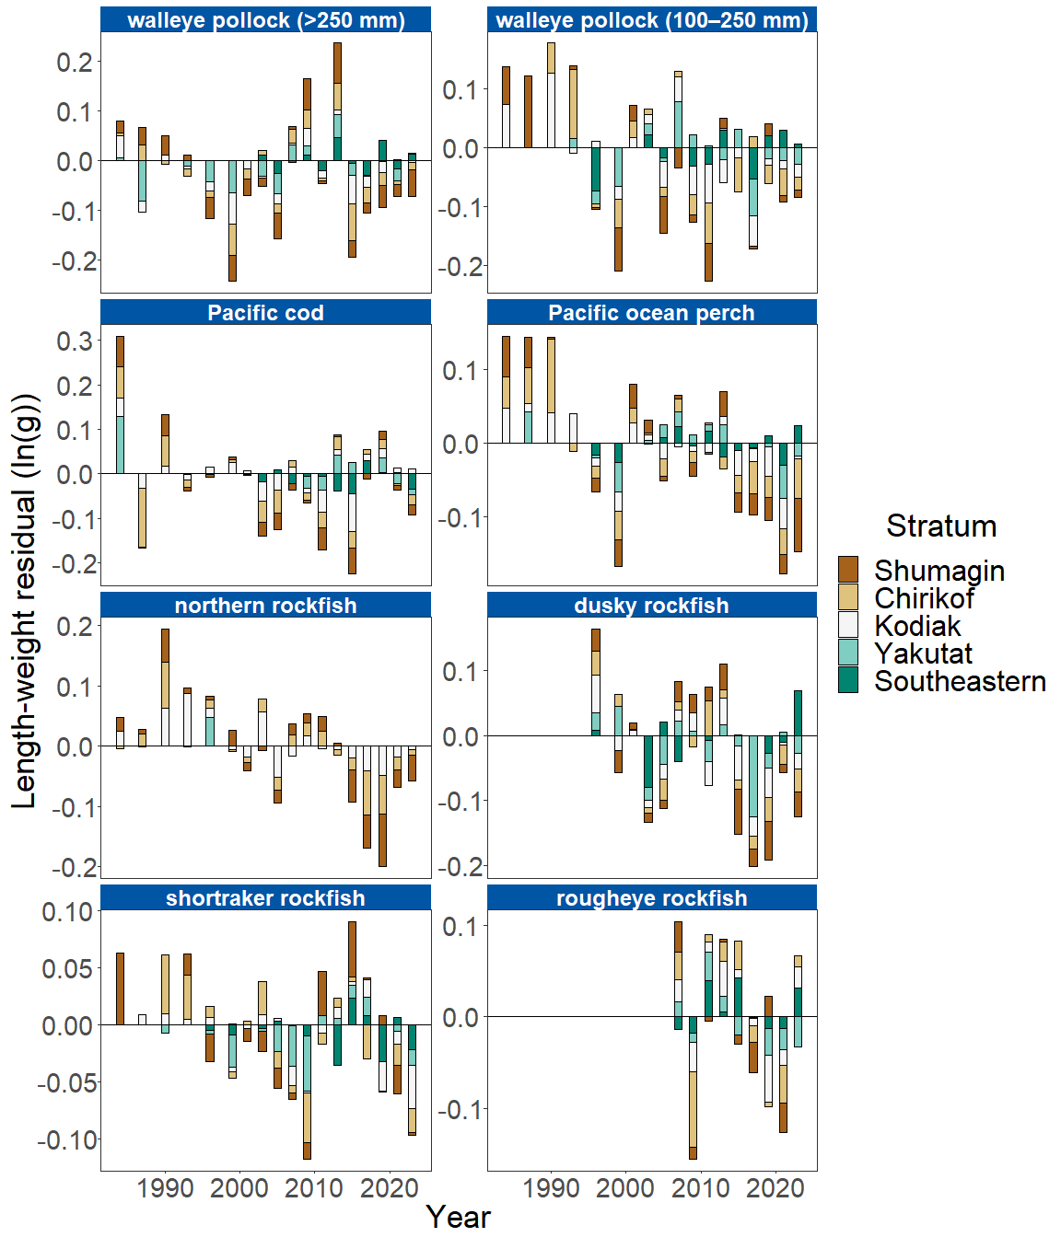

Figure 3A. Residual body condition index for fifteen Gulf of Alaska groundfish species collected on the National Marine Fisheries Service (NMFS) Alaska Fisheries Science Center Resource Assessment and Conservation Engineering (AFSC/RACE) Groundfish Assessment Program (GAP) standard summer bottom trawl survey (1984–2023) grouped by International North Pacific Fisheries Commission (INPFC) statistical sampling strata.

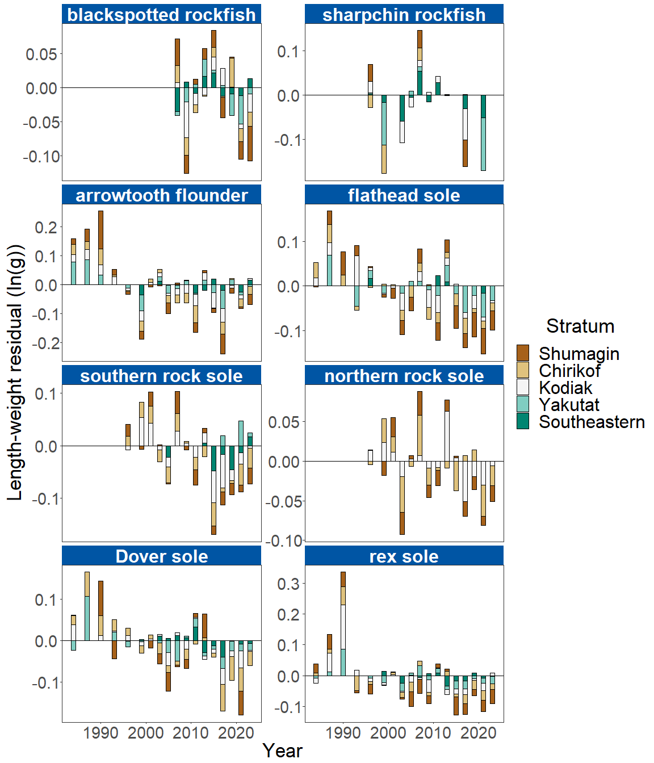

Figure 3B. Residual body condition index for fifteen Gulf of Alaska groundfish species collected on the National Marine Fisheries Service (NMFS) Alaska Fisheries Science Center Resource Assessment and Conservation Engineering (AFSC/RACE) Groundfish Assessment Program (GAP) standard summer bottom trawl survey (1984–2023) grouped by International North Pacific Fisheries Commission (INPFC) statistical sampling strata.

**Factors causing observed trends**: Factors that could affect residual fish body condition presented here include temperature, trawl survey timing, stomach fullness, movement in or out of the survey area, or variable somatic growth. Following an unprecedented warming event from 2014–2016 (Bond et al., 2015; Stabeno et al., 2019; Barbeaux et al., 2020), there has been a general trend of warming ocean temperatures in the survey area and sea surface temperature anomaly data continue to reflect temperatures above average historical conditions through 2023 (NOAA 2023); these warmer temperatures could be affecting fish growth conditions in this region. Changing ocean conditions along with normal patterns of movement can cause the proportion of the population resident in the sampling area during the annual bottom trawl survey to vary. Recorded changes attributed to the marine heatwave included species abundances, sizes, growth rates, weight/body condition, reproductive success, and species composition (Suryan et al., 2021). Warmer ocean temperatures can lead to lower energy (leaner) prey, increased metabolic needs of younger fish, and therefore slower growth for juveniles, as observed in Pacific cod (Barbeaux et al., 2020). Additionally, spatial and temporal trends in fish growth over the season become confounded with survey progress since the first length-weight data are generally collected in late May and the bottom trawl survey is conducted throughout the summer months moving from west to east. In addition, spatial variability in residual condition may also reflect local environmental conditions that influence growth and prey availability in the areas surveyed (e.g., local differences in average cross-shelf transport of heat via eddies reported this year in International Pacific Halibut Commission (IPHC) regions; NOAA 2023).

**Implications**: Variations in body condition likely have implications for fish survival. The condition of GOA groundfish may contribute to survival and recruitment. As future years are added to the time series, the relationship between length-weight residuals and subsequent survival will be examined further. It is important that residual body condition for most species in these analyses was computed for all sizes and sexes combined. Requirements for growth and survivorship differ for different fish life stages and some species have sexually dimorphic or even regional growth patterns. In the future, it may be more informative to examine body condition by life history stage (e.g., early juvenile, subadult, and adult phases), age, or sex.

Below average body condition for many GOA species over the last four to five RACE/AFSC GAP bottom trawl surveys is a potential cause for concern. It could indicate poor overwinter survival or may reflect the influence of locally changing environmental conditions depressing fish growth, local production, or survivorship. Indications are that the Warm Blob (Bond et al., 2015; Stabeno et al., 2019) has been followed by subsequent years with elevated water temperatures (e.g., Barbeaux et al., 2020; NOAA, 2021, 2023) which may be influence changes in fish condition in the species examined. It should be noted that while many GOA species’ body condition remained below average this year, most species’ condition improved relative to 2021; southern rock sole, dusky rockfish, Pacific cod, walleye pollock adults, and sharpchin rockfish were the exceptions. As we continue to add years of fish condition to the record and expand on our knowledge of the relationships between condition, growth, production, and survival, we hope to gain more insight into the overall health of fish populations in the GOA.

**Research priorities**: Research is being planned and implemented across multiple AFSC programs to explore standardization of statistical methods for calculating condition indicators and to examine relationships among putatively similar indicators of fish condition (e.g., morphometric, bioenergetic, physiological). Research is also underway to evaluate connections between morphometric condition indices, temperature, and competition.