**Larval Fish Abundance in the Gulf of Alaska 1981-2023**

Contributed by: Lauren Rogers, Kelia Axler (EcoFOCI, RACE Division, AFSC, NOAA)

Contact author: Lauren Rogers, EcoFOCI Program

Contact information: NOAA Alaska Fisheries Science Center, 7600 Sand Point Way NE, Seattle, WA 98115; e-mail lauren.rogers@noaa.gov

Last Updated: September 2023

Description of Indicator

The Alaska Fisheries Science Center’s (AFSC) Ecosystems and Fisheries Oceanography Coordinated Investigations Program (EcoFOCI) conducts spring larval fish surveys in the Gulf of Alaska (GOA), with annual sampling from 1981–2011 and biennial sampling thereafter (Matarese et al., 2003; Ichthyoplankton Information System https://apps-afsc.fisheries.noaa.gov/ichthyo/index.php). A subset of data from a consistently sampled time window (mid-May through early June) and area (Fig. 1) has been developed into time series of relative abundance. While quantitative data require a year for full laboratory processing and verification, Rapid Larval Assessments are conducted for 7 species by sorting samples at sea, allowing us to provide provisional time-series updates in the year of collection. In 2023, time-series calculations were updated to use a model-based approach (sdmTMB; Anderson et al. 2022) instead of the previous area-weighted mean, in part to better account for variable survey coverage in recent years due to ship-time constraints. Correlations between time-series estimated using the two approaches ranged from r = 0.91 – 0.99. In 2023, the EcoFOCI survey was truncated due to vessel staffing, resulting in only partial coverage of the core survey area. The 2023 data will be updated and are subject to change once laboratory processing is complete.

Status and trends

Reduced survey coverage limited our ability to assess larval fish abundance and distribution in 2023; however, based on the stations sampled, all species sampled were below their long-term means. Walleye pollock abundance was particularly low, similar to 2021. Pacific cod abundance increased very slightly from 2021 but remained low, although catches were higher to the SW of the core sampling area. Arrowtooth flounder abundance increased towards the long-term mean, while northern and southern rock sole declined from 2021 levels. Pacific sand lance abundance was lower than the previous 4 years surveyed, and rockfishes (*Sebastes* spp.) continued a declining trend observed since 2015.

Factors influencing observed trends

Sea surface temperatures in the Gulf of Alaska were cool-to-average during the winter and spring of 2023, which are typically associated with higher abundances of late winter and early-spring spawners including Pacific cod, pollock, and northern rock sole (Doyle et al. 2009, Laurel and Rogers 2020). We did not see that pattern this year. A prolonged period of offshore gap winds in the area of Kodiak in April may have altered the flow of the Alaska Coastal Current and advection patterns for larvae, but we were unable to investigate whether distributions were unusual with our abbreviated survey.

Implications

Ichthyoplankton surveys can provide early-warning indicators for ecosystem conditions and recruitment patterns in marine fishes. In both 2015 and 2019, low abundances of walleye pollock and Pacific cod larvae were the first indicators of failed year-classes for those species. In 2023, abundance of walleye pollock and Pacific cod larvae were again low, suggesting another poor year class, although abundances may have been higher outside the surveyed region. The low abundance of gadid larvae, combined with low to average abundance of the other indicator species, suggests poor to average forage for piscivorous predators, including seabirds, who rely on larval and juvenile fish.

Literature Cited

Anderson, S.C., Ward, E.J., English, P.A., and Barnett, L.A.K. 2022. sdmTMB: an R package for fast, flexible, and user-friendly generalized linear mixed effects models with spatial and spatiotemporal random fields. bioRxiv. <https://doi.org/10.1101/2022.03.24.485545>.

Laurel, B. J., and L. A. Rogers. 2020. Loss of spawning habitat and prerecruits of Pacific cod during a Gulf of Alaska heatwave. Canadian Journal of Fisheries and Aquatic Sciences 77:644–650. https://doi.org/10.1139/cjfas-2019-0238.

Doyle, M.J., Picquelle, S.J., Mier, K.L., Spillane, M., and Bond, N. 2009. Larval fish abundance and physical forcing in the Gulf of Alaska, 1981–2003. Prog. Oceanogr. 80:163–187.

Matarese, A.C., Blood, D.M., Picquelle, S.J., and Benson, J.L. 2003. Atlas of abundance and distribution patterns of ichthyoplankton from the northeast Pacific Ocean and Bering Sea ecosystems based on research conducted by the Alaska Fisheries Science Center (1972–1996). U.S. Dep. Commer., NOAA Prof. Paper NMFS 1, 281 pp.

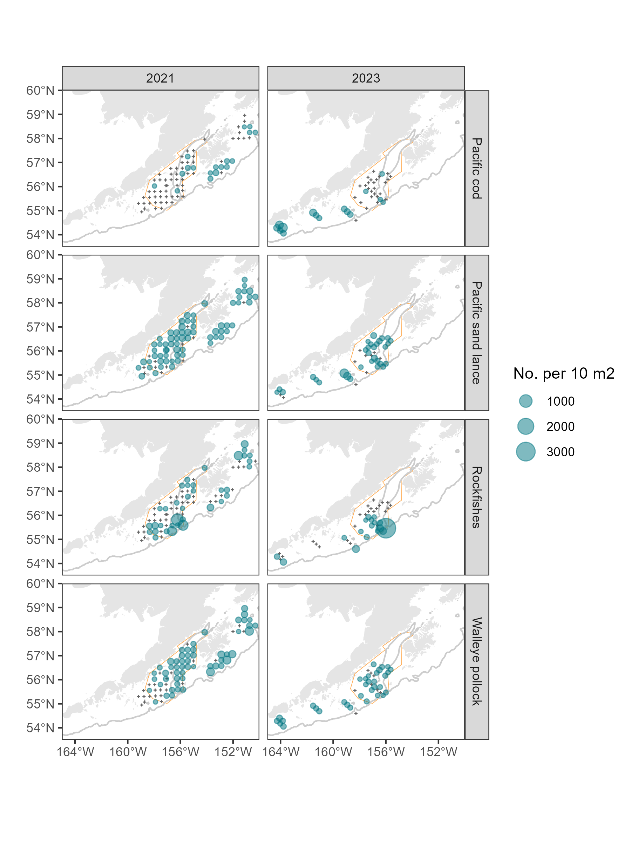

Figure 1. Abundance of larval Pacific cod, Pacific sand lance, rockfishes, and walleye pollock on the EcoFOCI spring larval survey for 2021-2023. The at-sea rough counts were used to generate the distribution for 2023 whereas quantitative laboratory data are shown for 2021. The orange polygon indicates the consistently sampled “core area” from which time-series are estimated.

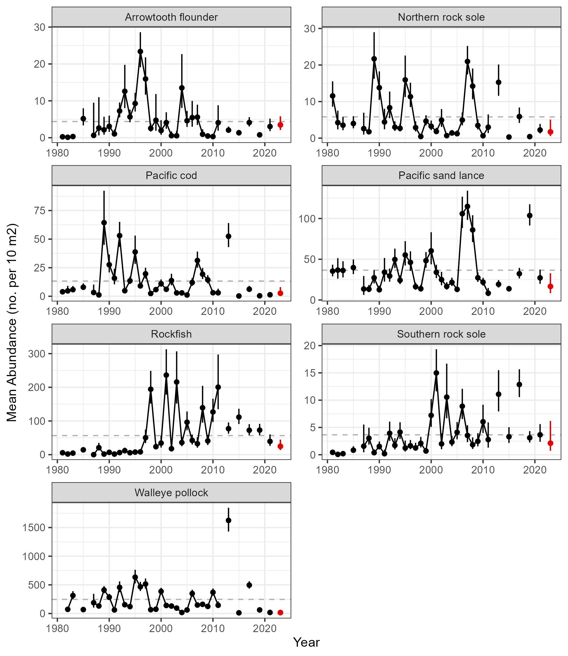

Figure 2. Interannual variation in late spring larval fish abundance in the Gulf of Alaska. The larval abundance index is expressed as the mean abundance (no. 10 m-2), and the long-term mean is indicated by the dashed line. Error bars show ± 1 SE. The 2023 values (red) are from the onboard Rapid Larval Assessment and are subject to change.