Summary of the 2024 Recommended Model Alternatives for Gulf of Alaska Pacific cod

Pete Hulson, Steve Barbeaux, and Ingrid Spies

# Executive Summary

The explored model alternatives for the 2024 assessment of Gulf of Alaska (GOA) Pacific cod involve changes to input data. The changes implemented in the model alternatives include correcting errors in data input files, improving model consistency with other AFSC cod assessments, updating important data input parameters, simplifying fishery length composition expansion methods, and improving model efficiency.

Ultimately, the models we recommend be presented for consideration at the November Groundfish Plan Team results in improvements as compared to the accepted model in 2023 (model 2019.1b).

# Data

An advancement made in this year’s GOA cod assessment included re-development of the R-programming code used to query and construct data files used in the model. The historical code was refactored for clarity, to align with ongoing efforts to streamline this assessments code base, to include documentation that describes the important steps in calculations, and to integrate with current efforts to develop R-packages for data querying, specifically to integrate with the afscdata R-package. Part of this re-development involved transitioning the querying of data tables housed in both the AFSC and AK Fisheries Information Network (AKFIN) databases to only querying data from the AKFIN database.

It is normally the case that the models presented at the September Groundfish Plan Team meeting only use data through the last full assessment. However, because of the differences in data sources used in the re-developed R-scripts, to follow this guideline additional functionality would have needed to be developed in order to filter data to match exactly with what was used in the 2023 assessment. This additional functionality development was not undertaken for two primary reasons: (1) it did not seem like a reasonable use of assessment authors’ time to develop this code that would only be used for this single assessment cycle, and (2) because there were no surveys conducted in the GOA in 2024, thus, the model will not be updated with any population index data and the only data updated thus far in 2024 was fishery catch and length composition. For these reasons, the model alternatives presented here include updated data through the beginning of September 2024. As would be done in the November SAFE document, in the following table we highlight the data that has been added since the last full assessment and inclued in the model alternatives presented here:

|  |  |  |  |
| --- | --- | --- | --- |
| **Data** | **Source** | **Type** | **Years** |
| Federal and state fishery catch, by gear type (trawl, longline, and pot) | AKFIN | Metric tons | 1977 – **2024** |
| Federal and state fishery catch-at-length, by gear type | AKFIN, ADF&G | Frequency observed at length (in cm) | 1977 – **2024** |
| GOA NMFS bottom trawl survey numbers | AKFIN | Total numbers | 1990 – 2023 |
| AFSC Sablefish Longline survey Pacific cod Relative Population Numbers | AKFIN | RPN | 1990 – 2023 |
| GOA NMFS bottom trawl survey length composition | AKFIN | Number at length (in cm) | 1990 – 2023 |
| GOA NMFS bottom trawl survey conditional age-at-length | AKFIN | Proportion age at length | 1990 – 2021 |
| AFSC Sablefish Longline survey Pacific Cod length composition | AKFIN | RPN at length (in cm) | 1990 – 2023 |
| Federal fishery conditional age-at-length | AKFIN | proportion age at length | 2007 – 2022 |

# Analytic Approach

The base model used in this analysis is the accepted model from the 2023 assessment cycle (model 2019.1b). Model 19.1b is a single sex, age-based model with length-based selectivity and is optimized with the Stock Synthesis software (Methot and Wetzell 2013).

## Description of Alternative Models

### 2019.1c

There are seven proposed changes to model input data files that culminate in model scenario 2019.1c. While these changes are all incorporated in model 2019.1c we also applied these changes one-by-one in order to evaluate the impact of each. Individually, these changes are:

1. 2019.1c.1: when fitting a log-normal population index the log-scale standard deviation (SD) is computed as where is the variance, and is the population index value. This method had been applied in the GOA cod model for the AFSC bottom trawl survey index, but had not been applied to the AFSC longline survey index. Model 2019.1c.1 applies this method to the AFSC longline survey RPN index.
2. 2019.1c.2: in the computation of the AFSC longline survey length composition, the lengths were inadvertently set to 1 cm larger. For example, the RPN of fish at 50 cm became the RPN of fish at 51 cm. Model 2019.1c.2 assigns the correct length when computing the AFSC longline survey length composition.
3. 2019.1c.3: in the data file the month for the longline survey length composition had been set at 1 (January) when it should have been 7 (July). Model 2019.1c.3 sets the month for the AFSC longline survey length composition at 7.
4. 2019.1c.4: the fishery length composition input sample size has hostorically been set at the number of hauls sampled, with a maximum of 200. However, in the computation of fishery length composition, hauls with less than 10 observations were removed, but this filtering was not reflected in the input sample size. Model 2019.1c.4 sets the fishery length composition at the number of hauls actually used in the computation of length composition, with a maximum of 200.
5. 2019.1c.5: the plus length bin for the length composition data had been set at 116 cm, but, since 1977 less than 2% of the years had a proportion of greater than 0.01 with a plus length bin of 104 cm. Model 2019.1c.5 sets the plus length bin at 104 cm.
6. 2019.1c.6: in the data file the month for the AFSC bottom trawl survey conditional age-at-length data was set at 1 (January), when it should have been set at 7 (July). Model 2019.1c.6 sets the month for the AFSC bottom trawl survey conditional age-at-length data at 7.
7. 2019.1c.7: in the assessment, the phase for the forecast recruitment parameters was set at a value which enabled the estimation of these parameters, whereas, in the Eastern Bering Sea (EBS) cod assessment these parameters are turned off. Model 2019.1c.7 turns off the forecast recruitment parameters.

### 2019.1d

Within the base model 2019.1b ageing error is applied using paired reader-tester data through 2017. In model 2019.1d we propose to build upon model 2019.1c and update the ageing error parameters with data through 2021. In addition, we propose to update these parameters after pooling the reader-tester data for the GOA and EBS in order to leverage the larger number of samples available within both regions. Using the a linear ageing error method within the R-package AgeingError (Punt et al. 2008) we found that there was minimal difference between the parameters estimated for each region separately, and each region combined. The estimated ageing error SD for age-1 was 0.11 regardless of how the data was pooled, and for age-10 (the plus age in the GOA assessment) was 1.09 for the GOA, 1.14 for the EBS, and 1.13 for combined regions. Thus, in model 2019.1d we apply these updated ageing error parameters starting at age-1 with an SD of 0.11 and ending at age-10 with an SD of 1.13 while using a linear relationship between. We note, that besides updating the ageing error SD parameters, a difference in this approach with model 2019.1b is that ageing error starts at age-3, whereas in 2019.1d we start ageing error at age-1.

Because bias was discovered in the age reading for cod prior to 2007 (Barbeaux ###) model 2019.1b estimates two parameters to apply bias in the ageing error for any age data fit prior to 2007 (a parameter for the bias starting at age-3 and the bias for the final age in the model, age-10, with a linear trend between these ages). In 2018, a set of specimen data (n = 2,056) that was originally aged in 2004 was re-read by age readers in the AFSC Age and Growth Program. Using this data within the AgeingError R-package we estimated the bias in the pre-2007 data (Figure 1). In model 2019.1d, rather than estimate bias, we set the bias parameters based on the results from the AgeingError model fit to these re-read data, where the bias was 0.24 for age-1, and 2.00 for age-10, with a linear relationship defined in the model between these two ages.

### 2019.1e

As has been noted since the 2022 assessment, fishery length composition (specifically for the pot fleet) has become increasingly variable. Within model 2019.1e we propose changes to the methods used to compute fishery length composition that aid in reducing this variability.

In the expansion of fishery length frequency observations to annual fishery length composition for each fleet fit in the cod assessment model (trawl, longline, and pot fisheries) hauls have been removed that sampled less than 10 fish for length frequency within the haul. Prior to around 2015, this represented a small proportion of hauls, particularly for the longline and trawl fleets (Table 1). However, since 2015 the numbers of hauls that sampled less than 10 fish per haul has increased. For example, since 2020 around 70% of the hauls sampled in the trawl fleet had less than 10 length frequencies observed per haul.

Length frequencies are also collected within the fisheries managed by the Alaska Department of Fish and Game (ADF&G) and have been integrated within the GOA cod assessment. The use of ADF&G length frequency data occurs when there is federal data missing at a trimester-area-gear level. It is important to note, that following this method if there is federal data within a trimester-area-gear the ADF&G length frequency data is not used, regardless of the quantity of federal length frequency data compared to the quantity of ADF&G length frequency data.

In model 2019.1e we use model 2019.1d and include two changes to how fishery length frequency data is handled. First, we eliminate the filter that removes hauls that sampled less than 10 lengths and use all length frequency data available. Second, rather than ‘fill-in’ missing federal length frequency data with ADF&G data we merge the ADF&G data with the federal data so that all length frequency data from both sources can be used in the expansion of length composition data fit in the GOA cod assessment. In order to merge the ADF&G data, we also transition the fishery length composition expansion from weighting by catch at the week-area-gear level to weighting by catch at the trimester-area-gear level. In general, these two changes help to smooth out much of the variability in the fishery length composition data (2020 pot fishery length composition shown in Figure 2 as an example).

Two additional models were considered as a subset of model 2019.1e to evaluate model performance and sensitivity to the bin size within the length composition and conditional age-at-length data. The first additional model, 2019.1e.2cm evaluates using 2 cm bins, and the second, 2019.1e.5cm, evaluates using 5 cm bins. Using recent bottom trawl survey length compositions as an example, increasing the bin size serves to smooth the length composition while retaining important signal within the data (Figure 3).

# Results

## Model 2019.1c – input data changes

The majority of the input data changes made within model 2019.1c resulted in minor changes to assessment estimates (estimates of spawning biomass shown as an example in Table 3). Only three input data changes resulted in an average percent difference in estimates of spawning biomass that was greater than 1%: 2019.1c.2 in which the length bin was corrected for the longline survey length composition, 2019.1c.4 in which the input sample size for fishery length composition data was set at the number of hauls actually used to compute length composition, and 2019.1c.6 in which the month for bottom trawl survey conditional age-at-length was changed from 1 (January) to 7 (July). The largest of these was from model 2019.1c.6, which resulted in a 10% decrease in spawning biomass estimates on average. Combining all of these changes within model 2019.1c resulted in a decrease in the estimated spawning biomass across the time series of the model (Figure 4). This decrease coincided with an increase in the bottom trawl catchability parameter to 1.19 in 2019.1c compared to 1.07 in 2019.1b.

## Model 2019.1d – updating ageing error

Updating ageing error and bias parameters in model 2019.1d resulted in a slight decrease in estimated spawning biomass compared to model 2019.1c (Figure 5). The overall negative log-likelihood of model 2019.1d was smaller than model 2019.1c, indicating that updating ageing error and bias parameters improved model fit. The largest decrease in negative log-likelihood occurred for the conditional age-at-length data component, although, there was a decrease in the negative log-likelihood for each data component of the model.

## Model 2019.1e – fishery length composition

Removing the filter and merging ADF&G length frequency data when expanding the fishery length composition data resulted in an increase in estimated spawning biomass in model 2019.1e compared to model 2019.1d (Figure 6). Model 2019.1e fit to fishery length composition (as illustrated by the aggregated fit in Figure 7) improved for the longline and pot fishery compared to model 2019.1d, but slightly degraded for the trawl fishery. While the fit to the fishery length composition improved in general, it was at the expense of fit to the survey indices, particularly the longline survey (Table 5). Visually, the fit to the bottom trawl survey is similar between models 2019.1d and 2019.1e (top panel Figure 8). The fit to the longline survey results in the largest differences between 2019.1d and 2019.1e in the mid-2000s (bottom panel Figure 8), although, the fit since 2010 has been similar between these two models.

Applying the 2 cm and 5 cm bins within model 2019.1e resulted in models that estimated similar trends and magnitudes in spawning biomass (Figure 9) and resulted in similar fits to data (Table 5).

## Recommended model 2019.1e.5cm/2024.0

We recommend that model 219.1e.5cm be pursued for consideration at the November Plan Team meeting as an alternative model to the accepted model 2019.1b. This model represents a number of improvements to the 2023 assessment model that include correcting errors in data input files, improving model consistency with other AFSC cod assessments, updating important data input parameters, simplifying fishery length composition expansion methods, and improving model efficiency through extending the bins for length composition data. Ultimately the model estimates a shift in spawning biomass to smaller values (Figure 10), however, model 2019.1e.5cm is consistent with model 2019.1b by the end of the model’s time series. We note that there are a number of important changes in parameter estimates that occur in model 2019.1e.5c compared to model 2019.1b (Table 6 and Figures 11 and 12); these changes primarily occurred due to model change 2019.1c.6, in which the month for the bottom trawl survey conditional age-at-length was corrected to July rather than January as opposed to model changes that updated ageing error and changed how fishery length composition was expanded. Because of these changes in parameter estimates and the number of improvements made to the input data sources for the model, we recommend consideration of a model renumbering to 2024.0 for this model.

# Literature Cited

Barbeaux. S. J., K. Aydin, B. Fissel, K. Holsman, W. Palsson, K. Shotwell, Q. Yang, and S. Zador. 2017. Assessment of the Pacific cod stock in the Gulf of Alaska. *In* Stock assessment and fishery evaluation report for the groundfish resources of the Gulf of Alaska. North Pacific Fishery Management Council, 605 W. 4th Avenue Suite 306, Anchorage, AK 99501

Burnham, K.P. and Anderson, D.R. (2002) Model Selection and Inference: A Practical Information-Theoretic Approach. 2nd Edition, Springer-Verlag, New York.

Methot, R. D., and C. R. Wetzell. 2013. Stock synthesis: A biological and statistical framework for fish stock assessment and fishery management. Fish. Rsch. 142:86-99.

Saha, S., J. M. Solé, R. Arasa, M. Picanyol, [M. Á. González](https://www.scirp.org/(S(351jmbntvnsjt1aadkposzje))/journal/articles.aspx?searchCode=M%c2%aa+%c3%81ngeles+Gonz%c3%a1lez&searchField=authors&page=1), [A. Domingo-Dalmau](https://www.scirp.org/(S(351jmbntvnsjt1aadkposzje))/journal/articles.aspx?searchCode=Anna+Domingo-Dalmau&searchField=authors&page=1), [M. Masdeu](https://www.scirp.org/(S(351jmbntvnsjt1aadkposzje))/journal/articles.aspx?searchCode=Marta+Masdeu&searchField=authors&page=1), [I. Porras](https://www.scirp.org/(S(351jmbntvnsjt1aadkposzje))/journal/articles.aspx?searchCode=Ignasi+Porras&searchField=authors&page=1), and [B. Codina](https://www.scirp.org/(S(351jmbntvnsjt1aadkposzje))/journal/articles.aspx?searchCode=Bernat+Codina&searchField=authors&page=1). 2010. The NCEP Climate Forecast System Reanalysis. Bulletin of American Meteorological Society, 91, 1015-1057.

# Tables

Table 1. Percent of hauls within fishery length frequency data that sampled less than 10 lengths per haul.

|  |  |  |  |  |
| --- | --- | --- | --- | --- |
|  | | Longline | Pot | Trawl |
| 1991-2012 | 2% | | 4% | 3% |
| 2013 | 12% | | 12% | 2% |
| 2014 | 6% | | 14% | 5% |
| 2015 | 5% | | 8% | 4% |
| 2016 | 13% | | 10% | 4% |
| 2017 | 12% | | 12% | 20% |
| 2018 | 23% | | 6% | 6% |
| 2019 | 22% | | 10% | 6% |
| 2020 | 60% | | -- | 79% |
| 2021 | 20% | | 14% | 72% |
| 2022 | 6% | | 30% | 76% |
| 2023 | 34% | | 36% | 68% |

Table 2. Percent of ADF&G length frequency data used to compute fishery length compositions in the GOA cod assessment.

|  |  |  |  |
| --- | --- | --- | --- |
|  | Longline | Pot | Trawl |
| 1997-2016 | 35% | 19% | 38% |
| 2017 | 33% | 0% | -- |
| 2018 | 40% | 33% | -- |
| 2019 | 40% | 50% | -- |
| 2020 | 100% | 100% | -- |
| 2021 | 67% | 67% | -- |
| 2022 | 60% | 0% | -- |
| 2023 | 50% | 100% | -- |

Table 3. Average percent difference in estimated spawning biomass (SSB) from models considered within model 2019.1c compared to the base model 2019.1b.

|  |  |
| --- | --- |
| Model | % difference in SSB |
| 2019.1c | -10.5% |
| 2019.1c.1 | -0.1% |
| 2019.1c.2 | -4.5% |
| 2019.1c.3 | 0.2% |
| 2019.1c.4 | 1.6% |
| 2019.1c.5 | -0.3% |
| 2019.1c.6 | -10.6% |
| 2019.1c.7 | 0.0% |

Table 4. Likelihood components from model 2019.1b (both from the 2023 assessment and with data updated through September 2024), 2019.1c, and 2019.1d.

|  |  |  |  |  |
| --- | --- | --- | --- | --- |
| Likelihood component | 2019.1b-23 | 2019.1b-24 | 2019.1c | 2019.1d |
| TOTAL | 2930.97 | 3050.99 | 2805.81 | 2727.26 |
| Catch | 1.089E-12 | 1.206E-12 | 5.98E-12 | 3.99E-12 |
| Survey | -3.32 | -3.78 | -6.80 | -8.03 |
| Srv | -5.58 | -5.82 | -6.98 | -7.19 |
| LLSrv | 2.26 | 2.04 | 0.18 | -0.84 |
| Length composition | 1817.93 | 1868.43 | 1704.53 | 1697.31 |
| Conditional age-at-length | 1101.99 | 1180.16 | 1100.23 | 1030.48 |
| Recruitment | 3.16 | -4.86 | -2.55 | -2.96 |
| InitEQ_Regime | 3.09 | 3.10 | 3.16 | 3.25 |
| Forecast_Recruitment | 0.61 | 0.41 | 0.00 | 0.00 |
| Parm_priors | 1.00 | 1.02 | 1.14 | 1.15 |
| Parm_softbounds | 0.01 | 0.01 | 0.01 | 0.01 |
| Parm_devs | 6.50 | 6.50 | 6.08 | 6.04 |

Table 5. Likelihood components from model 2019.1d, 2019.1e, 2019.1e.2cm, and 2019.1e.5cm.

|  |  |  |  |  |
| --- | --- | --- | --- | --- |
| Likelihood component | 2019.1d | 2019.1e | 2019.1e.2cm | 2019.1e.5cm |
| TOTAL | 2727.26 | 2693.24 | 2328.98 | 1967.19 |
| Catch | 3.99E-12 | 1.67E-12 | 1.40E-12 | 1.35E-12 |
| Survey | -8.03 | 3.81 | 4.68 | 5.64 |
| Srv | -7.19 | -5.25 | -5.14 | -5.22 |
| LLSrv | -0.84 | 9.06 | 9.82 | 10.85 |
| Length composition | 1817.93 | 1868.43 | 1704.53 | 1697.31 |
| Conditional age-at-length | 1101.99 | 1180.16 | 1100.23 | 1030.48 |
| Recruitment | -2.96 | -2.53 | -2.20 | -0.96 |
| InitEQ_Regime | 3.25 | 3.23 | 3.26 | 3.08 |
| Forecast_Recruitment | 0.00 | 0.00 | 0.00 | 0.00 |
| Parm_priors | 1.15 | 1.32 | 1.29 | 1.24 |
| Parm_softbounds | 0.01 | 0.01 | 0.01 | 0.01 |
| Parm_devs | 6.04 | 5.97 | 5.89 | 5.62 |

Table 6. Key parameter estimates from model 2019.1b (both from the 2023 assessment and with data updated through September 2024) and model 2019.1e.5cm.

|  |  |  |  |
| --- | --- | --- | --- |
| Parameter | 2019.1b-23 | 2019.1b-24 | 2019.1e.5cm |
| NatM | 0.46 | 0.46 | 0.47 |
| NatM: 14-16 | 0.79 | 0.80 | 0.83 |
| LN(R0) | 12.86 | 12.87 | 13.10 |
| q_twl | 1.08 | 1.07 | 1.16 |
| q_ll | 1.06 | 1.06 | 1.07 |
| q_llenv | 1.42 | 1.46 | 1.37 |

# Figures

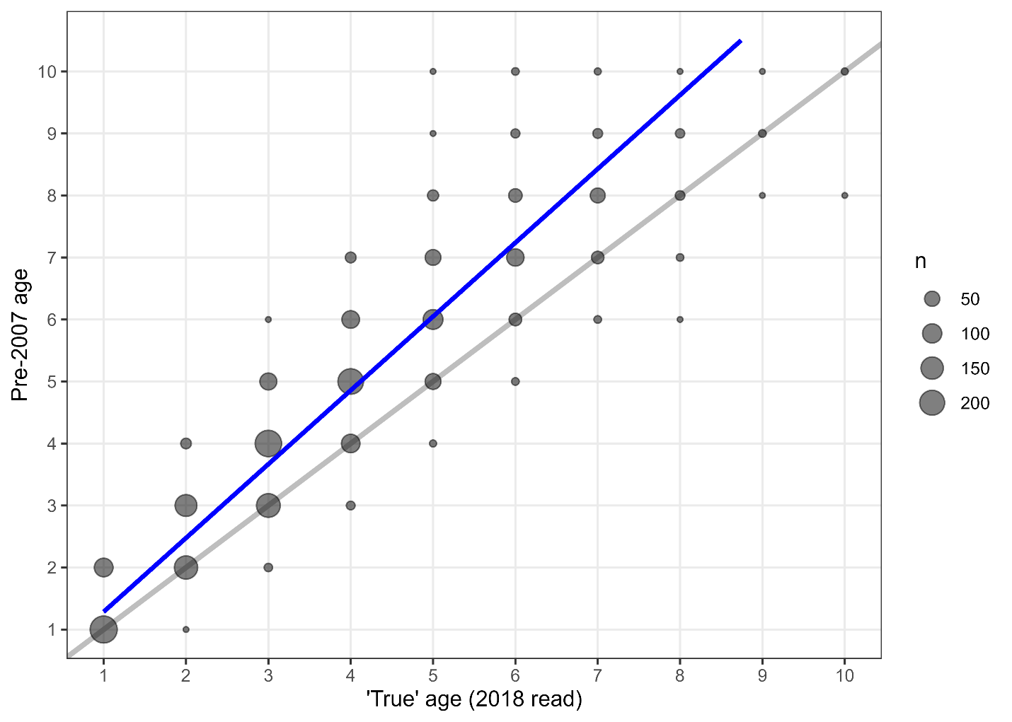

Figure 1. AgeingError R-package fit (blue line) to 2018 ageing compared to pre-2007 ageing (bubbles, with size indicating the number of times the particular age in 2018 matched the age pre-2007; grey line is 1-1 and shown for reference).

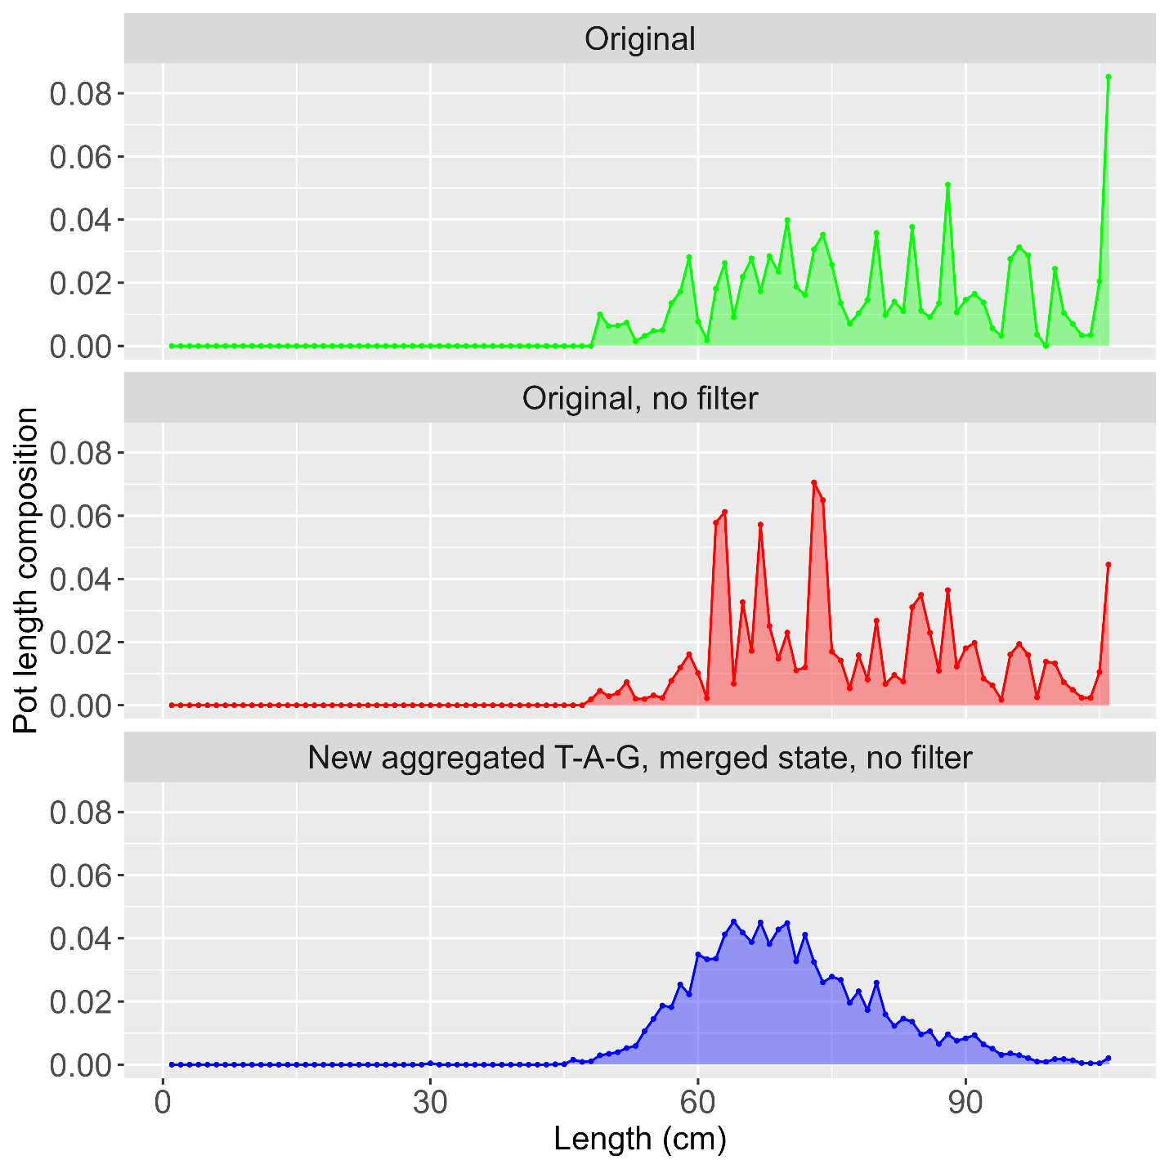

Figure 2. 2020 Pot fishery length composition following the original method for filtering and using ADF&G length frequency data (top panel), after removing the greater than 10 lengths per haul filter (middle panel), and after removing the greater than 10 lengths per haul filter and merging ADF&G length frequency data with federal data (bottom panel).

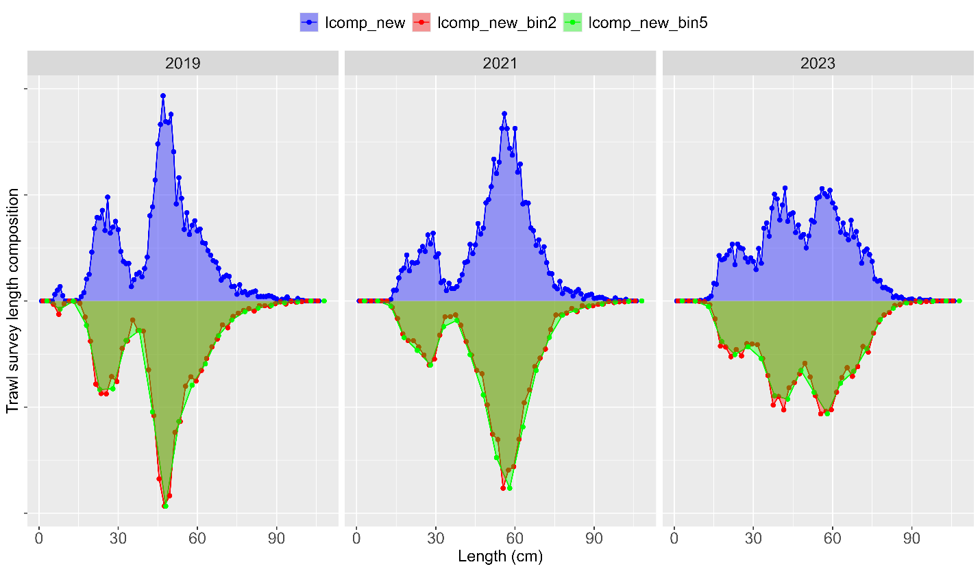

Figure 3. Recent bottom trawl survey length composition computed for 1cm (lcomp_new shown in blue), 2 cm (lcomp_new_bin2 shown in red), and 5cm (lcomp_new-bin5 shown in green) length bins.

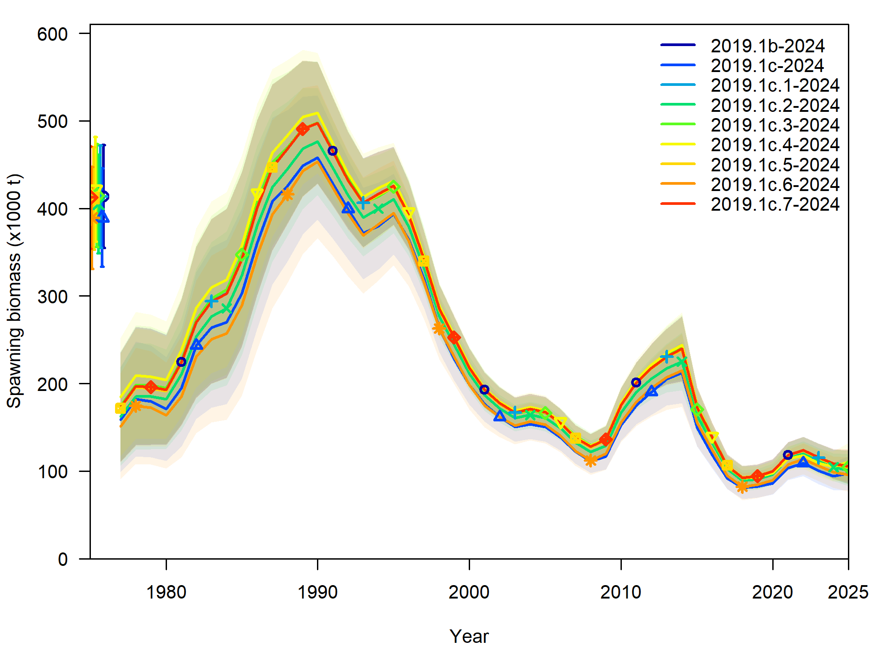

Figure 4. Estimated spawning biomass for the models considered in 2019.1c as compared to the 2023 assessment (2019.1b-2023) and the 2023 assessment with updated data (2019.1b-2024).

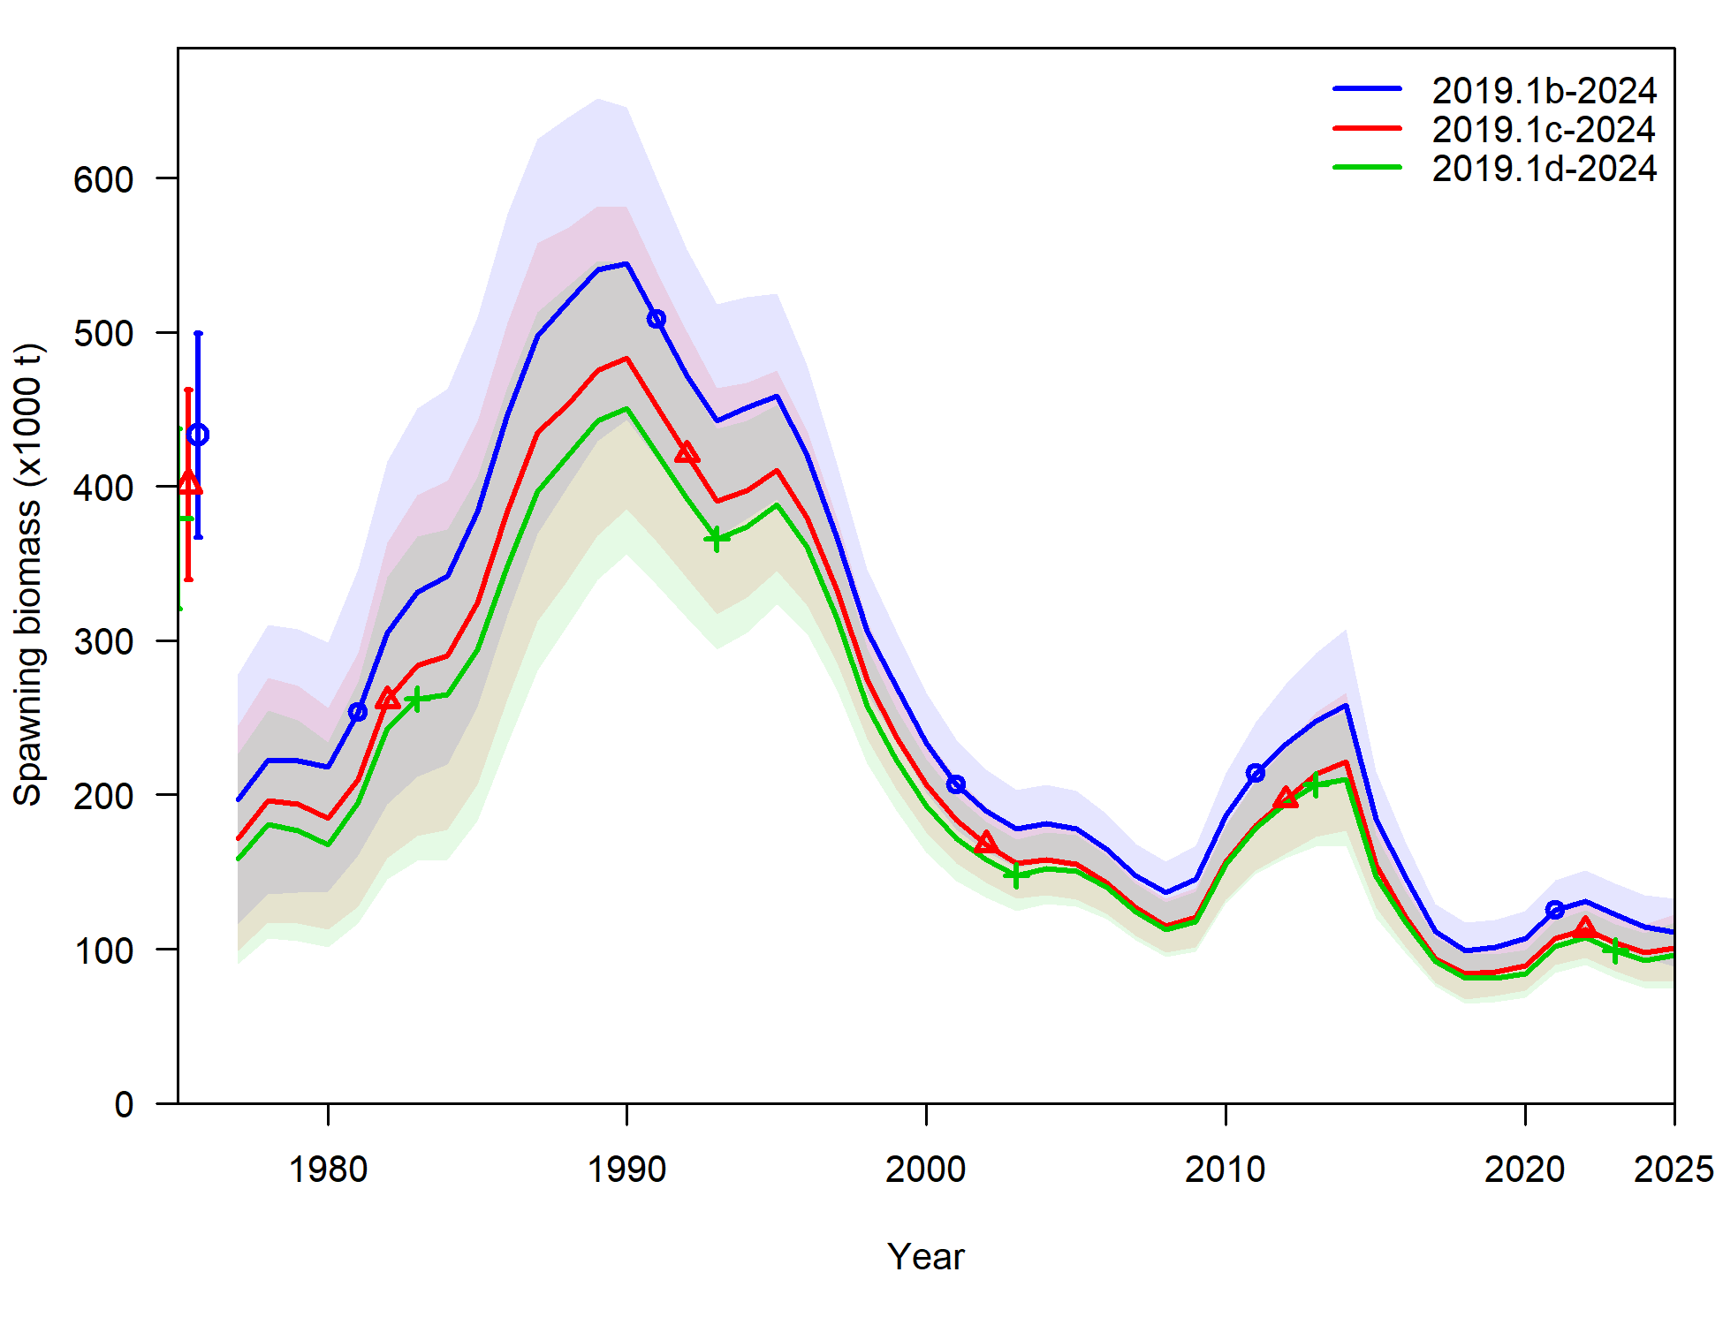

Figure 5. Estimated spawning biomass from models 2019.1b, 2019.1c, and 2019.1d.

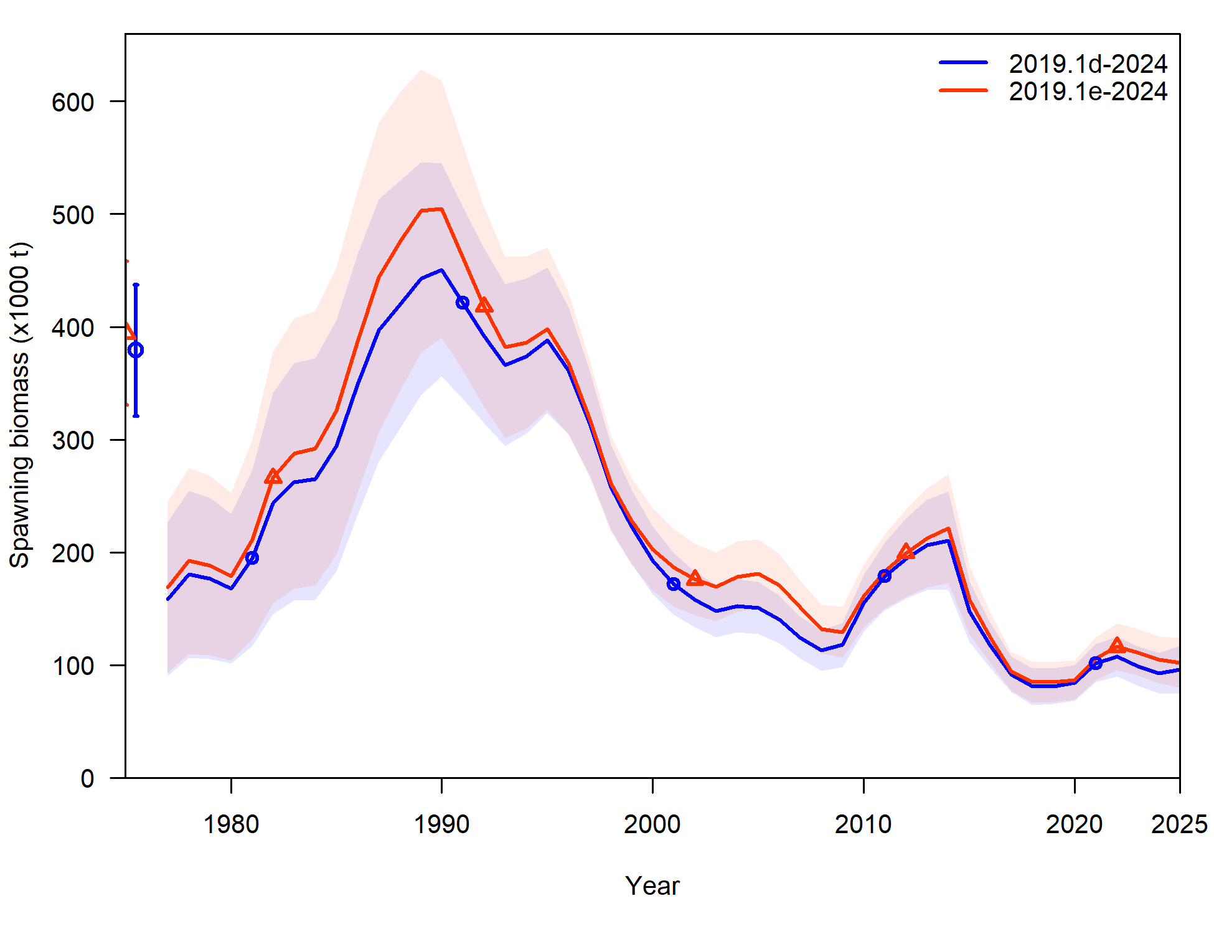

Figure 6. Estimated spawning biomass from models 2019.1d and 2019.1e.

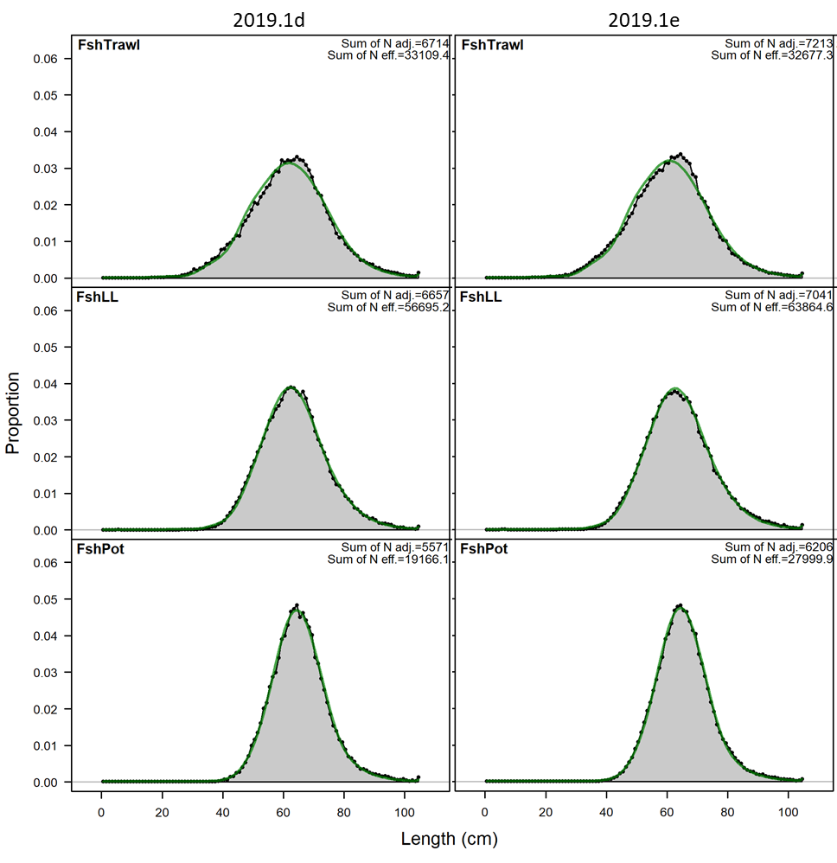

Figure 7. Aggregated fishery length composition fits for model 2019.1d (left panels) and 2019.1e (right panels).

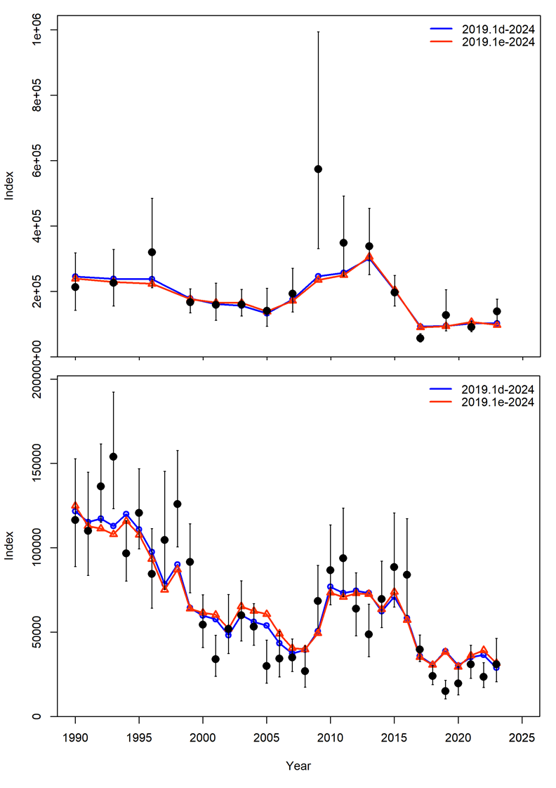

Figure 8. Model 2019.1d and 2019.1e fit to the bottom trawl survey numbers (top panel) and longline survey RPN (bottom panel).

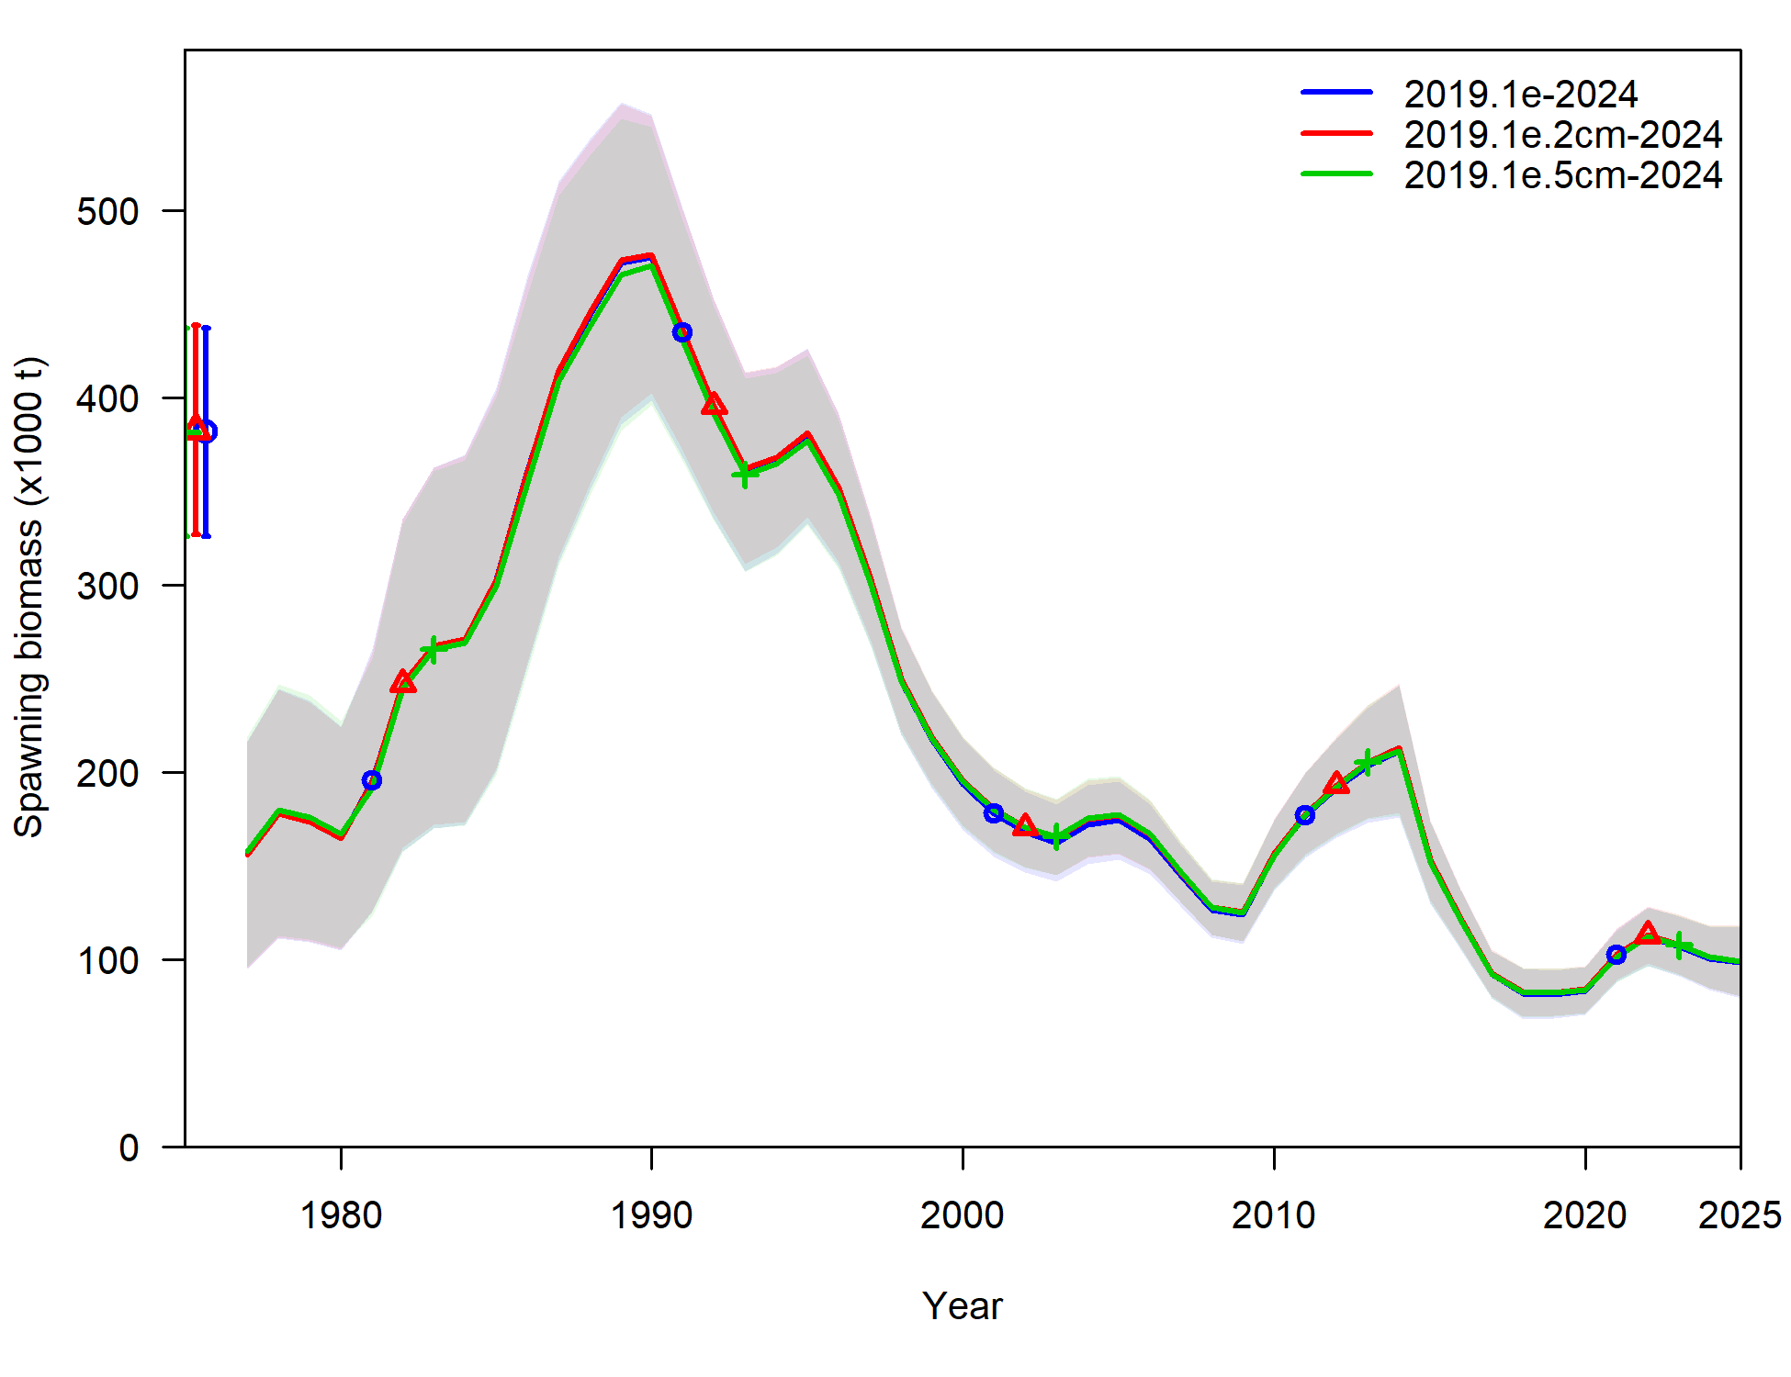

Figure 9. Estimated spawning biomass from models 2019.1e, 2019.1e.2cm, and 2019.1e.5cm.

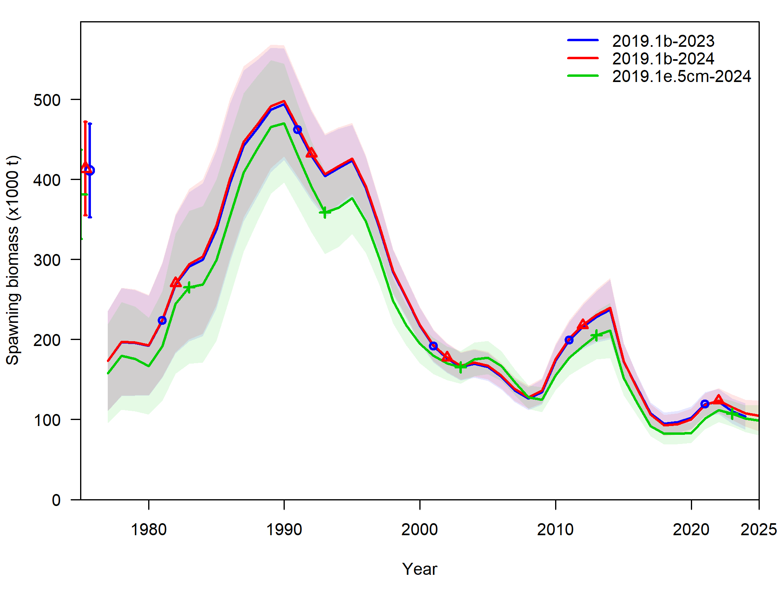

Figure 10. Estimated spawning biomass from the 2023 assessment model 2019.1b, model 2019.1b with updated data through 2024, and the recommended model 2019.1e.5cm.

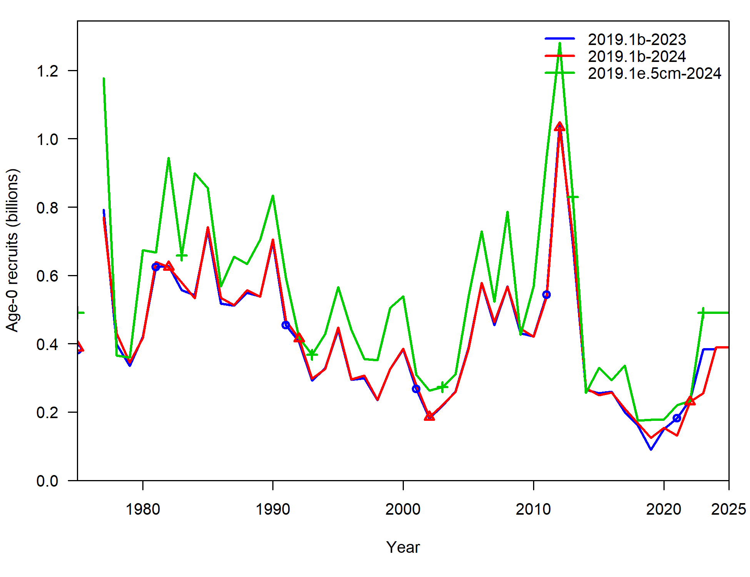

Figure 11. Estimated recruitment from the 2023 assessment model 2019.1b, model 2019.1b with updated data through 2024, and the recommended model 2019.1e.5cm.

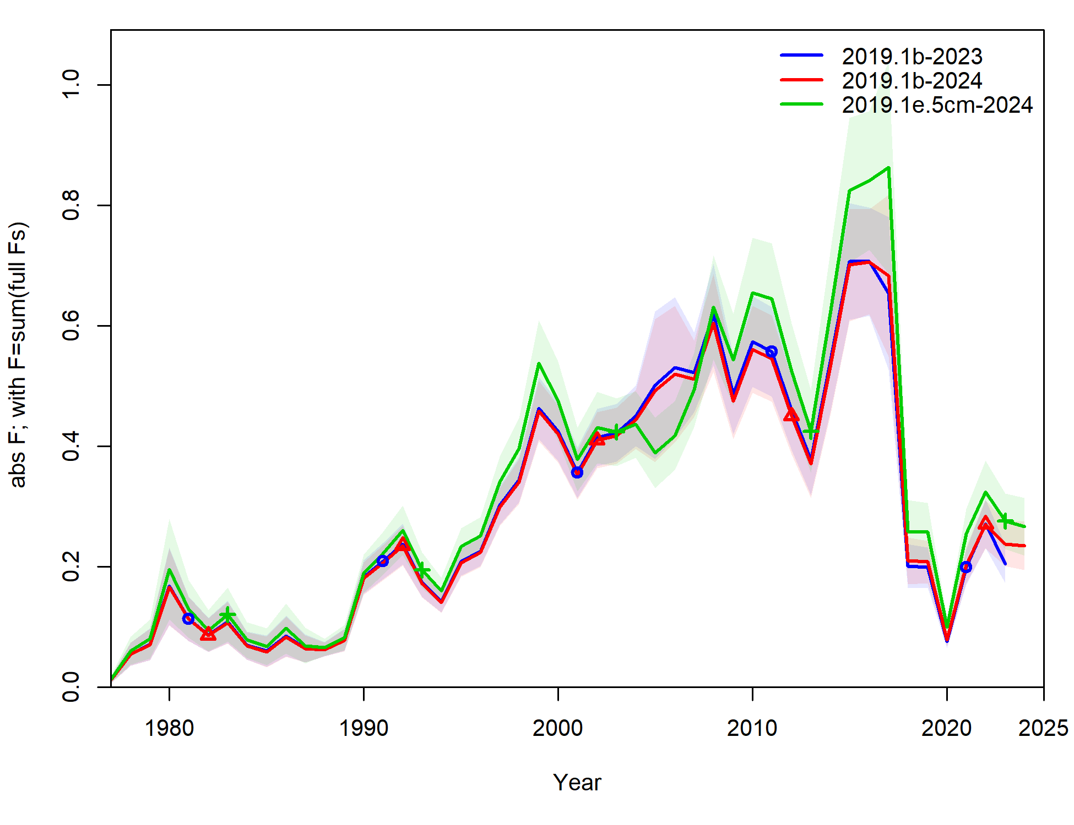

Figure 12. Estimated fishing mortality from the 2023 assessment model 2019.1b, model 2019.1b with updated data through 2024, and the recommended model 2019.1e.5cm.