Literature Cited
Ferriss, B.E. 2026. Abbreviated Ecosystem Status Report 2026: Gulf of Alaska, Stock Assessment and Fishery Evaluation Report for the Groundfish Resources of the Gulf of Alaska, North Pacific Fishery Management Council, 1007 West Third, Suite 400, Anchorage, Alaska 99501
Hulson, P.-J. F., S. J. Barbeaux, B. Ferriss, S. McDermott, and I. Spies. 2022. Assessment of the Pacific cod stock in the Gulf of Alaska. In Stock assessment and fishery evaluation report for the groundfish resources of the Gulf of Alaska. North Pacific Fishery Management Council, 605 W. 4th Avenue Suite 306, Anchorage, AK 99501.
Hulson, P.-J. F., S. J. Barbeaux, B. Ferriss, K. Echave, J. Nielsen, S. McDermott, B. Laurel, A. Abookire, I. Spies, and S. K. Shotwell. 2024. Assessment of the Pacific cod stock in the Gulf of Alaska. North Pacific Fishery Management Council, Anchorage, AK.
Hulson, P.-J. F., S. J. Barbeaux, B. Ferriss, K. Echave, J. Nielsen, S. McDermott, B. Laurel, A. Abookire, I. Spies, and S. K. Shotwell. 2026. Assessment of the Pacific cod stock in the Gulf of Alaska. North Pacific Fishery Management Council, Anchorage, AK. Available from https://www.npfmc.org/library/safe-reports/.
Methot, R. D., and C. R. Wetzell. 2013. Stock synthesis: A biological and statistical framework for fish stock assessment and fishery management. Fish. Rsch. 142:86-99.
Rutecki, T. L., C. J. Rodgveller, and C. R. Lunsford. 2016. National Marine Fisheries Service longline survey data report and survey history, 1990–2014. U.S. Dep. Commer., NOAA Tech. Memo. NMFS-AFSC-324, 329 p.
Siwicke, K., and P. Malecha. 2024. The 2023 longline survey of the Gulf of Alaska and eastern Bering Sea on the FV Alaskan Leader: Cruise Report AL-23-01. U.S. Department of Commerce, NOAA Technical Memorandum NMFS-AFSC-480, 39 p.
Thompson, G. G., Z. T. A’mar, and W. A. Palsson. 2011. Assessment of the Pacific cod stock in the Gulf of Alaska. In Stock assessment and fishery evaluation report for the groundfish resources of the Gulf of Alaska. North Pacific Fishery Management Council, 605 W. 4th Avenue Suite 306, Anchorage, AK 99501.

Tables

Table 2.1. Catch (t) for 1997 through 2026 by jurisdiction and gear type (as of 2026-10-26, ‘Other’ gear type is primarily jig).
 | Federal |  |  |  |  | State
Year | Trawl | Long-line | Pot | Other | Subtotal | Long-line | Pot | Other | Subtotal | Total
1997 | 48,406 | 10,978 | 9,065 | 26 | 68,475 | - | 7,368 | 1,327 | 8,695 | 77,170
1998 | 41,570 | 10,012 | 10,510 | 29 | 62,121 | - | 9,183 | 1,320 | 10,503 | 72,624
1999 | 37,167 | 12,363 | 19,015 | 70 | 68,615 | - | 12,410 | 1,518 | 13,928 | 82,543
2000 | 25,443 | 11,660 | 17,351 | 54 | 54,508 | - | 10,399 | 1,644 | 12,043 | 66,551
2001 | 24,383 | 9,910 | 7,171 | 155 | 41,619 | - | 7,829 | 2,083 | 9,912 | 51,531
2002 | 19,810 | 14,666 | 7,694 | 176 | 42,346 | - | 10,578 | 1,714 | 12,292 | 54,638
2003 | 18,884 | 9,525 | 12,765 | 161 | 41,335 | 62 | 7,943 | 3,242 | 11,247 | 52,582
2004 | 17,513 | 10,326 | 14,966 | 400 | 43,205 | 51 | 10,602 | 2,765 | 13,418 | 56,623
2005 | 14,549 | 5,732 | 14,749 | 203 | 35,233 | 26 | 9,653 | 2,673 | 12,352 | 47,585
2006 | 13,132 | 10,244 | 14,540 | 118 | 38,034 | 55 | 9,146 | 662 | 9,863 | 47,897
2007 | 14,775 | 11,539 | 13,573 | 44 | 39,931 | 270 | 11,378 | 682 | 12,330 | 52,261
2008 | 20,293 | 12,106 | 11,229 | 63 | 43,691 | 317 | 13,438 | 1,568 | 15,323 | 59,014
2009 | 13,976 | 13,968 | 11,951 | 206 | 40,101 | 676 | 9,919 | 2,500 | 13,095 | 53,196
2010 | 22,035 | 16,538 | 20,116 | 429 | 59,118 | 826 | 14,604 | 4,045 | 19,475 | 78,593
2011 | 16,456 | 16,622 | 29,233 | 722 | 63,033 | 1,033 | 16,675 | 4,627 | 22,335 | 85,368
2012 | 20,084 | 14,467 | 21,238 | 722 | 56,511 | 866 | 15,940 | 4,613 | 21,419 | 77,930
2013 | 21,706 | 12,836 | 17,011 | 476 | 52,029 | 1,088 | 14,156 | 1,303 | 16,547 | 68,576
2014 | 26,917 | 14,735 | 19,957 | 1,046 | 62,655 | 1,007 | 18,445 | 2,838 | 22,290 | 84,945
2015 | 22,268 | 13,047 | 20,653 | 408 | 56,376 | 577 | 19,719 | 2,808 | 23,104 | 79,480
2016 | 15,217 | 8,123 | 19,248 | 346 | 42,934 | 803 | 18,609 | 1,708 | 21,120 | 64,054
2017 | 13,041 | 8,965 | 13,426 | 67 | 35,499 | 155 | 13,011 | 62 | 13,228 | 48,727
2018 | 3,818 | 3,033 | 4,013 | 121 | 10,985 | 310 | 3,660 | 195 | 4,165 | 15,150
2019 | 4,535 | 2,763 | 3,732 | 178 | 11,208 | 358 | 3,820 | 329 | 4,507 | 15,715
2020 | 3,427 | 586 | 30 | - | 4,043 | 529 | 1,779 | 491 | 2,799 | 6,842
2021 | 5,986 | 3,834 | 3,427 | 52 | 13,299 | 558 | 4,230 | 1,085 | 5,873 | 19,172
2022 | 8,207 | 5,775 | 4,925 | 3 | 18,910 | 357 | 5,645 | 994 | 6,996 | 25,906
2023 | 6,473 | 5,179 | 4,069 | 378 | 16,099 | 563 | 3,653 | 1,412 | 5,628 | 21,727
2024 | 8,347 | 5,420 | 5,623 | 319 | 19,709 | 416 | 4,295 | 1,488 | 6,199 | 25,908
2025 | 8,092 | 5,154 | 6,408 | 533 | 20,187 | 314 | 5,674 | 1,387 | 7,375 | 27,562
2026 | 10,408 | 6,460 | 8,555 | 896 | 26,319 | 396 | 8,674 | 2,216 | 11,286 | 37,605

Table 2.2. History of Pacific cod catch (t, includes catch from State waters), Federal TAC, ABC, OFL and State of Alaska GHL since 1997. Catch for 2026 is current through 2025-10-26 and includes catch from State of Alaska fisheries.
Year | Catch | TAC | ABC | OFL | GHL
1997 | 77,170 | 69,115 | 81,500 | 180,000 | 12,385
1998 | 72,624 | 66,060 | 77,900 | 141,000 | 11,840
1999 | 82,543 | 67,835 | 84,400 | 134,000 | 16,565
2000 | 66,551 | 59,800 | 76,400 | 102,000 | 17,685
2001 | 51,531 | 52,110 | 67,800 | 91,200 | 15,690
2002 | 54,638 | 44,230 | 57,600 | 77,100 | 13,370
2003 | 52,582 | 40,540 | 52,800 | 70,100 | 12,260
2004 | 56,623 | 48,033 | 62,810 | 102,000 | 14,777
2005 | 47,585 | 44,433 | 58,100 | 86,200 | 13,667
2006 | 47,897 | 52,264 | 68,859 | 95,500 | 16,595
2007 | 52,261 | 52,264 | 68,859 | 97,600 | 16,595
2008 | 59,014 | 50,269 | 66,493 | 88,660 | 16,224
2009 | 53,196 | 41,807 | 55,300 | 66,600 | 13,493
2010 | 78,593 | 59,563 | 79,100 | 94,100 | 19,537
2011 | 85,368 | 65,100 | 86,800 | 102,600 | 21,700
2012 | 77,930 | 65,700 | 87,600 | 104,000 | 21,900
2013 | 68,576 | 60,600 | 80,800 | 97,200 | 20,200
2014 | 84,945 | 64,738 | 88,500 | 107,300 | 23,762
2015 | 79,480 | 75,202 | 102,850 | 140,300 | 27,648
2016 | 64,054 | 71,925 | 98,600 | 116,700 | 26,675
2017 | 48,727 | 64,442 | 88,342 | 105,378 | 23,900
2018 | 15,150 | 13,096 | 18,000 | 23,565 | 4,904
2019 | 15,715 | 12,368 | 17,000 | 23,669 | 4,632
2020 | 6,842 | 6,431 | 14,621 | 17,794 | 2,537
2021 | 19,172 | 17,321 | 23,627 | 28,977 | 6,306
2022 | 25,906 | 24,111 | 32,811 | 39,555 | 8,700
2023 | 21,727 | 18,103 | 24,634 | 29,737 | 6,531
2024 | 25,908 | 23,766 | 32,272 | 38,712 | 8,506
2025 | 27,562 | 23,670 | 32,141 | 38,688 | 8,471
2026 | 37,605 | 30,053 | 41,520 | 49,782 | 11,467

Table 2.3. 10-year Biologically informed Recommended Distributions (BRD) with total ABC for GOA Pacific cod.
 | BRD Apportionment
Year | Western | Central | Eastern | ABC
2016 | 40,503 | 49,312 | 8,785 | 98,600
2017 | 36,291 | 44,180 | 7,871 | 88,342
2018 | 8,082 | 8,118 | 1,800 | 18,000
2019 | 7,633 | 7,667 | 1,700 | 17,000
2020 | 4,942 | 8,458 | 1,221 | 14,621
2021 | 7,986 | 13,656 | 1,985 | 23,627
2022 | 9,942 | 19,752 | 3,117 | 32,811
2023 | 7,464 | 14,830 | 2,340 | 24,634
2024 | 8,745 | 20,590 | 2,937 | 32,272
2025 | 8,710 | 20,506 | 2,925 | 32,141
2026 | 10,297 | 28,732 | 2,491 | 41,520

Table 2.4. GOA AFSC Longline survey estimated Relative Population Numbers (RPNs), and bottom trawl survey estimated biomass (t) and numbers of fish (‘Abundance’, in 1000s) shown along with coefficients of variation (in parentheses).
Year | RPN | Biomass (t) | Abundance
1990 | 116,434 (13.9%) | 413,281 (15.4%) | 210,924 (20.9%)
1991 | 110,061 (14.1%) | - | -
1992 | 136,383 (8.7%) | - | -
1993 | 153,950 (11.4%) | 400,054 (18.1%) | 220,342 (19.5%)
1994 | 96,563 (9.4%) | - | -
1995 | 120,710 (10%) | - | -
1996 | 84,535 (14.1%) | 529,762 (20.3%) | 314,572 (21.8%)
1997 | 104,647 (16.9%) | - | -
1998 | 125,877 (11.5%) | - | -
1999 | 91,480 (11.3%) | 301,719 (12.7%) | 163,498 (11.3%)
2000 | 54,316 (14.5%) | - | -
2001 | 33,841 (18.1%) | 248,745 (20.6%) | 155,231 (18.2%)
2002 | 51,903 (17%) | - | -
2003 | 59,952 (15%) | 295,423 (15.1%) | 158,613 (13%)
2004 | 53,109 (11.8%) | - | -
2005 | 29,864 (21.4%) | 302,673 (26.9%) | 129,306 (21.6%)
2006 | 34,316 (19.7%) | - | -
2007 | 34,994 (14%) | 230,056 (14%) | 190,831 (17.6%)
2008 | 26,881 (22.8%) | - | -
2009 | 68,395 (13.8%) | 741,101 (30.8%) | 562,698 (29.1%)
2010 | 86,725 (13.8%) | - | -
2011 | 93,743 (14.1%) | 492,596 (13.8%) | 342,900 (17.9%)
2012 | 63,768 (14.8%) | - | -
2013 | 48,553 (16.2%) | 502,892 (14.8%) | 336,182 (15.2%)
2014 | 69,665 (14.3%) | - | -
2015 | 88,482 (15.9%) | 248,178 (10.6%) | 193,019 (12.1%)
2016 | 83,887 (17.2%) | - | -
2017 | 39,575 (10.1%) | 103,258 (12.7%) | 54,264 (11.7%)
2018 | 23,857 (12.1%) | - | -
2019 | 14,933 (18.5%) | 179,860 (21.6%) | 124,806 (24.7%)
2020 | 19,459 (21.8%) | - | -
2021 | 30,830 (16.2%) | 172,568 (8.9%) | 89,939 (8.7%)
2022 | 23,393 (15.9%) | - | -
2023 | 30,802 (20.9%) | 222,473 (12.6%) | 125,571 (9.9%)
2025 | 29,233 (18.5%) | 309,761 (23.4%) | 187,845 (23.3%)

Table 2.5. Key parameter estimates with standard deviations (SD) estimated from the author’s recommended model.
Name | Value | SD
Biology | -- | --
Beginning of year length at age-1 (cm) | 19.38 | 0.278
Beginning of year length at age-10 (cm) | 99.46 | 0.015
Growth rate | 0.2 | 0.002
SD in length-at-age for age-1 | 4.18 | 0.158
SD in length-at-age for age-10 | 8.41 | 0.305
Natural mortality (2014-2016) | 0.88 | 0.052
Natural mortality (all years) | 0.53 | 0.022
Recruitment/Abundance | -- | --
log(mean recruitment) | 13.15 | 0.194
1976 Regime adjustment | -0.73 | 0.199
Survey catchability | -- | --
Bottom trawl survey | 1.27 | 0.117
Longline survey | 1.15 | 0.098
Longline survey environmental coefficient | 1.02 | 0.41

Table 2.6. Estimated female spawning biomass (t), standard deviation in spawning biomass (SD), and total biomass (t, age 0+) from the previous accepted assessment and the current recommended model.
Year | Previous Sp.Bio | Previous SD[Sp.Bio] | Previous Tot.Bio. | Current Sp.Bio | Current SD[Sp.Bio] | Current Tot.Bio.
1977 | 81,532 | 18,421 | 261,922 | 79,492 | 17,927 | 257,756
1978 | 92,738 | 20,019 | 273,698 | 91,155 | 19,678 | 268,888
1979 | 90,442 | 19,279 | 305,621 | 89,314 | 19,051 | 299,281
1980 | 85,592 | 17,902 | 366,512 | 84,556 | 17,532 | 361,427
1981 | 99,580 | 21,044 | 402,120 | 101,672 | 21,012 | 402,166
1982 | 126,933 | 26,868 | 425,811 | 127,984 | 26,389 | 427,019
1983 | 137,040 | 28,806 | 459,934 | 138,850 | 28,515 | 461,824
1984 | 138,207 | 29,239 | 500,761 | 140,094 | 29,057 | 508,387
1985 | 153,132 | 30,386 | 563,723 | 157,626 | 30,602 | 579,692
1986 | 181,474 | 31,604 | 634,589 | 188,784 | 32,317 | 659,570
1987 | 209,168 | 32,386 | 696,611 | 218,602 | 32,621 | 723,553
1988 | 224,496 | 31,148 | 724,735 | 237,650 | 31,672 | 756,883
1989 | 238,932 | 29,563 | 730,025 | 251,888 | 29,769 | 762,340
1990 | 242,038 | 26,936 | 714,093 | 253,448 | 26,820 | 740,818
1991 | 223,096 | 23,770 | 672,712 | 233,224 | 23,504 | 693,817
1992 | 203,906 | 21,261 | 640,025 | 211,776 | 20,767 | 656,071
1993 | 187,434 | 19,357 | 607,742 | 194,050 | 18,828 | 624,776
1994 | 188,231 | 18,204 | 588,353 | 194,662 | 17,677 | 605,440
1995 | 191,054 | 16,749 | 557,137 | 197,645 | 16,299 | 573,119
1996 | 174,157 | 14,443 | 496,225 | 179,792 | 14,050 | 508,489
1997 | 149,887 | 11,918 | 444,617 | 154,128 | 11,560 | 452,172
1998 | 123,258 | 9,913 | 397,910 | 126,110 | 9,575 | 402,636
1999 | 108,093 | 8,911 | 362,078 | 110,788 | 8,607 | 365,406
2000 | 95,240 | 8,446 | 322,039 | 97,086 | 8,115 | 324,232
2001 | 86,876 | 7,922 | 304,118 | 88,510 | 7,639 | 304,682
2002 | 82,753 | 7,388 | 309,067 | 84,322 | 7,140 | 309,102
2003 | 81,684 | 7,252 | 310,329 | 83,218 | 7,021 | 312,011
2004 | 87,293 | 7,491 | 301,769 | 88,858 | 7,268 | 304,756
2005 | 87,188 | 7,305 | 279,496 | 88,906 | 7,117 | 282,052
2006 | 81,328 | 6,503 | 263,509 | 82,542 | 6,323 | 264,490
2007 | 72,336 | 5,671 | 260,909 | 73,588 | 5,522 | 259,403
2008 | 64,363 | 5,225 | 281,842 | 65,316 | 5,064 | 279,710
2009 | 64,250 | 5,588 | 319,879 | 65,474 | 5,426 | 319,250
2010 | 81,442 | 6,910 | 371,394 | 84,404 | 6,809 | 373,199
2011 | 94,092 | 8,337 | 395,909 | 97,195 | 8,219 | 399,171
2012 | 103,150 | 9,796 | 401,222 | 106,894 | 9,693 | 405,391
2013 | 110,236 | 10,979 | 418,360 | 113,111 | 10,807 | 422,206
2014 | 111,680 | 11,770 | 470,503 | 115,094 | 11,715 | 477,374
2015 | 78,400 | 7,375 | 363,504 | 80,917 | 7,293 | 370,397
2016 | 61,134 | 5,369 | 252,790 | 63,906 | 5,326 | 258,107
2017 | 46,249 | 4,128 | 156,551 | 47,816 | 4,056 | 157,790
2018 | 40,443 | 4,306 | 133,276 | 41,165 | 4,189 | 132,056
2019 | 39,932 | 4,099 | 143,626 | 39,874 | 3,921 | 141,295
2020 | 40,298 | 4,072 | 158,719 | 40,087 | 3,888 | 156,114
2021 | 49,127 | 4,451 | 179,657 | 49,208 | 4,282 | 176,681
2022 | 55,225 | 4,901 | 186,049 | 55,052 | 4,711 | 181,439
2023 | 55,298 | 5,036 | 185,759 | 54,158 | 4,792 | 180,987
2024 | 54,879 | 5,112 | 188,381 | 53,392 | 4,885 | 187,960
2025 | 54,728 | 5,564 | 185,884 | 53,591 | 5,423 | 191,084
2026 | 52,772 | 6,247 | 182,156 | 56,552 | 6,549 | 191,794
2027 | - | - | - | 51,423 | 7,550 | 192,257

Table 2.7. Age-0 recruitment (millions) and standard deviation of age-0 recruits by year from the previous accepted model 24.0 and the updated model 24.0 (denoted as ‘Current’). Highlighted are the 1977 and 2012 year classes.
Year | Previous Recruitment | Previous SD[Rec] | Current Recruitment | Current SD[Rec]
1977 | 1.18 | 0.35 | 1.03 | 0.3
1978 | 0.39 | 0.14 | 0.59 | 0.19
1979 | 0.36 | 0.13 | 0.42 | 0.14
1980 | 0.64 | 0.21 | 0.52 | 0.17
1981 | 0.69 | 0.22 | 0.83 | 0.24
1982 | 0.93 | 0.3 | 0.86 | 0.26
1983 | 0.68 | 0.27 | 0.92 | 0.31
1984 | 0.9 | 0.29 | 0.85 | 0.28
1985 | 0.88 | 0.25 | 0.98 | 0.26
1986 | 0.62 | 0.17 | 0.75 | 0.18
1987 | 0.66 | 0.16 | 0.68 | 0.15
1988 | 0.66 | 0.16 | 0.72 | 0.15
1989 | 0.69 | 0.16 | 0.69 | 0.15
1990 | 0.78 | 0.17 | 0.86 | 0.17
1991 | 0.58 | 0.13 | 0.67 | 0.14
1992 | 0.42 | 0.1 | 0.5 | 0.1
1993 | 0.36 | 0.08 | 0.41 | 0.08
1994 | 0.42 | 0.09 | 0.4 | 0.08
1995 | 0.54 | 0.1 | 0.57 | 0.1
1996 | 0.4 | 0.08 | 0.43 | 0.08
1997 | 0.37 | 0.07 | 0.42 | 0.08
1998 | 0.34 | 0.07 | 0.34 | 0.06
1999 | 0.52 | 0.1 | 0.49 | 0.09
2000 | 0.5 | 0.1 | 0.54 | 0.09
2001 | 0.3 | 0.06 | 0.39 | 0.07
2002 | 0.26 | 0.05 | 0.25 | 0.05
2003 | 0.3 | 0.06 | 0.34 | 0.06
2004 | 0.3 | 0.06 | 0.27 | 0.05
2005 | 0.54 | 0.1 | 0.49 | 0.08
2006 | 0.74 | 0.13 | 0.75 | 0.12
2007 | 0.54 | 0.1 | 0.59 | 0.1
2008 | 0.8 | 0.15 | 0.78 | 0.13
2009 | 0.44 | 0.09 | 0.54 | 0.1
2010 | 0.53 | 0.11 | 0.53 | 0.1
2011 | 0.82 | 0.17 | 0.75 | 0.15
2012 | 1.21 | 0.28 | 1.25 | 0.26
2013 | 0.76 | 0.2 | 0.95 | 0.23
2014 | 0.25 | 0.07 | 0.39 | 0.1
2015 | 0.29 | 0.08 | 0.23 | 0.06
2016 | 0.28 | 0.06 | 0.29 | 0.06
2017 | 0.31 | 0.06 | 0.28 | 0.05
2018 | 0.23 | 0.05 | 0.27 | 0.05
2019 | 0.19 | 0.04 | 0.17 | 0.03
2020 | 0.22 | 0.05 | 0.24 | 0.05
2021 | 0.27 | 0.06 | 0.25 | 0.05
2022 | 0.2 | 0.05 | 0.33 | 0.07
2023 | 0.19 | 0.06 | 0.17 | 0.04
2024 | 0.3 | 0.1 | 0.25 | 0.07
2025 | 0.48 | 0.23 | 0.44 | 0.2
2026 | - | - | 0.51 | 0.25
Mean 1977 - (Final year - 2) | 0.52 |  | 0.55

Table 2.8. Estimated fishing mortality in terms of apical F and total exploitation from Model 24.0.
Year | Sum Apical F | SD[F] | Total Exploitation
1977 | 0.012 | 0.003 | 0.009
1978 | 0.059 | 0.013 | 0.045
1979 | 0.079 | 0.018 | 0.05
1980 | 0.198 | 0.048 | 0.098
1981 | 0.121 | 0.026 | 0.09
1982 | 0.09 | 0.019 | 0.069
1983 | 0.114 | 0.024 | 0.079
1984 | 0.075 | 0.016 | 0.047
1985 | 0.064 | 0.016 | 0.025
1986 | 0.093 | 0.022 | 0.038
1987 | 0.063 | 0.015 | 0.046
1988 | 0.061 | 0.008 | 0.045
1989 | 0.076 | 0.011 | 0.057
1990 | 0.175 | 0.019 | 0.098
1991 | 0.205 | 0.021 | 0.11
1992 | 0.24 | 0.024 | 0.123
1993 | 0.179 | 0.018 | 0.09
1994 | 0.149 | 0.014 | 0.078
1995 | 0.223 | 0.019 | 0.12
1996 | 0.243 | 0.02 | 0.134
1997 | 0.334 | 0.026 | 0.171
1998 | 0.389 | 0.031 | 0.18
1999 | 0.523 | 0.044 | 0.226
2000 | 0.47 | 0.042 | 0.205
2001 | 0.38 | 0.035 | 0.169
2002 | 0.429 | 0.038 | 0.177
2003 | 0.412 | 0.036 | 0.169
2004 | 0.421 | 0.035 | 0.186
2005 | 0.383 | 0.037 | 0.169
2006 | 0.417 | 0.037 | 0.181
2007 | 0.478 | 0.038 | 0.201
2008 | 0.592 | 0.051 | 0.211
2009 | 0.489 | 0.043 | 0.167
2010 | 0.57 | 0.05 | 0.211
2011 | 0.557 | 0.051 | 0.214
2012 | 0.451 | 0.043 | 0.192
2013 | 0.373 | 0.037 | 0.162
2014 | 0.552 | 0.055 | 0.178
2015 | 0.742 | 0.067 | 0.215
2016 | 0.758 | 0.064 | 0.248
2017 | 0.729 | 0.073 | 0.309
2018 | 0.233 | 0.024 | 0.115
2019 | 0.247 | 0.025 | 0.111
2020 | 0.099 | 0.009 | 0.044
2021 | 0.242 | 0.022 | 0.109
2022 | 0.302 | 0.027 | 0.143
2023 | 0.252 | 0.023 | 0.12
2024 | 0.309 | 0.03 | 0.138
2025 | 0.328 | 0.035 | 0.144
2026 | 0.496 | 0.064 | 0.216

Table 2.9. Results for the projection scenarios from the author’s recommended model. Catch in tons, fishing mortality (F), and Female spawning stock biomass (SSB) in tons for the 7 standard projection scenarios. Scenarios 1 and 2 are most similar to the current management of GOA cod.
Year | Scenario 1 | Scenario 2 | Scenario 3 | Scenario 4 | Scenario 5 | Scenario 6 | Scenario 7
Catch | - | - | - | - | - | - | -
2026 | 41,520 | 41,520 | 41,520 | 41,520 | 41,520 | 41,520 | 41,520
2027 | 41,937 | 41,937 | 26,272 | 32,709 | 0 | 50,194 | 41,937
2028 | 35,866 | 35,866 | 27,205 | 31,527 | 0 | 38,517 | 35,866
2029 | 49,210 | 49,210 | 32,190 | 43,528 | 0 | 53,325 | 59,204
2030 | 70,987 | 70,987 | 38,939 | 59,006 | 0 | 78,231 | 79,221
2031 | 78,625 | 78,625 | 41,216 | 67,193 | 0 | 88,173 | 87,991
2032 | 83,006 | 83,006 | 39,071 | 72,326 | 0 | 91,056 | 90,936
2033 | 84,902 | 84,902 | 36,263 | 74,852 | 0 | 92,066 | 92,016
2034 | 85,636 | 85,636 | 34,405 | 75,990 | 0 | 92,379 | 92,362
2035 | 85,914 | 85,914 | 33,416 | 76,493 | 0 | 92,479 | 92,474
2036 | 86,014 | 86,014 | 32,916 | 76,702 | 0 | 92,510 | 92,508
2037 | 86,049 | 86,049 | 32,611 | 76,787 | 0 | 92,519 | 92,518
2038 | 86,060 | 86,060 | 32,481 | 76,819 | 0 | 92,521 | 92,521
2039 | 86,064 | 86,064 | 32,426 | 76,831 | 0 | 92,522 | 92,522
F | - | - | - | - | - | - | -
2026 | 0.5 | 0.5 | 0.5 | 0.5 | 0.5 | 0.5 | 0.5
2027 | 0.55 | 0.55 | 0.33 | 0.41 | 0 | 0.68 | 0.55
2028 | 0.49 | 0.49 | 0.33 | 0.4 | 0 | 0.57 | 0.49
2029 | 0.57 | 0.57 | 0.33 | 0.47 | 0 | 0.67 | 0.71
2030 | 0.7 | 0.7 | 0.33 | 0.52 | 0 | 0.83 | 0.84
2031 | 0.7 | 0.7 | 0.33 | 0.52 | 0 | 0.86 | 0.86
2032 | 0.7 | 0.7 | 0.33 | 0.52 | 0 | 0.86 | 0.86
2033 | 0.7 | 0.7 | 0.33 | 0.52 | 0 | 0.86 | 0.86
2034 | 0.7 | 0.7 | 0.33 | 0.52 | 0 | 0.86 | 0.86
2035 | 0.7 | 0.7 | 0.33 | 0.52 | 0 | 0.86 | 0.86
2036 | 0.7 | 0.7 | 0.33 | 0.52 | 0 | 0.86 | 0.86
2037 | 0.7 | 0.7 | 0.33 | 0.52 | 0 | 0.86 | 0.86
2038 | 0.7 | 0.7 | 0.33 | 0.52 | 0 | 0.86 | 0.86
2039 | 0.7 | 0.7 | 0.33 | 0.52 | 0 | 0.86 | 0.86
SSB | - | - | - | - | - | - | -
2026 | 56,552 | 56,552 | 56,552 | 56,552 | 56,552 | 56,552 | 56,552
2027 | 51,423 | 51,423 | 51,423 | 51,423 | 51,423 | 51,423 | 51,423
2028 | 46,230 | 46,230 | 51,927 | 49,530 | 61,572 | 43,322 | 46,230
2029 | 53,573 | 53,573 | 61,182 | 57,672 | 78,638 | 50,387 | 53,573
2030 | 65,696 | 65,696 | 75,902 | 70,760 | 102,598 | 61,900 | 62,428
2031 | 73,504 | 73,504 | 81,253 | 81,504 | 127,659 | 68,142 | 68,024
2032 | 78,356 | 78,356 | 77,016 | 88,716 | 149,514 | 70,870 | 70,767
2033 | 80,574 | 80,574 | 71,422 | 92,438 | 165,560 | 71,892 | 71,844
2034 | 81,478 | 81,478 | 67,688 | 94,202 | 177,312 | 72,229 | 72,211
2035 | 81,838 | 81,838 | 65,686 | 95,019 | 185,804 | 72,342 | 72,336
2036 | 81,970 | 81,970 | 64,652 | 95,367 | 191,330 | 72,376 | 72,374
2037 | 82,018 | 82,018 | 63,969 | 95,512 | 194,768 | 72,388 | 72,387
2038 | 82,034 | 82,034 | 63,678 | 95,565 | 196,789 | 72,390 | 72,390
2039 | 82,038 | 82,038 | 63,554 | 95,586 | 197,978 | 72,391 | 72,391

Figures

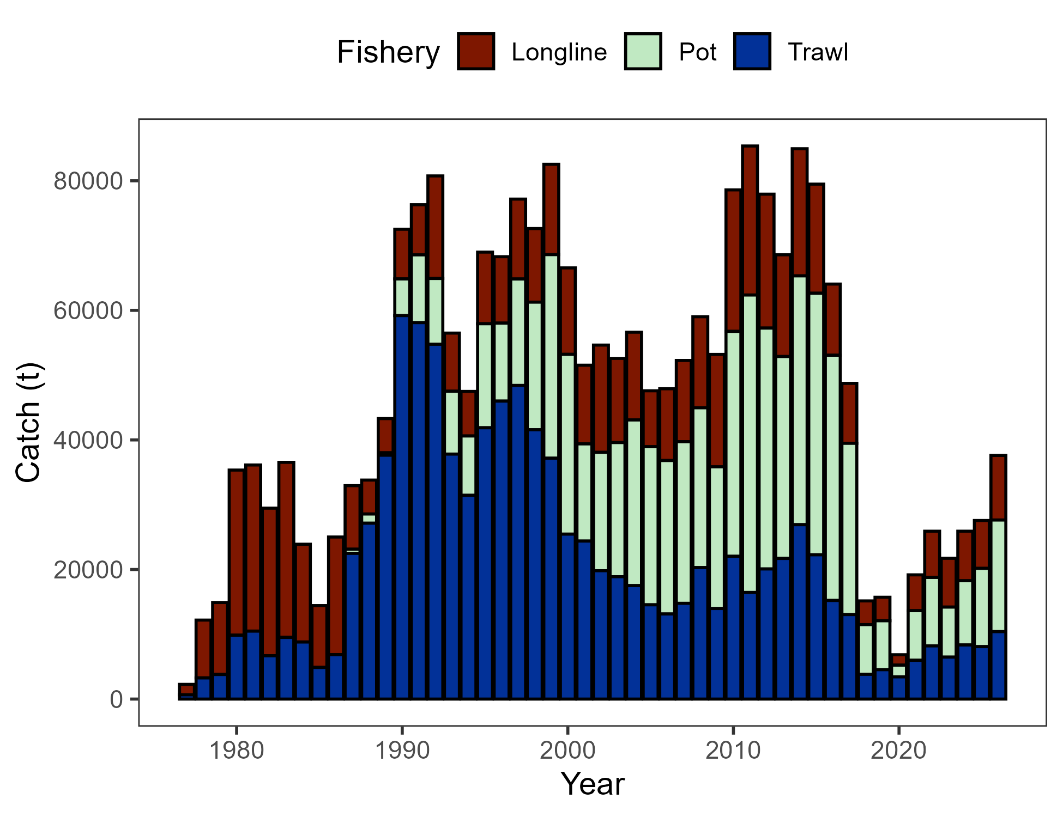

Figure 2.1. Commercial catch (mt) of Pacific cod in the GOA in trawl (FshTrawl), longline (FshLL), and pot (FshPot) gear from 1977-2026. Note that 2026 catch was through October 26.

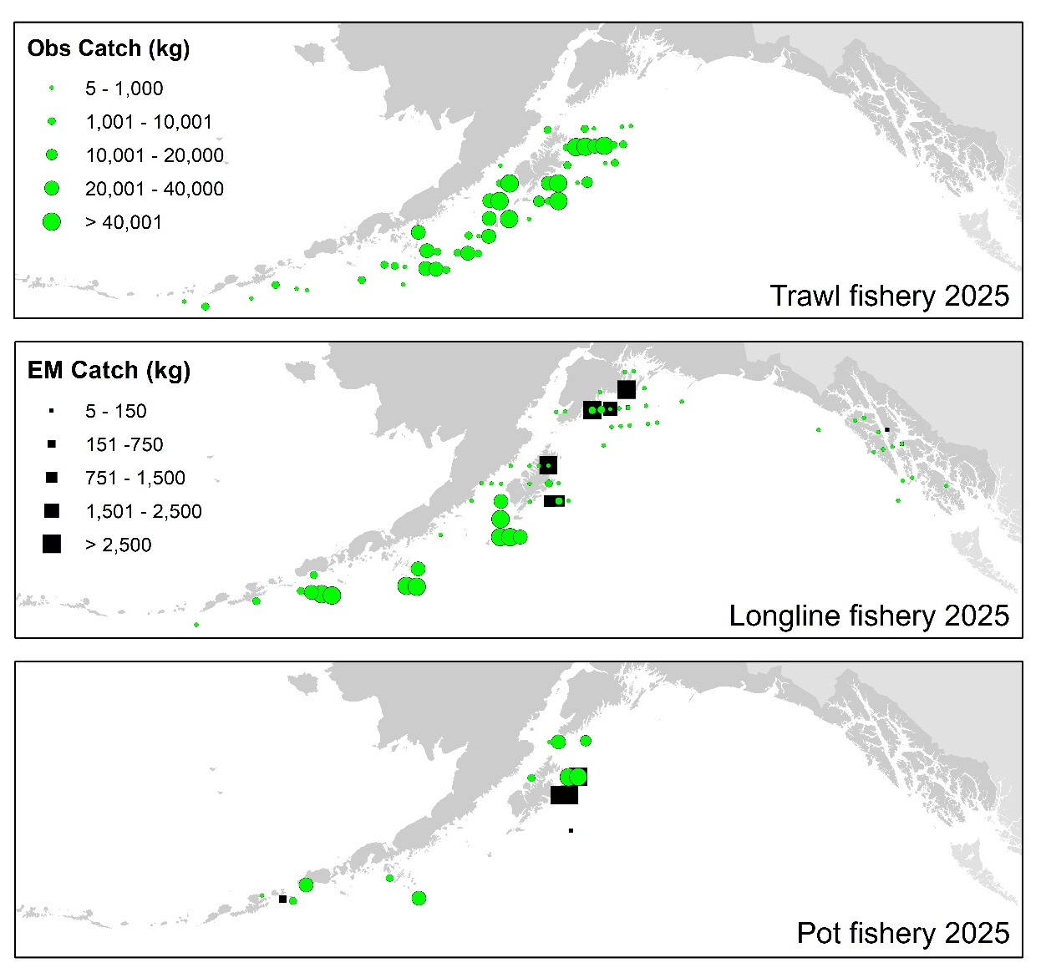

Figure 2.2. Observed (Obs) and electronic monitored (EM) commercial catch of Pacific cod in the GOA by 20 km² grid for 2025. These data include bycatch Pacific cod, but do not include trawl EM data as locations are not yet available.

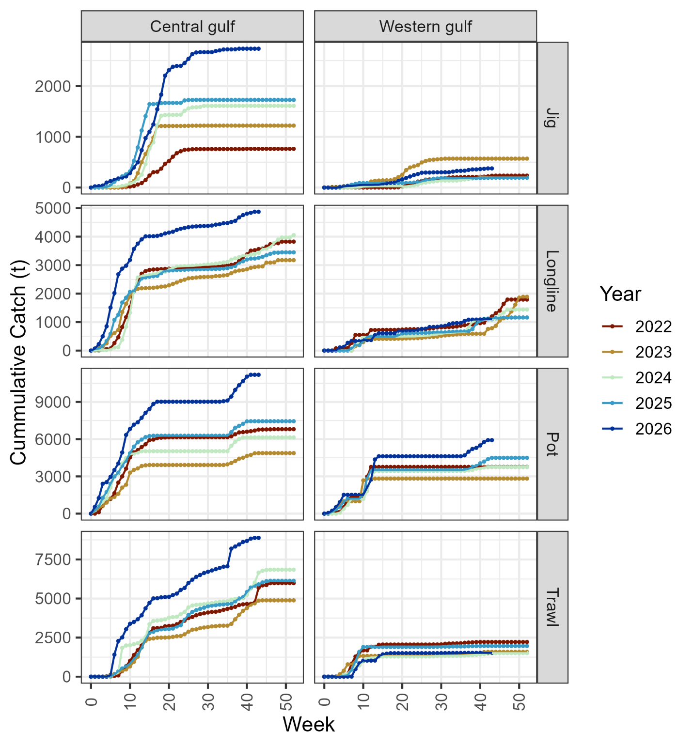

Figure 2.3. Cumulative catch week of the year for 2021-2025 by GOA sub-area and fleet (2025 catch through December 8). Note that for the assessment, data from the jig and longline gear were pooled into a distinct fishery.

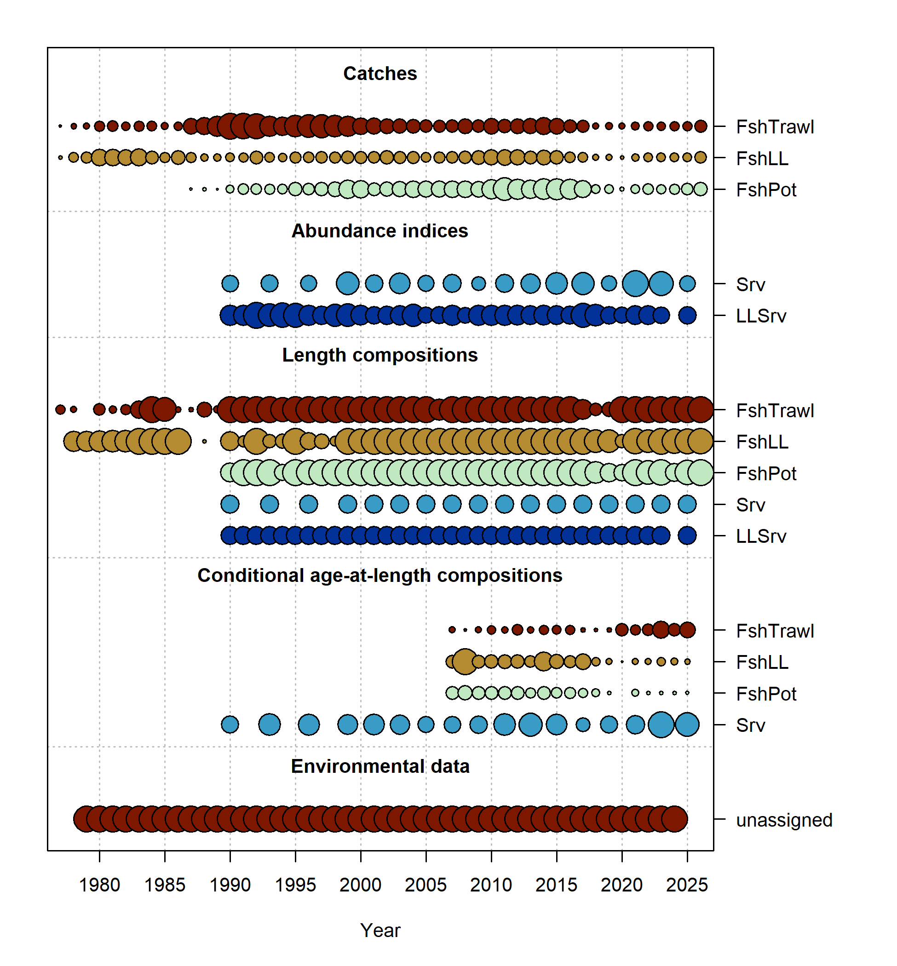

Figure 2.4. Data fit in Model 24.0. Circles are proportional to total catch for catches, precision for indices and input sample size for compositions and length-at-age observations. Data sources include fishery data from trawl (FshTrawl), longline (FshLL), and pot (FshPot) fisheries. Survey data include the AFSC longline (LLSrv) and bottom trawl (Srv) surveys. Note that since the circles are scaled relative to maximum within each type, the plots of scaling across dataset types should not be compared.

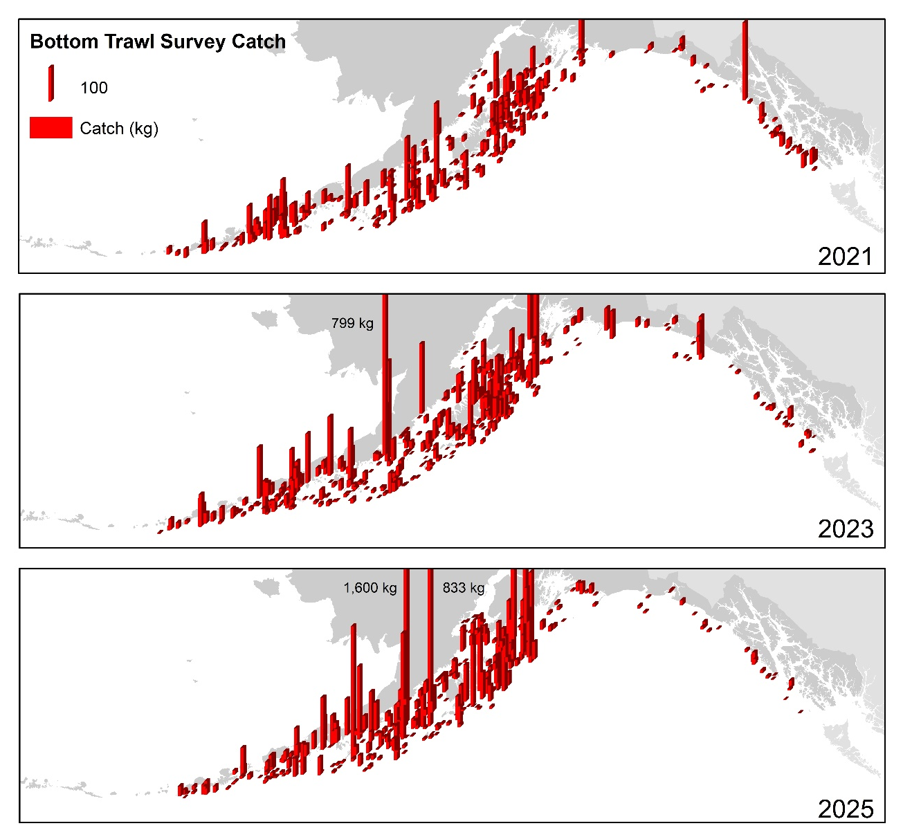

Figure 2.5. Distribution of AFSC bottom trawl survey catch (kg) of Pacific cod for 2021-2025.

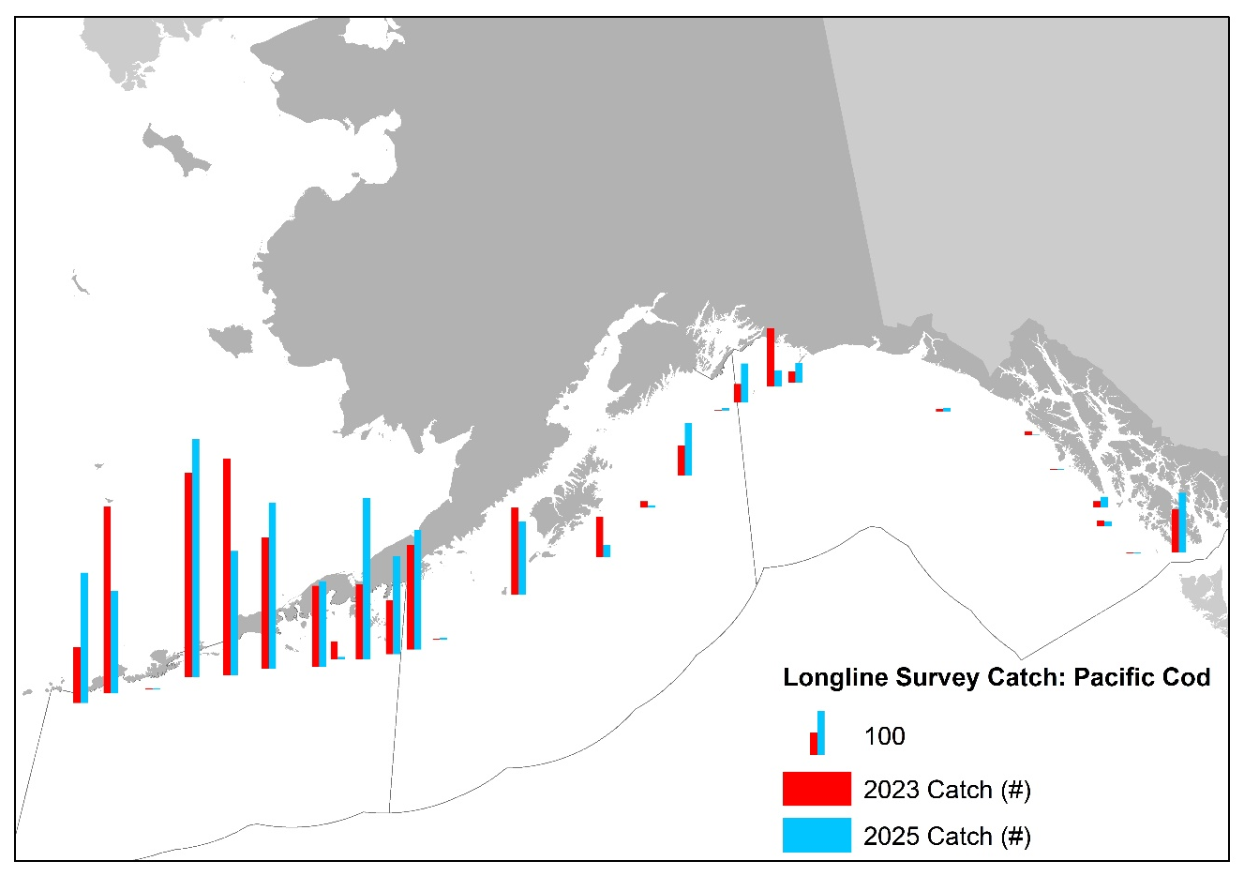

Figure 2.6. Distribution of AFSC longline survey catch (numbers) of Pacific cod in 2023 and 2025.

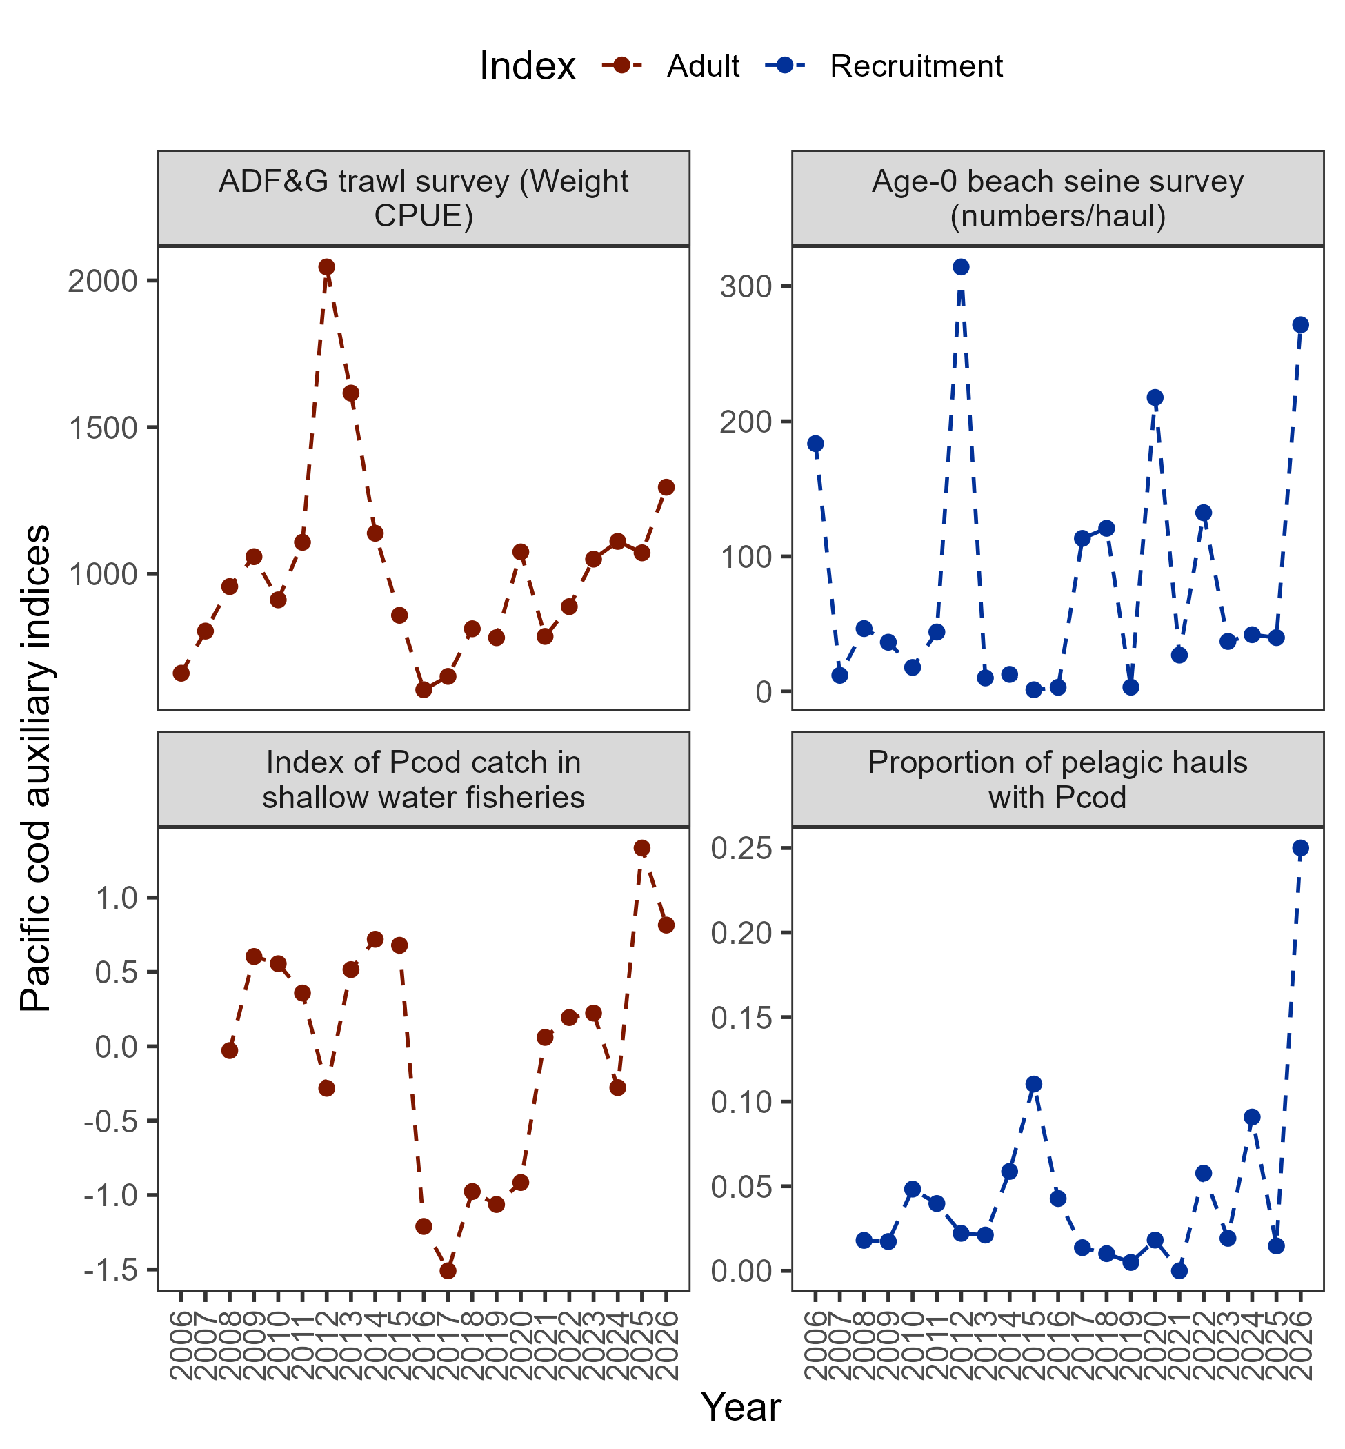

Figure 2.7. Auxiliary indices for GOA Pacific cod adult and recruitment abundance that are not used in the stock assessment model. ADFG bottom trawl survey numbers catch-per-unit-effort (top left panel) and proportion of Pacific cod bycatch in the GOA shallow water fisheries (bottom left panel) representing indices for adult abundance, and age-0 beach seine survey numbers per haul (top right panel) and proportion of pelagic trawls in the Central GOA A Season (January-April) walleye pollock fishery with Pacific cod present (bottom right panel) representing indices for recruitment.

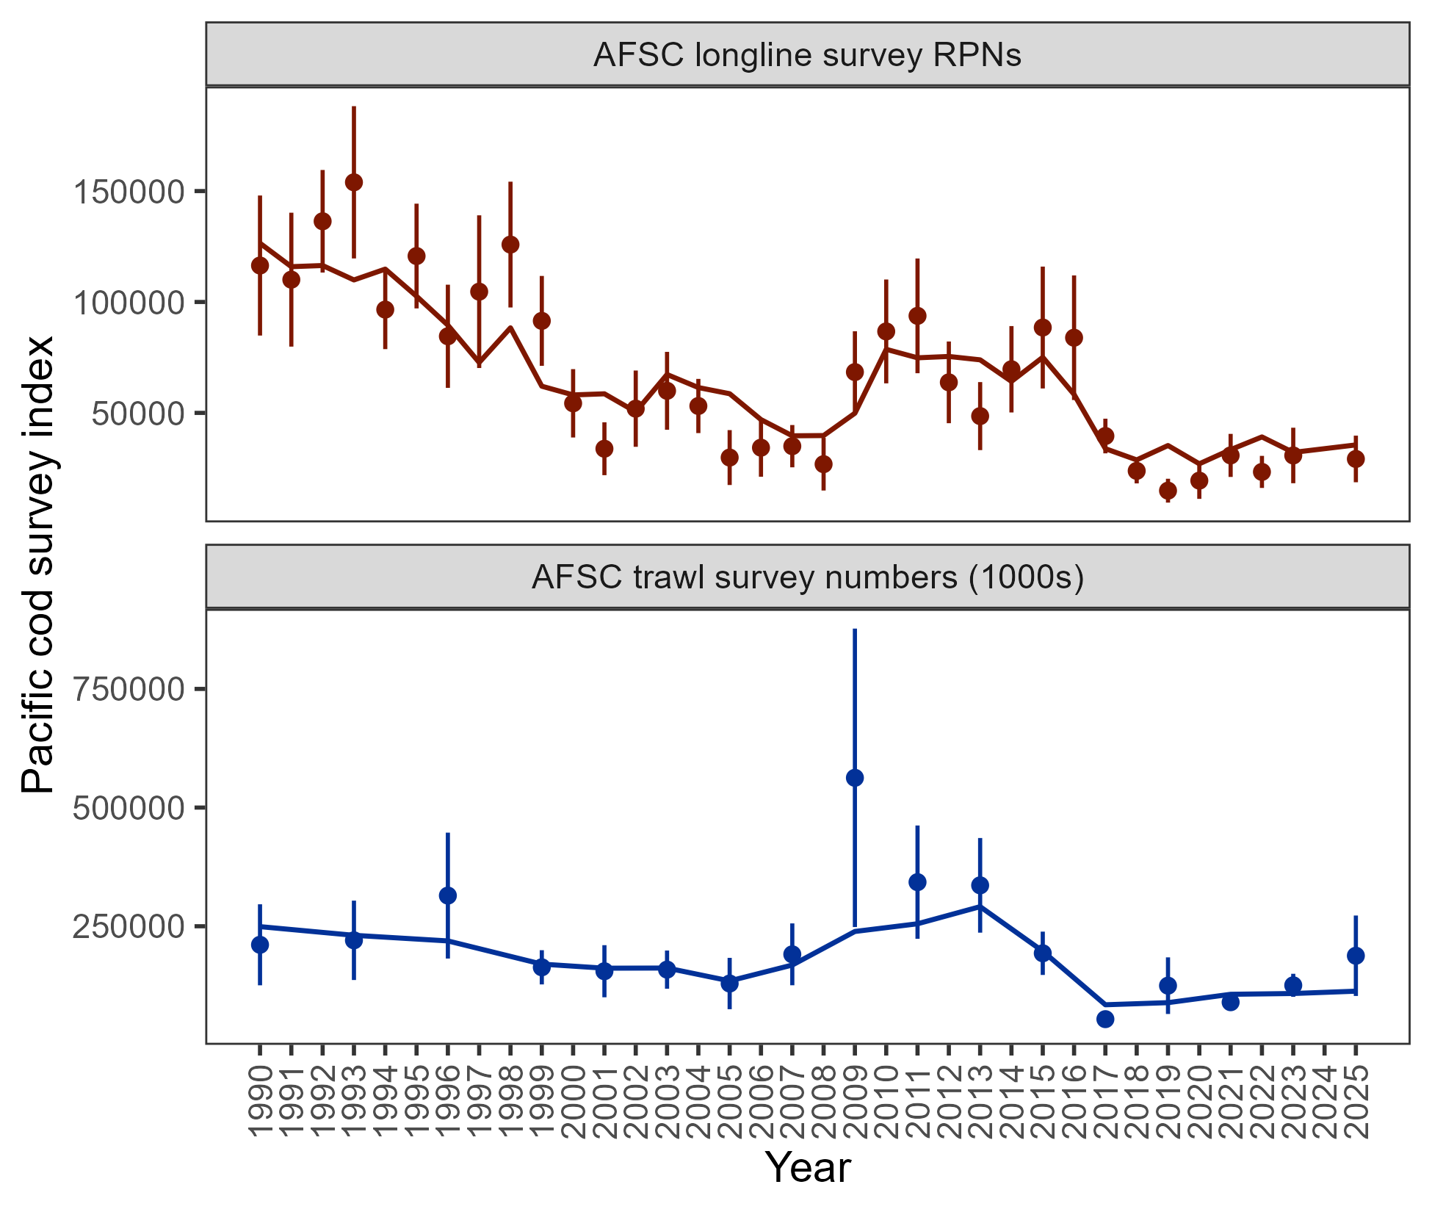

Figure 2.8. Population indices fit by model 24.0, including AFSC longline survey relative population numbers (RPN – top panel) and AFSC bottom trawl survey abundance (numbers – bottom panel). Model fit is shown as a solid line and observed data is shown as points (with error bars indicating the 95% confidence intervals).

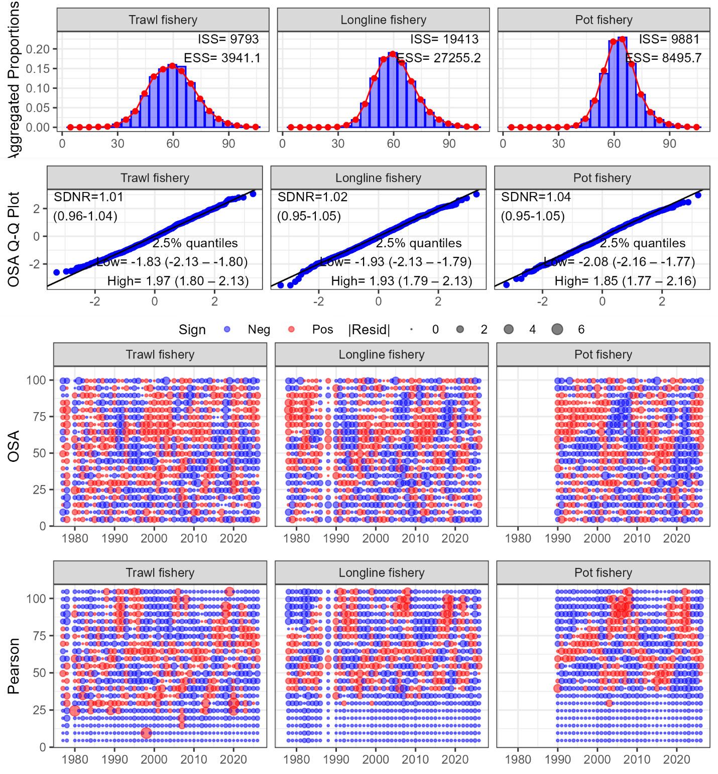

Figure 2.9. Aggregated model fit, theoretical versus sample quantiles, one-step ahead residuals, and Pearson residuals for the fishery length composition data (fleets shown across the columns) fit in model 24.0.

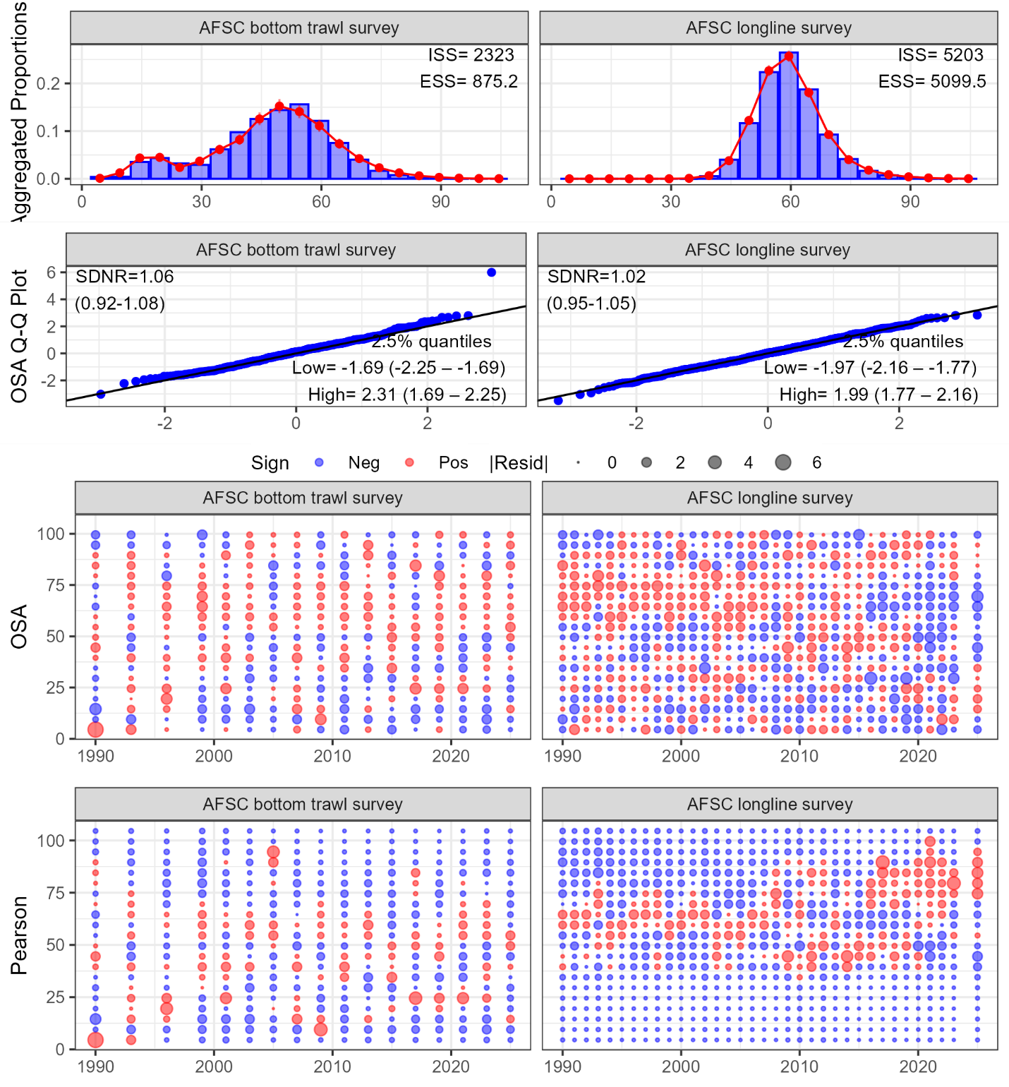

Figure 2.10. Aggregated model fit, theoretical versus sample quantiles, one-step ahead residuals, and Pearson residuals for the survey length composition data (surveys shown across the columns) fit in model 24.0.

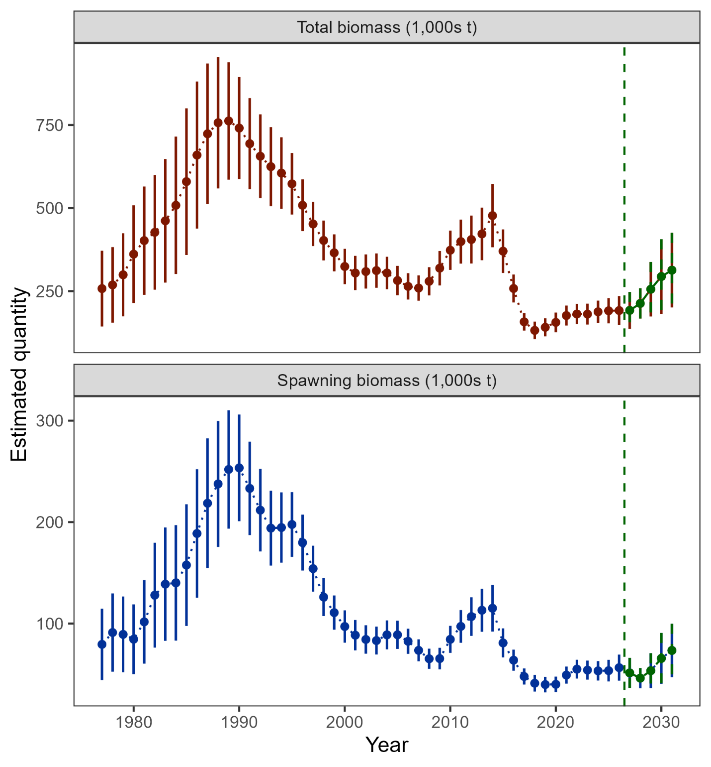

Figure 2.11. Estimated total biomass (top panel) and spawning biomass (bottom panel) from model 24.0 with 95% confidence intervals. The five-year forecasted biomass values are denoted in green shading and with the vertical dashed line in each plot.

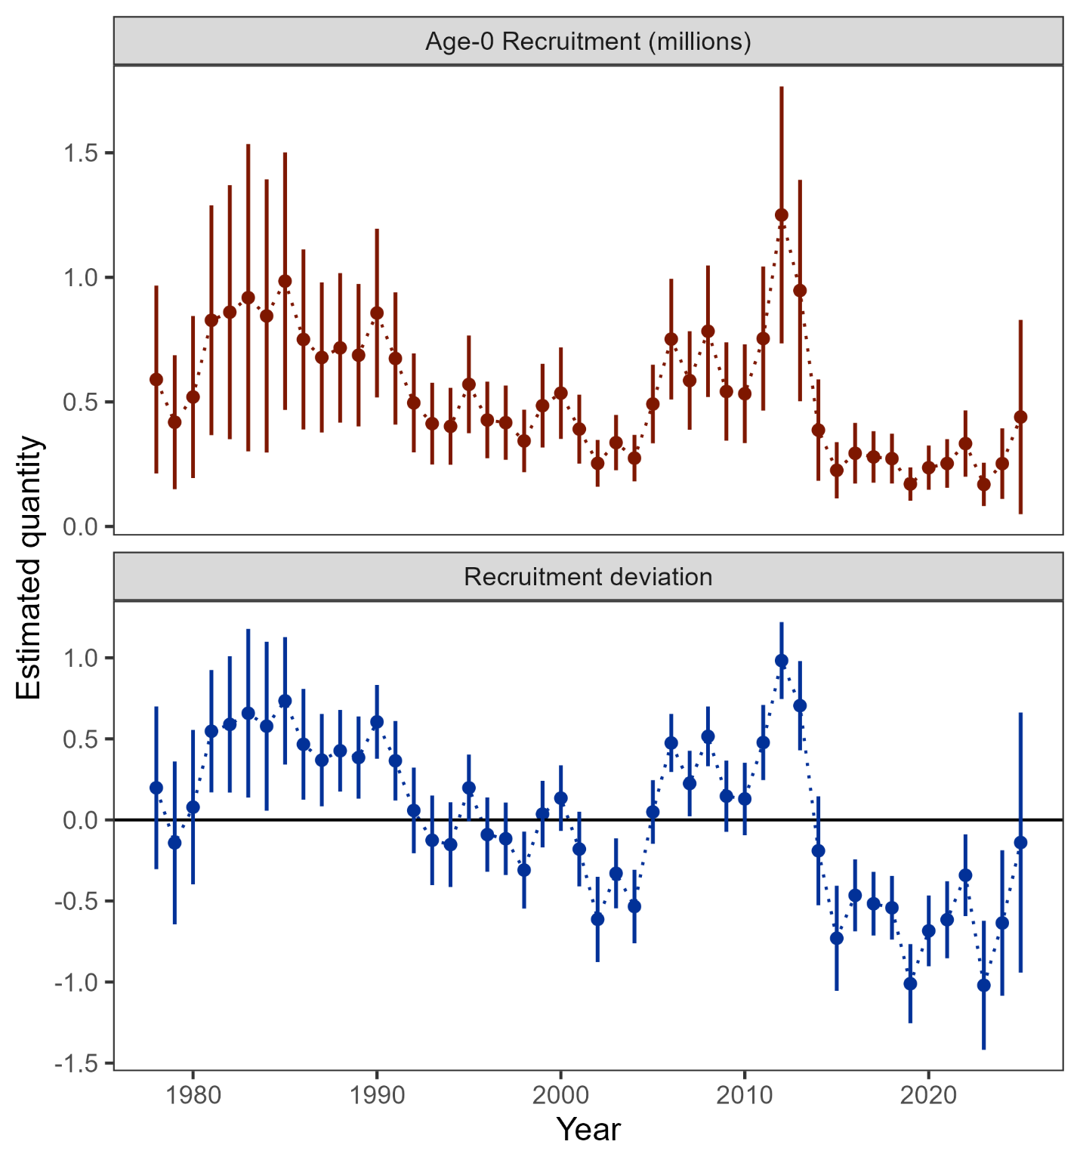

Figure 2.12. Age-0 recruitment (top panel) and log recruitment deviations (bottom panel) with 95% confidence intervals from model 24.0.

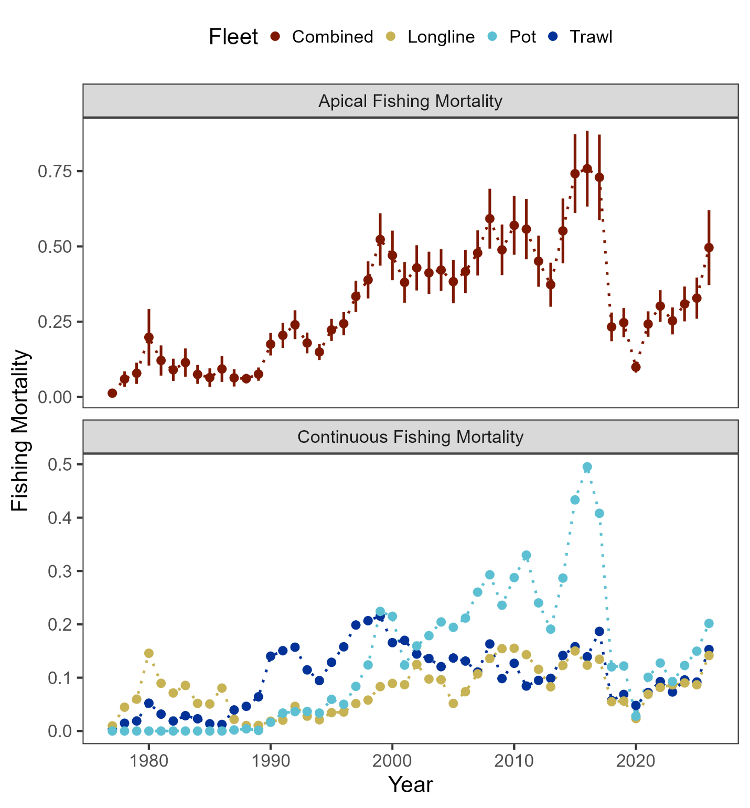

Figure 2.13. Sum of apical fishing mortality (top) and continuos fishing mortality by fisheries (bottom).

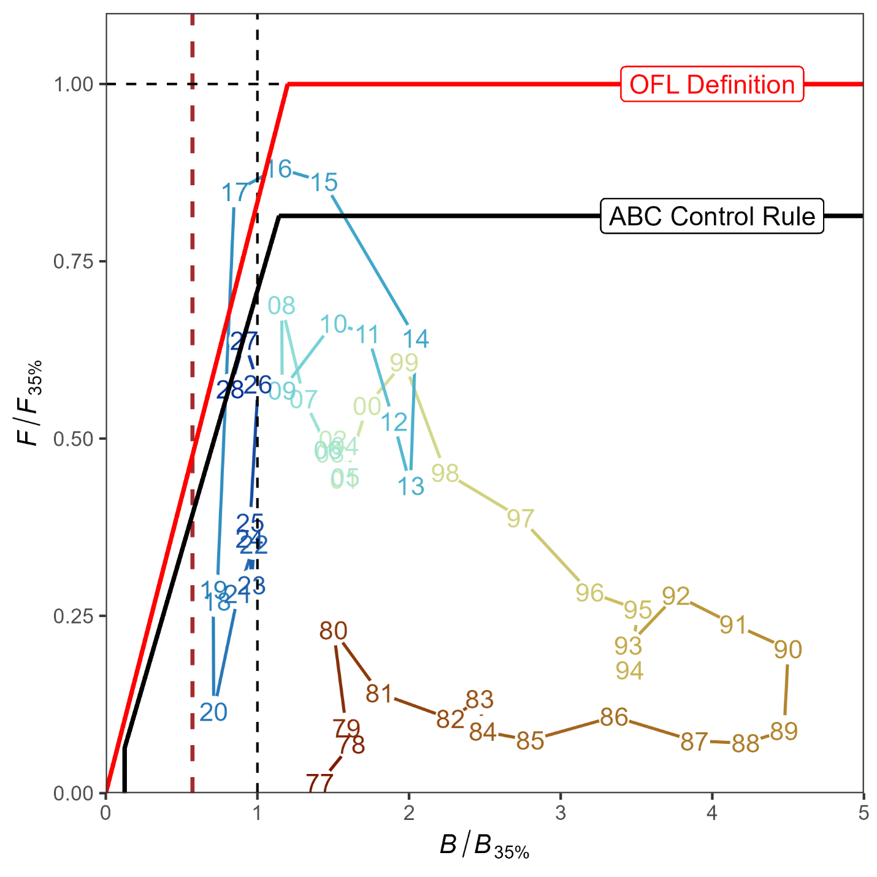

Figure 2.14. Ratio of historical F/F_{35%} versus female spawning biomass relative to B_{35%} for GOA pacific cod, 1977-2028. The Fs presented are the sum of the full Fs across fleets. Dashed vertical red line is at B_{20%}, Steller sea lion closure rule for GOA Pacific cod.

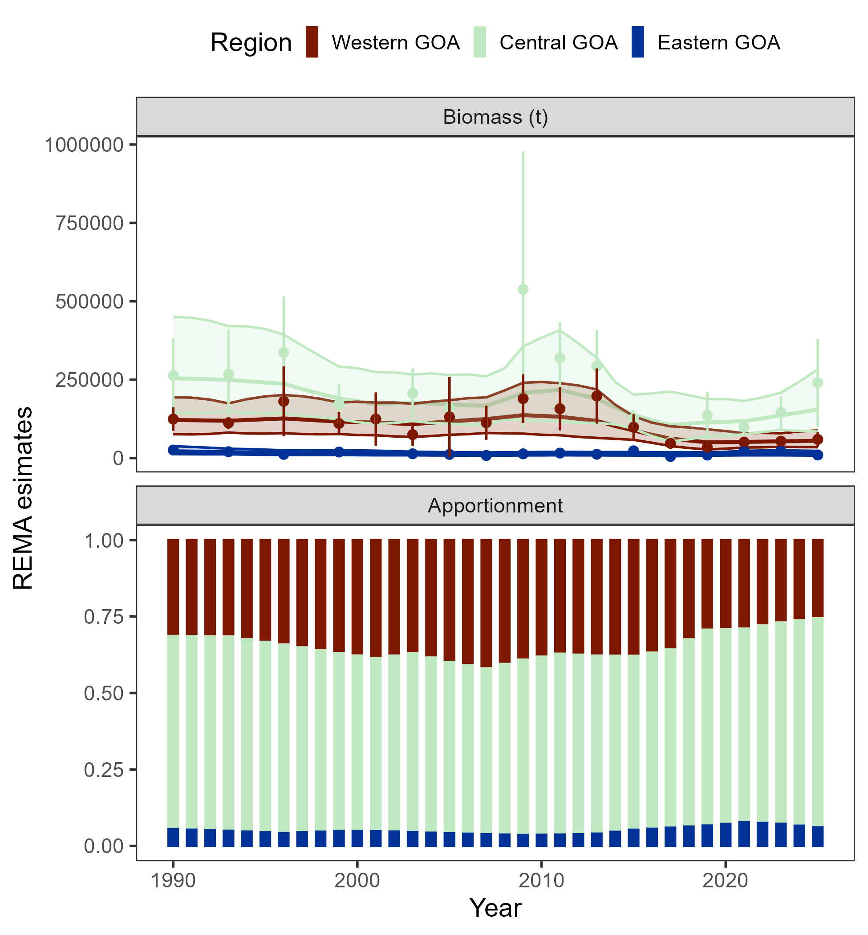

Figure 2.15. Fits from the rema model to the AFSC bottom trawl survey by area (top panel) and estimated apportionment (bottom panel).

