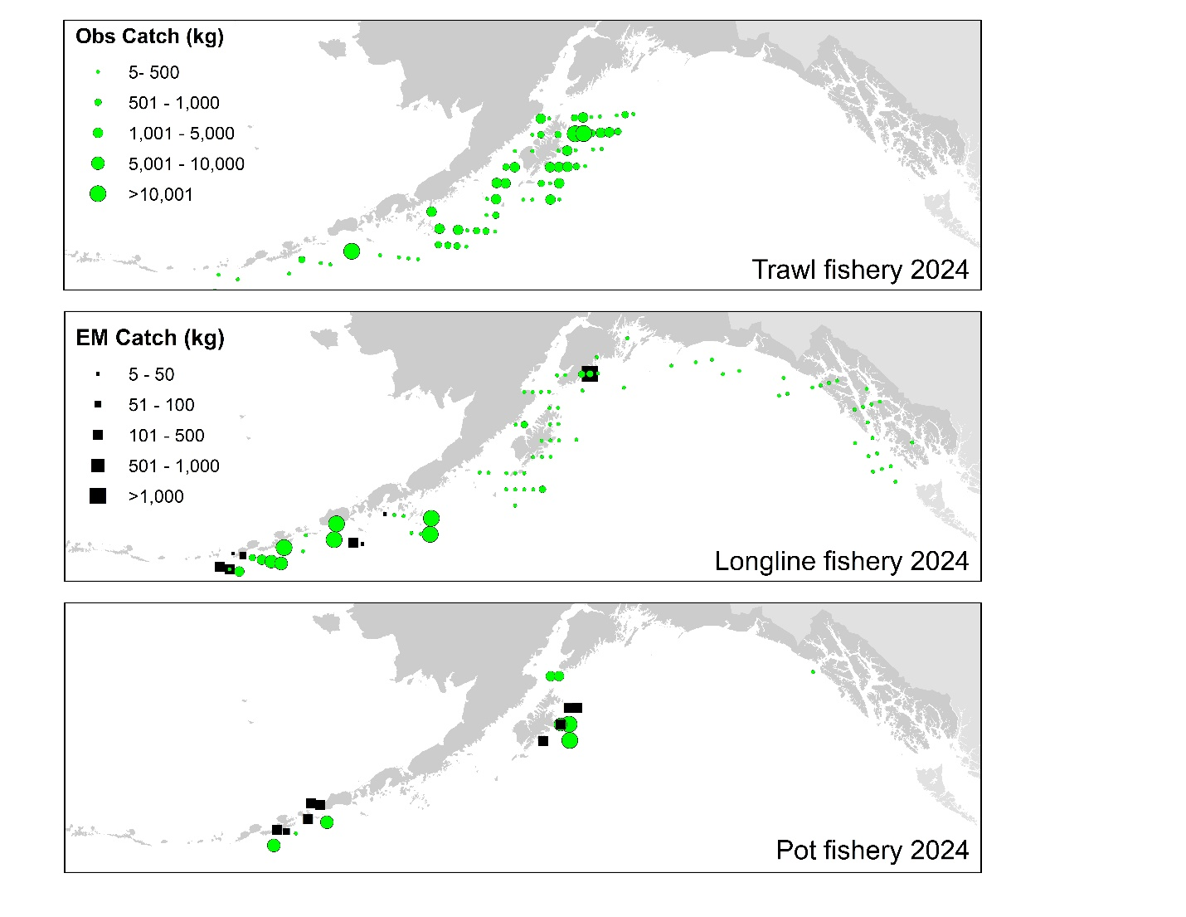

Figure 2.5. Observed (Obs) and electronic monitored (EM) commercial catch of Pacific cod in the GOA by 20 km² grid for 2023. These data include bycatch Pacific cod, but do not include trawl EM data as locations are not yet available.

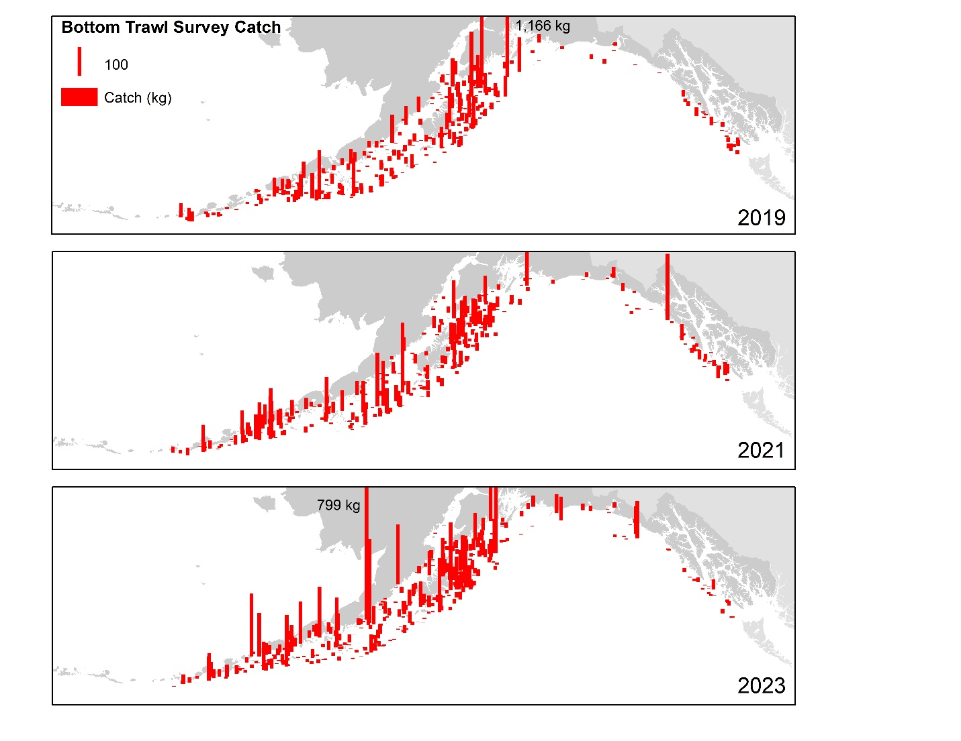

Figure 2.11. Distribution of AFSC bottom trawl survey catch (kg) of Pacific cod for 2019-2023.

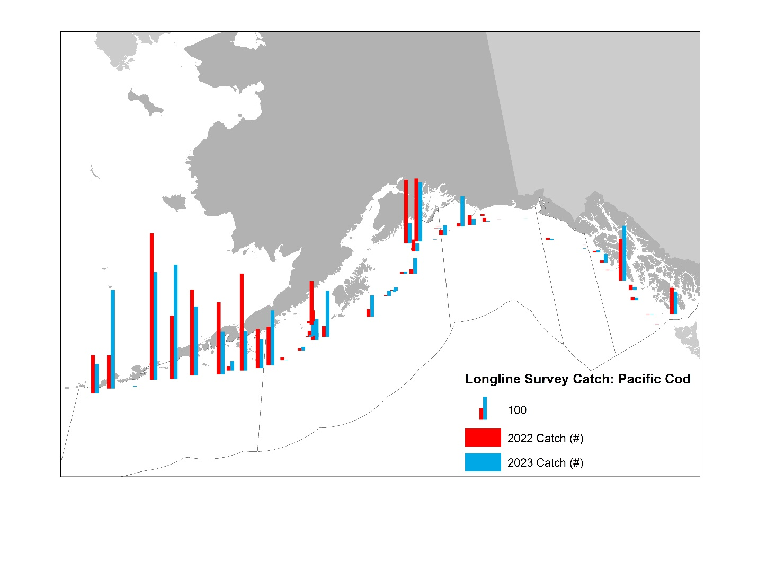

Figure 2.12. Distribution of AFSC longline survey catch (numbers) of Pacific cod in 2022 and 2023.

