Tables

Table 2.1. Catch (t) for 1991 through 2025 by jurisdiction and gear type (as of 2025-12-8)
 | Federal |  |  |  |  | State
Year | Trawl | Long-line | Pot | Other | Subtot | Long-line | Pot | Other | Subtot | Total
1991 | 58,092 | 7,630 | 10,464 | 115 | 76,301 | - | - | - | - | 76,301
1992 | 54,593 | 15,675 | 10,154 | 325 | 80,747 | - | - | - | - | 80,747
1993 | 37,806 | 8,963 | 9,708 | 11 | 56,488 | - | - | - | - | 56,488
1994 | 31,447 | 6,778 | 9,161 | 100 | 47,486 | - | - | - | - | 47,486
1995 | 41,875 | 10,978 | 16,055 | 77 | 68,985 | - | - | - | - | 68,985
1996 | 45,990 | 10,196 | 12,040 | 53 | 68,279 | - | - | - | - | 68,279
1997 | 48,406 | 10,978 | 9,065 | 26 | 68,475 | - | 7,368 | 1,327 | 8,695 | 77,170
1998 | 41,570 | 10,012 | 10,510 | 29 | 62,121 | - | 9,183 | 1,320 | 10,503 | 72,624
1999 | 37,167 | 12,363 | 19,015 | 70 | 68,615 | - | 12,410 | 1,518 | 13,928 | 82,543
2000 | 25,443 | 11,660 | 17,351 | 54 | 54,508 | - | 10,399 | 1,644 | 12,043 | 66,551
2001 | 24,383 | 9,910 | 7,171 | 155 | 41,619 | - | 7,829 | 2,083 | 9,912 | 51,531
2002 | 19,810 | 14,666 | 7,694 | 176 | 42,346 | - | 10,578 | 1,714 | 12,292 | 54,638
2003 | 18,884 | 9,525 | 12,765 | 161 | 41,335 | 62 | 7,943 | 3,242 | 11,247 | 52,582
2004 | 17,513 | 10,326 | 14,966 | 400 | 43,205 | 51 | 10,602 | 2,765 | 13,418 | 56,623
2005 | 14,549 | 5,732 | 14,749 | 203 | 35,233 | 26 | 9,653 | 2,673 | 12,352 | 47,585
2006 | 13,132 | 10,244 | 14,540 | 118 | 38,034 | 55 | 9,146 | 662 | 9,863 | 47,897
2007 | 14,775 | 11,539 | 13,573 | 44 | 39,931 | 270 | 11,378 | 682 | 12,330 | 52,261
2008 | 20,293 | 12,106 | 11,229 | 63 | 43,691 | 317 | 13,438 | 1,568 | 15,323 | 59,014
2009 | 13,976 | 13,968 | 11,951 | 206 | 40,101 | 676 | 9,919 | 2,500 | 13,095 | 53,196
2010 | 22,035 | 16,538 | 20,116 | 429 | 59,118 | 826 | 14,604 | 4,045 | 19,475 | 78,593
2011 | 16,456 | 16,622 | 29,233 | 722 | 63,033 | 1,033 | 16,675 | 4,627 | 22,335 | 85,368
2012 | 20,084 | 14,467 | 21,238 | 722 | 56,511 | 866 | 15,940 | 4,613 | 21,419 | 77,930
2013 | 21,706 | 12,836 | 17,011 | 476 | 52,029 | 1,088 | 14,156 | 1,303 | 16,547 | 68,576
2014 | 26,917 | 14,735 | 19,957 | 1,046 | 62,655 | 1,007 | 18,445 | 2,838 | 22,290 | 84,945
2015 | 22,268 | 13,047 | 20,653 | 408 | 56,376 | 577 | 19,719 | 2,808 | 23,104 | 79,480
2016 | 15,217 | 8,123 | 19,248 | 346 | 42,934 | 803 | 18,609 | 1,708 | 21,120 | 64,054
2017 | 13,041 | 8,965 | 13,426 | 67 | 35,499 | 155 | 13,011 | 62 | 13,228 | 48,727
2018 | 3,818 | 3,033 | 4,013 | 121 | 10,985 | 310 | 3,660 | 195 | 4,165 | 15,150
2019 | 4,535 | 2,763 | 3,732 | 178 | 11,208 | 358 | 3,820 | 329 | 4,507 | 15,715
2020 | 3,427 | 586 | 30 | - | 4,043 | 529 | 1,779 | 491 | 2,799 | 6,842
2021 | 5,986 | 3,834 | 3,427 | 52 | 13,299 | 558 | 4,230 | 1,085 | 5,873 | 19,172
2022 | 8,207 | 5,775 | 4,925 | 3 | 18,910 | 357 | 5,645 | 994 | 6,996 | 25,906
2023 | 6,473 | 5,179 | 4,069 | 378 | 16,099 | 563 | 3,653 | 1,412 | 5,628 | 21,727
2024 | 8,347 | 5,411 | 5,622 | 319 | 19,699 | 416 | 4,295 | 1,488 | 6,199 | 25,898
2025 | 8,024 | 4,699 | 6,347 | 533 | 19,603 | 283 | 5,674 | 1,387 | 7,344 | 26,947

Table 2.2. History of Pacific cod catch (t, includes catch from State waters), Federal TAC (does not include State guideline harvest level, GHL), ABC, OFL and State of Alaska GHL (1997-Present) since 1991. Catch for 2025 is current through 2025-12-8 and includes catch from State of Alaska fisheries. See Hulson et al. 2022 (Table 2.2) for catch history prior to 1991.
Year | Catch | TAC | ABC | OFL | GHL
1991 | 76,301 | 77,900 | 77,900 | - | -
1992 | 80,747 | 63,500 | 63,500 | 87,600 | -
1993 | 56,488 | 56,700 | 56,700 | 78,100 | -
1994 | 47,486 | 50,400 | 50,400 | 71,100 | -
1995 | 68,985 | 69,200 | 69,200 | 126,000 | -
1996 | 68,279 | 65,000 | 65,000 | 88,000 | -
1997 | 77,170 | 69,115 | 81,500 | 180,000 | 12,385
1998 | 72,624 | 66,060 | 77,900 | 141,000 | 11,840
1999 | 82,543 | 67,835 | 84,400 | 134,000 | 16,565
2000 | 66,551 | 59,800 | 76,400 | 102,000 | 17,685
2001 | 51,531 | 52,110 | 67,800 | 91,200 | 15,690
2002 | 54,638 | 44,230 | 57,600 | 77,100 | 13,370
2003 | 52,582 | 40,540 | 52,800 | 70,100 | 12,260
2004 | 56,623 | 48,033 | 62,810 | 102,000 | 14,777
2005 | 47,585 | 44,433 | 58,100 | 86,200 | 13,667
2006 | 47,897 | 52,264 | 68,859 | 95,500 | 16,595
2007 | 52,261 | 52,264 | 68,859 | 97,600 | 16,595
2008 | 59,014 | 50,269 | 66,493 | 88,660 | 16,224
2009 | 53,196 | 41,807 | 55,300 | 66,600 | 13,493
2010 | 78,593 | 59,563 | 79,100 | 94,100 | 19,537
2011 | 85,368 | 65,100 | 86,800 | 102,600 | 21,700
2012 | 77,930 | 65,700 | 87,600 | 104,000 | 21,900
2013 | 68,576 | 60,600 | 80,800 | 97,200 | 20,200
2014 | 84,945 | 64,738 | 88,500 | 107,300 | 23,762
2015 | 79,480 | 75,202 | 102,850 | 140,300 | 27,648
2016 | 64,054 | 71,925 | 98,600 | 116,700 | 26,675
2017 | 48,727 | 64,442 | 88,342 | 105,378 | 23,900
2018 | 15,150 | 13,096 | 18,000 | 23,565 | 4,904
2019 | 15,715 | 12,368 | 17,000 | 23,669 | 4,632
2020 | 6,842 | 6,431 | 14,621 | 17,794 | 2,537
2021 | 19,172 | 17,321 | 23,627 | 28,977 | 6,306
2022 | 25,906 | 24,111 | 32,811 | 39,555 | 8,700
2023 | 21,727 | 18,103 | 24,634 | 29,737 | 6,531
2024 | 25,898 | 23,766 | 32,272 | 38,712 | 8,506
2025 | 26,947 | 23,670 | 32,141 | 38,688 | 8,471

Table 2.3. History of GOA Pacific cod allocations by regulatory area (in percent) for 1991-2025, and proposed for 2026 (in parentheses). See Barbeaux et al. (2018) for 1977-1990.
Year(s) | Western | Central | Eastern
1991 | 33 | 62 | 5
1992 | 37 | 61 | 2
1993-1994 | 33 | 62 | 5
1995-1996 | 29 | 66 | 5
1997-1999 | 35 | 63 | 2
2000-2001 | 36 | 57 | 7
2002 | 39 | 55 | 6
2002 | 38 | 56 | 6
2003 | 39 | 55 | 6
2003 | 38 | 56 | 6
2004 | 36 | 57 | 7
2004 | 35.3 | 56.5 | 8.2
2005 | 36 | 57 | 7
2005 | 35.3 | 56.5 | 8.2
2006 | 39 | 55 | 6
2006 | 38.54 | 54.35 | 7.11
2007 | 39 | 55 | 6
2007 | 38.54 | 54.35 | 7.11
2008 | 39 | 57 | 4
2008 | 38.69 | 56.55 | 4.76
2009 | 39 | 57 | 4
2009 | 38.69 | 56.55 | 4.76
2010 | 35 | 62 | 3
2010 | 34.86 | 61.75 | 3.39
2011 | 35 | 62 | 3
2011 | 35 | 62 | 3
2012 | 35 | 62 | 3
2012 | 32 | 65 | 3
2013 | 38 | 60 | 3
2014 | 37 | 60 | 3
2015 | 38 | 60 | 3
2016 | 41 | 50 | 9
2017 | 41 | 50 | 9
2018 | 44.9 | 45.1 | 10
2019 | 44.9 | 45.1 | 10
2020 | 33.8 | 57.8 | 8.4
2021 | 33.8 | 57.8 | 8.4
2022 | 30.3 | 60.2 | 9.5
2023 | 30.3 | 60.2 | 9.5
2024 | 27.1 | 63.8 | 9.1
2025 | 27.1 | 63.8 | 9.1
2026 | 24.8 | 69.2 | 6

Table 2.4. Estimated retained and discarded GOA Pacific cod (t, as of 2025-12-8)
Year | Discarded | Retained | Total
1991 | 1,427 | 74,873 | 76,300
1992 | 3,920 | 76,827 | 80,747
1993 | 5,886 | 50,602 | 56,488
1994 | 3,122 | 44,363 | 47,485
1995 | 3,546 | 65,439 | 68,985
1996 | 7,555 | 60,725 | 68,280
1997 | 4,828 | 72,342 | 77,170
1998 | 1,732 | 70,893 | 72,625
1999 | 1,645 | 80,898 | 82,543
2000 | 1,378 | 65,174 | 66,552
2001 | 1,904 | 49,627 | 51,531
2002 | 3,715 | 50,923 | 54,638
2003 | 2,485 | 50,097 | 52,582
2004 | 1,268 | 55,355 | 56,623
2005 | 1,043 | 46,541 | 47,584
2006 | 1,852 | 46,045 | 47,897
2007 | 1,448 | 50,813 | 52,261
2008 | 3,307 | 55,707 | 59,014
2009 | 3,944 | 49,252 | 53,196
2010 | 3,097 | 75,496 | 78,593
2011 | 2,178 | 83,189 | 85,367
2012 | 949 | 76,981 | 77,930
2013 | 4,560 | 64,016 | 68,576
2014 | 5,302 | 79,643 | 84,945
2015 | 1,723 | 77,758 | 79,481
2016 | 868 | 63,187 | 64,055
2017 | 711 | 48,016 | 48,727
2018 | 604 | 14,546 | 15,150
2019 | 1,194 | 14,522 | 15,716
2020 | 1,748 | 5,094 | 6,842
2021 | 1,404 | 17,769 | 19,173
2022 | 1,676 | 24,231 | 25,907
2023 | 1,875 | 19,852 | 21,727
2024 | 1,607 | 24,292 | 25,899
2025 | 1,881 | 25,065 | 26,946

Table 2.5. GOA AFSC Longline survey estimated Relative Population Numbers (RPNs), and bottom trawl survey estimated biomass (t) and numbers of fish (‘Abundance’, in 1000s) shown along with coefficients of variation (in parentheses).
Year | RPN | Biomass (t) | Abundance
1990 | 116,434 (13.9%) | 413,281 (15.4%) | 210,924 (20.9%)
1991 | 110,061 (14.1%) | - | -
1992 | 136,383 (8.7%) | - | -
1993 | 153,950 (11.4%) | 400,054 (18.1%) | 220,342 (19.5%)
1994 | 96,563 (9.4%) | - | -
1995 | 120,710 (10%) | - | -
1996 | 84,535 (14.1%) | 529,762 (20.3%) | 314,572 (21.8%)
1997 | 104,647 (16.9%) | - | -
1998 | 125,877 (11.5%) | - | -
1999 | 91,480 (11.3%) | 301,719 (12.7%) | 163,498 (11.3%)
2000 | 54,316 (14.5%) | - | -
2001 | 33,841 (18.1%) | 248,745 (20.6%) | 155,231 (18.2%)
2002 | 51,903 (17%) | - | -
2003 | 59,952 (15%) | 295,423 (15.1%) | 158,613 (13%)
2004 | 53,109 (11.8%) | - | -
2005 | 29,864 (21.4%) | 302,673 (26.9%) | 129,306 (21.6%)
2006 | 34,316 (19.7%) | - | -
2007 | 34,994 (14%) | 230,056 (14%) | 190,831 (17.6%)
2008 | 26,881 (22.8%) | - | -
2009 | 68,395 (13.8%) | 741,101 (30.8%) | 562,698 (29.1%)
2010 | 86,725 (13.8%) | - | -
2011 | 93,743 (14.1%) | 492,596 (13.8%) | 342,900 (17.9%)
2012 | 63,768 (14.8%) | - | -
2013 | 48,553 (16.2%) | 502,892 (14.8%) | 336,182 (15.2%)
2014 | 69,665 (14.3%) | - | -
2015 | 88,482 (15.9%) | 248,178 (10.6%) | 193,019 (12.1%)
2016 | 83,887 (17.2%) | - | -
2017 | 39,575 (10.1%) | 103,258 (12.7%) | 54,264 (11.7%)
2018 | 23,857 (12.1%) | - | -
2019 | 14,933 (18.5%) | 179,860 (21.6%) | 124,806 (24.7%)
2020 | 19,459 (21.8%) | - | -
2021 | 30,830 (16.2%) | 172,568 (8.9%) | 89,939 (8.7%)
2022 | 23,393 (15.9%) | - | -
2023 | 30,802 (20.9%) | 222,473 (12.6%) | 125,571 (9.9%)
2025 | 29,233 (18.5%) | 309,761 (23.4%) | 187,845 (23.3%)

Table 2.6. Key parameter estimates with standard deviations (SD) estimated from the author’s recommended model.
Name | Value | SD
Biology | -- | --
Beginning of year length at age-1 (cm) | 17.64 | 0.303
Beginning of year length at age-10 (cm) | 99.46 | 0.015
Growth rate | 0.19 | 0.002
SD in length-at-age for age-1 | 4.01 | 0.182
SD in length-at-age for age-10 | 9.1 | 0.347
Natural mortality (2014-2016) | 0.84 | 0.053
Natural mortality (all years) | 0.5 | 0.023
Recruitment/Abundance | -- | --
log(mean recruitment) | 13.09 | 0.21
1976 Regime adjustment | -0.67 | 0.19
Survey catchability | -- | --
Bottom trawl survey | 1.28 | 0.123
Longline survey | 1.17 | 0.108
Longline survey environmental coefficient | 0.95 | 0.397

Table 2.7. Estimated female spawning biomass (t), standard deviation in spawning biomass (SD), and total biomass (t, age 0+) from the 2024 accepted assessment (denoted as ‘Previous’) and the author’s recommended model (denoted as ‘Current’).
Year | Previous Sp.Bio | Previous SD[Sp.Bio] | Previous Tot.Bio. | Current Sp.Bio | Current SD[Sp.Bio] | Current Tot.Bio.
1977 | 82,030 | 18,624 | 263,078 | 81,532 | 18,421 | 261,922
1978 | 93,526 | 20,289 | 274,934 | 92,738 | 20,019 | 273,698
1979 | 91,392 | 19,576 | 306,236 | 90,442 | 19,279 | 305,621
1980 | 86,468 | 18,181 | 367,433 | 85,592 | 17,902 | 366,512
1981 | 100,306 | 21,344 | 404,096 | 99,580 | 21,044 | 402,120
1982 | 128,098 | 27,305 | 429,094 | 126,933 | 26,868 | 425,811
1983 | 138,760 | 29,352 | 464,679 | 137,040 | 28,806 | 459,934
1984 | 140,462 | 29,869 | 506,907 | 138,207 | 29,239 | 500,761
1985 | 156,013 | 31,122 | 571,308 | 153,132 | 30,386 | 563,723
1986 | 185,062 | 32,452 | 643,066 | 181,474 | 31,604 | 634,589
1987 | 213,389 | 33,340 | 705,665 | 209,168 | 32,386 | 696,611
1988 | 228,887 | 32,111 | 733,973 | 224,496 | 31,148 | 724,735
1989 | 243,403 | 30,496 | 738,995 | 238,932 | 29,563 | 730,025
1990 | 246,430 | 27,784 | 722,469 | 242,038 | 26,936 | 714,093
1991 | 227,089 | 24,492 | 680,037 | 223,096 | 23,770 | 672,712
1992 | 207,464 | 21,875 | 646,435 | 203,906 | 21,261 | 640,025
1993 | 190,501 | 19,878 | 613,356 | 187,434 | 19,357 | 607,742
1994 | 191,073 | 18,675 | 593,657 | 188,231 | 18,204 | 588,353
1995 | 193,714 | 17,173 | 562,274 | 191,054 | 16,749 | 557,137
1996 | 176,600 | 14,814 | 500,923 | 174,157 | 14,443 | 496,225
1997 | 152,166 | 12,234 | 448,772 | 149,887 | 11,918 | 444,617
1998 | 125,266 | 10,174 | 401,629 | 123,258 | 9,913 | 397,910
1999 | 109,867 | 9,138 | 365,436 | 108,093 | 8,911 | 362,078
2000 | 96,878 | 8,662 | 324,871 | 95,240 | 8,446 | 322,039
2001 | 88,328 | 8,115 | 306,187 | 86,876 | 7,922 | 304,118
2002 | 84,006 | 7,558 | 310,405 | 82,753 | 7,388 | 309,067
2003 | 82,664 | 7,400 | 311,203 | 81,684 | 7,252 | 310,329
2004 | 88,050 | 7,629 | 302,383 | 87,293 | 7,491 | 301,769
2005 | 87,817 | 7,438 | 280,139 | 87,188 | 7,305 | 279,496
2006 | 81,816 | 6,620 | 264,404 | 81,328 | 6,503 | 263,509
2007 | 72,894 | 5,786 | 261,734 | 72,336 | 5,671 | 260,909
2008 | 65,126 | 5,343 | 282,345 | 64,363 | 5,225 | 281,842
2009 | 64,976 | 5,702 | 320,013 | 64,250 | 5,588 | 319,879
2010 | 82,099 | 7,028 | 370,972 | 81,442 | 6,910 | 371,394
2011 | 94,676 | 8,458 | 394,847 | 94,092 | 8,337 | 395,909
2012 | 103,497 | 9,906 | 399,102 | 103,150 | 9,796 | 401,222
2013 | 110,310 | 11,073 | 414,288 | 110,236 | 10,979 | 418,360
2014 | 111,288 | 11,831 | 463,262 | 111,680 | 11,770 | 470,503
2015 | 79,084 | 7,540 | 362,383 | 78,400 | 7,375 | 363,504
2016 | 62,598 | 5,599 | 255,983 | 61,134 | 5,369 | 252,790
2017 | 48,276 | 4,390 | 161,564 | 46,249 | 4,128 | 156,551
2018 | 42,448 | 4,549 | 137,613 | 40,443 | 4,306 | 133,276
2019 | 41,786 | 4,293 | 146,791 | 39,932 | 4,099 | 143,626
2020 | 41,907 | 4,216 | 159,919 | 40,298 | 4,072 | 158,719
2021 | 50,256 | 4,537 | 178,117 | 49,127 | 4,451 | 179,657
2022 | 55,452 | 4,940 | 180,403 | 55,225 | 4,901 | 186,049
2023 | 54,246 | 5,070 | 174,394 | 55,298 | 5,036 | 185,759
2024 | 52,034 | 5,160 | 174,445 | 54,879 | 5,112 | 188,381
2025 | 46,920 | 5,643 | 177,497 | 54,728 | 5,564 | 185,884
2026 | - | - | - | 52,772 | 6,247 | 182,156

Table 2.8. Age-0 recruitment (millions) and standard deviation of age-0 recruits by year from the 2024 accepted assessment (denoted as ‘Previous’) and the author’s recommended model (denoted as ‘Current’). Highlighted are the 1977 and 2012 year classes.
Year | Previous Recruitment | Previous SD[Rec] | Current Recruitment | Current SD[Rec]
1977 | 1.18 | 0.36 | 1.18 | 0.35
1978 | 0.39 | 0.14 | 0.39 | 0.14
1979 | 0.37 | 0.13 | 0.36 | 0.13
1980 | 0.65 | 0.21 | 0.64 | 0.21
1981 | 0.7 | 0.23 | 0.69 | 0.22
1982 | 0.94 | 0.3 | 0.93 | 0.3
1983 | 0.68 | 0.27 | 0.68 | 0.27
1984 | 0.9 | 0.3 | 0.9 | 0.29
1985 | 0.88 | 0.25 | 0.88 | 0.25
1986 | 0.61 | 0.17 | 0.62 | 0.17
1987 | 0.66 | 0.16 | 0.66 | 0.16
1988 | 0.66 | 0.16 | 0.66 | 0.16
1989 | 0.69 | 0.16 | 0.69 | 0.16
1990 | 0.78 | 0.17 | 0.78 | 0.17
1991 | 0.57 | 0.13 | 0.58 | 0.13
1992 | 0.43 | 0.1 | 0.42 | 0.1
1993 | 0.36 | 0.08 | 0.36 | 0.08
1994 | 0.42 | 0.09 | 0.42 | 0.09
1995 | 0.54 | 0.11 | 0.54 | 0.1
1996 | 0.4 | 0.08 | 0.4 | 0.08
1997 | 0.36 | 0.07 | 0.37 | 0.07
1998 | 0.34 | 0.07 | 0.34 | 0.07
1999 | 0.51 | 0.1 | 0.52 | 0.1
2000 | 0.5 | 0.1 | 0.5 | 0.1
2001 | 0.3 | 0.06 | 0.3 | 0.06
2002 | 0.26 | 0.05 | 0.26 | 0.05
2003 | 0.3 | 0.06 | 0.3 | 0.06
2004 | 0.3 | 0.06 | 0.3 | 0.06
2005 | 0.54 | 0.1 | 0.54 | 0.1
2006 | 0.74 | 0.13 | 0.74 | 0.13
2007 | 0.54 | 0.1 | 0.54 | 0.1
2008 | 0.79 | 0.15 | 0.8 | 0.15
2009 | 0.43 | 0.09 | 0.44 | 0.09
2010 | 0.52 | 0.11 | 0.53 | 0.11
2011 | 0.81 | 0.17 | 0.82 | 0.17
2012 | 1.18 | 0.27 | 1.21 | 0.28
2013 | 0.72 | 0.19 | 0.76 | 0.2
2014 | 0.24 | 0.07 | 0.25 | 0.07
2015 | 0.28 | 0.07 | 0.29 | 0.08
2016 | 0.28 | 0.06 | 0.28 | 0.06
2017 | 0.3 | 0.06 | 0.31 | 0.06
2018 | 0.21 | 0.04 | 0.23 | 0.05
2019 | 0.18 | 0.04 | 0.19 | 0.04
2020 | 0.19 | 0.04 | 0.22 | 0.05
2021 | 0.22 | 0.05 | 0.27 | 0.06
2022 | 0.21 | 0.07 | 0.2 | 0.05
2023 | 0.41 | 0.19 | 0.19 | 0.06
2024 | 0.49 | 0.24 | 0.3 | 0.1
2025 | - | - | 0.48 | 0.23
Mean 1977 - (Final year - 2) | 0.52 |  | 0.52

Table 2.9. Estimated fishing mortality in terms of apical F and total exploitation for the author’s recommended model.
Year | Sum Apical F | SD[F] | Total Exploitation
1977 | 0.012 | 0.003 | 0.009
1978 | 0.059 | 0.013 | 0.045
1979 | 0.078 | 0.018 | 0.049
1980 | 0.194 | 0.046 | 0.096
1981 | 0.124 | 0.027 | 0.09
1982 | 0.091 | 0.019 | 0.069
1983 | 0.117 | 0.025 | 0.079
1984 | 0.076 | 0.017 | 0.048
1985 | 0.066 | 0.016 | 0.026
1986 | 0.096 | 0.023 | 0.039
1987 | 0.067 | 0.016 | 0.047
1988 | 0.064 | 0.009 | 0.047
1989 | 0.08 | 0.012 | 0.059
1990 | 0.187 | 0.022 | 0.102
1991 | 0.217 | 0.024 | 0.113
1992 | 0.253 | 0.028 | 0.126
1993 | 0.189 | 0.02 | 0.093
1994 | 0.157 | 0.015 | 0.081
1995 | 0.234 | 0.021 | 0.124
1996 | 0.255 | 0.022 | 0.138
1997 | 0.348 | 0.029 | 0.174
1998 | 0.404 | 0.035 | 0.183
1999 | 0.546 | 0.05 | 0.228
2000 | 0.488 | 0.047 | 0.207
2001 | 0.395 | 0.038 | 0.169
2002 | 0.446 | 0.042 | 0.177
2003 | 0.429 | 0.04 | 0.169
2004 | 0.439 | 0.039 | 0.188
2005 | 0.4 | 0.041 | 0.17
2006 | 0.431 | 0.04 | 0.182
2007 | 0.493 | 0.042 | 0.2
2008 | 0.613 | 0.055 | 0.209
2009 | 0.515 | 0.048 | 0.166
2010 | 0.608 | 0.056 | 0.212
2011 | 0.591 | 0.057 | 0.216
2012 | 0.477 | 0.048 | 0.194
2013 | 0.39 | 0.041 | 0.164
2014 | 0.578 | 0.06 | 0.181
2015 | 0.788 | 0.075 | 0.219
2016 | 0.815 | 0.073 | 0.253
2017 | 0.799 | 0.085 | 0.311
2018 | 0.248 | 0.027 | 0.114
2019 | 0.255 | 0.027 | 0.109
2020 | 0.101 | 0.01 | 0.043
2021 | 0.253 | 0.024 | 0.107
2022 | 0.313 | 0.029 | 0.139
2023 | 0.257 | 0.024 | 0.117
2024 | 0.311 | 0.03 | 0.137
2025 | 0.399 | 0.043 | 0.173

Table 2.10. Biological reference points from GOA Pacific cod SAFE documents for years 2002 – 2025, and recommended for 2026 from the author’s recommended model (in italics).
Year | SB_{100%} | SB_{40%} | F_{40%} | OFL_{y+1} | maxABC_{y+1}
2002 | 212,000 | 85,000 | 0.41 | 82,000 | 57,600
2003 | 226,000 | 90,300 | 0.35 | 88,300 | 52,800
2004 | 222,000 | 88,900 | 0.34 | 103,000 | 62,810
2005 | 211,000 | 84,400 | 0.31 | 91,700 | 58,100
2006 | 329,000 | 132,000 | 0.56 | 165,000 | 68,859
2007 | 259,000 | 103,000 | 0.46 | 136,000 | 68,859
2008 | 302,000 | 121,000 | 0.49 | 108,000 | 66,493
2009 | 255,500 | 102,200 | 0.52 | 88,000 | 55,300
2010 | 291,500 | 116,600 | 0.49 | 117,600 | 79,100
2011 | 256,300 | 102,500 | 0.42 | 124,100 | 86,800
2012 | 261,000 | 104,000 | 0.44 | 121,000 | 87,600
2013 | 234,800 | 93,900 | 0.49 | 111,000 | 80,800
2014 | 227,800 | 91,100 | 0.54 | 120,100 | 88,500
2015 | 316,500 | 126,600 | 0.5 | 155,400 | 102,850
2016 | 325,200 | 130,000 | 0.41 | 116,700 | 98,600
2017 | 196,776 | 78,711 | 0.53 | 105,378 | 88,342
2018 | 168,583 | 67,433 | 0.34 | 23,565 | 19,401
2019 | 172,240 | 68,896 | 0.29 | 23,669 | 19,665
2020 | 187,780 | 75,112 | 0.22 | 17,794 | 14,621
2021 | 180,111 | 72,045 | 0.33 | 28,977 | 23,627
2022 | 165,508 | 66,203 | 0.5 | 39,555 | 32,811
2023 | 167,414 | 66,966 | 0.41 | 29,737 | 24,634
2024 | 175,187 | 70,075 | 0.42 | 38,712 | 32,272
2025 | 163,585 | 65,434 | 0.46 | 38,688 | 32,141
2026 | 159,595 | 63,838 | 0.54 | 49,782 | 41,520

Table 2.11. Results for the projection scenarios from the author’s recommended model. Catch in tons, fishing mortality (F), and Female spawning stock biomass (SSB) in tons for the 7 standard projection scenarios.
Year | Scenario 1 | Scenario 2 | Scenario 3 | Scenario 4 | Scenario 5 | Scenario 6 | Scenario 7
Catch | - | - | - | - | - | - | -
2025 | 32,141 | 32,141 | 32,141 | 32,141 | 32,141 | 32,141 | 32,141
2026 | 41,520 | 41,520 | 20,535 | 32,340 | 0 | 49,782 | 41,520
2027 | 32,209 | 32,209 | 20,887 | 28,434 | 0 | 34,424 | 32,209
2028 | 32,838 | 32,838 | 22,253 | 29,672 | 0 | 34,899 | 39,691
2029 | 47,592 | 47,592 | 26,758 | 42,138 | 0 | 51,807 | 53,219
2030 | 67,740 | 67,740 | 33,569 | 56,137 | 0 | 76,954 | 76,927
2031 | 75,310 | 75,310 | 39,973 | 64,128 | 0 | 83,998 | 83,896
2032 | 79,182 | 79,182 | 44,461 | 68,825 | 0 | 86,684 | 86,627
2033 | 80,798 | 80,798 | 47,200 | 71,138 | 0 | 87,572 | 87,548
2034 | 81,444 | 81,444 | 48,815 | 72,226 | 0 | 87,858 | 87,849
2035 | 81,714 | 81,714 | 49,773 | 72,749 | 0 | 87,963 | 87,959
2036 | 81,813 | 81,813 | 50,278 | 72,972 | 0 | 87,995 | 87,994
2037 | 81,845 | 81,845 | 50,526 | 73,060 | 0 | 88,003 | 88,003
2038 | 81,856 | 81,856 | 50,647 | 73,094 | 0 | 88,006 | 88,005
F | - | - | - | - | - | - | -
2025 | 0.4 | 0.4 | 0.4 | 0.4 | 0.4 | 0.4 | 0.4
2026 | 0.54 | 0.54 | 0.25 | 0.41 | 0 | 0.68 | 0.54
2027 | 0.47 | 0.47 | 0.25 | 0.38 | 0 | 0.54 | 0.47
2028 | 0.46 | 0.46 | 0.25 | 0.38 | 0 | 0.53 | 0.57
2029 | 0.56 | 0.56 | 0.25 | 0.45 | 0 | 0.65 | 0.66
2030 | 0.66 | 0.66 | 0.25 | 0.5 | 0 | 0.82 | 0.82
2031 | 0.66 | 0.66 | 0.25 | 0.5 | 0 | 0.83 | 0.83
2032 | 0.66 | 0.66 | 0.25 | 0.5 | 0 | 0.83 | 0.83
2033 | 0.66 | 0.66 | 0.25 | 0.5 | 0 | 0.83 | 0.83
2034 | 0.66 | 0.66 | 0.25 | 0.5 | 0 | 0.83 | 0.83
2035 | 0.66 | 0.66 | 0.25 | 0.5 | 0 | 0.83 | 0.83
2036 | 0.66 | 0.66 | 0.25 | 0.5 | 0 | 0.83 | 0.83
2037 | 0.66 | 0.66 | 0.25 | 0.5 | 0 | 0.83 | 0.83
2038 | 0.66 | 0.66 | 0.25 | 0.5 | 0 | 0.83 | 0.83
SSB | - | - | - | - | - | - | -
2025 | 54,728 | 54,728 | 54,728 | 54,728 | 54,728 | 54,728 | 54,728
2026 | 52,772 | 52,772 | 52,772 | 52,772 | 52,772 | 52,772 | 52,772
2027 | 45,838 | 45,838 | 53,440 | 49,137 | 61,074 | 42,910 | 45,838
2028 | 45,359 | 45,359 | 55,636 | 49,387 | 69,692 | 42,204 | 45,359
2029 | 54,298 | 54,298 | 65,974 | 58,499 | 85,168 | 51,177 | 52,016
2030 | 67,138 | 67,138 | 83,250 | 72,180 | 107,920 | 63,374 | 63,394
2031 | 75,512 | 75,512 | 100,185 | 83,416 | 131,896 | 69,498 | 69,418
2032 | 80,051 | 80,051 | 112,440 | 90,336 | 151,858 | 72,201 | 72,148
2033 | 82,043 | 82,043 | 120,216 | 93,903 | 167,166 | 73,152 | 73,128
2034 | 82,878 | 82,878 | 125,016 | 95,662 | 178,886 | 73,476 | 73,466
2035 | 83,245 | 83,245 | 127,988 | 96,548 | 187,781 | 73,600 | 73,596
2036 | 83,382 | 83,382 | 129,578 | 96,932 | 193,586 | 73,639 | 73,638
2037 | 83,426 | 83,426 | 130,359 | 97,082 | 197,123 | 73,649 | 73,648
2038 | 83,442 | 83,442 | 130,742 | 97,141 | 199,278 | 73,652 | 73,652

Figures

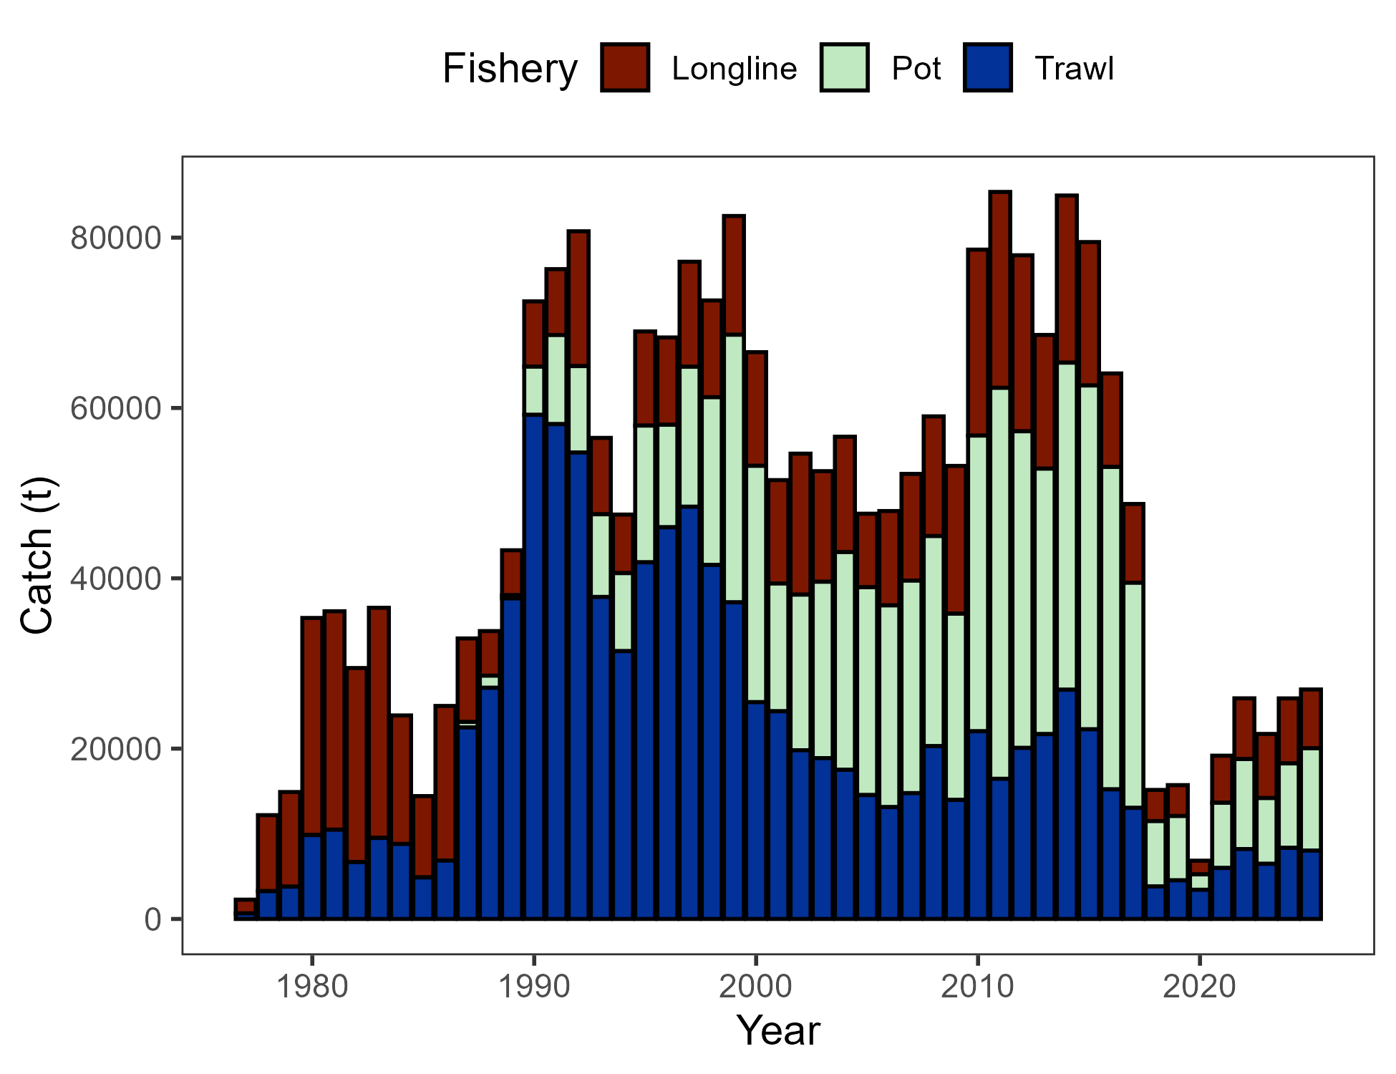

Figure 2.1. Commercial catch (mt) of Pacific cod in the GOA in trawl (FshTrawl), longline (FshLL), and pot (FshPot) gear from 1977-2025. Note that 2025 catch was through December 8.

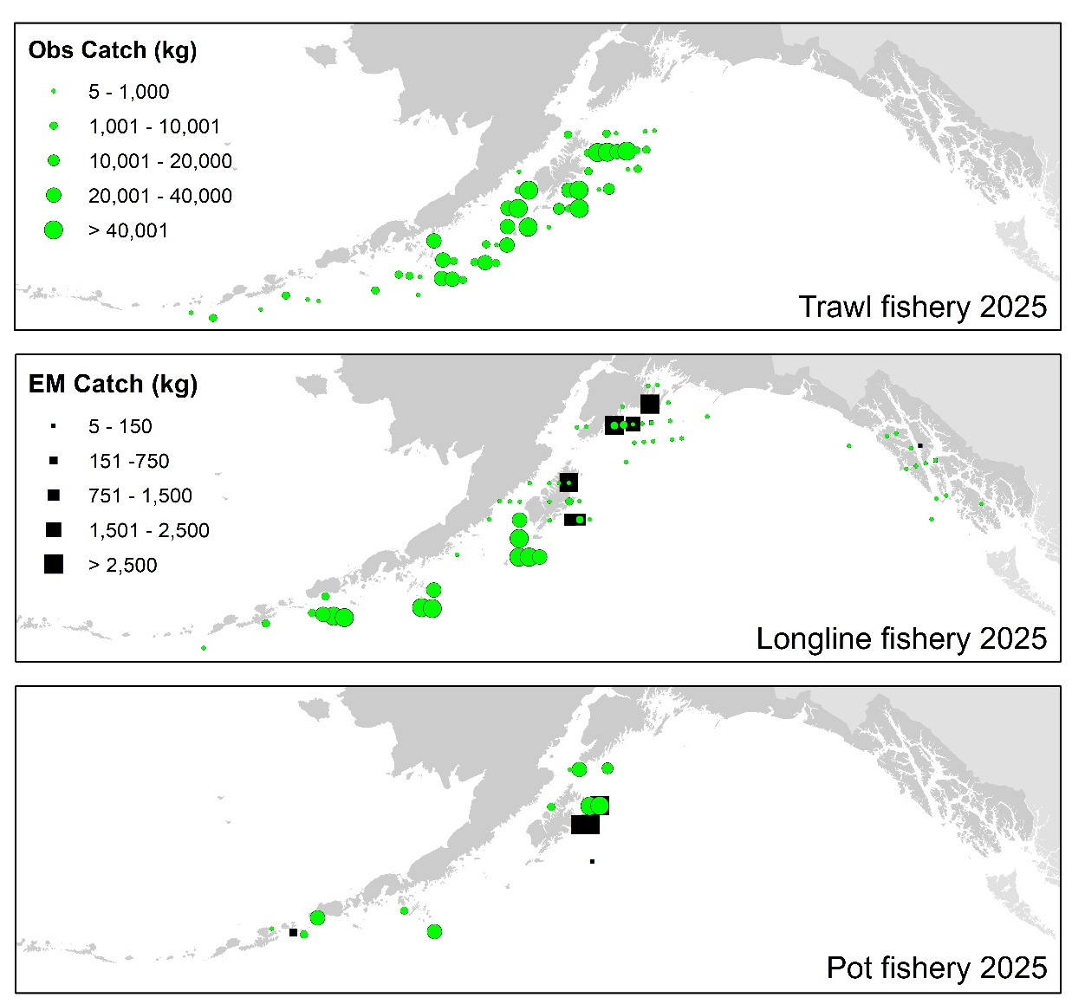

Figure 2.2. Observed (Obs) and electronic monitored (EM) commercial catch of Pacific cod in the GOA by 20 km² grid for 2025. These data include bycatch Pacific cod, but do not include trawl EM data as locations are not yet available.

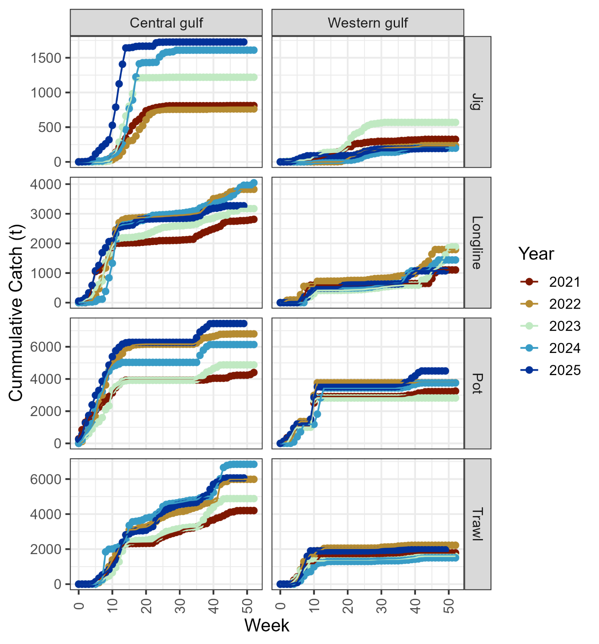

Figure 2.3. Cumulative catch week of the year for 2021-2025 by GOA sub-area and fleet (2025 catch through December 8).

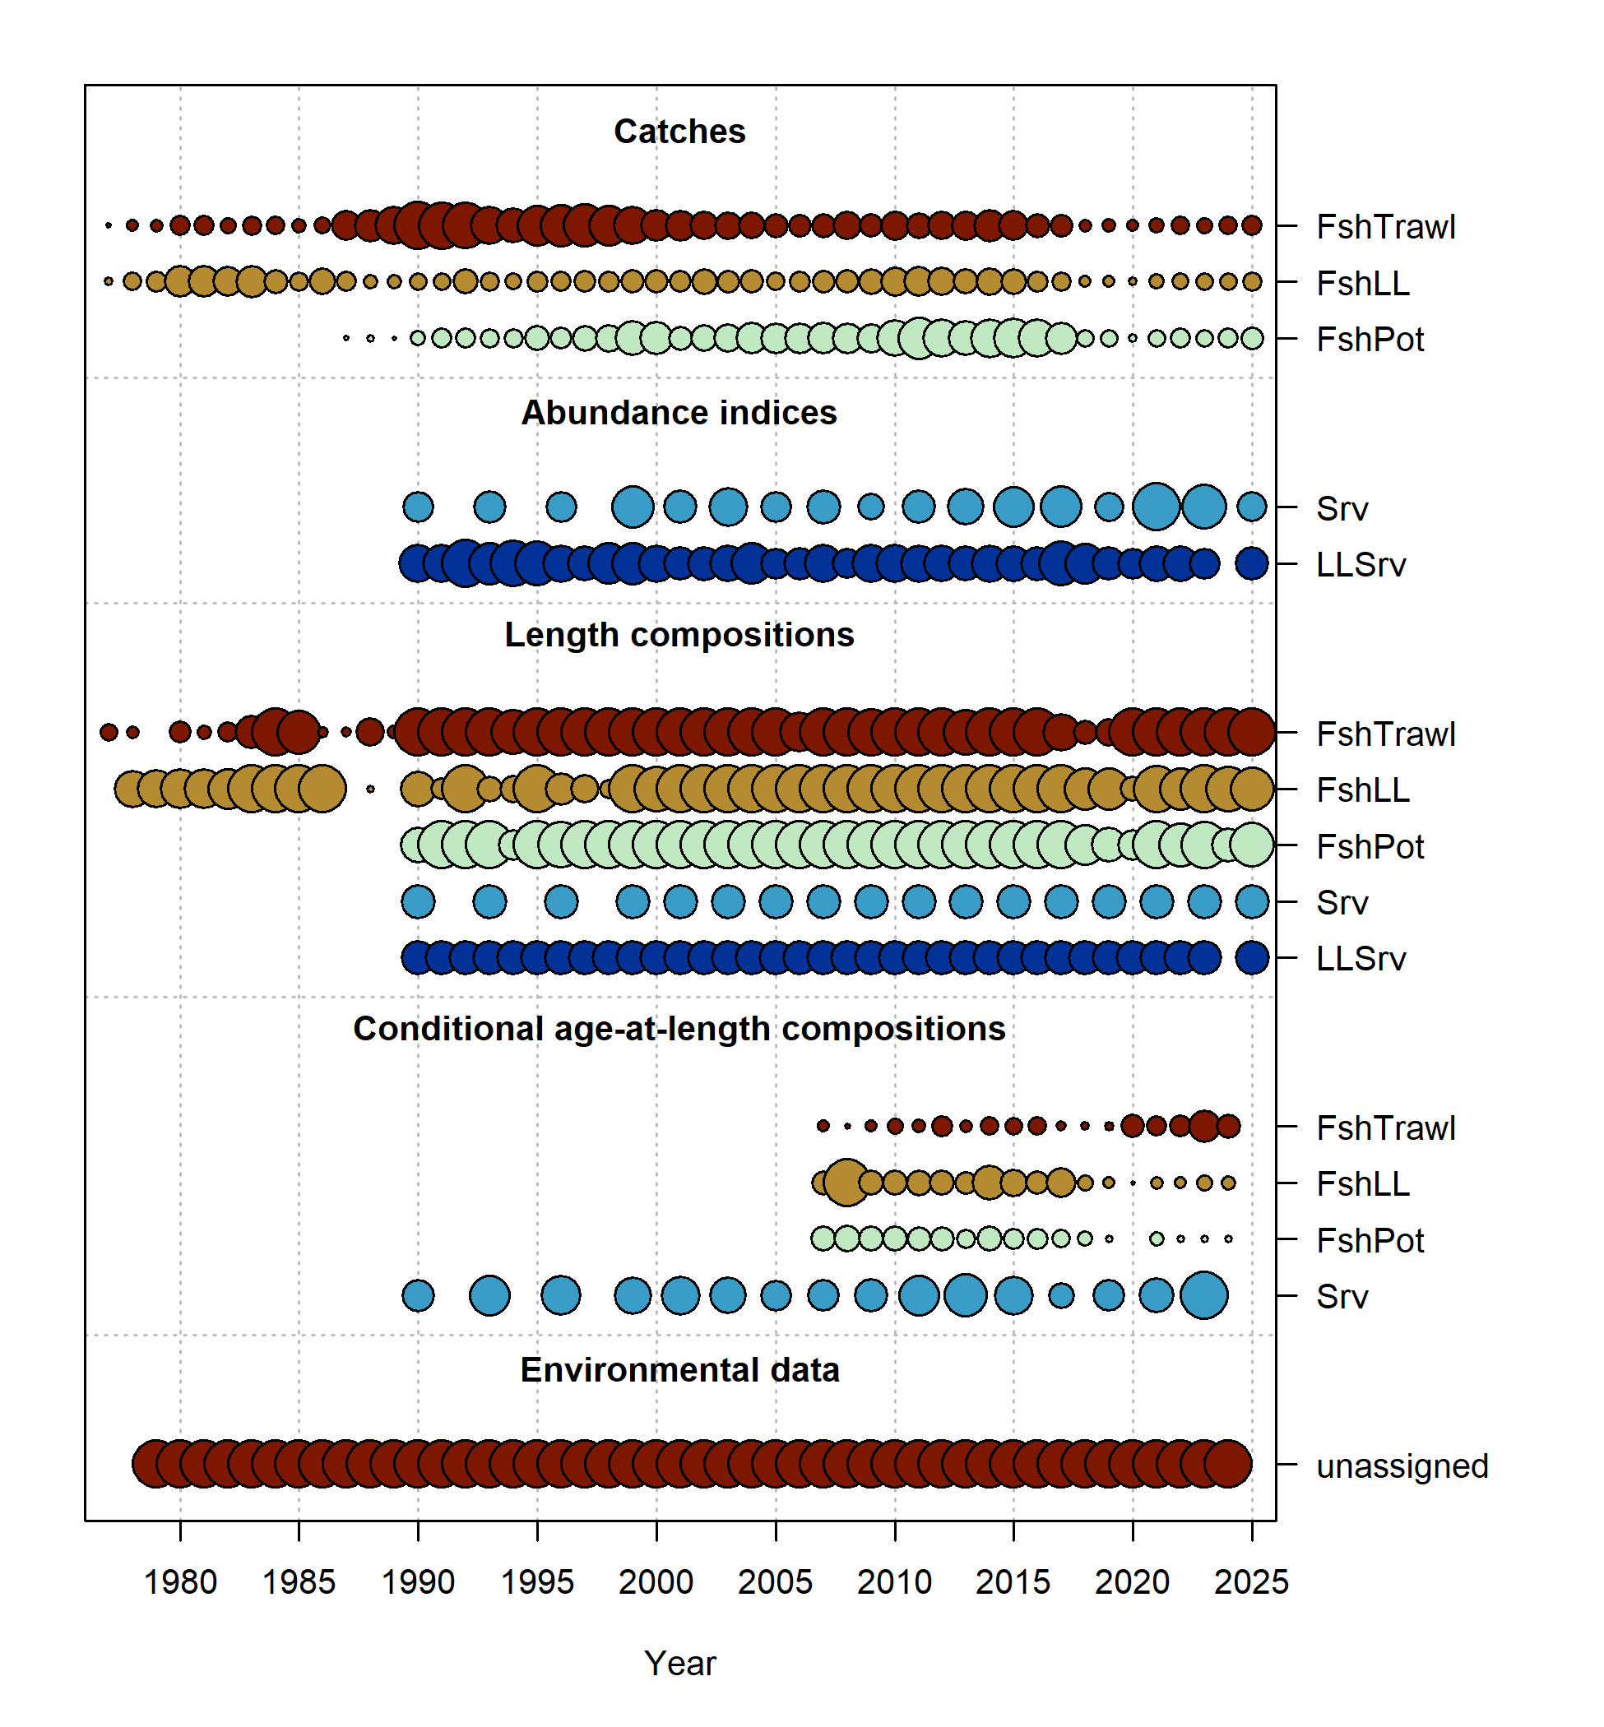

Figure 2.4. Data fit in Model 24.0. Circles are proportional to total catch for catches, precision for indices and input sample size for compositions and length-at-age observations. Data source include fishery data from trawl (FshTrawl), longline (FshLL), and pot (FshPot) fisheries. Survey data include the AFSC longline (LLSrv) and bottom trawl (Srv) surveys. Note that since the circles are scaled relative to maximum within each type, the plots of scaling across dataset types should not be compared.

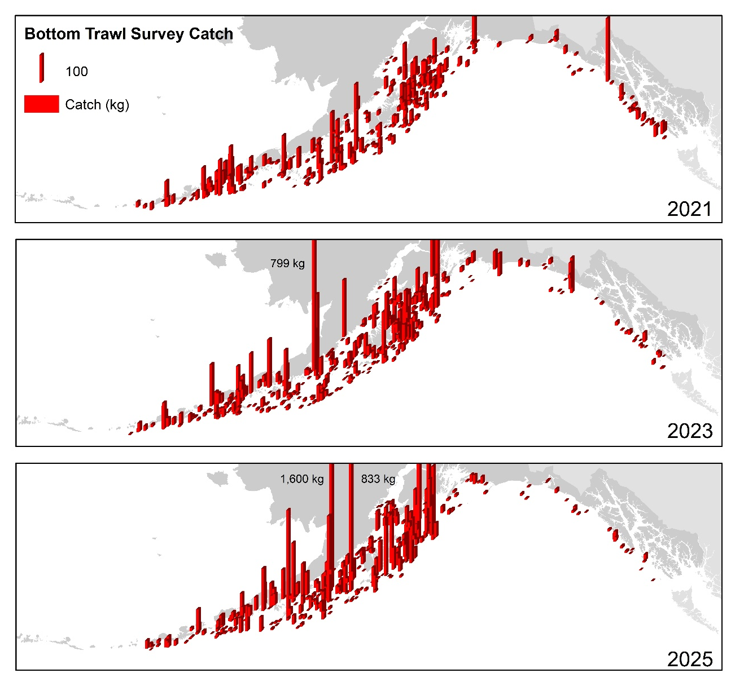

Figure 2.5. Distribution of AFSC bottom trawl survey catch (kg) of Pacific cod for 2021-2025.

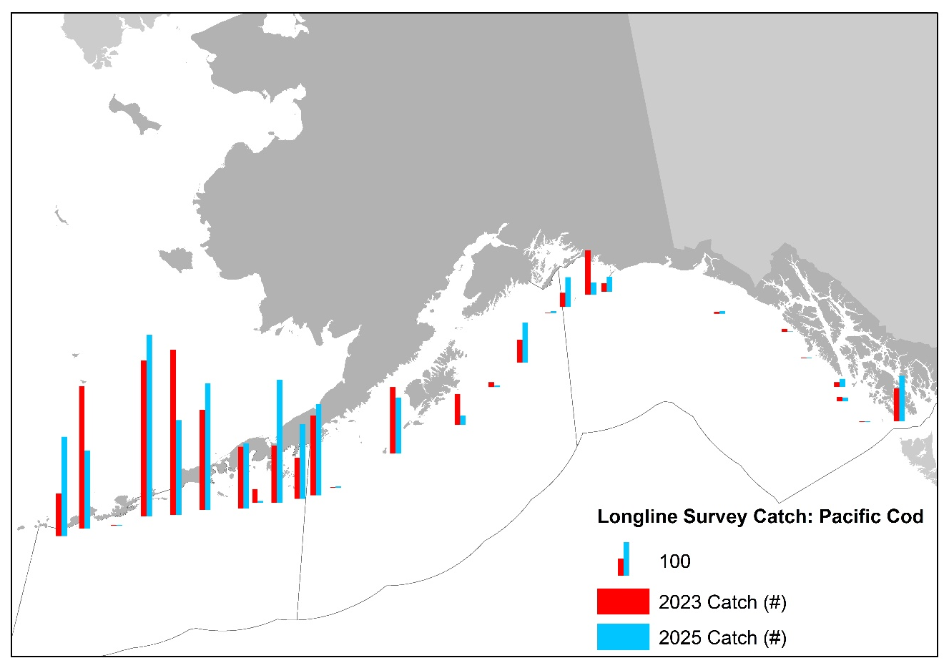

Figure 2.6. Distribution of AFSC longline survey catch (numbers) of Pacific cod in 2023 and 2025.

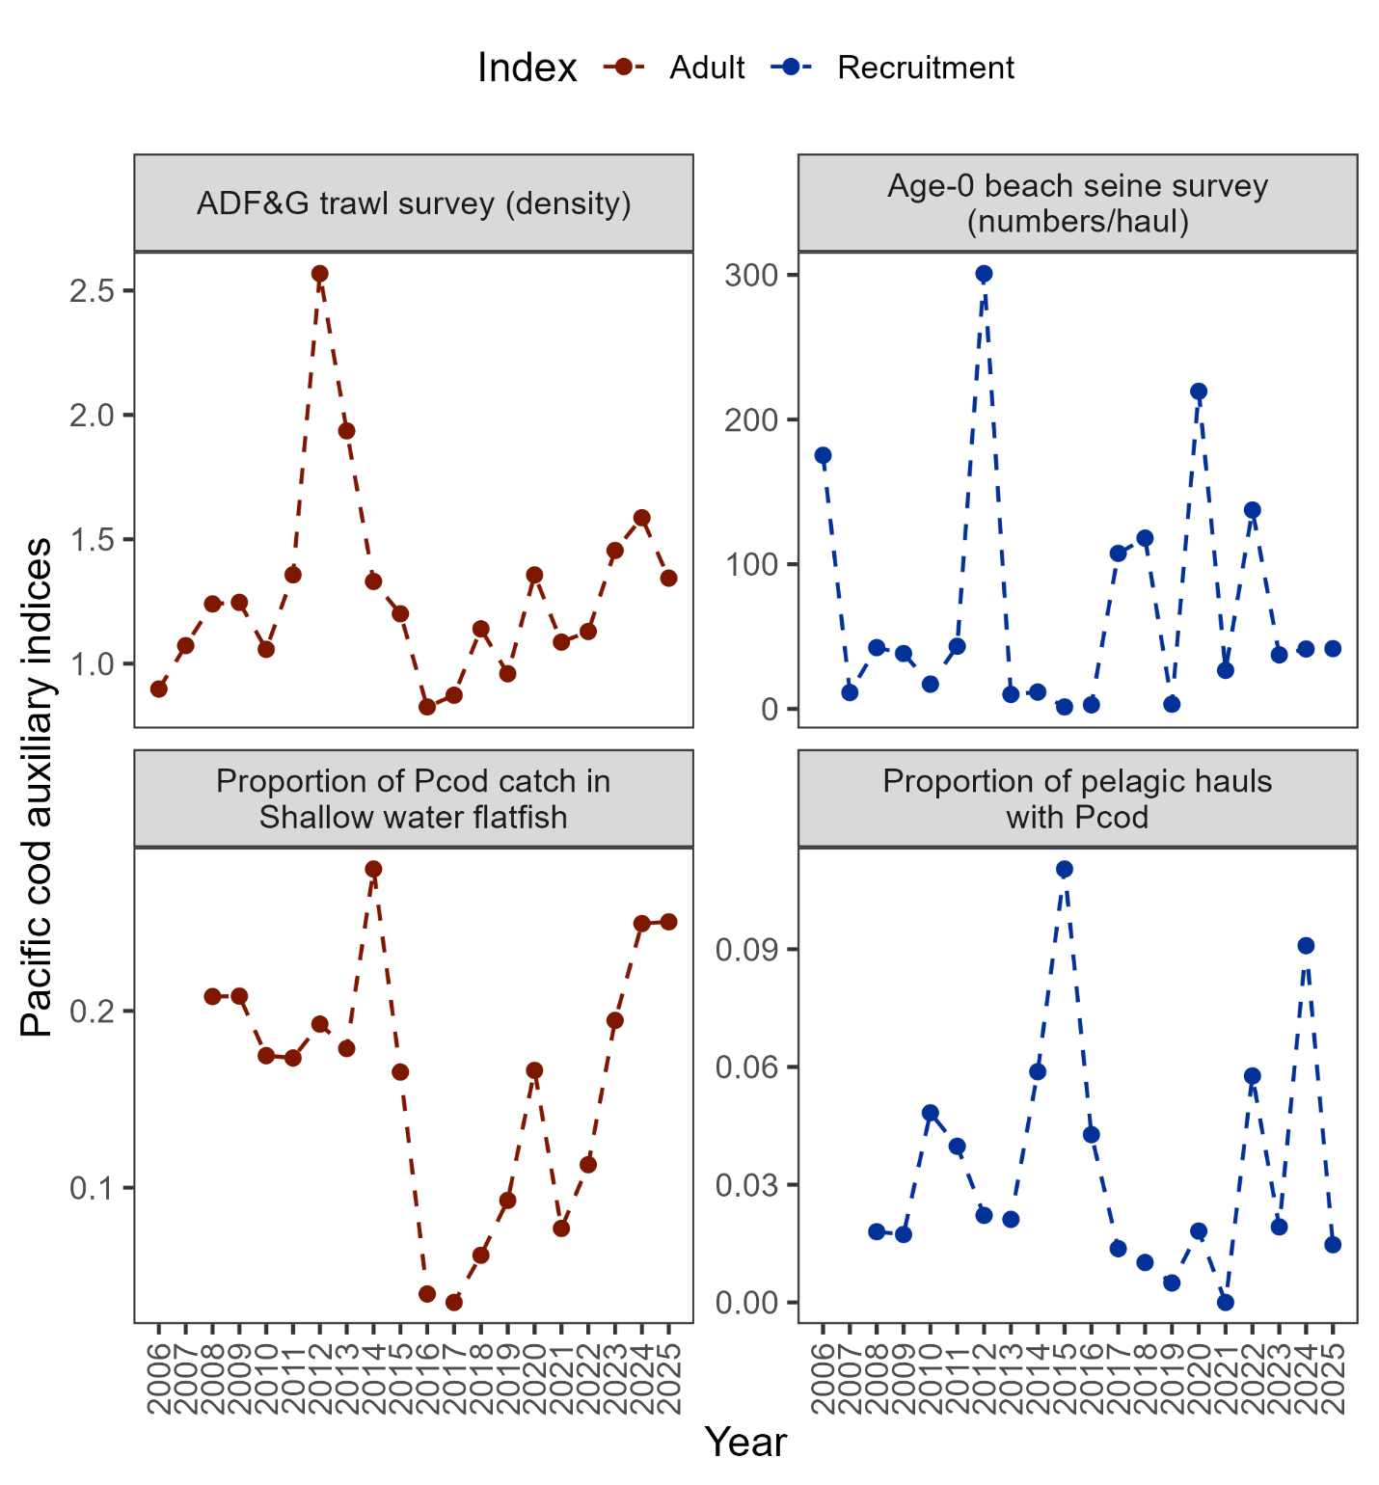

Figure 2.7. Auxiliary indices for GOA Pacific cod adult and recruitment abundance. ADFG bottom trawl survey delta-glm density (top left panel) and proportion of Pacific cod bycatch in the GOA shallow water flatfish fishery (bottom left panel) representing indices for adult abundance, and age-0 beach seine survey numbers per haul (top right panel) and proportion of pelagic trawls in the Central GOA A Season (January-April) walleye pollock fishery with Pacific cod present (bottom right panel) representing indices for recruitment.

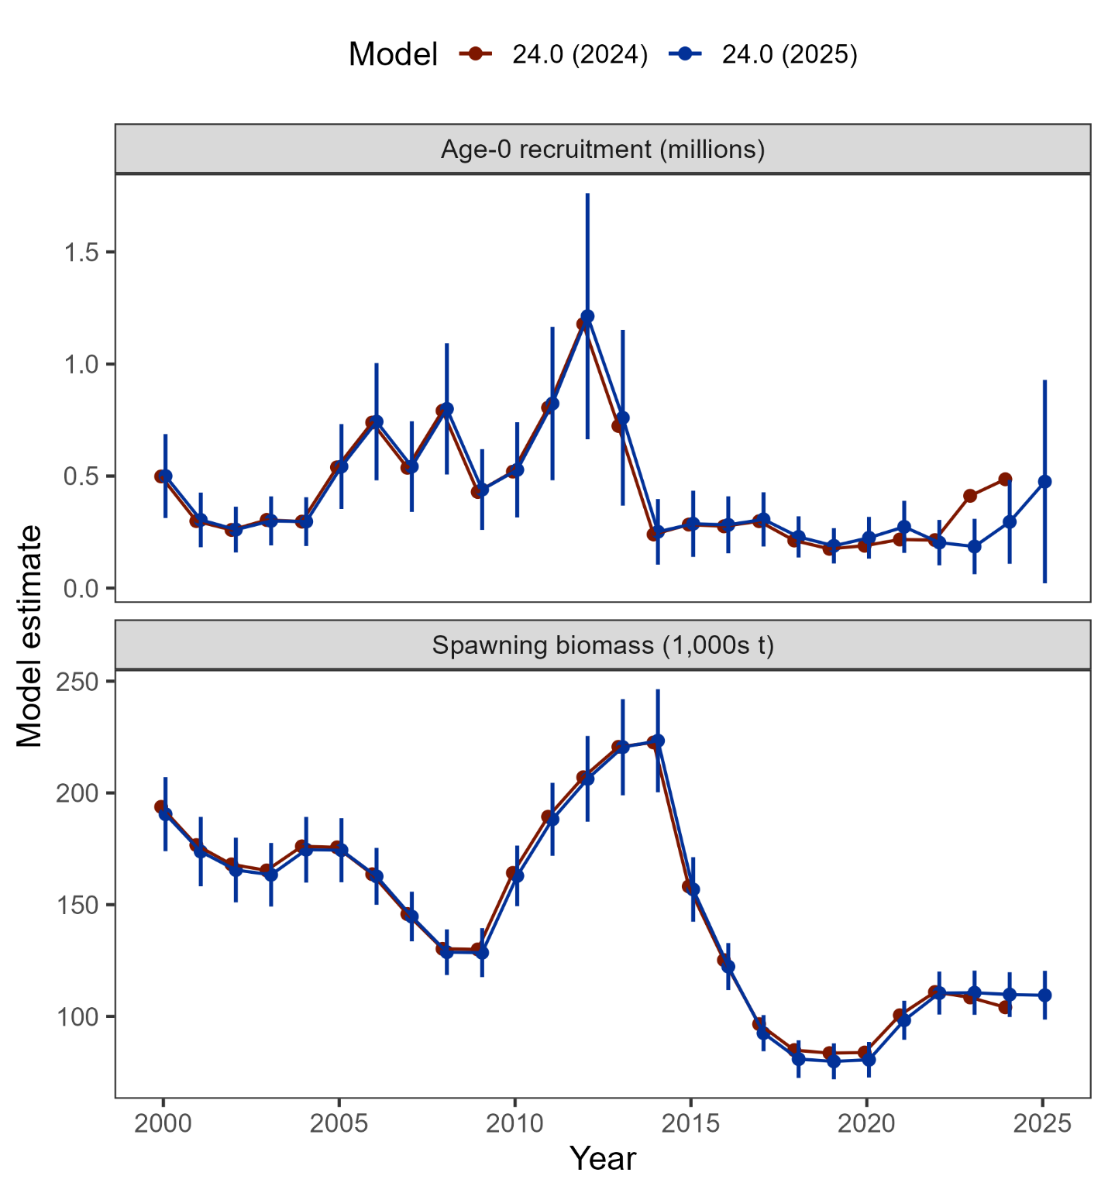

Figure 2.8. Comparison of recruitment and spawning biomass estimated from Model 24.0 as applied in 2024 and with updated data in 2025 (including 95% confidence intervals).

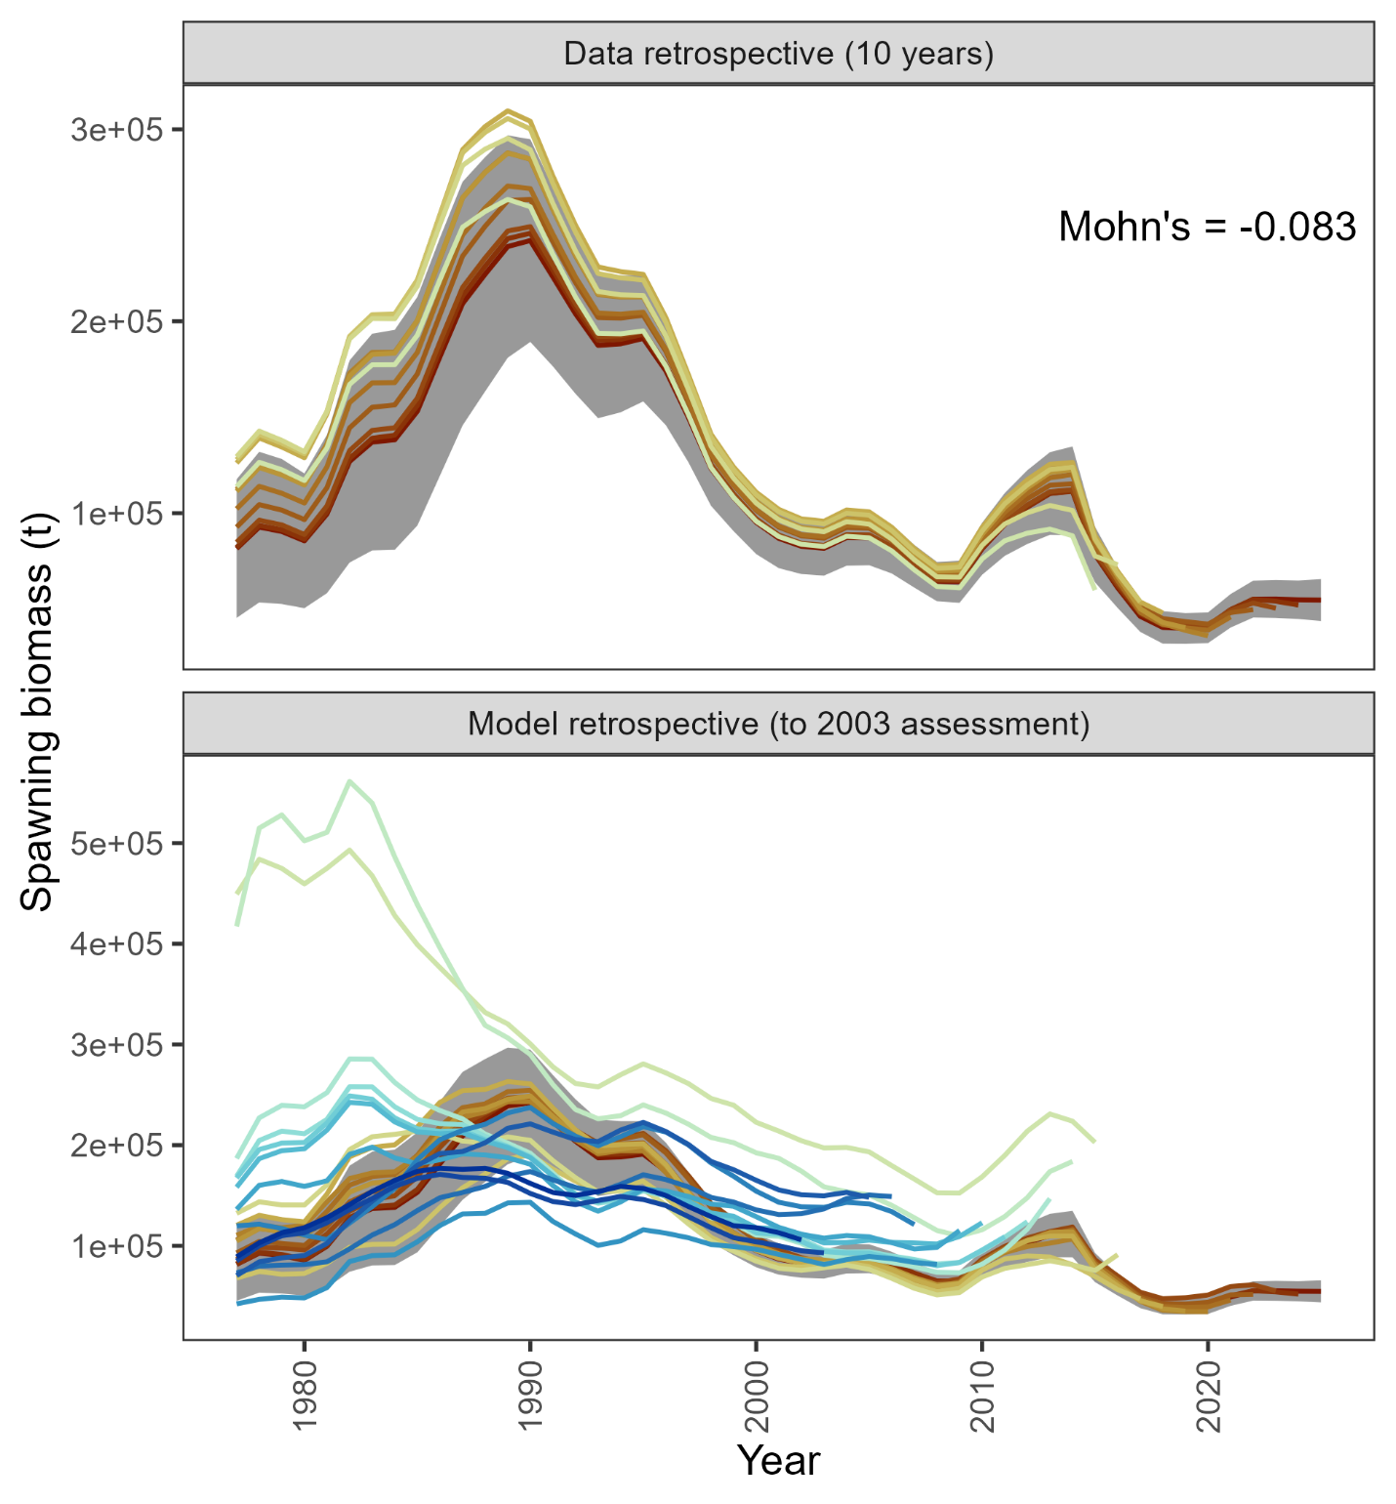

Figure 2.9. Retrospective analysis of spawning biomass upon removing data from Model 24.0 (top panel) and in comparison to previously accepted models (bottom panel). The shaded region is the 95% confidence intervals from Model 24.0.

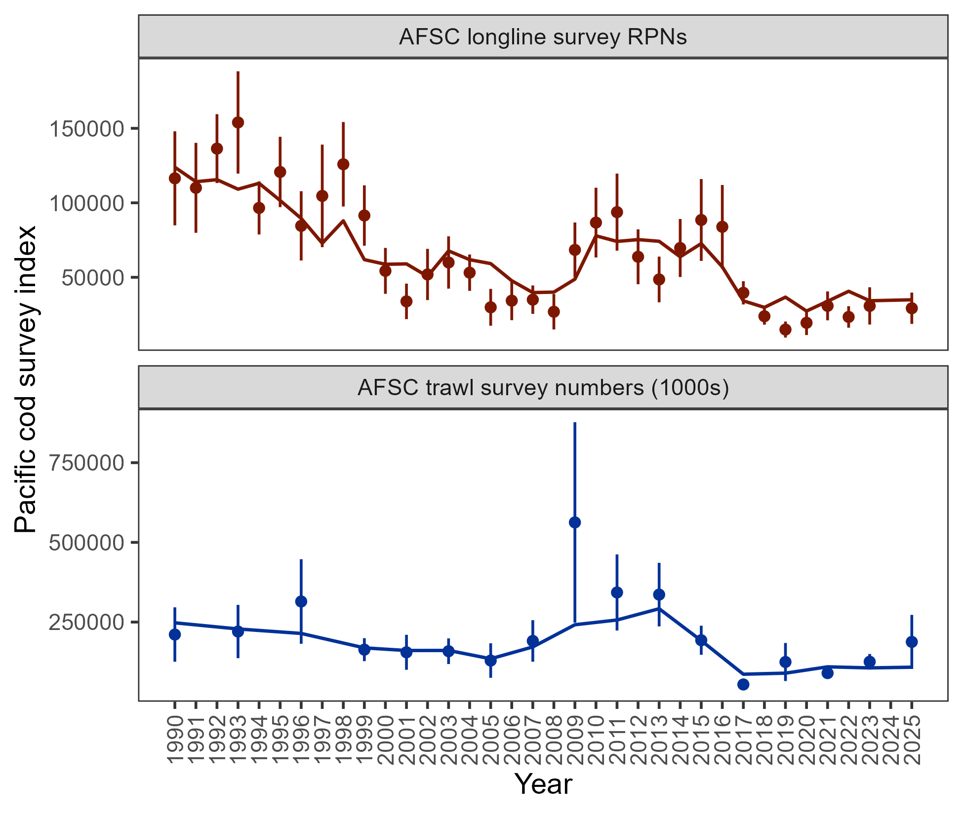

Figure 2.10. Population indices fit by the assessment model, including AFSC longline survey relative population numbers (RPN – top panel) and AFSC bottom trawl survey abundance (numbers – bottom panel). Model fit is shown as a solid line and observed data is shown as points (with error bars indicating the 95% confidence intervals).

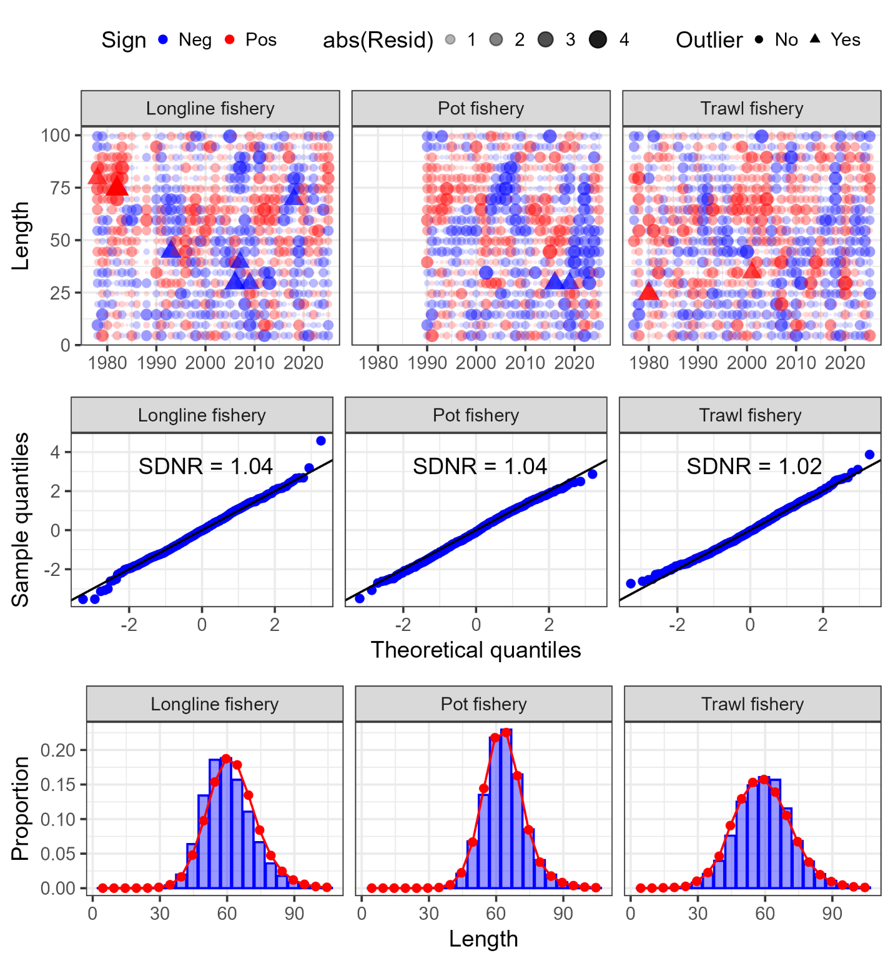

Figure 2.11. One-step ahead residuals (top panels), theoretical versus sample quantiles (middle panels), and aggregated model fit (bottom panels) for the fishery length composition data (fleets shown across the columns) fit in the author’s recommended model.

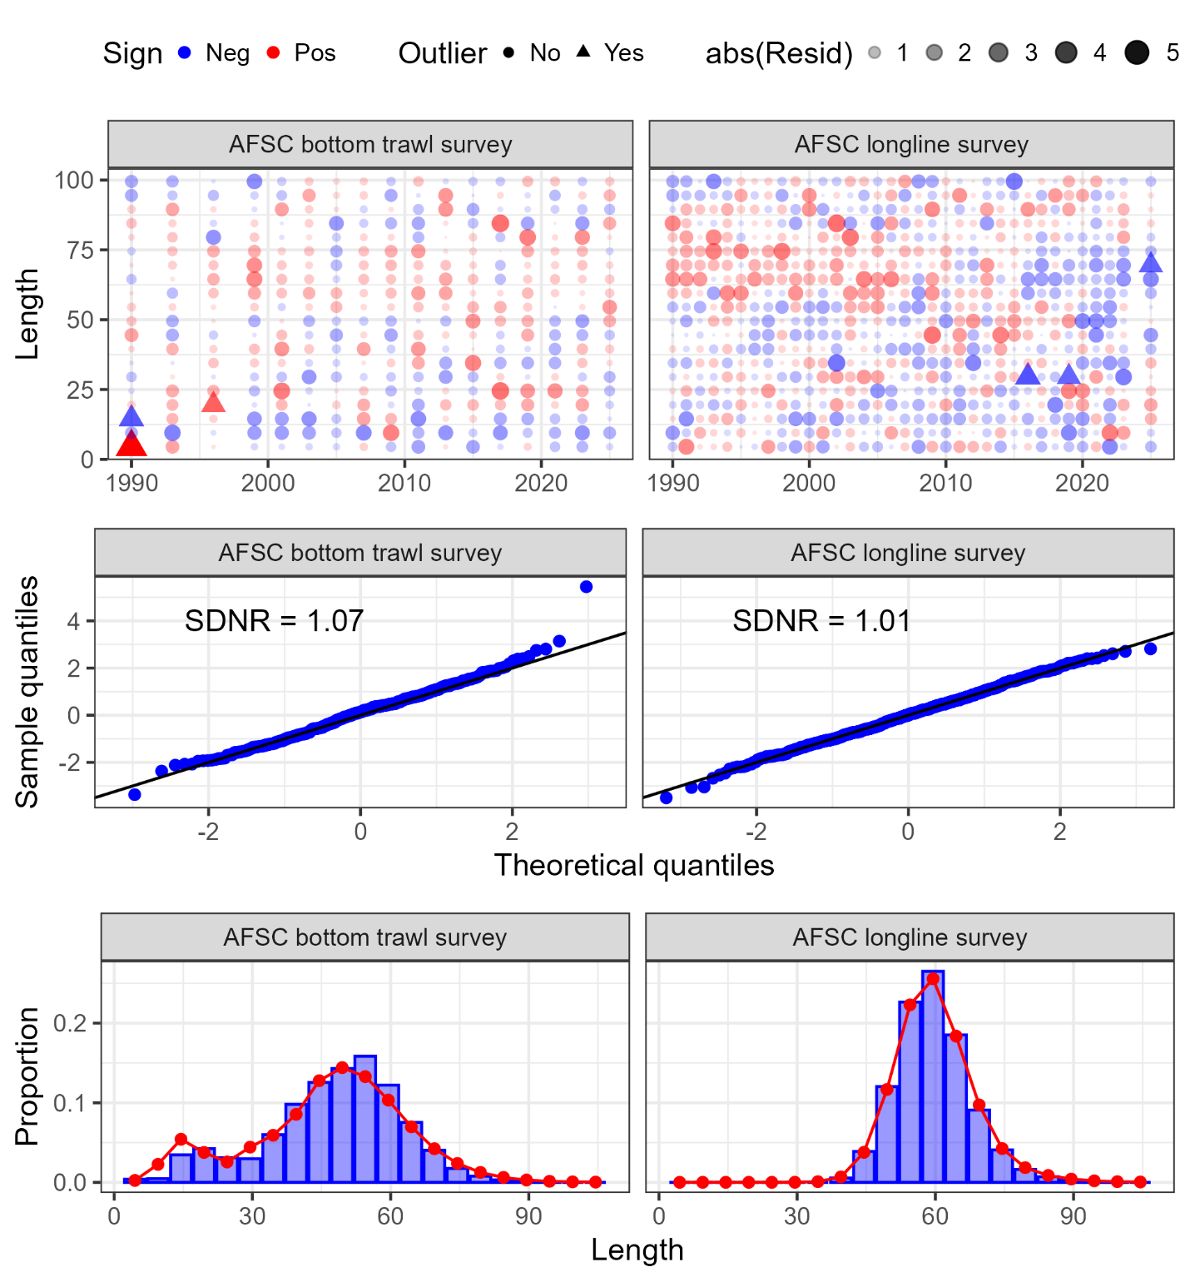

Figure 2.12. One-step ahead residuals (top panels), theoretical versus sample quantiles (middle panels), and aggregated model fit (bottom panels) for the survey length composition data (surveys shown across the columns) fit in the author’s recommended model.

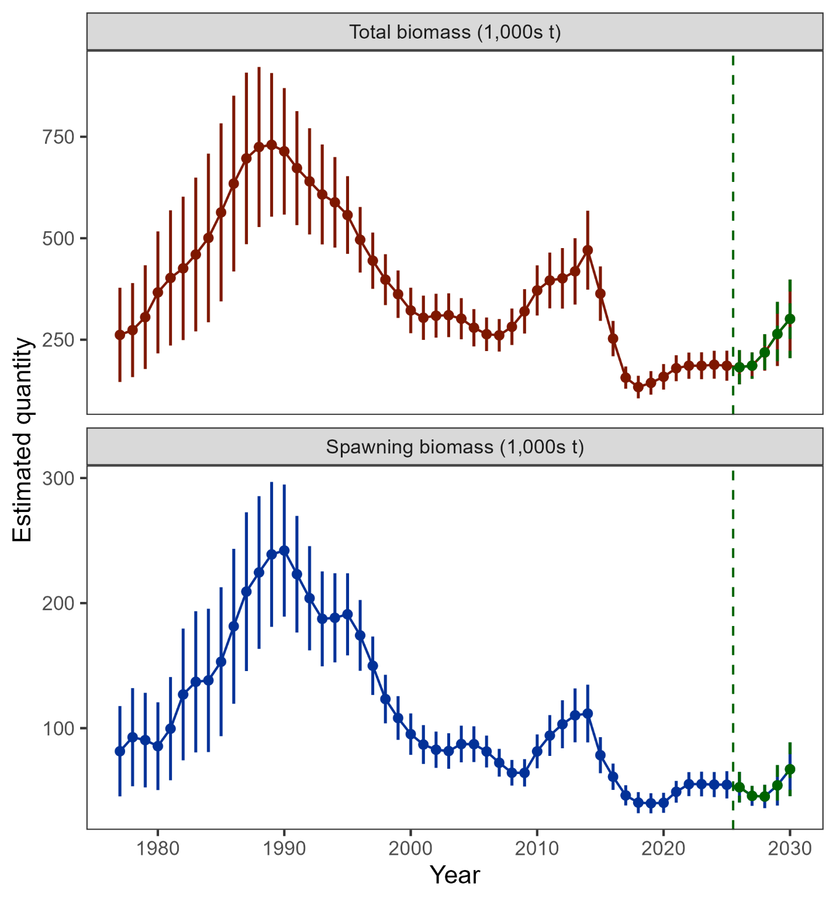

Figure 2.13. Estimated total biomass (top panel) and spawning biomass (bottom panel) from the author’s recommended model with 95% confidence intervals. The five-year forecasted biomass values are denoted in green shading and with the vertical dashed line in each plot.

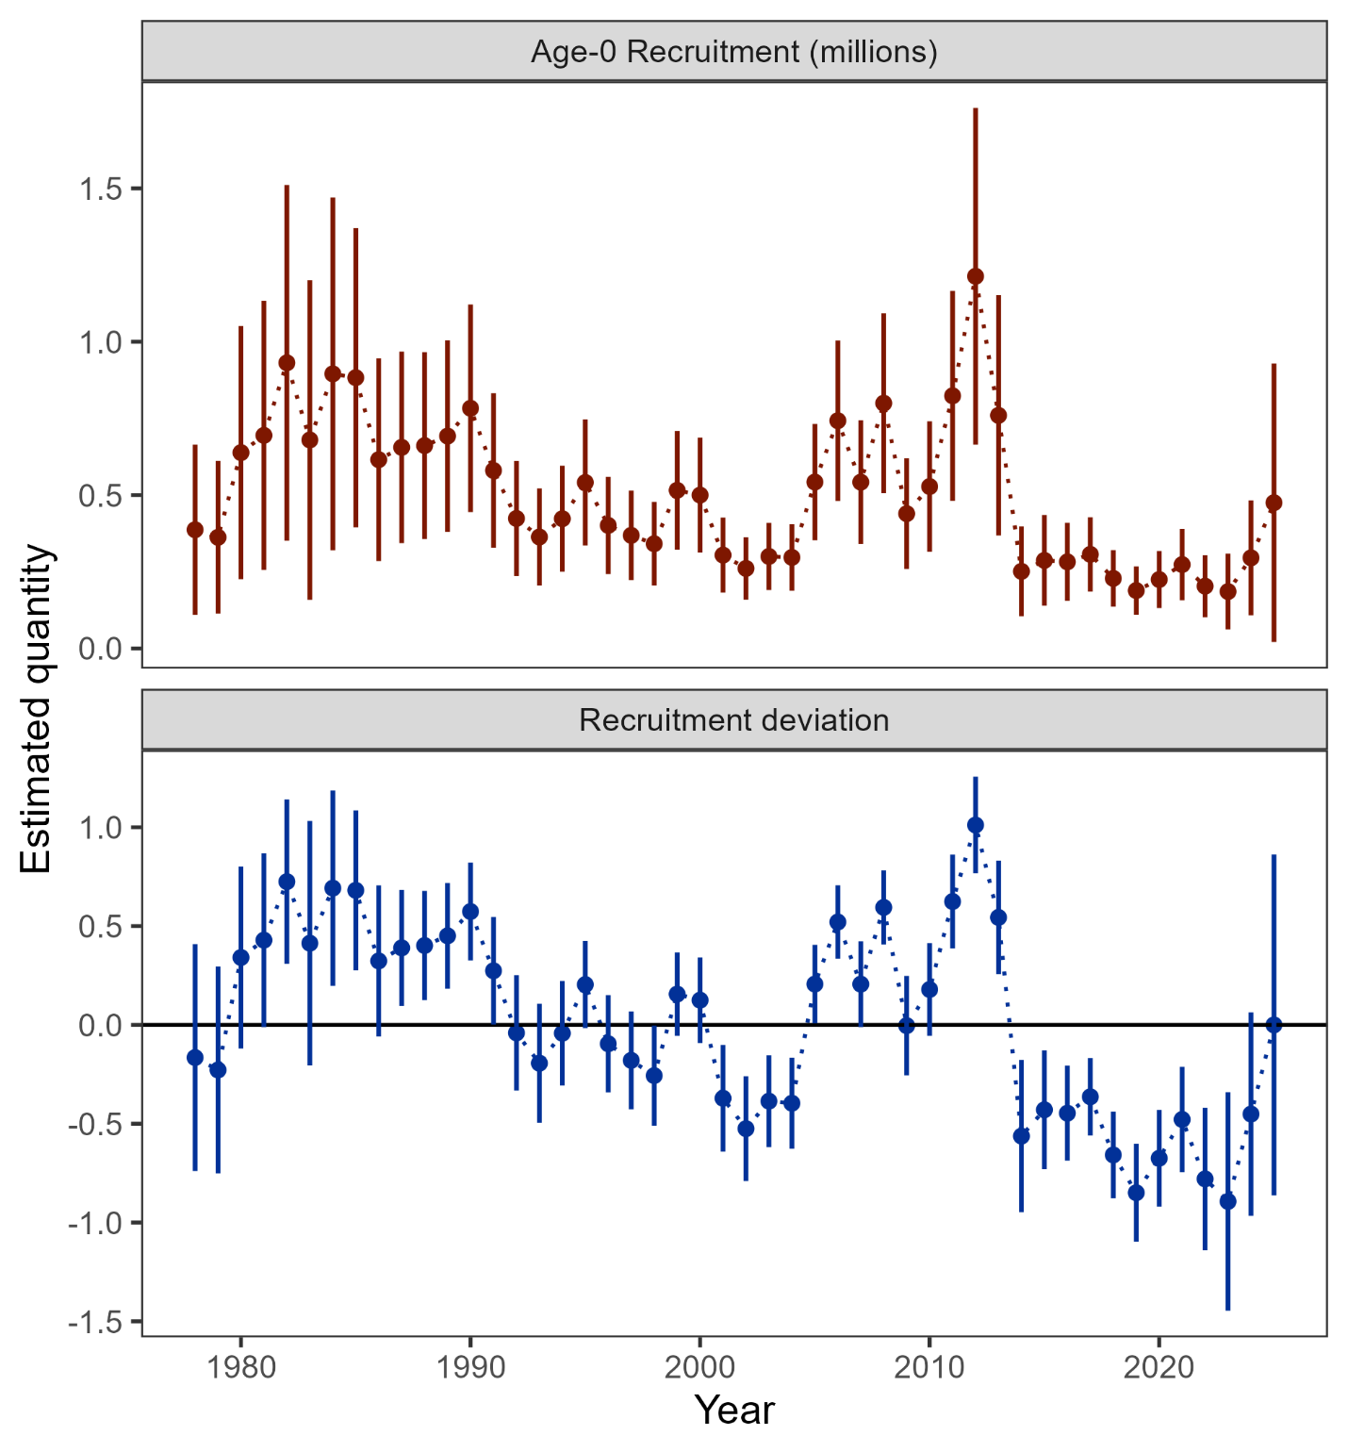

Figure 2.14. Age-0 recruitment (top panel) and log recruitment deviations (bottom panel) with 95% confidence intervals from the author’s recommended model.

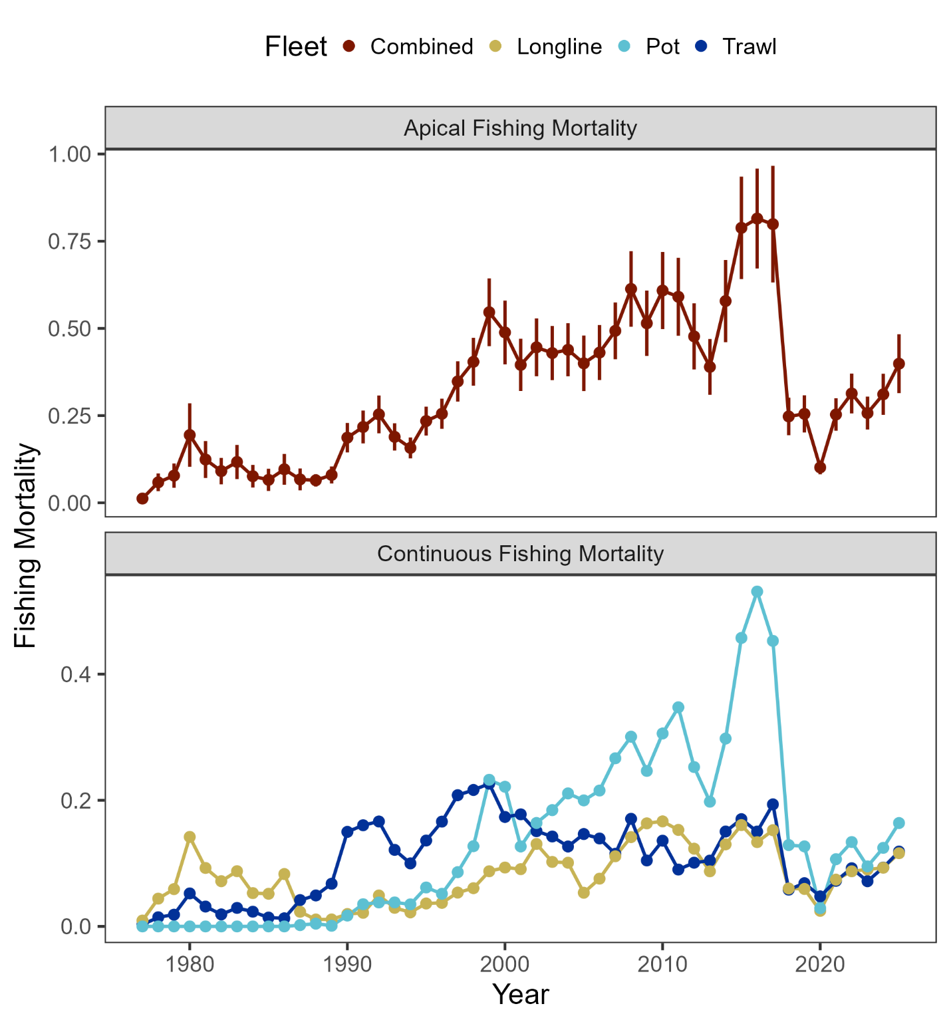

Figure 2.15. Sum of apical fishing mortality (top) and continuos fishing mortality by fisheries (bottom) from the author’s recommended model.

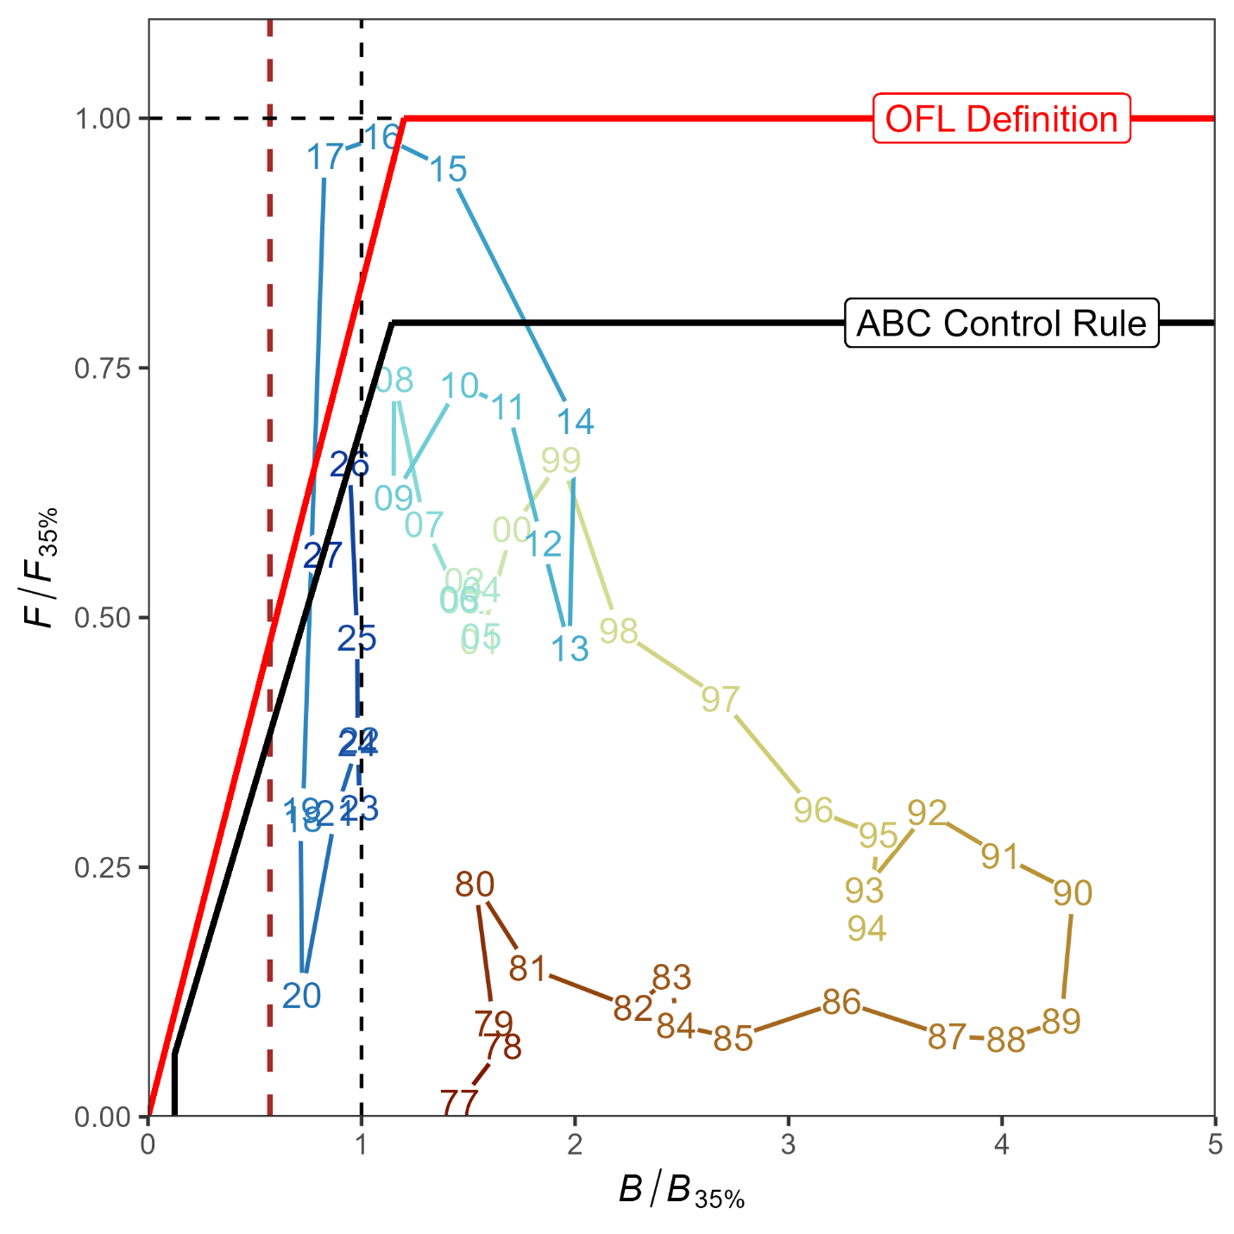

Figure 2.16. Ratio of historical F/F_{35%} versus female spawning biomass relative to B_{35%} for GOA pacific cod, 1977-2027 from the author’s recommended model. The Fs presented are the sum of the full Fs across fleets. Dashed vertical red line is at B_{20%}, Steller sea lion closure rule for GOA Pacific cod.

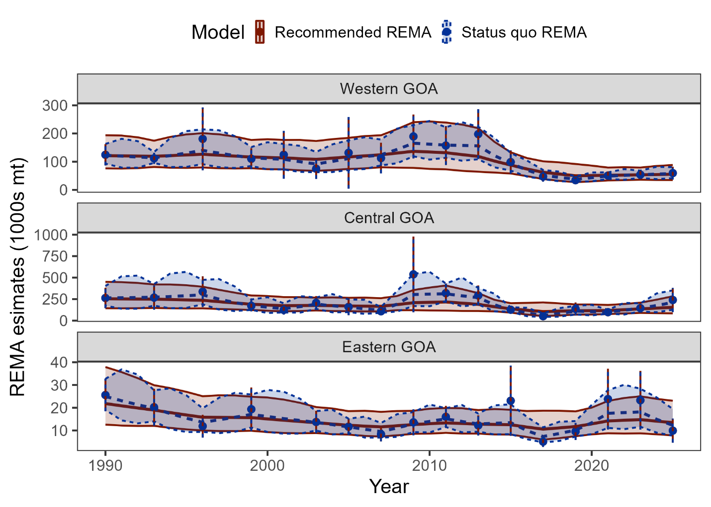

Figure 2.17. Recommended and status quo REMA results as fit to the AFSC bottom trawl survey by area.

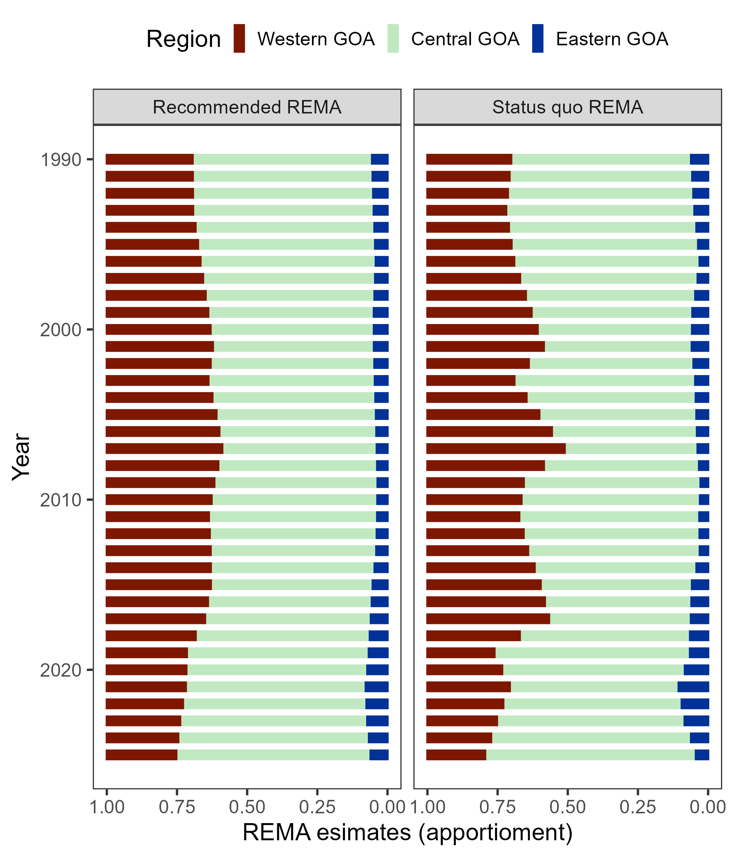

Figure 2.18. Recommended and status quo REMA apportionment results.

