Chapter 2: Assessment of the Pacific cod stock
in the Gulf of Alaska
Peter-John F. Hulson, Steven J. Barbeaux, Bridget Ferriss, Katy Echave, Julie Nielsen, Susanne McDermott, Ben Laurel, Alisa Abookire, Ingrid Spies and S. Kalei Shotwell

January 2026

This report may be cited as: Hulson, P.-J. F., S. J. Barbeaux, B. Ferriss, K. Echave, J. Nielsen, S. McDermott, B. Laurel, A. Abookire, I. Spies, and S. K. Shotwell. 2026. Assessment of the Pacific cod stock in the Gulf of Alaska. North Pacific Fishery Management Council, Anchorage, AK. Available from https://www.npfmc.org/library/safe-reports/.

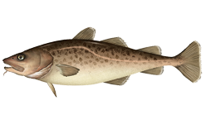

With contributions from:
Mike Litzow, Kimberly Rand, Charlotte Levy, and Muyin Wang

Executive Summary
Pacific cod in the Gulf of Alaska are assessed on an annual stock assessment schedule to coincide with the availability of new survey data. We use a statistical age-structured model as the primary assessment tool for Gulf of Alaska Pacific cod which qualifies as a Tier 3 stock. This assessment consists of a population model, which uses survey and fishery data to generate a historical time series of population estimates, and a projection model, which uses results from the population model to predict future population estimates and recommended harvest levels. Model input files, plots, and presentations pertaining to this assessment can be found at this link.

Summary of Changes in Assessment Inputs
Relative to last year’s assessment, the following changes have been made in the current assessment:

Changes in the input data
- Federal and state catch data for 2024 were updated and preliminary federal and state catch data for 2025 were included;
- Commercial federal and state fishery size composition data for 2024 were updated, and preliminary commercial federal and state fishery size composition data for 2025 were included;
- Commercial federal conditional age-at-length data for 2024 were included;
- AFSC longline survey Pacific cod abundance index and length composition data for the GOA for 2025 were included;
- AFSC bottom trawl survey abundance index and length composition data for 2025 were included;

Changes in the methodology
The methodology remains the same as Model 24.0 accepted in 2024.

Summary of Results
The stock appears to be recovering from low levels with the 2026 the stock estimated to be nearly equal to the B_{MSY} proxy of B_{35%} (the estimate is B_{33%}). By the FMP, being below B_{40%} categorizes the stock status as being in sub-tier “b” of Tier 3. Under Tier 3b, the estimated maximum allowable ABC is 41,520 t. This represents an increase from the 2026 ABC projected in last year’s assessment due to updated survey data and an increase in the estimated stock status. In Tier 3b, stock status increases along the harvest control rule ramp results in increases the allowable fishing mortality rate and affects both the ABC and OFL. The corresponding reference values are summarized in the following table, with the recommended ABC and OFL values in bold. The stock is not subject to overfishing, is not currently overfished, nor is it approaching a condition of being overfished.
Quantity | As estimated or specified last year for: |  | As estimated or specified this year for:
Quantity | 2025 | 2026 | 2026 | 2027
M (natural mortality rate) | 0.49* | 0.49* | 0.5* | 0.5*
Tier | 3b | 3b | 3b | 3b
Projected total (age 0+) biomass (t) | 177,497 | 200,521 | 182,156 | 186,118
Female spawning biomass (t)
Projected | 46,920 | 44,674 | 52,772 | 45,838
B_{100%} | 163,585 | 163,585 | 159,595 | 159,595
B_{40%} | 65,434 | 65,434 | 63,838 | 63,838
B_{35%} | 57,255 | 57,255 | 55,858 | 55,858
F_{OFL} | 0.57 | 0.51 | 0.68 | 0.54
maxF_{ABC} | 0.46 | 0.43 | 0.54 | 0.47
F_{ABC} | 0.46 | 0.43 | 0.54 | 0.47
OFL (t) | 38,688 | 33,099 | 49,782 | 38,812
maxABC (t) | 32,141 | 30,193 | 41,520 | 32,209
ABC (t) | 32,141 | 30,193 | 41,520 | 32,209
Status | As determined last year for: |  | As determined this year for:
Status | 2023 | 2024 | 2024 | 2025
Overfishing | No | n/a | No | n/a
Overfished | n/a | No | n/a | No
Approaching overfished | n/a | No | n/a | No
*Base natural mortality M varies between 0.5 and 0.84
** Assumed 2025 catch to be the 2025 ABC. For 2027 projections the 2026 catch was assumed to be at the projected ABC.

Area apportionment
Using the recommended random effects model (described in the Area Allocation of Harvests section as applied within the rema R-package, Sullivan et al. 2022) with the trawl survey biomass estimates through 2025, the Biologically informed Recommended Distributions (BRD) are:
 | Western | Central | Eastern | Total
Area apportionment | 24.80% | 69.20% | 6% | 100%
2026 BRD | 10,297 | 28,732 | 2,491 | 41,520
2027 BRD | 7,987 | 22,289 | 1,933 | 32,209

Introduction
This document is an update from the 2024 assessment and includes newly available data. . The model used for management recommendations is the same as the last accepted model in 2024, Model 24.0. For brevity we included the document sections in which data or model results changed; other unchanged sections are available here.

Fishery

Fishery history and management measures
For a full description of the fishery history and management measures see Hulson et al. 2022. Catches of Pacific cod since 1991 by gear type and jurisdiction are shown in Table 2.1; catches prior to that are listed in Thompson et al. (2011). Presently, the Pacific cod stock is exploited by a variety of fisheries, including trawl, longline, pot, and jig components; Figure 2.1 shows landings by gear since 1977. The history of Total Allowable Catch (TAC), Acceptable Biological Catch (ABC), Overfishing Level (OFL), and State of Alaska Guideline Harvest Levels (GHL) are summarized since 1991 and compared with the time series of aggregate commercial catches in Table 2.2 (data prior to 1991 are shown in Hulson et al. 2022). The complete history of allocation (in percentage terms) by regulatory area within the GOA is shown in Table 2.3. Catch reported in Tables 2.1 and 2.2 include discarded Pacific cod, estimated retained and discarded amounts are shown in Table 2.4.

Recent fishery performance
The distribution of directed cod fishing is distinct to gear type. Figure 2.2 shows the distribution of observed catch for the most recent year of complete catch data (2024) for the three major gear types, as well as the distinction between observed and electronic monitored catch. Cumulative catch by week in 2025 is comparable to previous years catch across the gear types (Fig. 2.3).
In 2025 the federal TAC was set at 23,670 t and state GHL set at 8,471 t (Table 2.2). As of December 8, 2025 a total of 26,947 t (84% of the ABC) has been harvested (Table 2.1). State fisheries have harvested 7,344 t (87% of the GHL) and federal fisheries 19,603 t (83% of the TAC). In 2025 41% of the Pacific cod catch was by trawl, 32% by pot gear, and 24% by longline, while jig and other gear harvested 3% (Table 2.1).

Data
This section describes updates to the data used in the current assessment. The following table and Figure 2.4 present the data included in this assessment (the years shown in bold font are those that are new to this assessment).

Data | Source | Type | Years
Federal and state fishery catch, by gear type (trawl, pot, and longline) | AKFIN | Metric tons | 1977 – 2025
Federal and state fishery catch-at-length, by gear type | AKFIN, ADF&G | Frequency observed at length (in cm) | 1977 – 2025
GOA NMFS bottom trawl survey abundance | AKFIN | Total numbers | 1990 – 2025
AFSC Sablefish Longline survey Pacific cod Relative Population Numbers | AKFIN | RPN | 1990 – 2025
GOA NMFS bottom trawl survey length composition | AKFIN | Number at length (in cm) | 1990 – 2025
GOA NMFS bottom trawl survey conditional age-at-length | AKFIN | Proportion age at length | 1990 – 2023
AFSC Sablefish Longline survey Pacific Cod length composition | AKFIN | RPN at length (in cm) | 1990 – 2025
Federal fishery conditional age-at-length | AKFIN | proportion age at length | 2007 – 2024
CFSR bottom temperature indices | National Center for Atmospheric Research | temperature anomaly at mean depth for P. cod size bins | 1979 – 2024

Fishery:

Catch Biomass
Total catches for the period 1991-2025 are shown for the three main gear types in Table 2.1, with the 2025 values through December 8, 2025. The current year’s catch within the assessment model is assumed to reach the full Total Allowable Catch (TAC) and state Guideline Harvest Level (GHL). Three fisheries were modeled (by gear categories); trawl (all trawl types), longline (longline and jig) and pot.

Length Composition
Fishery length compositions are available by fishery from 1977 through December of 2025 (in some years data are unavailable for some fisheries, Fig. 2.4). The length composition observed in 2025 for each gear type are consistent with recent observed length compositions.

Age composition
Age data collected since 2007 from the commercial fishery were used to develop an annual conditional length-at-age matrix for each fishery (Fig. 2.4). The conditional age-at-length observed in 2024 do not indicate any notable departures from those observed in recent years.

Surveys

AFSC bottom trawl survey
In 2025, the scientists from the AFSC transitioned to a new stratified random design for this survey. The new design changed from the previous 59 strata defined by INPFC management area, depth, and general habitat type (shelf, gully, and slope) to 28 strata defined by NMFS management area and depth. We describe results of analysis comparing historical bottom trawl survey data using the restratified design in Appendix 2 and noted a negligible impact on Pacific cod estimates compared to the previous design. We note that for 2025 the survey was conducted with two chartered vessels completing 431 stations and that this represented an 18% reduction compared to the number of stations sampled in 2023.
The spatial distribution of Pacific cod in the 2025 trawl survey was comparable to the most recent surveys (in 2023 and 2021, Fig. 2.5). In general, the 2025 survey resulted in stations with higher Pacific cod densities than those from 2021 and 2023.

Biomass and abundance estimates
Since the time-series low in 2017, the Pacific cod biomass and abundance estimates from the bottom trawl survey suggest an increasing trend in the population (Table 2.5). Compared to the 2023 survey, the 2025 trawl survey biomass estimate increased by 39.2% and the abundance estimate increased by 49.6%. As seen in Figure 2.5, these increases in biomass and abundance were driven by overall increases in haul catch, rather than a few high-density stations. Nonetheless, the coefficient of variation (CV) estimate was 23% which is larger than recent CVs but within the range estimated for other years of the time-series. This increase in CV is likely due to a combination of fewer strata in the restratified survey design and the reduction in the number of stations sampled in 2025 as compared to recent surveys.

Length Composition
The bottom trawl survey 2025 length composition was observed to be bi-modal, with a mode at 15-20 cm (representing catches of age-1 cod, which would be the 2024 year class) and a mode at 35-70 cm.

Age Composition
Otoliths for bottom trawl survey age composition estimation were collected in each survey and were used as conditional age-at-length data within the GOA Pacific cod assessment. Data from the 2025 survey were unavailable (trawl-survey age data were the same as in the 2024 assessment).

AFSC longline survey
Conducting the AFSC longline survey involves sampling the continental slope and major gullies in the GOA, providing data to calculate relative abundance in this area (Rutecki et al. 2016, Siwicke and Malecha 2024). The survey is primarily directed at sablefish, but also catches considerable numbers of Pacific cod. The survey was conducted in 2025 after missing a year in 2024.
Pacific cod catch in the longline survey primarily occurs in the western and central GOA (Fig. 2.6), with inconsistent peaks in catch. The location of 2025 survey catches were similar to the 2023 survey, with consistent increases in catch in the western GOA in 2025 compared to 2023 for most stations.

Abundance index
The AFSC longline survey index indicates a generally increasing trend since the time-series low in 2019 (Table 2.5). The 2025 estimate declined slightly (5%) compared to the most recent 2023 value. The decline was primarily due to densities observed from the eastern GOA subregion (the Western and Central GOA subregions increased compared to 2023). We note that the GOA-wide mean CPUE from the longline survey increased by 7% in 2025 compared to 2023.

Length composition
The observed 2025 longline survey was unimodal and consistent with previous survey length compositions.

Other auxiliary indices updated but not fit in model

Laurel and Litzow age-0 index
Beach seine sampling of age-0 cod was conducted in 2025. The beach seine age-0 CPUE index resulted in estimated values in 2025 that were very similar to the 2024 and 2023 estimates, all which are below the time-series mean (top right panel of Fig. 2.7).

Alaska Department of Fish and Game bottom trawl survey
The Alaska Department of Fish and Game (ADFG) bottom trawl survey index suggests an increasing trend in the Pacific cod population since the time-series low in 2016 (top left panel of Fig. 2.7). In 2025 the ADFG bottom trawl survey of cod biomass decreased by 15% and the index of cod abundance decreased by 9% compared to 2024.

Commercial fishery indices
Non-targeted catch of Pacific cod in other directed fisheries was examined as an indicator of population trends. We examine two disparate fisheries to evaluate trends in incidental catch of Pacific cod: the pelagic walleye pollock fishery and the bottom trawl shallow water flatfish fishery. The occurrence of Pacific cod in the pelagic pollock fishery appears to be an abundance indicator for 2-year-old Pacific cod, which are thought to be more pelagic. As an index of recruitment abundance, we tracked the incidence of occurrence as proportion of hauls with cod in the central GOA pollock A season. The shallow water flatfish fishery tracked a larger portion of the adult population of Pacific cod. As an index of the adult population abundance, we track the catch rates in tons of Pacific cod per ton of all species caught in the shallow water flatfish fishery. For the walleye pollock fishery in the central GOA, abundance of small cod in pelagic trawls has exhibited an alternating trend in the most recent 5 years, with larger catches in 2022 and 2024 and smaller catches in 2021, 2023, and 2025 (bottom right panel of Fig. 2.7). The catch of Pacific cod in the shallow water flatfish fisheries has trended up since the time series low in 2017. The 2024 and 2025 values are the largest in the recent time series and only smaller than the 2014 value since 2008 (bottom right panel of Fig. 2.7). It should be noted that none of these indices are controlled for gear, vessel, effort, or fishing practice changes.

Environmental indices
The Climate Forecast System Reanalysis (CFSR) temperature index was discontinued for 2025. An alternative environmental index will be used in the next full assessment.

Analytic Approach
We use Model 24.0 in this assessment (described in Hulson et al. 2024). The model for this year was run in SS3 version 3.30.22.1 (the same version as the 2024 assessment, Methot and Wetzell 2013). The SS3 control and forecast files for this year’s model can be found at the link provided in the Executive Summary section of this document.

Results

Model Evaluation
Model evaluation criteria included changes to the negative-log likelihood, model adherence to biological principles and assumptions, the relative sizes of the negative-log likelihood components, how well the model fits to the survey indices, the survey and fishery length composition, and conditional age-at-length data, reasonable curves for fishery and survey selectivity, retrospective pattern, and model behavior during sensitivity analyses.
In the 2024 assessment a full suite of model diagnostics and sensitivities were provided for Model 24.0. In the next full assessment when alternative models are explored these will be updated. As with the results in the 2024 assessment, the update here indicate that the likelihoods appear well defined with acceptably low final gradients and asymptotic approximations of parameter variances.
As in 2024, Model 24.0 configuration resulted in acceptable fits and parameter estimates (Table 2.6). Patterns in abundance compared favorably to previous assessments (Fig. 2.8 and 2.9). On the whole, Model 24.0 fits the AFSC bottom trawl and longline survey indices reasonably well (Fig. 2.10). However, positive residuals have persisted in the fit to the longline survey since 2018 and the model does not fit the 2025 increase in bottom trawl survey abundance. The aggregated fit from Model 24.0 to the fishery length composition data and one-step-ahead residuals excellent but appeared to have a few outlier residuals in proportions at length (Fig. 2.11). The fits to the survey age composition data in aggregate were also excellent but also had some outliers present in the one-step ahead residuals (Fig. 2.12). The standard SS3 plots, which contain additional results, can be found at the link provided in the Executive Summary section of this document
Overall, Model 24.0 yields reasonable results and we continue to use it to recommend the 2026 ABC and OFL.

Time Series Results

Definitions
The annual biomass estimates presented were: total biomass ( the biomass of all fish aged 0 years or greater in a given year) and spawning biomass (the estimated biomass mature females at the date of peak spawning (month?)). Recruitment is defined as the number of age-0 fish by year. actual recruitment to fishery and survey depends on selectivity curves as estimated (noting that there are no indices involving age-0 Pacific cod).

Biomass
Total biomass estimates show a long decline from their peak in 1988 (Table 2.7 and Fig. 2.13) to a low in 2006 and then an increase to another peak in 2014, after which there was a sharp decline through 2018 followed by a slight increase through 2024 and is forecasted to slightly decrease in 2026 followed by an increase through 2030.
Spawning biomass (Table 2.7 and Fig. 2.13) shows a similar trend of decline since the late 1980s with a peak in 1989 to a low in 2008. There was then a short increase in spawning biomass coincident with the maturation of the 2005-2008 year classes through 2014, after which the decline continued to lowest level in 2019 and 2020. The spawning biomass then slightly increased through 2022 and is projected to decrease through 2028 and then increase through 2030. Compared to the most recent assessment in 2024, the current Model 24.0 results in slightly smaller spawning biomass estimates from 2015 to 2021, then larger after 2022 (Fig. 2.8).

Recruitment and Numbers-at-Age
The recruitment predictions in Model 24.0 (Table 2.8 and Fig. 2.14) show above average recruitment for most of the 1980s, below average recruitment from the mid-1990s to mid-2000s, above average recruitment from the mid-2000s to 2013, and below average recruitment since. Compared to the most recent assessment in 2024, the current Model 24.0 results in larger estimates of the 2020 and 2021 year classes, and smaller 2023 and 2024 year classes (Fig. 2.8).

Fishing Mortality
Fishing mortality appears to have increased steadily with the decline in abundance from 1990 through a peak in 2008 with continued high fishing mortality through 2017 (Table 2.9 and Fig. 2.15). 2017 had the highest total exploitation rate of the time series. The period between 1990 and 2008 saw both a decline in recruitment paired with increases in catch. The period of increasing fishing mortality was mainly attributed to the rise in the pot fishery, which also shows the largest increase in continuous F (Fig. 2.15). In 2018 through 2020 there was a sharp decrease in fishing mortality coincident with the drastic cuts in ABC and closure of the federal directed fishery in 2020. In 2021 with the reopening of the federal fishery mortality once again increased, but remained lower than observed in the previous decade prior to 2017. In retrospect, the phase plane plots (Fig. 2.16) show that F was estimated to have been above the ABC control rule advised levels from 2015 to 2017 and biomass has been below B_{35%} since 2017 and projected to continue to be below through 2027. It should be noted that this plot shows current model predictions, not what the past assessments had estimated.

Harvest Recommendations

Amendment 56 Reference Points
Amendment 56 to the GOA Groundfish Fishery Management Plan (FMP) defines the “overfishing level” (OFL), the fishing mortality rate used to set OFL (F_{OFL}), the maximum permissible ABC, and the fishing mortality rate used to set the maximum permissible ABC. The fishing mortality rate used to set ABC (F_{ABC}) may be less than this maximum permissible level, but not greater. Because reliable estimates of reference points related to maximum sustainable yield (MSY) are currently not available but reliable estimates of reference points related to spawning per recruit are available, Pacific cod in the GOA have generally been managed under Tier 3 of Amendment 56. Tier 3 uses the following reference points: B_{40%}, equal to 40% of the equilibrium spawning biomass that would be obtained in the absence of fishing; F_{35%}, equal to the fishing mortality rate that reduces the equilibrium level of spawning per recruit to 35% of the level that would be obtained in the absence of fishing; and F_{40%}, equal to the fishing mortality rate that reduces the equilibrium level of spawning per recruit to 40% of the level that would be obtained in the absence of fishing. The following formulae apply under Tier 3:
3a) Stock status: B/B_{40%} > 1
F_{OFL} = F_{35%}
F_{ABC} < F_{40%}
3b) Stock status: 0.05 < B/B_{40%} < 1
F_{OFL} = F_{35%} × (B/B_{40%} - 0.05) × 1/0.95
F_{ABC} < F_{40%} × (B/B_{40%} - 0.05) × 1/0.95
3c) Stock status: B/B_{40%} < 0.05
F_{OFL} = 0
F_{ABC} = 0
Other useful biomass reference points which can be calculated using this assumption are B_{100%} and B_{35%}, defined analogously to B_{40%}. These reference points are estimated as follows, based on this year’s model, Model 24.0:

Reference point: | B_{35%} | B_{40%} | B_{100%}
Spawning biomass: | 55,858 t | 63,838 t | 159,595 t

For a stock exploited by multiple gear types, estimation of F_{35%} and F_{40%} requires an assumption regarding the apportionment of fishing mortality among those gear types. For this assessment, the apportionment was based on this year’s model’s estimates of fishing mortality by gear for the five most recent complete years of data.

Specification of OFL and Maximum Permissible ABC
For Model 24.0 spawning biomass for 2026 is estimated by this year’s model to be 52,772 t at spawning. This is below the B_{40%} value of 63,838 t, thereby placing Pacific cod in sub-tier “b” of Tier 3. Given this, the model estimates OFL, maximum permissible ABC, and the associated fishing mortality rates for 2026 and 2027 as follows (2027 values are predicated on the assumption of the full TAC and GHL being taken in 2025 and that the 2026 catch will be at maximum ABC in the projection):
Units | Year | Overfishing  Level (OFL) | Maximum  Permissible ABC
Harvest amount | 2026 | 49,782 | 41,520
Harvest amount | 2027 | 38,812 | 32,209
Fishing mortality rate | 2026 | 0.68 | 0.54
Fishing mortality rate | 2027 | 0.54 | 0.47

The age 0+ biomass projections for 2026 and 2027 from this year’s model are 182,156 t and 186,118 t, respectively.

Risk Table and ABC Recommendation

Risk table summary
The risk table is included to identify considerations that introduce additional risk to the recommended ABC that are not explicitly captured within the stock assessment model for Pacific cod and could support a reduction in the recommended ABC. These risks are described in the following and are, in part, aided by a synthesis and interpretation of the most recent ecosystem and socioeconomic information available for GOA Pacific cod from the Ecosystem and Socioeconomic Profile (ESP, Appendix 2.1) and the GOA Ecosystem Status Report (ESR, Ferriss 2026).
These results are summarized in the table below:
Assessment-related Considerations | Population Dynamics Considerations | Ecosystem Considerations | Fishery-informed Stock Considerations
Level 1: Normal | Level 2: Increased Concern | Level 2: Increased Concern | Level 1: Normal
Model 24.0 does not have a concerning retrospective pattern and fits the available data well | Continued historically low spawning biomass coupled with below average recruitment | Prolonged warm ocean temperatures throughout the water column in 2025, and concerns of prey base availability, may adversely impact adult Pacific cod biological status in 2026. | Fishery performance indicators are consistent with previous years

The following sections contain further details supporting these risk levels.

Assessment-related considerations:
Risk Level 1: Normal
- The GOA Pacific cod assessment does not show a strong retrospective pattern in recent estimates of spawning biomass, either in the data retrospective or in the model retrospective across recent assessments (Fig. 2.9). The retrospective pattern in spawning biomass in the current assessment is negative, which means that as years of data were added to the model the estimates of spawning biomass increase.
- Model 24.0 is, in general, responding appropriately to observed data sources. However, neither the increase in the 2025 bottom trawl survey abundance index nor the decrease in the longline survey are not fit well by Model 24.0. While Model 24.0 does not fit the most recent index data points well, the estimates of spawning and total biomass from Model 24.0 as applied with updated data though 2025 responds to and reflects the balance between the changes in the index data compared to previous assessments.
- We continue to note that the projection model uses mean recruitment from 1977 – 2023 to project biomass into future years while Model 24.0 estimates below average recruitment since 2014. Therefore, given these recent low recruitment estimates it is likely that the forecasted spawning biomass is overly optimistic. However, the effect on the two-year projections that result in ABC and OFL recommendations is not largely impacted by this recruitment assumption, as the year classes that are assumed to be at mean recruitment aren’t contributing much to the overall level of spawning biomass in the short term.
- A sharp decline in maximum ABC in the two-year projection (2027) compared to the one-year projection (2026) resulted from Model 24.0 after updating data through 2025. This decline is the result of declining abundance estimates of the 2020 and 2021 year-classes in the forecasted population in combination with moving down the ramp of the NPFMC Harvest Control Rule (HCR) for Tier 3b status. While this decline is notable, increases in two-year ABC in recent assessments have resulted as well. For example, the two-year projected ABC in 2022 was 61% larger than the one-year projected ABC for 2021 due to moving up the ramp of the HCR (Barbeaux et al. 2020). We make this note to highlight that this is not an additional risk to the recommended 2026 ABC but rather observe that this is a feature of the HCR ramp for Tier 3b status as applied to the population characteristics of GOA Pacific cod.
- We continue to rate the assessment considerations category at risk level 1 – typical to moderately increased concern due to 1) Model 24.0 fitting the available data reasonably well, 2) lack of a retrospective pattern, and 3) the limited impact of projected mean recruitment that is higher than the past decade of estimated recruitments on 2-year ABC and OFL recommendations,.

Population dynamics considerations:
Risk Level 2: Increased Concern
- Female spawning biomass is estimated to decrease over the next 3 years, then increase in the medium-term once the projected year classes (i.e., based on mean recruitment since 1977) begin contributing to the SSB. Total biomass is estimated to increase through 2030.
- Auxiliary information on recruitment from non-target fishery sources and the beach seine survey of age-0 fish surveys suggest above average 2020- and 2022-year classes, followed by below average years classes after 2023. Within the observations of length composition (and age composition) from the AFSC bottom trawl survey these relatively stronger year classes are present but not estimated well by the model.
- The 2025 observations of population scale from both the fitted data sources (bottom trawl survey and longline survey) and the monitored data sources (ADFG trawl survey and shallow water flatfish incidental catch) indicate mixed signals compared to the most recent previous data points. However, each of these data sources indicate a generally increasing trend in population size since historically low levels.
- Spawning conditions were considered below average to low in 2025. This is based on an uptick of heatwave events during the spawning period in 2025 (Appendix 2.1: S. Barbeaux), low habitat suitability index (based on temperatures at GAK 1 of the Seward line from January to April, Appendix 2.1: L. Rogers), and low Mesoscale eddy kinetic energy in the Kodiak region (implying reduced larval retention and cross-shelf transport to suitable nearshore nursery environments, Appendix 2.1: W. Cheng).
- Overall, the stock has yet to recover in the GOA to historical levels. Because of the persistent low levels of observed and estimated abundance and continued estimates of below average recruitment of recent year-classes, we continue to rate the population dynamics considerations category at risk level 2 – increased concern.

Ecosystem considerations:
Risk Level 2: Increased Concern
- Prolonged periods of above average temperatures, including periods in moderate marine heatwave status, through the winter, early spring, late summer, and fall, throughout the water column on the shelf and offshore in the gyre (Lemagie and Bell, Lemagie and Callahan, and Ocean Temperature Synthesis, in Ferriss 2026) may lead to higher metabolic demands of adult cod (requiring increased prey base to support their energetic needs, Appendix 2.1: Adams).
- Juvenile cod (<50cm) body condition decreased slightly and remained below average while adult Pacific cod (>50cm) decreased from average to below average in 2025 (Appendix 2.1: Rohan, Prohaska and Rohan). This decrease in body condition may imply below average prey availability.
- There are mixed signals in the indicators for prey base. An adequate prey base is supported by observations of above-average euphausiid spring biomass in the northern GOA (Hopcroft, in Ferriss 2026), elevated herring ocean stocks in SE Alaska (Dressel et al., in Ferriss 2026), elevated capelin presence in seabird diets (Whelan et al., in Ferriss 2026), good reproductive success of fish-eating seabirds (Appendix 2.1: Zador, Drummond et al., in Ferriss 2026), and an increase in hermit crabs (representing benthic prey) in the western GOA (Whitehouse and Aydin, in Ferriss 2026). An inadequate prey base is supported by observations of continued low presence of P. sandlance in seabird diets in the northern GOA (Whelan et al., in Ferriss 2026), reduced biomass of brittle stars and echinoderms (representing benthic prey, Whitehouse and Aydin, in Ferriss 2026) and average to below-average pandalid shrimp (Friedman, in Ferriss 2026) in the western GOA.
- The spring phytoplankton bloom (satellite derived mean chlorophyll a) was slightly above average (Gann, in Ferriss 2026), while the peak timing of the spring bloom has stabilized somewhat since 2020 and is at the average for the time series (Appendix 2.1: Callahan). This may provide a buffer to increased metabolic demands in warming temperatures. However, the phytoplankton community size index observed along Seward Line was dominated by smaller-cell dominated spring bloom, comparable to recent marine heatwave years (in contrast to 2021-2024), indicating a less efficient transfer of energy up the foodweb (Hennon, in Ferriss 2026).
- Competition and predation indicators of early juvenile Pacific cod show mixed signals with low abundance of apex fish predators such as arrowtooth flounder and Pacific halibut (Whitehouse, in Ferriss 2026), slight increase in projected biomass consumed from the CEATTLE multispecies model (Appendix 2.1: Adams), and steadily increasing population of Steller sea lions in the GOA (Appendix 2.1: Sweeney).
- Overall, due to the prolonged periods of above average temperatures throughout the water column coupled with the decrease to below average body condition for adult Pacific cod as an indication of prey availability in 2025 we increase the risk level for ecosystem considerations to risk level 2 – increased concern. These conditions, while not as extreme as observed during the heatwave years, still present an increased risk to the adult population that comprises the 2026 recommended ABC.

Fishery-informed stock considerations:
Risk Level 1: Normal
- Where data were available, catch-per-unit effort measures in the GOA fisheries showed mixed signals that are consistent with previous years.
- It should be noted that catch levels and fishery participation have been low over the past 5 years in comparison with pre fishery closure years due to the lower population size resulting in lower catch limits than historical limits.
- Bycatch in other fisheries still remain low compared to fisheries prior to the 2014-2016 marine heatwave, with the exception of the shallow water flatfish fishery, within which we have noted that Pacific cod catch has increased.
- We continue to rate the fishery-informed stock considerations at risk level 1 – no apparent concerns.

ABC recommendation
While the largest score of the risk table is level 2, we recommend that the ABC be set based on the FMP control rule.. The Tier 3B stock status includes an adjustment that reduces the OFL and ABC and this builds in precaution to help the stock increase to above B_{MSY} (B_{35%} in this case). Nonetheless, we acknowledge the potential increased risk from unknown factors outside of data and considerations included in the stock assessment model. Warmer than average temperatures through most of 2025 may impact population productivity even though the spawning biomass is near the B_{MSY} estimate.
In terms of the marine heatwave index, similar conditions to those in 2025 have been observed in recent years, notably in 2014 and again in 2019. After 2014, the severe marine heatwave hit in 2015 and 2016 during which the population collapsed. It must be noted that the magnitude of the population was much different in 2014 prior to the severe marine heatwave event compared to 2025; the spawning biomass in 2014 (as estimated by the 2014 assessment) was 250% larger than the spawning biomass estimated in 2025 by Model 24.0, and the adopted ABC for 2015 (the largest ABC on record) was nearly 150% larger than the recommended ABC for 2026. Rescaling the 2015 and 2026 ABCs with the total biomass estimated in these years by Model 24.0 results in an ABC that was 24% larger in 2015 compared to the recommended 2026 ABC. In other words, the 2026 ABC is buffered by an additional 24% compared to the ABC that would have resulted given the current stock status and assessment model structure as compared to that which existed in 2015. After 2019 the marine heatwave did not persist and we have since observed and estimated that the adult population trend continues to increase after 2019. However, the 2019 year class was the smallest of the time series. We suspect that it is likely that the 2025 year class will be small due to the 2025 conditions, however, it is less clear as to the impact of the conditions in 2025 on the adult population that comprises the 2026 recommended ABC. It is also unknown whether the conditions we observed in 2025 will continue into 2026, even though current conditions have cooled compared to previously in 2025. We emphasize that this is an additional risk when considering the recommended 2026 ABC.
When considering additional buffers that reduce ABC due to increased risk, it must be acknowledged that the Pacific cod stock is in Tier 3b status, or, on the ramp of the HCR. This translates to a reduction in F_{40%} of 18% to obtain the 2026 F_{ABC} and 30% to obtain the 2027 F_{ABC}. An additional point to make is that when conducting the projections, the assumption for current year catch is that the full ABC will be taken. However, since the fishery closure in 2020 an average of 82% of the ABC has been prosecuted. If the actual catch in 2025 were used in Model 24.0 instead of the full 2025 ABC this results in a 5% increase in the 2026 recommended ABC, thus, this model assumption results in an inherent reduction of roughly 5% in the recommended ABC. Interestingly, if the fishery operates in 2026 similarly to the last few years and less than 90% of the recommended 2026 ABC is taken, this translates to a projected spawning biomass in 2026 that would roughly be at the same level as the 2025 estimated spawning biomass. Finally, it should be noted that the assessment model in its current form is fundamentally the same as the model adopted in 2019. While improvements to the data and model have been adopted in the intervening years, the current model is much the same as the model that was used to recommend the fishery closure in 2020.
While we have presented several additional buffers that are inherent to the assessment process and serve to reduce the recommended 2026 ABC, including the current model structure, projection assumptions, and NPFMC Tier status, it is not clear to what extent the risk we highlight would be mitigated. While an additional buffer to the ones already included may be desirable, we have been provided no guidance in applying a method with clear and discernable objectives to add buffers that are in addition to the NPFMC HCR and Tier status that mitigate additional risk not explicitly considered in the assessment model. It is also unclear as to the measurable effect, or risk reduction, that previous additional buffers employed across stocks assessed by the AFSC have provided.
For 2026 the spawning stock biomass is projected to be above B_{20%} , and despite a drop in spawning biomass in 2027 is projected to remain above B_{20%} in 2027.

Area Allocation of Harvests
To determine the Biologically informed Recommended Distributions (BRD) for GOA subregions, we utilize the rema R package. For this year’s assessment, two modifications to the rema model configuration are recommended:
- Process Error: Estimate a single process error parameter across all GOA subregions rather than a process error parameter for each subregion.
- Observation Error: Estimate the parameter that defines additional observation error within the AFSC bottom trawl survey subregion biomass.
Estimates of regional trawl survey biomass from the recommended model compared to the status quo model are shown in Figure 2.17. The recommended rema model provides estimates of regional biomass and uncertainty that are more stable across the time-series than the status quo model. The biomass estimates from the recommended rema model respond to the trawl survey biomass, however, do not over-fit any given year as can be the case with the status quo rema model. Additionally, the estimated uncertainty in the recommended rema model does not have high inter-annual variability as is common in the status quo rema model estimates. It should be noted that the estimates of biomass from the recommended rema model are more reflective of the year-to-year changes in Pacific cod biomass as estimated by the recommended assessment model that integrates numerous sources of information on the Pacific cod stock in addition to the bottom trawl survey abundance index (Fig. 2.13).
The stability inherent in the recommended rema model's biomass estimates translates directly to more consistent subregion apportionment (Fig. 2.18). The recommended rema model adjusts to regional bottom trawl survey data and it prevents the drastic, improbable shifts in Pacific cod distribution often produced by the status quo model, shifts that are inconsistent with our understanding of the species' life history and movement patterns.
Therefore, we recommend a rema model configuration that reduces the number of process error parameters from regional parameters to a single parameter and estimates the extra observation error parameter to be used to estimate subregion apportionment. Beside the increased stability and biological reality that these changes produce in the recommended rema model, these are statistically defensible changes in that they provide parsimony by reducing the number of fixed parameters from three to two, and they have precedent in other stock assessments performed by AFSC (Siwicke et al. 2024).
Using the status quo and recommended rema model, as well as comparison with the 2025 apportionment, resulted in the following BRDs:
 | Western | Central | Eastern | Total
Previous apportionment | 27.1% | 63.8% | 9.1% | 100%
2025 BRD | 8,710 | 20,506 | 2,925 | 32,141
Status quo apportionment | 20.6% | 75.1% | 4.3% | 100%
2026 BRD | 8,553 | 31,182 | 1,785 | 41,520
Recommended apportionment | 24.8% | 69.2% | 6% | 100%
2026 BRD | 10,297 | 28,732 | 2,491 | 41,520

Using the status quo rema model to estimate the 2026 recommended BRD resulted in a 2% decrease in the Western GOA, a 52% increase in the Central GOA, and a 39% decrease in the Eastern GOA as compared to the 2025 BRDs. Alternatively, in comparison with the 2025 BRDs the recommended rema model resulted in an 18% increase in BRD for the Western GOA, and 40% increase in BRD in the Central GOA, and a 14% decrease in the Eastern GOA.
Using the recommended rema model area-apportioned BRDs for the two-year projections of Model 24.0 would be:
 | Western | Central | Eastern | Total
Area apportionment | 24.8% | 69.2% | 6% | 100%
2026 BRD | 10,297 | 28,732 | 2,491 | 41,520
2027 BRD | 7,987 | 22,289 | 1,933 | 32,209

Status Determination
A standard set of projections is required for each stock managed under Tiers 1, 2, or 3 of Amendment 56. This set of projections encompasses seven harvest scenarios designed to satisfy the requirements of Amendment 56, the National Environmental Policy Act, and the Magnuson-Stevens Fishery Conservation and Management Act (MSFCMA). Year-end catch for 2025 was set equal to the 2025 ABC. In each subsequent year, the fishing mortality rate is prescribed based on the spawning biomass in that year and the respective harvest scenario.
Selectivity used in the projections was the mean selectivity since 2000, recruitment was based on average recruitment from 1977-2023 and growth and mortality were as estimated in 2025.
Five of the seven standard scenarios support the alternative harvest strategies analyzed in the Alaska Groundfish Harvest Specifications Final Environmental Impact Statement. These five scenarios, which are designed to provide a range of harvest alternatives that are likely to bracket the final TAC for 2026, are as follow (“max F_{ABC}” refers to the maximum permissible value of F_{ABC} under Amendment 56):
Scenario 1: In all future years, F is set equal to max F_{ABC}. (Rationale: Historically, TAC has been constrained by ABC, so this scenario provides a likely upper limit on future TACs.)
Scenario 2: In all future years, F is set equal to the author’s recommend level, max ABC.
Scenario 3: In all future years, F is set equal to the 2021-2025 average F. (Rationale: For some stocks, TAC can be well below ABC, and recent average F may provide a better indicator of F_{TAC} than F_{ABC}.)
Scenario 4: In all future years, F is set equal to the F_{75%}. (Rationale: This scenario was developed by the NMFS Regional Office based on public feedback on alternatives.
Scenario 5: In all future years, F is set equal to zero. (Rationale: In extreme cases, TAC may be set at a level close to zero.)
Two other scenarios are needed to satisfy the MSFCMA’s requirement to determine whether a stock is currently in an overfished condition or is approaching an overfished condition. These two scenarios are as follows (for Tier 3 stocks, the MSY level is defined as B_{35%}):
Scenario 6: In all future years, F is set equal to F_{OFL}. (Rationale: This scenario determines whether a stock is overfished. If the stock is expected to be above half of its B_{MSY} level in 2025 and above its B_{MSY} level in 2035 under this scenario, then the stock is not overfished.)
Scenario 7: In 2026 and 2027, F is set equal to max F_{ABC}, and in all subsequent years, F is set equal to F_{OFL}. (Rationale: This scenario determines whether a stock is approaching an overfished condition. If the stock is 1) above its MSY level in 2027 or 2) above 1/2 of its MSY level in 2027 and expected to be above its MSY level in 2037 under this scenario, then the stock is not approaching an overfished condition.)
Scenarios 1 through 7 were projected 15 years from 2025 in Model 24.0 (Table 2.11). Scenarios 3, 4, and 5 (no fishing) project the stock to be below B_{35%} until 2029, scenarios 1, 2, 6, and 7 have the stock below B_{35%} until 2030. Fishing at the maximum permissible rate indicates that the spawning stock will be below B_{35%} in 2026 through 2029 due to poor recruitment and high mortality in 2015-2017. Under an assumption of environmental conditions at the 1977-2022 mean, the stock recovers above B_{35%} by 2030.
Our projection model run under these conditions indicates that for Scenario 6, the GOA Pacific cod stock although below B_{35%} in 2025 at 54,728 t will be above its MSY value in 2035 at 83,245 t and therefore would not be classified as overfished.
Projections 7 with fishing at the OFL after 2026 results in an expected spawning biomass of 73,648 by 2037 and would therefore not be approaching an overfished condition.
Under Scenarios 6 and 7 for Model 24.0 the GOA Pacific cod stock would not currently be considered overfished, nor would it be approaching an overfished status. The 2024 OFL given Model 24.0 would have produced a sum of apical F of 0.48 in 2024.

Literature Cited
Barbeaux. S. J., B. Ferriss, W. Palsson, K. Shotwell, I. Spies, M. Wang, and S. Zador. 2020. Assessment of the Pacific cod stock in the Gulf of Alaska. In Stock assessment and fishery evaluation report for the groundfish resources of the Gulf of Alaska. North Pacific Fishery Management Council, 605 W. 4th Avenue Suite 306, Anchorage, AK 99501.
Ferriss, B.E. 2026. Abbreviated Ecosystem Status Report 2026: Gulf of Alaska, Stock Assessment and Fishery Evaluation Report for the Groundfish Resources of the Gulf of Alaska, North Pacific Fishery Management Council, 1007 West Third, Suite 400, Anchorage, Alaska 99501
Hulson, P.-J. F., S. J. Barbeaux, B. Ferriss, S. McDermott, and I. Spies. 2022. Assessment of the Pacific cod stock in the Gulf of Alaska. In Stock assessment and fishery evaluation report for the groundfish resources of the Gulf of Alaska. North Pacific Fishery Management Council, 605 W. 4th Avenue Suite 306, Anchorage, AK 99501.
Hulson, P.-J. F., S. J. Barbeaux, B. Ferriss, K. Echave, J. Nielsen, S. McDermott, B. Laurel, A. Abookire, I. Spies, and S. K. Shotwell. 2024. Assessment of the Pacific cod stock in the Gulf of Alaska. North Pacific Fishery Management Council, Anchorage, AK.
Methot, R. D., and C. R. Wetzell. 2013. Stock synthesis: A biological and statistical framework for fish stock assessment and fishery management. Fish. Rsch. 142:86-99.
Rutecki, T. L., C. J. Rodgveller, and C. R. Lunsford. 2016. National Marine Fisheries Service longline survey data report and survey history, 1990–2014. U.S. Dep. Commer., NOAA Tech. Memo. NMFS-AFSC-324, 329 p.
Siwicke, K., and P. Malecha. 2024. The 2023 longline survey of the Gulf of Alaska and eastern Bering Sea on the FV Alaskan Leader: Cruise Report AL-23-01. U.S. Department of Commerce, NOAA Technical Memorandum NMFS-AFSC-480, 39 p.
Siwicke, K. A., K. B. Echave, and B. Ferriss, 2024. Assessment of the Thornyhead stock complex in the Gulf of Alaska. North Pacific Fishery Management Council, Anchorage, AK.
Thompson, G. G., Z. T. A’mar, and W. A. Palsson. 2011. Assessment of the Pacific cod stock in the Gulf of Alaska. In Stock assessment and fishery evaluation report for the groundfish resources of the Gulf of Alaska. North Pacific Fishery Management Council, 605 W. 4th Avenue Suite 306, Anchorage, AK 99501.

Tables

Table 2.1. Catch (t) for 1991 through 2025 by jurisdiction and gear type (as of 2025-12-8)
 | Federal |  |  |  |  | State
Year | Trawl | Long-line | Pot | Other | Subtotal | Long-line | Pot | Other | Subtotal | Total
1991 | 58,092 | 7,630 | 10,464 | 115 | 76,301 | - | - | - | - | 76,301
1992 | 54,593 | 15,675 | 10,154 | 325 | 80,747 | - | - | - | - | 80,747
1993 | 37,806 | 8,963 | 9,708 | 11 | 56,488 | - | - | - | - | 56,488
1994 | 31,447 | 6,778 | 9,161 | 100 | 47,486 | - | - | - | - | 47,486
1995 | 41,875 | 10,978 | 16,055 | 77 | 68,985 | - | - | - | - | 68,985
1996 | 45,990 | 10,196 | 12,040 | 53 | 68,279 | - | - | - | - | 68,279
1997 | 48,406 | 10,978 | 9,065 | 26 | 68,475 | - | 7,368 | 1,327 | 8,695 | 77,170
1998 | 41,570 | 10,012 | 10,510 | 29 | 62,121 | - | 9,183 | 1,320 | 10,503 | 72,624
1999 | 37,167 | 12,363 | 19,015 | 70 | 68,615 | - | 12,410 | 1,518 | 13,928 | 82,543
2000 | 25,443 | 11,660 | 17,351 | 54 | 54,508 | - | 10,399 | 1,644 | 12,043 | 66,551
2001 | 24,383 | 9,910 | 7,171 | 155 | 41,619 | - | 7,829 | 2,083 | 9,912 | 51,531
2002 | 19,810 | 14,666 | 7,694 | 176 | 42,346 | - | 10,578 | 1,714 | 12,292 | 54,638
2003 | 18,884 | 9,525 | 12,765 | 161 | 41,335 | 62 | 7,943 | 3,242 | 11,247 | 52,582
2004 | 17,513 | 10,326 | 14,966 | 400 | 43,205 | 51 | 10,602 | 2,765 | 13,418 | 56,623
2005 | 14,549 | 5,732 | 14,749 | 203 | 35,233 | 26 | 9,653 | 2,673 | 12,352 | 47,585
2006 | 13,132 | 10,244 | 14,540 | 118 | 38,034 | 55 | 9,146 | 662 | 9,863 | 47,897
2007 | 14,775 | 11,539 | 13,573 | 44 | 39,931 | 270 | 11,378 | 682 | 12,330 | 52,261
2008 | 20,293 | 12,106 | 11,229 | 63 | 43,691 | 317 | 13,438 | 1,568 | 15,323 | 59,014
2009 | 13,976 | 13,968 | 11,951 | 206 | 40,101 | 676 | 9,919 | 2,500 | 13,095 | 53,196
2010 | 22,035 | 16,538 | 20,116 | 429 | 59,118 | 826 | 14,604 | 4,045 | 19,475 | 78,593
2011 | 16,456 | 16,622 | 29,233 | 722 | 63,033 | 1,033 | 16,675 | 4,627 | 22,335 | 85,368
2012 | 20,084 | 14,467 | 21,238 | 722 | 56,511 | 866 | 15,940 | 4,613 | 21,419 | 77,930
2013 | 21,706 | 12,836 | 17,011 | 476 | 52,029 | 1,088 | 14,156 | 1,303 | 16,547 | 68,576
2014 | 26,917 | 14,735 | 19,957 | 1,046 | 62,655 | 1,007 | 18,445 | 2,838 | 22,290 | 84,945
2015 | 22,268 | 13,047 | 20,653 | 408 | 56,376 | 577 | 19,719 | 2,808 | 23,104 | 79,480
2016 | 15,217 | 8,123 | 19,248 | 346 | 42,934 | 803 | 18,609 | 1,708 | 21,120 | 64,054
2017 | 13,041 | 8,965 | 13,426 | 67 | 35,499 | 155 | 13,011 | 62 | 13,228 | 48,727
2018 | 3,818 | 3,033 | 4,013 | 121 | 10,985 | 310 | 3,660 | 195 | 4,165 | 15,150
2019 | 4,535 | 2,763 | 3,732 | 178 | 11,208 | 358 | 3,820 | 329 | 4,507 | 15,715
2020 | 3,427 | 586 | 30 | - | 4,043 | 529 | 1,779 | 491 | 2,799 | 6,842
2021 | 5,986 | 3,834 | 3,427 | 52 | 13,299 | 558 | 4,230 | 1,085 | 5,873 | 19,172
2022 | 8,207 | 5,775 | 4,925 | 3 | 18,910 | 357 | 5,645 | 994 | 6,996 | 25,906
2023 | 6,473 | 5,179 | 4,069 | 378 | 16,099 | 563 | 3,653 | 1,412 | 5,628 | 21,727
2024 | 8,347 | 5,411 | 5,622 | 319 | 19,699 | 416 | 4,295 | 1,488 | 6,199 | 25,898
2025 | 8,024 | 4,699 | 6,347 | 533 | 19,603 | 283 | 5,674 | 1,387 | 7,344 | 26,947

Table 2.2. History of Pacific cod catch (t, includes catch from State waters), Federal TAC (does not include State guideline harvest level, GHL), ABC, OFL and State of Alaska GHL (1997-Present) since 1991. Catch for 2025 is current through 2025-12-8 and includes catch from State of Alaska fisheries. See Hulson et al. 2022 (Table 2.2) for catch history prior to 1991.
Year | Catch | TAC | ABC | OFL | GHL
1991 | 76,301 | 77,900 | 77,900 | - | -
1992 | 80,747 | 63,500 | 63,500 | 87,600 | -
1993 | 56,488 | 56,700 | 56,700 | 78,100 | -
1994 | 47,486 | 50,400 | 50,400 | 71,100 | -
1995 | 68,985 | 69,200 | 69,200 | 126,000 | -
1996 | 68,279 | 65,000 | 65,000 | 88,000 | -
1997 | 77,170 | 69,115 | 81,500 | 180,000 | 12,385
1998 | 72,624 | 66,060 | 77,900 | 141,000 | 11,840
1999 | 82,543 | 67,835 | 84,400 | 134,000 | 16,565
2000 | 66,551 | 59,800 | 76,400 | 102,000 | 17,685
2001 | 51,531 | 52,110 | 67,800 | 91,200 | 15,690
2002 | 54,638 | 44,230 | 57,600 | 77,100 | 13,370
2003 | 52,582 | 40,540 | 52,800 | 70,100 | 12,260
2004 | 56,623 | 48,033 | 62,810 | 102,000 | 14,777
2005 | 47,585 | 44,433 | 58,100 | 86,200 | 13,667
2006 | 47,897 | 52,264 | 68,859 | 95,500 | 16,595
2007 | 52,261 | 52,264 | 68,859 | 97,600 | 16,595
2008 | 59,014 | 50,269 | 66,493 | 88,660 | 16,224
2009 | 53,196 | 41,807 | 55,300 | 66,600 | 13,493
2010 | 78,593 | 59,563 | 79,100 | 94,100 | 19,537
2011 | 85,368 | 65,100 | 86,800 | 102,600 | 21,700
2012 | 77,930 | 65,700 | 87,600 | 104,000 | 21,900
2013 | 68,576 | 60,600 | 80,800 | 97,200 | 20,200
2014 | 84,945 | 64,738 | 88,500 | 107,300 | 23,762
2015 | 79,480 | 75,202 | 102,850 | 140,300 | 27,648
2016 | 64,054 | 71,925 | 98,600 | 116,700 | 26,675
2017 | 48,727 | 64,442 | 88,342 | 105,378 | 23,900
2018 | 15,150 | 13,096 | 18,000 | 23,565 | 4,904
2019 | 15,715 | 12,368 | 17,000 | 23,669 | 4,632
2020 | 6,842 | 6,431 | 14,621 | 17,794 | 2,537
2021 | 19,172 | 17,321 | 23,627 | 28,977 | 6,306
2022 | 25,906 | 24,111 | 32,811 | 39,555 | 8,700
2023 | 21,727 | 18,103 | 24,634 | 29,737 | 6,531
2024 | 25,898 | 23,766 | 32,272 | 38,712 | 8,506
2025 | 26,947 | 23,670 | 32,141 | 38,688 | 8,471

Table 2.3. History of GOA Pacific cod allocations by regulatory area (in percent) for 1991-2025, and proposed for 2026 (in parentheses). See Barbeaux et al. (2018) for 1977-1990.
Year(s) | Western | Central | Eastern
1991 | 33 | 62 | 5
1992 | 37 | 61 | 2
1993-1994 | 33 | 62 | 5
1995-1996 | 29 | 66 | 5
1997-1999 | 35 | 63 | 2
2000-2001 | 36 | 57 | 7
2002 | 39 | 55 | 6
2002 | 38 | 56 | 6
2003 | 39 | 55 | 6
2003 | 38 | 56 | 6
2004 | 36 | 57 | 7
2004 | 35.3 | 56.5 | 8.2
2005 | 36 | 57 | 7
2005 | 35.3 | 56.5 | 8.2
2006 | 39 | 55 | 6
2006 | 38.54 | 54.35 | 7.11
2007 | 39 | 55 | 6
2007 | 38.54 | 54.35 | 7.11
2008 | 39 | 57 | 4
2008 | 38.69 | 56.55 | 4.76
2009 | 39 | 57 | 4
2009 | 38.69 | 56.55 | 4.76
2010 | 35 | 62 | 3
2010 | 34.86 | 61.75 | 3.39
2011 | 35 | 62 | 3
2011 | 35 | 62 | 3
2012 | 35 | 62 | 3
2012 | 32 | 65 | 3
2013 | 38 | 60 | 3
2014 | 37 | 60 | 3
2015 | 38 | 60 | 3
2016 | 41 | 50 | 9
2017 | 41 | 50 | 9
2018 | 44.9 | 45.1 | 10
2019 | 44.9 | 45.1 | 10
2020 | 33.8 | 57.8 | 8.4
2021 | 33.8 | 57.8 | 8.4
2022 | 30.3 | 60.2 | 9.5
2023 | 30.3 | 60.2 | 9.5
2024 | 27.1 | 63.8 | 9.1
2025 | 27.1 | 63.8 | 9.1
2026 | 24.8 | 69.2 | 6

Table 2.4. Estimated retained and discarded GOA Pacific cod (t, as of 2025-12-8)
Year | Discarded | Retained | Total
1991 | 1,427 | 74,873 | 76,300
1992 | 3,920 | 76,827 | 80,747
1993 | 5,886 | 50,602 | 56,488
1994 | 3,122 | 44,363 | 47,485
1995 | 3,546 | 65,439 | 68,985
1996 | 7,555 | 60,725 | 68,280
1997 | 4,828 | 72,342 | 77,170
1998 | 1,732 | 70,893 | 72,625
1999 | 1,645 | 80,898 | 82,543
2000 | 1,378 | 65,174 | 66,552
2001 | 1,904 | 49,627 | 51,531
2002 | 3,715 | 50,923 | 54,638
2003 | 2,485 | 50,097 | 52,582
2004 | 1,268 | 55,355 | 56,623
2005 | 1,043 | 46,541 | 47,584
2006 | 1,852 | 46,045 | 47,897
2007 | 1,448 | 50,813 | 52,261
2008 | 3,307 | 55,707 | 59,014
2009 | 3,944 | 49,252 | 53,196
2010 | 3,097 | 75,496 | 78,593
2011 | 2,178 | 83,189 | 85,367
2012 | 949 | 76,981 | 77,930
2013 | 4,560 | 64,016 | 68,576
2014 | 5,302 | 79,643 | 84,945
2015 | 1,723 | 77,758 | 79,481
2016 | 868 | 63,187 | 64,055
2017 | 711 | 48,016 | 48,727
2018 | 604 | 14,546 | 15,150
2019 | 1,194 | 14,522 | 15,716
2020 | 1,748 | 5,094 | 6,842
2021 | 1,404 | 17,769 | 19,173
2022 | 1,676 | 24,231 | 25,907
2023 | 1,875 | 19,852 | 21,727
2024 | 1,607 | 24,292 | 25,899
2025 | 1,881 | 25,065 | 26,946

Table 2.5. GOA AFSC Longline survey estimated Relative Population Numbers (RPNs), and bottom trawl survey estimated biomass (t) and numbers of fish (‘Abundance’, in 1000s) shown along with coefficients of variation (in parentheses).
Year | RPN | Biomass (t) | Abundance
1990 | 116,434 (13.9%) | 413,281 (15.4%) | 210,924 (20.9%)
1991 | 110,061 (14.1%) | - | -
1992 | 136,383 (8.7%) | - | -
1993 | 153,950 (11.4%) | 400,054 (18.1%) | 220,342 (19.5%)
1994 | 96,563 (9.4%) | - | -
1995 | 120,710 (10%) | - | -
1996 | 84,535 (14.1%) | 529,762 (20.3%) | 314,572 (21.8%)
1997 | 104,647 (16.9%) | - | -
1998 | 125,877 (11.5%) | - | -
1999 | 91,480 (11.3%) | 301,719 (12.7%) | 163,498 (11.3%)
2000 | 54,316 (14.5%) | - | -
2001 | 33,841 (18.1%) | 248,745 (20.6%) | 155,231 (18.2%)
2002 | 51,903 (17%) | - | -
2003 | 59,952 (15%) | 295,423 (15.1%) | 158,613 (13%)
2004 | 53,109 (11.8%) | - | -
2005 | 29,864 (21.4%) | 302,673 (26.9%) | 129,306 (21.6%)
2006 | 34,316 (19.7%) | - | -
2007 | 34,994 (14%) | 230,056 (14%) | 190,831 (17.6%)
2008 | 26,881 (22.8%) | - | -
2009 | 68,395 (13.8%) | 741,101 (30.8%) | 562,698 (29.1%)
2010 | 86,725 (13.8%) | - | -
2011 | 93,743 (14.1%) | 492,596 (13.8%) | 342,900 (17.9%)
2012 | 63,768 (14.8%) | - | -
2013 | 48,553 (16.2%) | 502,892 (14.8%) | 336,182 (15.2%)
2014 | 69,665 (14.3%) | - | -
2015 | 88,482 (15.9%) | 248,178 (10.6%) | 193,019 (12.1%)
2016 | 83,887 (17.2%) | - | -
2017 | 39,575 (10.1%) | 103,258 (12.7%) | 54,264 (11.7%)
2018 | 23,857 (12.1%) | - | -
2019 | 14,933 (18.5%) | 179,860 (21.6%) | 124,806 (24.7%)
2020 | 19,459 (21.8%) | - | -
2021 | 30,830 (16.2%) | 172,568 (8.9%) | 89,939 (8.7%)
2022 | 23,393 (15.9%) | - | -
2023 | 30,802 (20.9%) | 222,473 (12.6%) | 125,571 (9.9%)
2025 | 29,233 (18.5%) | 309,761 (23.4%) | 187,845 (23.3%)

Table 2.6. Key parameter estimates with standard deviations (SD) estimated from the author’s recommended model.
Name | Value | SD
Biology | -- | --
Beginning of year length at age-1 (cm) | 17.64 | 0.303
Beginning of year length at age-10 (cm) | 99.46 | 0.015
Growth rate | 0.19 | 0.002
SD in length-at-age for age-1 | 4.01 | 0.182
SD in length-at-age for age-10 | 9.1 | 0.347
Natural mortality (2014-2016) | 0.84 | 0.053
Natural mortality (all years) | 0.5 | 0.023
Recruitment/Abundance | -- | --
log(mean recruitment) | 13.09 | 0.21
1976 Regime adjustment | -0.67 | 0.19
Survey catchability | -- | --
Bottom trawl survey | 1.28 | 0.123
Longline survey | 1.17 | 0.108
Longline survey environmental coefficient | 0.95 | 0.397

Table 2.7. Estimated female spawning biomass (t), standard deviation in spawning biomass (SD), and total biomass (t, age 0+) from the previous accepted assessment and the current recommended model.
Year | Previous Sp.Bio | Previous SD[Sp.Bio] | Previous Tot.Bio. | Current Sp.Bio | Current SD[Sp.Bio] | Current Tot.Bio.
1977 | 82,030 | 18,624 | 263,078 | 81,532 | 18,421 | 261,922
1978 | 93,526 | 20,289 | 274,934 | 92,738 | 20,019 | 273,698
1979 | 91,392 | 19,576 | 306,236 | 90,442 | 19,279 | 305,621
1980 | 86,468 | 18,181 | 367,433 | 85,592 | 17,902 | 366,512
1981 | 100,306 | 21,344 | 404,096 | 99,580 | 21,044 | 402,120
1982 | 128,098 | 27,305 | 429,094 | 126,933 | 26,868 | 425,811
1983 | 138,760 | 29,352 | 464,679 | 137,040 | 28,806 | 459,934
1984 | 140,462 | 29,869 | 506,907 | 138,207 | 29,239 | 500,761
1985 | 156,013 | 31,122 | 571,308 | 153,132 | 30,386 | 563,723
1986 | 185,062 | 32,452 | 643,066 | 181,474 | 31,604 | 634,589
1987 | 213,389 | 33,340 | 705,665 | 209,168 | 32,386 | 696,611
1988 | 228,887 | 32,111 | 733,973 | 224,496 | 31,148 | 724,735
1989 | 243,403 | 30,496 | 738,995 | 238,932 | 29,563 | 730,025
1990 | 246,430 | 27,784 | 722,469 | 242,038 | 26,936 | 714,093
1991 | 227,089 | 24,492 | 680,037 | 223,096 | 23,770 | 672,712
1992 | 207,464 | 21,875 | 646,435 | 203,906 | 21,261 | 640,025
1993 | 190,501 | 19,878 | 613,356 | 187,434 | 19,357 | 607,742
1994 | 191,073 | 18,675 | 593,657 | 188,231 | 18,204 | 588,353
1995 | 193,714 | 17,173 | 562,274 | 191,054 | 16,749 | 557,137
1996 | 176,600 | 14,814 | 500,923 | 174,157 | 14,443 | 496,225
1997 | 152,166 | 12,234 | 448,772 | 149,887 | 11,918 | 444,617
1998 | 125,266 | 10,174 | 401,629 | 123,258 | 9,913 | 397,910
1999 | 109,867 | 9,138 | 365,436 | 108,093 | 8,911 | 362,078
2000 | 96,878 | 8,662 | 324,871 | 95,240 | 8,446 | 322,039
2001 | 88,328 | 8,115 | 306,187 | 86,876 | 7,922 | 304,118
2002 | 84,006 | 7,558 | 310,405 | 82,753 | 7,388 | 309,067
2003 | 82,664 | 7,400 | 311,203 | 81,684 | 7,252 | 310,329
2004 | 88,050 | 7,629 | 302,383 | 87,293 | 7,491 | 301,769
2005 | 87,817 | 7,438 | 280,139 | 87,188 | 7,305 | 279,496
2006 | 81,816 | 6,620 | 264,404 | 81,328 | 6,503 | 263,509
2007 | 72,894 | 5,786 | 261,734 | 72,336 | 5,671 | 260,909
2008 | 65,126 | 5,343 | 282,345 | 64,363 | 5,225 | 281,842
2009 | 64,976 | 5,702 | 320,013 | 64,250 | 5,588 | 319,879
2010 | 82,099 | 7,028 | 370,972 | 81,442 | 6,910 | 371,394
2011 | 94,676 | 8,458 | 394,847 | 94,092 | 8,337 | 395,909
2012 | 103,497 | 9,906 | 399,102 | 103,150 | 9,796 | 401,222
2013 | 110,310 | 11,073 | 414,288 | 110,236 | 10,979 | 418,360
2014 | 111,288 | 11,831 | 463,262 | 111,680 | 11,770 | 470,503
2015 | 79,084 | 7,540 | 362,383 | 78,400 | 7,375 | 363,504
2016 | 62,598 | 5,599 | 255,983 | 61,134 | 5,369 | 252,790
2017 | 48,276 | 4,390 | 161,564 | 46,249 | 4,128 | 156,551
2018 | 42,448 | 4,549 | 137,613 | 40,443 | 4,306 | 133,276
2019 | 41,786 | 4,293 | 146,791 | 39,932 | 4,099 | 143,626
2020 | 41,907 | 4,216 | 159,919 | 40,298 | 4,072 | 158,719
2021 | 50,256 | 4,537 | 178,117 | 49,127 | 4,451 | 179,657
2022 | 55,452 | 4,940 | 180,403 | 55,225 | 4,901 | 186,049
2023 | 54,246 | 5,070 | 174,394 | 55,298 | 5,036 | 185,759
2024 | 52,034 | 5,160 | 174,445 | 54,879 | 5,112 | 188,381
2025 | 46,920 | 5,643 | 177,497 | 54,728 | 5,564 | 185,884
2026 | - | - | - | 52,772 | 6,247 | 182,156

Table 2.8. Age-0 recruitment (millions) and standard deviation of age-0 recruits by year from the 2024 accepted assessment (denoted as ‘Previous’) and the author’s recommended model (denoted as ‘Current’). Highlighted are the 1977 and 2012 year classes.
Year | Previous Recruitment | Previous SD[Rec] | Current Recruitment | Current SD[Rec]
1977 | 1.18 | 0.36 | 1.18 | 0.35
1978 | 0.39 | 0.14 | 0.39 | 0.14
1979 | 0.37 | 0.13 | 0.36 | 0.13
1980 | 0.65 | 0.21 | 0.64 | 0.21
1981 | 0.7 | 0.23 | 0.69 | 0.22
1982 | 0.94 | 0.3 | 0.93 | 0.3
1983 | 0.68 | 0.27 | 0.68 | 0.27
1984 | 0.9 | 0.3 | 0.9 | 0.29
1985 | 0.88 | 0.25 | 0.88 | 0.25
1986 | 0.61 | 0.17 | 0.62 | 0.17
1987 | 0.66 | 0.16 | 0.66 | 0.16
1988 | 0.66 | 0.16 | 0.66 | 0.16
1989 | 0.69 | 0.16 | 0.69 | 0.16
1990 | 0.78 | 0.17 | 0.78 | 0.17
1991 | 0.57 | 0.13 | 0.58 | 0.13
1992 | 0.43 | 0.1 | 0.42 | 0.1
1993 | 0.36 | 0.08 | 0.36 | 0.08
1994 | 0.42 | 0.09 | 0.42 | 0.09
1995 | 0.54 | 0.11 | 0.54 | 0.1
1996 | 0.4 | 0.08 | 0.4 | 0.08
1997 | 0.36 | 0.07 | 0.37 | 0.07
1998 | 0.34 | 0.07 | 0.34 | 0.07
1999 | 0.51 | 0.1 | 0.52 | 0.1
2000 | 0.5 | 0.1 | 0.5 | 0.1
2001 | 0.3 | 0.06 | 0.3 | 0.06
2002 | 0.26 | 0.05 | 0.26 | 0.05
2003 | 0.3 | 0.06 | 0.3 | 0.06
2004 | 0.3 | 0.06 | 0.3 | 0.06
2005 | 0.54 | 0.1 | 0.54 | 0.1
2006 | 0.74 | 0.13 | 0.74 | 0.13
2007 | 0.54 | 0.1 | 0.54 | 0.1
2008 | 0.79 | 0.15 | 0.8 | 0.15
2009 | 0.43 | 0.09 | 0.44 | 0.09
2010 | 0.52 | 0.11 | 0.53 | 0.11
2011 | 0.81 | 0.17 | 0.82 | 0.17
2012 | 1.18 | 0.27 | 1.21 | 0.28
2013 | 0.72 | 0.19 | 0.76 | 0.2
2014 | 0.24 | 0.07 | 0.25 | 0.07
2015 | 0.28 | 0.07 | 0.29 | 0.08
2016 | 0.28 | 0.06 | 0.28 | 0.06
2017 | 0.3 | 0.06 | 0.31 | 0.06
2018 | 0.21 | 0.04 | 0.23 | 0.05
2019 | 0.18 | 0.04 | 0.19 | 0.04
2020 | 0.19 | 0.04 | 0.22 | 0.05
2021 | 0.22 | 0.05 | 0.27 | 0.06
2022 | 0.21 | 0.07 | 0.2 | 0.05
2023 | 0.41 | 0.19 | 0.19 | 0.06
2024 | 0.49 | 0.24 | 0.3 | 0.1
2025 | - | - | 0.48 | 0.23
Mean 1977 - (Final year - 2) | 0.52 |  | 0.52

Table 2.9. Estimated fishing mortality in terms of apical F and total exploitation for the author’s recommended model.
Year | Sum Apical F | SD[F] | Total Exploitation
1977 | 0.012 | 0.003 | 0.009
1978 | 0.059 | 0.013 | 0.045
1979 | 0.078 | 0.018 | 0.049
1980 | 0.194 | 0.046 | 0.096
1981 | 0.124 | 0.027 | 0.09
1982 | 0.091 | 0.019 | 0.069
1983 | 0.117 | 0.025 | 0.079
1984 | 0.076 | 0.017 | 0.048
1985 | 0.066 | 0.016 | 0.026
1986 | 0.096 | 0.023 | 0.039
1987 | 0.067 | 0.016 | 0.047
1988 | 0.064 | 0.009 | 0.047
1989 | 0.08 | 0.012 | 0.059
1990 | 0.187 | 0.022 | 0.102
1991 | 0.217 | 0.024 | 0.113
1992 | 0.253 | 0.028 | 0.126
1993 | 0.189 | 0.02 | 0.093
1994 | 0.157 | 0.015 | 0.081
1995 | 0.234 | 0.021 | 0.124
1996 | 0.255 | 0.022 | 0.138
1997 | 0.348 | 0.029 | 0.174
1998 | 0.404 | 0.035 | 0.183
1999 | 0.546 | 0.05 | 0.228
2000 | 0.488 | 0.047 | 0.207
2001 | 0.395 | 0.038 | 0.169
2002 | 0.446 | 0.042 | 0.177
2003 | 0.429 | 0.04 | 0.169
2004 | 0.439 | 0.039 | 0.188
2005 | 0.4 | 0.041 | 0.17
2006 | 0.431 | 0.04 | 0.182
2007 | 0.493 | 0.042 | 0.2
2008 | 0.613 | 0.055 | 0.209
2009 | 0.515 | 0.048 | 0.166
2010 | 0.608 | 0.056 | 0.212
2011 | 0.591 | 0.057 | 0.216
2012 | 0.477 | 0.048 | 0.194
2013 | 0.39 | 0.041 | 0.164
2014 | 0.578 | 0.06 | 0.181
2015 | 0.788 | 0.075 | 0.219
2016 | 0.815 | 0.073 | 0.253
2017 | 0.799 | 0.085 | 0.311
2018 | 0.248 | 0.027 | 0.114
2019 | 0.255 | 0.027 | 0.109
2020 | 0.101 | 0.01 | 0.043
2021 | 0.253 | 0.024 | 0.107
2022 | 0.313 | 0.029 | 0.139
2023 | 0.257 | 0.024 | 0.117
2024 | 0.311 | 0.03 | 0.137
2025 | 0.399 | 0.043 | 0.173

Table 2.10. Biological reference points from GOA Pacific cod SAFE documents for years 2002 – 2025, and recommended for 2026 from the author’s recommended model (in italics).
Year | SB_{100%} | SB_{40%} | F_{40%} | OFL_{y+1} | maxABC_{y+1}
2002 | 212,000 | 85,000 | 0.41 | 82,000 | 57,600
2003 | 226,000 | 90,300 | 0.35 | 88,300 | 52,800
2004 | 222,000 | 88,900 | 0.34 | 103,000 | 62,810
2005 | 211,000 | 84,400 | 0.31 | 91,700 | 58,100
2006 | 329,000 | 132,000 | 0.56 | 165,000 | 68,859
2007 | 259,000 | 103,000 | 0.46 | 136,000 | 68,859
2008 | 302,000 | 121,000 | 0.49 | 108,000 | 66,493
2009 | 255,500 | 102,200 | 0.52 | 88,000 | 55,300
2010 | 291,500 | 116,600 | 0.49 | 117,600 | 79,100
2011 | 256,300 | 102,500 | 0.42 | 124,100 | 86,800
2012 | 261,000 | 104,000 | 0.44 | 121,000 | 87,600
2013 | 234,800 | 93,900 | 0.49 | 111,000 | 80,800
2014 | 227,800 | 91,100 | 0.54 | 120,100 | 88,500
2015 | 316,500 | 126,600 | 0.5 | 155,400 | 102,850
2016 | 325,200 | 130,000 | 0.41 | 116,700 | 98,600
2017 | 196,776 | 78,711 | 0.53 | 105,378 | 88,342
2018 | 168,583 | 67,433 | 0.34 | 23,565 | 19,401
2019 | 172,240 | 68,896 | 0.29 | 23,669 | 19,665
2020 | 187,780 | 75,112 | 0.22 | 17,794 | 14,621
2021 | 180,111 | 72,045 | 0.33 | 28,977 | 23,627
2022 | 165,508 | 66,203 | 0.5 | 39,555 | 32,811
2023 | 167,414 | 66,966 | 0.41 | 29,737 | 24,634
2024 | 175,187 | 70,075 | 0.42 | 38,712 | 32,272
2025 | 163,585 | 65,434 | 0.46 | 38,688 | 32,141
2026 | 159,595 | 63,838 | 0.54 | 49,782 | 41,520

Table 2.11. Results for the projection scenarios from the author’s recommended model. Catch in tons, fishing mortality (F), and Female spawning stock biomass (SSB) in tons for the 7 standard projection scenarios.
Year | Scenario 1 | Scenario 2 | Scenario 3 | Scenario 4 | Scenario 5 | Scenario 6 | Scenario 7
Catch | - | - | - | - | - | - | -
2025 | 32,141 | 32,141 | 32,141 | 32,141 | 32,141 | 32,141 | 32,141
2026 | 41,520 | 41,520 | 20,535 | 32,340 | 0 | 49,782 | 41,520
2027 | 32,209 | 32,209 | 20,887 | 28,434 | 0 | 34,424 | 32,209
2028 | 32,838 | 32,838 | 22,253 | 29,672 | 0 | 34,899 | 39,691
2029 | 47,592 | 47,592 | 26,758 | 42,138 | 0 | 51,807 | 53,219
2030 | 67,740 | 67,740 | 33,569 | 56,137 | 0 | 76,954 | 76,927
2031 | 75,310 | 75,310 | 39,973 | 64,128 | 0 | 83,998 | 83,896
2032 | 79,182 | 79,182 | 44,461 | 68,825 | 0 | 86,684 | 86,627
2033 | 80,798 | 80,798 | 47,200 | 71,138 | 0 | 87,572 | 87,548
2034 | 81,444 | 81,444 | 48,815 | 72,226 | 0 | 87,858 | 87,849
2035 | 81,714 | 81,714 | 49,773 | 72,749 | 0 | 87,963 | 87,959
2036 | 81,813 | 81,813 | 50,278 | 72,972 | 0 | 87,995 | 87,994
2037 | 81,845 | 81,845 | 50,526 | 73,060 | 0 | 88,003 | 88,003
2038 | 81,856 | 81,856 | 50,647 | 73,094 | 0 | 88,006 | 88,005
F | - | - | - | - | - | - | -
2025 | 0.4 | 0.4 | 0.4 | 0.4 | 0.4 | 0.4 | 0.4
2026 | 0.54 | 0.54 | 0.25 | 0.41 | 0 | 0.68 | 0.54
2027 | 0.47 | 0.47 | 0.25 | 0.38 | 0 | 0.54 | 0.47
2028 | 0.46 | 0.46 | 0.25 | 0.38 | 0 | 0.53 | 0.57
2029 | 0.56 | 0.56 | 0.25 | 0.45 | 0 | 0.65 | 0.66
2030 | 0.66 | 0.66 | 0.25 | 0.5 | 0 | 0.82 | 0.82
2031 | 0.66 | 0.66 | 0.25 | 0.5 | 0 | 0.83 | 0.83
2032 | 0.66 | 0.66 | 0.25 | 0.5 | 0 | 0.83 | 0.83
2033 | 0.66 | 0.66 | 0.25 | 0.5 | 0 | 0.83 | 0.83
2034 | 0.66 | 0.66 | 0.25 | 0.5 | 0 | 0.83 | 0.83
2035 | 0.66 | 0.66 | 0.25 | 0.5 | 0 | 0.83 | 0.83
2036 | 0.66 | 0.66 | 0.25 | 0.5 | 0 | 0.83 | 0.83
2037 | 0.66 | 0.66 | 0.25 | 0.5 | 0 | 0.83 | 0.83
2038 | 0.66 | 0.66 | 0.25 | 0.5 | 0 | 0.83 | 0.83
SSB | - | - | - | - | - | - | -
2025 | 54,728 | 54,728 | 54,728 | 54,728 | 54,728 | 54,728 | 54,728
2026 | 52,772 | 52,772 | 52,772 | 52,772 | 52,772 | 52,772 | 52,772
2027 | 45,838 | 45,838 | 53,440 | 49,137 | 61,074 | 42,910 | 45,838
2028 | 45,359 | 45,359 | 55,636 | 49,387 | 69,692 | 42,204 | 45,359
2029 | 54,298 | 54,298 | 65,974 | 58,499 | 85,168 | 51,177 | 52,016
2030 | 67,138 | 67,138 | 83,250 | 72,180 | 107,920 | 63,374 | 63,394
2031 | 75,512 | 75,512 | 100,185 | 83,416 | 131,896 | 69,498 | 69,418
2032 | 80,051 | 80,051 | 112,440 | 90,336 | 151,858 | 72,201 | 72,148
2033 | 82,043 | 82,043 | 120,216 | 93,903 | 167,166 | 73,152 | 73,128
2034 | 82,878 | 82,878 | 125,016 | 95,662 | 178,886 | 73,476 | 73,466
2035 | 83,245 | 83,245 | 127,988 | 96,548 | 187,781 | 73,600 | 73,596
2036 | 83,382 | 83,382 | 129,578 | 96,932 | 193,586 | 73,639 | 73,638
2037 | 83,426 | 83,426 | 130,359 | 97,082 | 197,123 | 73,649 | 73,648
2038 | 83,442 | 83,442 | 130,742 | 97,141 | 199,278 | 73,652 | 73,652

Figures

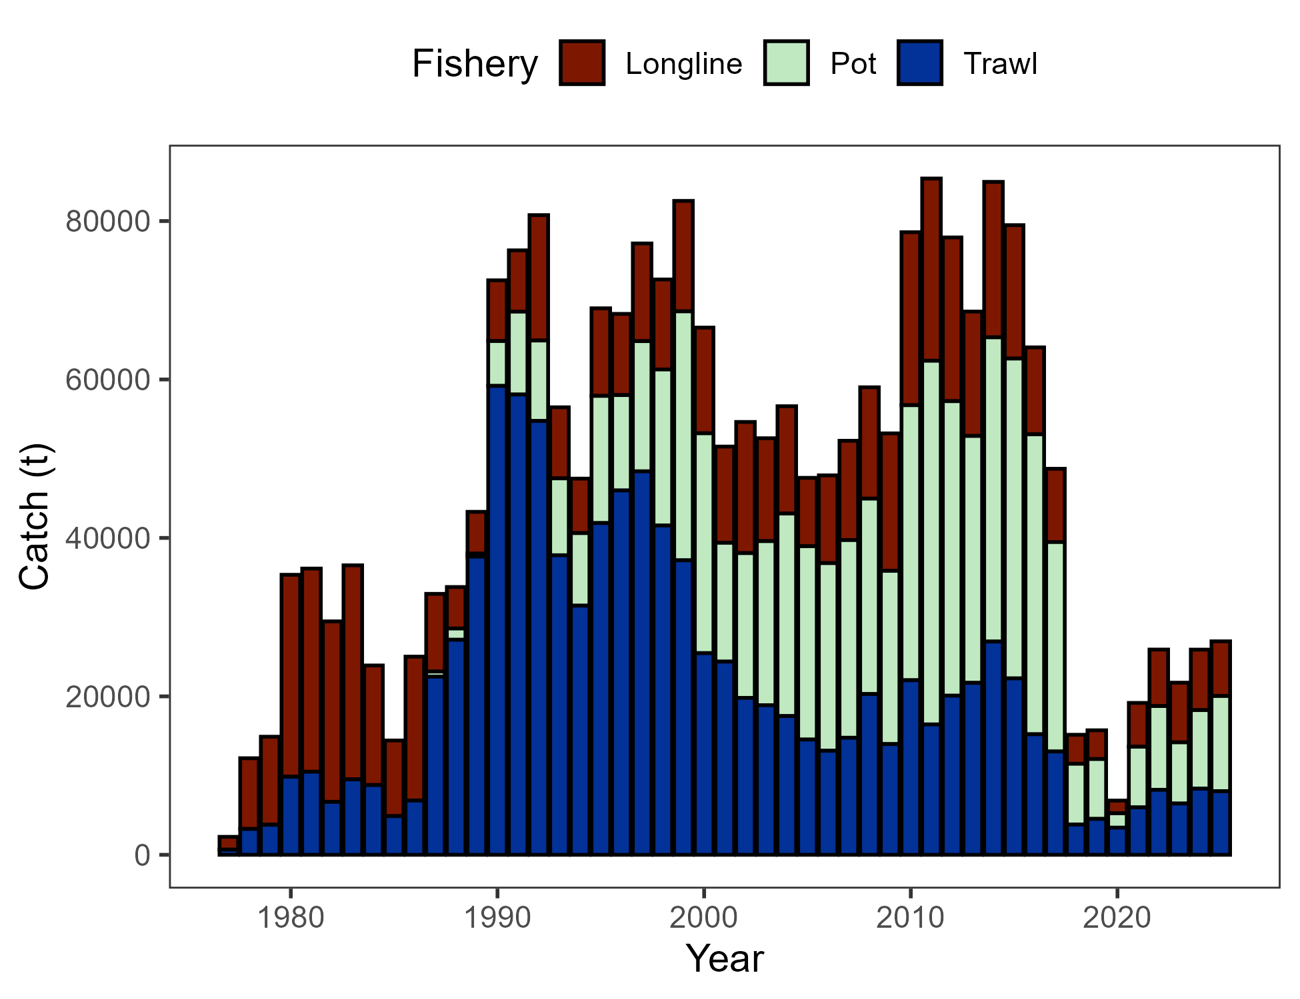

Figure 2.1. Commercial catch (mt) of Pacific cod in the GOA in trawl (FshTrawl), longline (FshLL), and pot (FshPot) gear from 1977-2025. Note that 2025 catch was through December 8.

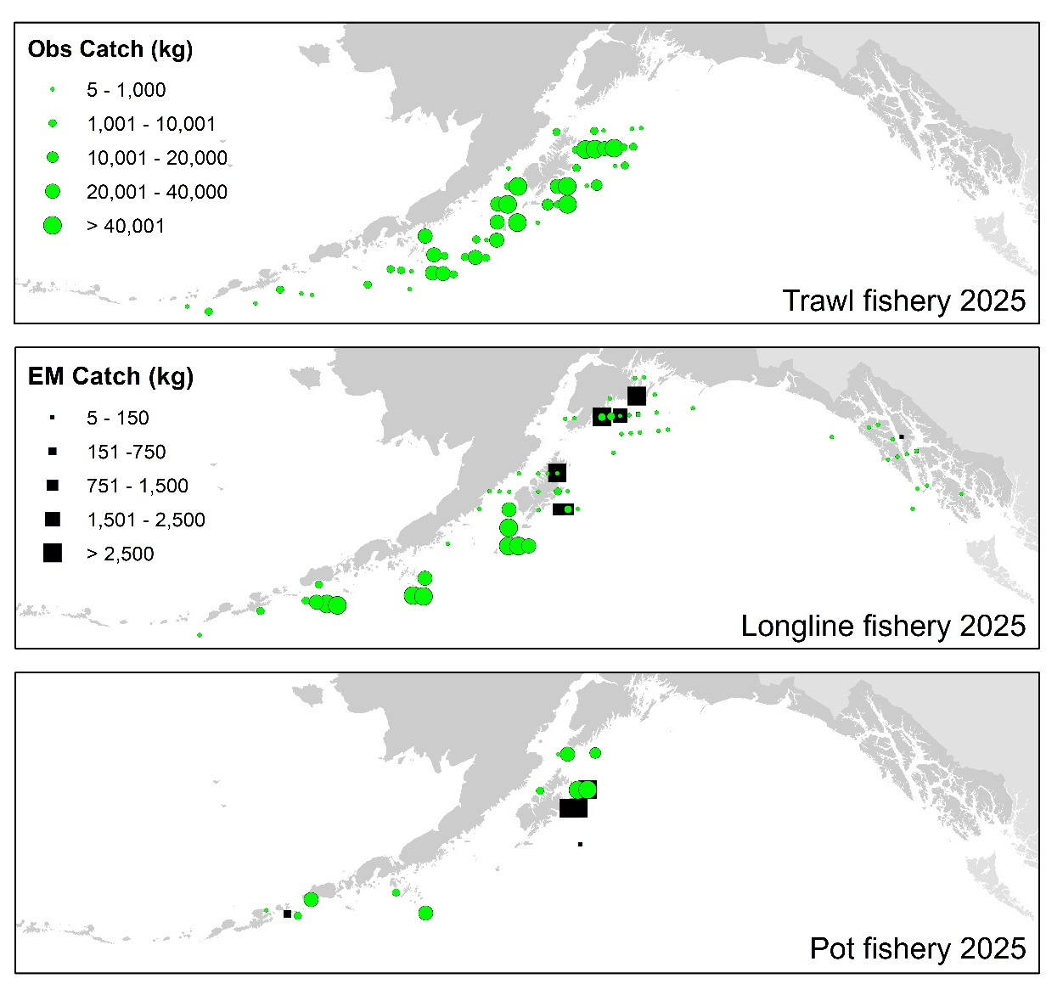

Figure 2.2. Observed (Obs) and electronic monitored (EM) commercial catch of Pacific cod in the GOA by 20 km² grid for 2025. These data include bycatch Pacific cod, but do not include trawl EM data as locations are not yet available.

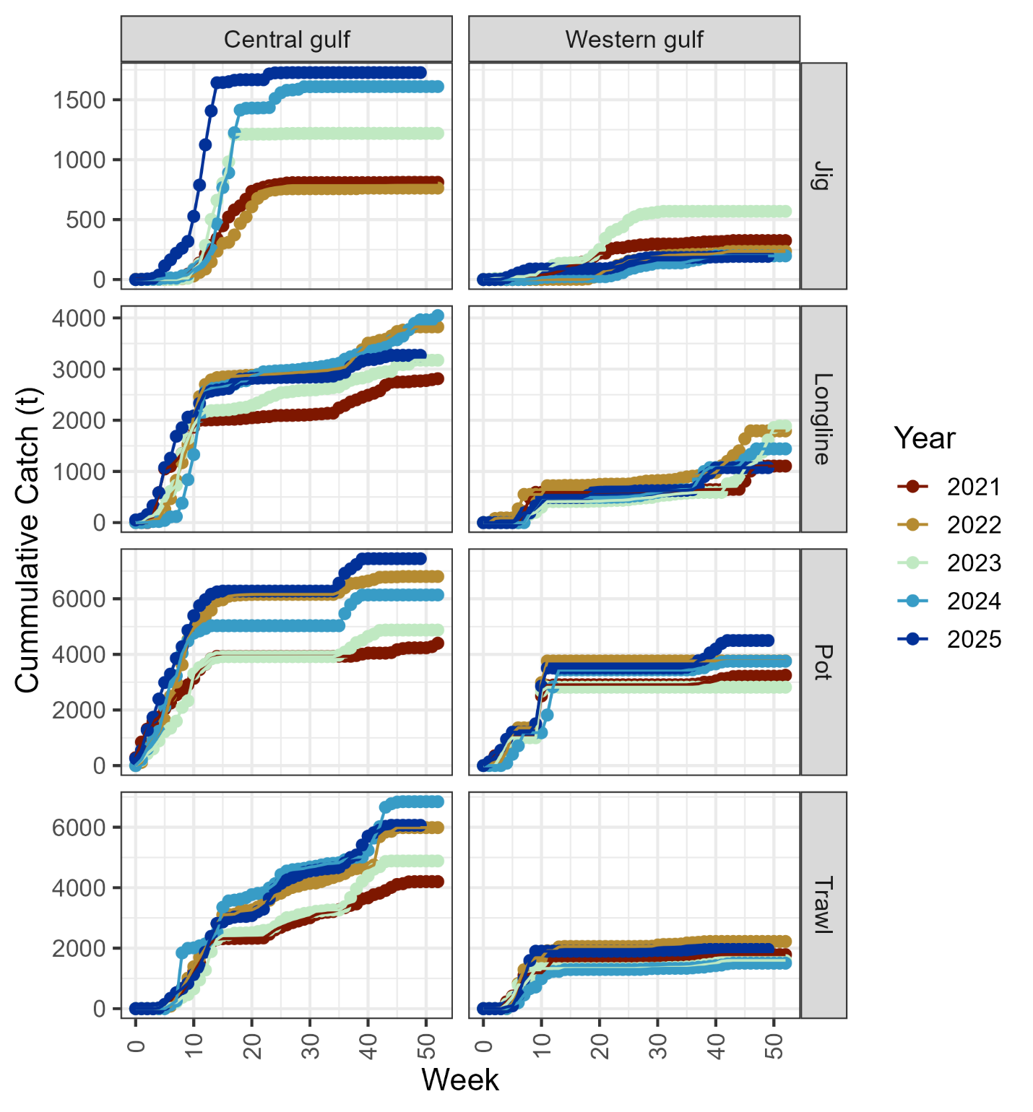

Figure 2.3. Cumulative catch week of the year for 2021-2025 by GOA sub-area and fleet (2025 catch through December 8). Note that for the assessment, data from the jig and longline gear were pooled into a distinct fishery.

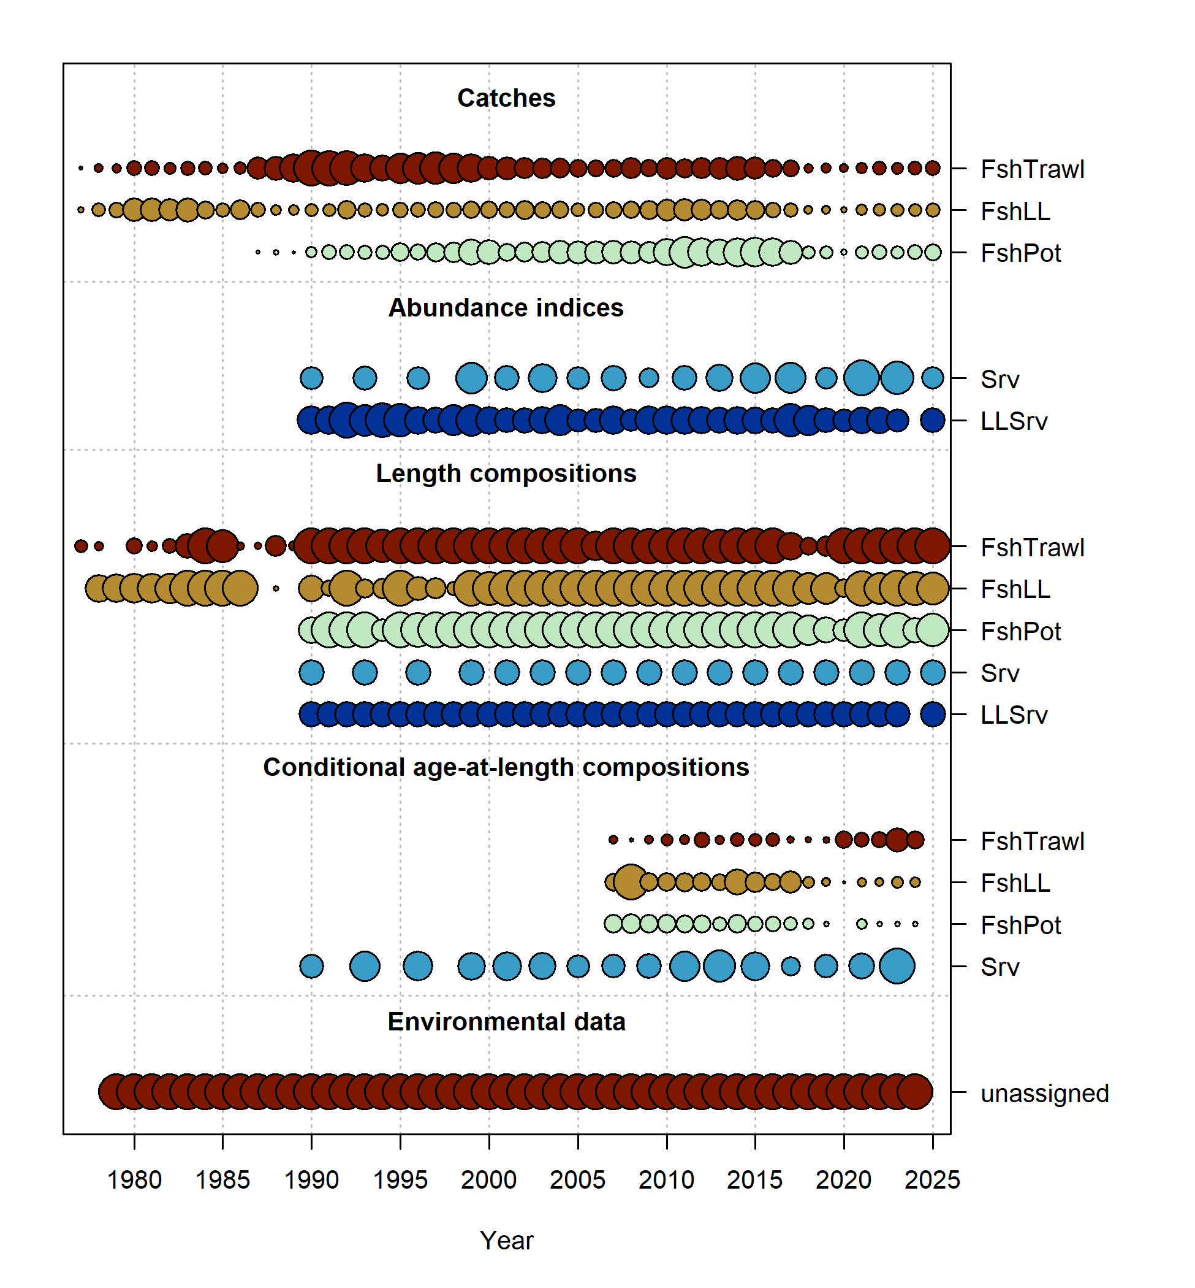

Figure 2.4. Data fit in Model 24.0. Circles are proportional to total catch for catches, precision for indices and input sample size for compositions and length-at-age observations. Data sources include fishery data from trawl (FshTrawl), longline (FshLL), and pot (FshPot) fisheries. Survey data include the AFSC longline (LLSrv) and bottom trawl (Srv) surveys. Note that since the circles are scaled relative to maximum within each type, the plots of scaling across dataset types should not be compared.

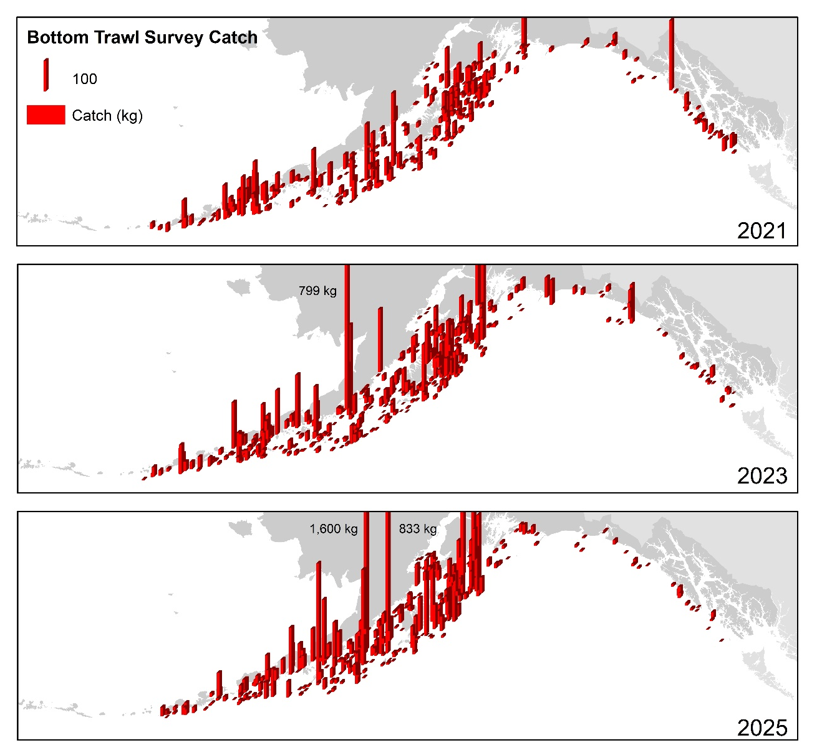

Figure 2.5. Distribution of AFSC bottom trawl survey catch (kg) of Pacific cod for 2021-2025.

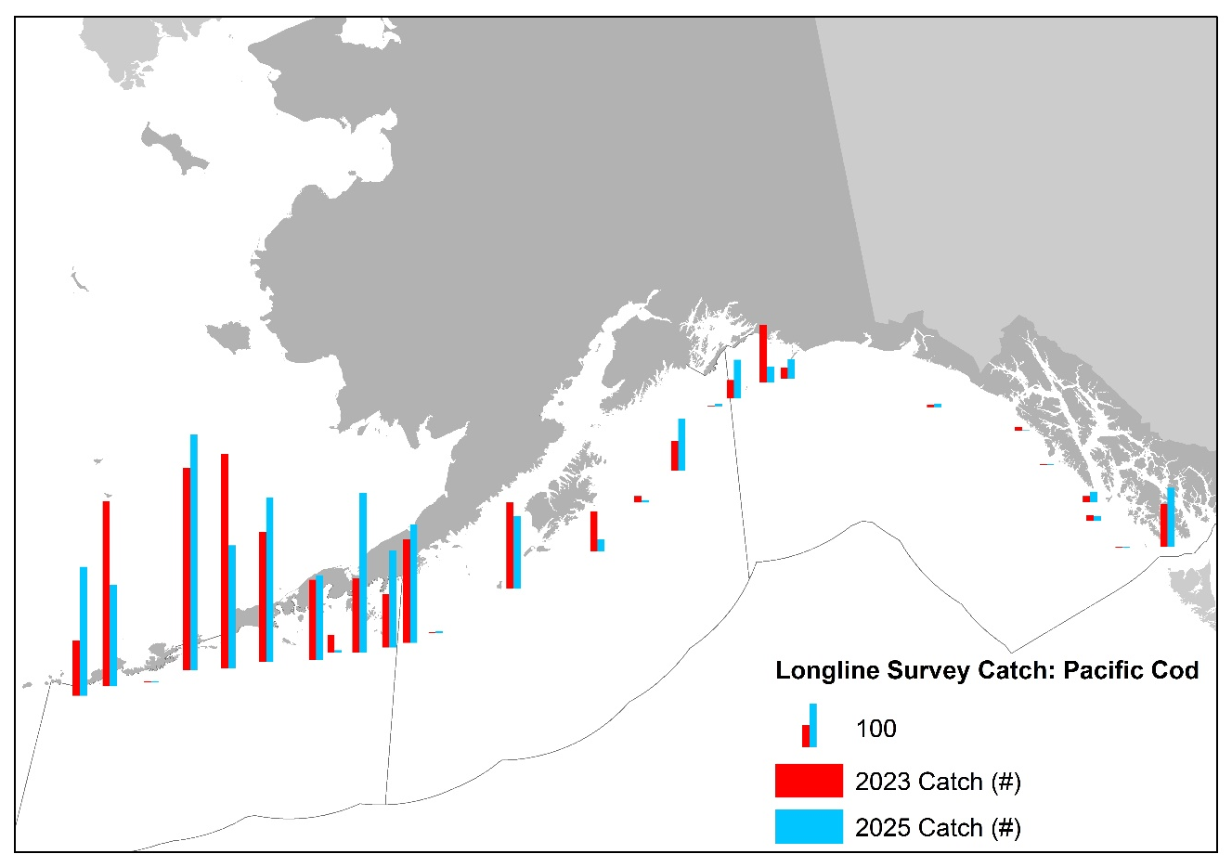

Figure 2.6. Distribution of AFSC longline survey catch (numbers) of Pacific cod in 2023 and 2025.

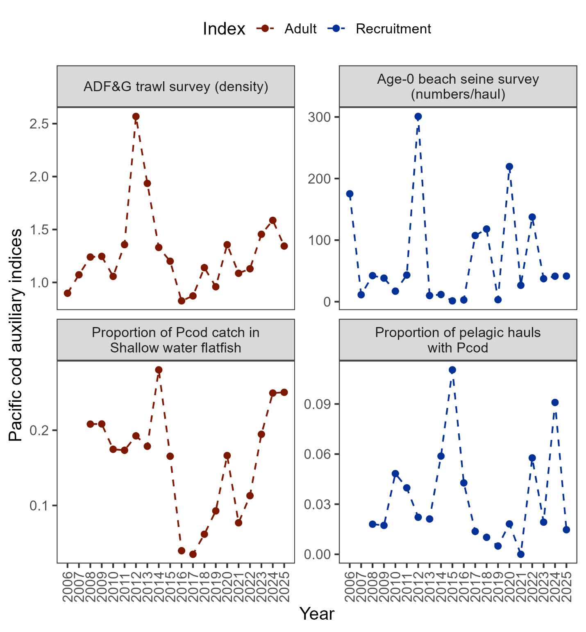

Figure 2.7. Auxiliary indices for GOA Pacific cod adult and recruitment abundance that are not used in the stock assessment model. ADFG bottom trawl survey delta-glm density (top left panel) and proportion of Pacific cod bycatch in the GOA shallow water flatfish fishery (bottom left panel) representing indices for adult abundance, and age-0 beach seine survey numbers per haul (top right panel) and proportion of pelagic trawls in the Central GOA A Season (January-April) walleye pollock fishery with Pacific cod present (bottom right panel) representing indices for recruitment.

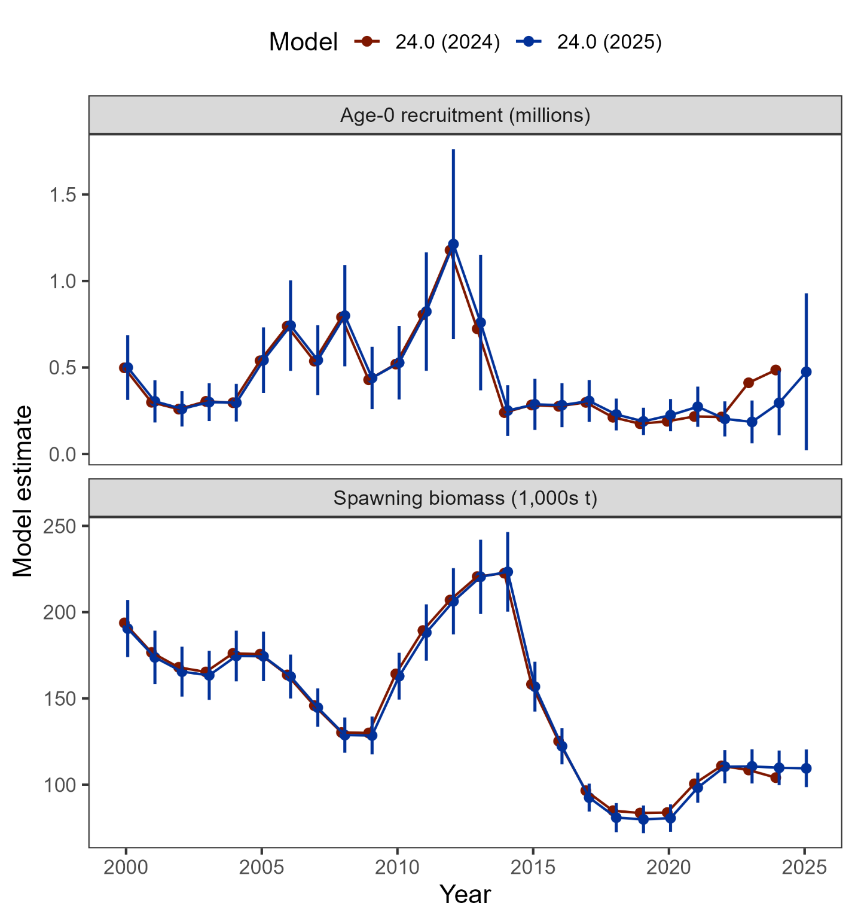

Figure 2.8. Comparison of post-2000 recruitment and spawning biomass estimated from Model 24.0 as applied in 2024 and with updated data in 2025 (including 95% confidence intervals).

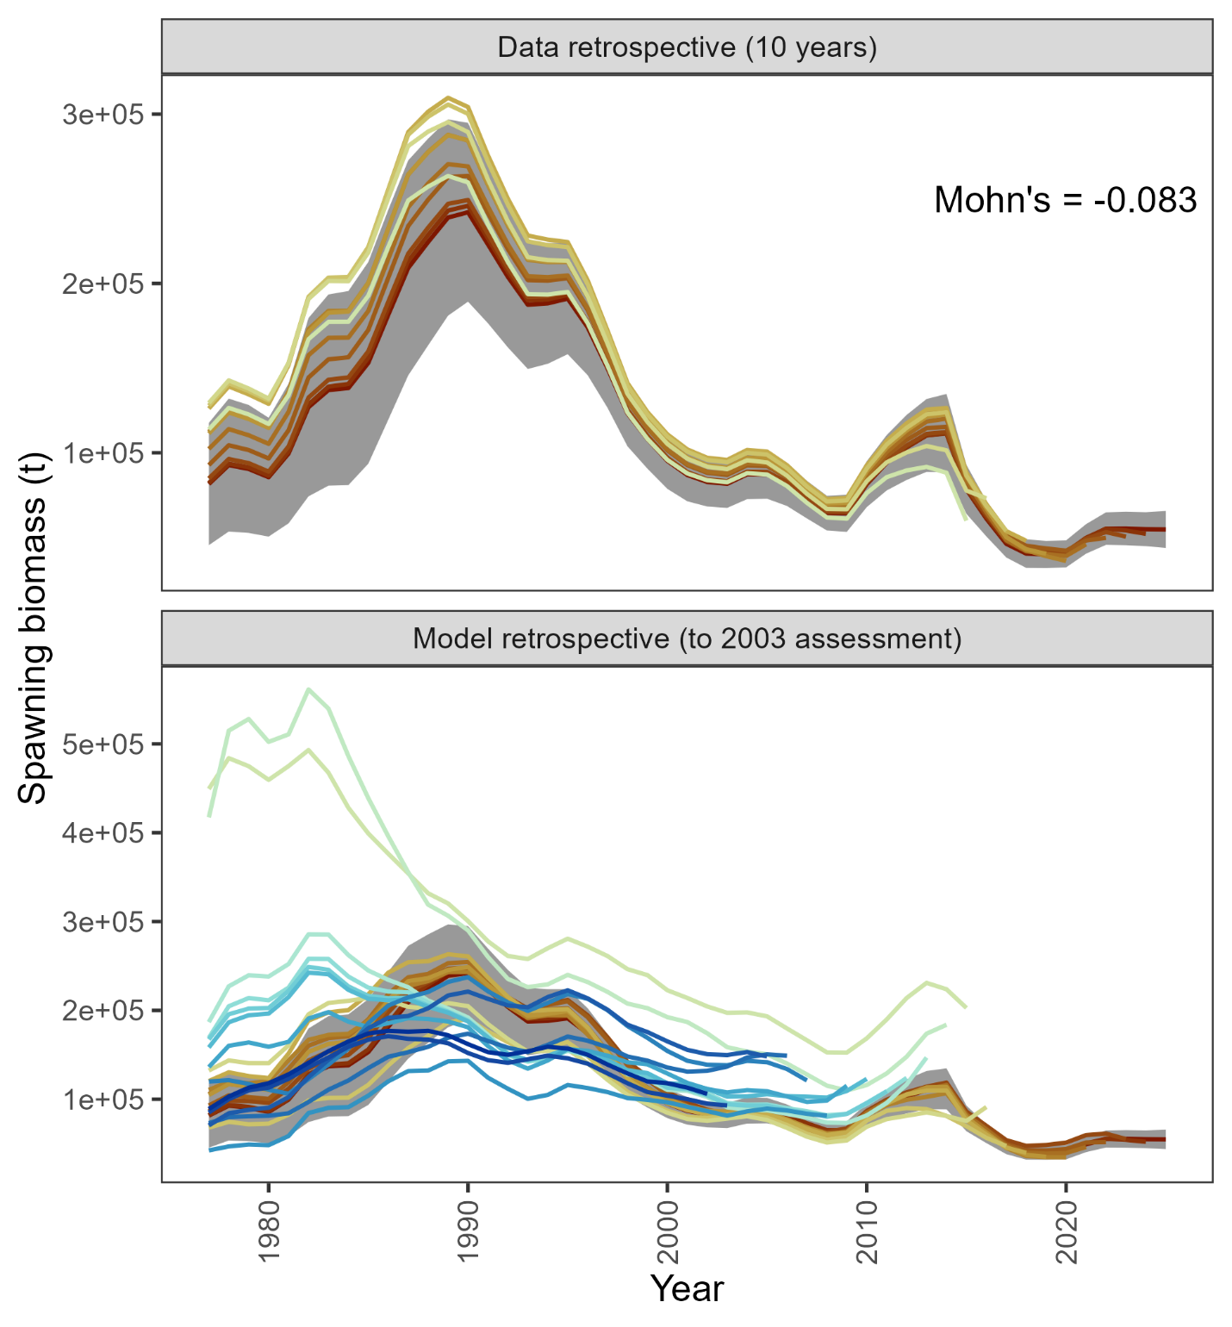

Figure 2.9. Retrospective analysis of spawning biomass upon removing data from Model 24.0 (top panel) and in comparison to previously accepted models (bottom panel). The shaded region is the 95% confidence intervals from Model 24.0.

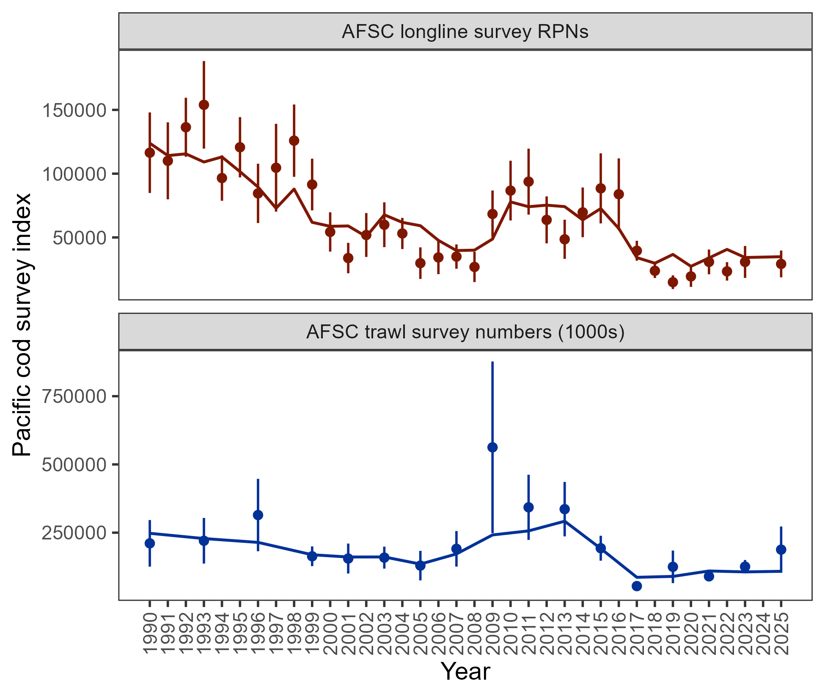

Figure 2.10. Population indices fit by the assessment model, including AFSC longline survey relative population numbers (RPN – top panel) and AFSC bottom trawl survey abundance (numbers – bottom panel). Model fit is shown as a solid line and observed data is shown as points (with error bars indicating the 95% confidence intervals).

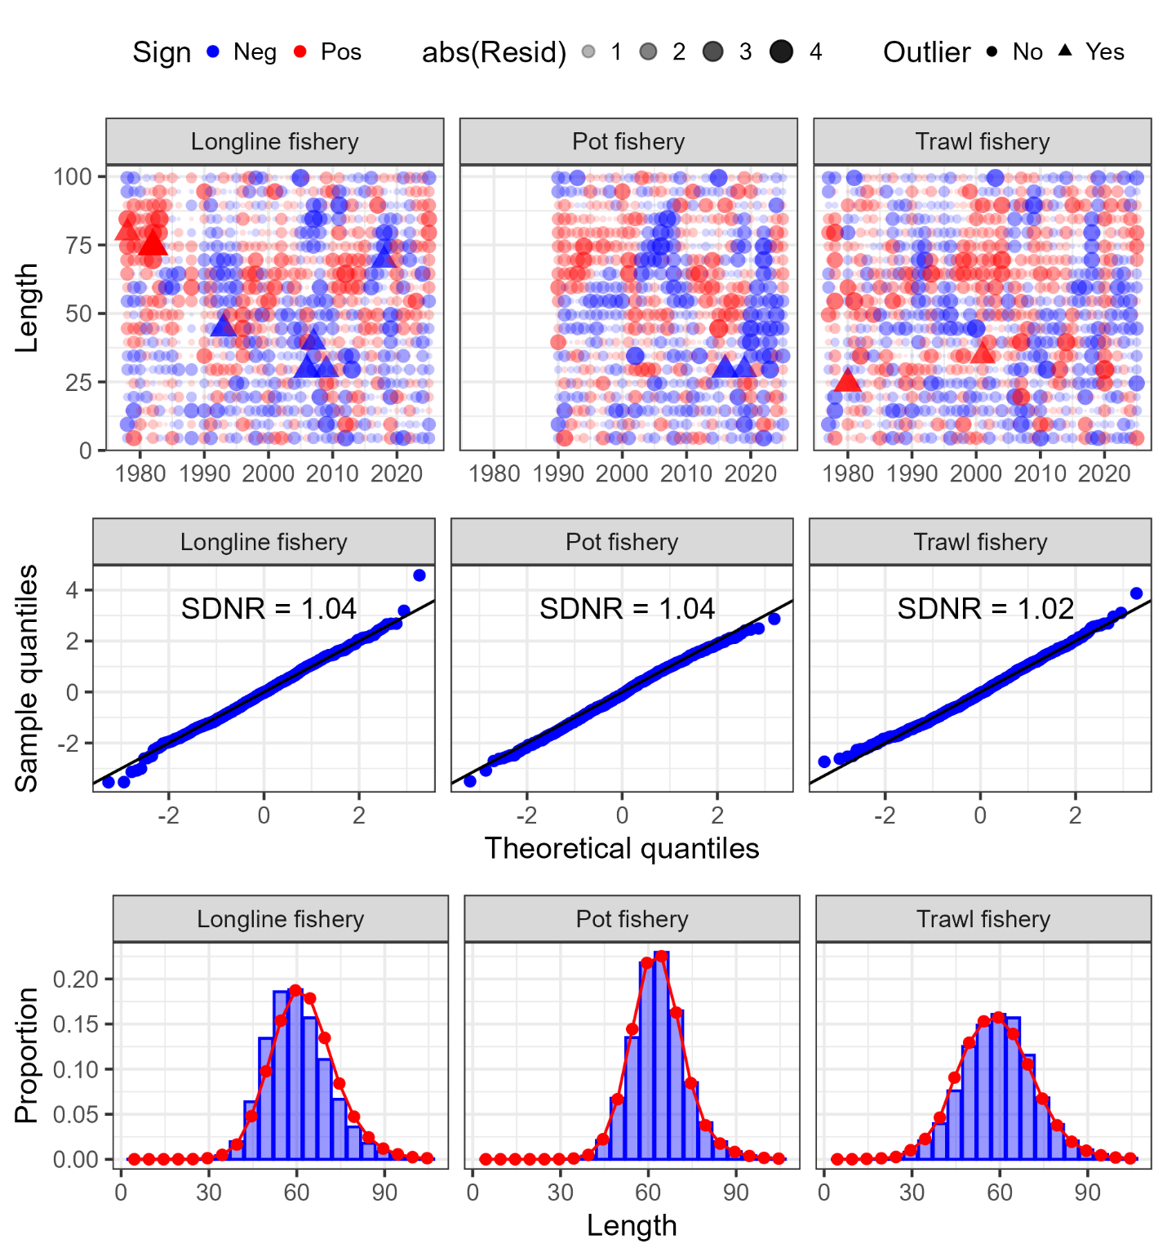

Figure 2.11. One-step ahead residuals (top panels), theoretical versus sample quantiles (middle panels), and aggregated model fit (bottom panels) for the fishery length composition data (fleets shown across the columns) fit in the author’s recommended model.

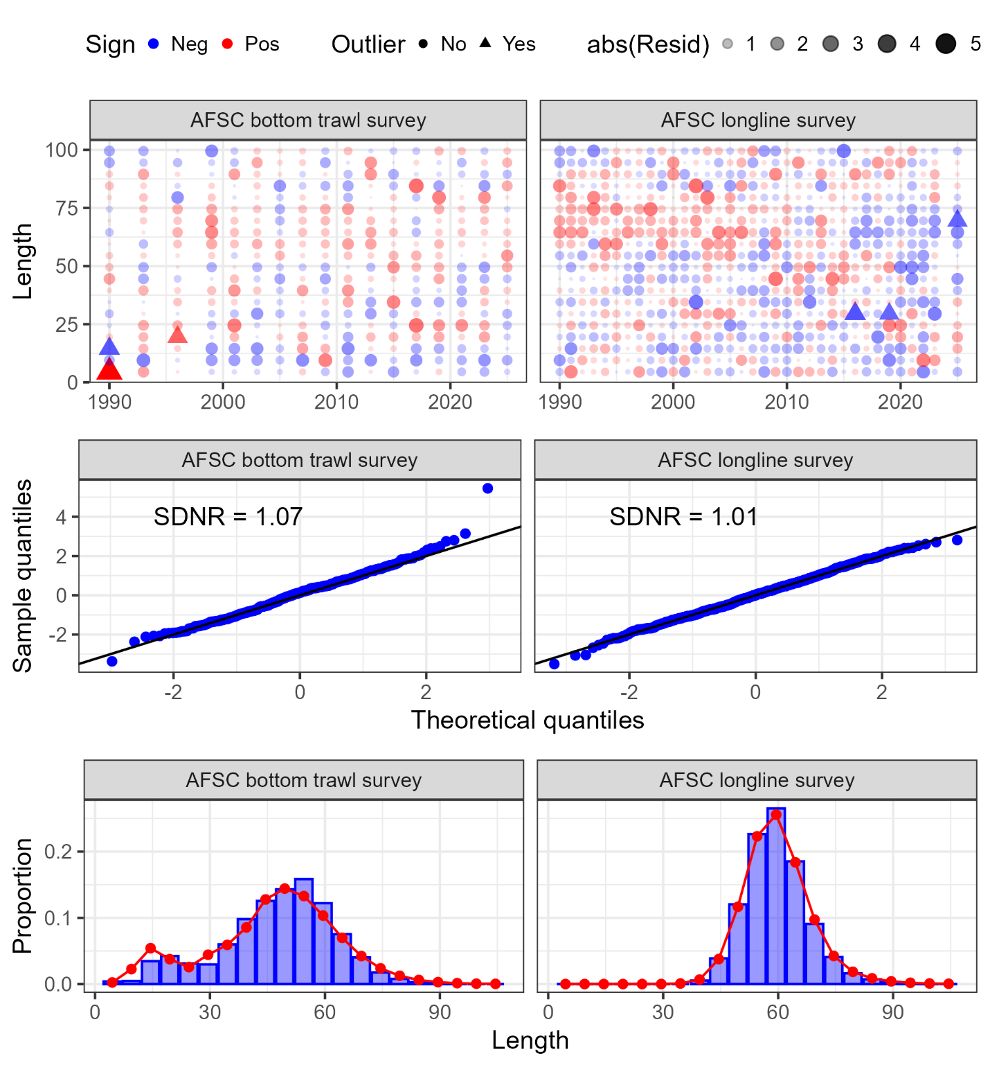

Figure 2.12. One-step ahead residuals (top panels), theoretical versus sample quantiles (middle panels), and aggregated model fit (bottom panels) for the survey length composition data (surveys shown across the columns) fit in the author’s recommended model.

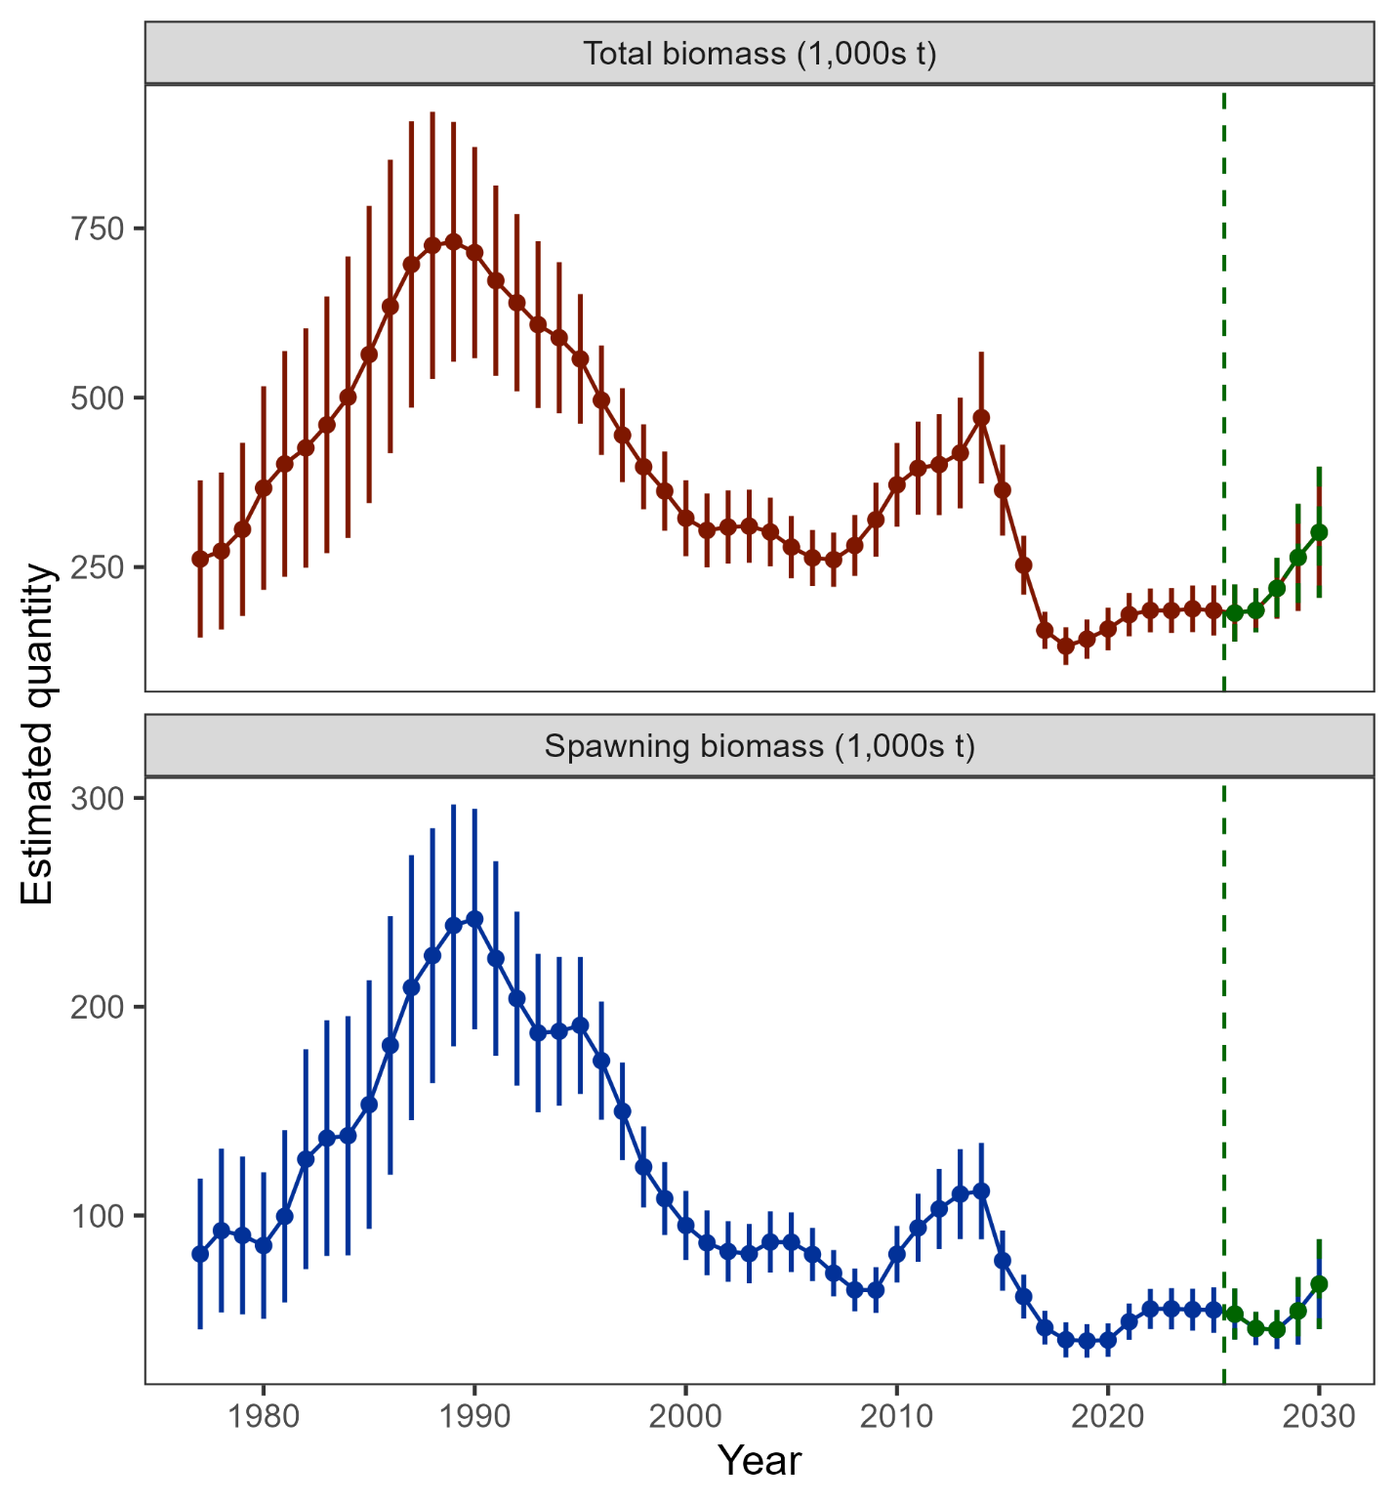

Figure 2.13. Estimated total biomass (top panel) and spawning biomass (bottom panel) from the author’s recommended model with 95% confidence intervals. The five-year forecasted biomass values are denoted in green shading and with the vertical dashed line in each plot.

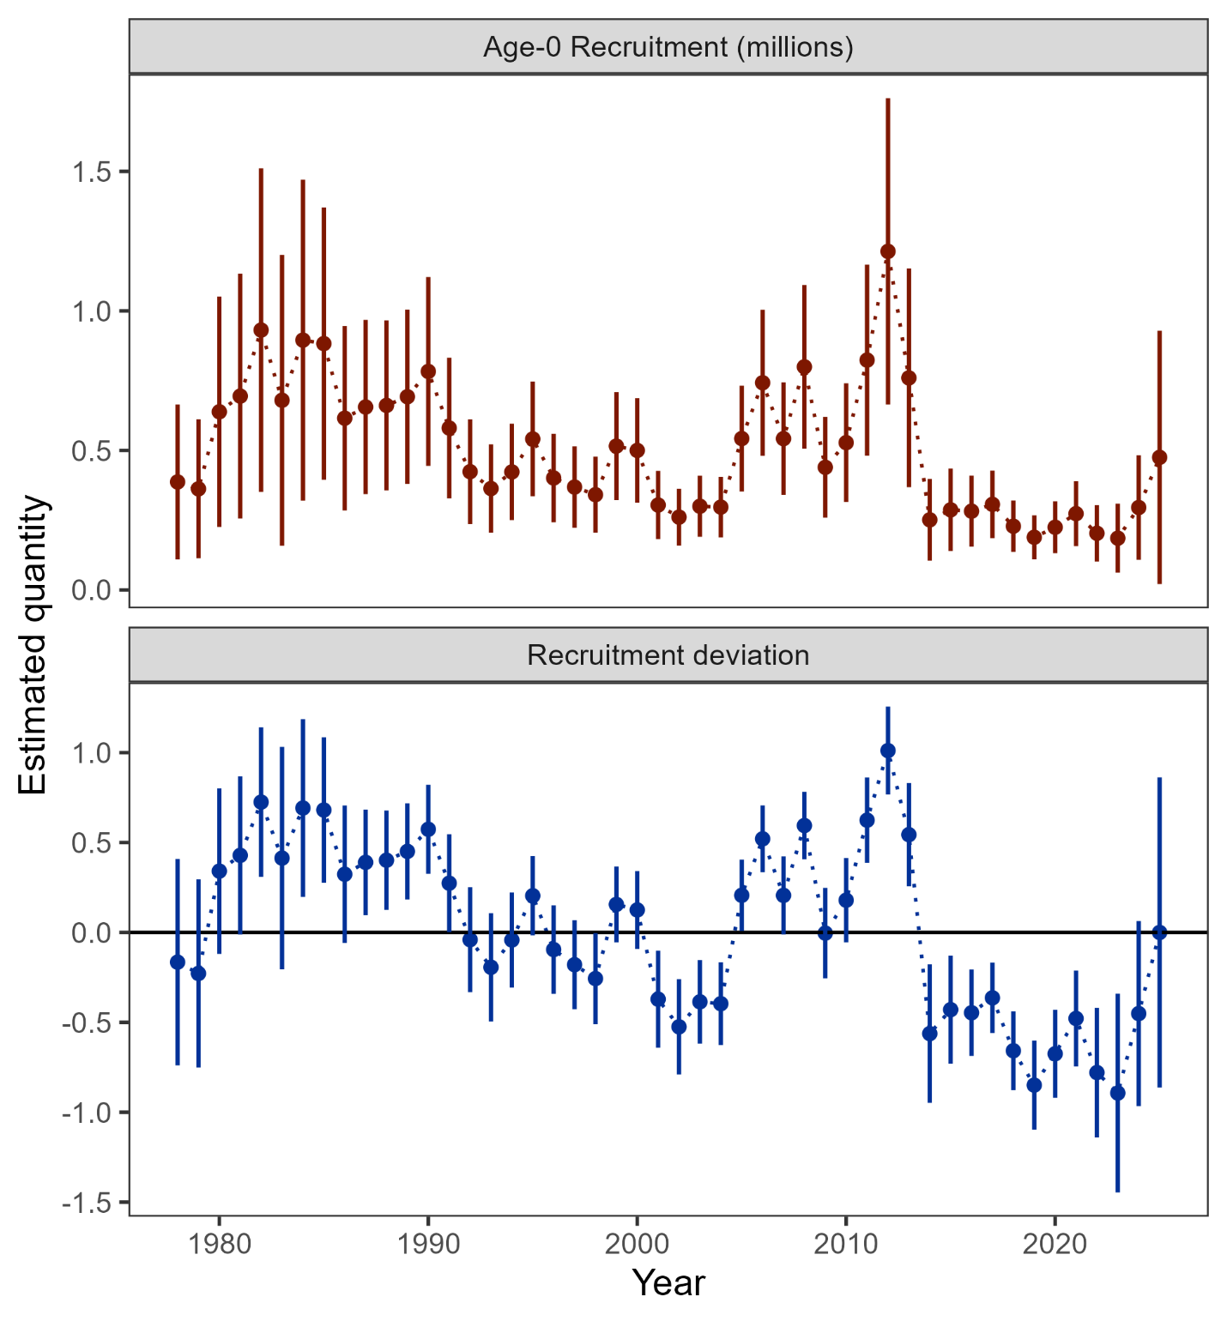

Figure 2.14. Age-0 recruitment (top panel) and log recruitment deviations (bottom panel) with 95% confidence intervals from the author’s recommended model.

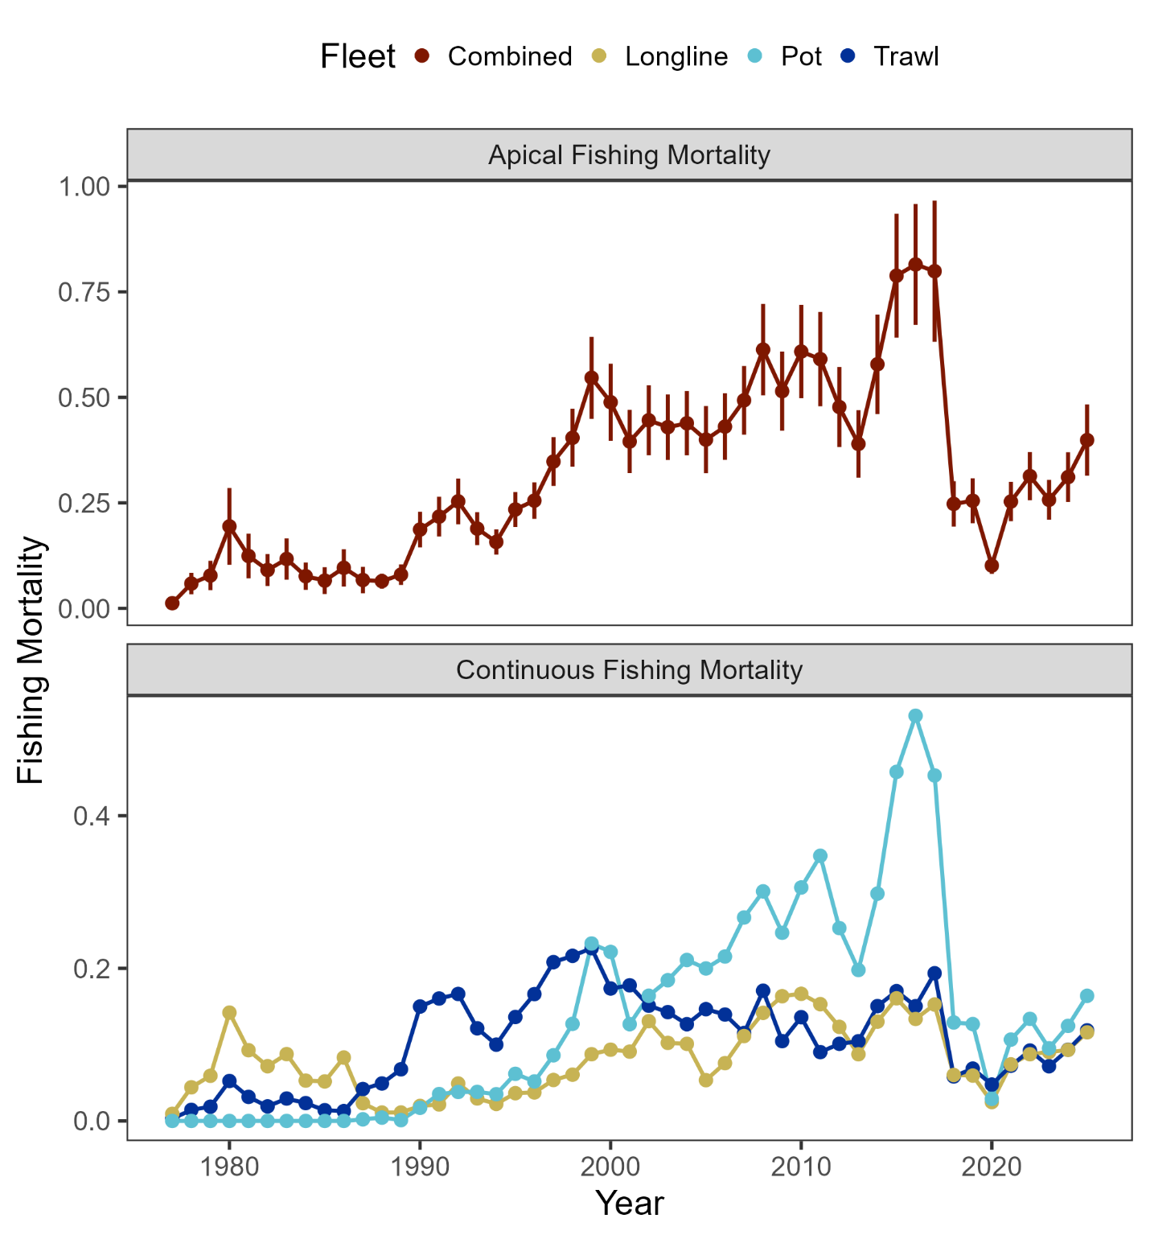

Figure 2.15. Sum of apical fishing mortality (top) and continuos fishing mortality by fisheries (bottom).

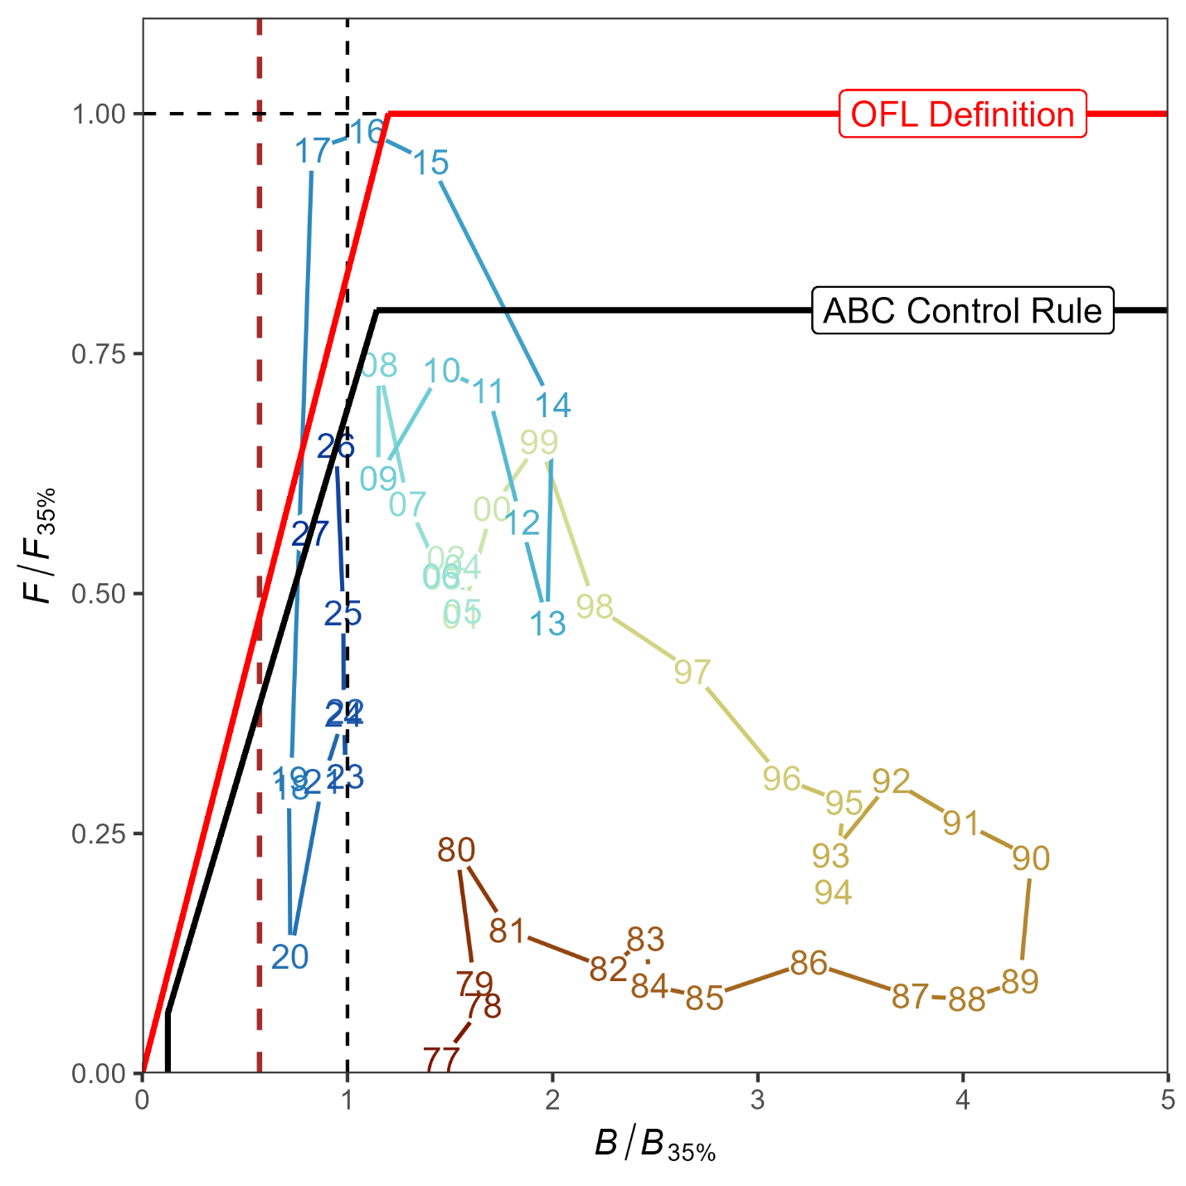

Figure 2.16. Ratio of historical F/F_{35%} versus female spawning biomass relative to B_{35%} for GOA pacific cod, 1977-2027. The Fs presented are the sum of the full Fs across fleets. Dashed vertical red line is at B_{20%}, Steller sea lion closure rule for GOA Pacific cod.

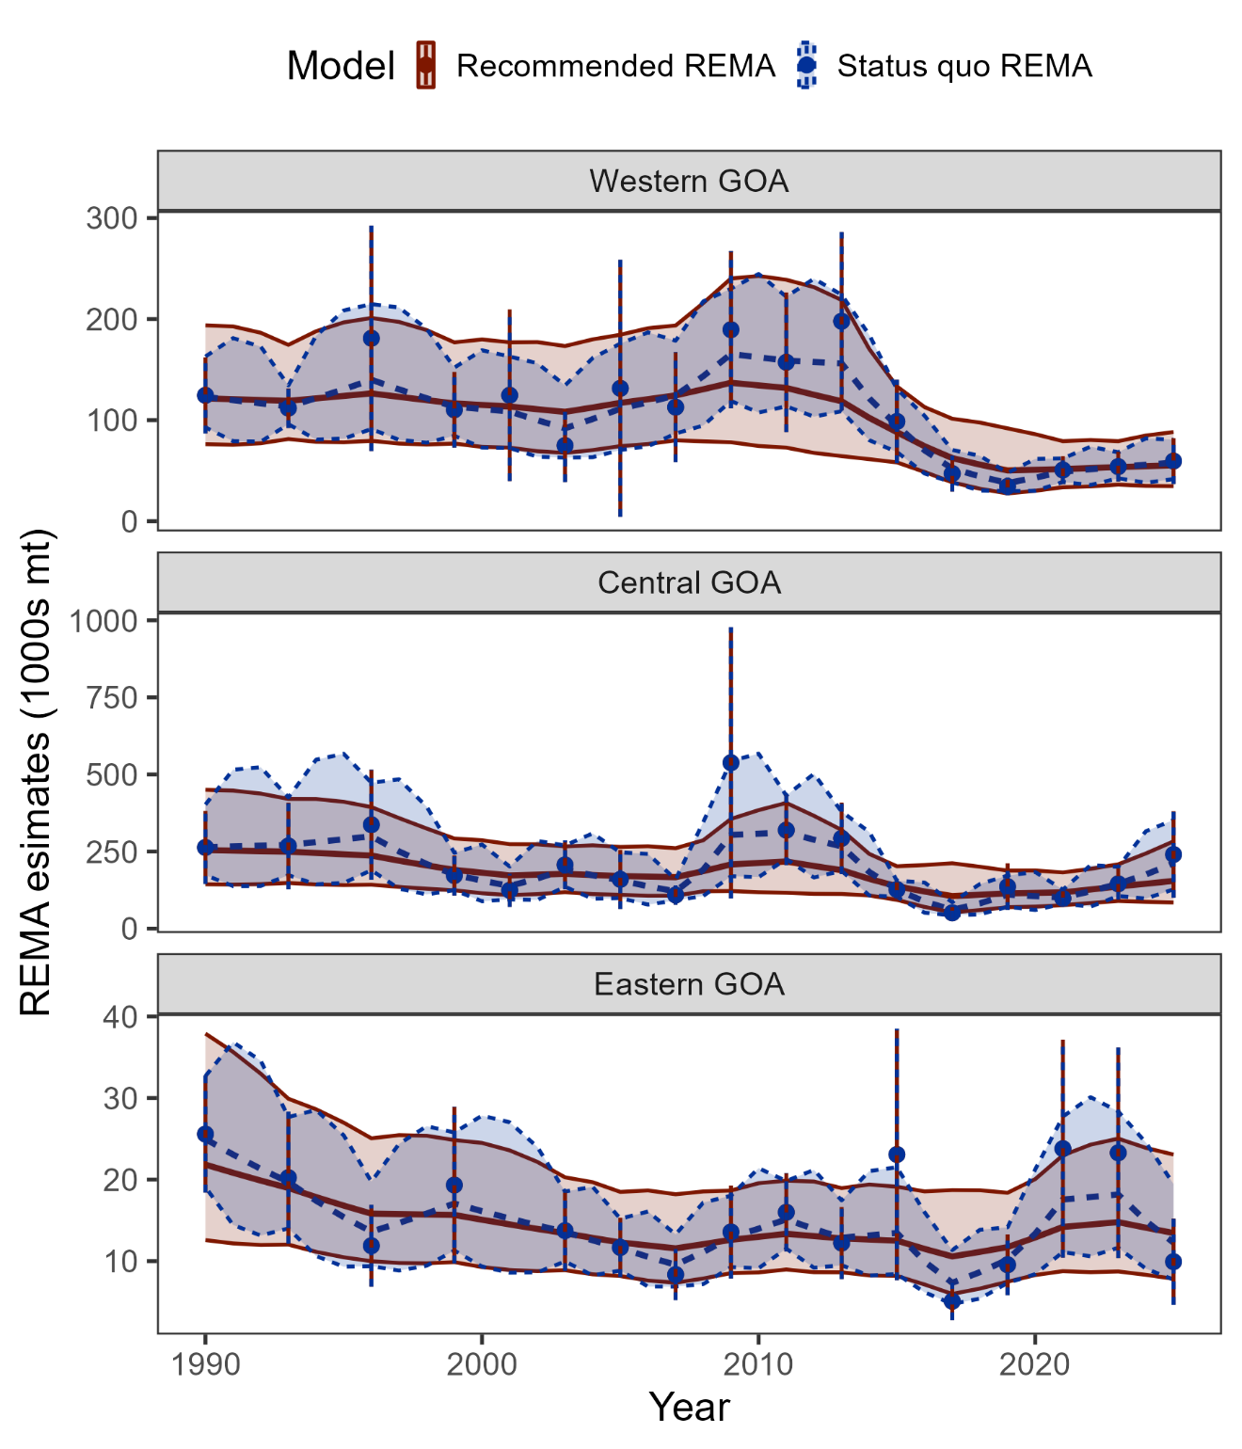

Figure 2.17. Recommended and status quo REMA results as fit to the AFSC bottom trawl survey by area.

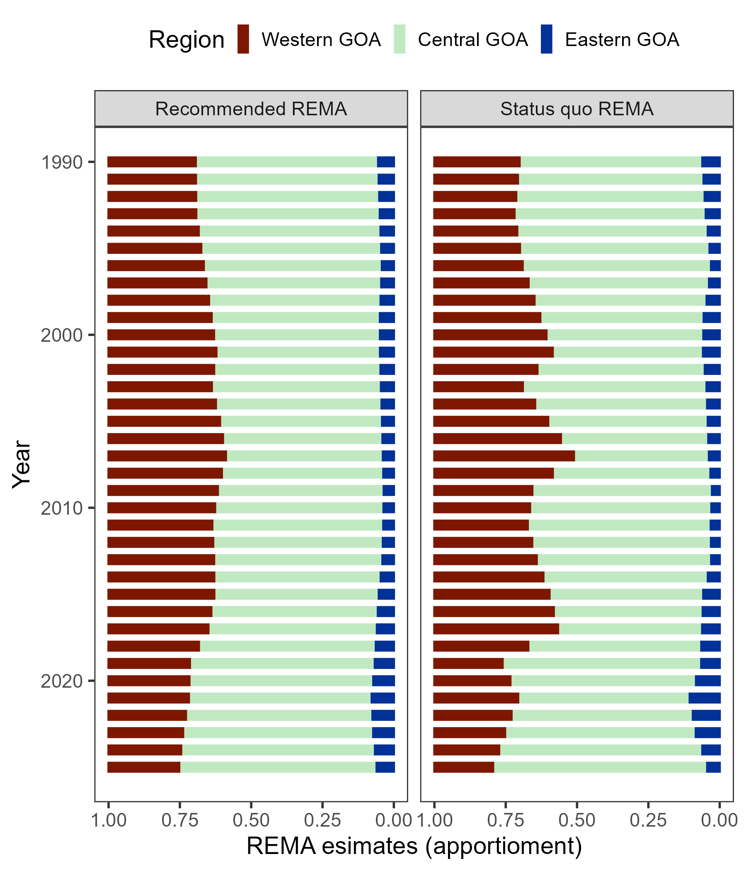

Figure 2.18. Recommended and status quo REMA apportionment results.

Appendix 2.1 Ecosystem and Socioeconomic Profile of the Pacific cod stock in the Gulf of Alaska - Report Card
The ESP can be found at this link.

Appendix 2.2 Analysis of the Gulf of Alaska Bottom Trawl survey restratification for Pacific cod
Pete Hulson, Zack Oyafuso, and Stan Kotwicki

Executive Summary
In 2025, the Alaska Fisheries Science Center’s (AFSC) Gulf of Alaska (GOA) bottom trawl survey transitioned to a new stratified random design. The survey design from 1990-2023 consisted of 59 strata defined by INPFC management area, depth, and general habitat type (shelf, gully, and slope). The development of a new survey design started in 2019 and has undergone extensive simulation evaluation (Oyafuso et al. 2021, 2022) and review by management bodies (e.g., NPFMC Groundfish Plan Team and SSC) prior to implementation in 2025. This new survey design was implemented to increase sampling efficiency while maintaining unbiased estimates of population indices and composition data that are used within stock assessments conducted by the AFSC. The new survey design now consists of 28 strata defined by NMFS management area and depth.
In this appendix we compared the historical bottom trawl survey’s time-series of design-based estimates of biomass and abundance to what the estimates could have been had historical stations been post-stratified under the new survey design. We use GOA Pacific cod as an example species because it is well sampled and consistently distributed across the continental shelf of the GOA. We find that the historical indices of biomass and abundance are remarkably similar when post-stratified under the new survey design. We conclude that the new survey design of the GOA bottom trawl survey provides consistent estimates with the historical time-series of important indices in both magnitude and trend. Furthermore, the 2025 estimates of biomass and abundance for Pacific cod under the new survey design follow and continue the recent trends observed in the population. We emphasize that the new survey design maintains a robust time-series of indices provided by the GOA bottom trawl survey that are based upon unbiased sampling designs and provide our best information available to understand population trends for stocks assessed within the GOA.

Data
Data used in this analysis included historical haul-level area-swept CPUE (in kg per km² for biomass estimation and in numbers per km² for abundance estimation) from the AFSC GOA bottom trawl survey. The time-series of the surveys investigated were triennially from 1990-1999, then biennially from 2001-2023.

Analytic Approach
To assess how the restratified survey design might have impacted historical biomass and abundance indices for GOA Pacific cod, we employed a two-step reanalysis. First, historical hauls were spatially reassigned to the strata under the new survey design. Second, we utilized the “survey” R package (Lumley 2024) to re-calculate total survey biomass/abundance and associated variances using post-stratified weights to correctly account for differences in stratum inclusion probabilities of the post-stratified stations. We recalculated total survey biomass and abundance across the GOA-wide region as well as GOA management subregions (Western, Central, and Eastern GOA).

Results
Reanalysis of the historical GOA bottom trawl survey time-series reveals high consistency between the original time-series and the original time-series post-stratified under the new design (Figures 2.2.1 and 2.2.2). GOA-wide biomass and abundance estimates (Figure 2.2.1) align most closely during periods of lower magnitude (e.g., 1990–2007 and 2015–2023), with minor divergence occurring during peak years (2009–2013), though given the high overlap in the 95% confidence intervals, these divergences do not appear to be statistically meaningful. Since 2015, the two time-series have been nearly indistinguishable. The 2025 indices under the new design continue the established historical trends in both magnitude and direction.
The consistencies between the two time-series also persist at the subregional scale (Figure 2.2.2). With the exception of some slight divergences in the point estimates in the Western GOA (1996, 2009), Central GOA (2009) and the Eastern GOA (1990, 2015), the subregional indices were also very similar between the original and post-stratified time series. Furthermore, in the cases of these years with slight divergences, the high overlap in their 95% confidence intervals suggest these differences are not statistically meaningful. The 2025 Eastern GOA index, while lower than recent years, remains within the historical range of biomass estimates in this subregion.
The remarkable consistency observed in well-sampled stocks like Pacific cod demonstrates that the new design continues an unbiased design for the GOA bottom trawl survey and is functioning as intended. Mismatches between the original and post-stratified estimators are to be expected given the random nature of the sampling process. For species with inherently patchy distributions (e.g., rockfish), no stratification design can fully overcome inherent sampling variability that then translates through to survey indices. Furthermore, for such species, within a reanalysis of historical survey data like undertaken for Pacific cod it is statistically impossible to disentangle the effects of the restratified survey design from the natural variability and "zero-heavy" skewed catch data associated with their distributions.

Literature Cited
Lumley, T.. 2024. “survey: analysis of complex survey samples.” R package version 4.4.
Oyafuso, Z. S., L. A. K. Barnett, and S. Kotwicki. 2021. Incorporating spatiotemporal variability in multispecies survey design optimization addresses trade-offs in uncertainty. ICES Journal of Marine Science 78, 1288–1300.
Oyafuso, Z., L. A. K. Barnett, M. Siple, and S. Kotwicki. 2022. A flexible approach to optimizing the Gulf of Alaska groundfish bottom trawl survey design for abundance estimation. NOAA technical memorandum NMFS-AFSC ; 434.

Figures

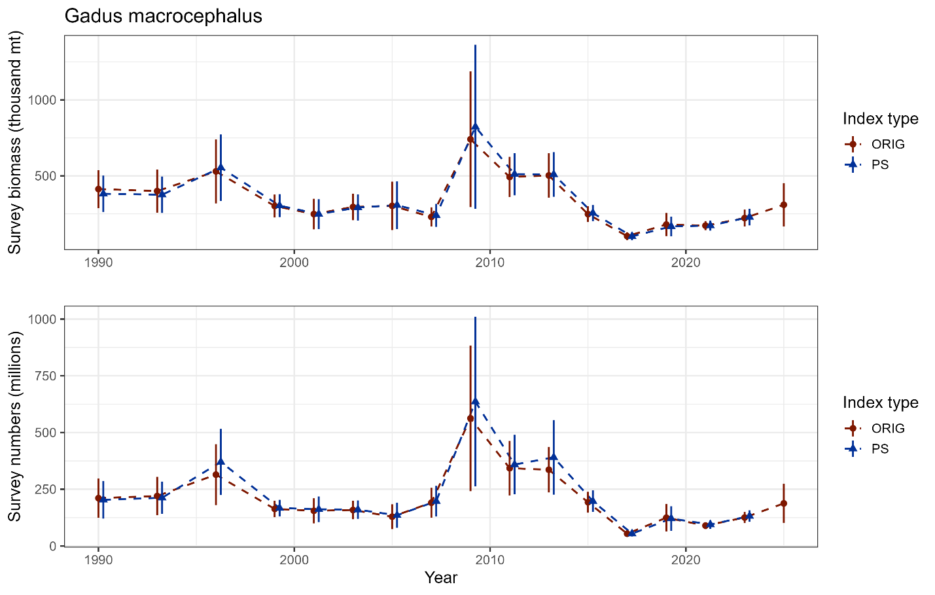

Figure 2.2.1. GOA bottom trawl survey population indices for Pacific cod from the original design-based estimates (ORIG) and the reanalyzed design-based estimates (PS) under the new survey design.

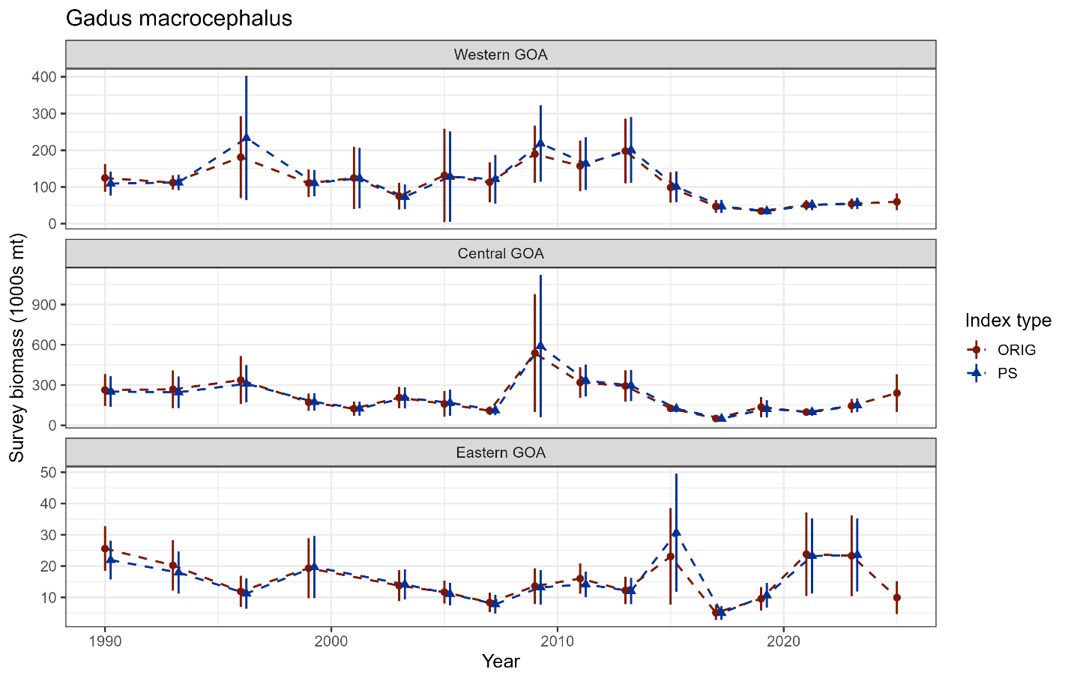

Figure 2.2.2. GOA subregion bottom trawl survey biomass indices for Pacific cod from the original design-based estimates (ORIG) and the reanalyzed design-based estimates (PS) under the new survey design.

