A comparison of analytical and bootstrap variance estimates for AFSC longline survey Relative Population Numbers/Weights

Jane Sullivan, Cara Rodgveller, Kevin Siwicke

Summary

Methods for calculating Relative Population Numbers/Weights (RPNs/RPWs) from the AFSC longline survey effort data have changed over time and multiple versions now exist. In particular, variance estimation was added in 2016, though methods were never fully documented or implemented in the longline production database. Here we apply a bootstrap variance method to compare with the existing analytical method. The motivation for this study was to (1) generate transparency and confidence in the variance estimation methods prior to implementation, and (2) test the assumption that the 5% fixed coefficient of variation that was assumed for sablefish prior to 2016 was based on a bootstrap analysis (Hanselman et al. 2017). We found no substantial differences between the analytical and bootstrap variance methods, and this result was consistent across species and FMP subareas. We recommend the analytical method, because it is more computationally efficient than the bootstrap method. Finally, we recommend reconciling the multiple versions of the RPN code that exist and rewriting the variance code prior to implementing it in the database.

Background

Relative indices of abundance from the annual AFSC longline survey are crucial inputs to sablefish and slope rockfish stock assessments and apportionment strategies. These indices, termed Relative Population Number (RPN) and Relative Population Weight (RPW), are catch per unit effort (CPUE) values scaled or weighted by area size. Specifically, the RPN is the number of fish caught per hachi (i.e. skate) weighted by the area size (km²) of a depth stratum within a geographic area. The secondary RPW index is the product of the RPN and the mean weight of fish collected within the corresponding depth stratum and geographic area. The mean weights are obtained by converting mean lengths to weights using allometric parameters stored in the longline database. The resultant RPN and RPW means and variances are summed over space as needed, usually to the FMP subarea area (e.g. Western, Central, and Eastern GOA), FMP (e.g. GOA/BSAI), or coastwide in the case of sablefish.

While the calculations described above appear simple and straightforward at first glance, assumptions related to the area size definitions, data processing, variance calculations, and methods to account for whale depredation on sablefish have been added or changed over time. For example, the original area sizes used to scale CPUE were determined using charts and a planimeter. Although these area sizes were recalculated in 2013 using GIS (Echave et al. 2013) and implemented in the sablefish assessment’s RPN calculations in 2016 (Hanselman et al. 2017), they were never updated in the longline database. Along with new area sizes, Hanselman et al. (2017) added new variance estimates and a novel whale correction factor to account for whale depredation of sablefish. Consequently, the RPN/RPW values stored in the longline database and hosted by AKFIN do not match the values presented in the SAFE documents or used in stock assessments. Additionally, several versions of the script files used to generate these indices now exist. To our knowledge, these include the following:
- The sablefish script: this file was developed by Dana Hanselman and is sourced when generating the .dat file for the sablefish stock assessment. It includes the most up to date method for incorporating whale depredation into the calculation of the RPN/RPW mean and variance. It is our assumption this file also uses the new area sizes developed by Katy Echave in 2013.
- The rockfish/PT script: this was the original file given to the author by Kevin Siwicke in fall of 2020. It is the one used for rockfish assessments/apportionment and Plan Team presentations. It includes the new area sizes and variance estimation code written by Dana Hanselman in 2016. Additionally, it includes whale correction factor code, but it has not been determined yet what exact methods differ between the rockfish/PT script and the sablefish script.
- The database script: this code populates the database and what is hosted on AKFIN Answers. This script uses old area sizes, does not estimate variance, and does not account for whale depredation. We also anticipate that this code may have different filtering, extrapolating, or other data processing methods that have yet to be uncovered.

The ultimate goal is to merge these scripts such that the most current and relevant methods are being used in the database script. One of the key components of this exercise is to document, validate, and implement the RPN/RPW variance code. During the initial review of the variance code in the rockfish/PT script in November 2020, the authors found this code difficult to follow and understand. In a subsequent review, further documentation of the variance method and transition to new area sizes was found in the 2016 sablefish SAFE (page 26; Hanselman et al. 2017). In this document, the authors found that the analytical variance method (i.e. what is currently in the rockfish/PT script) closely matched the fixed 5% CV assumed for sablefish RPNs in previous assessments. They stated that the fixed 5% CV was based on a bootstrap analysis, but we found no record of this past bootstrap analysis. Because of the difficulty in interpreting the existing analytical variance code and a collective desire for transparency in the RPN variance methodology, we developed bootstrap variance estimates to compare these to the existing analytical methods. As part of the process, we provide a summary of the two methods and recommendations for a path forward.

Methods

Due to the alternate sampling of the BS/AI, we limited variance method comparisons to the GOA and present results by FMP subarea. We used sablefish, shortraker rockfish, rougheye rockfish, and shortspine thornyhead as example species, though results for other species (e.g. Pacific cod, Greenland turbot, or Pacific halibut) can be provided upon request. All mean and analytical variance results were taken from the rockfish/PT script. As such, sablefish RPN/RPWs do not include the whale correction factor and will not match what is used in the sablefish stock assessment. Similar to the rockfish/PT script, we used the new area sizes.

Several important assumptions from the analytical variance method were adopted in the bootstrap analysis. The first is that variances were calculated using all available data within a geographic area, regardless of whether depth strata were later filtered or extrapolated for the final RPN/RPW estimates. This means that the mean RPN associated with the analytical and bootstrap methods do not match the mean RPNs that are ultimately reported. The underlying assumption is that the coefficient of variation ($CV$) of an RPN in a geographic area is the same regardless of which strata is used. Additionally, the RPN’s $CV$ was assumed to be the same for the associated RPW. Any uncertainty in mean length due to low sample sizes within a stratum or in the underlying allometric relationship is not accounted for in the RPW variance estimate. The sensitivity of estimates to these assumptions have not been tested.

The second key assumption borrowed from the analytical method is implied in the definition of a CPUE observation. The CPUE ($\hat{θ}$) is defined as the number of fish per skate by station ($i$), depth strata ($j$), and geographic area ($k$):
${\hat{θ}}_{ijk}=\frac{{n_fish}_{i,j,k}}{{n_hachi}_{i,j,k}}$.
Because stations are usually fished across several depth strata, the number of observations from a single station is equal to the number of depth strata that were fished. Stations within a depth strata and geographic area receive equal weight, regardless of the number of hachis fished in a given stratum. Under this configuration, the mean and variance are calculated among stations within a depth stratum and geographic area for both variance methods. This makes sample sizes low compared to the hypothetical alternative in which the observation occurs at the hachi level.

Finally, the analytical method accounts for the covariance between station mean CPUEs from other depth strata within a geographic area. While the bootstrap method does not explicitly do this, it mimics this additional source of variability by bootstrapping within the geographic area. Both methods assume independence among geographic areas, and therefore the variances were summed in order to obtain variances at the FMP subarea or FMP level.

All analyses were conducted using the open source software R version 4.0.4 (R Core Team 2021). The existing RPN/RPW scripts used in the database and for stock assessments relies on the data processing R library plyr (Wickham 2011). Any script files developed for the present analysis use the data processing library dplyr (Wickham et al. 2021). Note that plyr and dplyr have numerous common functions, which may cause conflicts if the scripts are run in the same session.

Analytical variance estimates

For a single species, the mean CPUE of a given depth stratum and geographic area is the arithmetic mean of the station CPUE observation
$E\left[{\overline{θ}}_{j,k}\right]=\sum_{i}{\frac{{\hat{θ}}_{i,j,k}}{n_{j,k}}}$,
where $n_{jk}$is the number of station-level CPUE observations within the depth stratum and geographic area. The associated sample variance of station CPUE by depth strata and geographic area is defined as
$\hat{V}\left[{\overline{θ}}_{j,k}\right]=\frac{s^{2}({\hat{θ}}_{i,j,k})}{n_{j,k}}$.
The mean RPN of a given depth stratum and geographic area is the product of the arithmetic mean of the station CPUE observation and the area size ($w_{jk}$):
$$E\left[{\overline{ψ}}_{j,k}\right]=\sum_{i}{\frac{{\hat{θ}}_{i,j,k}w_{j,k}}{n_{j,k}}}$$
As previously described, each station observation within a depth stratum receives equal weight, regardless of the number of hachis observed in the stratum. While the covariance among hachis within a station and stratum is not explicitly accounted for, the covariance between stratum station mean CPUEs (${\hat{θ}}_{i,j,k})$that share station-level data (i.e. stations that span multiple strata) is calculated and added to the variance within a geographic area. For example, the covariance between depth stratum $j$ and neighboring depth stratum $m$ within geographic area $k$ is given by
$cov\left[{\overline{θ}}_{j,k}, {\overline{θ}}_{m,k}\right]= \frac{n_{j∩m,k}cov[\left\{{\hat{θ}}_{i,j,k}\right\}\left\{{\hat{θ}}_{i,m,k}\right\}]}{n_{j,k}n_{m,k}}$,
where $n_{j}$ and $n_{m}$ are the number of station-level CPUE observations within depth stratum $j$ and $m$, respectively. The total RPN variance of a geographic area is then the sum of the depth stratum variances and the covariance among stratum within the area:
$\hat{V}[{\hat{ψ}}_{k}]=\sum_{j}{w_{j,k}^{2}\hat{V}\left[{\overline{θ}}_{j,k}\right]}+2\sum_{j}{\sum_{m≠j}{cov\left[{\overline{θ}}_{j,k}, {\overline{θ}}_{m,k}\right]}}$.
The total RPN variance for a given region of interest $a$ (e.g. FMP subarea, FMP, or coastwide) is the sum of geographic area variances within $a$:
$\hat{V}\left[{\hat{ψ}}_{a}\right]=\sum_{k∈a}{\hat{V}[{\hat{ψ}}_{k}]}$.
The mean RPN of a geographic area is simply the sum of mean depth stratum RPNs within that area $E\left[{\overline{ψ}}_{k}\right]= \sum_{i}{E\left[{\overline{ψ}}_{i,k}\right]}$, which can be subsequently summed to any region of interest $E\left[{\overline{ψ}}_{a}\right]$. As previously described, this variance is converted to a $CV:$
${CV}_{k}=\frac{\sqrt{\hat{V}\left[{\hat{ψ}}_{k}\right]}}{E\left[{\overline{ψ}}_{k}\right]}.$
This $CV$ is used to obtain variance estimates for both RPNs and RPWs, which may be calculated using different data filtering processes. For example, most RPNs exclude certain depth strata, which is not accounted for in the variance calculations.

Bootstrap analysis

The bootstrap analysis followed an ordinary nonparametric (i.e. resampling) approach using the R library ‘boot’ (Canty and Ripley 2021; Davison and Hinkley 1997). When possible we adhered to the structure and assumptions inherent in the analytical variance method. These assumptions included: (1) the definition of an observation as the station CPUE within a depth stratum and area, and (2) that variances above the geographic area level are independent and therefore additive.

Each data set was defined as the number ($n$) of CPUE observations ($\hat{θ}$) within a geographic area ($k$), such that there was one observation for each station ($i$) and depth stratum ($j$) combination within the area $\left[{\hat{θ}}_{1},…{\hat{θ}}_{n}\right]$. A total of 500 bootstrap replicates ($B$) were run for each species and geographic area, though exploratory runs showed that 100 replicates would be sufficient. Each bootstrap replicate was comprised of a set of $n$ bootstrap samples ${[\hat{θ}}_{1}^{*}, …{\hat{θ}}_{n}^{*}]$ where each ${\hat{θ}}_{i,j,k}^{*}$ was a random sample with replacement from the original dataset. For each bootstrap replicate, the geographic area mean RPN was calculated as the sum of area-weighted CPUEs over all depth strata
$${E\left[{\overline{ψ}}_{k}\right]}^{*}=\sum_{j}{\sum_{i}{\frac{{\hat{θ}}_{i,j,k}^{*}w_{j,k}}{n_{j,k}^{*}}}}.$$
The estimate of the geographic mean RPN was calculated as the mean of the bootstrap replicates
$$E\left[{\overline{ψ}}_{k}\right]= \frac{1}{B}\sum_{B}{{E\left[{\overline{ψ}}_{k}\right]}^{*}},$$
and the associated bootstrap variance estimate was given by
$$\hat{V}\left[{\overline{ψ}}_{k}\right]= \frac{1}{B-1}\sum_{B}{{(E\left[{\overline{ψ}}_{k}\right]}^{*}-E\left[{\overline{ψ}}_{k}\right])}.$$
Following the same process used in the analytical variance method, this bootstrap variance was converted to a $CV$ and subsequently applied to both RPNs and RPWs.

Results

The bootstrap variance method yielded very similar results to the status quo analytical method. Results are shown as 95% confidence intervals, in a similar fashion to how they are presented to Plan Teams. We present comparisons for sablefish, shortspine thornyhead, shortraker rockfish, and rougheye rockfish by FMP subarea in the GOA. The confidence intervals between methods were consistently the same magnitude and trend regardless of FMP subarea or species (Figures 1 and 2). In general, we found the bootstrap confidence intervals to be slightly wider for sablefish and shortspine thornyhead and slightly narrower for shortraker and rougheye rockfish. Although the RPW assumes the same CV as the RPN in both methods, we present both because the indices have varying relevance by species.

Recommendations

As part of this project, the code for the analytical variance method was thoroughly reviewed and documented. Though cumbersome, the existing code functions as described in the 2016 SAFE summary of methods. Results from this analysis show that the analytical and bootstrap methods yield nearly identical results. This finding, coupled with the computational demand of the bootstrap, make the analytical method the preferred approach.

In the existing rockfish/PT script, no data filtering or extrapolations are executed prior to the variance calculations. Consequently, the variances are not directly linked to estimate of the mean RPN or RPW within a geographic area. Although the impact of this simplifying assumption has not been evaluated, this analysis should only happen once the status quo method is implemented in the database.

We recommend the following next steps on variance:
- Review the sablefish, database, and rockfish/PT scripts and identify differences between them. Using a version-controlled and up to date version of the database calcRPW script, create place holders for any different logic found in the sablefish or rockfish/PT script.
- Rewrite and annotate the variance/whale correction code
- Work with Rick to determine how best to incorporate the whale correction and variance methods into the database code, either as a separate R script or as new sections in the existing script.
- The new area sizes and whale correction factor code are part of the variance and should probably be implemented in the database at the same time.

References

Angelo Canty and Brian Ripley. 2021. boot: Bootstrap R (S-Plus) Functions. R package version 1.3-27.

Davison, A. C. & Hinkley, D. V. 1997. Bootstrap Methods and Their Applications. Cambridge University Press, Cambridge. ISBN 0-521-57391-2.

Echave, K., C. Rodgveller, and S. K. Shotwell. 2013. Calculation of the geographic sizes used to create population indices for the Alaska Fisheries Science Center longline survey. U.S. Dep. Commer., NOAA Tech. Memo. NMFS-AFSC-253, 93 p.

Hadley Wickham, Romain François, Lionel Henry and Kirill Müller (2021). dplyr: A Grammar of Data Manipulation. R package version 1.0.4. https://CRAN.R-project.org/package=dplyr

Hadley Wickham. 2011. The Split-Apply-Combine Strategy for Data Analysis. Journal of Statistical Software, 40(1), 1-29. URL http://www.jstatsoft.org/v40/i01/.

Hanselman, D. H., C. Lunsford, C. Rodgveller, and M. Peterson. 2017. Assessment of the sablefish stock in Alaska. In Stock assessment and fishery evaluation report for the groundfish resources of the GOA and BS/AI as projected for 2017. North Pacific Fishery Management Council, 605 W 4th Ave, Suite 306 Anchorage, AK 99501.

R Core Team (2021). R: A language and environment for statistical computing. R Foundation for Statistical Computing, Vienna, Austria. https://www.R-project.org/.

Figures
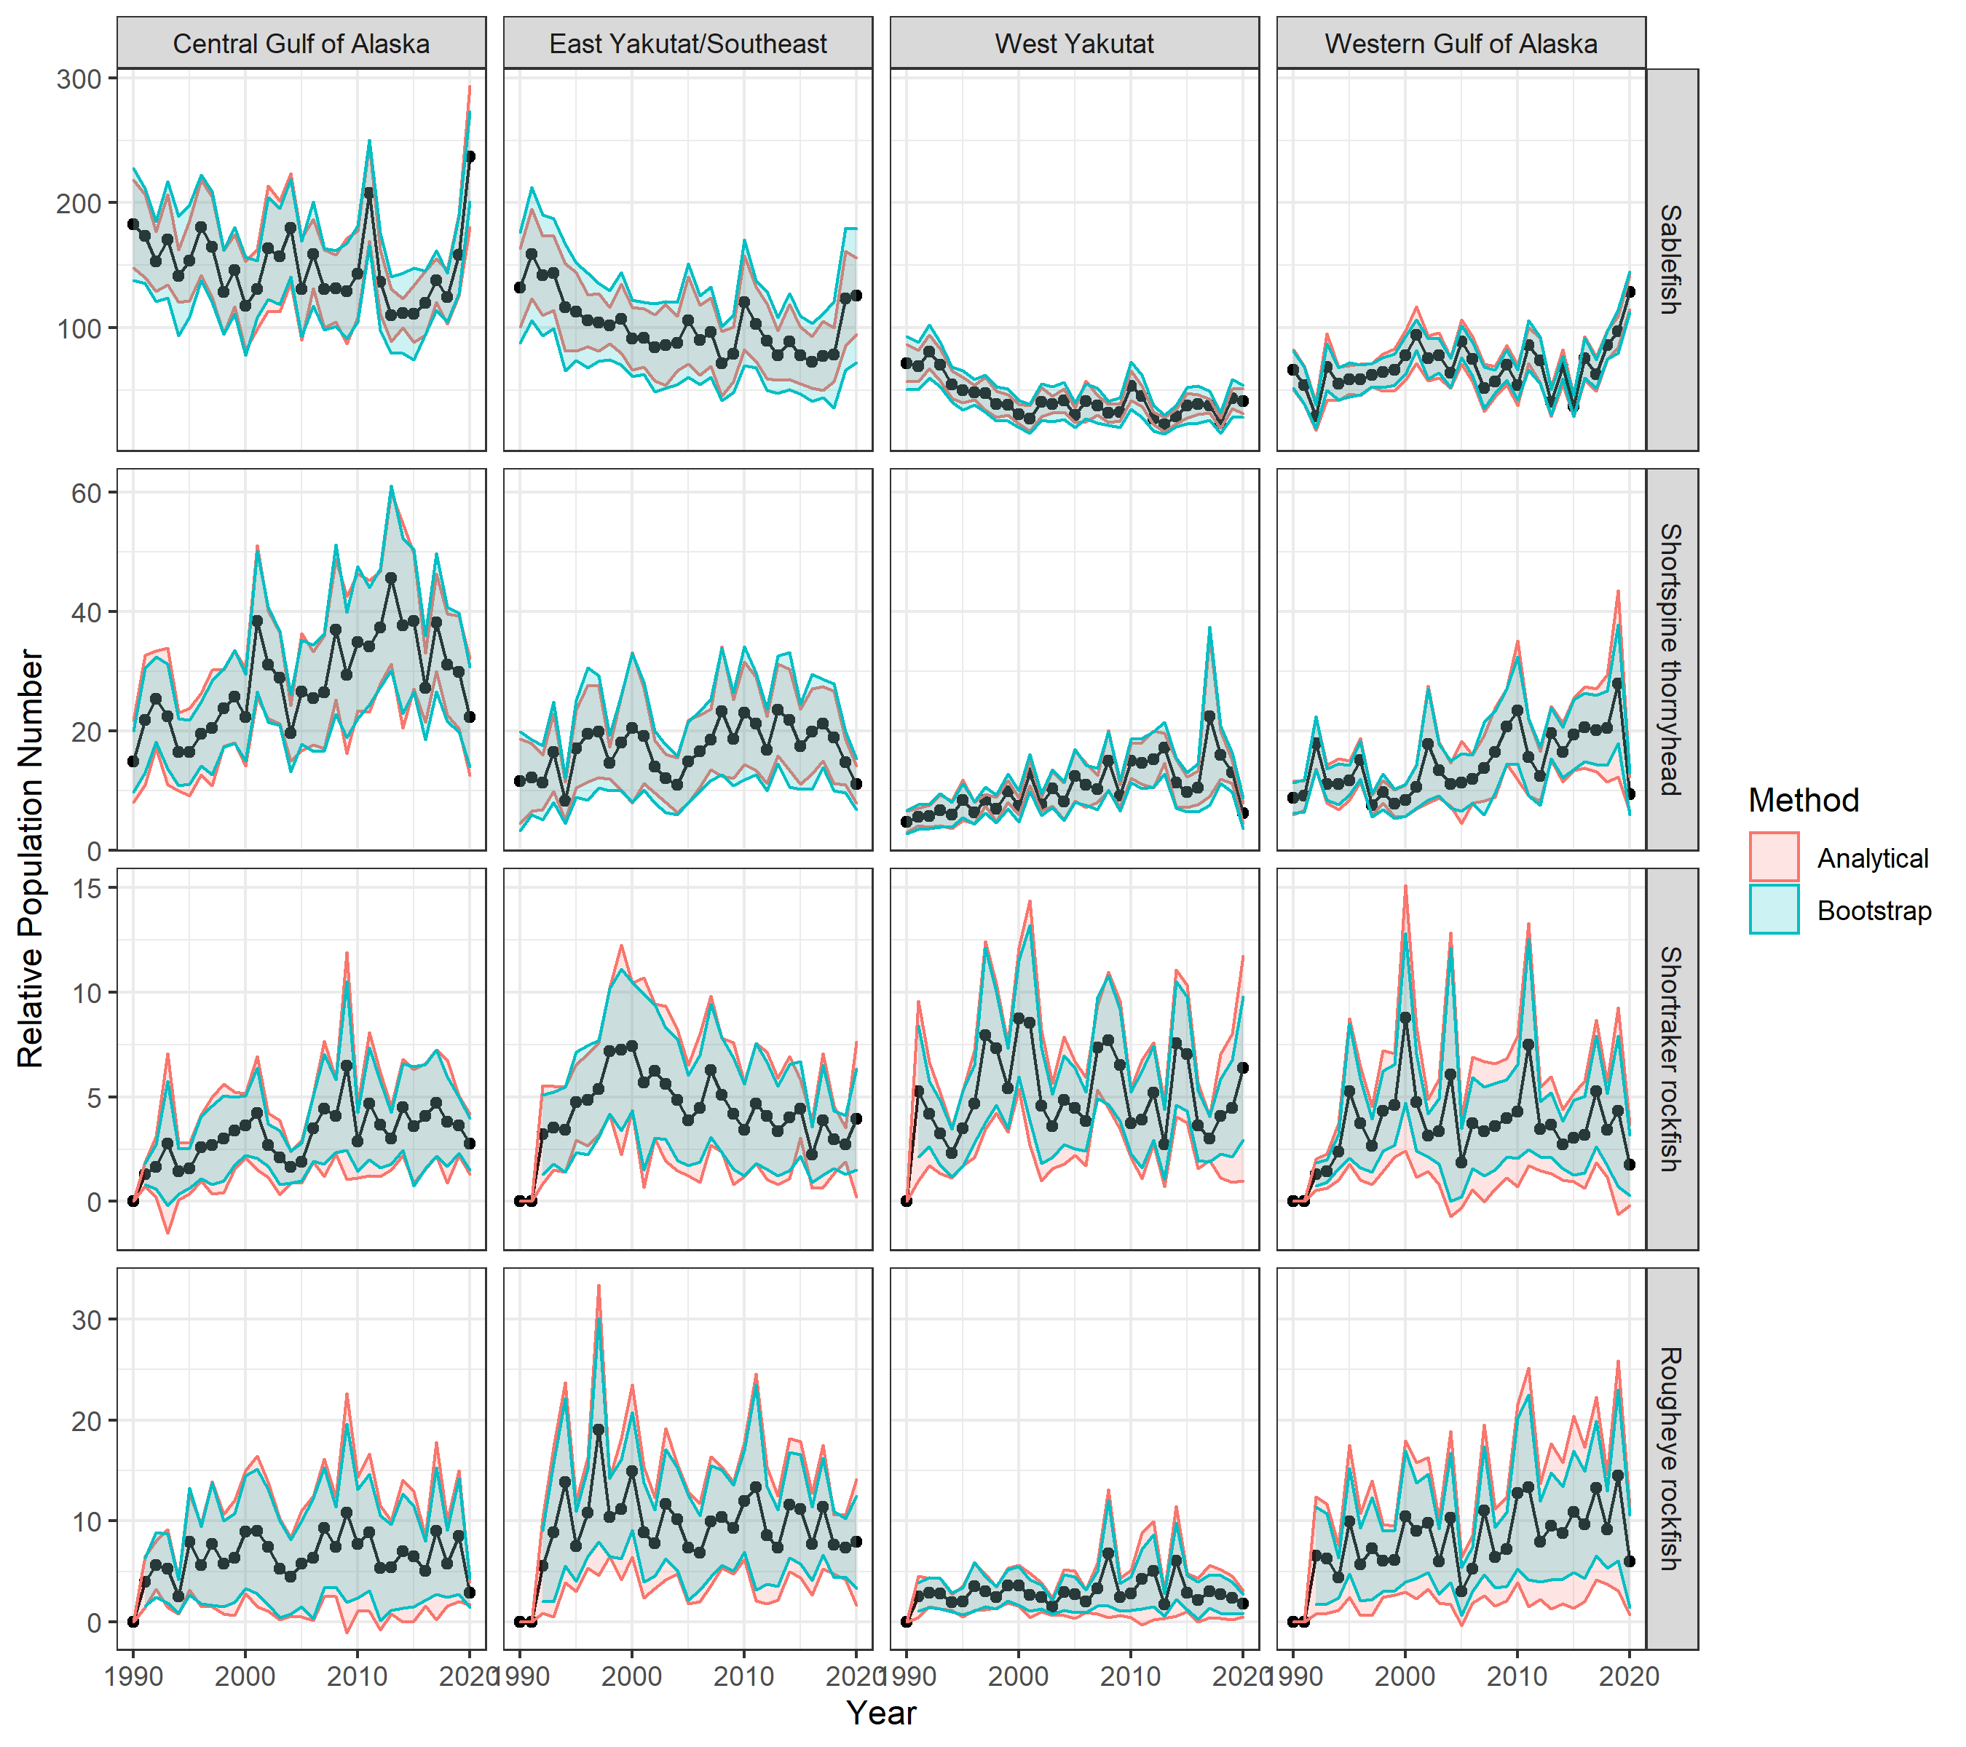
Figure 1. Relative population number (RPN) by FMP subarea and species with 95% confidence intervals estimated using the status quo analytical (red) and bootstrap (blue) methods.

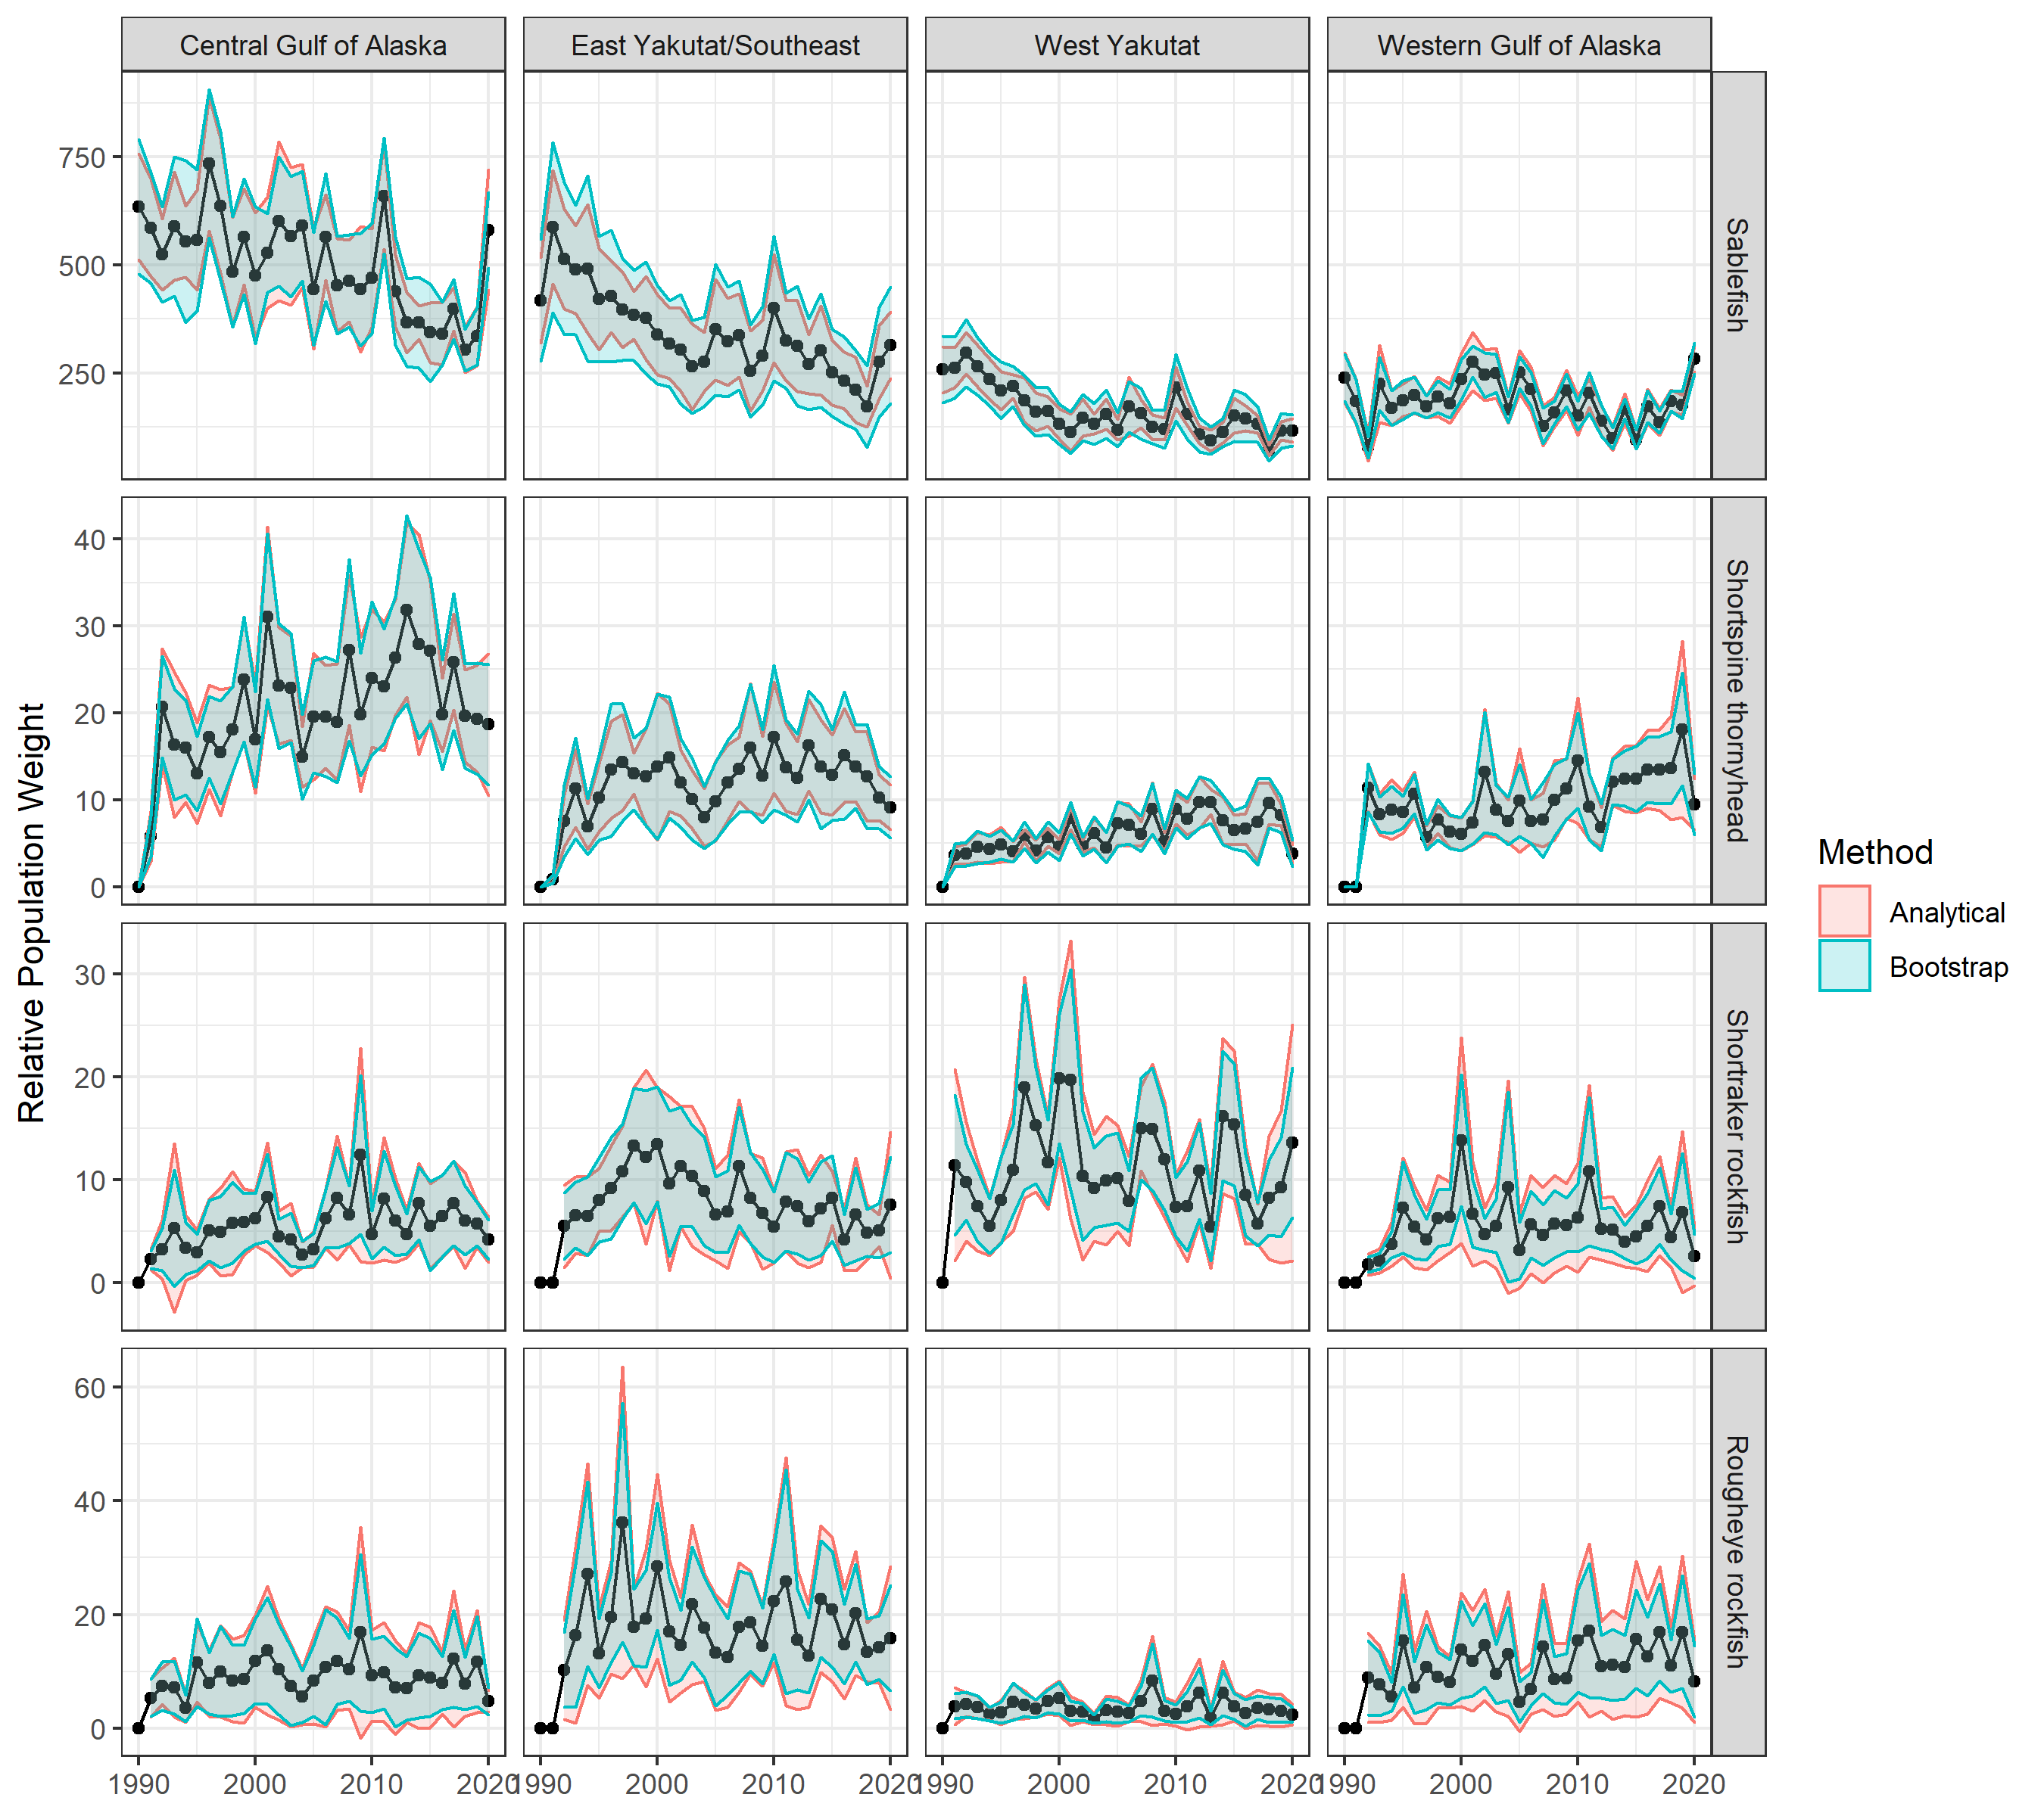
Figure 2. Relative population weight (RPW) by FMP subarea and species with 95% confidence intervals estimated using the status quo analytical (red) and bootstrap (blue) methods.

