Chapter 2: Assessment of the Pacific cod stock
in the Gulf of Alaska
Peter-John F. Hulson, Steven J. Barbeaux, Bridget Ferriss, Katy Echave, Julie Nielsen, Susanne McDermott, Ben Laurel, Alisa Abookire, Ingrid Spies and S. Kalei Shotwell

November 2026

This report may be cited as: Hulson, P.-J. F., S. J. Barbeaux, B. Ferriss, K. Echave, J. Nielsen, S. McDermott, B. Laurel, A. Abookire, I. Spies, and S. K. Shotwell. 2026. Assessment of the Pacific cod stock in the Gulf of Alaska. North Pacific Fishery Management Council, Anchorage, AK. Available from https://www.npfmc.org/library/safe-reports/.

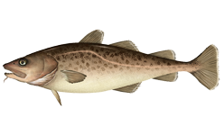

With contributions from:
Mike Litzow, Kimberly Rand, Charlotte Levy, and Muyin Wang

Executive Summary
Pacific cod in the Gulf of Alaska are assessed on an annual stock assessment schedule to coincide with the availability of new survey data. We used a statistical age-structured model as the primary assessment tool for Gulf of Alaska Pacific cod used here to calculate proposed Tier 3 specifications. This assessment consists of a population model, which uses survey and fishery data to generate a historical time series of population estimates, and a projection model, which uses results from the population model to predict future population estimates and recommended harvest levels. Model input files, additional plots and model diagnostics, and presentations pertaining to this assessment can be found at this link.

Summary of Changes in Assessment Inputs
Relative to last year’s assessment, the following changes have been made in the current assessment:

Changes in the input data
- Federal and state catch data for 2025 were updated and preliminary federal and state catch data for 2026 were included;
- Commercial federal and state fishery size composition data for 2025 were updated, and preliminary commercial federal and state fishery size composition data for 2026 were included;
- Commercial federal conditional age-at-length data for 2025 were included;
- AFSC bottom trawl survey conditional age-at-length data for 2025 were included;

Changes in the methodology
The operational model structure was retained from Model 24.0 accepted in February 2026. The model was updated and run in SS3 version 3.30.25.1 (Methot and Wetzell 2013). Updated documentation for setting the bounds of the length bins in the conditional age-at-length data within the SS3 user manual is forthcoming. In this assessment we adjusted the bounds of the length bins in the conditional age-at-length data to be consistent with the updated documentation. This change resulted in negligible differences in model estimates.

Summary of Results
The stock appears to be recovering from low levels with the stock projected to be at B_{32%} in 2027. Under the FMP HCR, projected SSB below B_{40%} is consistent with sub-tier “b” of Tier 3. Under Tier 3b, the calculated maximum permissible ABC is 41,937 t. This maximum ABC is 1% larger than the 2026 ABC of 41,520 t and 30% larger than the 2027 ABC projected in last year’s assessment due to updated data and an increase in the estimated stock status. In Tier 3b, increases in projected stock status along the harvest control rule ramp result in increases to the allowable fishing mortality rate and affect both the ABC and OFL. The corresponding reference values are summarized in the following table, with the recommended ABC and OFL values in bold. The stock is not subject to overfishing, is not currently overfished, nor is it approaching a condition of being overfished.
Quantity | As estimated or specified last year for: |  | As estimated or specified this year for:
Quantity | 2026 | 2027 | 2027 | 2028
M (natural mortality rate) | 0.5* | 0.5* | 0.53* | 0.53*
Tier | 3b | 3b | 3b | 3b
Projected total (age 0+) biomass (t) | 182,156 | 186,118 | 192,257 | 213,107
Female spawning biomass (t)
Projected | 52,772 | 45,838 | 51,423 | 46,230
B_{100%} | 159,595 | 159,595 | 160,874 | 160,874
B_{40%} | 63,838 | 63,838 | 64,350 | 64,350
B_{35%} | 55,858 | 55,858 | 56,306 | 56,306
F_{OFL} | 0.68 | 0.54 | 0.68 | 0.57
maxF_{ABC} | 0.54 | 0.47 | 0.55 | 0.49
F_{ABC} | 0.54 | 0.47 | 0.55 | 0.49
OFL (t) | 49,782 | 38,812 | 50,194 | 43,208
maxABC (t) | 41,520 | 32,209 | 41,937 | 35,866
ABC (t) | 41,520 | 32,209 | 41,937 | 35,866
Status | As determined last year for: |  | As determined this year for:
Status | 2024 | 2025 | 2025 | 2026
Overfishing | No | n/a | No | n/a
Overfished | n/a | No | n/a | No
Approaching overfished | n/a | No | n/a | No
*Base natural mortality M varies between 0.53 and 0.88
** Assumed 2026 catch to be the 2026 ABC. For 2028 projections the 2027 catch was assumed to be at the projected ABC.

Area apportionment
Using the recommended random effects model (described in the Area Allocation of Harvests section as applied within the rema R-package, Sullivan et al. 2022) with the trawl survey biomass estimates through 2025, the Biologically-informed Recommended Distributions (BRD) are:
 | Western | Central | Eastern | Total
Area apportionment | 24.80% | 69.20% | 6% | 100%
2027 BRD | 10,401 | 29,020 | 2,516 | 41,937
2028 BRD | 8,894 | 24,820 | 2,152 | 35,866

Responses to SSC and Plan Team Comments on Assessments in General
Not applicable.

Responses to SSC and Plan Team Comments Specific to this Assessment
“With respect to the choice of length bin structure, the SSC recommends that the authors continue to explore finer bin structure closer to inflection points of key processes like selectivity and maturity, and areas of the growth curve where cod are growing quickly, rather than using uniform 5 cm bins across the length range.” (SSC, Oct 2024)
“The Team recommends continued work on the modeling of size and weight at age, potentially including:
- whether the conditional age-at-length data needs to be corrected for length-stratified survey sampling;
- evaluating time-varying growth;
- using age compositions rather than conditional length at age; and
- using empirical estimates of length and weight at age.” (PT, Nov 2024)
“The SSC offers the following additional recommendations for the authors:
- The relatively large increase in trawl survey catchability from last year’s assessment to this year’s assessment is concerning. The SSC recommends the following avenues of research to address this concern:
  - Consider estimating catchability using an informative prior. There has been considerable research on the survey catchability of Pacific cod, and use of an informative prior would help to reduce assessment uncertainty. Development of a catchability prior should be done collaboratively with the AI Pacific cod assessment authors as a prior for GOA and AI trawl survey gear would be valuable for that assessment as well.
  - Evaluate covariation among estimates of trawl survey catchability, longline survey catchability, and natural mortality. Plots of the joint posterior distributions of these parameters might be informative. Explore whether the use of conditional age-at-length data influences estimation of survey catchability.
  - Survey catchability is affected by the availability of Pacific cod, which may be undergoing distributional shifts due to a changing climate. Evaluate whether such distributional shifts are occurring (either in the water column or geographically). Research into the connectivity between the Pacific cod populations in the GOA and the Bering Sea, discussed in the EBS Pacific cod section of this SSC report, may also be relevant to survey catchability.
- Report Mohn’s rho for the retrospective analysis.
- Evaluate whether GOA Pacific cod growth is more appropriately modeled with a Richards growth curve, as is now done for EBS and AI Pacific cod.
- The SSC continues to request a thorough revaluation of the current modeling approach for survey selectivity and catchability, including alternatives to the current selectivity blocks in the trawl survey, and alternatives to a strongly dome-shaped selectivity in the longline survey, and whether selectivity rather than catchability is more appropriately modeled with a time-varying temperature covariate.” (SSC, Dec 2024)
“The SSC notes that there have been numerous suggestions for model improvements since the last full assessment and looks forward to the authors and other analysts exploring recommendations from that assessment as well as those below in the next full assessment and through ongoing or new research.
- Given that recruitment as estimated in the model has been below average since 2014 and the expectation of continuing warm conditions, the SSC supports the GPT recommendation that the authors re-evaluate the portion of the recruitment time series used for projections to better reflect currently prevailing environmental conditions.
- The SSC suggests that the authors explore the use of temperature-informed mechanisms within the assessment model and temperature-informed growth or mortality. For example, the spawning habitat index identified in the ESP could be used as a predictor of recruitment. Alternatively, these relationships could first be explored and refined through causal modeling (e.g., DSEM) before considering their use in the assessment.
- The SSC highlights and supports public comments to re-examine the stock structure of Pacific cod in the Bering Sea and GOA regions based on historical and ongoing tagging work and other information. The SSC notes that a research project developing a spatial model for the combined GOA and Bering Sea region is under development and will incorporate movement among regions informed by tagging work. The SSC looks forward to results from this work.
- In light of emerging information about the migratory behavior of Pacific cod, the SSC highlights the need to re-consider the assessment and management of Pacific cod in the Alaska region. In addition to the development of a combined model that accounts for movement among regions, this may require an assessment of the data needed to support these modeling efforts as well as changes to the management of Pacific cod.
- The SSCs reiterates its recommendations from December 2024 regarding the relationship between trawl and longline survey selectivities and natural mortality, as well as among temperatures, changes in spatial distribution and estimates of selectivity (see December 2024 SSC report).
- The SSC supports the authors’ plans to re-examine the computation of the RPN indices from longline survey data to better reflect the distribution of longline sets across depth strata and between the eastern and western portions of the survey region.
- The SSC supports bringing forward either harvest projections or an operational update in the fall 2026 assessment cycle, and looks forward to the next full assessment to address some of the research recommendations from various review bodies. Regardless of the type of assessment brought forward, the SSC requests that previous GPT and SSC comments, author responses, and plans for the next operational full assessment and for research models be tracked for prioritization.
- In response to the authors’ request for feedback on abbreviated SAFE documents, such as this update, the SSC recommends including a brief section that describes planned or anticipated improvements by the assessment team. This is not intended to replace the Responses to SSC/GPT comments section typically included in operational assessments.” (SSC, Feb 2026)
We collate these comments in this update assessment and responses will be provided in the next full assessment.

Introduction
Pacific cod (Gadus macrocephalus) is a transoceanic species, occurring at depths from shoreline to 500 m. The southern limit of the species’ distribution is about 34° N latitude, with a northern limit of about 63° N latitude. Pacific cod is distributed widely over Gulf of Alaska (GOA), as well as the eastern Bering Sea (EBS) and the Aleutian Islands (AI) area.
Conventional tagging studies have found that Pacific cod migrate both within and between the EBS, AI, and GOA outside of their winter (January – April) spawning season. In 2021, a cooperative tagging study between the Alaska Fisheries Science Center (AFSC) and the Aleutians East Borough (AEB) was initiated to examine the seasonal movements of Pacific cod captured in the western GOA during the winter spawning season using pop-up satellite tags. Pop-up satellite tags are designed to release from the fish after a predetermined deployment time (e.g., 180 days) and transmit archived data to satellites after floating to the surface, whereas conventional tags require a platform of recovery such as a fishery. Pathways between release and pop-up locations can be reconstructed from archived depth, temperature, and light data recorded by the tags using a hidden Markov model. Satellite tags were released on Pacific cod in the western GOA in March 2021 and April 2022 to improve understanding of seasonal connectivity between winter spawning locations of Pacific cod in the western GOA and foraging locations in GOA and EBS during summer months when AFSC bottom- trawl surveys are conducted. In 2023 - 2025, the study was expanded to the central GOA to improve understanding of seasonal migration patterns for western and central GOA fish. During the expanded winter study, satellite tags were deployed at 10 release locations ranging from Sanak Island in the west to the entrance of Prince William Sound in the east. Winter release tags were programmed to pop up after either 6 months (80% of tags) or 15 months (20% of tags). In 2023 and 2024, satellite tags were also released during the summer in the western and central GOA to better understand annual movement patterns and movement from summer foraging to winter spawning areas. Summer release tags were programmed to pop up after 12 months. To date, 251 satellite tags have been deployed in the GOA from 2021 to 2025. In the western GOA, 119 satellite tags were released on the annual winter cruises and 30 satellite tags were released during the summer. In the central GOA, 100 satellite tags were released on the winter cruises and 2 satellite tags were released during the summer. Pop-up locations for satellite tags deployed in the GOA to date indicate that seasonal connectivity exists between the western GOA (Shumagin Islands and westward), EBS, northern Bering Sea, western Bering Sea (Russia), and Chukchi Sea. Approximately 50% of cod tagged in the western GOA during the winter moved to summer foraging locations in the Bering Sea across all five years of tagging, although some annual variation in the migration rate was observed. In contrast, fish tagged in the central GOA were not observed to move into the EBS, AI, or eastern GOA and movement between the western and central GOA was limited. Within the central GOA, some tagged fish displayed considerable movement but largely remained in the same management area where they were released. Partial migration (i.e., only part of the population undertakes seasonal migration) was evident in reconstructed pathways, as some fish remained in the vicinity of their release location year-round. Detailed cruise information and reconstructed pathways for GOA releases for years 2021 - 2024 are available in NOAA Technical Memos (Rand et al. 2026a, Rand et al. 2026b, Rand et al. 2026c, Rand et al. 2026d). Analyses to further quantify and characterize movement between management areas within the GOA and between the GOA and the Bering Sea for years 2021 - 2025 are on-going. A pilot study to determine the feasibility of detecting seasonal movement of Pacific cod between the western GOA and the EBS with an acoustic telemetry array has yielded promising results. Combining satellite tag with acoustic tag technology would allow larger sample sizes and movement monitoring over multi-year time periods.
Although there appears to be some genetic differentiation within the GOA management area and some cross migration between the western GOA and EBS that may vary seasonally, the Pacific cod stock in the GOA region is currently managed as a single stock. Further work is ongoing to understand the genetic stock structure and movement of cod in the GOA and its relationship with the EBS stock of cod during spawning and feeding periods.

Fishery

Fishery history and management measures
For a full description of the fishery history and management measures see Hulson et al. 2022. Catches of Pacific cod since 1997 by gear type and jurisdiction are shown in Table 2.1; catches prior to that are listed in Thompson et al. 2011. Presently, the Pacific cod stock is exploited by a variety of fisheries, including trawl, longline, pot, and jig components; Figure 2.1 shows landings by gear since 1977. The history of Total Allowable Catch (TAC), Acceptable Biological Catch (ABC), Overfishing Level (OFL), and State of Alaska Guideline Harvest Levels (GHL) are summarized since 1997 and compared with the time series of aggregate commercial catches in Table 2.2 (data prior to 1997 are shown in Hulson et al. 2022). The 10-year Biologically informed Recommended Distribution (BRD) by regulatory area within the GOA is shown in Table 2.3. Catch reported in Tables 2.1 and 2.2 include discarded Pacific cod, historical estimated retained and discarded amounts through December 2025 are shown in Hulson et al. 2026, no unusual results in discard amounts were noted for 2026.

Recent fishery performance
Figure 2.2 shows the distribution of observed catch for the most recent year of complete catch data (2025) for the three major gear types, as well as the distinction between observed and electronically monitored catch. Cumulative catch by week in 2026 is larger for the Central GOA compared to previous years across the gear types, while the catch in 2026 is comparable in the Western GOA to previous years (Figure 2.3).
In 2026 the federal TAC was set at 30,053 t and state GHL set at 11,467 t (Table 2.2). As of October 26, 2026 a total of 37,605 t (91% of the ABC) has been harvested (Table 2.1); State fisheries have harvested 11,286 t (98% of the GHL) and federal fisheries 26,319 t (88% of the TAC). In 2026, 28% of the Pacific cod catch was by trawl, 46% by pot gear, and 18% by longline, while jig and other gear harvested 8% (Table 2.1).

Data
This section describes updates to the data used in the current assessment. The following table and Figure 2.4 present the data included in this assessment (the years shown in bold font are those that are new to this assessment).
Data | Source | Type | Years
Federal and state fishery catch, by gear type (trawl, pot, and longline) | AKFIN | Metric tons | 1977 – 2026
Federal and state fishery catch-at-length, by gear type | AKFIN, ADF&G | Frequency observed at length (in cm) | 1977 – 2026
GOA NMFS bottom trawl survey abundance | AKFIN | Total numbers | 1990 – 2025
AFSC Sablefish Longline survey Pacific cod Relative Population Numbers | AKFIN | RPN | 1990 – 2025
GOA NMFS bottom trawl survey length composition | AKFIN | Number at length (in cm) | 1990 – 2025
GOA NMFS bottom trawl survey conditional age-at-length | AKFIN | Proportion age at length | 1990 – 2025
AFSC Sablefish Longline survey Pacific Cod length composition | AKFIN | RPN at length (in cm) | 1990 – 2025
Federal fishery conditional age-at-length | AKFIN | proportion age at length | 2007 – 2025
CFSR bottom temperature indices | National Center for Atmospheric Research | temperature anomaly at mean depth for P. cod size bins | 1979 – 2024

Fishery

Catch Biomass
Total catches for the period 1991-2026 are shown for the three main gear types in Table 2.1, with the 2026 values through October 26, 2026. The current year’s catch within the assessment model is assumed to reach the full Total Allowable Catch (TAC) and state Guideline Harvest Level (GHL). Three fisheries were modeled (by gear categories); trawl (all trawl types), longline (longline and jig) and pot.

Length Composition
Fishery length compositions are available by fishery from 1977 through the October 26, 2026 data cutoff (Figure 2.4). Due to the selectivity of the fisheries, these length compositions are not informative about incoming year classes and primarily catch adult Pacific cod.

Age composition
Age data collected since 2007 from the commercial fishery were used to develop an annual conditional age-at-length matrix for each fishery, these data were updated to include new 2025 information (Figure 2.4).

Surveys

AFSC bottom trawl survey
In 2025, the scientists from the AFSC transitioned to a new stratified random design for this survey. The new design changed from the previous 59 strata defined by INPFC management area, depth, and general habitat type (shelf, gully, and slope) to 28 strata defined by NMFS management area and depth. We describe results of analysis comparing historical bottom trawl survey data using the restratified design in Hulson et al. 2026 (Appendix 2.2) and noted a negligible impact on Pacific cod estimates compared to the previous design. We note that for 2025 the survey was conducted with two chartered vessels completing 431 stations and that this represented an 18% reduction compared to the number of stations sampled in 2023. The number of stations sampled in the GOA bottom trawl survey in 2025 was the fewest since 1990, including 2001 when the Eastern GOA was not sampled.
The spatial distribution of Pacific cod catch in the 2025 trawl survey was comparable to the most recent surveys (in 2023 and 2021, Figure 2.5). In general, the 2025 survey resulted in stations with higher Pacific cod catch than those from 2021 and 2023.

Indices
Since the time-series low in 2017, the Pacific cod biomass and abundance estimates from the bottom trawl survey suggest an increasing trend in the population (Table 2.4). Compared to the 2023 survey, the 2025 trawl survey biomass estimate increased by 39.2% and the abundance estimate increased by 49.6%. These increases in biomass and abundance were driven by overall increases in station density observations, rather than a few high-density stations. Nonetheless, the coefficient of variation (CV) estimate was 23%, which is larger than recent CVs but within the range estimated for other years of the time-series. This increase in CV is likely influenced by the reduction in the number of stations sampled in 2025. The restratified survey design resulted in negligible differences in uncertainty (see Hulson et al. 2026 Appendix 2.2).

Length Composition
The bottom trawl survey 2025 length composition was observed to be bi-modal, with a mode at 15-20 cm (representing catches of age-1 cod, which would be the 2024 year class) and a mode at 35-70 cm (fishery and survey length composition figures can be found in the SS3 plots at the link provided for additional resources in the Executive Summary section, and here).

Age Composition
Otoliths for bottom trawl survey age composition estimation were collected in each survey and were used as conditional age-at-length data within the GOA Pacific cod assessment. Data from the 2025 survey were updated in this assessment.

AFSC longline survey
Conducting the AFSC longline survey involves sampling the continental slope and major gullies in the GOA, providing data to calculate relative abundance in this area (Rutecki et al. 2016, Siwicke and Malecha 2024). The survey is primarily directed at sablefish but also catches considerable numbers of Pacific cod. The survey was conducted in 2025 after missing a year in 2024.
Pacific cod catches in the longline survey primarily occur in the Western and Central GOA (Figure 2.6). There were consistent increases in catch in the Western and Central GOA in 2025 compared to 2023 for the majority of stations, with a large decrease at a single station in the Eastern GOA.

Abundance index
The AFSC longline survey Relative Population Number (RPN) index indicates a generally increasing trend since the time-series low in 2019 (Table 2.4). The 2025 estimate declined slightly (5%) compared to the most recent 2023 value. The decline was primarily due to densities observed from the Eastern GOA subregion, while the Western and Central GOA subregions increased compared to 2023. This decline was not due to the redesign of the survey by dropping several stations, which had negligible impact on Pacific cod RPNs.
The AFSC longline survey RPN index is computed by multiplying the average station density (catch per hook) within a stratum by the stratum area size (where the stratum is based upon geographic region and depth). Upon further investigation, it was discovered that the magnitude of Eastern GOA RPN is driven by the area size for the 150-200m depth stratum, which is larger in the Eastern GOA than the Central or Western GOA. This has resulted in a distribution of RPN across the GOA that is inconsistent with the distribution of abundance as observed from the AFSC bottom trawl survey; Eastern GOA RPN represents an average of 33% of the total GOA RPN across the time-series of the index, whereas the AFSC bottom trawl survey has observed Eastern GOA cod abundance that is, on average, less than 5% of the total GOA abundance across the time-series. Ultimately, this has resulted in a subregion which contains the fewest stations that catch cod (Figure 2.6) having the greatest influence on the GOA-wide RPN index. Further, the decrease in the Eastern GOA RPN index in 2025 compared to 2023 was driven by reduced catch at a single station (Figure 2.6).
Upon computing the mean numbers CPUE from the AFSC longline survey we found that the GOA-wide CPUE increased by 7% in 2025 compared to 2023. Based upon the discovery of the influence of Eastern GOA RPN on the total GOA RPN index, prior to the next full assessment we will be investigating a new method to compute the AFSC longline index. Because this is an update assessment, we continue to use the AFSC longline survey RPN index in its current form.

Length composition
The observed length composition from the 2025 longline survey was unimodal and consistent with previous survey length compositions, with a peak at 60 cm.

Other indicators
There are several indicators that are monitored but not fit in the assessment model that provide auxiliary information on the GOA cod stock. We include those within the following sections.

Laurel and Litzow age-0 index
Beach seine sampling of age-0 cod was conducted in 2026. The beach seine age-0 CPUE index resulted in estimated values in 2026 that was the second largest in the time-series, only smaller than the 2012 year class (top right panel of Figure 2.7).

Alaska Department of Fish and Game bottom trawl survey
The Alaska Department of Fish and Game (ADFG) bottom trawl survey index suggests an increasing trend in the Pacific cod population since the time-series low in 2016 (top left panel of Figure 2.7). In 2026 the ADFG bottom trawl survey CPUE of cod numbers increased by 21% compared to 2025.

Commercial fishery indices
Non-targeted catch of Pacific cod in other directed fisheries was examined as an indicator of population trends. We examine two indices to evaluate trends in incidental catch of Pacific cod: the pelagic walleye pollock fishery and six different shallow water fisheries. The occurrence of Pacific cod in the pelagic pollock fishery appears to be an abundance indicator for 2-year-old or younger Pacific cod, which are thought to be more pelagic. As an index of recruitment abundance, we tracked the incidence of occurrence as proportion of hauls with cod in the central GOA pollock A season. For the walleye pollock fishery in the central GOA, abundance of small cod in pelagic trawls was the largest of the time series in 2026, generally consistent with the trend from the beach seine age-0 index (bottom right panel of Figure 2.7).
Incidental catch of Pacific cod in shallow water fisheries track a larger portion of the adult population of Pacific cod. As an index of the adult population abundance, we track the catch rates in tons of Pacific cod per ton of all species caught in shallow water fisheries. In this assessment, we propose a new index for incidental catch of Pacific cod in shallow water fisheries. Historically we have only used incidental catch from the shallow water flatfish fishery, this year we also examined information from the arrowtooth flounder, Pacific halibut, walleye pollock bottom-trawl, rockfish, and sablefish fisheries operating in depths less than 300 m. We compute a composite index as the weighted mean of the standardized proportion of Pacific cod catch to all other species catch within each of these fisheries, weighted by the number of observed hauls within the given year. The catch of Pacific cod in shallow water fisheries has trended up since the time series low in 2017. The 2025 and 2026 values are the largest in the recent time series, while the 2026 value decreased compared to 2025 (bottom left panel of Figure 2.7). It should be noted that none of these indices are controlled for vessel, effort, or fishing practice changes.

Environmental indices
The Climate Forecast System Reanalysis (CFSR) temperature index has been discontinued and was not available for 2025. When an environmental index is not available in a certain year the SS3 protocol is to set that year’s index value at 0, meaning that the mean parameter estimate for that year is used. An alternative environmental index will be used in the next full assessment.

Analytic Approach
We retained Model 24.0 in this assessment (described in Hulson et al. 2024). The model was updated and run in SS3 version 3.30.25.1 (Methot and Wetzell 2013). Updated documentation for setting the bounds of the length bins in the conditional age-at-length data within the SS3 user manual is forthcoming. In this assessment we adjusted the bounds of the length bins in the conditional age-at-length data to be consistent with the updated documentation. This change resulted in less than a 0.5% difference in spawning biomass (for example) on average across the time series. The SS3 control and forecast files for this year’s model can be found at the link provided in the Executive Summary section of this document.

Results

Model Evaluation
In the 2024 assessment a full suite of model diagnostics and sensitivities were provided for Model 24.0. In the next full assessment when alternative models are explored these will be provided within this document. Model diagnostics and sensitivities that were provided in the 2024 assessment and applied to the 2026 update assessment that are not contained in this document are provided in the link in the Executive Section. This update assessment indicates that the likelihoods appear well defined with acceptably low final gradients (the final gradient was 8.65e⁻⁶) and asymptotic approximations of parameter variances. Convergence of this year’s updated Model 24.0 was further examined by “jittering” starting parameters by a factor of 5% over 50 runs to evaluate if models had converged to local minima. The 5% starting-value jitter analysis showed that all 50 jitter runs met the stated convergence criteria, and 80% of these runs recovered the lowest objective-function value from the accepted models.
The update assessment with Model 24.0 resulted in acceptable fits and parameter estimates (Table 2.5). Overall, Model 24.0 fits the AFSC bottom trawl and longline survey indices reasonably well (Figure 2.8). However, positive residuals have persisted in the fit to the longline survey since 2018 and the model does not fit the 2025 increase in bottom trawl survey abundance. The aggregated fit from Model 24.0 to the fishery length composition data and one-step-ahead residuals are acceptable but appeared to have a few outlier residuals in proportions at length (Figure 2.9). The fits to the survey length composition data in aggregate were also acceptable but also had some outliers present in the one-step ahead residuals (Figure 2.10). The standard SS3 plots, which contain additional results, can be found at the link provided in the Executive Summary section of this document.

Time Series Results

Definitions
The annual biomass estimates presented were: total biomass (the biomass at the start of the year of all fish aged 0 years or greater each year) and spawning biomass (the estimated biomass of mature females at the start of the year). Recruitment is defined as the number of age-0 fish by year.

Biomass
Total biomass estimates show a long decline from their peak in 1989 (Table 2.6 and Figure 2.11) to a low in 2006 and then an increase to another peak in 2014, after which there was a sharp decline through 2018 followed by a slight increase through 2024. Total biomass in 2026 is estimated to be essentially unchanged from 2025.
Spawning biomass (Table 2.6 and Figure 2.11) shows a similar trend of decline since the late 1980s with a peak in 1989 to a low in 2008. There was then a short increase in spawning biomass coincident with the maturation of the 2005-2008 year classes through 2014, after which the decline continued to lowest level in 2019 and 2020. The spawning biomass then slightly increased through 2022, remained steady through 2025, and slightly increased in 2026.

Recruitment and Numbers-at-Age
The recruitment predictions in Model 24.0 (Table 2.7 and Figure 2.12) show above average recruitment for most of the 1980s, below average recruitment from the mid-1990s to mid-2000s, above average recruitment from the mid-2000s to 2013, and below average recruitment since. Compared to the most recent assessment, the current Model 24.0 results in larger estimates of the 2020 and 2022 year classes.

Fishing Mortality
Fishing mortality appears to have increased steadily with the decline in abundance from 1990 through a peak in 2008 with continued high fishing mortality through 2017 (Table 2.8 and Figure 2.13). 2017 had the highest total exploitation rate of the time series. The period between 1990 and 2008 saw both a decline in recruitment paired with increases in catch. The period of increasing fishing mortality was mainly attributed to the rise in the pot fishery, which also shows the largest increase in continuous F (Figure 2.13). In 2018 through 2020 there was a sharp decrease in fishing mortality coincident with the drastic cuts in ABC and closure of the federal directed fishery in 2020. In 2021 with the reopening of the federal fishery mortality once again increased but remained lower than observed in the previous decade prior to 2017. In retrospect, the phase plane plots (Figure 2.14) show that F was estimated to have been above the ABC control rule advised levels from 2015 to 2017 and biomass has been below B_{35%} from 2017-2025, slightly above B_{35%} in 2026, and projected to be below B_{35%} through 2028. It should be noted that this plot shows current model predictions, not what the past assessments had estimated.

Harvest Recommendations

Amendment 56 Reference Points
Amendment 56 to the GOA Groundfish Fishery Management Plan (FMP) defines the “overfishing level” (OFL), the fishing mortality rate used to set OFL (F_{OFL}), the maximum permissible ABC, and the fishing mortality rate used to set the maximum permissible ABC. The fishing mortality rate used to set ABC (F_{ABC}) may be less than this maximum permissible level, but not greater. Because reliable estimates of reference points related to maximum sustainable yield (MSY) are currently not available but reliable estimates of reference points related to spawning per recruit are available, Pacific cod in the GOA have generally been managed under Tier 3 of Amendment 56. Tier 3 uses the following reference points: B_{40%}, equal to 40% of the equilibrium spawning biomass that would be obtained in the absence of fishing; F_{35%}, equal to the fishing mortality rate that reduces the equilibrium level of spawning per recruit to 35% of the level that would be obtained in the absence of fishing; and F_{40%}, equal to the fishing mortality rate that reduces the equilibrium level of spawning per recruit to 40% of the level that would be obtained in the absence of fishing. The following formulae apply under Tier 3:
3a) Stock status: B/B_{40%} > 1
F_{OFL} = F_{35%}
F_{ABC} < F_{40%}
3b) Stock status: 0.05 < B/B_{40%} < 1
F_{OFL} = F_{35%} × (B/B_{40%} - 0.05) × 1/0.95
F_{ABC} < F_{40%} × (B/B_{40%} - 0.05) × 1/0.95
3c) Stock status: B/B_{40%} < 0.05
F_{OFL} = 0
F_{ABC} = 0
Other useful biomass reference points which can be calculated using this assumption are B_{100%} and B_{35%}, defined analogously to B_{40%}. These reference points are estimated as follows, based on this year’s model, Model 24.0:

Reference point: | B_{35%} | B_{40%} | B_{100%}
Spawning biomass: | 56,306 t | 64,350 t | 160,874 t

For a stock exploited by multiple gear types, estimation of F_{35%} and F_{40%} requires an assumption regarding the apportionment of fishing mortality among those gear types. For this assessment, the apportionment was based on this year’s model’s estimates of fishing mortality by gear for the five most recent complete years of data.

Specification of OFL and Maximum Permissible ABC
For Model 24.0 spawning biomass for 2027 is estimated by this year’s model to be 51,423 t at the start of the year. This is below the B_{40%} value of 64,350 t, consistent with applying sub-tier “b” of Tier 3. Given this, application of the HCR yielded OFL, maximum permissible ABC, and the associated fishing mortality rates for 2027 and 2028 as follows (2028 values are predicated on the assumption of the full TAC and GHL being taken in 2026 and that the 2027 catch will be at maximum ABC in the projection):
Units | Year | Overfishing  Level (OFL) | Maximum  Permissible ABC
Harvest amount (t) | 2027 | 50,194 | 41,937
Harvest amount (t) | 2028 | 43,208 | 35,866
Fishing mortality rate (F) | 2027 | 0.68 | 0.55
Fishing mortality rate (F) | 2028 | 0.57 | 0.49

The age 0+ biomass projections for 2027 and 2028 from this year’s model are 192,257 t and 213,107 t, respectively.

Risk Table and ABC Recommendation

Risk table summary
The risk table is included to identify considerations that introduce additional risk to the recommended ABC that are not explicitly captured within the stock assessment model for the GOA cod stock and could support a reduction in the recommended ABC. These risks are described in the following and are, in part, aided by a synthesis and interpretation of the most recent ecosystem and socioeconomic information available for GOA Pacific cod from the Ecosystem and Socioeconomic Profile (ESP, Appendix 2.1) and the GOA Ecosystem Status Report (ESR, Ferriss 2026).
These results are summarized in the table below:
Assessment-related Considerations | Population Dynamics Considerations | Ecosystem Considerations | Fishery-informed Stock Considerations
Level 1: Normal | Level 1: Normal | Level 1: Normal | Level 1: Normal
Model 24.0 does not have a concerning retrospective pattern and fits the available data well | Stock continues to experience historically low spawning biomass coupled with below average recruitment | The adult population experienced cooler/average environmental conditions with average/above- average prey resources in 2026 (limited reporting). El Niño conditions in 2027 are not expected to impact adult survival at the population level, but reduced egg/larval survival and diminished adult prey base may occur. | Fishery performance indicators are consistent with previous years

The following sections contain further details supporting these risk levels.

Assessment-related considerations:
Risk Level 1: Normal
- The updated Model 24.0 does not show a strong retrospective pattern in recent estimates of spawning biomass, either in the data retrospective or in the model retrospective across recent assessments (see supplemental diagnostics provided in the link in the Executive Summary section).
- Model 24.0 is, in general, responding appropriately to observed data sources. While the model fits the indices within the 2025 confidence intervals, the model underfits the trawl survey mean and overfits the longline survey mean. Given these results, the estimates of spawning and total biomass from Model 24.0 as applied with updated data though 2025 responds to and reflects the balance between the changes in the index data compared to previous assessments.
- We continue to note that the projection model uses mean recruitment from 1977 – 2024 to project biomass into future years while Model 24.0 estimates below average recruitment since 2014. Therefore, given these recent low recruitment estimates it is likely that the forecasted spawning biomass is overly optimistic. However, the effect on the two-year projections that result in ABC and OFL recommendations is not largely impacted by this recruitment assumption, as the year classes that are assumed to be at mean recruitment aren’t contributing much to the overall level of spawning biomass in the short term.
- Auxiliary information on recruitment from non-target fishery sources and the beach seine survey of age-0 fish surveys suggest below-average year classes in 2024–2025 and a relatively strong 2026 year class. Within the observations of length composition (and age composition) from the AFSC bottom trawl survey, these relatively stronger year classes are present, but the model estimates lower abundance of these year classes than have been observed. Therefore, we note this inconsistency between the assessment results and observations but make the point that this inconsistency would not result in increased risk that the stock is smaller in 2026 than projected by Model 24.0, rather, that the assessment may underestimate the magnitude of recruitment since 2014.
- We continue to rate the assessment considerations category at Level 1 – Normal due to 1) Model 24.0 fitting the available data reasonably well, 2) lack of a retrospective pattern, and 3) the limited impact of projected mean recruitment that is higher than the past decade of estimated recruitments on 2-year ABC and OFL recommendations.

Population dynamics considerations:
Risk Level 1: Normal
- Female spawning biomass is estimated to decrease over the next 2 years, then increase in the medium-term once the projected year classes (i.e., those after 2025 that are based on mean recruitment since 1977) begin contributing to the SSB. Total biomass is estimated to increase through 2031.
- The 2025 observations of population scale from both the fitted data sources (bottom trawl survey and longline survey) and the updated monitored data sources (ADFG trawl survey and shallow water fisheries incidental catch) through 2026 continue to indicate a generally increasing trend in population size since historically low levels.
- Overall, the stock has yet to recover in the GOA to historical levels and Model 24.0 continues to estimate below average recruitment of recent year-classes.
- We continue to rate the risk level for the population dynamics considerations category at Level 1 – Normal. We set this risk level while recognizing that the GOA cod stock remains in an undesirable stock status.

Ecosystem considerations:
Risk Level 1: Normal
- Temperatures at depth were observed to be cooler than survey average in the summer around Kodiak (5.8 °C bottom temperature, ADFG survey) but warmer than the survey average along the Seward Line (spring 5.7 °C 200m and 7 °C at surface).
- There were no spawning heatwave events in 2026 and above average habitat suitability index (based on MOM6 temperatures January to April) similar to 2022, implying improved conditions for successful hatching.
- Mesoscale eddy kinetic energy in the Kodiak region increased from last year but still slightly below average, implying improved larval retention and cross-shelf transport to suitable nearshore nursery environments from 2025.
- Evidence of time-varying predation mortality for age-1 Pacific cod from the CEATTLE multispecies model that has been above the time-invariant single species stock assessment value in all years.
- Competition and predation indicators of Pacific cod show mixed signals with below-average biomass of apex fish predators in the western GOA (arrowtooth flounder, Pacific halibut, sablefish) with continued slight increase in projected biomass consumed from the CEATTLE multispecies model.
- The spring phytoplankton bloom increased to a time series high in 2026, while the peak timing of the spring bloom was much earlier than the mean, potentially creating a mismatch for larval prey resources.
- Upcoming 2027 winter and spring surface temperatures are predicted to be warmer than average, in alignment with strong El Niño conditions. Ecosystem responses to previous warm years in the GOA have resulted in reduced primary production, changes in the zooplankton community (reduced euphausiids and reduced large copepods), and changes in the forage fish community (reduced capelin populations, potentially good conditions for herring and sandlance). Depending on the strength and duration of the El Niño event in the GOA, adult cod may experience reduced prey base, perhaps resulting in lower body condition (skinnier), earlier spawning timing, and other non-mortality related responses at the population level.

Fishery-informed stock considerations:
Risk Level 1: Normal
- Where data were available, catch-per-unit effort measures in the GOA fisheries showed mixed signals that are consistent with previous years.
- It should be noted that catch levels and fishery participation have been low over the past 5 years in comparison with pre fishery closure years due to the lower population size resulting in lower catch limits than historical limits.
- Bycatch in other fisheries remains low compared to fisheries prior to the 2014-2016 marine heatwave, with the exception of the shallow water fisheries, within which we have noted that Pacific cod catch has shown an increasing trend in recent years.
- We continue to rate the fishery-informed stock considerations at risk level 1 – no apparent concerns.

ABC recommendation
We recommend ABCs equal to the maxima calculated from the FMP HCR, for Plan Team and SSC consideration. The Tier 3b stock status includes an adjustment that reduces the OFL and ABC and this builds in precaution to help the stock increase to above B_{MSY} (B_{35%} in this case). Nonetheless, we acknowledge the potential increased risk from unknown factors outside of data and considerations included in the stock assessment model. Predicted warmer than average temperatures in 2027 based on El Nino conditions may impact population productivity even though the spawning biomass is near the B_{MSY} estimate.
For 2027 the spawning stock biomass is projected to be above B_{20%} and despite a drop in spawning biomass in 2028 is projected to remain above B_{20%} in 2028.

Spatial Apportionment: Biologically-informed Recommended Distributions (BRDs)
To determine the Biologically informed Recommended Distributions (BRD) for GOA subregions, we utilize the rema R package. These results remain unchanged from the previously accepted assessment. Estimates of regional trawl survey biomass and apportionment are shown in Figure 2.15.
Applying the retained REMA proportions to the proposed stock ABCs yielded the following BRDs:
 | Western | Central | Eastern | Total
Area apportionment | 24.80% | 69.20% | 6% | 100%
2027 BRD | 10,401 | 29,020 | 2,516 | 41,937
2028 BRD | 8,894 | 24,820 | 2,152 | 35,866

Status Determination
A standard set of projections is required for each stock managed under Tiers 1, 2, or 3 of Amendment 56. This set of projections encompasses seven harvest scenarios designed to satisfy the requirements of Amendment 56, the National Environmental Policy Act, and the Magnuson-Stevens Fishery Conservation and Management Act (MSFCMA). Year-end catch for current year was set equal to the current year’s ABC. In each subsequent year, the fishing mortality rate is prescribed based on the spawning biomass in that year and the respective harvest scenario.
Selectivity used in the projections was the mean selectivity since 2000, recruitment was based on average recruitment from 1977-2024 and growth and mortality were as estimated in 2026.
These five scenarios, which are designed to provide a range of harvest alternatives that are likely to bracket the final TAC for 2027, are as follow (“max F_{ABC}” refers to the maximum permissible value of F_{ABC} under Amendment 56):
Scenario 1: In all future years, F is set equal to max F_{ABC}. (Rationale: Historically, TAC has been constrained by ABC, so this scenario provides a likely upper limit on future TACs.)
Scenario 2: In all future years, F is set equal to the author’s recommend level, max ABC.
Scenario 3: In all future years, F is set equal to the 2022-2026 average F. (Rationale: For some stocks, TAC can be well below ABC, and recent average F may provide a better indicator of F_{TAC} than F_{ABC}.)
Scenario 4: In all future years, F is set equal to the F_{75%}. (Rationale: This scenario was developed by the NMFS Regional Office based on public feedback on alternatives.
Scenario 5: In all future years, F is set equal to zero. (Rationale: In extreme cases, TAC may be set at a level close to zero.)
Two other scenarios are needed to satisfy the MSFCMA’s requirement to determine whether a stock is currently in an overfished condition or is approaching an overfished condition. These two scenarios are as follows (for Tier 3 stocks, the MSY level is defined as B_{35%}):
Scenario 6: In all future years, F is set equal to F_{OFL}. (Rationale: This scenario determines whether a stock is overfished. If the stock is expected to be above half of its B_{MSY} level in 2026 and above its B_{MSY} level in 2036 under this scenario, then the stock is not overfished.)
Scenario 7: In 2027 and 2028, F is set equal to max F_{ABC}, and in all subsequent years, F is set equal to F_{OFL}. (Rationale: This scenario determines whether a stock is approaching an overfished condition. If the stock is 1) above its MSY level in 2028 or 2) above 1/2 of its MSY level in 2028 and expected to be above its MSY level in 2038 under this scenario, then the stock is not approaching an overfished condition.)
Scenarios 1 through 7 were projected 15 years from 2026 in Model 24.0 (Table 2.9). Scenarios 3 and 4 project the stock to be below B_{35%} until 2029, scenarios 1, 2, 6, and 7 have the stock below B_{35%} until 2030. Fishing at the maximum permissible rate indicates that the spawning stock will be below B_{35%} in 2027 through 2029. Under the assumed mean recruitment from 1977–2024 and the stated biological and fishery schedules, the stock recovers above B_{35%} by 2030.
Our projection model indicates that for Scenario 6, the GOA Pacific cod stock is above half of B_{35%} in 2026 and above B_{35%} in 2036 and therefore would not be classified as overfished. Under Scenario 7, the GOA Pacific cod stock is above half of B_{35%} in 2028 and above B_{35%} in 2038 and would therefore not be approaching an overfished condition. The 2025 OFL given Model 24.0 would have produced a sum of apical F of 0.48 in 2025.

Literature Cited
Ferriss, B.E. 2026. Ecosystem Status Report 2026: Gulf of Alaska, Stock Assessment and Fishery Evaluation Report for the Groundfish Resources of the Gulf of Alaska, North Pacific Fishery Management Council, 1007 West Third, Suite 400, Anchorage, Alaska 99501
Hulson, P.-J. F., S. J. Barbeaux, B. Ferriss, S. McDermott, and I. Spies. 2022. Assessment of the Pacific cod stock in the Gulf of Alaska. In Stock assessment and fishery evaluation report for the groundfish resources of the Gulf of Alaska. North Pacific Fishery Management Council, 605 W. 4th Avenue Suite 306, Anchorage, AK 99501.
Hulson, P.-J. F., S. J. Barbeaux, B. Ferriss, K. Echave, J. Nielsen, S. McDermott, B. Laurel, A. Abookire, I. Spies, and S. K. Shotwell. 2024. Assessment of the Pacific cod stock in the Gulf of Alaska. North Pacific Fishery Management Council, Anchorage, AK.
Hulson, P.-J. F., S. J. Barbeaux, B. Ferriss, K. Echave, J. Nielsen, S. McDermott, B. Laurel, A. Abookire, I. Spies, and S. K. Shotwell. 2026. Assessment of the Pacific cod stock in the Gulf of Alaska. North Pacific Fishery Management Council, Anchorage, AK. Available from https://www.npfmc.org/library/safe-reports/.
Methot, R. D., and C. R. Wetzell. 2013. Stock synthesis: A biological and statistical framework for fish stock assessment and fishery management. Fish. Rsch. 142:86-99.
Rand, K. M., Levy, C., McDermott, S., Nielsen, J., Prohaska, B. K., Haehn-Tam, R., Dawson, E., Dowlin, A., and Markowitz, E. H. 2026a. Pacific cod satellite tagging results from Gulf of Alaska deployments: spring 2021. U.S. Department of Commerce, NOAA Technical Memorandum NMFS-AFSC-518, 50 p
Rand, K. M., Levy, C., McDermott, S., Nielsen, J., Prohaska, B. K., Dawson, E., Dowlin, A., and Markowitz, E. H. 2026b. Pacific cod satellite tagging results from Gulf of Alaska deployments: spring 2022. U. S. Department of Commerce, NOAA Technical Memorandum NMFS-AFSC-522, 53 p.
Rand, K. M., Levy, C., McDermott, S., Nielsen, J., Prohaska, B. K., Dawson, E., Dowlin, A., and Markowitz, E. H. 2026c. Pacific cod satellite tagging results from Gulf of Alaska deployments: spring 2023. U. S. Department of Commerce, NOAA Technical Memorandum NMFS-AFSC-523, 83 p.
Rand, K. M., Levy, C., McDermott, S., Nielsen, J., Prohaska, B. K., Vinson, A., E., Dowlin, A., and Markowitz, E. H. 2026d. Pacific cod satellite tagging results from Gulf of Alaska deployments: spring 2024. U. S. Department of Commerce, NOAA Technical Memorandum NMFS-AFSC-524, 93 p.
Rutecki, T. L., C. J. Rodgveller, and C. R. Lunsford. 2016. National Marine Fisheries Service longline survey data report and survey history, 1990–2014. U.S. Dep. Commer., NOAA Tech. Memo. NMFS-AFSC-324, 329 p.
Siwicke, K., and P. Malecha. 2024. The 2023 longline survey of the Gulf of Alaska and eastern Bering Sea on the FV Alaskan Leader: Cruise Report AL-23-01. U.S. Department of Commerce, NOAA Technical Memorandum NMFS-AFSC-480, 39 p.
Sullivan, J., C. Monnahan, P. Hulson, J. Ianelli, J. Thorson, and A. Havron. 2022. REMA: a consensus version of the random effects model for ABC apportionment and Tier 4/5 assessments. Plan Team Report, Joint Groundfish Plan Teams, North Pacific Fishery Management Council. 605 W 4th Ave, Suite 306 Anchorage, AK 99501.
Thompson, G. G., Z. T. A’mar, and W. A. Palsson. 2011. Assessment of the Pacific cod stock in the Gulf of Alaska. In Stock assessment and fishery evaluation report for the groundfish resources of the Gulf of Alaska. North Pacific Fishery Management Council, 605 W. 4th Avenue Suite 306, Anchorage, AK 99501.

Tables

Table 2.1. Catch (t) for 1997 through 2026 by jurisdiction and gear type (as of 2026-10-26, ‘Other’ gear type is primarily jig).
 | Federal |  |  |  |  | State
Year | Trawl | Long-line | Pot | Other | Subtotal | Long-line | Pot | Other | Subtotal | Total
1997 | 48,406 | 10,978 | 9,065 | 26 | 68,475 | - | 7,368 | 1,327 | 8,695 | 77,170
1998 | 41,570 | 10,012 | 10,510 | 29 | 62,121 | - | 9,183 | 1,320 | 10,503 | 72,624
1999 | 37,167 | 12,363 | 19,015 | 70 | 68,615 | - | 12,410 | 1,518 | 13,928 | 82,543
2000 | 25,443 | 11,660 | 17,351 | 54 | 54,508 | - | 10,399 | 1,644 | 12,043 | 66,551
2001 | 24,383 | 9,910 | 7,171 | 155 | 41,619 | - | 7,829 | 2,083 | 9,912 | 51,531
2002 | 19,810 | 14,666 | 7,694 | 176 | 42,346 | - | 10,578 | 1,714 | 12,292 | 54,638
2003 | 18,884 | 9,525 | 12,765 | 161 | 41,335 | 62 | 7,943 | 3,242 | 11,247 | 52,582
2004 | 17,513 | 10,326 | 14,966 | 400 | 43,205 | 51 | 10,602 | 2,765 | 13,418 | 56,623
2005 | 14,549 | 5,732 | 14,749 | 203 | 35,233 | 26 | 9,653 | 2,673 | 12,352 | 47,585
2006 | 13,132 | 10,244 | 14,540 | 118 | 38,034 | 55 | 9,146 | 662 | 9,863 | 47,897
2007 | 14,775 | 11,539 | 13,573 | 44 | 39,931 | 270 | 11,378 | 682 | 12,330 | 52,261
2008 | 20,293 | 12,106 | 11,229 | 63 | 43,691 | 317 | 13,438 | 1,568 | 15,323 | 59,014
2009 | 13,976 | 13,968 | 11,951 | 206 | 40,101 | 676 | 9,919 | 2,500 | 13,095 | 53,196
2010 | 22,035 | 16,538 | 20,116 | 429 | 59,118 | 826 | 14,604 | 4,045 | 19,475 | 78,593
2011 | 16,456 | 16,622 | 29,233 | 722 | 63,033 | 1,033 | 16,675 | 4,627 | 22,335 | 85,368
2012 | 20,084 | 14,467 | 21,238 | 722 | 56,511 | 866 | 15,940 | 4,613 | 21,419 | 77,930
2013 | 21,706 | 12,836 | 17,011 | 476 | 52,029 | 1,088 | 14,156 | 1,303 | 16,547 | 68,576
2014 | 26,917 | 14,735 | 19,957 | 1,046 | 62,655 | 1,007 | 18,445 | 2,838 | 22,290 | 84,945
2015 | 22,268 | 13,047 | 20,653 | 408 | 56,376 | 577 | 19,719 | 2,808 | 23,104 | 79,480
2016 | 15,217 | 8,123 | 19,248 | 346 | 42,934 | 803 | 18,609 | 1,708 | 21,120 | 64,054
2017 | 13,041 | 8,965 | 13,426 | 67 | 35,499 | 155 | 13,011 | 62 | 13,228 | 48,727
2018 | 3,818 | 3,033 | 4,013 | 121 | 10,985 | 310 | 3,660 | 195 | 4,165 | 15,150
2019 | 4,535 | 2,763 | 3,732 | 178 | 11,208 | 358 | 3,820 | 329 | 4,507 | 15,715
2020 | 3,427 | 586 | 30 | - | 4,043 | 529 | 1,779 | 491 | 2,799 | 6,842
2021 | 5,986 | 3,834 | 3,427 | 52 | 13,299 | 558 | 4,230 | 1,085 | 5,873 | 19,172
2022 | 8,207 | 5,775 | 4,925 | 3 | 18,910 | 357 | 5,645 | 994 | 6,996 | 25,906
2023 | 6,473 | 5,179 | 4,069 | 378 | 16,099 | 563 | 3,653 | 1,412 | 5,628 | 21,727
2024 | 8,347 | 5,420 | 5,623 | 319 | 19,709 | 416 | 4,295 | 1,488 | 6,199 | 25,908
2025 | 8,092 | 5,154 | 6,408 | 533 | 20,187 | 314 | 5,674 | 1,387 | 7,375 | 27,562
2026 | 10,408 | 6,460 | 8,555 | 896 | 26,319 | 396 | 8,674 | 2,216 | 11,286 | 37,605

Table 2.2. History of Pacific cod catch (t, includes catch from State waters), Federal TAC, ABC, OFL and State of Alaska GHL since 1997. Catch for 2026 is current through 2026-10-26 and includes catch from State of Alaska fisheries.
Year | Catch | TAC | ABC | OFL | GHL
1997 | 77,170 | 69,115 | 81,500 | 180,000 | 12,385
1998 | 72,624 | 66,060 | 77,900 | 141,000 | 11,840
1999 | 82,543 | 67,835 | 84,400 | 134,000 | 16,565
2000 | 66,551 | 59,800 | 76,400 | 102,000 | 17,685
2001 | 51,531 | 52,110 | 67,800 | 91,200 | 15,690
2002 | 54,638 | 44,230 | 57,600 | 77,100 | 13,370
2003 | 52,582 | 40,540 | 52,800 | 70,100 | 12,260
2004 | 56,623 | 48,033 | 62,810 | 102,000 | 14,777
2005 | 47,585 | 44,433 | 58,100 | 86,200 | 13,667
2006 | 47,897 | 52,264 | 68,859 | 95,500 | 16,595
2007 | 52,261 | 52,264 | 68,859 | 97,600 | 16,595
2008 | 59,014 | 50,269 | 66,493 | 88,660 | 16,224
2009 | 53,196 | 41,807 | 55,300 | 66,600 | 13,493
2010 | 78,593 | 59,563 | 79,100 | 94,100 | 19,537
2011 | 85,368 | 65,100 | 86,800 | 102,600 | 21,700
2012 | 77,930 | 65,700 | 87,600 | 104,000 | 21,900
2013 | 68,576 | 60,600 | 80,800 | 97,200 | 20,200
2014 | 84,945 | 64,738 | 88,500 | 107,300 | 23,762
2015 | 79,480 | 75,202 | 102,850 | 140,300 | 27,648
2016 | 64,054 | 71,925 | 98,600 | 116,700 | 26,675
2017 | 48,727 | 64,442 | 88,342 | 105,378 | 23,900
2018 | 15,150 | 13,096 | 18,000 | 23,565 | 4,904
2019 | 15,715 | 12,368 | 17,000 | 23,669 | 4,632
2020 | 6,842 | 6,431 | 14,621 | 17,794 | 2,537
2021 | 19,172 | 17,321 | 23,627 | 28,977 | 6,306
2022 | 25,906 | 24,111 | 32,811 | 39,555 | 8,700
2023 | 21,727 | 18,103 | 24,634 | 29,737 | 6,531
2024 | 25,908 | 23,766 | 32,272 | 38,712 | 8,506
2025 | 27,562 | 23,670 | 32,141 | 38,688 | 8,471
2026 | 37,605 | 30,053 | 41,520 | 49,782 | 11,467

Table 2.3. 10-year Biologically informed Recommended Distributions (BRD) with total ABC for GOA Pacific cod.
 | BRD Apportionment
Year | Western | Central | Eastern | ABC
2016 | 40,503 | 49,312 | 8,785 | 98,600
2017 | 36,291 | 44,180 | 7,871 | 88,342
2018 | 8,082 | 8,118 | 1,800 | 18,000
2019 | 7,633 | 7,667 | 1,700 | 17,000
2020 | 4,942 | 8,458 | 1,221 | 14,621
2021 | 7,986 | 13,656 | 1,985 | 23,627
2022 | 9,942 | 19,752 | 3,117 | 32,811
2023 | 7,464 | 14,830 | 2,340 | 24,634
2024 | 8,745 | 20,590 | 2,937 | 32,272
2025 | 8,710 | 20,506 | 2,925 | 32,141
2026 | 10,297 | 28,732 | 2,491 | 41,520

Table 2.4. GOA AFSC Longline survey estimated Relative Population Numbers (RPNs), and bottom trawl survey estimated biomass (t) and numbers of fish (‘Abundance’, in 1000s) shown along with coefficients of variation (in parentheses).
Year | RPN | Biomass (t) | Abundance
1990 | 116,434 (13.9%) | 413,281 (15.4%) | 210,924 (20.9%)
1991 | 110,061 (14.1%) | - | -
1992 | 136,383 (8.7%) | - | -
1993 | 153,950 (11.4%) | 400,054 (18.1%) | 220,342 (19.5%)
1994 | 96,563 (9.4%) | - | -
1995 | 120,710 (10%) | - | -
1996 | 84,535 (14.1%) | 529,762 (20.3%) | 314,572 (21.8%)
1997 | 104,647 (16.9%) | - | -
1998 | 125,877 (11.5%) | - | -
1999 | 91,480 (11.3%) | 301,719 (12.7%) | 163,498 (11.3%)
2000 | 54,316 (14.5%) | - | -
2001 | 33,841 (18.1%) | 248,745 (20.6%) | 155,231 (18.2%)
2002 | 51,903 (17%) | - | -
2003 | 59,952 (15%) | 295,423 (15.1%) | 158,613 (13%)
2004 | 53,109 (11.8%) | - | -
2005 | 29,864 (21.4%) | 302,673 (26.9%) | 129,306 (21.6%)
2006 | 34,316 (19.7%) | - | -
2007 | 34,994 (14%) | 230,056 (14%) | 190,831 (17.6%)
2008 | 26,881 (22.8%) | - | -
2009 | 68,395 (13.8%) | 741,101 (30.8%) | 562,698 (29.1%)
2010 | 86,725 (13.8%) | - | -
2011 | 93,743 (14.1%) | 492,596 (13.8%) | 342,900 (17.9%)
2012 | 63,768 (14.8%) | - | -
2013 | 48,553 (16.2%) | 502,892 (14.8%) | 336,182 (15.2%)
2014 | 69,665 (14.3%) | - | -
2015 | 88,482 (15.9%) | 248,178 (10.6%) | 193,019 (12.1%)
2016 | 83,887 (17.2%) | - | -
2017 | 39,575 (10.1%) | 103,258 (12.7%) | 54,264 (11.7%)
2018 | 23,857 (12.1%) | - | -
2019 | 14,933 (18.5%) | 179,860 (21.6%) | 124,806 (24.7%)
2020 | 19,459 (21.8%) | - | -
2021 | 30,830 (16.2%) | 172,568 (8.9%) | 89,939 (8.7%)
2022 | 23,393 (15.9%) | - | -
2023 | 30,802 (20.9%) | 222,473 (12.6%) | 125,571 (9.9%)
2025 | 29,233 (18.5%) | 309,761 (23.4%) | 187,845 (23.3%)

Table 2.5. Key parameter estimates with standard deviations (SD) estimated from the author’s recommended model.
Name | Value | SD
Biology | -- | --
Beginning of year length at age-1 (cm) | 19.38 | 0.278
Beginning of year length at age-10 (cm) | 99.46 | 0.015
Growth rate | 0.2 | 0.002
SD in length-at-age for age-1 | 4.18 | 0.158
SD in length-at-age for age-10 | 8.41 | 0.305
Natural mortality (2014-2016) | 0.88 | 0.052
Natural mortality (all years) | 0.53 | 0.022
Recruitment/Abundance | -- | --
log(mean recruitment) | 13.15 | 0.194
1976 Regime adjustment | -0.73 | 0.199
Survey catchability | -- | --
Bottom trawl survey | 1.27 | 0.117
Longline survey | 1.15 | 0.098
Longline survey environmental coefficient | 1.02 | 0.41

Table 2.6. Estimated female spawning biomass (t), standard deviation in spawning biomass (SD), and total biomass (t, age 0+) from the previous accepted assessment and the current recommended model.
Year | Previous Sp.Bio | Previous SD[Sp.Bio] | Previous Tot.Bio. | Current Sp.Bio | Current SD[Sp.Bio] | Current Tot.Bio.
1977 | 81,532 | 18,421 | 261,922 | 79,492 | 17,927 | 257,756
1978 | 92,738 | 20,019 | 273,698 | 91,155 | 19,678 | 268,888
1979 | 90,442 | 19,279 | 305,621 | 89,314 | 19,051 | 299,281
1980 | 85,592 | 17,902 | 366,512 | 84,556 | 17,532 | 361,427
1981 | 99,580 | 21,044 | 402,120 | 101,672 | 21,012 | 402,166
1982 | 126,933 | 26,868 | 425,811 | 127,984 | 26,389 | 427,019
1983 | 137,040 | 28,806 | 459,934 | 138,850 | 28,515 | 461,824
1984 | 138,207 | 29,239 | 500,761 | 140,094 | 29,057 | 508,387
1985 | 153,132 | 30,386 | 563,723 | 157,626 | 30,602 | 579,692
1986 | 181,474 | 31,604 | 634,589 | 188,784 | 32,317 | 659,570
1987 | 209,168 | 32,386 | 696,611 | 218,602 | 32,621 | 723,553
1988 | 224,496 | 31,148 | 724,735 | 237,650 | 31,672 | 756,883
1989 | 238,932 | 29,563 | 730,025 | 251,888 | 29,769 | 762,340
1990 | 242,038 | 26,936 | 714,093 | 253,448 | 26,820 | 740,818
1991 | 223,096 | 23,770 | 672,712 | 233,224 | 23,504 | 693,817
1992 | 203,906 | 21,261 | 640,025 | 211,776 | 20,767 | 656,071
1993 | 187,434 | 19,357 | 607,742 | 194,050 | 18,828 | 624,776
1994 | 188,231 | 18,204 | 588,353 | 194,662 | 17,677 | 605,440
1995 | 191,054 | 16,749 | 557,137 | 197,645 | 16,299 | 573,119
1996 | 174,157 | 14,443 | 496,225 | 179,792 | 14,050 | 508,489
1997 | 149,887 | 11,918 | 444,617 | 154,128 | 11,560 | 452,172
1998 | 123,258 | 9,913 | 397,910 | 126,110 | 9,575 | 402,636
1999 | 108,093 | 8,911 | 362,078 | 110,788 | 8,607 | 365,406
2000 | 95,240 | 8,446 | 322,039 | 97,086 | 8,115 | 324,232
2001 | 86,876 | 7,922 | 304,118 | 88,510 | 7,639 | 304,682
2002 | 82,753 | 7,388 | 309,067 | 84,322 | 7,140 | 309,102
2003 | 81,684 | 7,252 | 310,329 | 83,218 | 7,021 | 312,011
2004 | 87,293 | 7,491 | 301,769 | 88,858 | 7,268 | 304,756
2005 | 87,188 | 7,305 | 279,496 | 88,906 | 7,117 | 282,052
2006 | 81,328 | 6,503 | 263,509 | 82,542 | 6,323 | 264,490
2007 | 72,336 | 5,671 | 260,909 | 73,588 | 5,522 | 259,403
2008 | 64,363 | 5,225 | 281,842 | 65,316 | 5,064 | 279,710
2009 | 64,250 | 5,588 | 319,879 | 65,474 | 5,426 | 319,250
2010 | 81,442 | 6,910 | 371,394 | 84,404 | 6,809 | 373,199
2011 | 94,092 | 8,337 | 395,909 | 97,195 | 8,219 | 399,171
2012 | 103,150 | 9,796 | 401,222 | 106,894 | 9,693 | 405,391
2013 | 110,236 | 10,979 | 418,360 | 113,111 | 10,807 | 422,206
2014 | 111,680 | 11,770 | 470,503 | 115,094 | 11,715 | 477,374
2015 | 78,400 | 7,375 | 363,504 | 80,917 | 7,293 | 370,397
2016 | 61,134 | 5,369 | 252,790 | 63,906 | 5,326 | 258,107
2017 | 46,249 | 4,128 | 156,551 | 47,816 | 4,056 | 157,790
2018 | 40,443 | 4,306 | 133,276 | 41,165 | 4,189 | 132,056
2019 | 39,932 | 4,099 | 143,626 | 39,874 | 3,921 | 141,295
2020 | 40,298 | 4,072 | 158,719 | 40,087 | 3,888 | 156,114
2021 | 49,127 | 4,451 | 179,657 | 49,208 | 4,282 | 176,681
2022 | 55,225 | 4,901 | 186,049 | 55,052 | 4,711 | 181,439
2023 | 55,298 | 5,036 | 185,759 | 54,158 | 4,792 | 180,987
2024 | 54,879 | 5,112 | 188,381 | 53,392 | 4,885 | 187,960
2025 | 54,728 | 5,564 | 185,884 | 53,591 | 5,423 | 191,084
2026 | 52,772 | 6,247 | 182,156 | 56,552 | 6,549 | 191,794
2027 | - | - | - | 51,423 | 7,550 | 192,257

Table 2.7. Age-0 recruitment (millions) and standard deviation of age-0 recruits by year from the previous accepted model 24.0 and the updated model 24.0 (denoted as ‘Current’). Highlighted are the 1977 and 2012 year classes.
Year | Previous Recruitment | Previous SD[Rec] | Current Recruitment | Current SD[Rec]
1977 | 1.18 | 0.35 | 1.03 | 0.3
1978 | 0.39 | 0.14 | 0.59 | 0.19
1979 | 0.36 | 0.13 | 0.42 | 0.14
1980 | 0.64 | 0.21 | 0.52 | 0.17
1981 | 0.69 | 0.22 | 0.83 | 0.24
1982 | 0.93 | 0.3 | 0.86 | 0.26
1983 | 0.68 | 0.27 | 0.92 | 0.31
1984 | 0.9 | 0.29 | 0.85 | 0.28
1985 | 0.88 | 0.25 | 0.98 | 0.26
1986 | 0.62 | 0.17 | 0.75 | 0.18
1987 | 0.66 | 0.16 | 0.68 | 0.15
1988 | 0.66 | 0.16 | 0.72 | 0.15
1989 | 0.69 | 0.16 | 0.69 | 0.15
1990 | 0.78 | 0.17 | 0.86 | 0.17
1991 | 0.58 | 0.13 | 0.67 | 0.14
1992 | 0.42 | 0.1 | 0.5 | 0.1
1993 | 0.36 | 0.08 | 0.41 | 0.08
1994 | 0.42 | 0.09 | 0.4 | 0.08
1995 | 0.54 | 0.1 | 0.57 | 0.1
1996 | 0.4 | 0.08 | 0.43 | 0.08
1997 | 0.37 | 0.07 | 0.42 | 0.08
1998 | 0.34 | 0.07 | 0.34 | 0.06
1999 | 0.52 | 0.1 | 0.49 | 0.09
2000 | 0.5 | 0.1 | 0.54 | 0.09
2001 | 0.3 | 0.06 | 0.39 | 0.07
2002 | 0.26 | 0.05 | 0.25 | 0.05
2003 | 0.3 | 0.06 | 0.34 | 0.06
2004 | 0.3 | 0.06 | 0.27 | 0.05
2005 | 0.54 | 0.1 | 0.49 | 0.08
2006 | 0.74 | 0.13 | 0.75 | 0.12
2007 | 0.54 | 0.1 | 0.59 | 0.1
2008 | 0.8 | 0.15 | 0.78 | 0.13
2009 | 0.44 | 0.09 | 0.54 | 0.1
2010 | 0.53 | 0.11 | 0.53 | 0.1
2011 | 0.82 | 0.17 | 0.75 | 0.15
2012 | 1.21 | 0.28 | 1.25 | 0.26
2013 | 0.76 | 0.2 | 0.95 | 0.23
2014 | 0.25 | 0.07 | 0.39 | 0.1
2015 | 0.29 | 0.08 | 0.23 | 0.06
2016 | 0.28 | 0.06 | 0.29 | 0.06
2017 | 0.31 | 0.06 | 0.28 | 0.05
2018 | 0.23 | 0.05 | 0.27 | 0.05
2019 | 0.19 | 0.04 | 0.17 | 0.03
2020 | 0.22 | 0.05 | 0.24 | 0.05
2021 | 0.27 | 0.06 | 0.25 | 0.05
2022 | 0.2 | 0.05 | 0.33 | 0.07
2023 | 0.19 | 0.06 | 0.17 | 0.04
2024 | 0.3 | 0.1 | 0.25 | 0.07
2025 | 0.48 | 0.23 | 0.44 | 0.2
2026 | - | - | 0.51 | 0.25
Mean 1977 - (Final year - 2) | 0.52 |  | 0.55

Table 2.8. Estimated fishing mortality in terms of apical F and total exploitation from Model 24.0.
Year | Sum Apical F | SD[F] | Total Exploitation
1977 | 0.012 | 0.003 | 0.009
1978 | 0.059 | 0.013 | 0.045
1979 | 0.079 | 0.018 | 0.05
1980 | 0.198 | 0.048 | 0.098
1981 | 0.121 | 0.026 | 0.09
1982 | 0.09 | 0.019 | 0.069
1983 | 0.114 | 0.024 | 0.079
1984 | 0.075 | 0.016 | 0.047
1985 | 0.064 | 0.016 | 0.025
1986 | 0.093 | 0.022 | 0.038
1987 | 0.063 | 0.015 | 0.046
1988 | 0.061 | 0.008 | 0.045
1989 | 0.076 | 0.011 | 0.057
1990 | 0.175 | 0.019 | 0.098
1991 | 0.205 | 0.021 | 0.11
1992 | 0.24 | 0.024 | 0.123
1993 | 0.179 | 0.018 | 0.09
1994 | 0.149 | 0.014 | 0.078
1995 | 0.223 | 0.019 | 0.12
1996 | 0.243 | 0.02 | 0.134
1997 | 0.334 | 0.026 | 0.171
1998 | 0.389 | 0.031 | 0.18
1999 | 0.523 | 0.044 | 0.226
2000 | 0.47 | 0.042 | 0.205
2001 | 0.38 | 0.035 | 0.169
2002 | 0.429 | 0.038 | 0.177
2003 | 0.412 | 0.036 | 0.169
2004 | 0.421 | 0.035 | 0.186
2005 | 0.383 | 0.037 | 0.169
2006 | 0.417 | 0.037 | 0.181
2007 | 0.478 | 0.038 | 0.201
2008 | 0.592 | 0.051 | 0.211
2009 | 0.489 | 0.043 | 0.167
2010 | 0.57 | 0.05 | 0.211
2011 | 0.557 | 0.051 | 0.214
2012 | 0.451 | 0.043 | 0.192
2013 | 0.373 | 0.037 | 0.162
2014 | 0.552 | 0.055 | 0.178
2015 | 0.742 | 0.067 | 0.215
2016 | 0.758 | 0.064 | 0.248
2017 | 0.729 | 0.073 | 0.309
2018 | 0.233 | 0.024 | 0.115
2019 | 0.247 | 0.025 | 0.111
2020 | 0.099 | 0.009 | 0.044
2021 | 0.242 | 0.022 | 0.109
2022 | 0.302 | 0.027 | 0.143
2023 | 0.252 | 0.023 | 0.12
2024 | 0.309 | 0.03 | 0.138
2025 | 0.328 | 0.035 | 0.144
2026 | 0.496 | 0.064 | 0.216

Table 2.9. Results for the projection scenarios from the author’s recommended model. Catch in tons, fishing mortality (F), and Female spawning stock biomass (SSB) in tons for the 7 standard projection scenarios. Scenarios 1 and 2 are most similar to the current management of GOA cod.
Year | Scenario 1 | Scenario 2 | Scenario 3 | Scenario 4 | Scenario 5 | Scenario 6 | Scenario 7
Catch | - | - | - | - | - | - | -
2026 | 41,520 | 41,520 | 41,520 | 41,520 | 41,520 | 41,520 | 41,520
2027 | 41,937 | 41,937 | 26,272 | 32,709 | 0 | 50,194 | 41,937
2028 | 35,866 | 35,866 | 27,205 | 31,527 | 0 | 38,517 | 35,866
2029 | 49,210 | 49,210 | 32,190 | 43,528 | 0 | 53,325 | 59,204
2030 | 70,987 | 70,987 | 38,939 | 59,006 | 0 | 78,231 | 79,221
2031 | 78,625 | 78,625 | 41,216 | 67,193 | 0 | 88,173 | 87,991
2032 | 83,006 | 83,006 | 39,071 | 72,326 | 0 | 91,056 | 90,936
2033 | 84,902 | 84,902 | 36,263 | 74,852 | 0 | 92,066 | 92,016
2034 | 85,636 | 85,636 | 34,405 | 75,990 | 0 | 92,379 | 92,362
2035 | 85,914 | 85,914 | 33,416 | 76,493 | 0 | 92,479 | 92,474
2036 | 86,014 | 86,014 | 32,916 | 76,702 | 0 | 92,510 | 92,508
2037 | 86,049 | 86,049 | 32,611 | 76,787 | 0 | 92,519 | 92,518
2038 | 86,060 | 86,060 | 32,481 | 76,819 | 0 | 92,521 | 92,521
2039 | 86,064 | 86,064 | 32,426 | 76,831 | 0 | 92,522 | 92,522
F | - | - | - | - | - | - | -
2026 | 0.5 | 0.5 | 0.5 | 0.5 | 0.5 | 0.5 | 0.5
2027 | 0.55 | 0.55 | 0.33 | 0.41 | 0 | 0.68 | 0.55
2028 | 0.49 | 0.49 | 0.33 | 0.4 | 0 | 0.57 | 0.49
2029 | 0.57 | 0.57 | 0.33 | 0.47 | 0 | 0.67 | 0.71
2030 | 0.7 | 0.7 | 0.33 | 0.52 | 0 | 0.83 | 0.84
2031 | 0.7 | 0.7 | 0.33 | 0.52 | 0 | 0.86 | 0.86
2032 | 0.7 | 0.7 | 0.33 | 0.52 | 0 | 0.86 | 0.86
2033 | 0.7 | 0.7 | 0.33 | 0.52 | 0 | 0.86 | 0.86
2034 | 0.7 | 0.7 | 0.33 | 0.52 | 0 | 0.86 | 0.86
2035 | 0.7 | 0.7 | 0.33 | 0.52 | 0 | 0.86 | 0.86
2036 | 0.7 | 0.7 | 0.33 | 0.52 | 0 | 0.86 | 0.86
2037 | 0.7 | 0.7 | 0.33 | 0.52 | 0 | 0.86 | 0.86
2038 | 0.7 | 0.7 | 0.33 | 0.52 | 0 | 0.86 | 0.86
2039 | 0.7 | 0.7 | 0.33 | 0.52 | 0 | 0.86 | 0.86
SSB | - | - | - | - | - | - | -
2026 | 56,552 | 56,552 | 56,552 | 56,552 | 56,552 | 56,552 | 56,552
2027 | 51,423 | 51,423 | 51,423 | 51,423 | 51,423 | 51,423 | 51,423
2028 | 46,230 | 46,230 | 51,927 | 49,530 | 61,572 | 43,322 | 46,230
2029 | 53,573 | 53,573 | 61,182 | 57,672 | 78,638 | 50,387 | 53,573
2030 | 65,696 | 65,696 | 75,902 | 70,760 | 102,598 | 61,900 | 62,428
2031 | 73,504 | 73,504 | 81,253 | 81,504 | 127,659 | 68,142 | 68,024
2032 | 78,356 | 78,356 | 77,016 | 88,716 | 149,514 | 70,870 | 70,767
2033 | 80,574 | 80,574 | 71,422 | 92,438 | 165,560 | 71,892 | 71,844
2034 | 81,478 | 81,478 | 67,688 | 94,202 | 177,312 | 72,229 | 72,211
2035 | 81,838 | 81,838 | 65,686 | 95,019 | 185,804 | 72,342 | 72,336
2036 | 81,970 | 81,970 | 64,652 | 95,367 | 191,330 | 72,376 | 72,374
2037 | 82,018 | 82,018 | 63,969 | 95,512 | 194,768 | 72,388 | 72,387
2038 | 82,034 | 82,034 | 63,678 | 95,565 | 196,789 | 72,390 | 72,390
2039 | 82,038 | 82,038 | 63,554 | 95,586 | 197,978 | 72,391 | 72,391

Figures

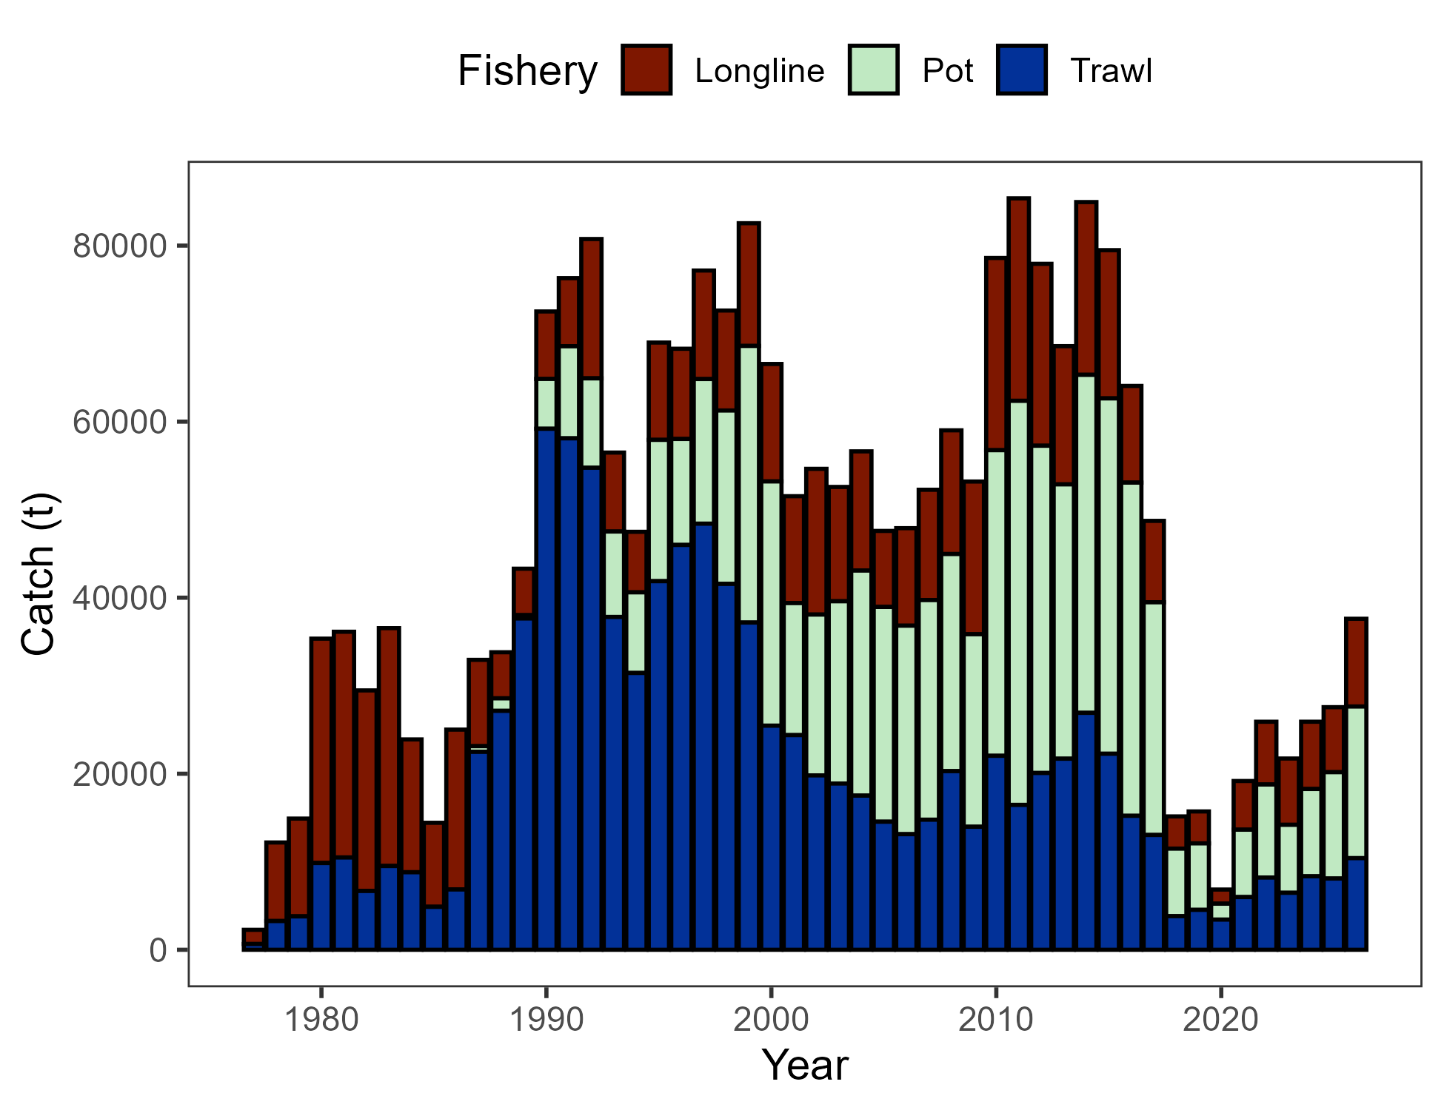

Figure 2.1. Commercial catch (mt) of Pacific cod in the GOA in trawl (FshTrawl), longline (FshLL), and pot (FshPot) gear from 1977-2026. Note that 2026 catch was through October 26.

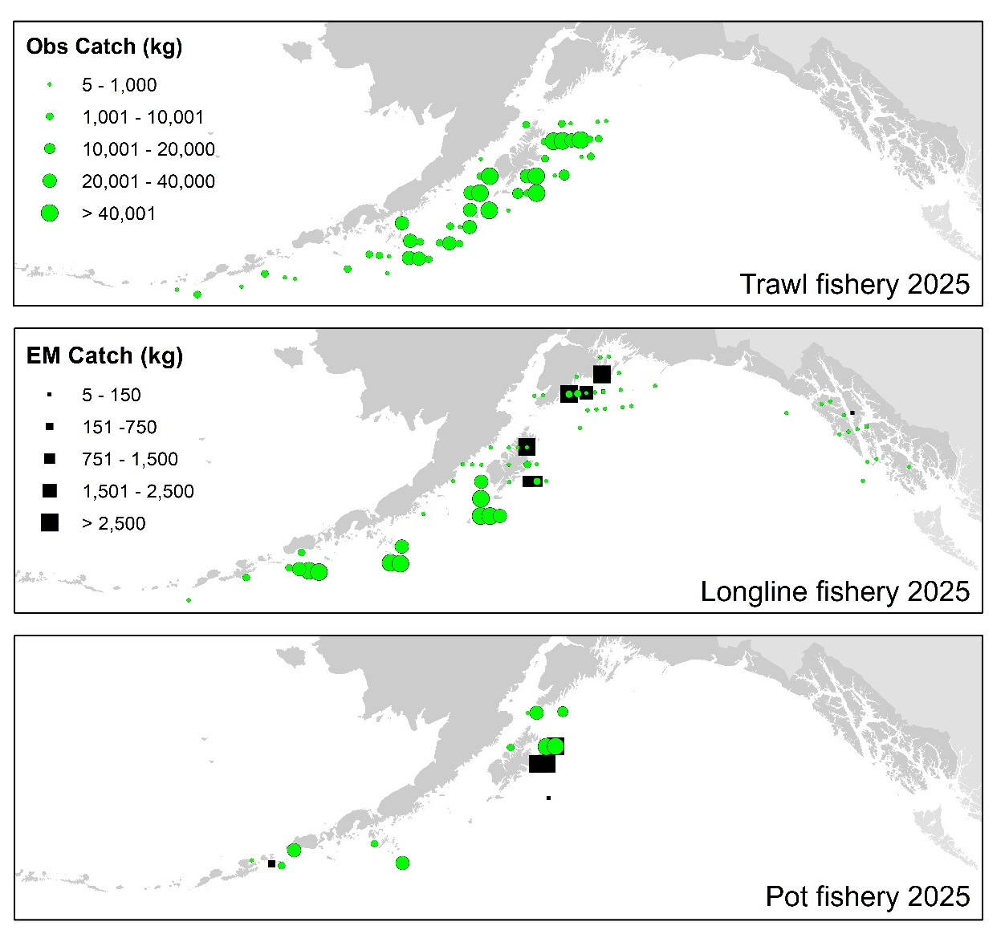

Figure 2.2. Observed (Obs) and electronically monitored (EM) commercial catch of Pacific cod in the GOA by 20 km² grid for 2025. These data include bycatch Pacific cod, but do not include trawl EM data as locations are not yet available.

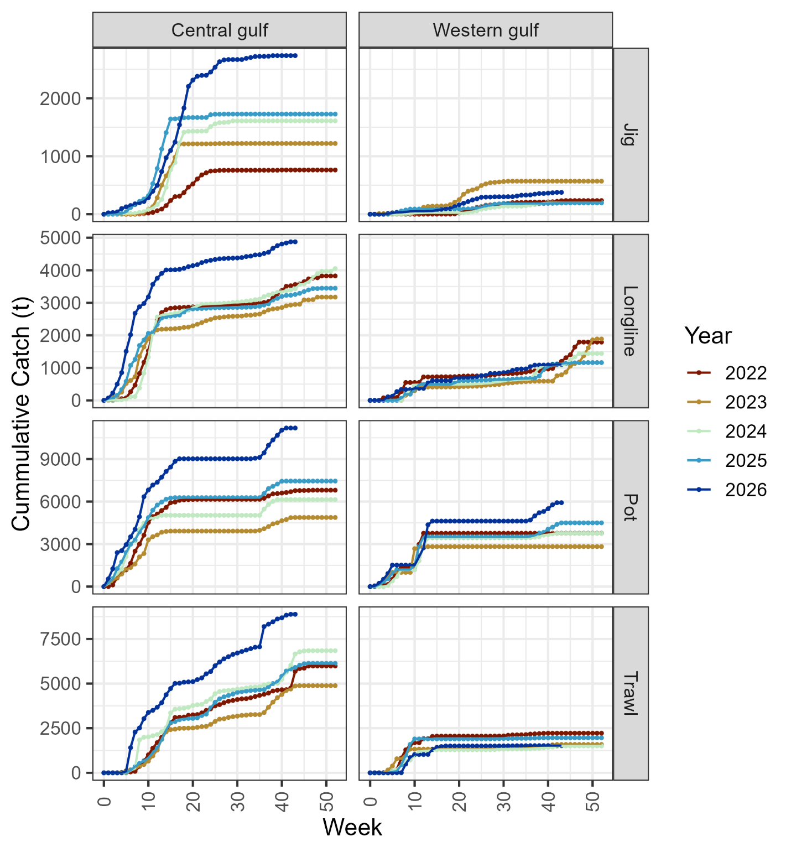

Figure 2.3. Cumulative catch week of the year for 2022–2026 by GOA sub-area and fleet (2026 catch through October 26). Note that for the assessment, data from the jig and longline gear were pooled into a distinct fishery.

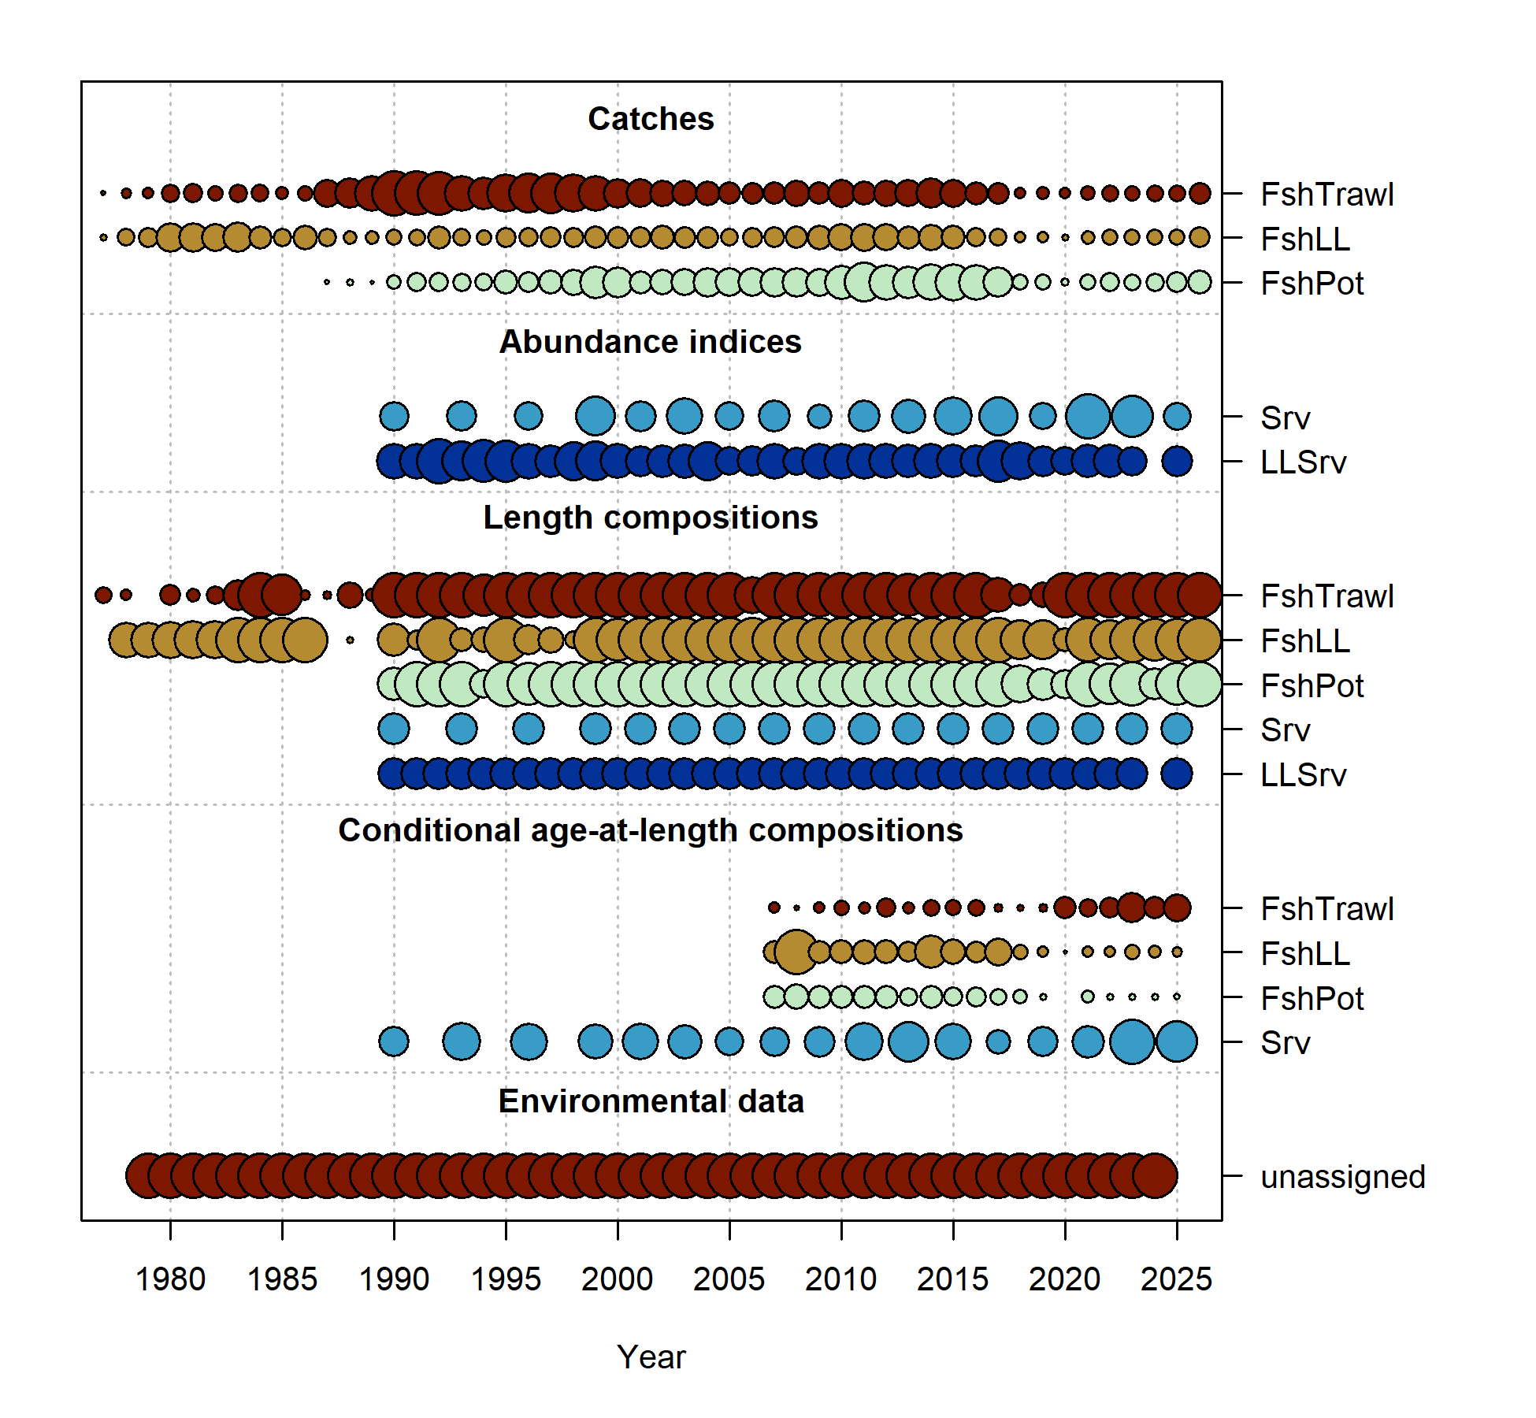

Figure 2.4. Data fit in Model 24.0. Circles are proportional to total catch for catches, precision for indices and input sample size for compositions and length-at-age observations. Data sources include fishery data from trawl (FshTrawl), longline (FshLL), and pot (FshPot) fisheries. Survey data include the AFSC longline (LLSrv) and bottom trawl (Srv) surveys. Note that since the circles are scaled relative to maximum within each type, the plots of scaling across dataset types should not be compared.

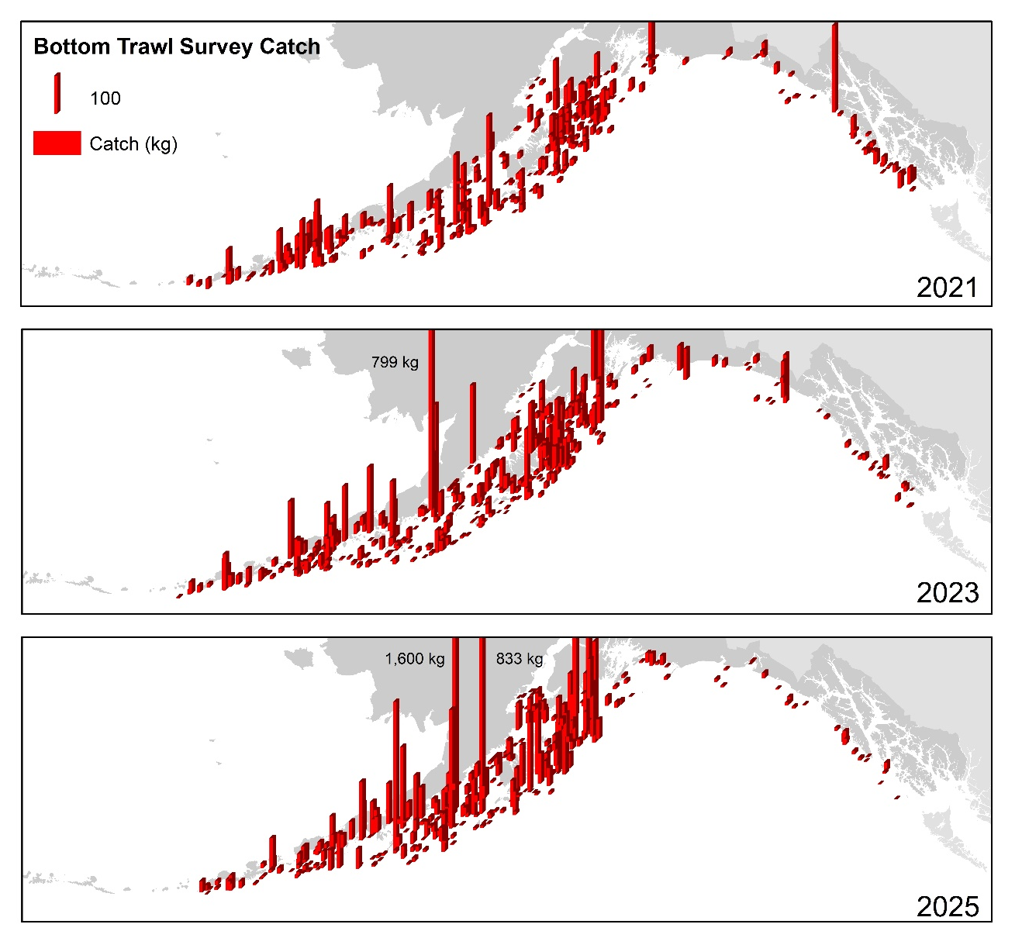

Figure 2.5. Distribution of AFSC bottom trawl survey catch (kg) of Pacific cod for 2021-2025.

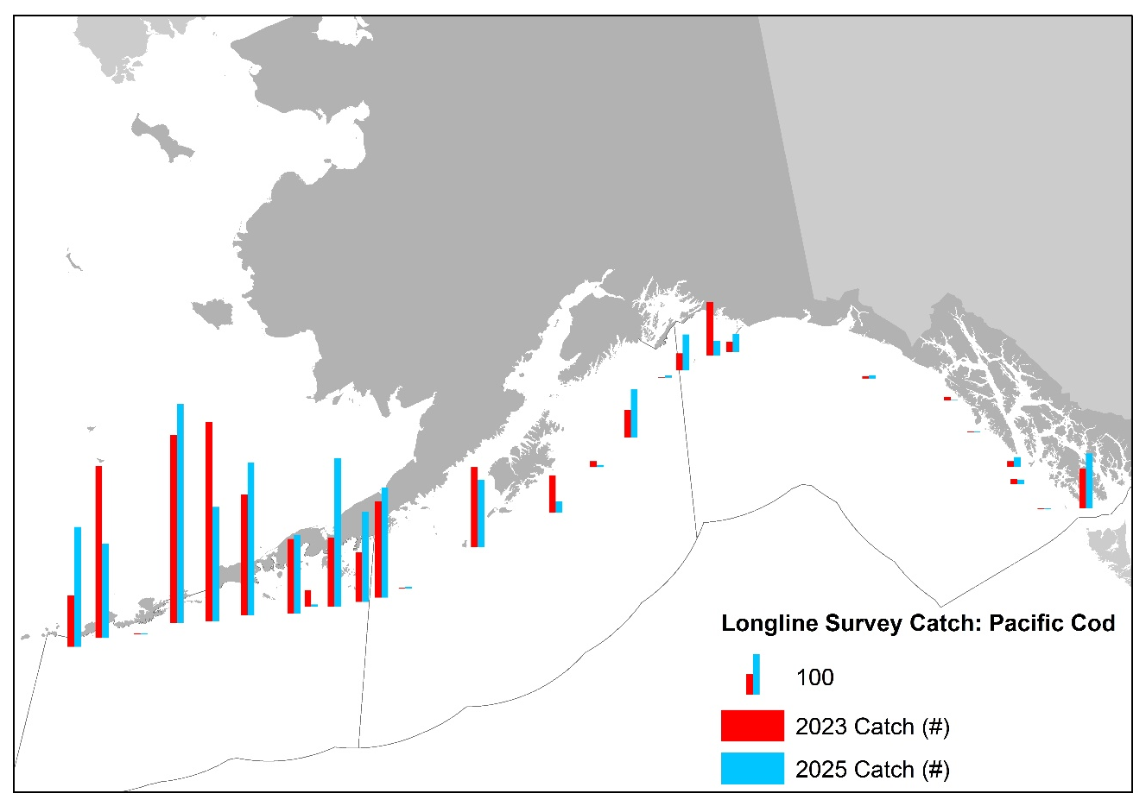

Figure 2.6. Distribution of AFSC longline survey catch (numbers) of Pacific cod in 2023 and 2025.

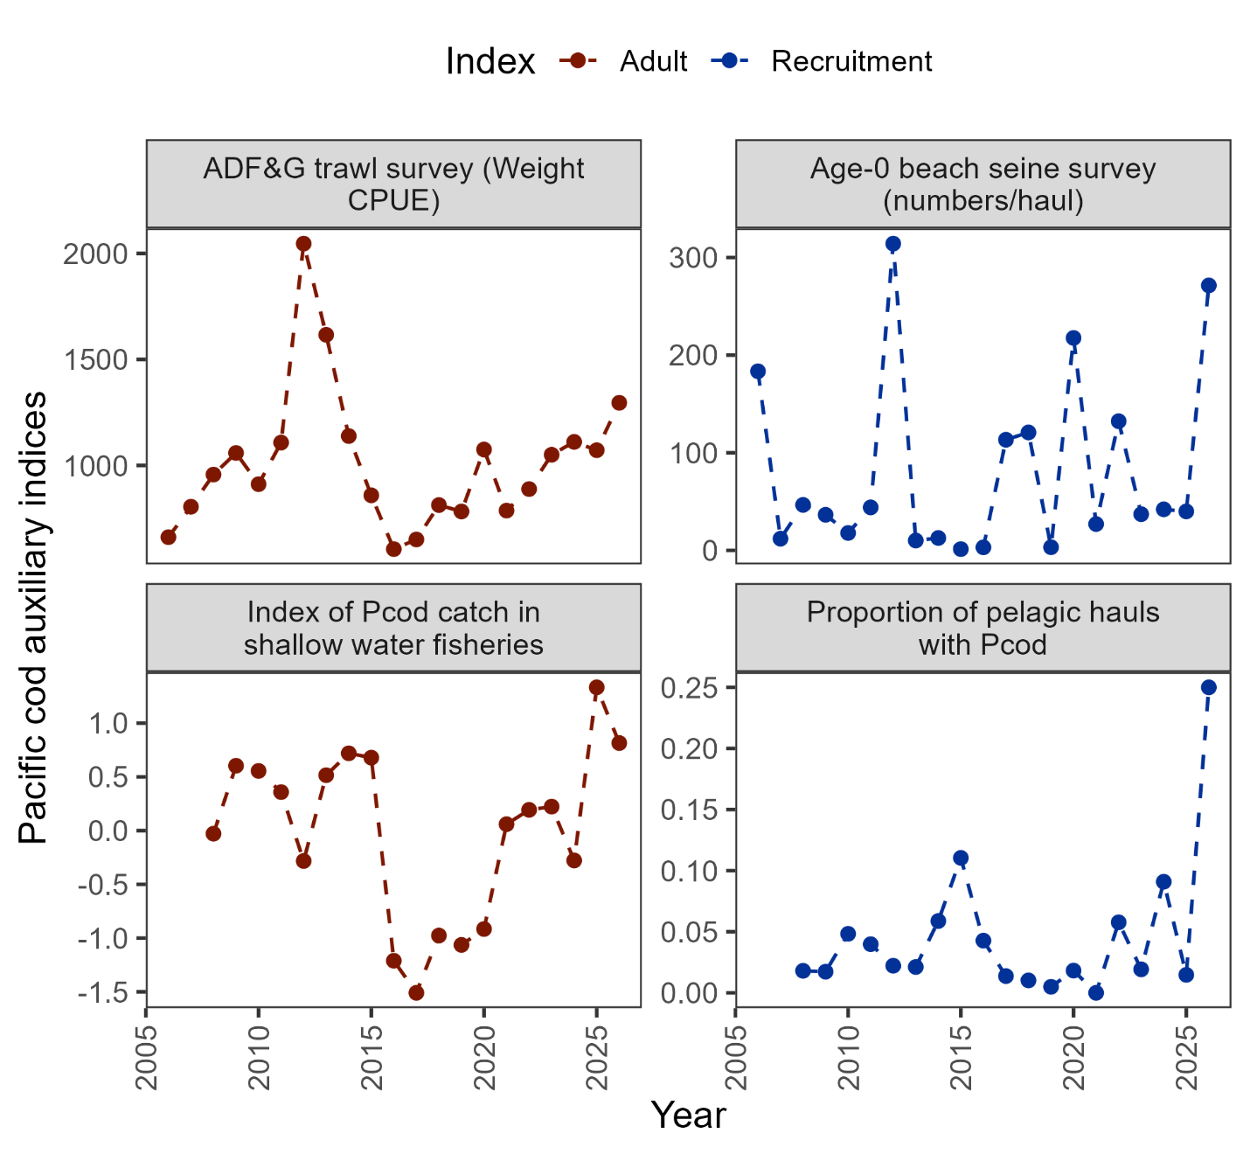

Figure 2.7. Auxiliary indices for GOA Pacific cod adult and recruitment abundance that are not used in the stock assessment model. ADFG bottom trawl survey numbers catch-per-unit-effort (top left panel) and proportion of Pacific cod bycatch in the GOA shallow water fisheries (bottom left panel) representing indices for adult abundance, and age-0 beach seine survey numbers per haul (top right panel) and proportion of pelagic trawls in the Central GOA A Season (January-April) walleye pollock fishery with Pacific cod present (bottom right panel) representing indices for recruitment.

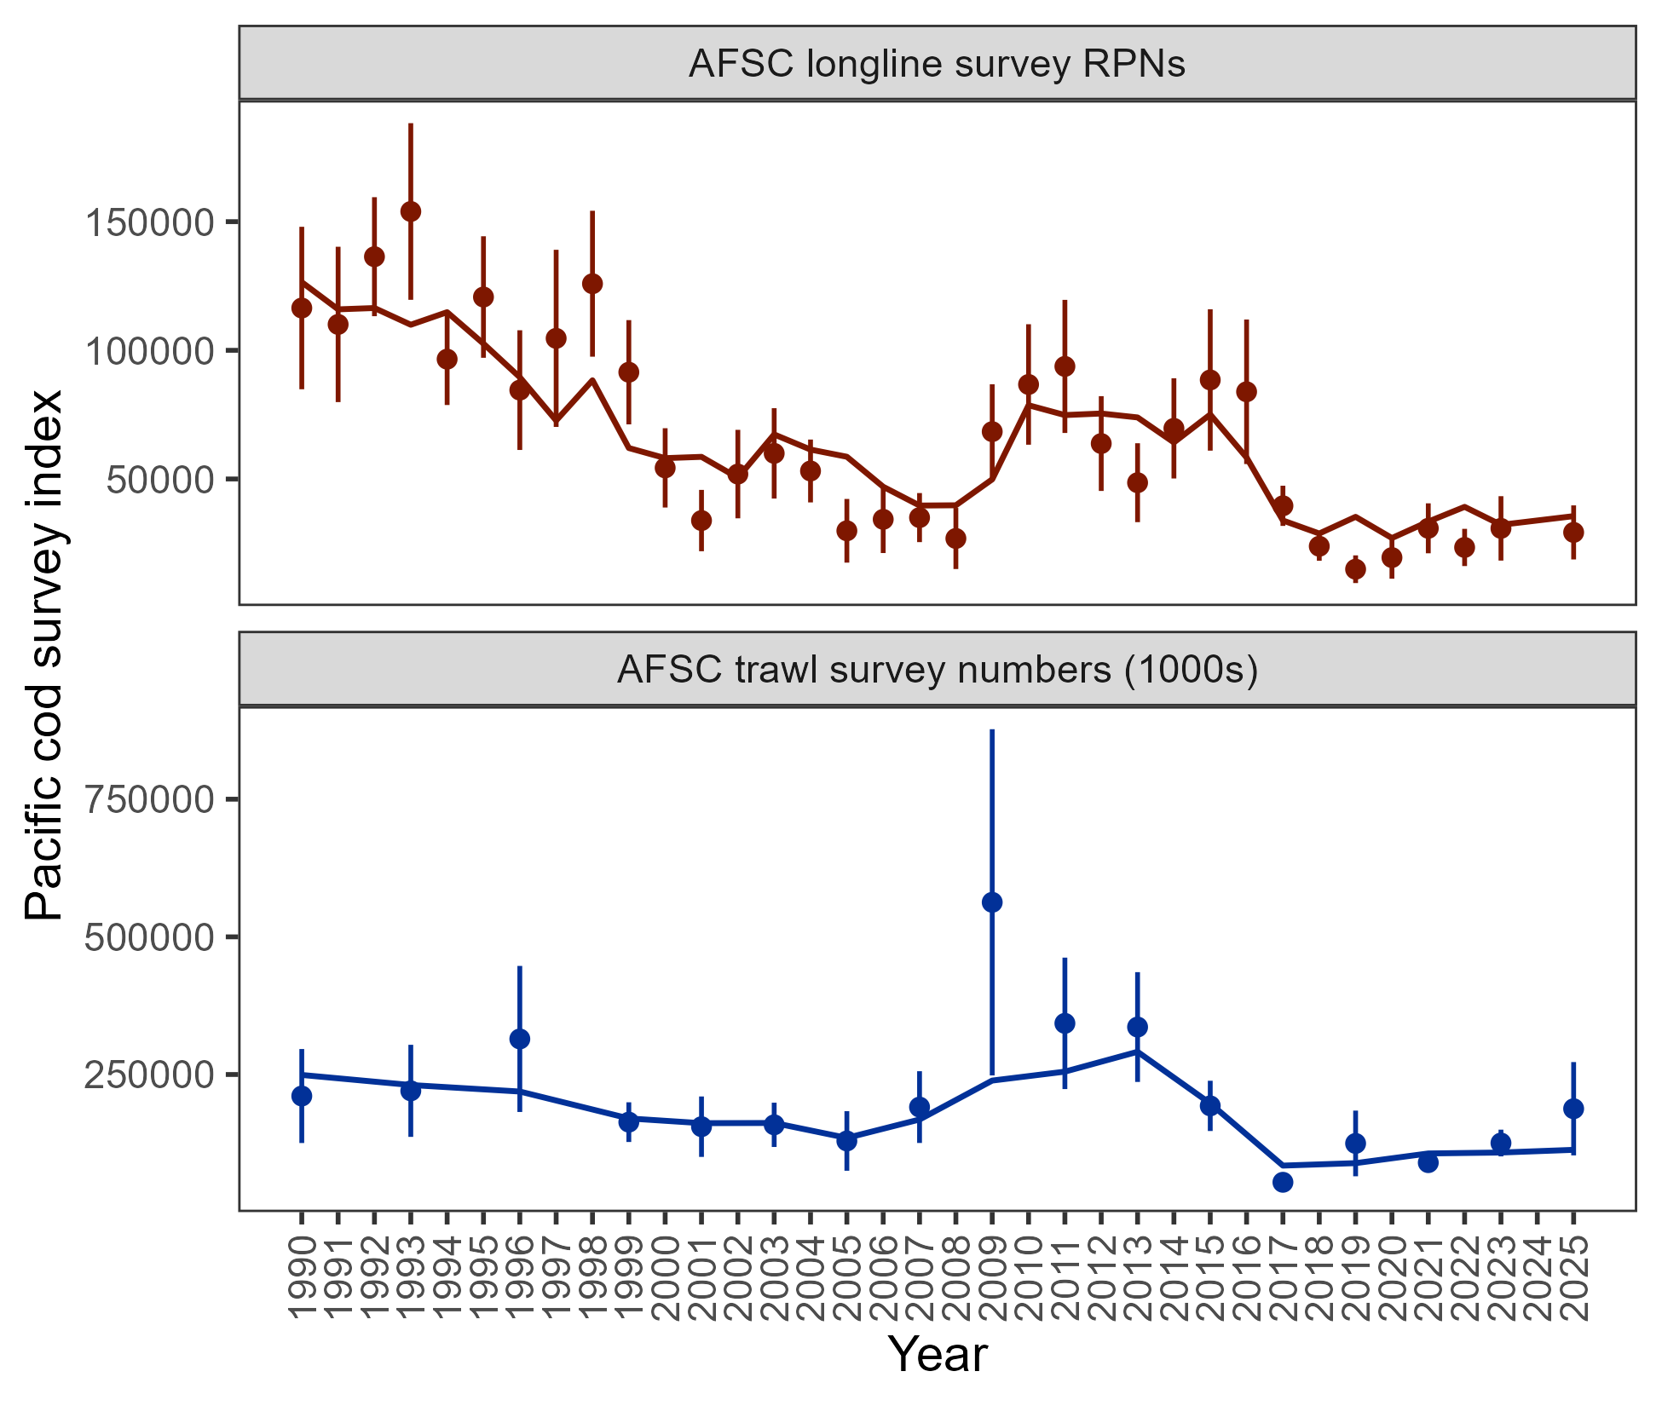

Figure 2.8. Population indices fit by model 24.0, including AFSC longline survey relative population numbers (RPN – top panel) and AFSC bottom trawl survey abundance (numbers – bottom panel). Model fit is shown as a solid line and observed data is shown as points (with error bars indicating the 95% confidence intervals).

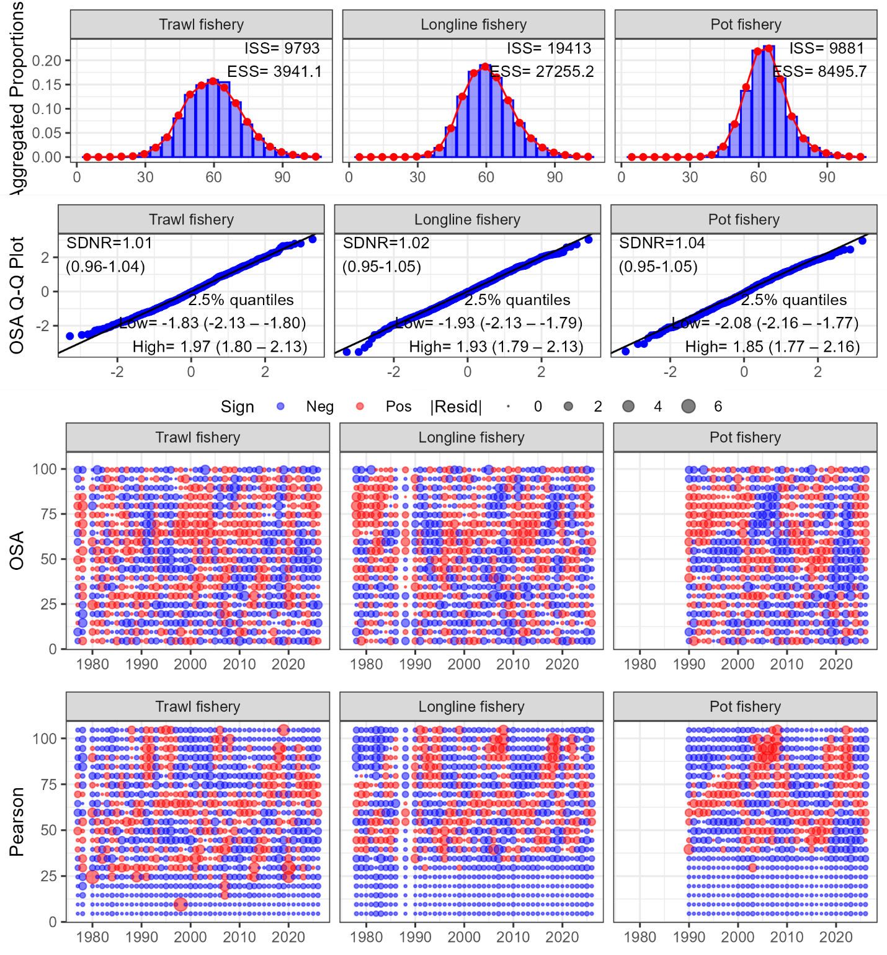

Figure 2.9. Aggregated model fit, theoretical versus sample quantiles, one-step ahead residuals, and Pearson residuals for the fishery length composition data (fleets shown across the columns) fit in model 24.0.

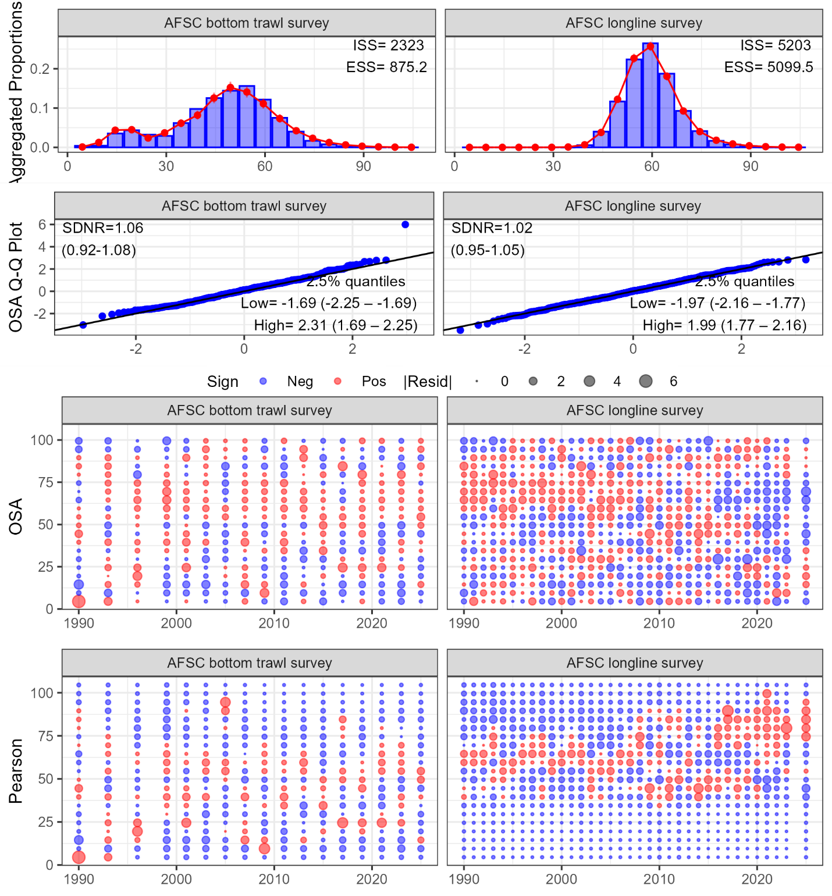

Figure 2.10. Aggregated model fit, theoretical versus sample quantiles, one-step ahead residuals, and Pearson residuals for the survey length composition data (surveys shown across the columns) fit in model 24.0.

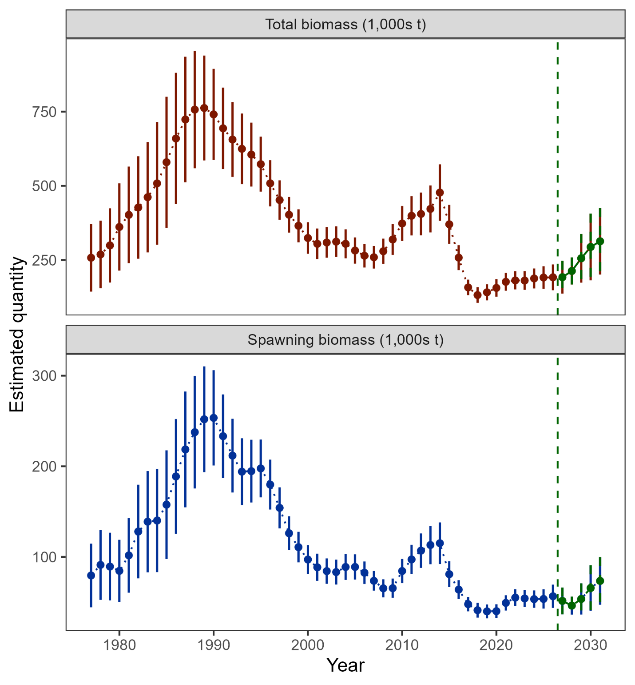

Figure 2.11. Estimated total biomass (top panel) and spawning biomass (bottom panel) from model 24.0 with 95% confidence intervals. The five-year forecasted biomass values are denoted in green shading and with the vertical dashed line in each plot.

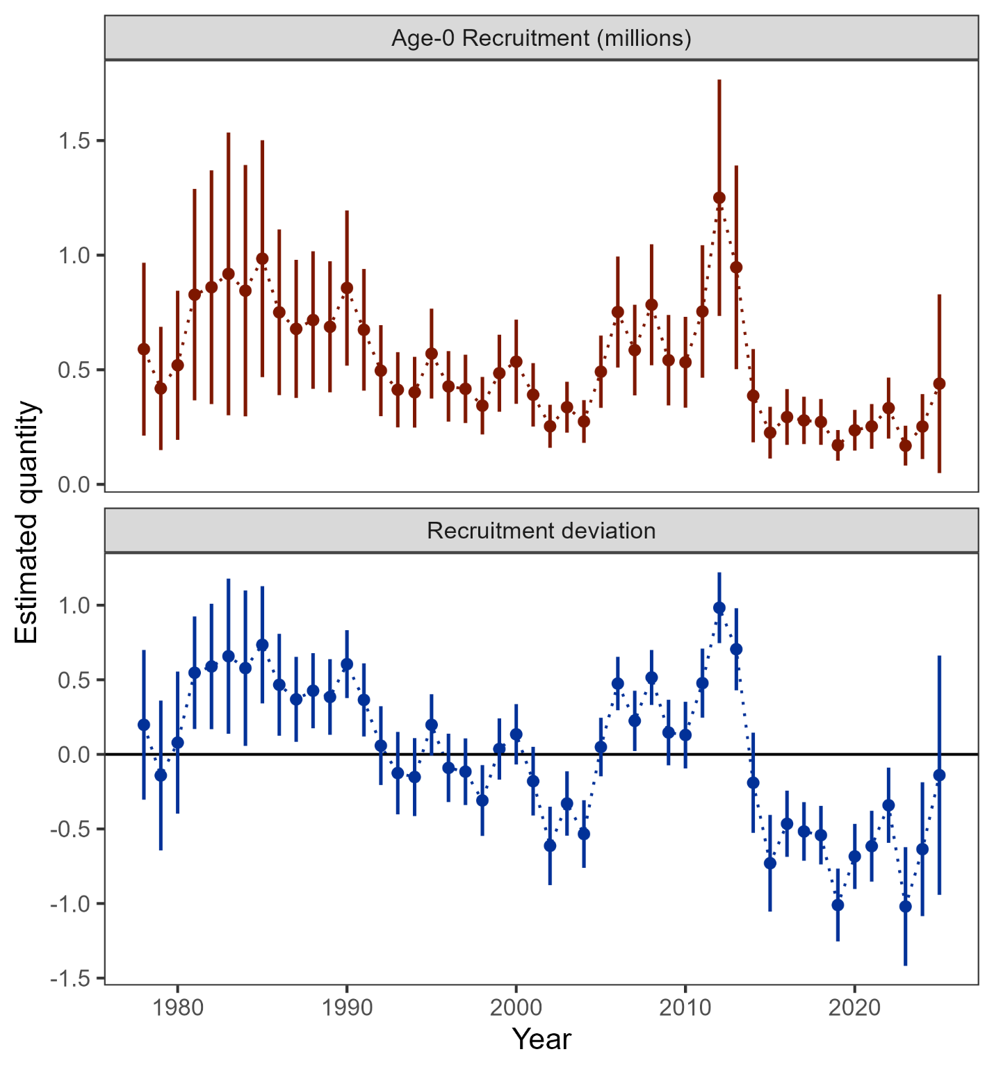

Figure 2.12. Age-0 recruitment (top panel) and log recruitment deviations (bottom panel) with 95% confidence intervals from model 24.0.

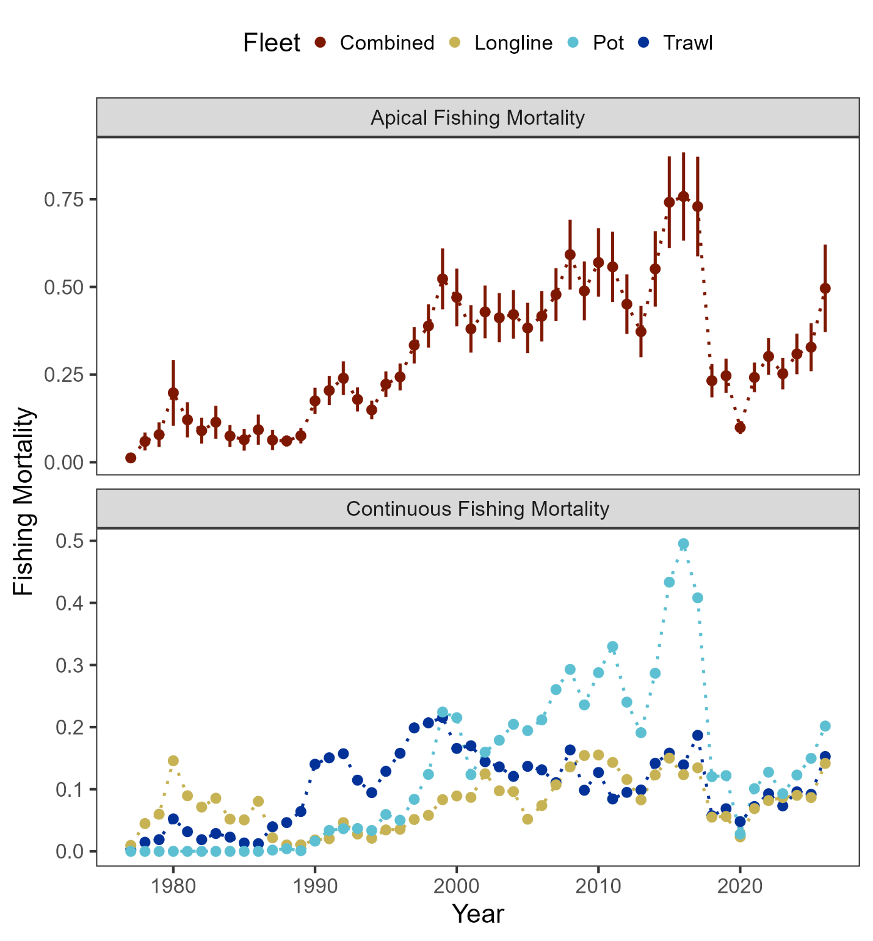

Figure 2.13. Sum of apical fishing mortality (top) and continuous fishing mortality by fisheries (bottom).

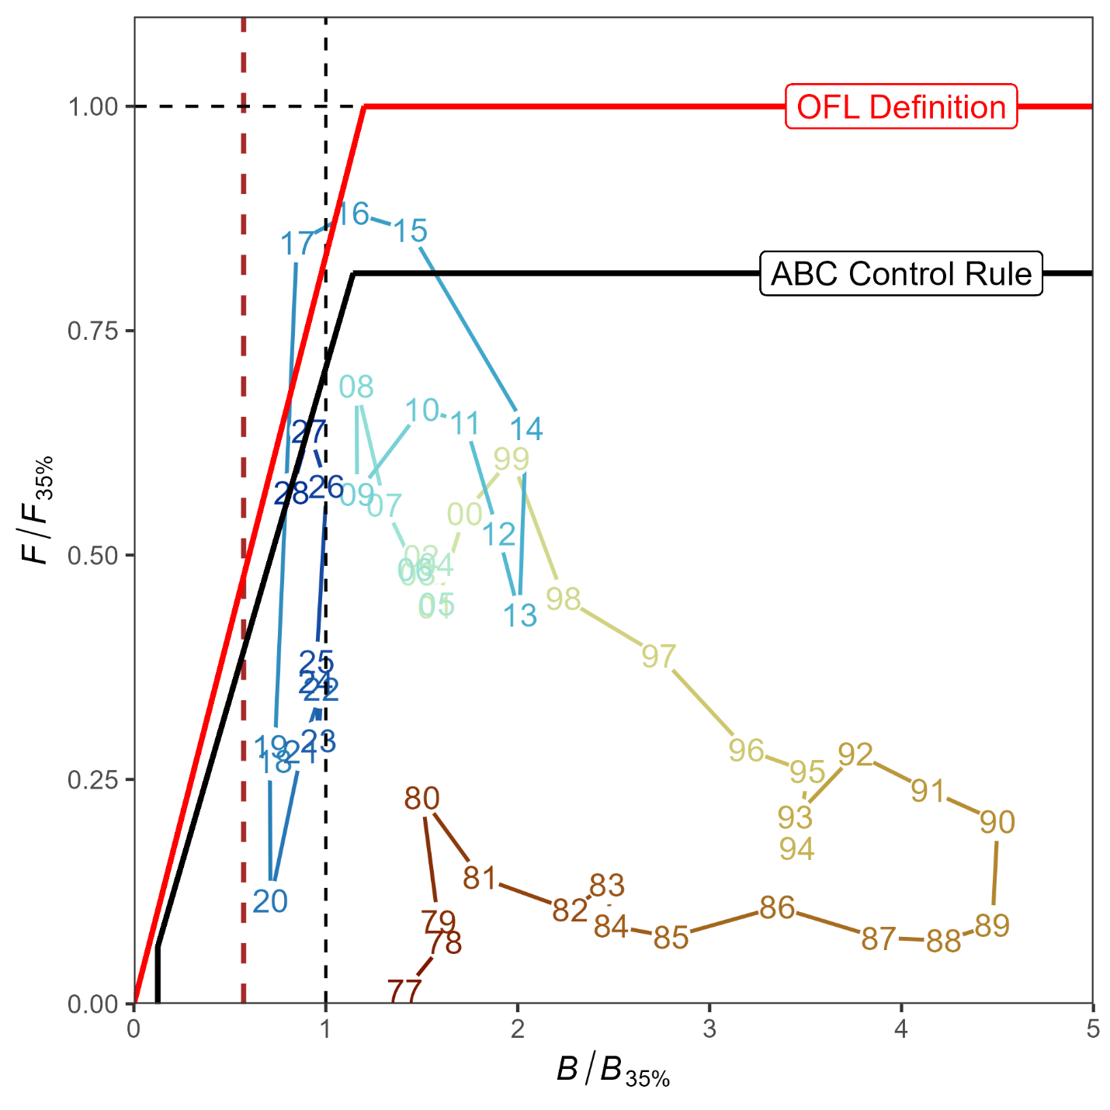

Figure 2.14. Ratio of historical F/F_{35%} versus female spawning biomass relative to B_{35%} for GOA Pacific cod, 1977-2028. The Fs presented are the sum of the full Fs across fleets. Dashed vertical red line is at B_{20%}, Steller sea lion closure rule for GOA Pacific cod.

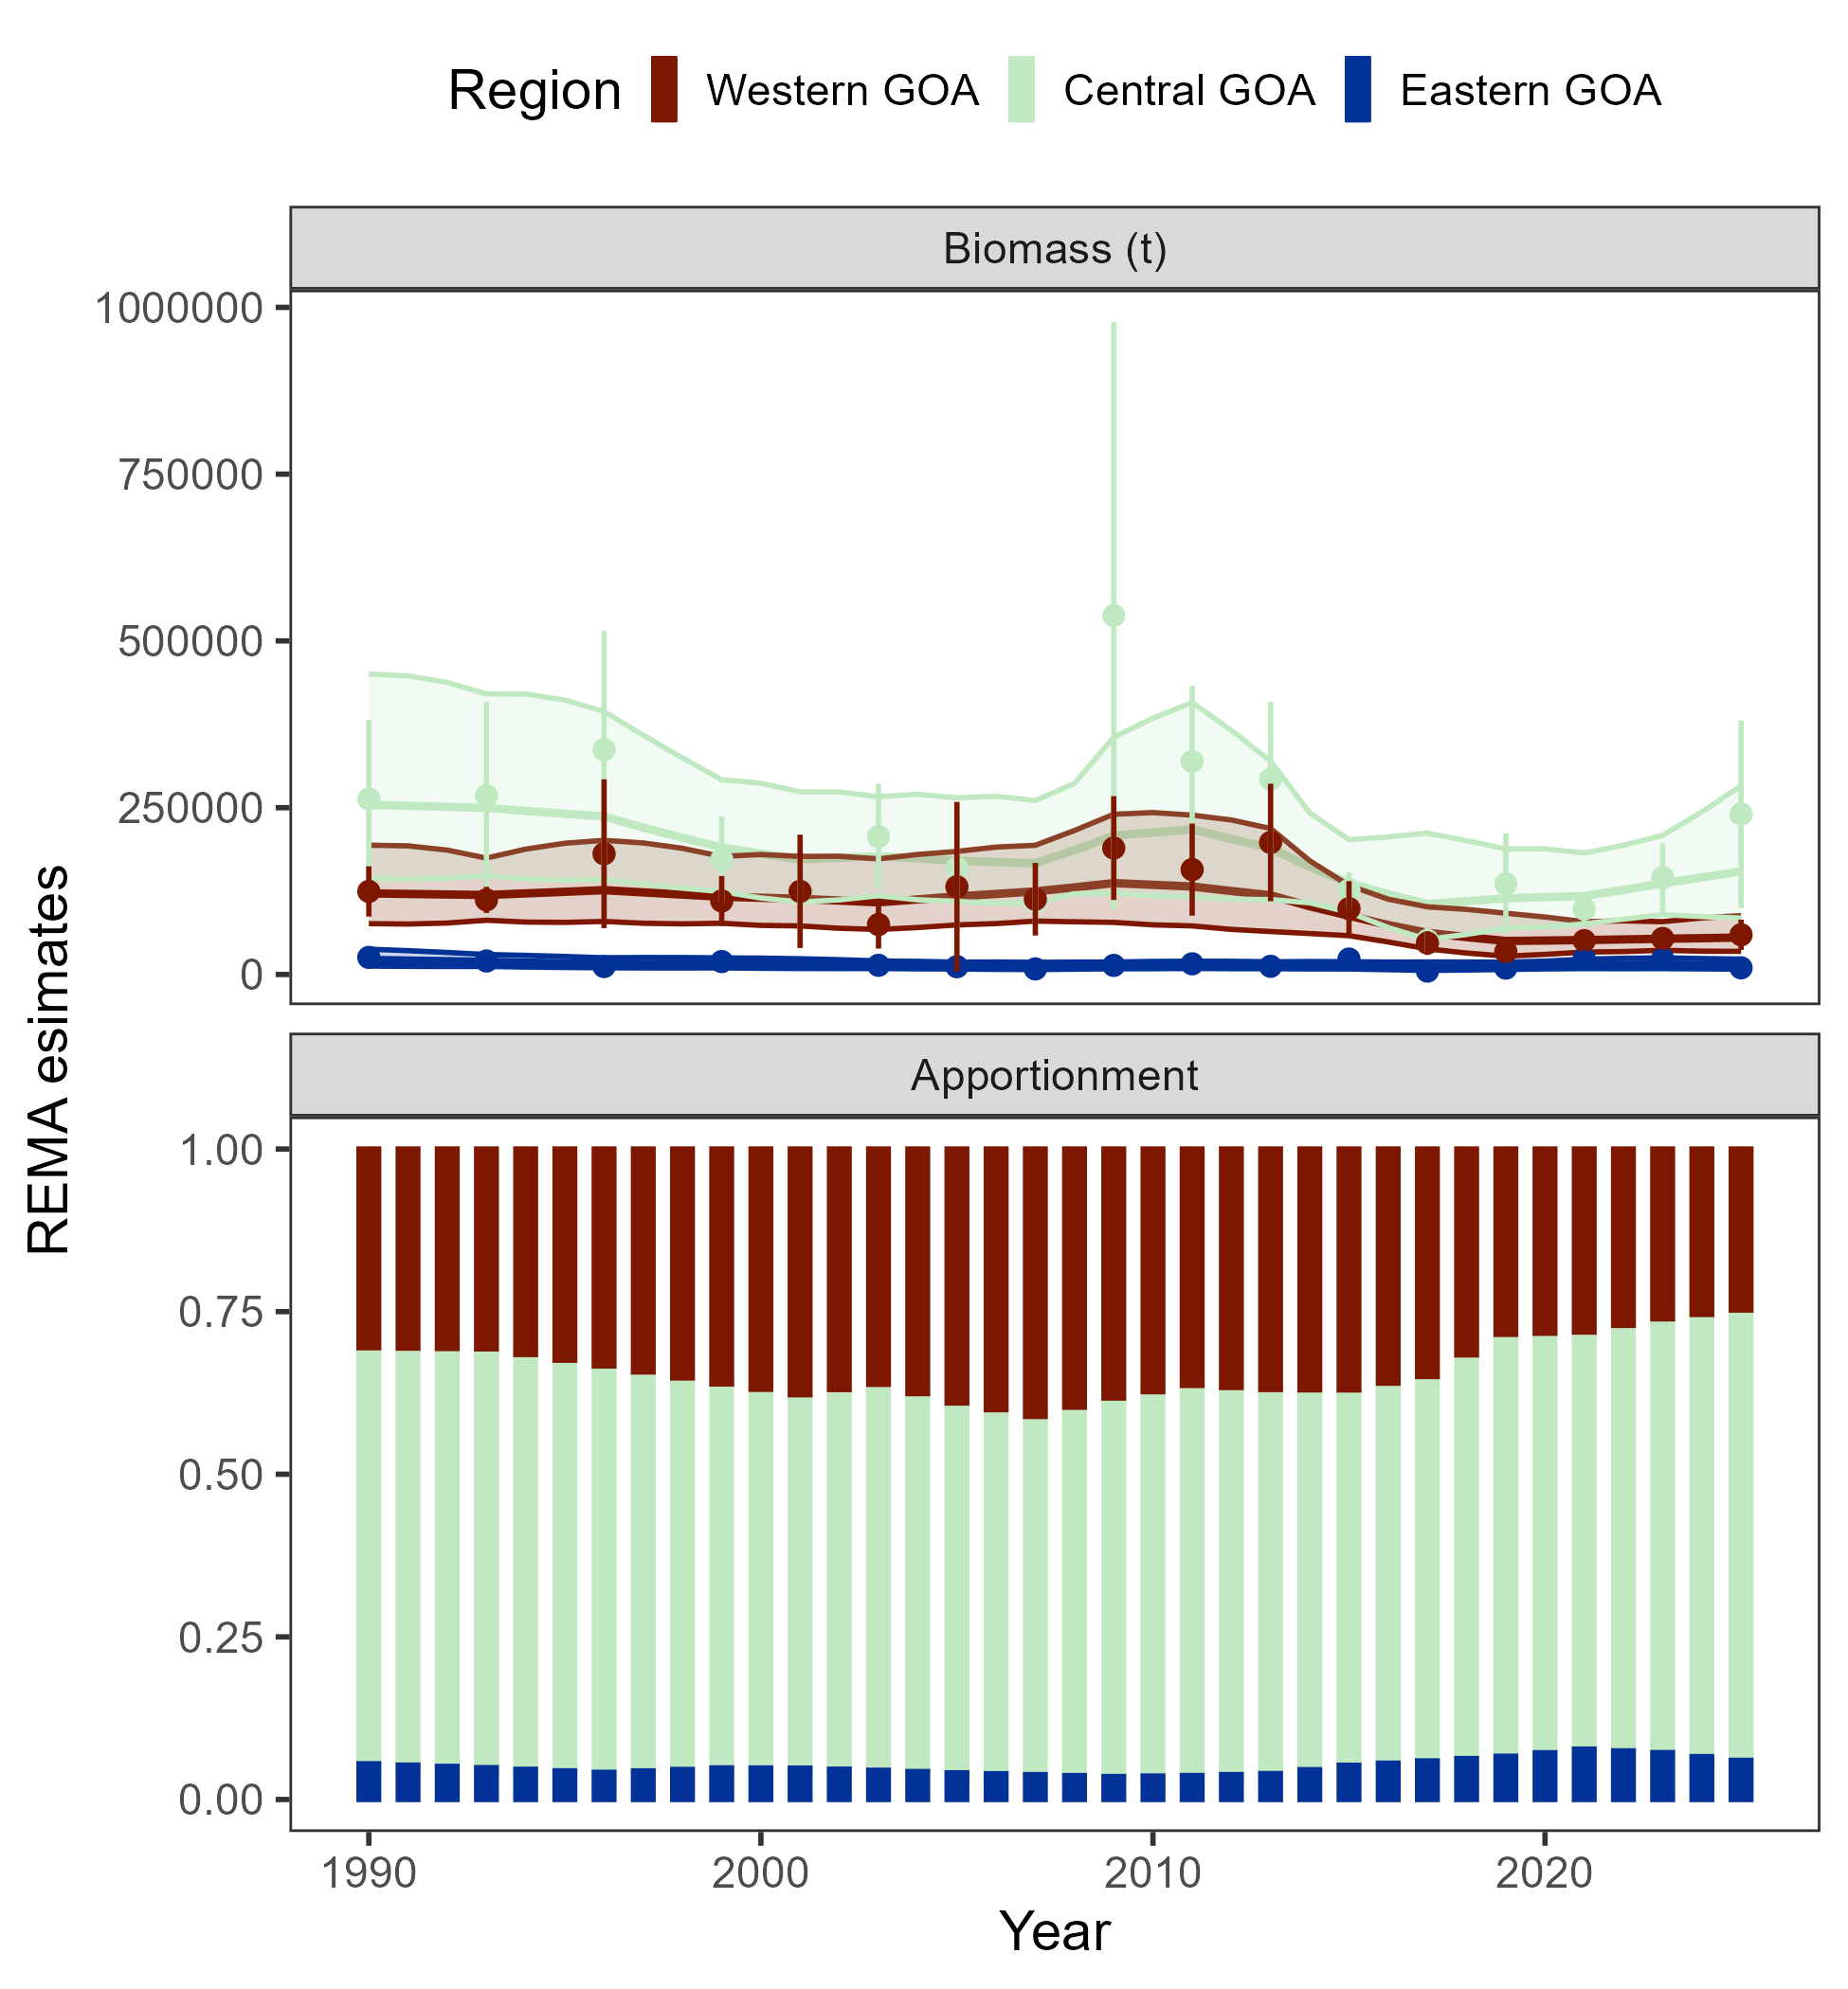

Figure 2.15. Fits from the rema model to the AFSC bottom trawl survey by area (top panel) and estimated apportionment (bottom panel).

Appendix 2.1 Ecosystem and Socioeconomic Profile of the Pacific cod stock in the Gulf of Alaska - Report Card
The ESP can be found at this link.

