# Supplementary Material

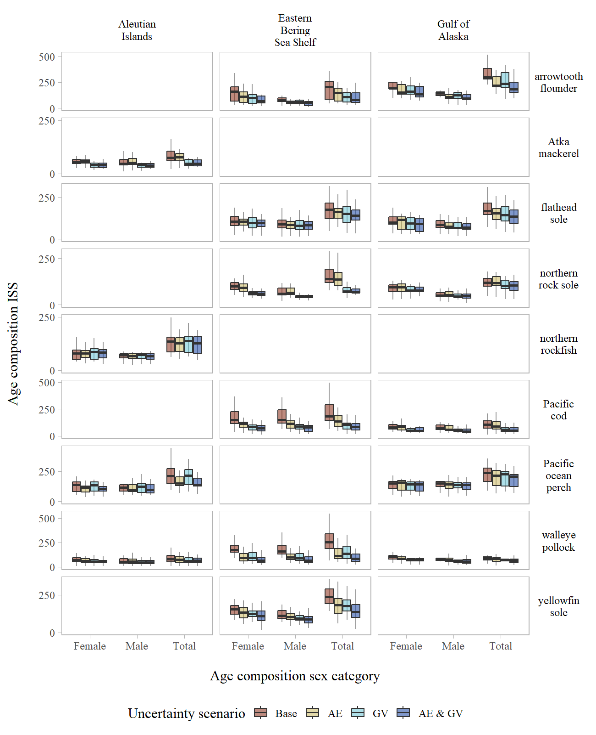

Figure S1. Age composition input sample size by sex-category across the uncertainty scenarios evaluated for 1 cm length bins with pooled growth data used for growth variability.

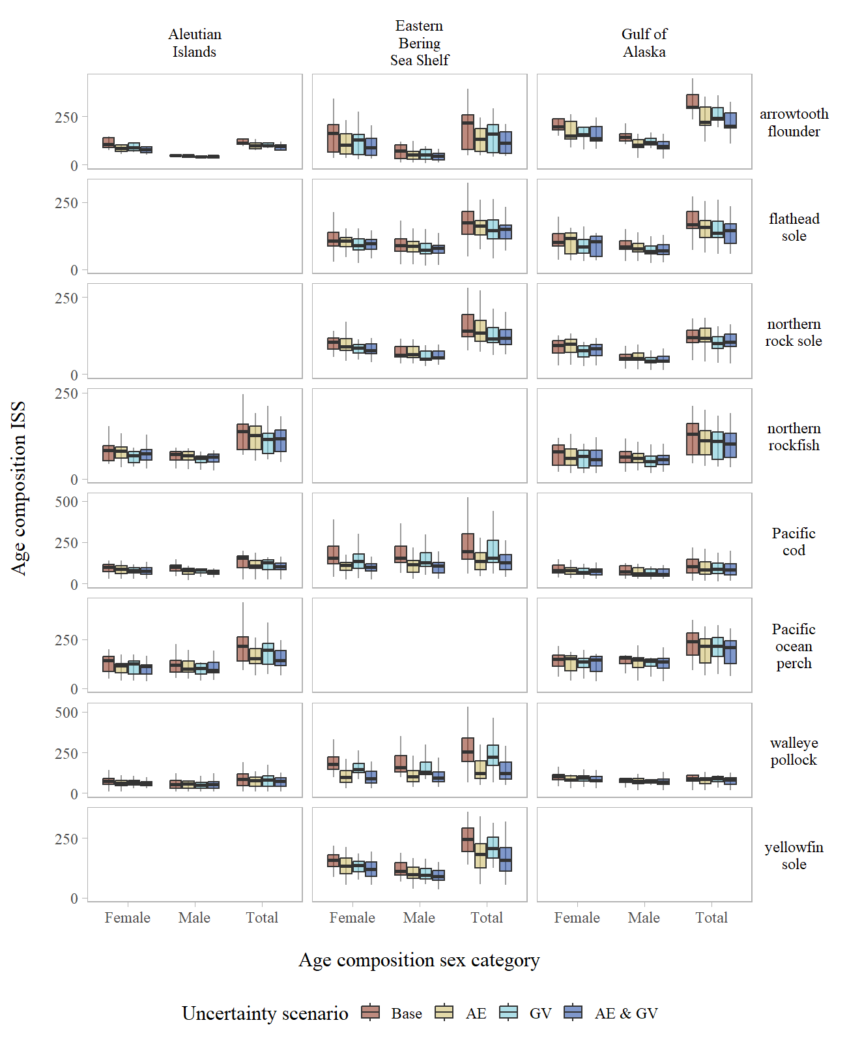

Figure S2. Age composition input sample size by sex-category across the uncertainty scenarios evaluated for 1 cm length bins with annual growth data used for growth variability.

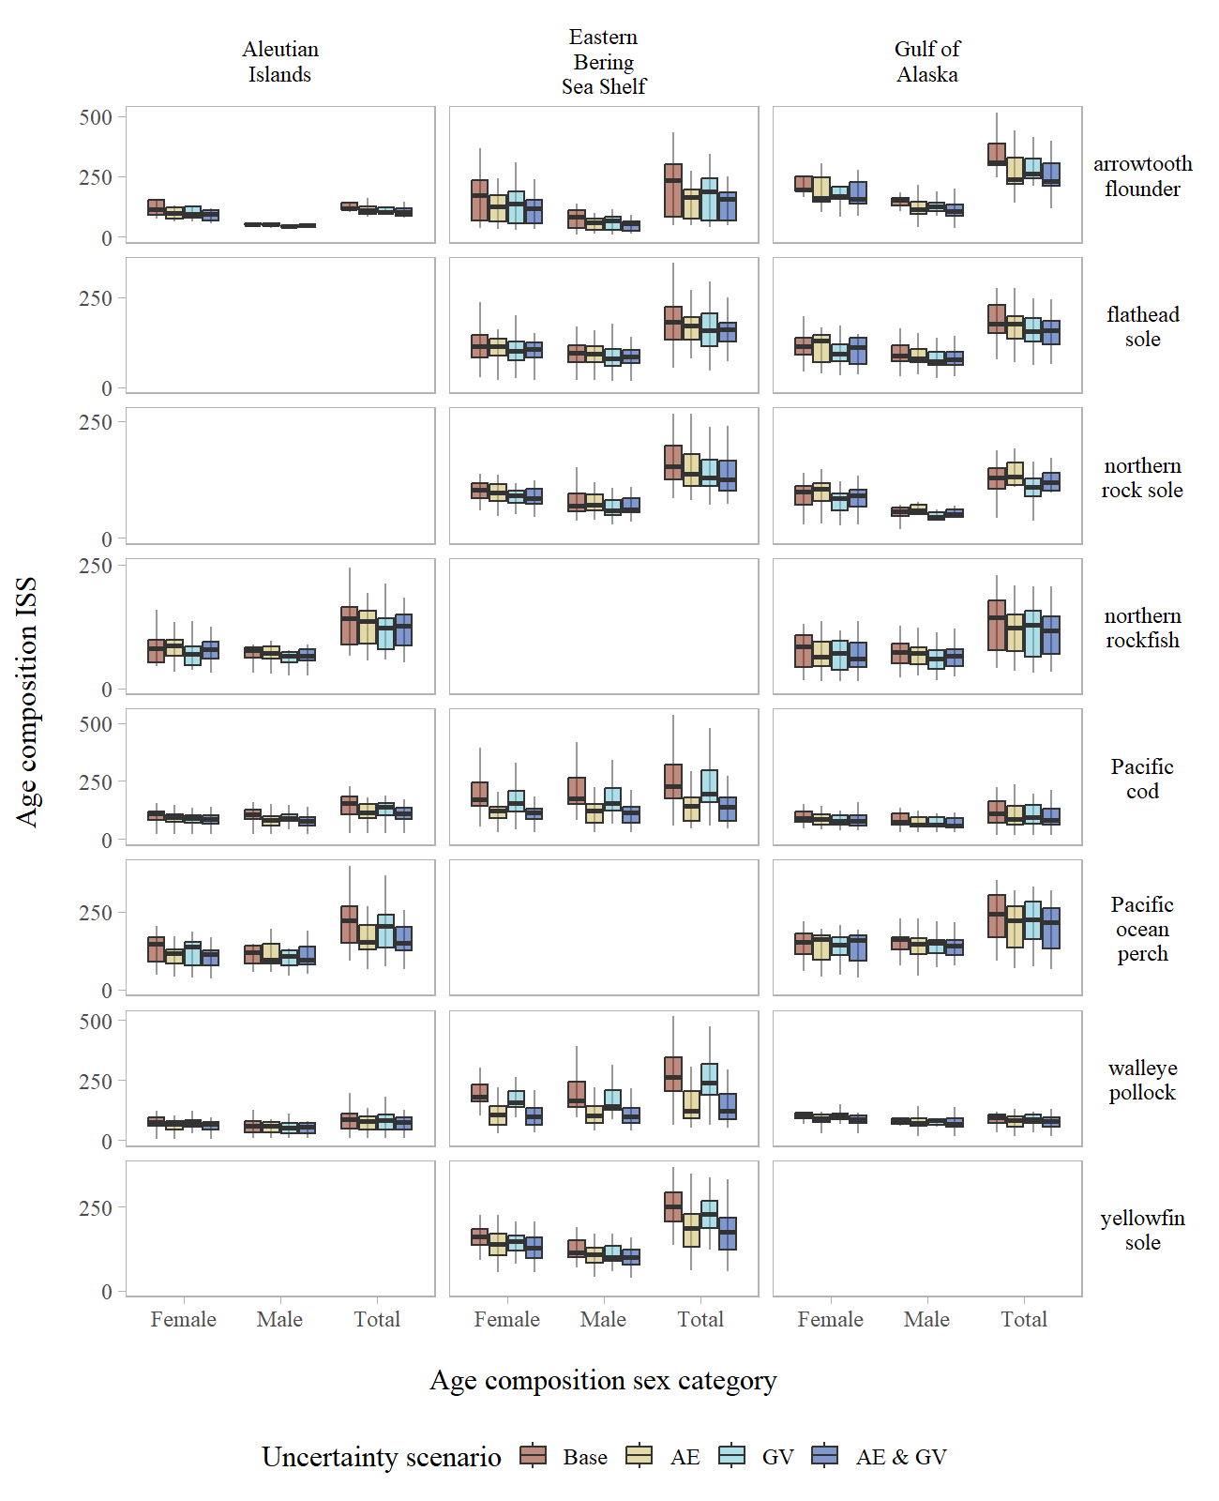

Figure S3. Age composition input sample size by sex-category across the uncertainty scenarios evaluated for 2 cm length bins with annual growth data used for growth variability.

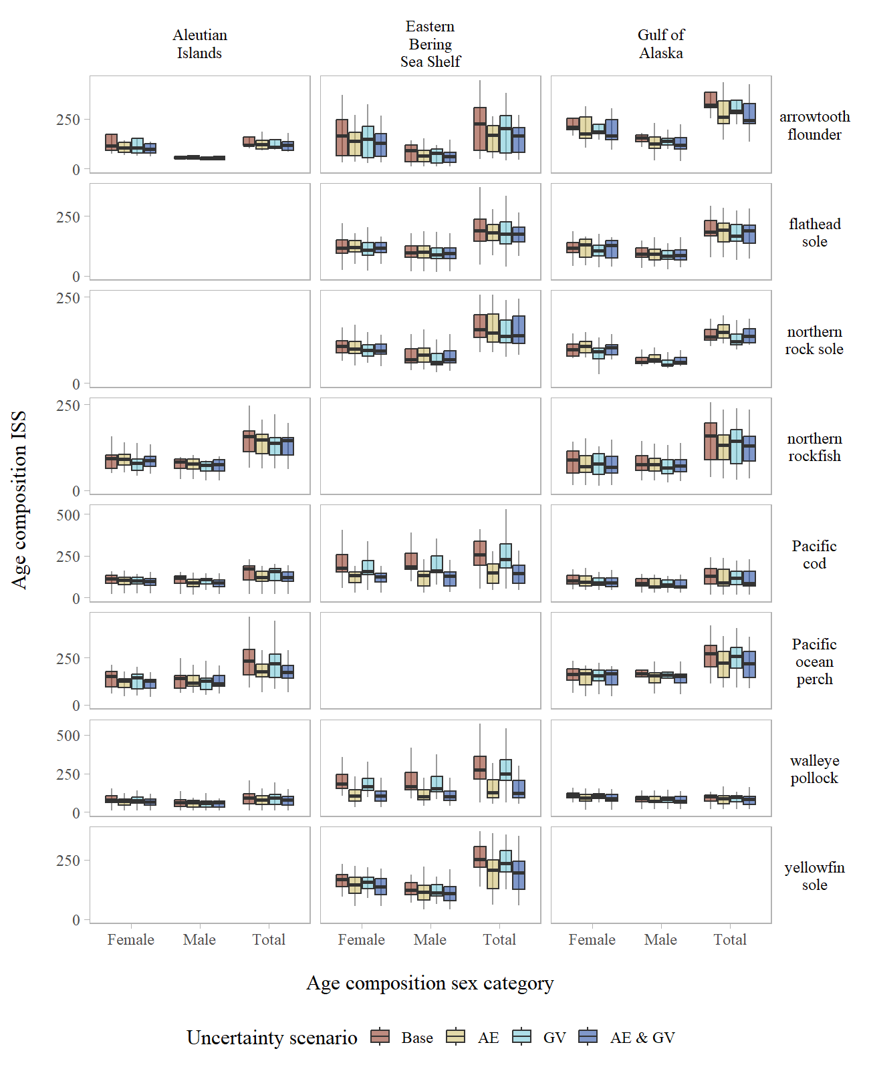

Figure S4. Age composition input sample size by sex-category across the uncertainty scenarios evaluated for 5 cm length bins with annual growth data used for growth variability.