# Tables

Table 1: Average annual age samples from the AFSC bottom trawl surveys by region (rounded to the nearest 10), and total reader-tester age pairs (rounded to the nearest 100) for the stocks evaluated in the bootstrap-simulation.

| Stock (species type) | Scientific name | AI | EBS | GOA | R-T |
| --- | --- | --- | --- | --- | --- |
| arrowtooth flounder (flatfish) | *Atheresthes stomias* | 450 | 480 | 850 | 6,100 |
| flathead sole (flatfish) | *Hippoglossoides elassodon* | – | 560 | 520 | 9,400 |
| northern rock sole (flatfish) | *Lepidopsetta polyxystra* | – | 460 | 450 | 8,900 |
| northern rockfish (rockfish) | *Sebastes polyspinis* | 570 | – | 450 | 6,400 |
| Pacific cod (gadid) | *Gadus macrocephalus* | 800 | 1070 | 650 | 21,200 |
| Pacific ocean perch (rockfish) | *Sebastes alutus* | 940 | – | 1030 | 13,500 |
| walleye pollock (gadid) | *Gadus chalcogrammus* | 790 | 1500 | 1300 | 84,400 |
| yellowfin sole (flatfish) | *Limanda aspera* | – | 750 | – | 10,300 |

Table 2. Description and notation for Bootstrap-simulation evaluations.

|  |  |
| --- | --- |
| Uncertainty scenarios | |
| Base | Standard bootstrap-simulation (omitting steps 5 and 6 that include ageing error and growth variability in the Bootstrap-Simulation framework) |
| AE | Bootstrap-simulation including ageing error only |
| GV | Bootstrap-simulation including growth variability only |
| AE & GV | Bootstrap-simulation including both ageing error and growth variability |
| Treatments | |
| Growth variability treatment | Resample lengths for a given age after pooling age-length data across survey years ('Pooled') or using annual age-length data ('Annual') |
| Length bin treatment | Implement 1 cm, 2 cm, and 5 cm length bins in the length data |
| Aggregation treatment | Aggregate length and age data before ('Pre-expansion') or after ('Post-expansion') length and age expansion |

# Figures

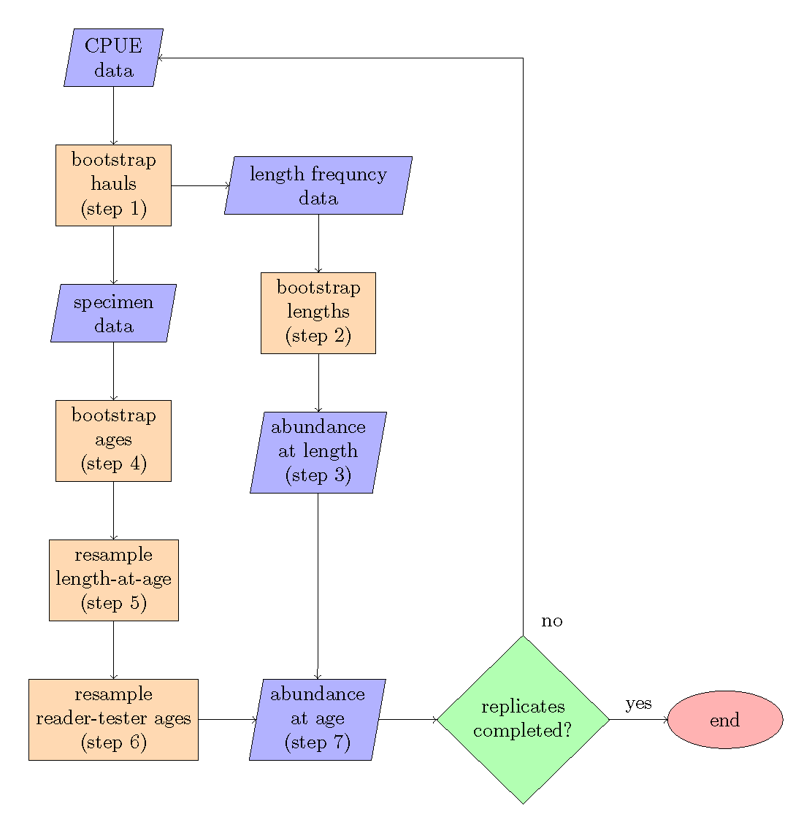

Figure 1: Bootstrap-simulation flow chart, the steps refer to the order of operations.

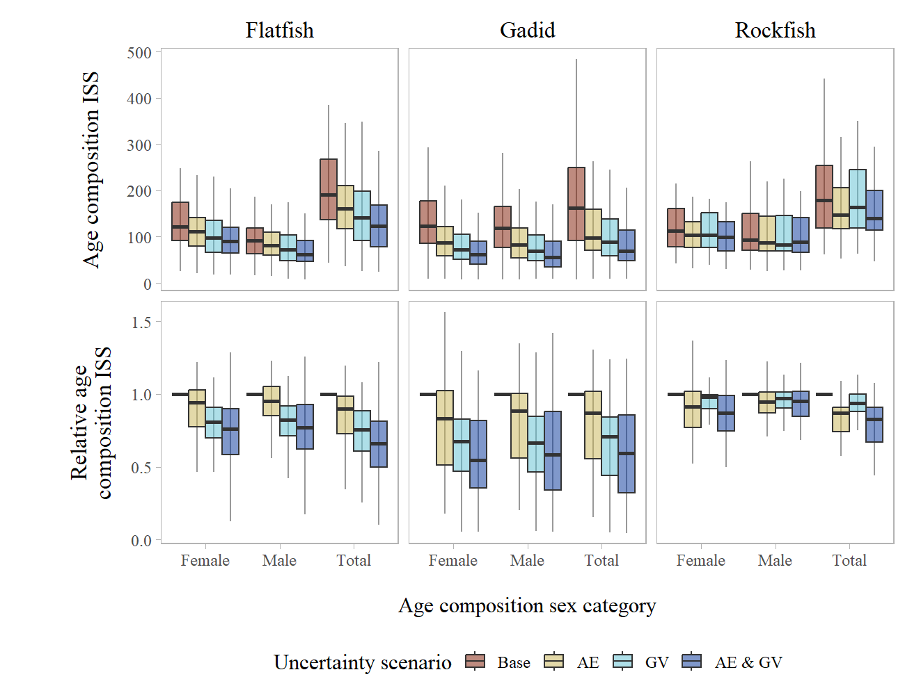

Figure 2: Boxplot of annual age composition input sample size (top row) and relative age composition input sample size (bottom row) aggregated by species type across uncertainty scenarios within each sex category (for 1 cm length bins and pooled growth data). ‘Base’ refers to the case that includes no additional sources of uncertainty, ‘AE’ is the case when ageing error is included, ‘GV’ is the case when growth variability is included, and ‘AE & GV’ is the case when both ageing error and growth variability is included. The boxplots shows the median (solid line), 25% - 75% percentile range (box limits, also called the inter-quartile range), and 1.5 times the inter-quartile range (whiskers).

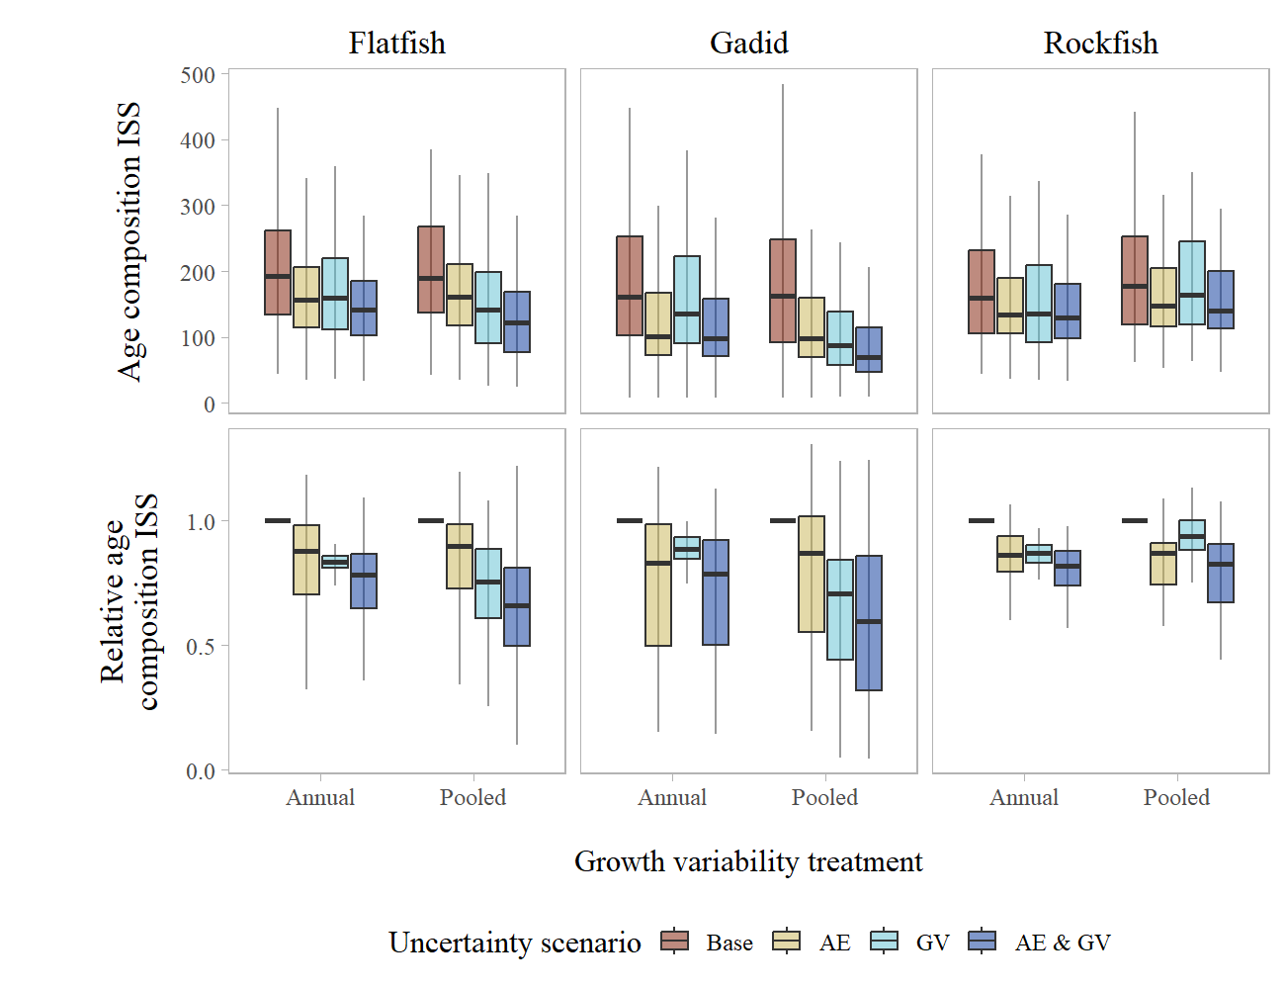

Figure 3: Boxplot of annual age composition input sample size (top row) and relative age composition input sample size (bottom row) aggregated by species type across uncertainty scenarios within each growth variability treatment (for 1 cm length bins, averaged across sex categories). ‘Base’ refers to the case that includes no additional sources of uncertainty, ‘AE’ is the case when ageing error is included, ‘GV’ is the case when growth variability is included, and ‘AE & GV’ is the case when both ageing error and growth variability is included. The boxplots shows the median (solid line), 25% - 75% percentile range (box limits, also called the inter-quartile range), and 1.5 times the inter-quartile range (whiskers).

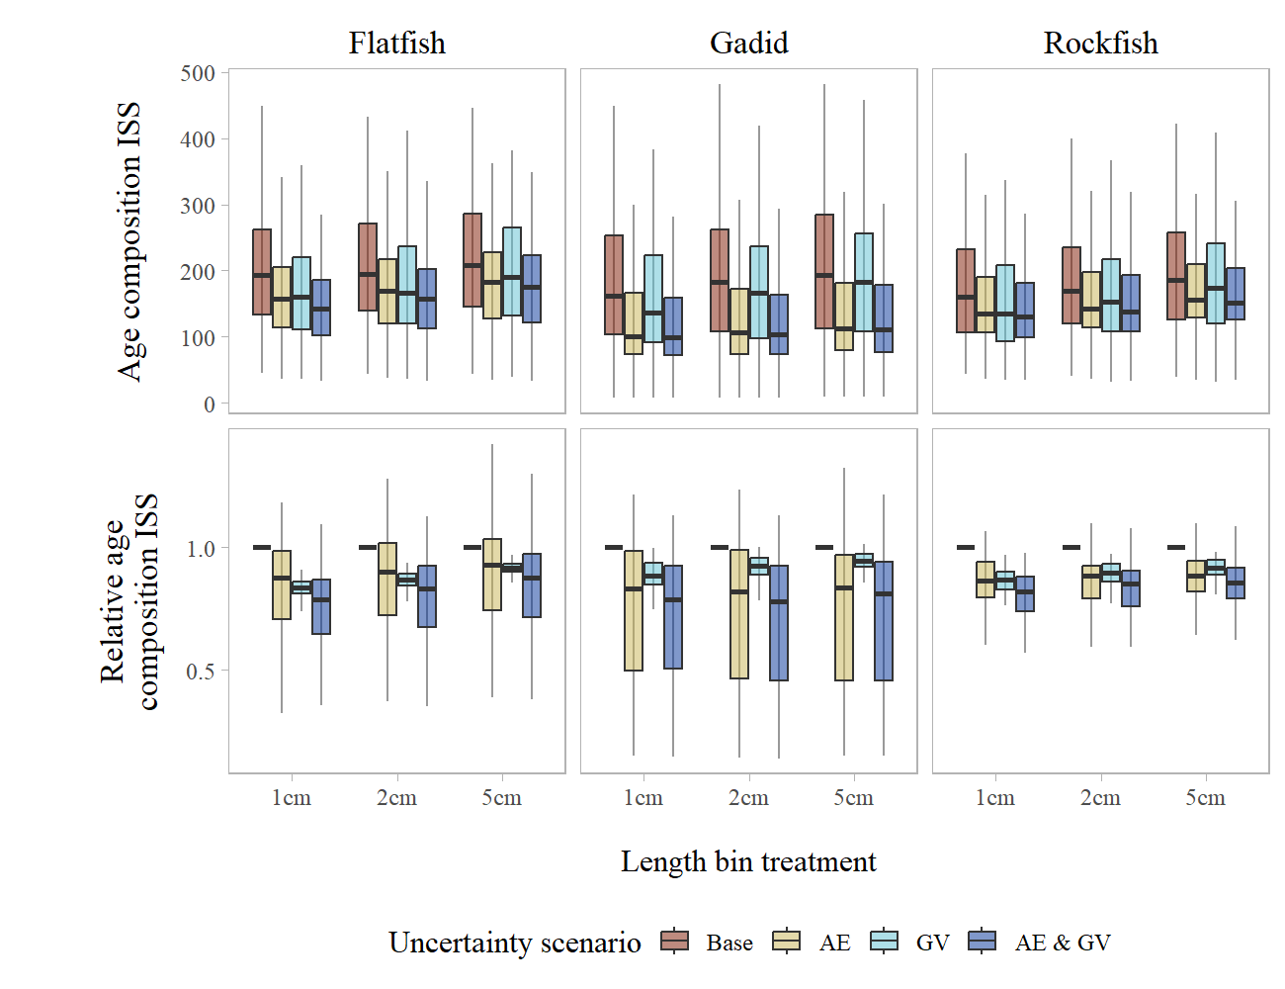

Figure 4: Boxplot of annual age composition input sample size (top row) and relative age composition input sample size (bottom row) aggregated by species type across uncertainty scenarios within each length bin treatment (using annual growth data and total age composition). ‘Base’ refers to the case that includes no additional sources of uncertainty, ‘AE’ is the case when ageing error is included, ‘GV’ is the case when growth variability is included, and ‘AE & GV’ is the case when both ageing error and growth variability is included. The boxplots shows the median (solid line), 25% - 75% percentile range (box limits, also called the inter-quartile range), and 1.5 times the inter-quartile range (whiskers).

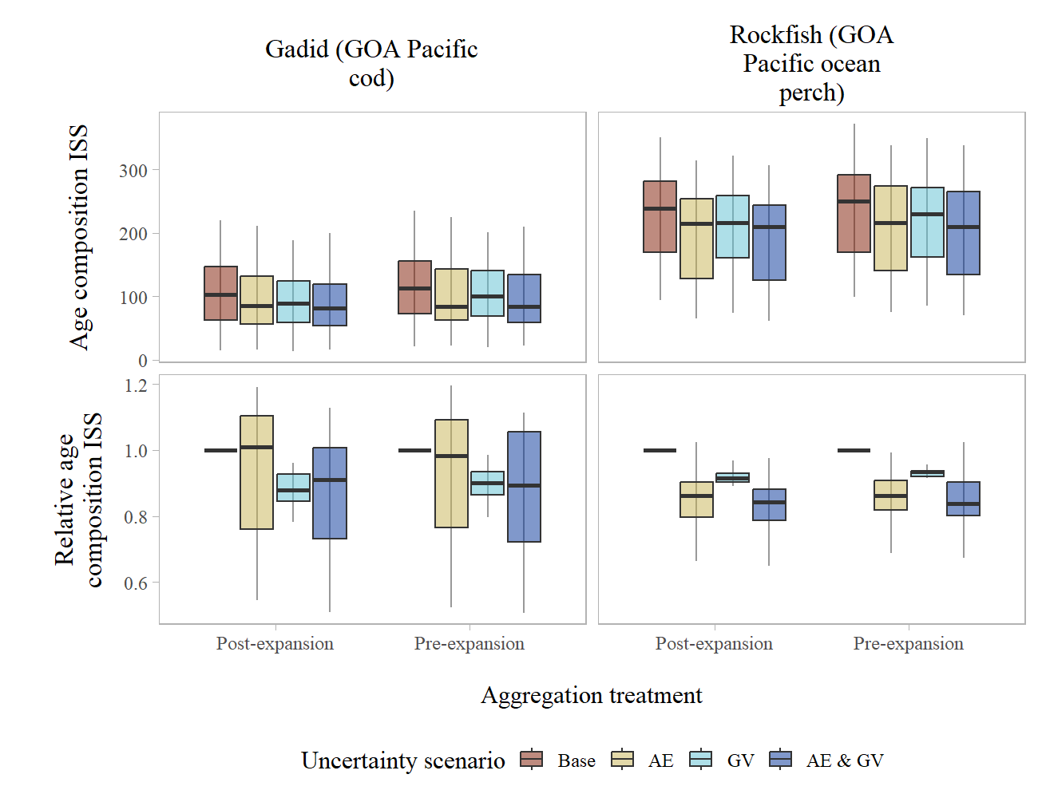

Figure 5: Boxplot of annual age composition input sample size (top row) and relative age composition input sample size (bottom row) for the selected example species type stocks across uncertainty scenarios within each aggregation treatment (using annual growth data, 1 cm length bins and total age composition). ‘Base’ refers to the case that includes no additional sources of uncertainty, ‘AE’ is the case when ageing error is included, ‘GV’ is the case when growth variability is included, and ‘AE & GV’ is the case when both ageing error and growth variability is included. The boxplots shows the median (solid line), 25% - 75% percentile range (box limits, also called the inter-quartile range), and 1.5 times the inter-quartile range (whiskers).

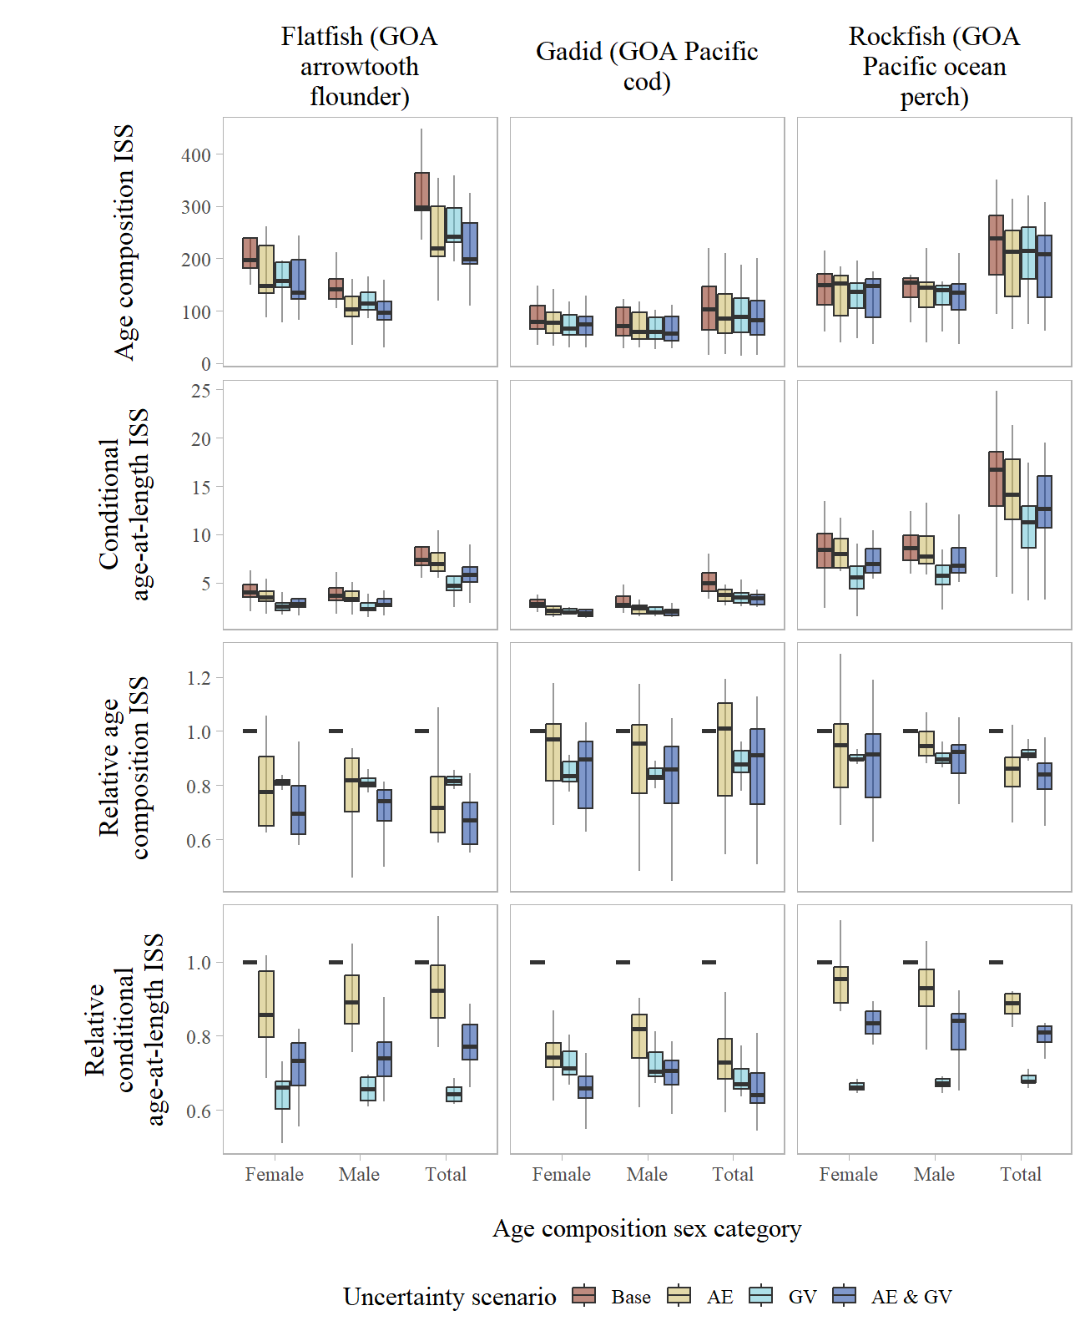

Figure 6: Boxplot of annual age composition and conditional age-at-length input sample size (top two rows) and relative age composition and conditional age-at-length input sample size (bottom two rows) for the selected example species type stocks across uncertainty scenarios within sex category (using annual growth data and 1 cm length bins). ‘Base’ refers to the case that includes no additional sources of uncertainty, ‘AE’ is the case when ageing error is included, ‘GV’ is the case when growth variability is included, and ‘AE & GV’ is the case when both ageing error and growth variability is included. The boxplots shows the median (solid line), 25% - 75% percentile range (box limits, also called the inter-quartile range), and 1.5 times the inter-quartile range (whiskers).

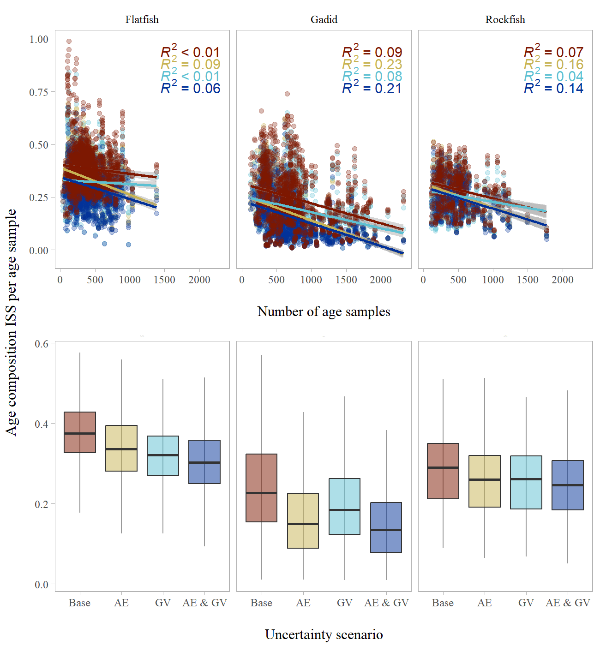

Figure 7: Age composition input sample size per age sample compared to the number of ages sampled (top panels) and across uncertainty scenarios (bottom panels) aggregated by species types. ‘Base’ refers to the case that includes no additional sources of uncertainty, ‘AE’ is the case when ageing error is included, ‘GV’ is the case when growth variability is included, and ‘AE & GV’ is the case when both ageing error and growth variability is included. Linear relationships are shown in the top panels, along with the *R*2 values, for each uncertainty scenario. The boxplots in the bottom panels shows the median (solid line), 25% - 75% percentile range (box limits, also called the inter-quartile range), and 1.5 times the inter-quartile range (whiskers).

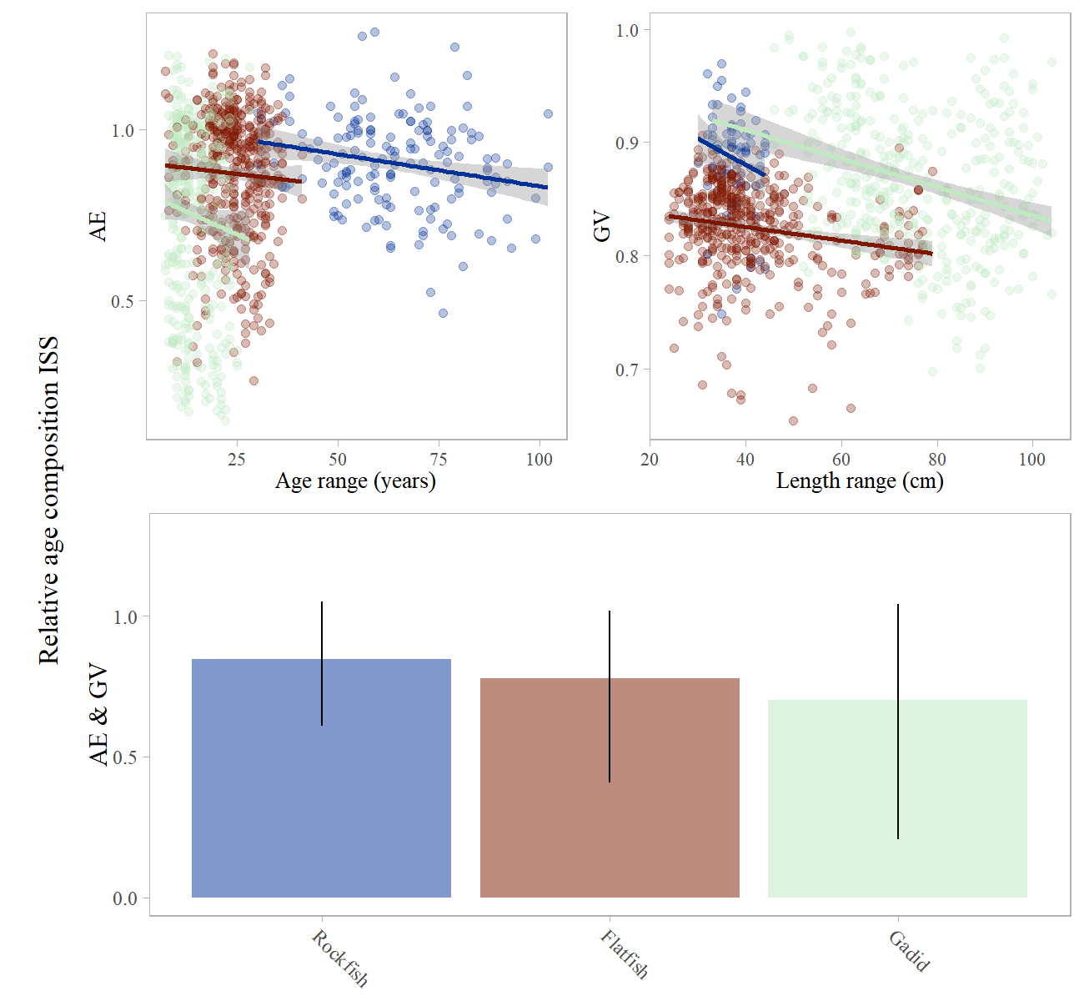

Figure 8: Relative age composition input sample size when including ageing error (‘AE’) or growth variability (‘GV’) compared to age range and length range (top panels) and when including both ageing error and growth variability (‘AE & GV’) across the species types evaluated (bottom panel, with the whiskers indicating the 95% confidence intervals). For illustration, linear relationships for each species type are shown in the top panels.