**A generalized fishery-dependent age and length composition expansion method for AFSC**

Here we attempt to develop a method that can be generalized across stocks that are assessed at AFSC that integrates the fishery-dependent observer sampling-design with stock-specific considerations made by assessment scientists. This expansion, at its fundamental level, is motivated by the expansion developed in Kimura 1989. As we develop notation and derive the proposed expansion we note the differences and developments made upon the Kimura 1989 method. The following sections follow from Kimura 1989

**Indices and Subscripts**

From Kimura 1989:

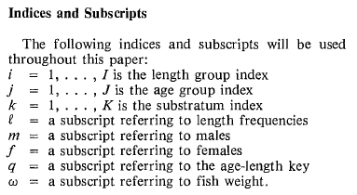

Here, we use the following indices and subscripts:

*l* = 1, …, *L* is the length group (i.e., cm or some bin of lengths) subscript

*a* = 1, …, *A* is the age group subscript

*g* = 1, …, *G* is the analyst grouping subscript. We note that this is referred to as ‘substrata’ *k* in Kimura 1989. Here we use *g* to reflect the grouping chosen by an assessment analyst that, in their expert onion, best represents the temporal and spatial considerations that need to be made when expanding the fishery-dependent observations to the population scale. We use the term ‘group’ rather than ‘substrata’ to differentiate this variable from ‘sampling strata’, which is a term used by the observer sampling design in trip selection (more detail provided below).

*s* = sex subscript (either females, males, or unsexed)

*i* = 1, …, *I* is the sampling strata-gear subscript. The sampling strata is defined by the observer sampling design from which random trips are selected to be observed (Table ##), we composite within this subscript a gear-specific consideration as well. For example, if multiple gear types (e.g., trawl and longline) are combined within an observer sampling strata (e.g., the full coverage) this subscript denotes the gear-specific sampling strata. We note that the sampling strata definitions and the proportion of trips selected to be observed within strata are variable across time and management regions and subareas.

*h* = 1, …, *H* is the subscript for hauls that were sampled for length and/or age composition

*pl* = is the index for proportions-at-length, and can include any of the proceeding subscripts

*qla* = is the index for the proportion of age-at-length, often referred to as the age-length key (and follows Kimura 1989 notation)

**Variables obtained from the fishery**

From Kimura 1989:

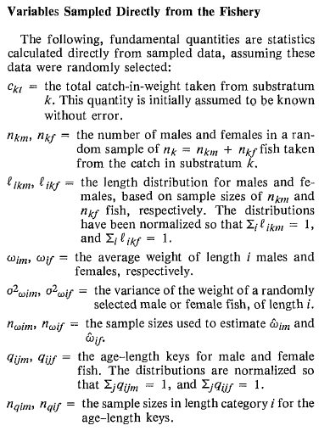

Here we define the following variables that are either recorded from the fishery (e.g., landed weight), sampled directly by an observer, or are estimated by the observer:

*cig* = the total catch in weight taken within sampling strata-gear *i*, and analyst grouping *g*.

*ωlsig* = the mean weight-at-length *l* for sex *s* within sampling strata-gear *i* and analyst grouping *g*

*nlsh* = the number sampled at length *l* for sex­ *s* within haul *h* (note that the haul *h* will inherently be assigned to some sampling strata-gear and analyst grouping, and thus, for simplicity, those subscripts are not included in this term, this holds for each of the following variables as well)

${\hat{ω}}_{h}$ = the estimated mean weight of fish within a sampled haul­ *h*

${\hat{N}}_{h}$ = the observer extrapolated numbers of fish within a sampled haul­-*h*

${\hat{W}}_{h}$ = the observer extrapolated weight of fish within a sampled haul­-*h*

**Formulas for expanding haul-level length samples to numbers-at-length**

From Kimura 1989:

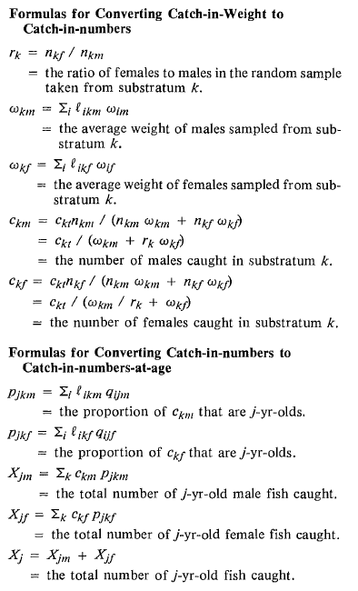

For our purposes, the initial level to which length samples are expanded to numbers at length is at the sampling strata-gear *i* and analyst group *g* level.

First, we note that within the observer sampling plan length samples within hauls are capped at some magnitude, which may vary depending upon species (and the magnitude can change across time). Thus, the haul-level length sample size needs to be weighted by the haul-level catch across the sampling strata-gear and analyst group level to reflect that the fixed-level subsample were obtained from groups of fish that differ in abundance. The weighted haul-level sample size is computed as:

$${\tilde{n}}_{lsh}={n_{lsh}{\hat{N}}_{h}}/{\sum_{hϵi, g}{{\hat{N}}_{h}}}$$

Then, the proportions-at-length at the sampling strata-gear and analyst group level are computed as:

$$p_{lsig}={\sum_{h}{{\tilde{n}}_{lsh}}}/{\sum_{l}{\sum_{h}{{\tilde{n}}_{lsh}}}}$$

This an important consideration of the observer sampling design that is not taken into account in Kimura 1989, rather, the haul-level length samples are combined across the pre-determined substrata without regard to the magnitude of haul-level catch. This assumption is valid if the sub-sample for lengths is proportional to catch, however, if the subsample level is capped this assumption would not be valid.

Next, following the derivation provided in Kimura 1989, we compute the average sex-specific weight at the sampling strata-gear and analyst group level with:

$$ω_{sig}=\sum_{l}{p_{lsig}ω_{lsig}}$$

And then the sex-specific numbers of fish caught at the sampling strata-gear *i* and analyst group *g* level with:

$$c_{sig}={c_{ig}}/{\sum_{s}{ω_{sig}}}$$

Sim analysis to show potential bias when sub-sampling rate fixed rather than proportional to catch