# Supplementary material

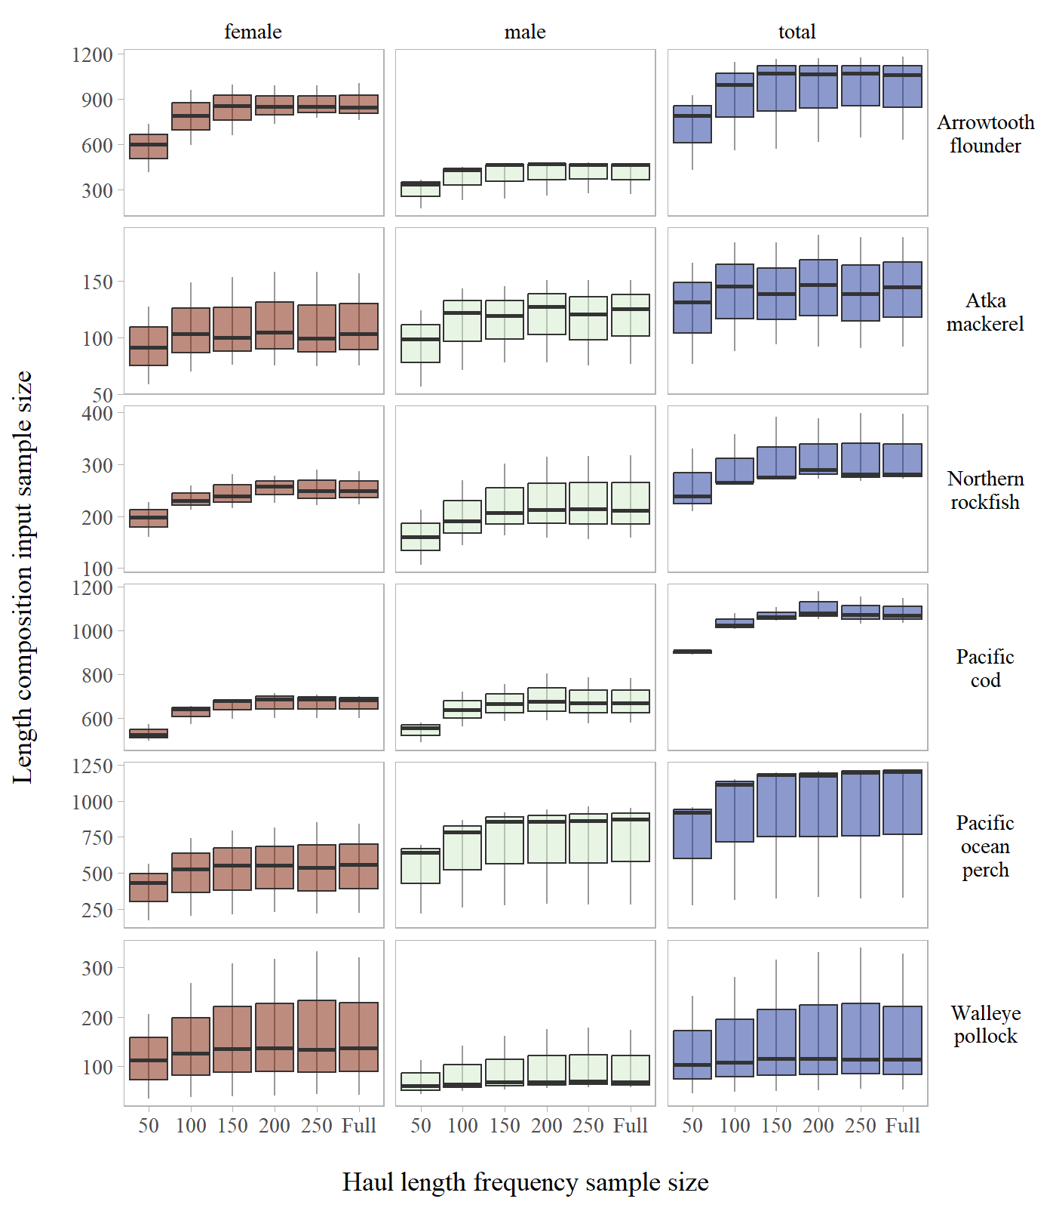

Figure S1: Annual length composition input sample size by stock across haul length frequency sub-sampling levels evaluated for the Aleutian Islands.

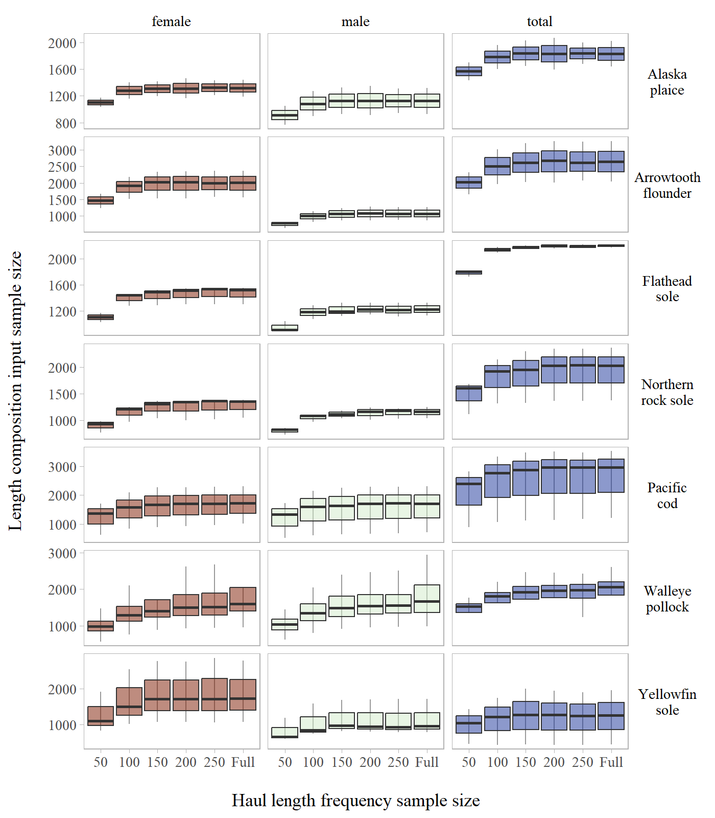

Figure S2: Annual length composition input sample size by stock across haul length frequency sub-sampling levels evaluated for the Eastern Bering Sea Shelf.

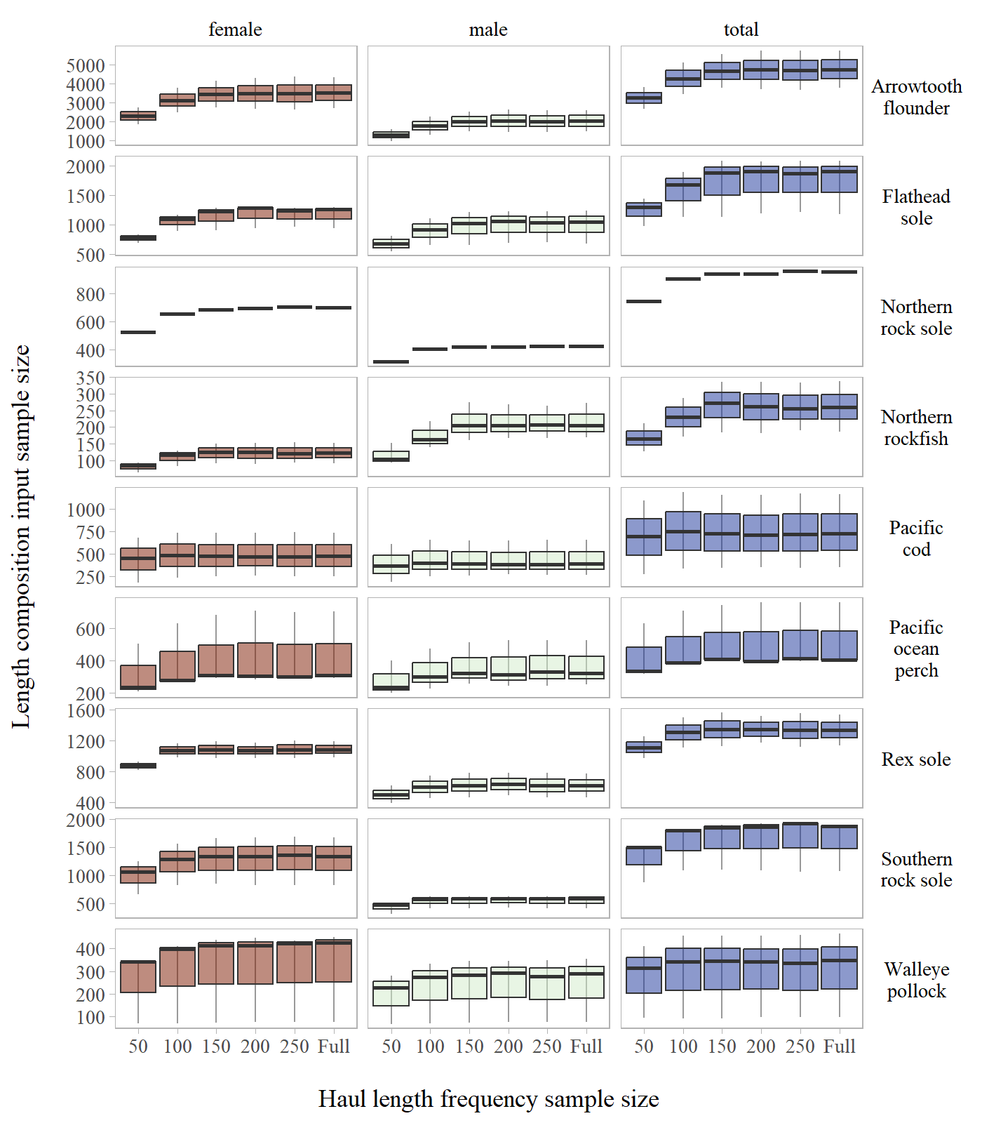

Figure S3: Annual length composition input sample size by stock across haul length frequency sub-sampling levels evaluated for the Gulf of Alaska.

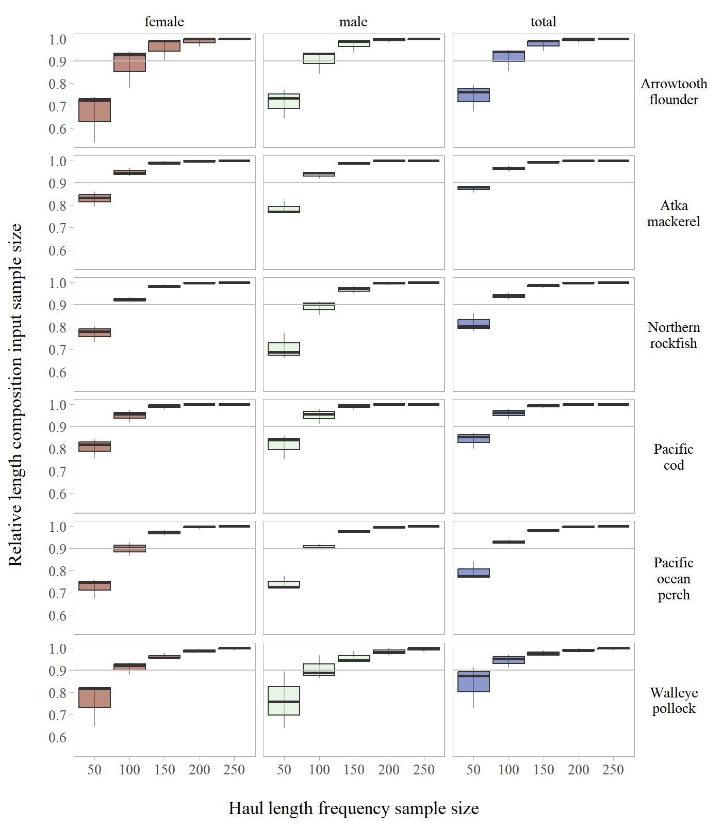

Figure S4: Annual length composition relative input sample size by stock across haul length frequency sub-sampling levels evaluated for the Aleutian Islands.

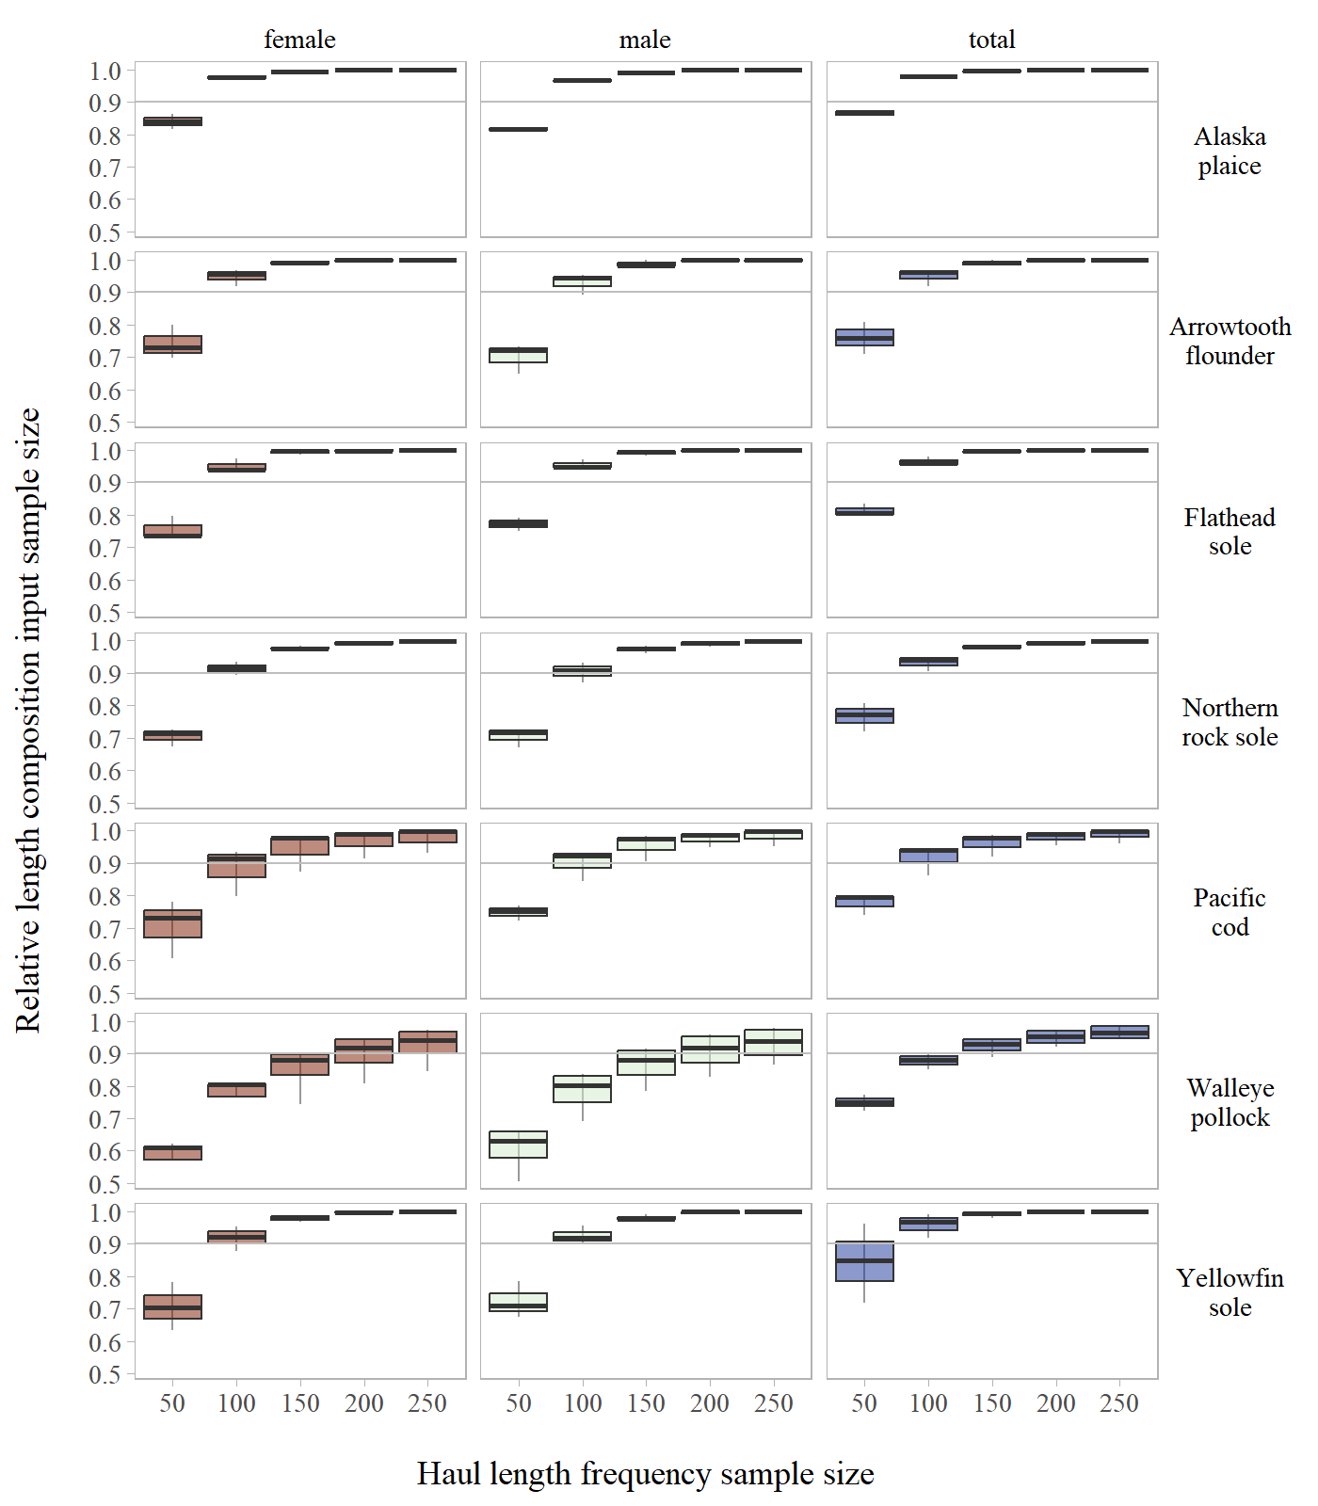

Figure S5: Annual length composition relative input sample size by stock across haul length frequency sub-sampling levels evaluated for the Eastern Bering Sea Shelf.

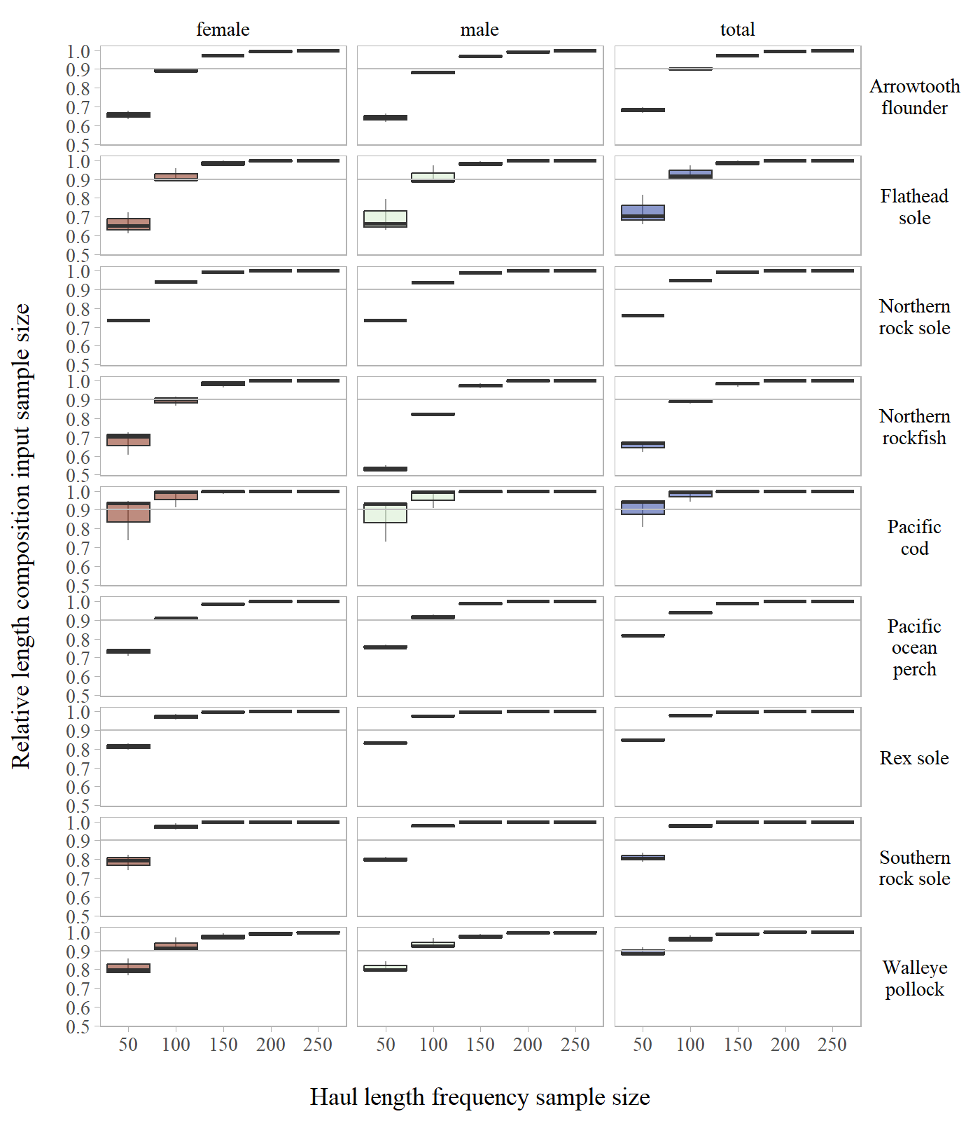

Figure S6: Annual length composition relative input sample size by stock across haul length frequency sub-sampling levels evaluated for the Gulf of Alaska.

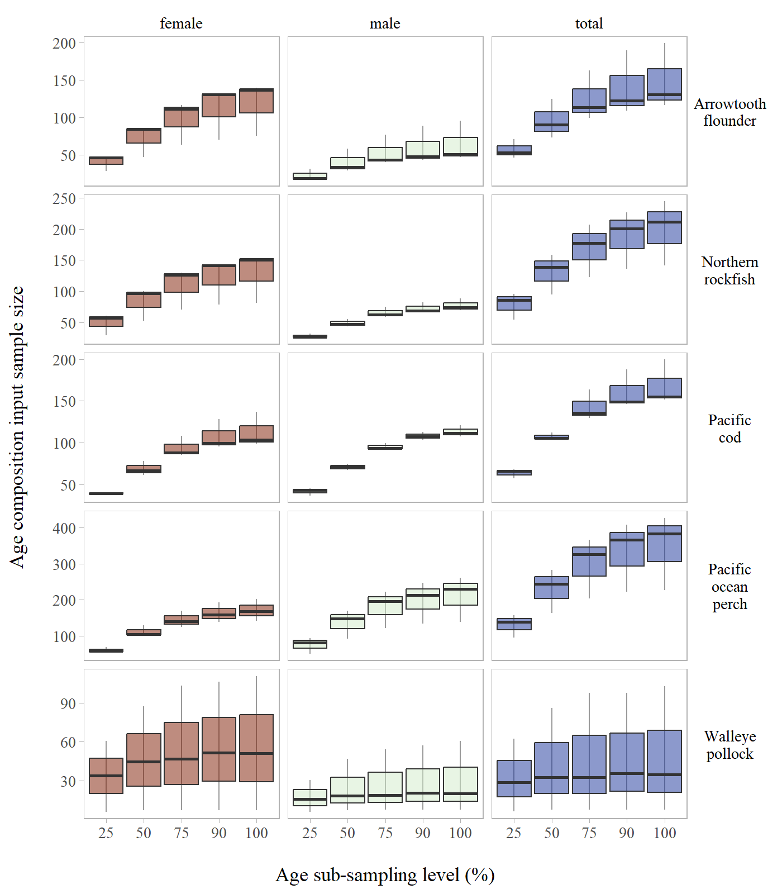

Figure S7: Annual age composition input sample size by stock across age sub-sampling levels evaluated for the Aleutian Islands.

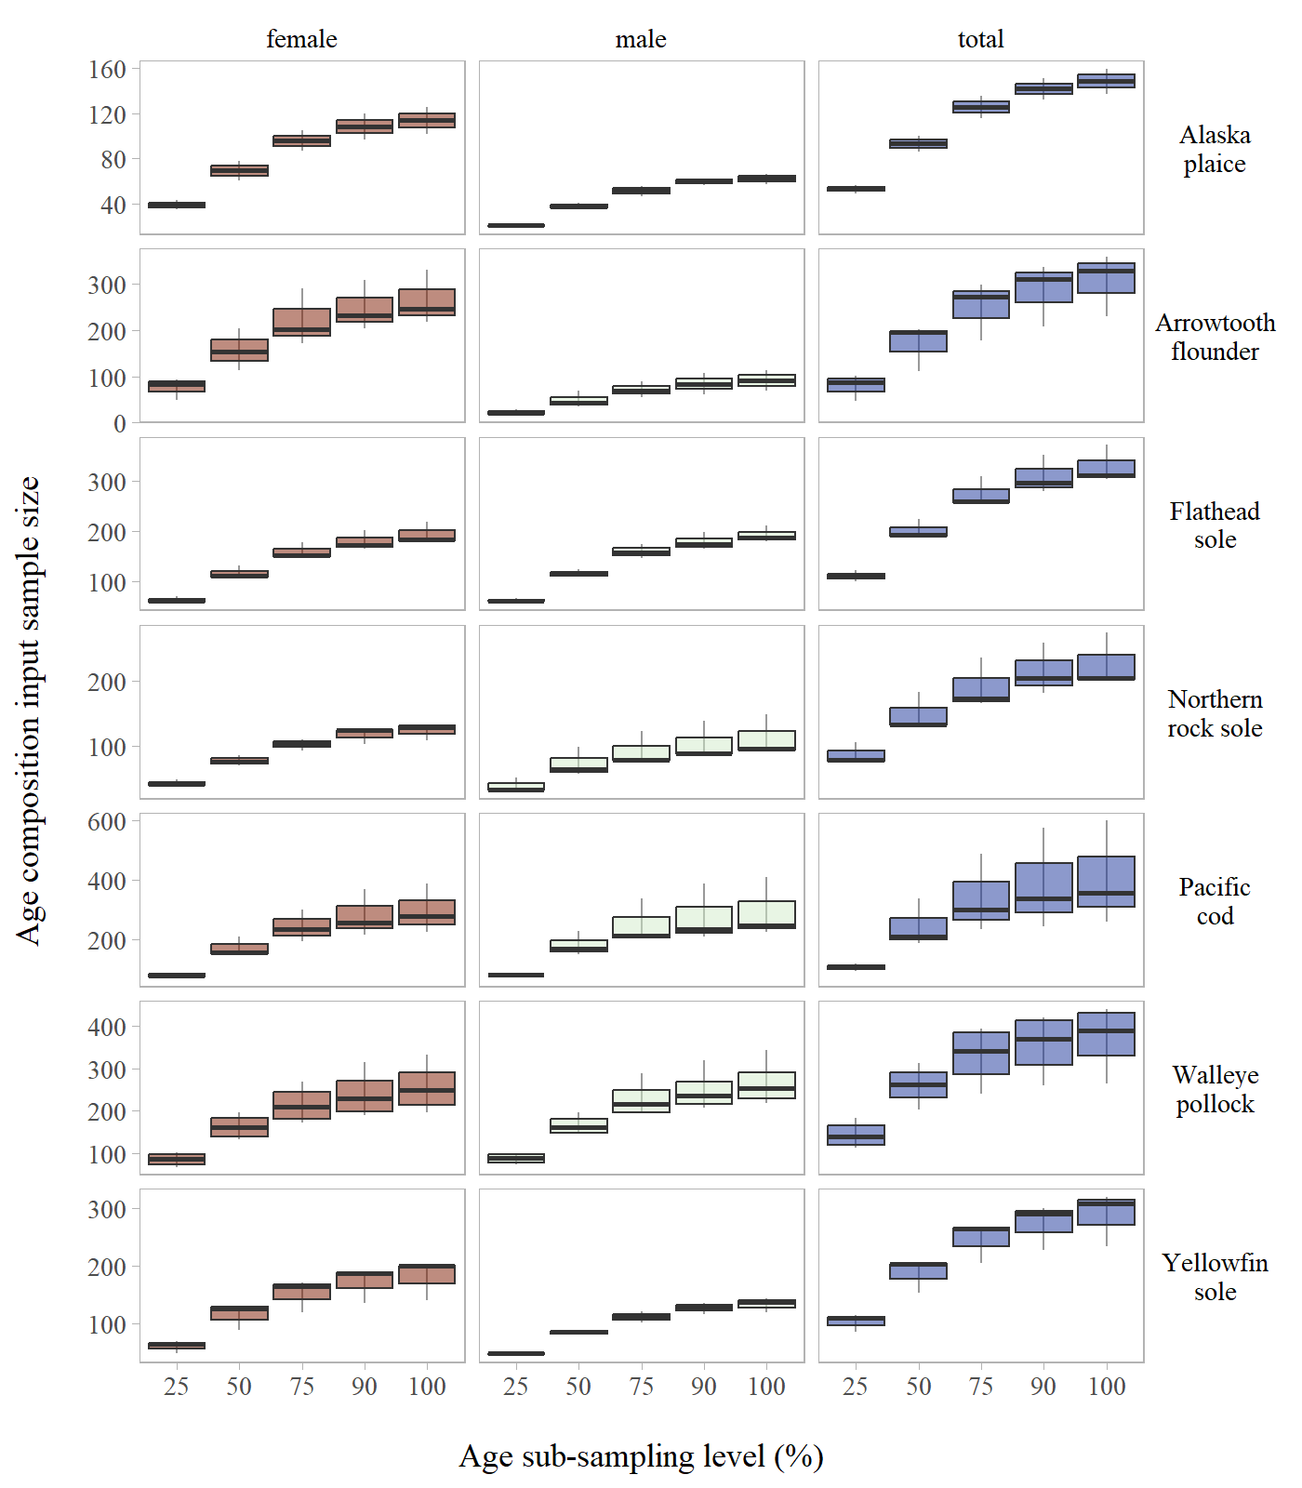

Figure S8: Annual age composition input sample size by stock across age sub-sampling levels evaluated for the Eastern Bering Sea Shelf.

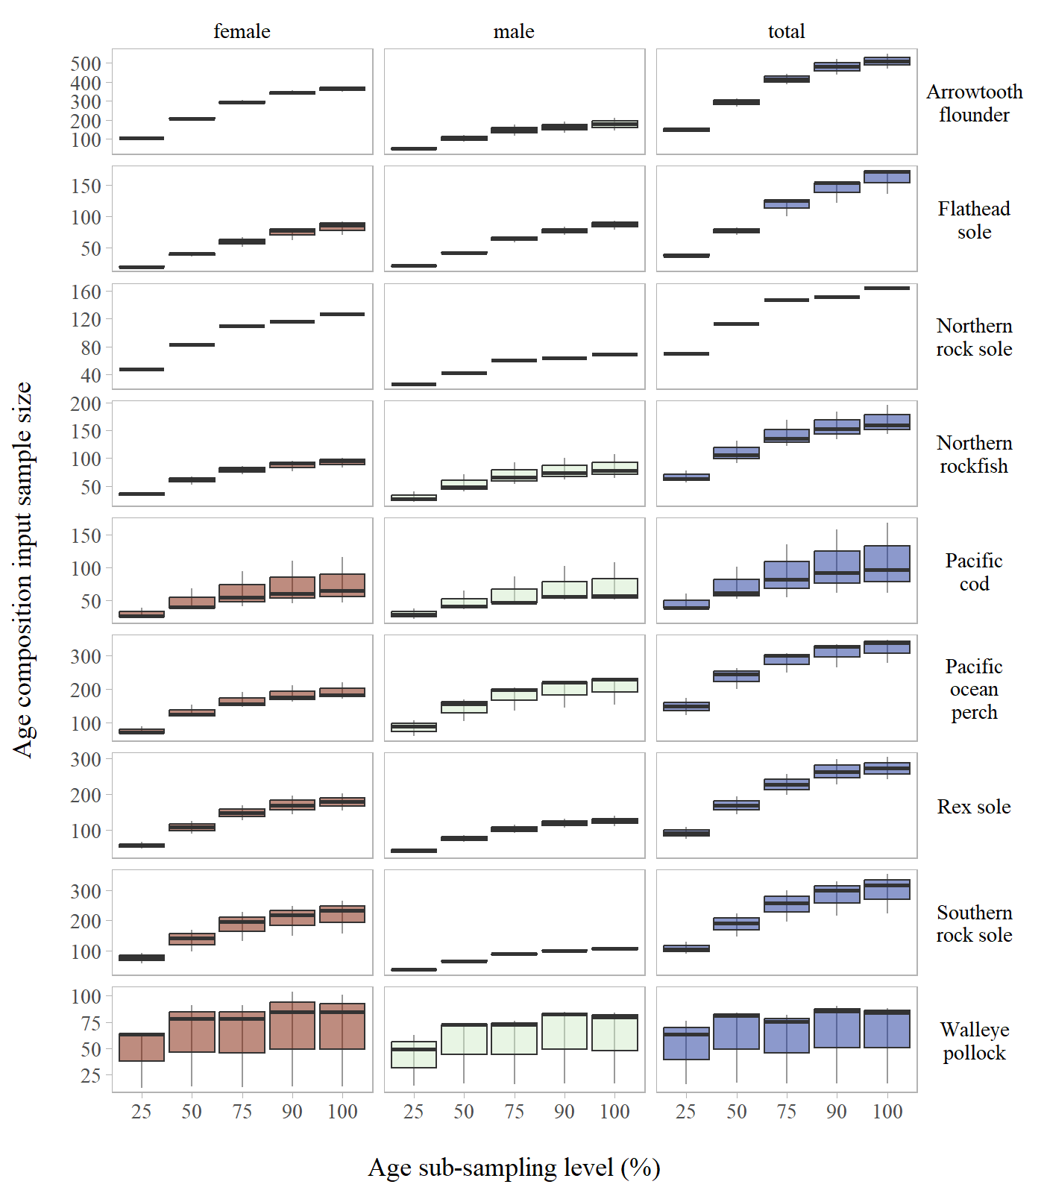

Figure S9: Annual age composition input sample size by stock across age sub-sampling levels evaluated for the Gulf of Alaska.

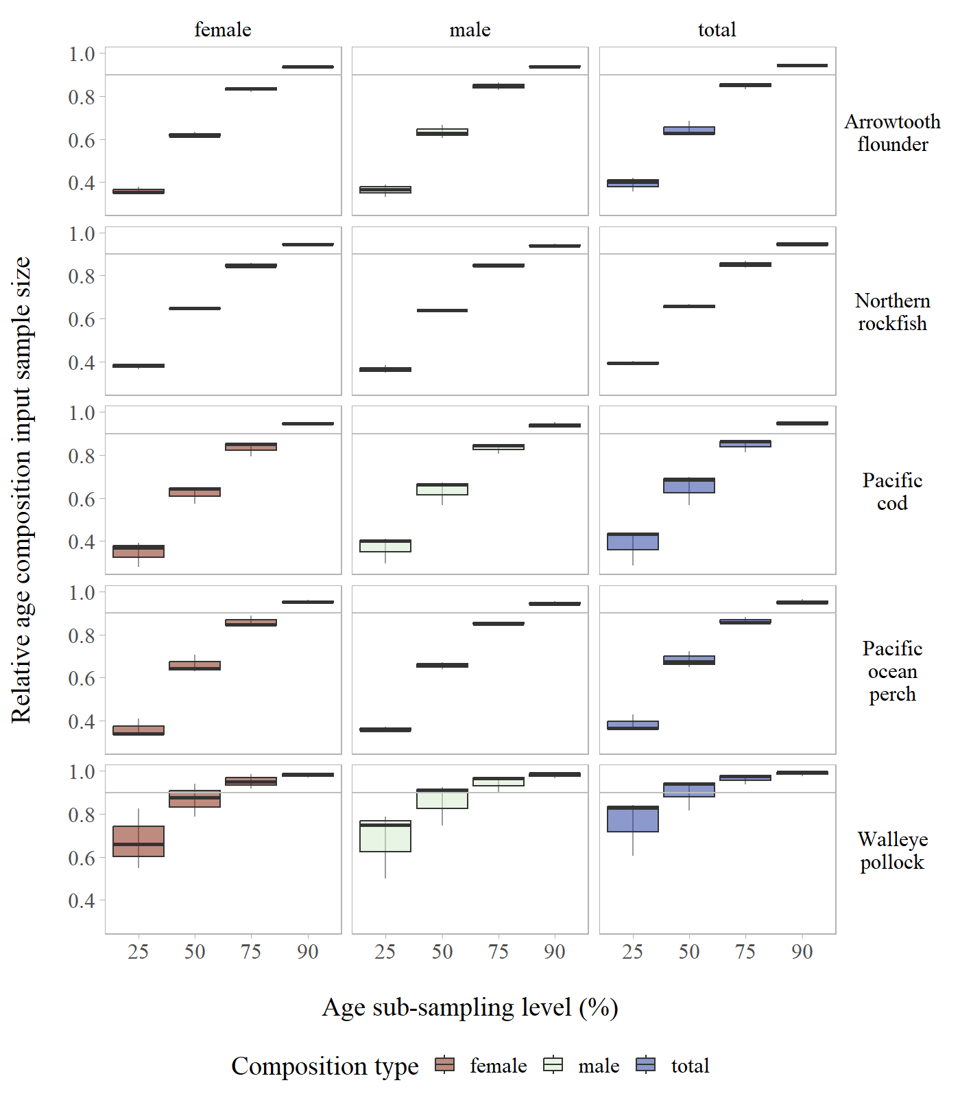

Figure S10: Annual age composition relative input sample size by stock across age sub-sampling levels evaluated for the Aleutian Islands.

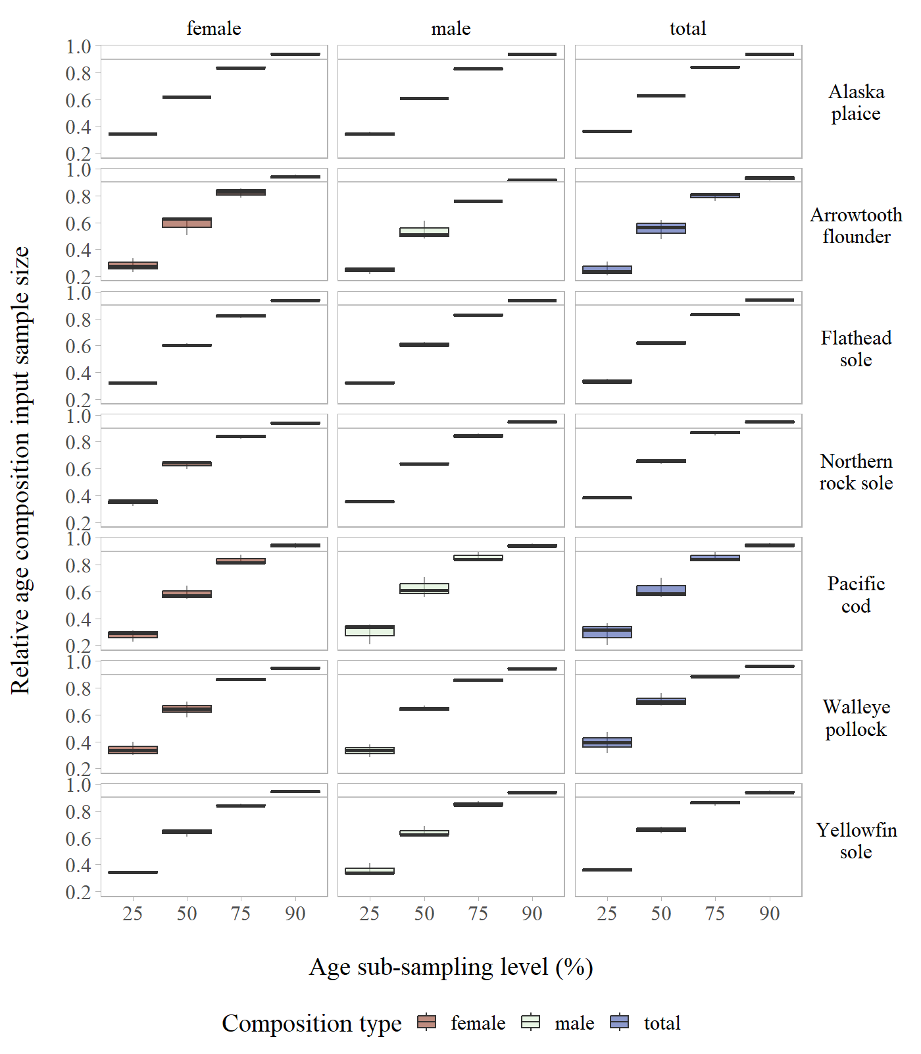

Figure S11: Annual age composition relative input sample size by stock across age sub-sampling levels evaluated for the Eastern Bering Sea Shelf.

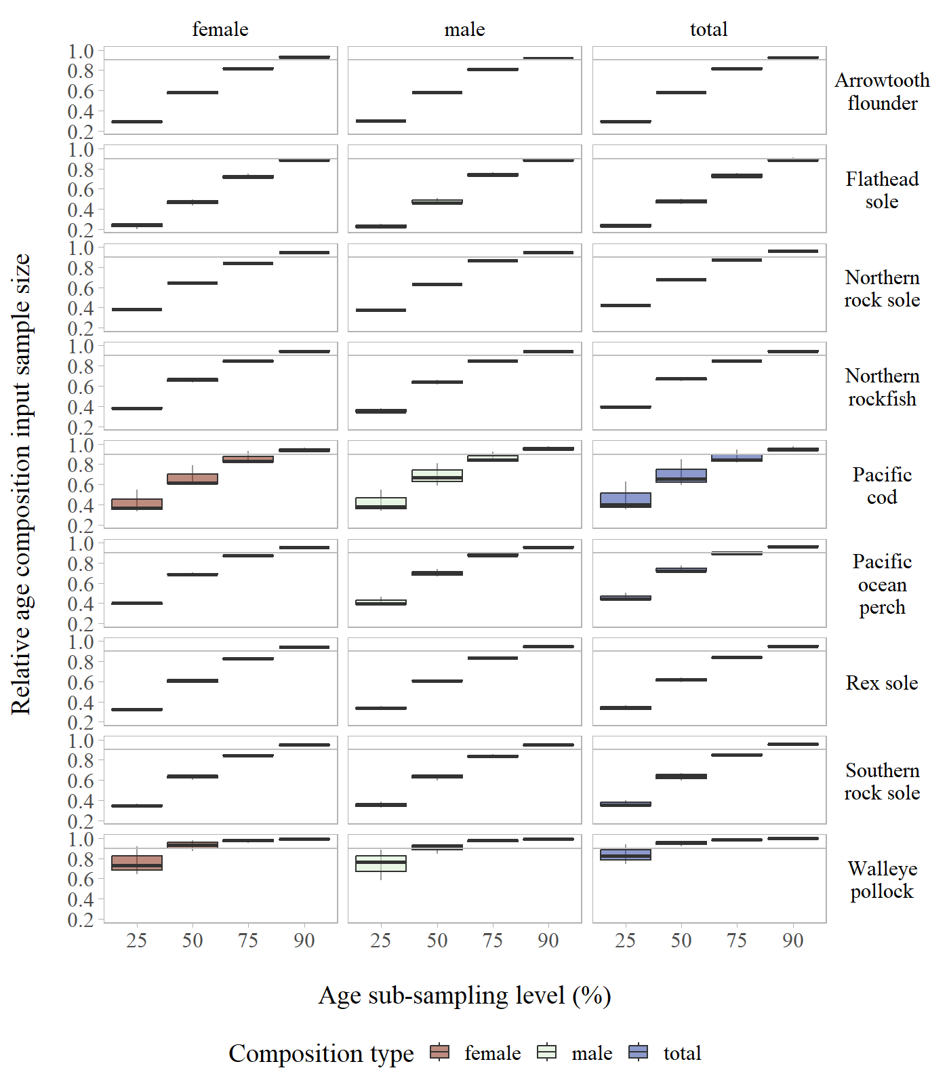

Figure S12: Annual age composition relative input sample size by stock across age sub-sampling levels evaluated for the Gulf of Alaska.