# Supplementary material

Table S1: Average number of hauls with catch (first number), average number of hauls sampled for length frequency (middle number), and average number of hauls sampled for age specimen data (last number) from the most recent three AFSC bottom trawl surveys by region for the stocks evaluated in the bootstrap-simulation for reduction in length and age collections. Species types are shown in parentheses in the stock column (f - flatfish, g - gadid, r - rockfish, o - other)

| Stock | AI | EBS | GOA |
| --- | --- | --- | --- |
| Alaska plaice (f) | – | 272 | 271 | 60 | – |
| arrowtooth flounder (f) | 321 | 321 | 136 | 272 | 272 | 236 | 499 | 499 | 448 |
| Atka mackerel (o) | 192 | 192 | 102 | – | – |
| flathead sole (f) | 149 | 149 | 0 | 328 | 327 | 274 | 315 | 314 | 202 |
| northern rock sole (f) | – | 323 | 322 | 71 | 154 | 152 | 74 |
| northern rockfish (r) | 220 | 220 | 118 | – | 79 | 79 | 71 |
| Pacific cod (g) | 295 | 295 | 163 | 368 | 367 | 325 | 303 | 303 | 93 |
| Pacific ocean perch (r) | 296 | 296 | 201 | – | 289 | 288 | 206 |
| rex sole (f) | – | – | 400 | 399 | 209 |
| southern rock sole (f) | – | – | 204 | 204 | 115 |
| walleye pollock (g) | 275 | 275 | 120 | 373 | 373 | 346 | 432 | 430 | 207 |
| yellowfin sole (f) | – | 252 | 251 | 132 | – |

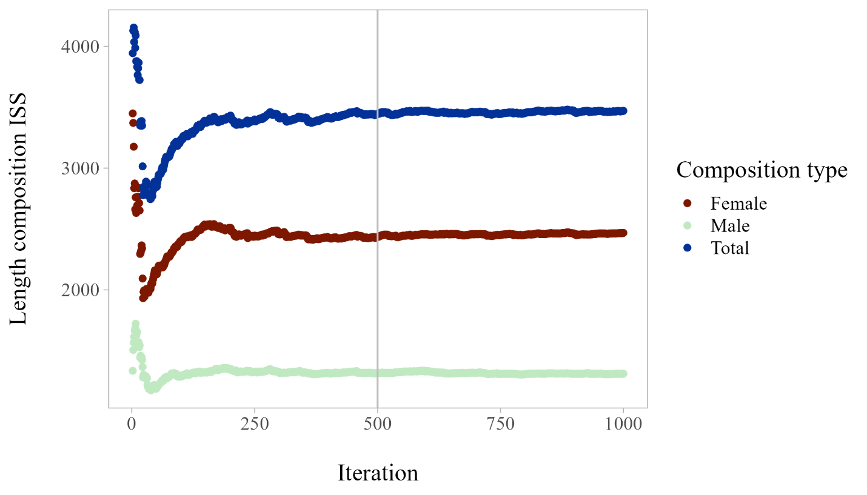

Figure S1: Example length composition input sample size (ISS) as computed across 1,000 iterations of the bootstrap-simulation resampling; the vertical line denotes the ISS at 500 iterations, the number used for this analysis.

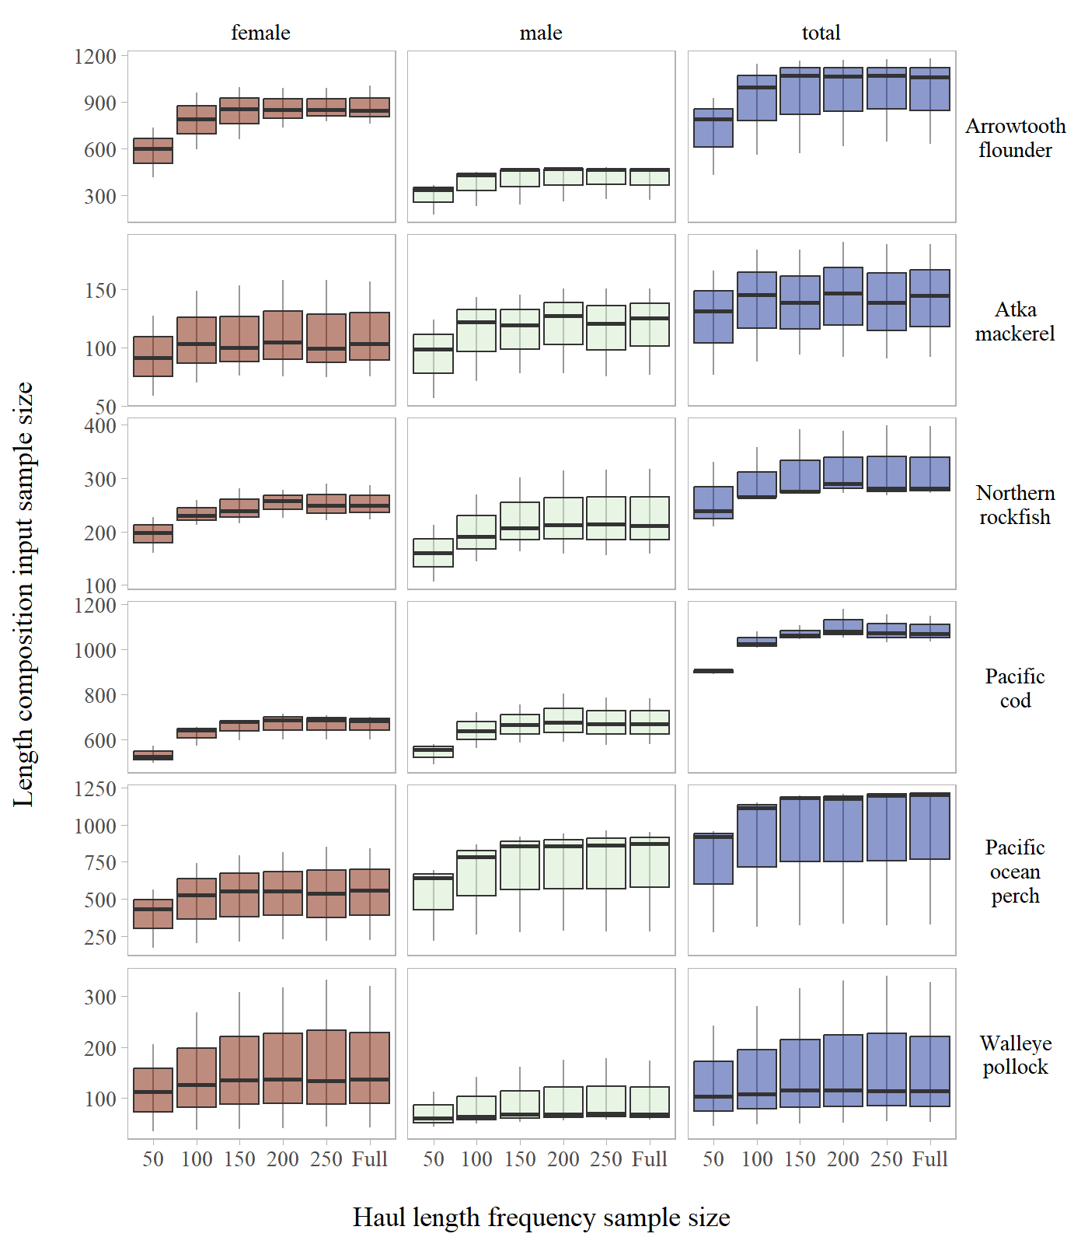

Figure S2: Length composition input sample size by stock across haul length frequency sub-sampling levels evaluated for the Aleutian Islands.

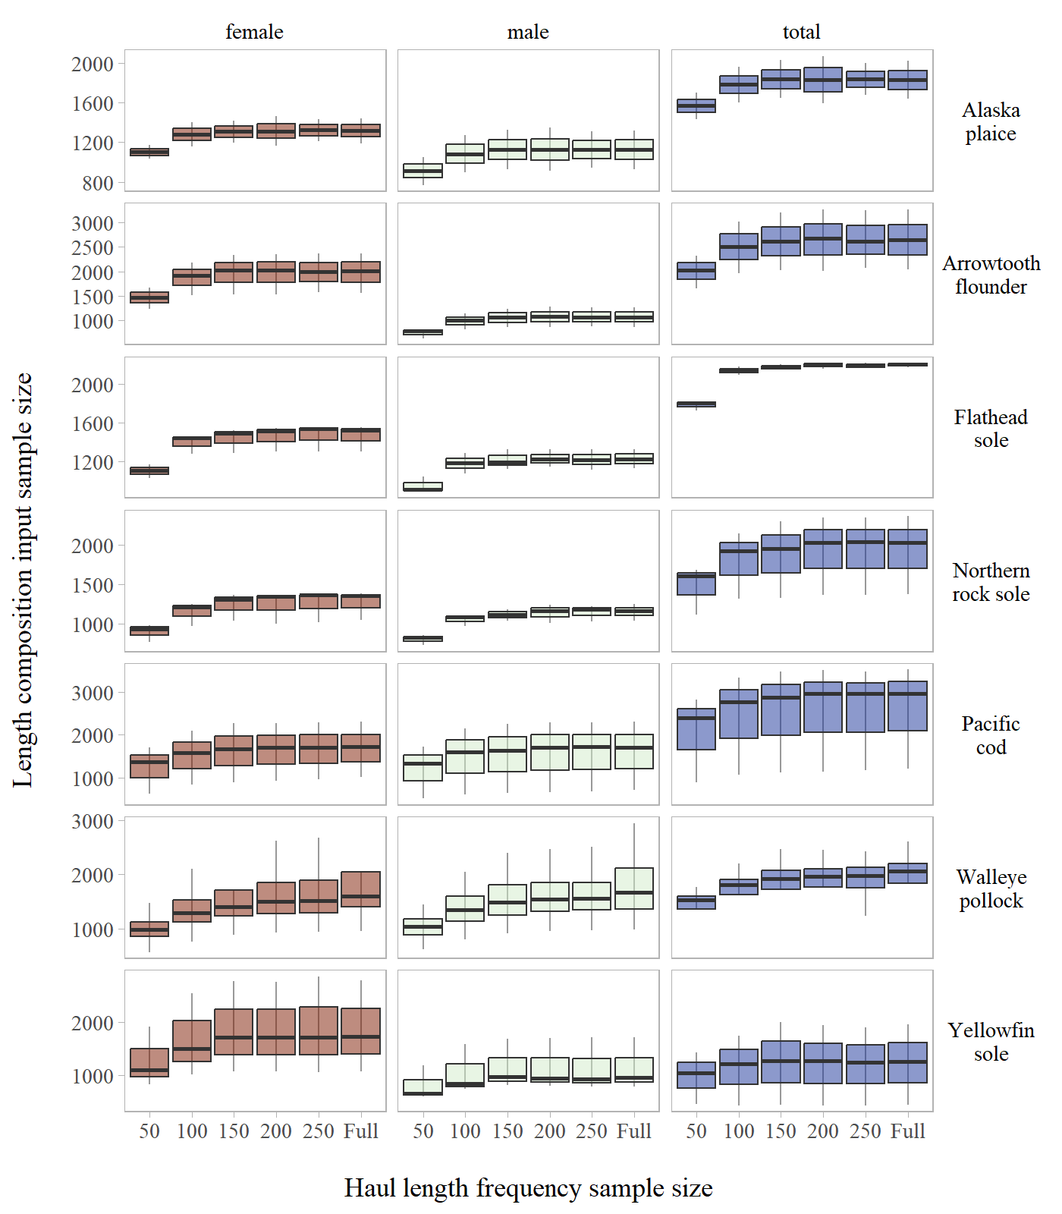

Figure S3: Length composition input sample size by stock across haul length frequency sub-sampling levels evaluated for the Eastern Bering Sea Shelf.

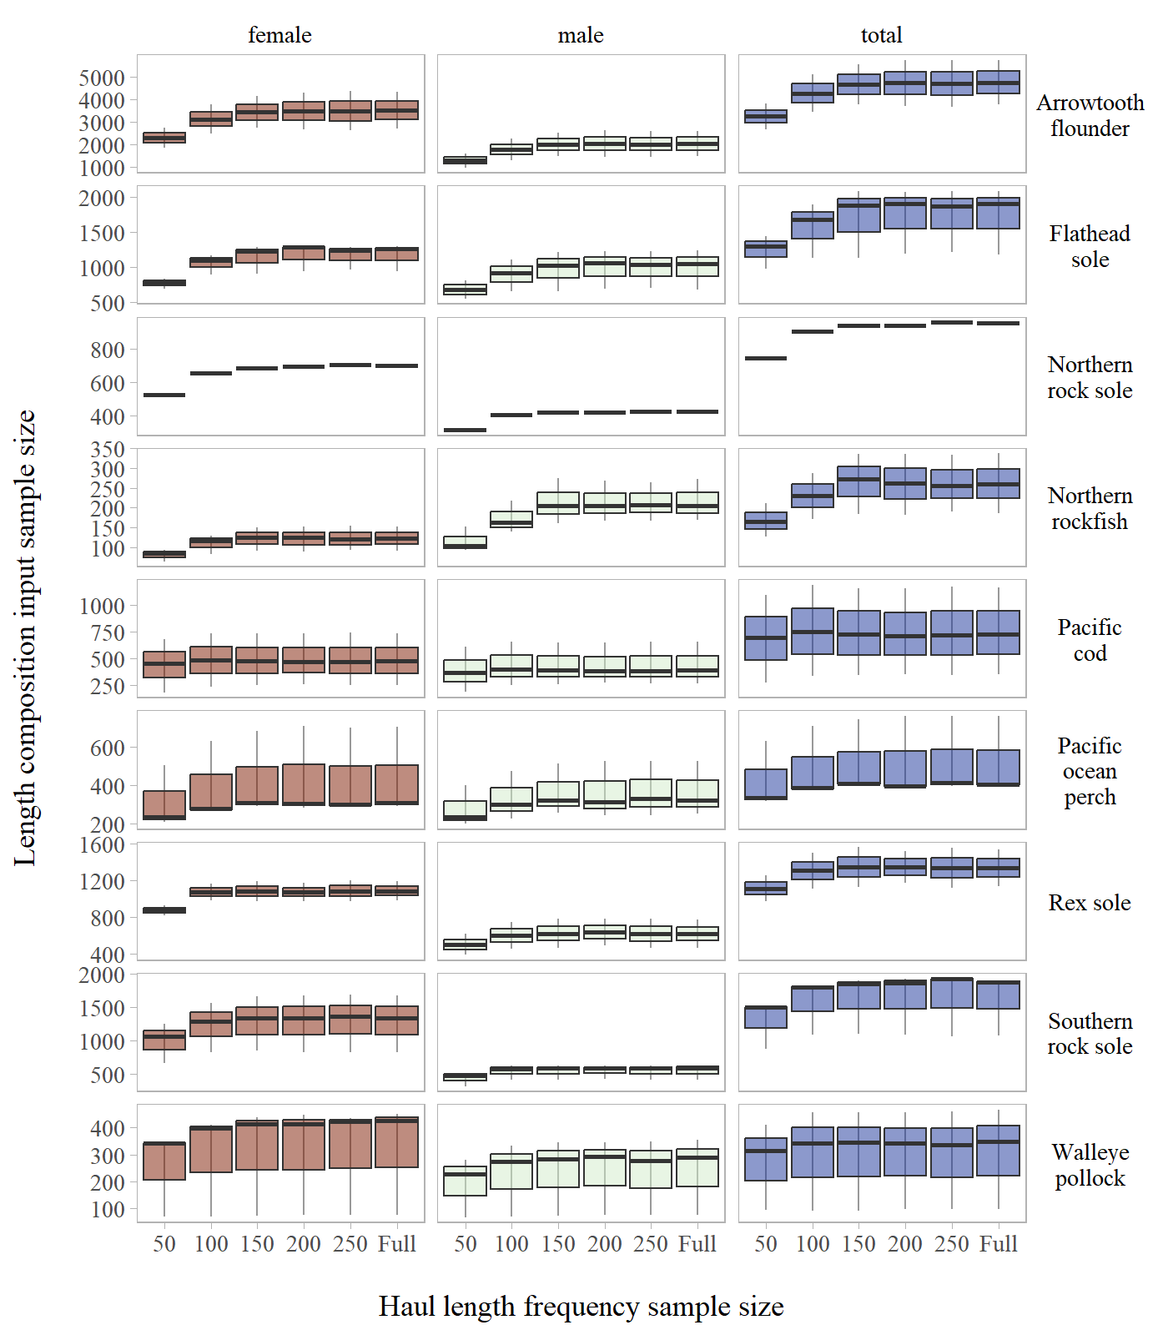

Figure S4: Length composition input sample size by stock across haul length frequency sub-sampling levels evaluated for the Gulf of Alaska.

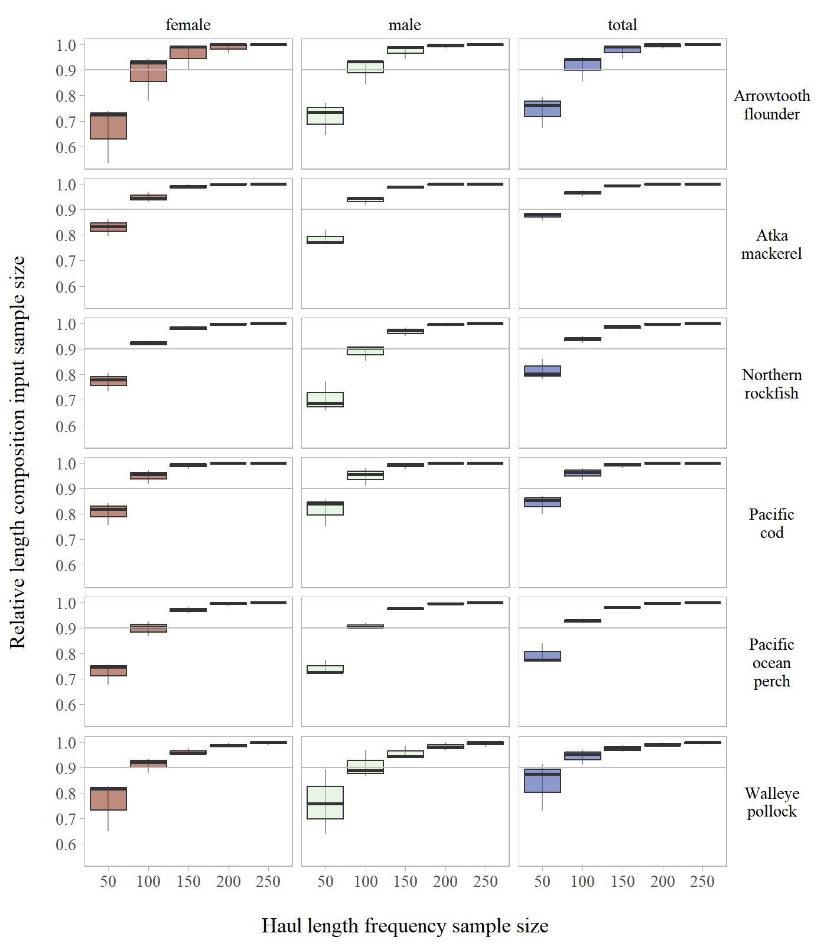

Figure S5: Length composition relative input sample size by stock across haul length frequency sub-sampling levels evaluated for the Aleutian Islands.

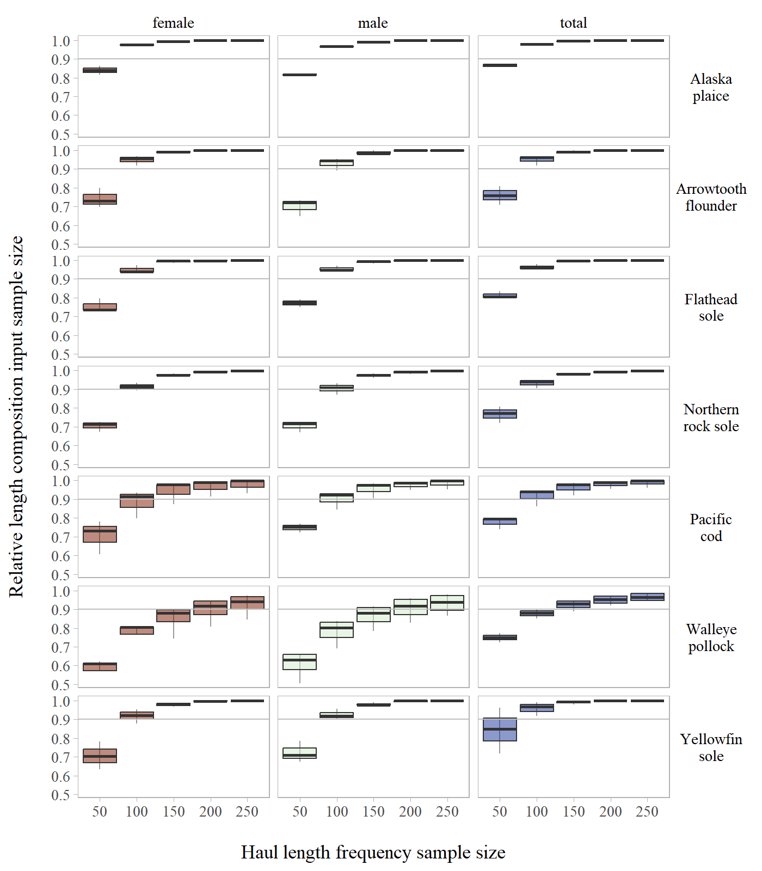

Figure S6: Length composition relative input sample size by stock across haul length frequency sub-sampling levels evaluated for the Eastern Bering Sea Shelf.

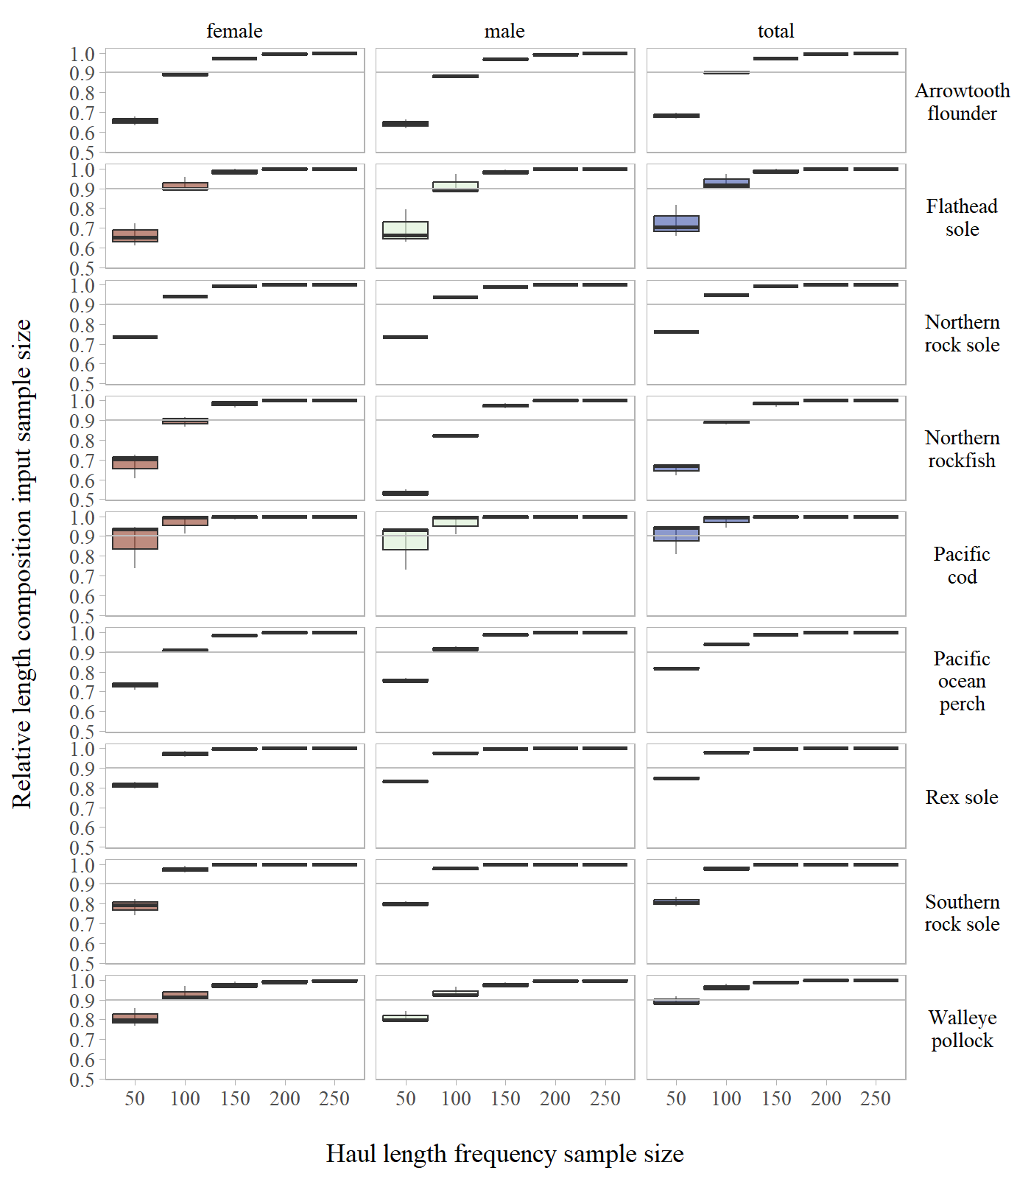

Figure S7: Length composition relative input sample size by stock across haul length frequency sub-sampling levels evaluated for the Gulf of Alaska.

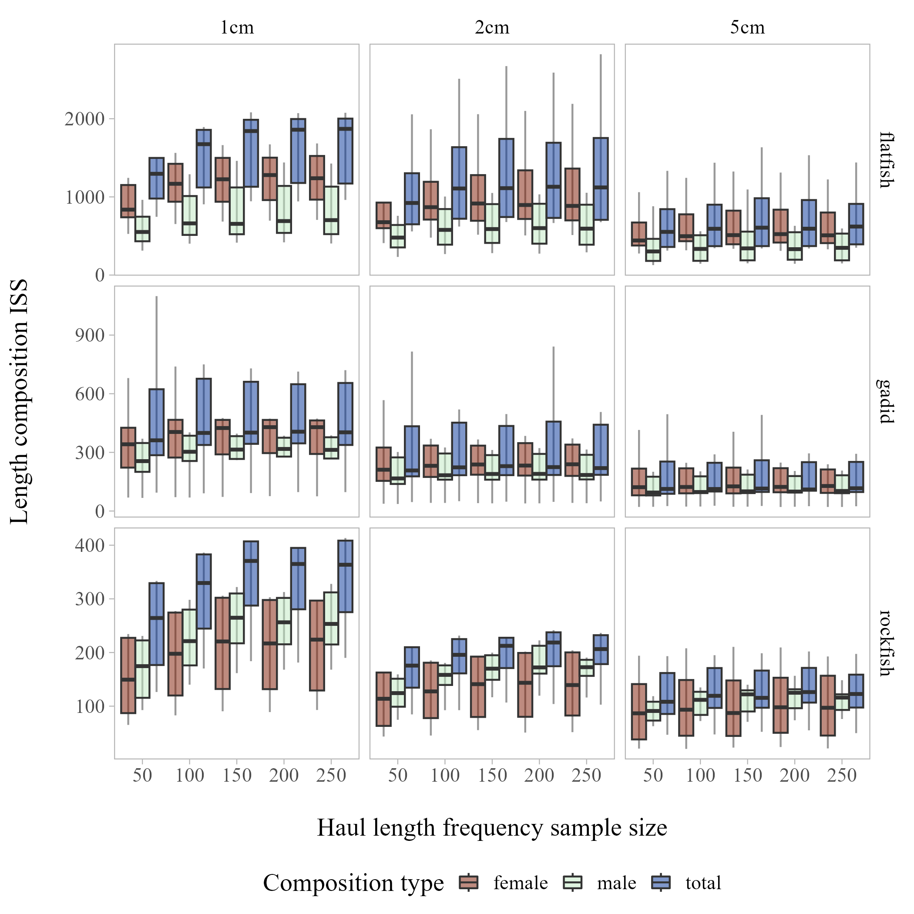

Figure S8: Length composition input sample size by length composition bin and species type (aggregated across stocks within the Gulf of Alaska) across haul length frequency sub-sampling levels evaluated.

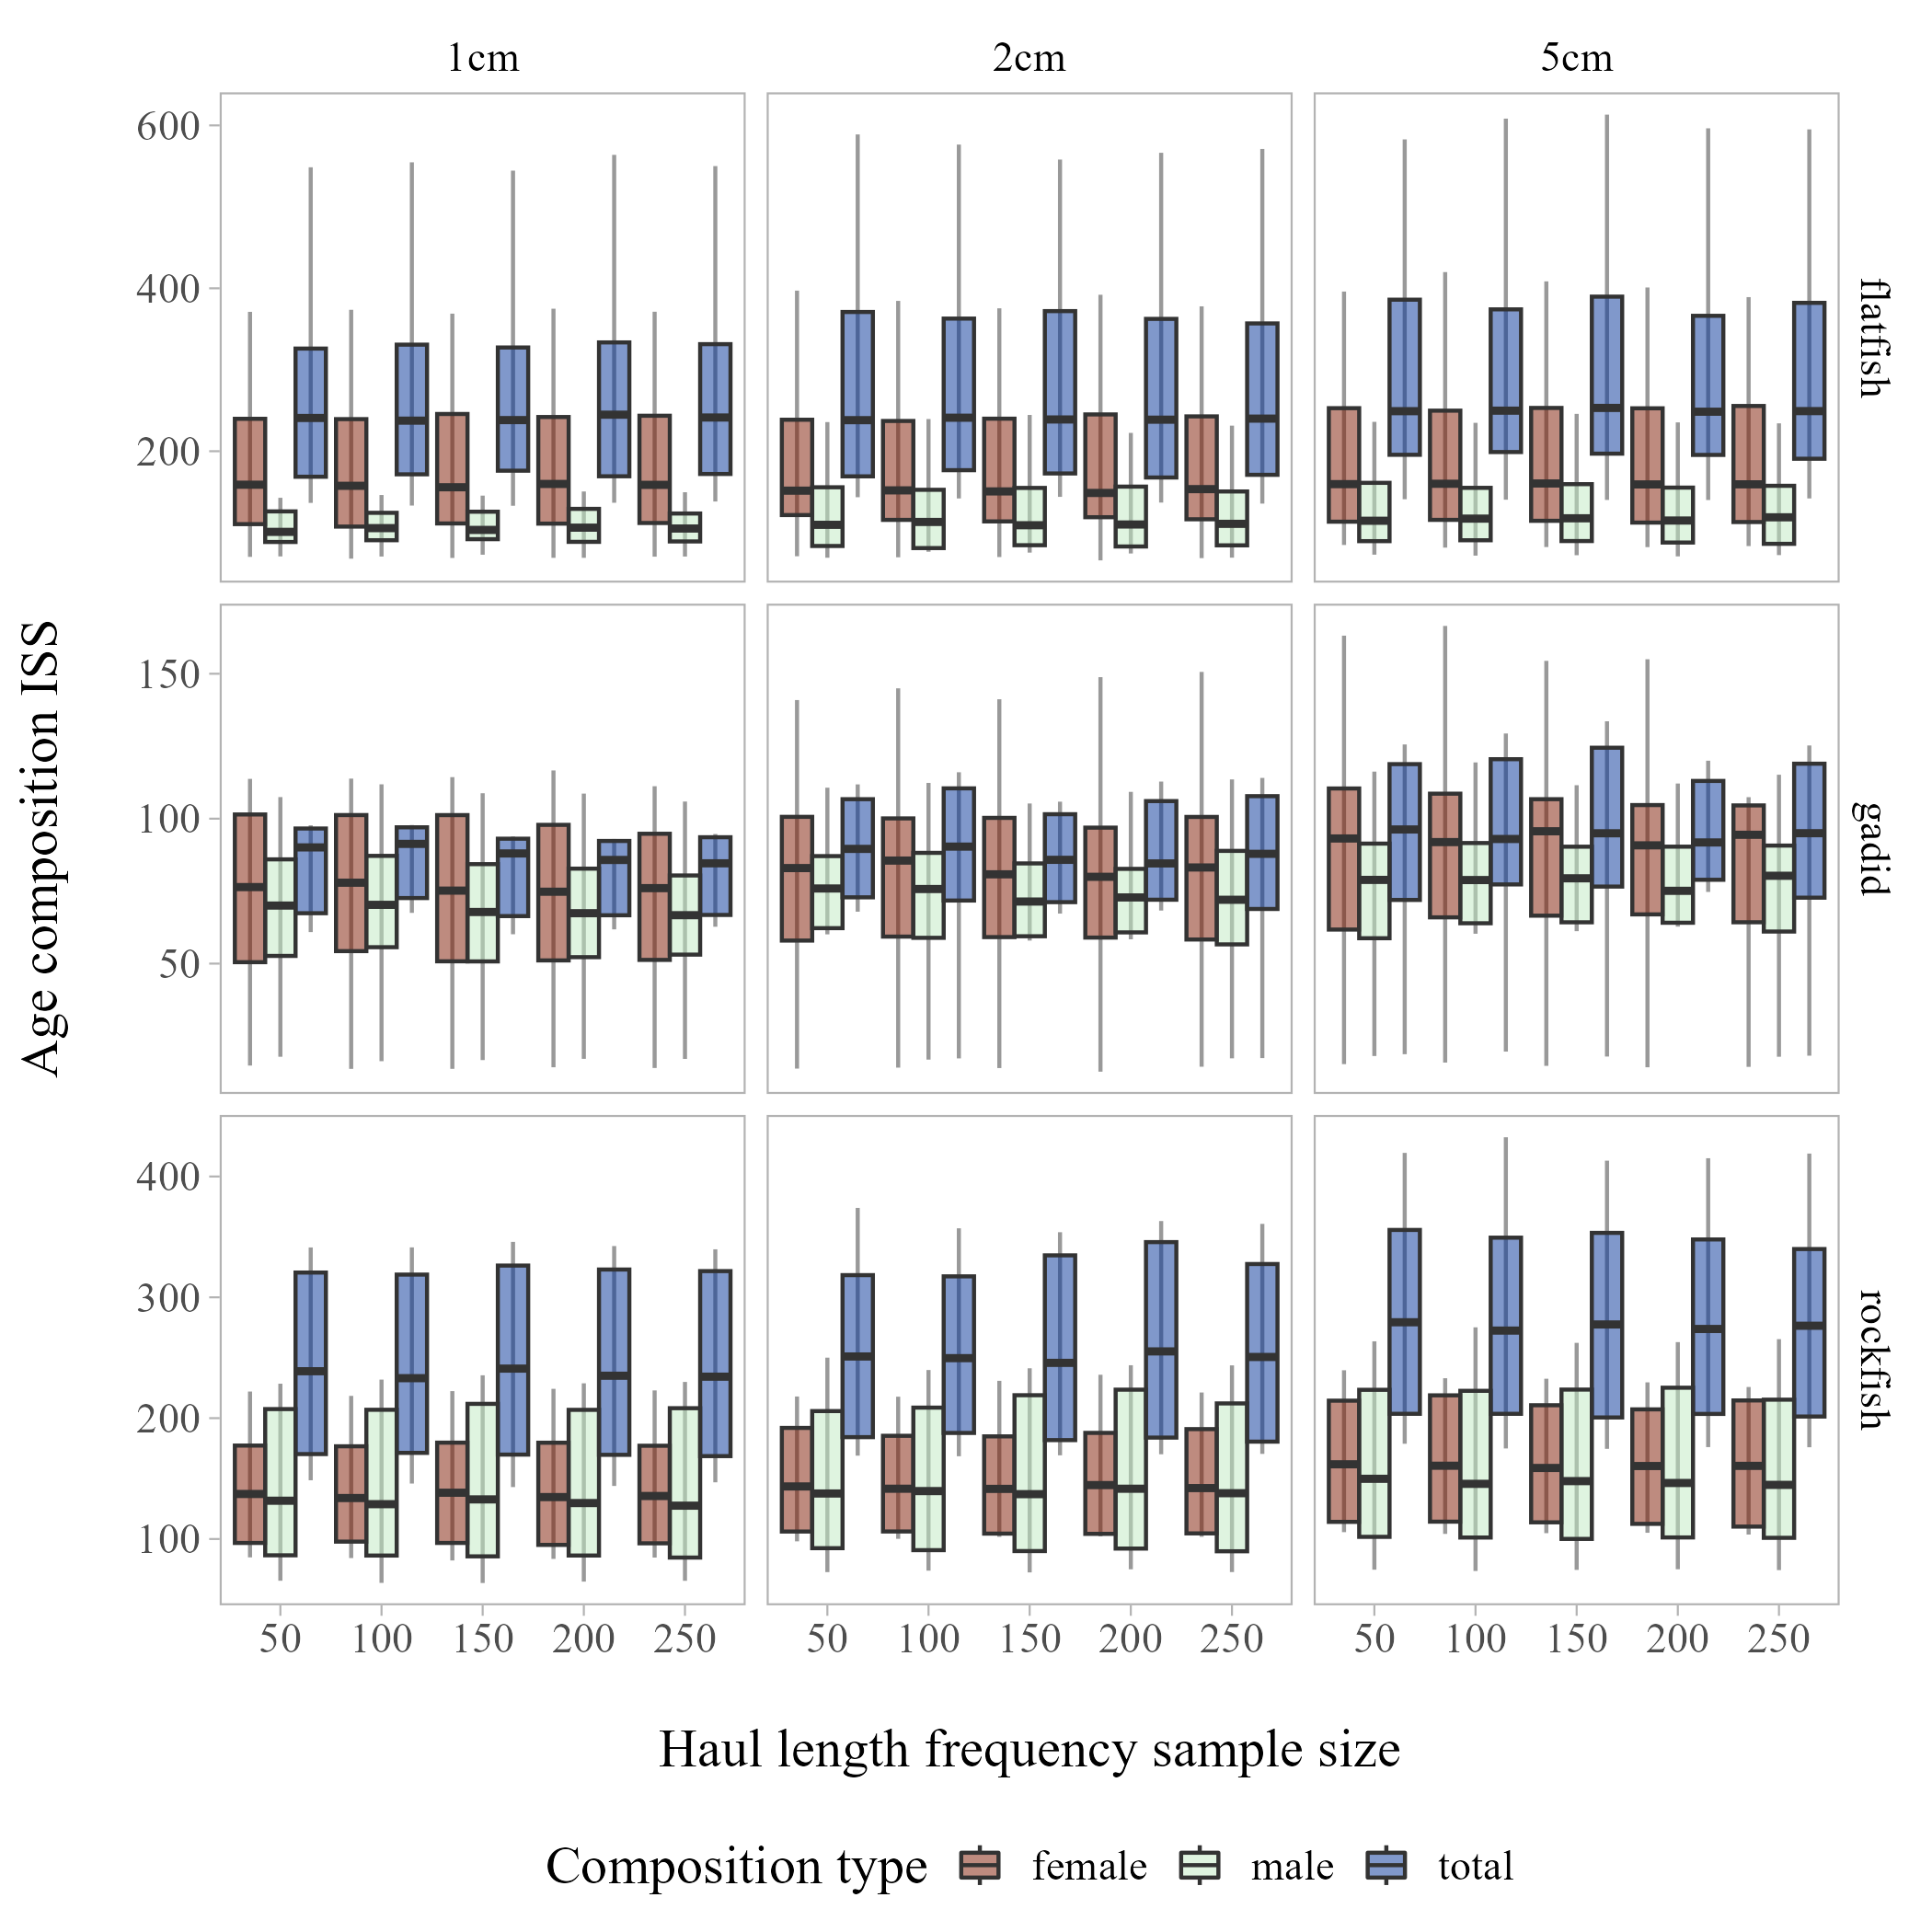

Figure S9: Age composition input sample size by length composition bin and species type (aggregated across stocks within the Gulf of Alaska) across haul length frequency sub-sampling levels evaluated.

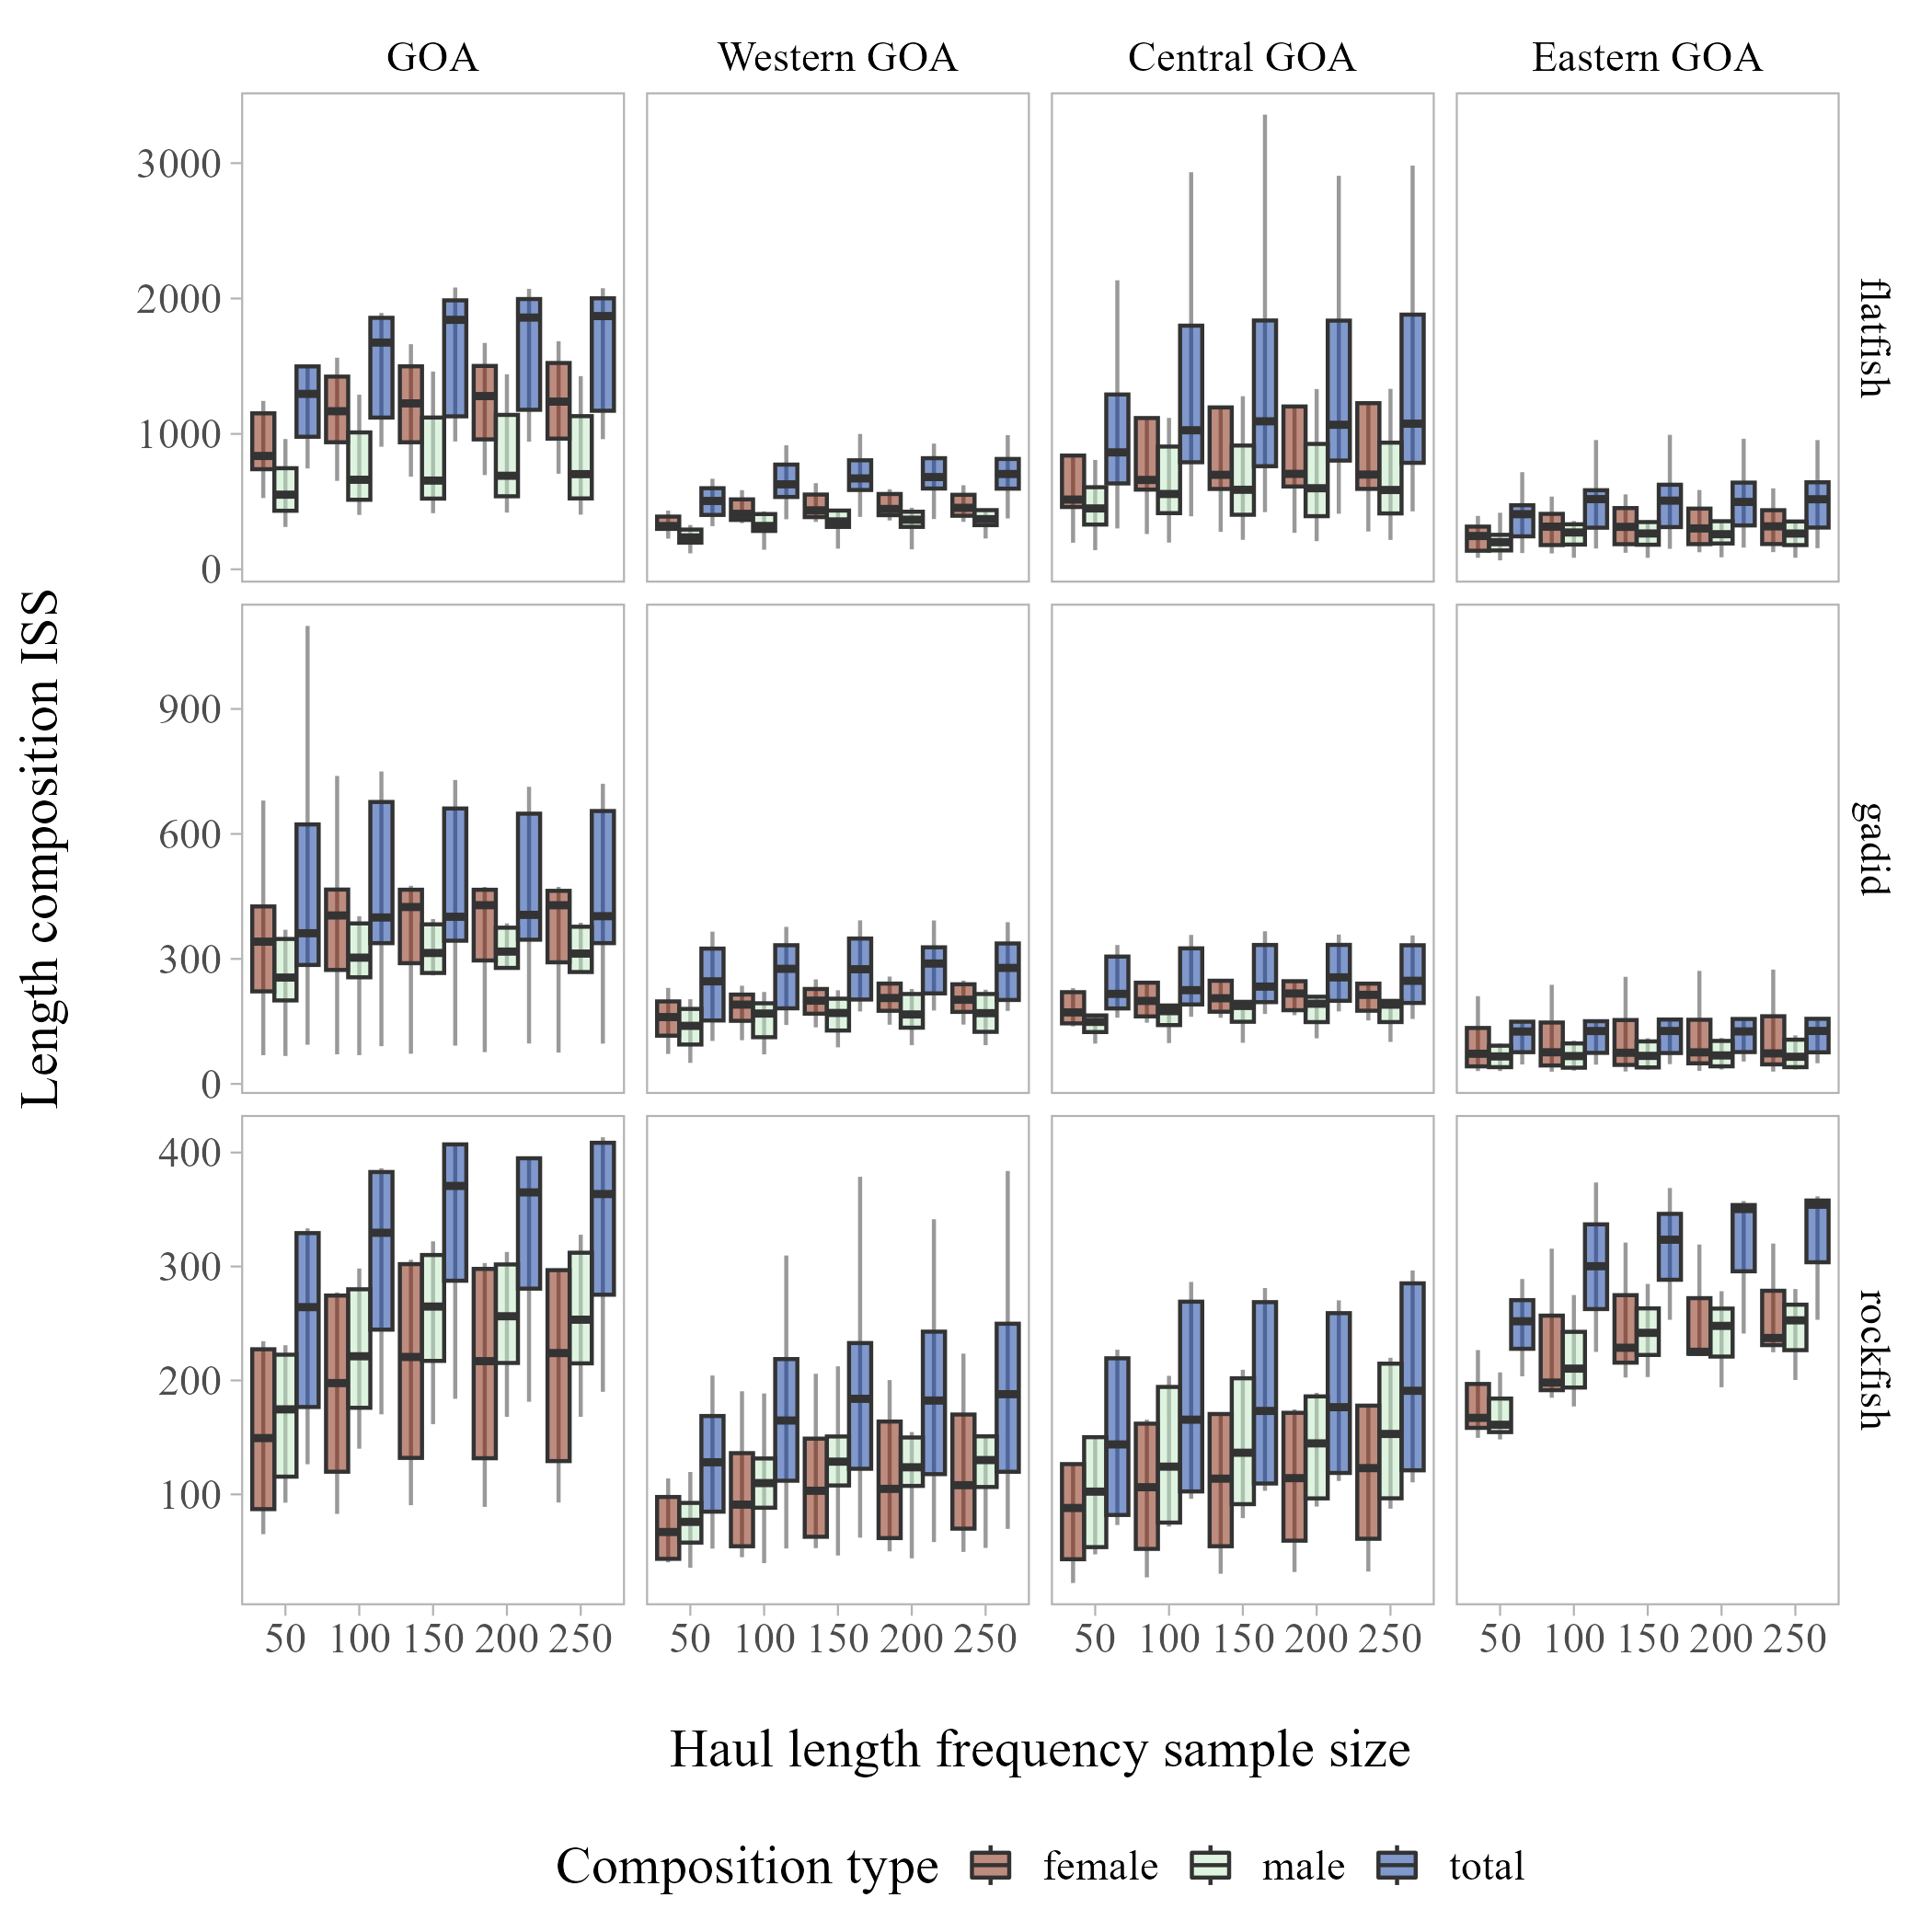

Figure S10: Length composition input sample size by regional scale in the Gulf of Alaska and species type (aggregated across stocks) across haul length frequency sub-sampling levels evaluated.

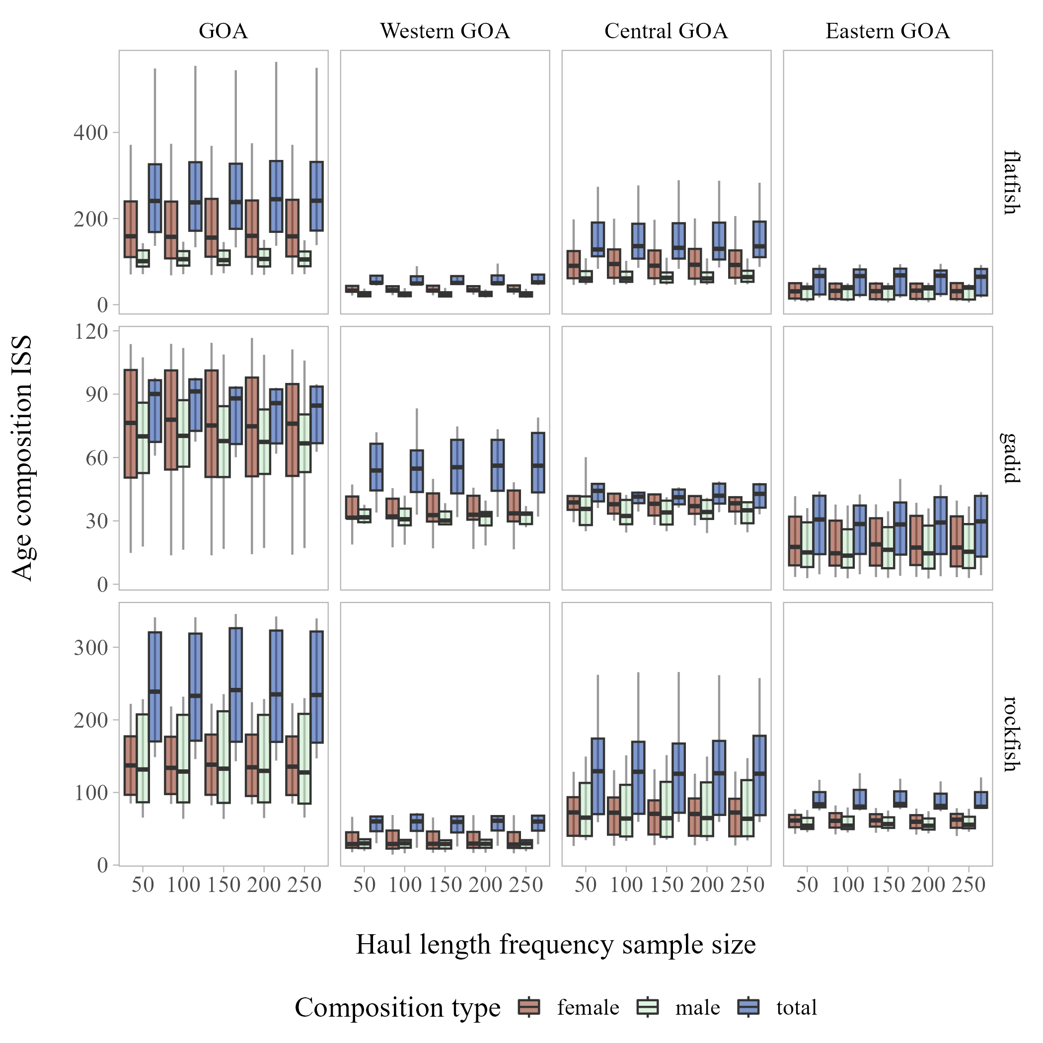

Figure S11: Age composition input sample size by regional scale in the Gulf of Alaska and species type (aggregated across stocks) across haul length frequency sub-sampling levels evaluated.

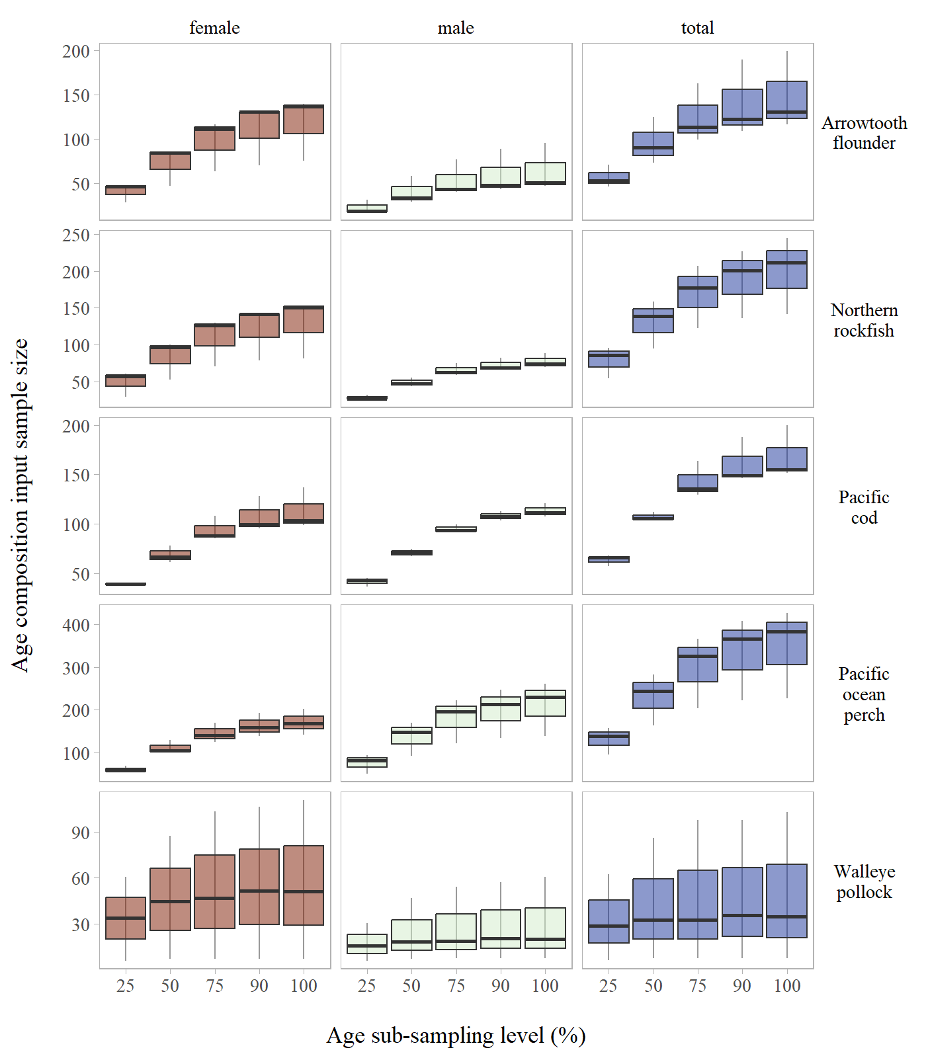

Figure S12: Age composition input sample size by stock across age sub-sampling levels evaluated for the Aleutian Islands.

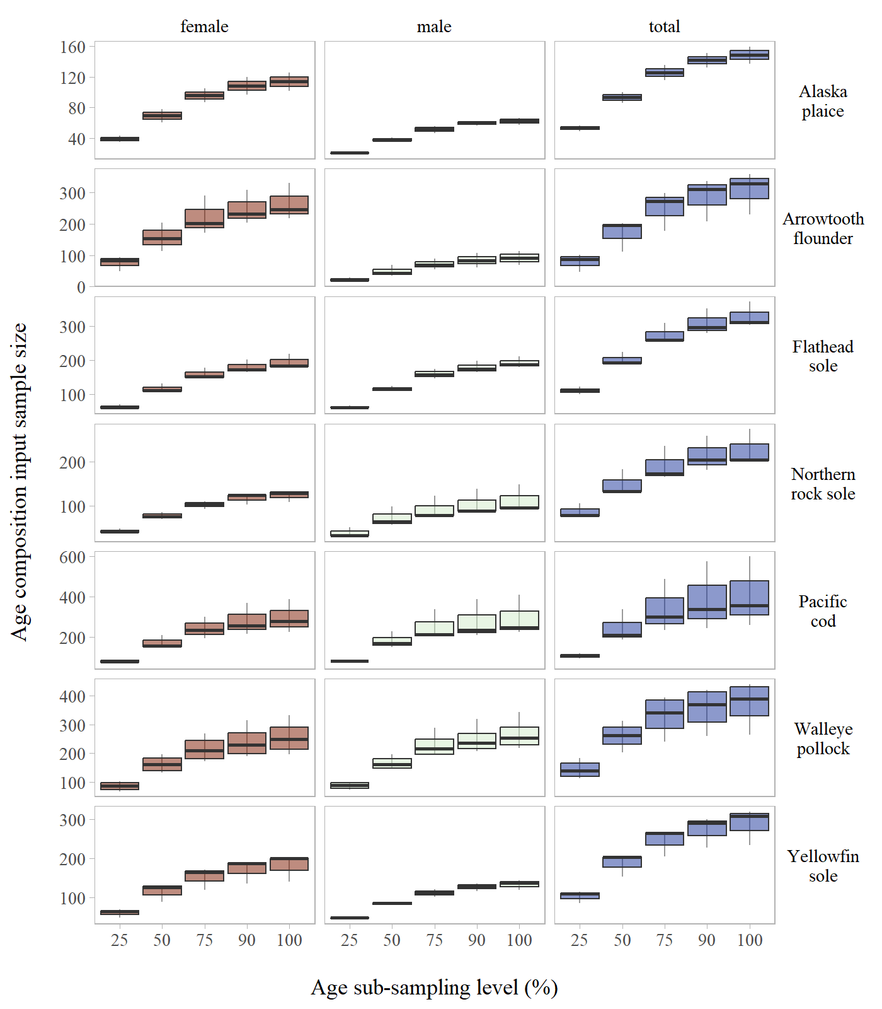

Figure S13: Age composition input sample size by stock across age sub-sampling levels evaluated for the Eastern Bering Sea Shelf.

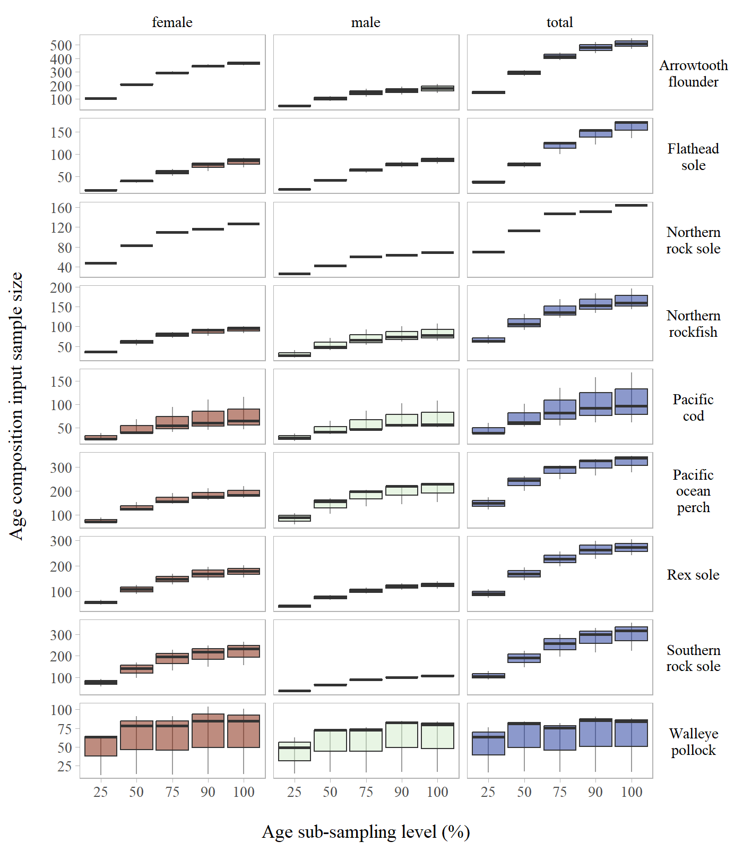

Figure S14: Age composition input sample size by stock across age sub-sampling levels evaluated for the Gulf of Alaska.

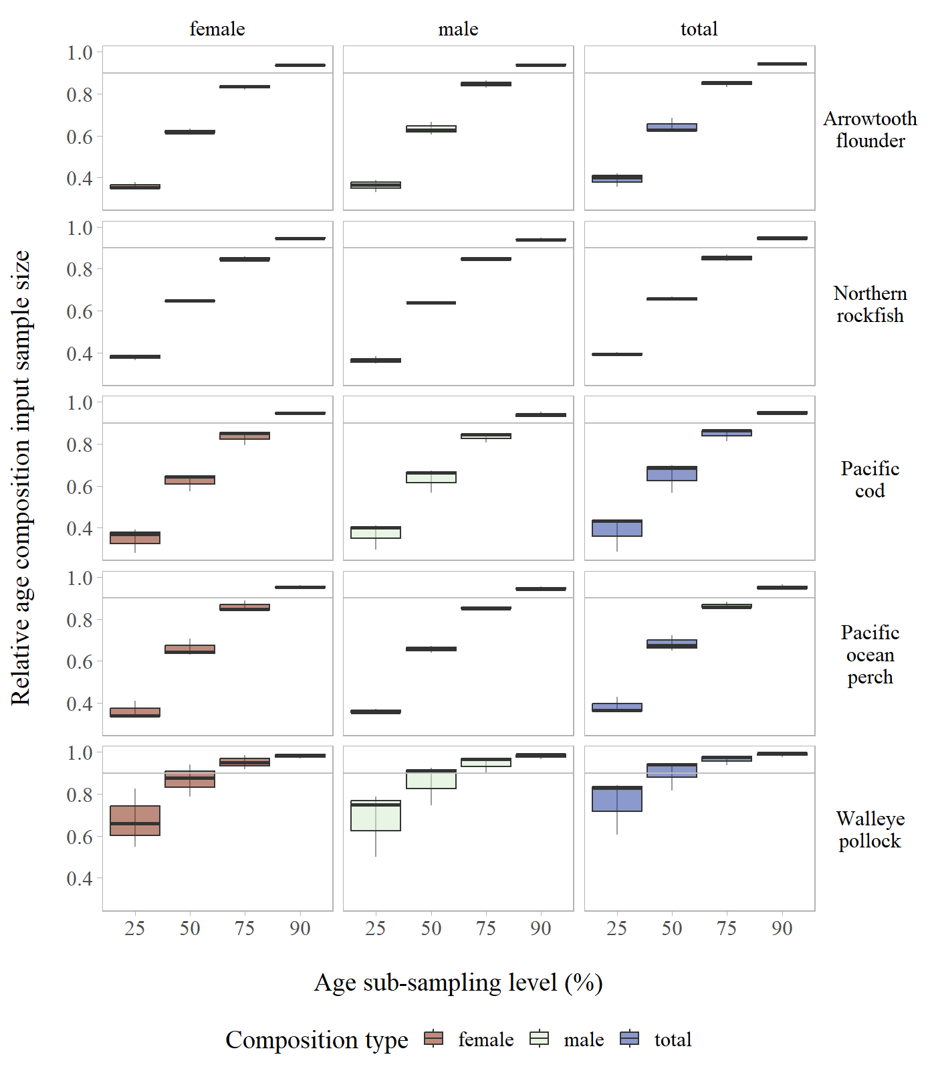

Figure S15: Age composition relative input sample size by stock across age sub-sampling levels evaluated for the Aleutian Islands.

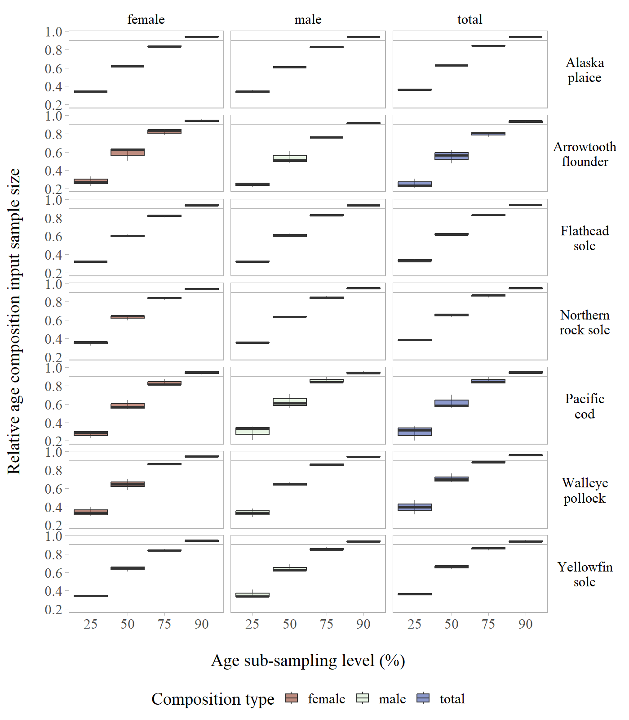

Figure S16: Age composition relative input sample size by stock across age sub-sampling levels evaluated for the Eastern Bering Sea Shelf.

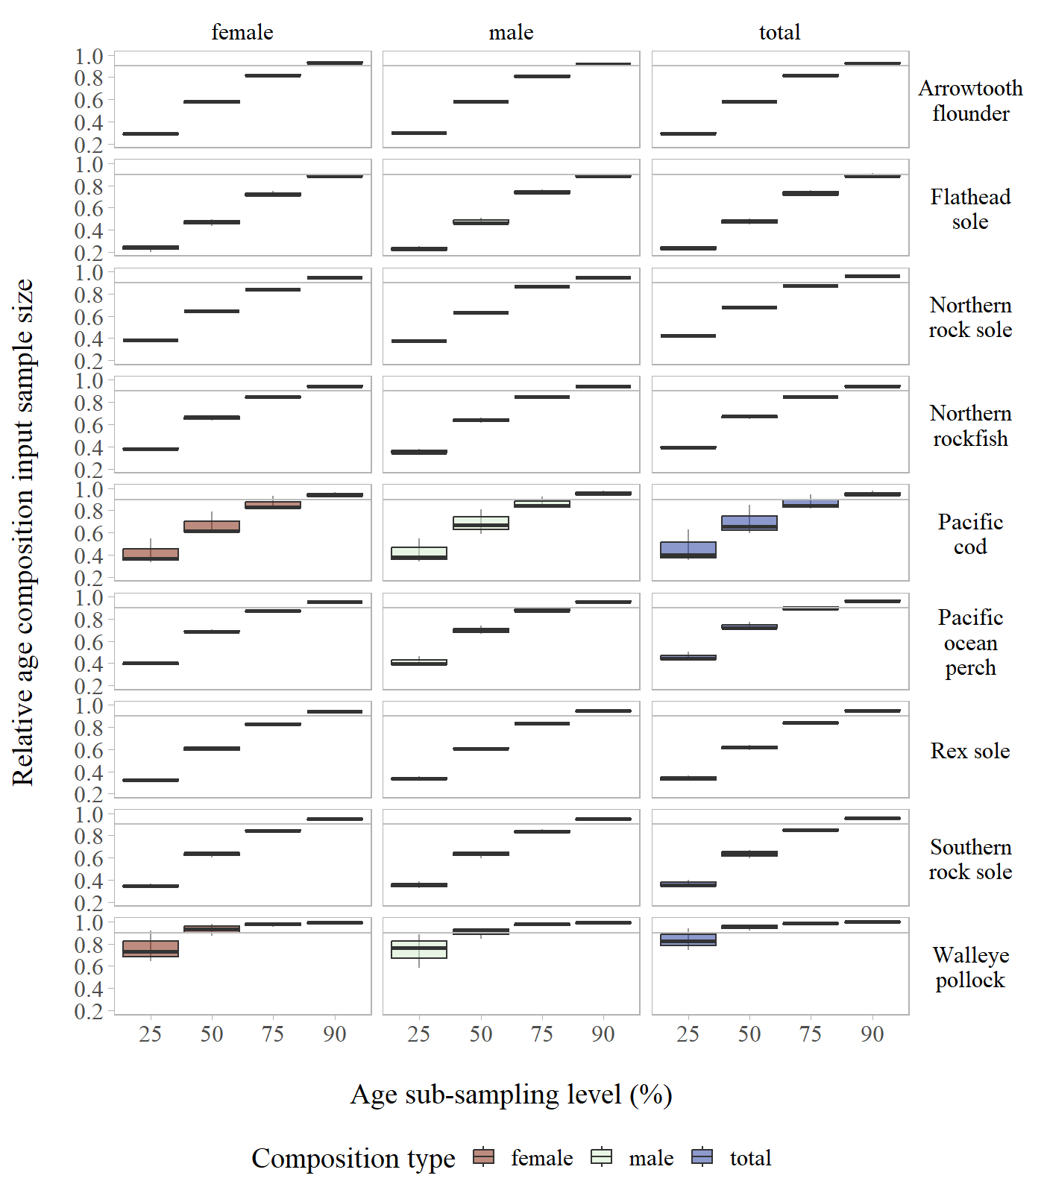

Figure S17: Age composition relative input sample size by stock across age sub-sampling levels evaluated for the Gulf of Alaska.