1. Import a CSV file with all of the Accuserv transactions. This CSV should have no headers and contain all of the information in the job costing report:

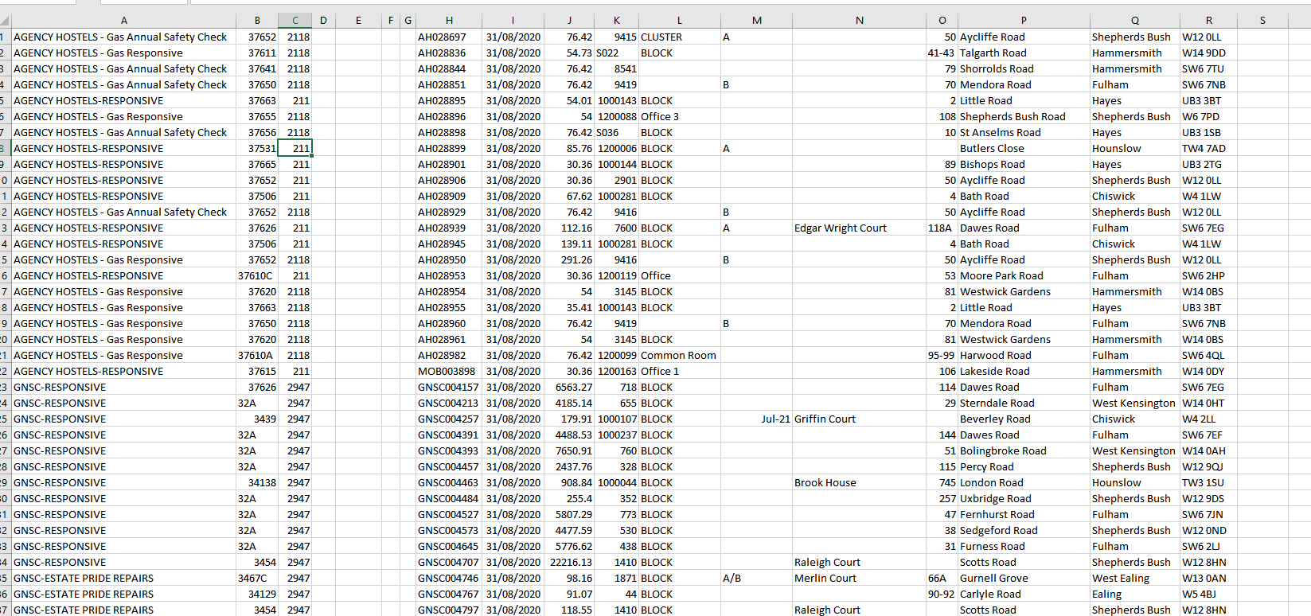



1. Click on the convertor icon.
2. Enter the transaction date and financial period – then press enter and the screen will close.

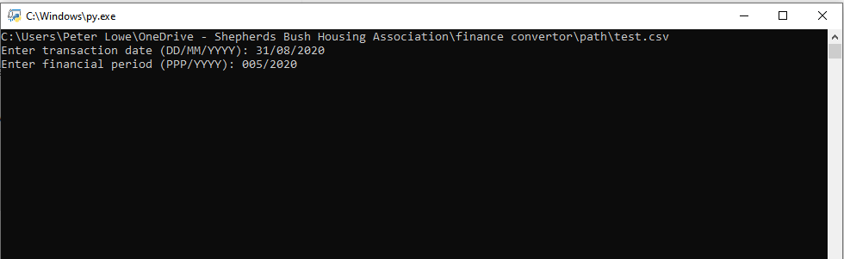

1. Your converted file will be located in the same directory and named SUN6conversion.csv